 

**TAX INVOICE**

**Money Matters Mortgage Brokers**

1009, Tamani Arts Office Tower, Business Bay,P.O. Box- 120380, Dubai, U.A.E.

**…………..**

|  |  |
| --- | --- |
| **Bill To:**  **[bank name]**  **[address]**  **TRN:** [bank TRN] | **Invoice Number: [invoice number]**  **Invoice Date: [date today]**  **TRN: 100368164800003** |

**Description: Professional Fees for Case Disbursed – for the month of [month year]**

|  |  |  |  |  |  |
| --- | --- | --- | --- | --- | --- |
| **Disbursal Date** | **LMF No.** | **Customer Name** | **Loan Amount** | **Payment Slab** | **Incentive (AED)** |

|  |  |  |  |
| --- | --- | --- | --- |
| **Taxable Value** |  |  | **[total incent]** |
| **VAT OUTPUT 5%** |  |  | **[five percent]** |
| **TOTAL** | **[total loan]** |  | **[VAT&incent]** |

Amount in Words: AED [AmtinWords]

Thank You for your Business.

**Bank Details**

Account Name: Money Matters Mortgage Brokers

Bank Name: Mashreq Bank

Account Number: 019100453057

IBAN: AE130330000019100453057 S

WIFT CODE: BOMLAEAD

Branch: Dubai, UAE

**For: Money Matters Mortgage Brokers**

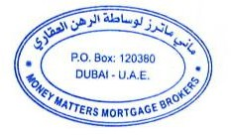

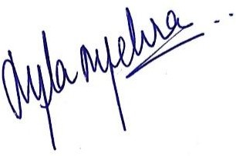

Authorized Signatory

Mala Mehra