AIRLINE PASSENGER SATISFACTION
Data Analysis Report
Exploratory Data Analysis using Python · pandas · NumPy · Matplotlib
─────────────────────────────────────────────
Submitted by:
Aryan Chawla
College:
[GALGOTIAS COLLEGE OF ENGINEERING AND TECHNOLOGY]
Internship Programme:
Data Analyst with AI
Submission Date:
[23rd September 2026]
─────────────────────────────────────────────
Dataset Source: Kaggle — Airline Passenger Satisfaction (teejmahal20)
Training Dataset: 103,904 records · 25 attributes · Binary satisfaction label

TABLE OF CONTENTS
1. Abstract ........................................................................ 3
2. Introduction ................................................................... 4
3. Problem Statement ............................................................ 4
4. Project Objectives ............................................................. 4
5. Dataset Description ........................................................... 5
6. Tools and Technologies ...................................................... 6
7. Methodology .................................................................... 7
8. Results and Key Findings .................................................... 9
9. Consolidated Key Insights ................................................ 12
10. Visualisation ................................................................ 13
11. Recommendations .......................................................... 14
12. Conclusion ................................................................... 15
13. Limitations and Future Improvements ................................. 16
14. References ................................................................... 17

1. ABSTRACT
This report presents a structured Exploratory Data Analysis (EDA) of the Airline Passenger Satisfaction dataset, undertaken as part of a Data Analyst with AI internship. The dataset contains 103,904 passenger records across 25 attributes, encompassing demographic details, flight information, service quality ratings, and a binary satisfaction label.
The analysis was conducted entirely in Python using the pandas, NumPy, and Matplotlib libraries. The project covers data loading, inspection, missing-value handling via median imputation, duplicate checking, and a series of cross-tabulation analyses examining satisfaction levels across customer type, travel class, type of travel, gender, inflight Wi-Fi service rating, and departure delay status.
Key findings indicate that travel class, customer loyalty, and type of travel are strongly associated with passenger satisfaction, while gender shows minimal differentiation. Business-class passengers show a 69.43% satisfaction rate compared to 18.61% for Economy passengers. Business travellers report 58.26% satisfaction versus only 10.17% for personal travellers. The project concludes with a summary of findings and actionable recommendations for airline service improvement.
Keywords: Airline Passenger Satisfaction, Exploratory Data Analysis, Python, pandas, Cross-Tabulation, Data Cleaning, Median Imputation

2. INTRODUCTION
The airline industry operates in an intensely competitive environment where passenger satisfaction is a primary determinant of customer retention, brand loyalty, and financial performance. Understanding the factors that drive — or diminish — satisfaction enables airlines to prioritise service improvements and allocate resources more effectively.
This project analyses a publicly available airline passenger satisfaction dataset sourced from Kaggle. The dataset captures a wide range of passenger attributes — including demographic information, flight details, and ratings for individual in-flight services — along with an overall satisfaction label for each passenger. By applying exploratory data analysis techniques in Python, this project aims to identify patterns and associations that help explain why certain groups of passengers are more satisfied than others.
The project is structured as a beginner-friendly, step-by-step Python script (analysis.py) containing 20 clearly commented stages, making it fully accessible to anyone new to data analysis. All findings reported in this document are directly derived from that script applied to the training dataset.

3. PROBLEM STATEMENT
Airlines routinely collect large volumes of passenger feedback data, but deriving actionable insights from this data requires systematic, reproducible analysis. The central question addressed by this project is:
"Which passenger characteristics and service factors are most strongly associated with overall airline satisfaction, and how do satisfaction rates differ across key passenger segments?"
Specifically, this project investigates satisfaction differences across: Customer Type (loyal vs. disloyal), Travel Class (Business, Eco Plus, Economy), Type of Travel (Business vs. Personal), Gender (Male vs. Female), Inflight Wi-Fi Service Rating (0–5 scale), and Departure Delay Status (Delayed vs. No Delay).

4. PROJECT OBJECTIVES
The objectives of this project are as follows:
1. Load and inspect the airline passenger satisfaction dataset from train.csv.
2. Identify and handle missing values using median imputation to maintain data integrity.
3. Check for and report duplicate records in the dataset.
4. Understand the overall distribution of the target variable (passenger satisfaction).
5. Analyse satisfaction levels across six key passenger segments using cross-tabulation.
6. Visualise the satisfaction distribution using a bar chart created with Matplotlib.
7. Consolidate all key findings in a structured, reproducible summary report.

5. DATASET DESCRIPTION
The dataset used in this project is the publicly available Airline Passenger Satisfaction dataset hosted on Kaggle (teejmahal20). It contains real-world survey and flight record data for airline passengers and is widely used in data analysis and machine learning projects.

Dataset Summary
Detail | Information
Dataset Name | Airline Passenger Satisfaction
Source | Kaggle — teejmahal20 (https://www.kaggle.com/datasets/teejmahal20/airline-passenger-satisfaction)
Primary File Used | train.csv
Dataset Size | 103,904 rows × 25 columns

Column Structure and Features
The training dataset contains 103,904 rows and 25 columns. Each row represents one passenger survey response and flight record. The columns are grouped into four categories:
Feature Category | Column Names
Demographics | Gender, Age, Customer Type (Loyal / Disloyal)
Flight Details | Type of Travel, Class, Flight Distance, Departure Delay in Minutes, Arrival Delay in Minutes
Service Ratings (0–5 scale) | Inflight wifi service, Ease of Online booking, Gate location, Food and drink, Online boarding, Seat comfort, Inflight entertainment, On-board service, Leg room service, Baggage handling, Check-in service, Inflight service, Cleanliness
Target Variable | satisfaction (satisfied / neutral or dissatisfied)

Missing Values
The only column with missing values was Arrival Delay in Minutes, which had 310 missing entries (approximately 0.30% of rows). These were handled using median imputation in Step 11 of the analysis script. After imputation, zero missing values remained in the cleaned dataset.

6. TOOLS AND TECHNOLOGIES
Tool / Library | Version | Purpose
Python 3 | 3.x | Programming language used for the entire analysis
pandas | Latest stable | Data loading, inspection, cleaning, and cross-tabulation analysis
NumPy | Latest stable | Creating the Departure Delay Status column using np.where()
Matplotlib | Latest stable | Plotting the satisfaction distribution bar chart (Step 19)
Implementation note | — | The analysis was implemented in Python using open-source libraries; no commercial software or proprietary tools were used.

7. METHODOLOGY
The analysis was carried out as a single Python script (analysis.py) divided into 20 clearly labelled and commented steps. The methodology follows a standard EDA workflow, beginning with raw data ingestion and ending with a consolidated findings summary.

7.1 Data Loading and Inspection
The dataset was loaded from train.csv into a pandas DataFrame using pd.read_csv(). Initial inspection covered the first five rows (df.head()), the shape of the dataset (df.shape returning 103,904 rows × 25 columns), all column names (df.columns), data types of each column (df.dtypes), and summary statistics for numerical columns (df.describe()).

7.2 Missing Value and Duplicate Checks
Missing values were identified using df.isnull().sum(). The only column with missing data was Arrival Delay in Minutes with 310 missing entries. Duplicate rows were verified using df.duplicated().sum(), which returned 0 — confirming no duplicate records existed in the dataset.

7.3 Handling Missing Values — Median Imputation
A clean working copy of the dataset, df_clean, was created using df.copy() to ensure the original DataFrame remained unchanged. The 310 missing values in Arrival Delay in Minutes were filled with the column median (0.0 minutes). The median was chosen over the mean because arrival delay data contains extreme outliers that would skew a mean-based imputation. Post-imputation, the column contained zero missing values.

7.4 Satisfaction Distribution Analysis
The overall distribution of the target variable was examined using df_clean['satisfaction'].value_counts() for absolute counts and value_counts(normalize=True) for percentage shares. This established the baseline split between satisfied and neutral or dissatisfied passengers across the full 103,904-record dataset.

7.5 Cross-Tabulation Analysis
pd.crosstab() was used to compare satisfaction against each of the following variables: Customer Type, Class, Type of Travel, Gender, Inflight wifi service rating, and Departure Delay Status. For each variable, both raw counts and row-wise percentages (normalize='index') were calculated. The Departure Delay Status column was created using np.where() to classify passengers as Delayed or No Delay based on whether Departure Delay in Minutes was greater than zero.

7.6 Visualisation
A bar chart of the overall satisfaction distribution was created using Matplotlib (Step 19). The chart includes a descriptive title, labelled axes, and passenger counts displayed above each bar. plt.tight_layout() was applied to prevent label clipping. The bars are coloured in steelblue (neutral or dissatisfied) and coral (satisfied) for clear visual contrast.

7.7 Summary of Key Findings
Step 20 of the script consolidates all key results into a single printed summary, recalculating all figures dynamically from df_clean rather than using hardcoded values. This ensures the summary remains accurate if the dataset or earlier steps are modified.

8. RESULTS AND KEY FINDINGS
All results below are derived from analysis.py applied to train.csv. They represent observed associations in the data and should not be interpreted as proof of causation.
8.1 Dataset Overview
Metric | Value
Total rows (passengers) | 103,904
Total columns (features) | 25
Missing values (Arrival Delay in Minutes) | 310 (filled using median = 0.0 min)
Duplicate rows | 0
8.2 Overall Satisfaction Distribution
The dataset shows more passengers in the neutral or dissatisfied category than in the satisfied category. This baseline distribution provides context for the segment-level analyses.
Satisfaction Category | Passenger Count | Percentage
Neutral or Dissatisfied | 58,879 | 56.67%
Satisfied | 45,025 | 43.33%
8.3 Satisfaction by Customer Type
These percentages describe satisfaction by customer type; the analysis does not establish why the rates differ.
Customer Type | Satisfied | Neutral or Dissatisfied
Loyal Customer | 47.73% | 52.27%
Disloyal Customer | 23.67% | 76.33%
8.4 Satisfaction by Travel Class
The figures compare satisfaction rates across travel classes but do not identify which service features account for the differences.
Travel Class | Satisfied | Neutral or Dissatisfied
Business | 69.43% | 30.57%
Eco Plus | 24.61% | 75.39%
Eco (Economy) | 18.61% | 81.39%
8.5 Satisfaction by Type of Travel
Business travellers had a satisfaction rate of 58.26%, compared with 10.17% for personal travellers—a difference of 48.09 percentage points. Further analysis would be needed to examine other variables, such as travel class.
Type of Travel | Satisfied | Neutral or Dissatisfied
Business Travel | 58.26% | 41.74%
Personal Travel | 10.17% | 89.83%
8.6 Satisfaction by Gender
Satisfaction rates were similar between male and female passengers, with a difference of 1.21 percentage points.
Gender | Satisfied | Neutral or Dissatisfied
Female | 42.74% | 57.26%
Male | 43.95% | 56.05%
8.7 Satisfaction by Inflight Wi-Fi Service Rating
The figures show an association between Wi-Fi rating and overall satisfaction. The reason for the unusually high satisfaction rate in the rating-0 group is not established by this analysis and warrants further investigation.
Wi-Fi Rating (0–5) | Total Passengers | Satisfied % | Neutral or Dissatisfied %
0 (Not applicable) | 3,103 | 99.74% | 0.26%
1 (Very poor) | 17,840 | 32.54% | 67.46%
2 (Poor) | 25,830 | 24.87% | 75.13%
3 (Moderate) | 25,868 | 25.06% | 74.94%
4 (Good) | 19,794 | 59.90% | 40.10%
5 (Excellent) | 11,469 | 99.08% | 0.92%
8.8 Satisfaction by Departure Delay Status
Passengers with no departure delay had a satisfaction rate of 45.75% (26,842 satisfied out of 58,668), compared with 40.20% (18,183 satisfied out of 45,236) for delayed flights. This is a difference of 5.55 percentage points. The comparison does not establish causation.
Departure Delay Status | Total Passengers | Satisfied % | Neutral or Dissatisfied %
No Delay (0 min) | 58,668 | 45.75% | 54.25%
Delayed (> 0 min) | 45,236 | 40.20% | 59.80%
Section 8 Summary of Key Findings
Area | Key result | Summary / interpretation
Dataset | 103,904 rows; 25 columns; 310 missing arrival-delay values imputed with median 0.0; no duplicates | Results use the cleaned training dataset.
Overall satisfaction | 43.33% satisfied; 56.67% neutral or dissatisfied | More passengers were neutral or dissatisfied.
Customer type | Loyal 47.73%; disloyal 23.67% satisfied | Difference: 24.06 percentage points.
Travel class | Business 69.43%; Eco Plus 24.61%; Economy 18.61% satisfied | Business–Economy difference: 50.82 percentage points.
Type of travel | Business travel 58.26%; personal travel 10.17% satisfied | Difference: 48.09 percentage points.
Gender | Male 43.95%; female 42.74% satisfied | Difference: 1.21 percentage points.
Inflight Wi-Fi | Ratings 0–5 satisfaction: 99.74%, 32.54%, 24.87%, 25.06%, 59.90%, 99.08% | Rating 0 is unusual and merits further investigation.
Departure delay | No delay 45.75%; delayed 40.20% satisfied | Difference: 5.55 percentage points; association only.
Visual evidence: Insert the Step 19 satisfaction bar chart and Step 20 console output screenshots here if required by the submission guidelines.

9. CONSOLIDATED KEY INSIGHTS
Analysis Factor | Highest Satisfaction Group | Lowest Satisfaction Group | Satisfaction Differential
Travel Class | Business (69.43%) | Economy (18.61%) | 50.82 pp
Type of Travel | Business Travel (58.26%) | Personal Travel (10.17%) | 48.09 pp
Customer Type | Loyal Customer (47.73%) | Disloyal Customer (23.67%) | 24.06 pp
Inflight Wi-Fi Rating | Rating 4–5 (Higher sat.) | Rating 1–2 (Lower sat.) | Qualitative (see 8.7)
Departure Delay Status | No Delay (45.75% satisfied) | Delayed (40.20% satisfied) | 5.55 pp
Gender | Male (43.95%) | Female (42.74%) | 1.21 pp
Overall Dataset | Satisfied: 43.33% | Neutral/Dissatisfied: 56.67% | 103,904 total passengers

10. VISUALISATION
Step 19 of analysis.py generates a bar chart showing the overall satisfaction distribution across the 103,904 passengers in the training dataset. The chart was produced using Matplotlib and displays the exact passenger count above each bar.
Chart Specifications:
• Chart type: Vertical bar chart | X-axis: Satisfaction Category | Y-axis: Number of Passengers
• Bar colours: Steelblue (neutral or dissatisfied) and Coral (satisfied)
• Count labels displayed above each bar (formatted with comma separators)
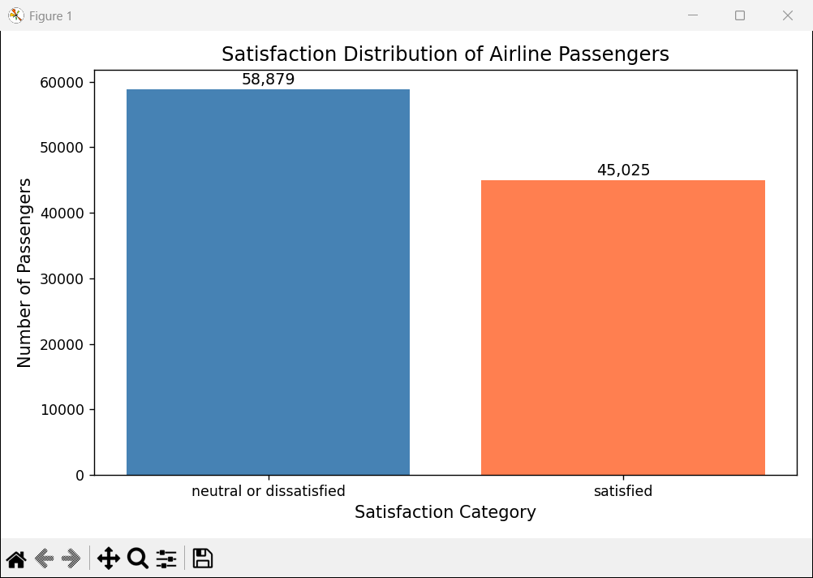Expected values: Neutral or Dissatisfied bar = 58,879 | Satisfied bar = 45,025
To generate: Run python analysis.py from the project folder. The chart appears at Step 19.
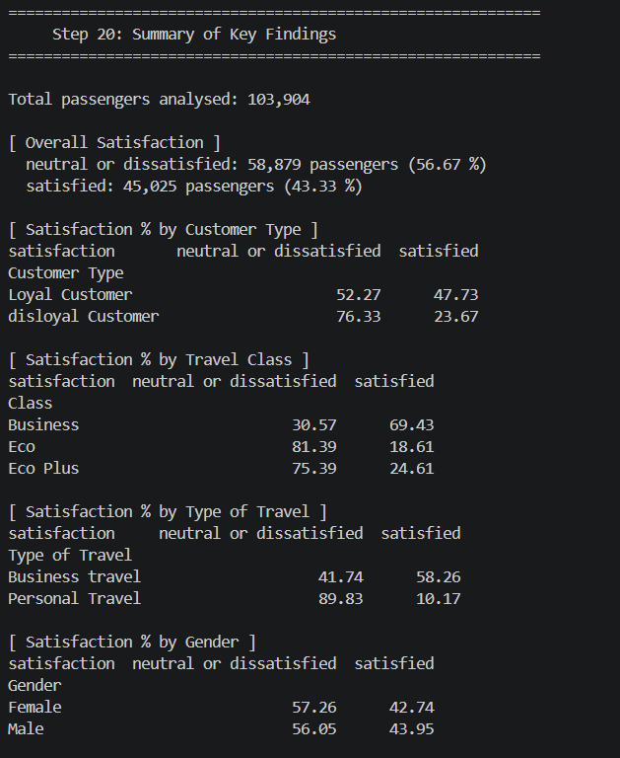A 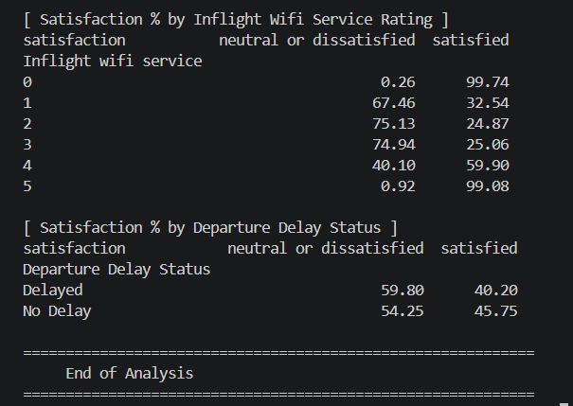screenshot of the Step 20 console output can be inserted above as evidence of script execution and to display all cross-tabulation results in their original format.

11. RECOMMENDATIONS
Finding | Recommendation | Priority
Economy passengers: 81.39% dissatisfied | Investigate which Economy service attributes (for example, seat comfort, boarding, and Wi-Fi ratings) are associated with lower satisfaction. Consider targeted improvements after validating the findings. | High
Personal travellers: 89.83% dissatisfied | Investigate the needs and experience of personal travellers. Evaluate options such as flexible check-in, family-friendly services, and value-added offers before implementation. | High
Disloyal customers: 76.33% dissatisfied | Review the onboarding and service experience for disloyal customers; test whether specific touchpoints are associated with dissatisfaction before selecting interventions. | High
High Wi-Fi ratings correlated with satisfaction | Assess Wi-Fi reliability and speed, and investigate how Wi-Fi ratings relate to satisfaction. Validate the relationship and operational feasibility before investing. | Medium
Scope limited to EDA — no causal analysis performed | Apply machine learning (logistic regression, random forest) to the dataset to identify the strongest predictors of satisfaction with statistical confidence. | Future Work

12. CONCLUSION
This project successfully carried out a structured exploratory data analysis of the Airline Passenger Satisfaction dataset using Python and widely used open-source data science libraries. Working through 20 clearly commented steps in analysis.py, the analysis covered data loading, inspection, cleaning, and a comprehensive series of cross-tabulation analyses across six passenger segments.
The findings indicate that travel class, customer loyalty status, and type of travel are among the most strongly differentiated factors associated with passenger satisfaction. Business-class passengers show a satisfaction rate of 69.43% compared to just 18.61% for Economy passengers — a 50.82 percentage-point gap. Business travellers report 58.26% satisfaction versus only 10.17% for personal travellers — a 48.09 percentage-point gap, the second-largest differential observed across the six factors analysed.
Gender shows minimal differentiation, with less than 1.5 percentage points separating male and female passengers. Inflight Wi-Fi ratings and departure delay status also show observable associations with satisfaction outcomes, though these are correlational patterns rather than causal claims.
The project demonstrates a practical, beginner-accessible approach to data analysis and provides a solid foundation for more advanced work, such as feature engineering, correlation analysis, and predictive modelling using machine learning classifiers.

Interactive dashboard
Interactive Dashboard
An interactive dashboard was developed using Streamlit, Pandas, and Matplotlib to present the key findings of the Airline Passenger Satisfaction Data Analysis project. It provides a clear and user-friendly view of passenger satisfaction through KPI cards, visualizations, and interactive filters.
The dashboard allows users to explore satisfaction patterns across different customer types, travel purposes, travel classes, and genders. It also includes service ratings analysis, flight delay analysis, key observations, and practical recommendations. By applying filters, users can focus on specific passenger groups and observe how the results change.
The dashboard transforms the analyzed data into an accessible visual format, making it easier to understand passenger satisfaction patterns and identify areas for further investigation.
Figure: Interactive Airline Passenger Satisfaction Dashboard

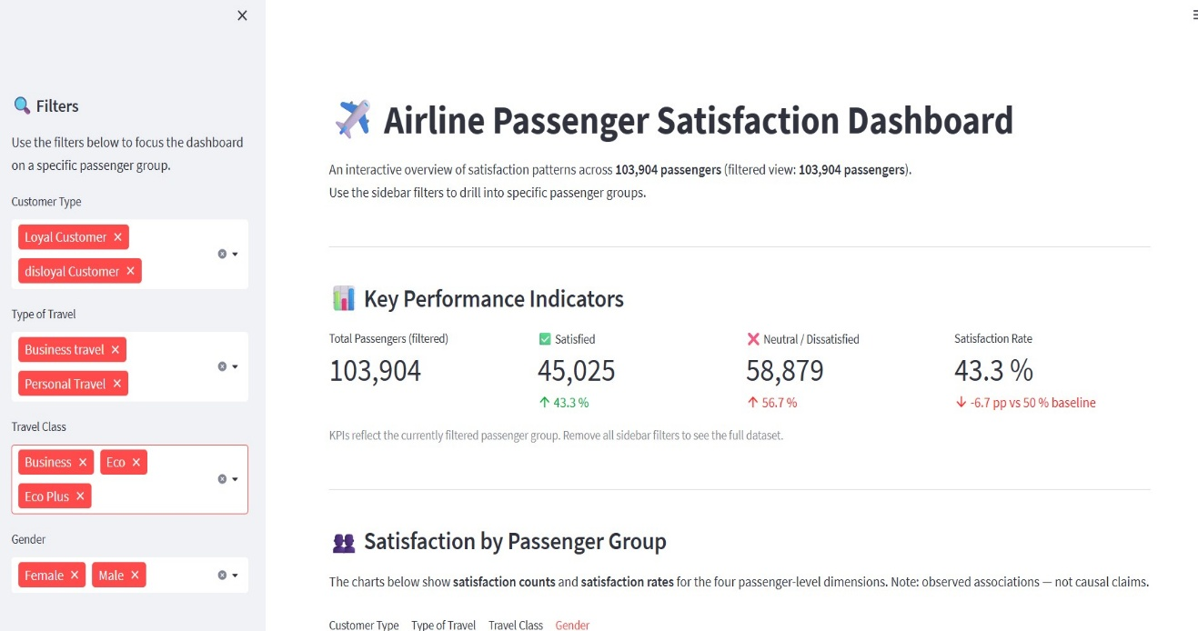
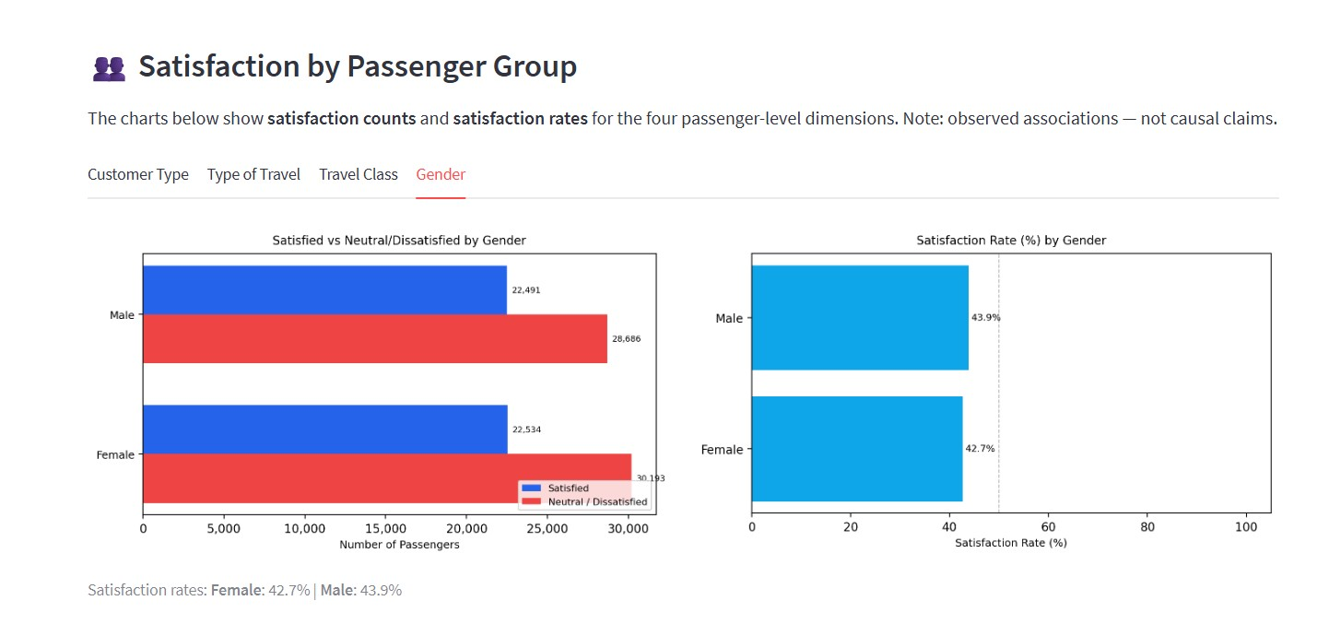

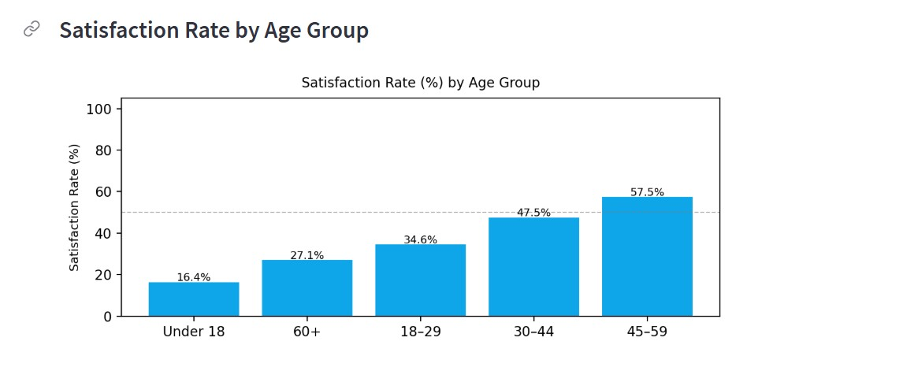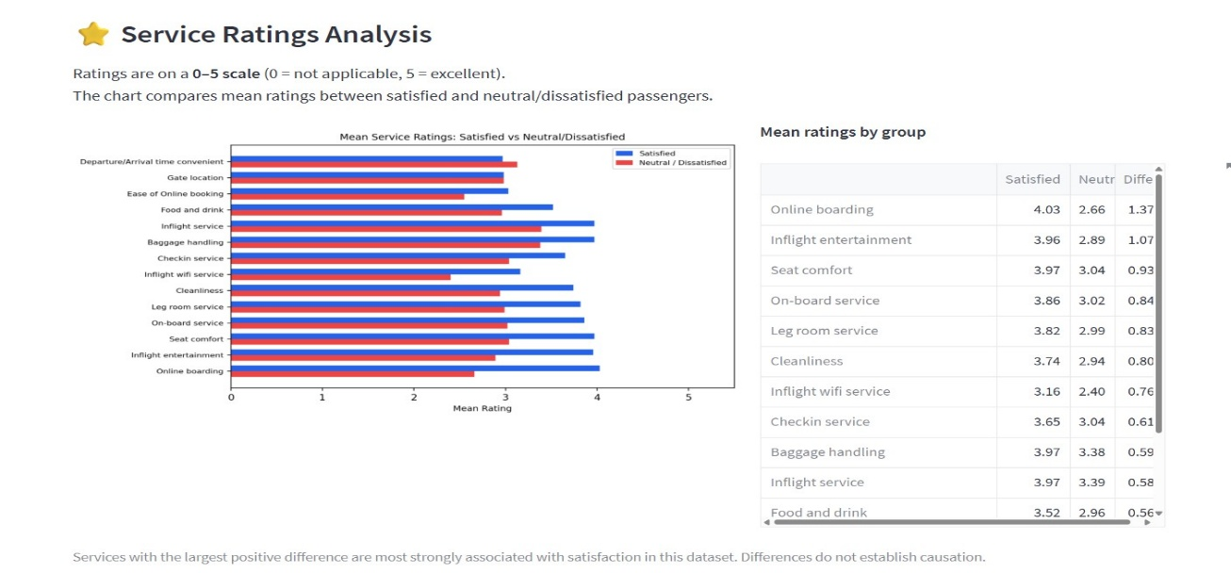
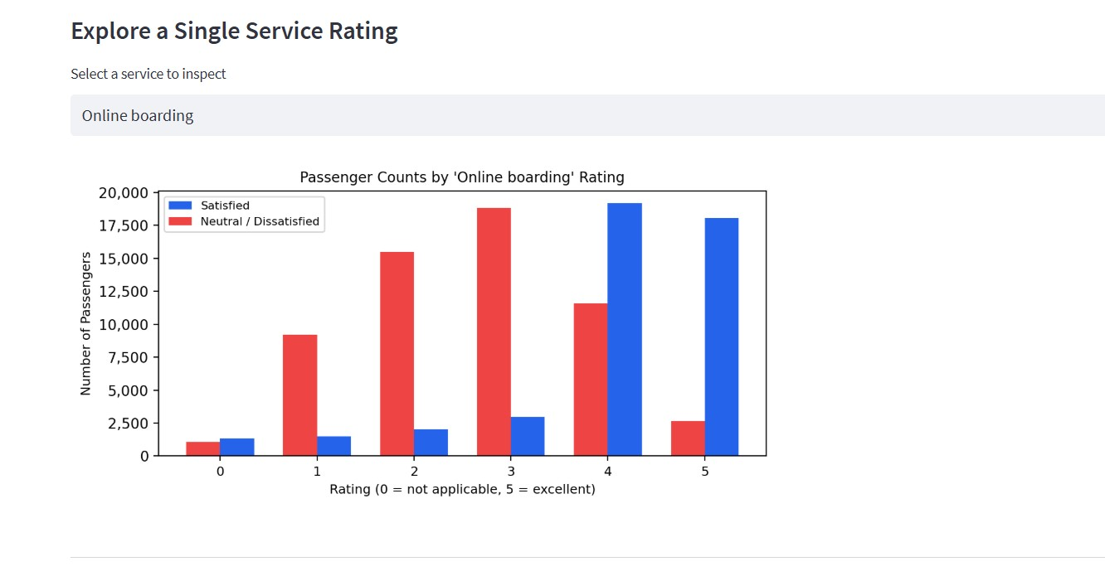
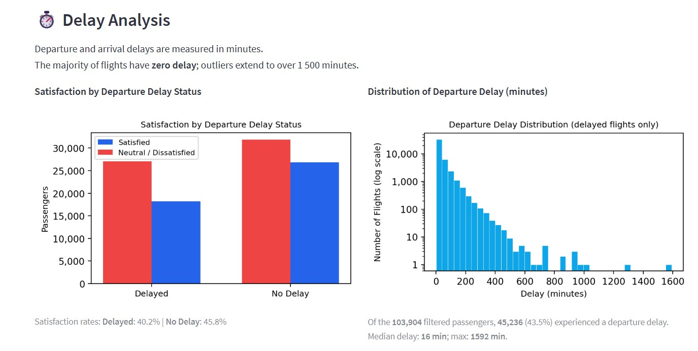
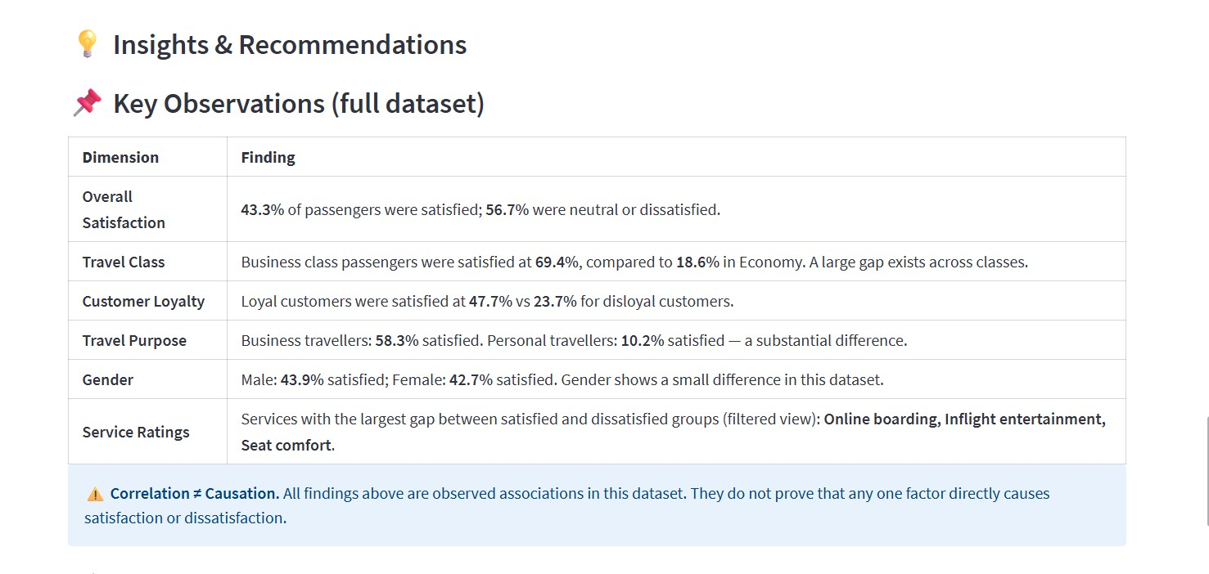
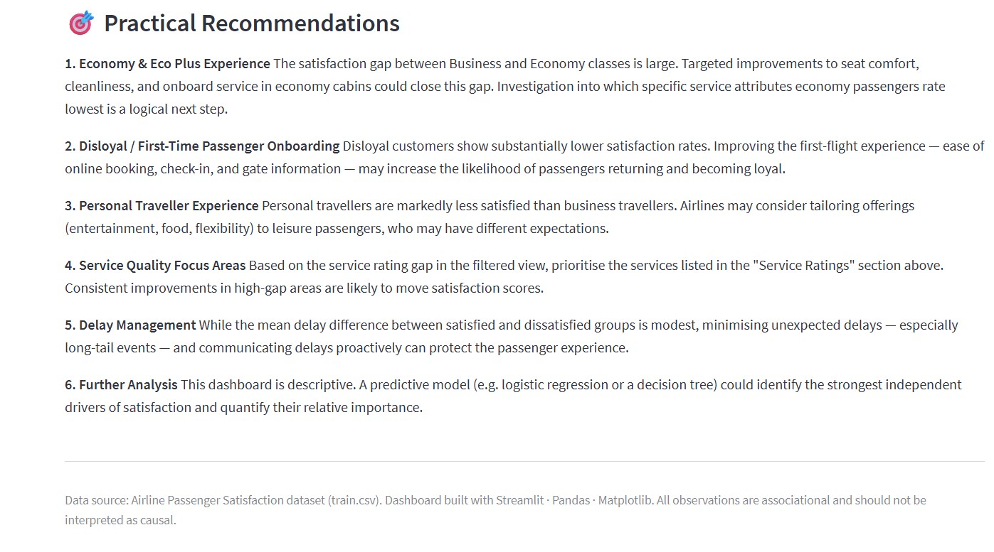

13. LIMITATIONS AND FUTURE IMPROVEMENTS
Current Limitation | Suggested Future Improvement
Scope limited to exploratory analysis only — no predictive modelling | Apply ML classifiers (logistic regression, random forest) to predict satisfaction and rank feature importance
Single-variable comparisons only — no multivariate analysis | Control for class when analysing type of travel; use regression or decision trees for richer insights
test.csv not used in this project | Apply a trained model to test.csv for out-of-sample validation and evaluation
Only one visualisation produced (satisfaction bar chart) | Add heatmaps of service ratings, age distribution plots, and stacked bar charts for multi-variable comparisons
No outlier analysis — extreme values in Flight Distance and Delay not investigated | Perform outlier detection to assess impact on satisfaction distribution and data quality

14. REFERENCES
1. Airline Passenger Satisfaction Dataset — Kaggle (teejmahal20):
https://www.kaggle.com/datasets/teejmahal20/airline-passenger-satisfaction
2. pandas Development Team. pandas: Python Data Analysis Library.
https://pandas.pydata.org
3. NumPy Development Team. NumPy: The fundamental package for scientific computing with Python.
https://numpy.org
4. Hunter, J. D. (2007). Matplotlib: A 2D graphics environment. Computing in Science & Engineering, 9(3), 90-95.
https://matplotlib.org
5. Python Software Foundation. Python Language Reference, version 3.x.
https://www.python.org

