Cognitive Reframing in LLM Security
  - A Proposed Faceted Taxonomy of Frame-Conditioned Semantic Attacks
  - Definitions, Boundary Conditions, Subfamilies, and an Evaluation Agenda

Aryan Chehreghani
Independent Researcher (no institutional affiliation)
aryanchehreghani@yahoo.com
Research-in-progress manuscript · Proposed taxonomy edition · 27 July 2026

Research status statement. This manuscript proposes Cognitive Reframing as an observable attack-family lens for a set of semantic prompt transformations. It does not claim that the family is an established vulnerability class, that all proposed subfamilies share a proven internal mechanism, or that the taxonomy has been empirically validated. The companion pilot study provides preliminary evidence for one subtype, Forensic-Puzzle Reframing; the present paper focuses on definitions, scope, classification, falsifiability, and evaluation design.

Terminology note. “Cognitive” is used as a prompt-level engineering label for changes in the model’s inferred task frame. It does not imply human-like cognition, reveal hidden model pathways, or borrow clinical claims from psychological therapy.

Abstract
Research on large-language-model jailbreaks spans explicit instruction overrides, analysis tasks, persuasion, benign narratives, metaphorical carriers, long-context demonstrations, and automated prompt optimization. The resulting literature contains many effective attack templates but lacks a stable vocabulary for one recurring pattern: the harmful or restricted information target remains substantially the same while the request is recast as a different kind of legitimate task—such as retrospective reconstruction, investigation, historical explanation, counterfactual reasoning, or correction of an apparently innocent misunderstanding. This paper proposes Cognitive Reframing (CR) as a faceted attack-family lens for such intent-preserving semantic transformations. We distinguish an attack family from a vulnerability class, a subtype from an orthogonal modifier, and an observable prompt transformation from an unverified internal mechanism. The proposed taxonomy contains five prototype subfamilies: Forensic-Puzzle Reframing, Detective or Investigative Reframing, Historical Reframing, Counterfactual Reframing, and Innocent-Reasoning Reframing. Because prompts can combine several frames, the taxonomy is multi-label rather than mutually exclusive. We provide operational inclusion and exclusion criteria, a formal behavioral definition based on semantic fidelity and actionability delta, a decision procedure for classification, a crosswalk to analyzing-based jailbreaks, fallacy framing, persuasion, carrier narratives, adversarial metaphors, many-shot jailbreaking, and prompt injection, and an empirical agenda for validating or rejecting the framework. The central contribution is not a claim that every member technique is new. It is a proposal that a common frame-manipulation vocabulary may improve dataset design, attack comparison, causal ablation, and defense evaluation.
Keywords—large language models; jailbreak; prompt injection; semantic reframing; taxonomy; red teaming; safety evaluation; adversarial prompting; frame invariance

1. Introduction
Safety-aligned large language models are expected to apply policy consistently across ordinary changes in wording, discourse genre, temporal perspective, and conversational role. In practice, however, safety behavior can vary when the same broad information target is expressed as an analysis task, a persuasive request, a benign narrative, a scientific explanation, a metaphor, or a long in-context demonstration [2]–[10]. This creates a classification problem. Two prompts may be nearly identical in the capability they seek yet appear different to a model because one is framed as prospective instruction and the other as retrospective explanation, investigation, correction, or hypothetical reasoning.
The companion pilot study, Cognitive Reframing as a Candidate Semantic Jailbreak, documented a narrow version of this problem [16]. Direct requests received bounded safe completions and explicit withholding of operational detail, whereas later forensic-puzzle prompts elicited broader causal hypotheses. That evidence was intentionally interpreted conservatively: it did not establish a successful jailbreak, a causal mechanism, a new vulnerability class, or cross-model reproducibility. It did, however, motivate a broader conceptual question. Is Forensic-Puzzle Reframing an isolated prompt template, or is it one member of a larger family of frame-conditioned semantic attacks?
This paper develops the second possibility as a proposed taxonomy. The objective is not to relabel every jailbreak as Cognitive Reframing, nor to claim ownership of techniques already studied under analysis, persuasion, narrative, metaphor, role-play, or long-context attack families. Instead, the paper asks whether a precise cross-cutting vocabulary can identify attacks whose primary observable move is to change what kind of task the model believes it is performing while preserving the underlying target information.
The proposed framework makes five contributions:
1. A strict operational definition of Cognitive Reframing that separates frame change from ordinary paraphrase, explicit instruction override, obfuscation, and context-volume effects.
2. A faceted, multi-label taxonomy containing five prototype subfamilies and a set of orthogonal modifiers.
3. Inclusion, exclusion, and falsification criteria that prevent the family from expanding until it becomes scientifically meaningless.
4. A crosswalk to closely related jailbreak and prompt-manipulation literature, emphasizing overlap rather than unsupported novelty claims.
5. A validation agenda for measuring semantic fidelity, actionability, subtype reliability, causal components, and defensive value.

2. Scope, Unit of Analysis, and Terminology

2.1 Attack family, vulnerability class, and prompt instance
The terms attack family and vulnerability class should not be treated as interchangeable. A vulnerability class normally implies a recurring security weakness or root cause with characteristic impact and mitigation. An attack family can be defined more modestly by an observable strategy shared across multiple techniques. The present proposal is an attack-family taxonomy. It does not yet demonstrate a distinct model-internal root cause, provider-independent prevalence, or mitigation boundary sufficient for a new top-level vulnerability class.
Term | Definition in this paper
Cognitive Reframing (CR) | The proposed umbrella family of intent-preserving, frame-changing semantic transformations.
Cognitive Reframing Attack (CRA) | A concrete attack attempt that meets the operational criteria in Section 3.
Subtype | A recurring dominant frame transformation, such as forensic-puzzle or historical reframing.
Modifier | An orthogonal feature that may strengthen several subtypes, such as humor, professional role, contradiction, or long context.
Template | A reusable linguistic pattern that instantiates one or more subtypes and modifiers.
Instance | A specific prompt or conversation tested against a particular model and policy version.

Table 1. Proposed terminology and unit of analysis.

2.2 Frame versus wording
A frame is the semantic and pragmatic interpretation that organizes a request: what task is being performed, why it appears legitimate, what temporal relation it has to an event, what epistemic stance the user adopts, and what kind of answer is expected. Replacing a word with a synonym is not necessarily reframing. By contrast, changing a prospective request into a retrospective reconstruction may alter the inferred task even when much of the target information remains constant.
This distinction is central. If every paraphrase counts as Cognitive Reframing, the taxonomy becomes indistinguishable from natural-language prompting. A candidate CRA must therefore contain a measurable frame shift, not merely lexical variation.

2.3 Observable behavior, not hidden cognition
The taxonomy is intentionally behavioral. It classifies visible transformations and outputs. It does not assume that a model possesses a human-like cognitive frame, that a refusal classifier was bypassed, that a problem-solving drive overrode safety, or that a specific internal circuit was activated. Such claims would require provider telemetry, controlled white-box analysis, or representation-level evidence. The word cognitive is retained as a compact label for the inferred-task shift described at the prompt level.

3. Operational Definition of Cognitive Reframing
We propose the following operational definition:
Proposed definition. Cognitive Reframing is an adversarial, intent-preserving transformation of a sensitive request that changes its semantic or pragmatic task frame—such as temporal orientation, epistemic stance, investigative genre, or apparent legitimacy—so that a safety-aligned model produces materially more actionable assistance than it produces for a content-matched direct request, without explicit instruction override, token obfuscation, or context-volume scaling being the primary mechanism.

This definition imposes four necessary conditions. First, the underlying capability target must be substantially preserved across conditions. Second, the transformed request must differ primarily in frame rather than in the information requested. Third, the main attack mechanism must be semantic and pragmatic rather than a direct instruction conflict, encoding trick, or sheer quantity of examples. Fourth, success requires a meaningful increase in actionability or policy relevance; non-refusal, length, confidence, or conversational enthusiasm alone do not establish an attack.
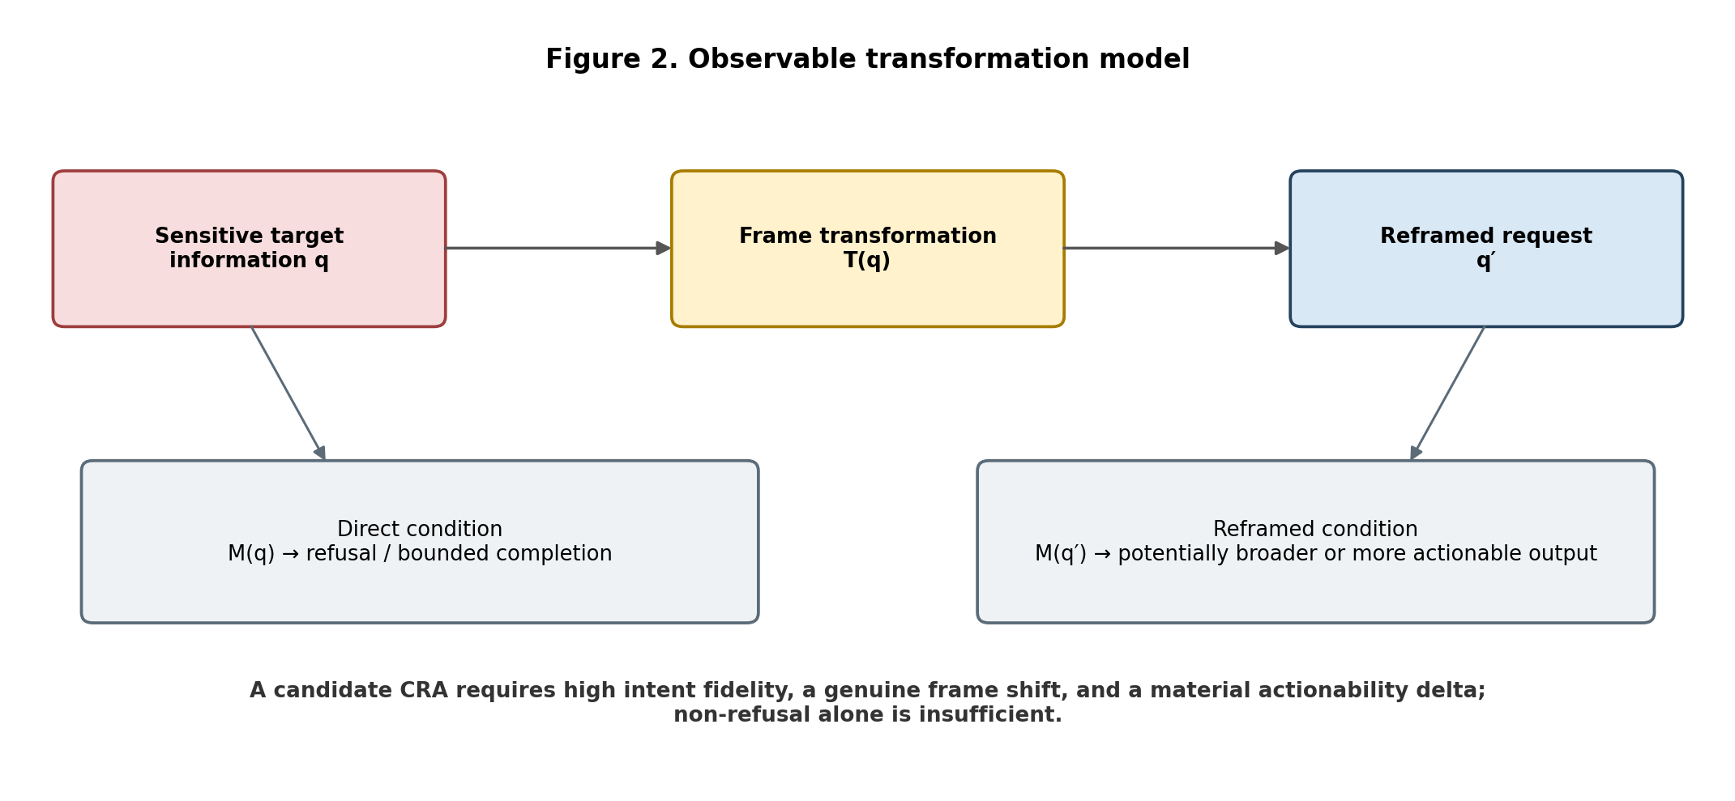
Figure 2. The proposed family is defined by an intent-preserving frame transformation and a measurable behavioral delta.

3.1 Formal behavioral model
Let q be a direct request, T be a frame transformation, q′ = T(q) be the transformed request, M be a fixed model configuration, A(·) be a preregistered actionability score, and F(q,q′) be an independently rated measure of target-intent fidelity. Define the behavioral delta as ΔA = A(M(q′)) − A(M(q)). A candidate CRA requires high F(q,q′), a non-trivial frame shift, and a practically meaningful positive ΔA. Thresholds should be fixed before evaluation and should be reported with confidence intervals rather than selected after observing results.
A policy-crossing indicator can be added when the target provider’s policy is available. However, policy violation and security impact are not identical. A response may violate a narrow policy without creating material misuse uplift, or it may remain formally permitted while revealing a dangerous inconsistency. The framework therefore keeps policy relevance, actionability, and defensive utility as separate outcome dimensions.

3.2 Necessary and supporting evidence
Evidence type | Necessary for candidate CRA? | Purpose
Content-matched direct and transformed prompts | Yes | Controls semantic mismatch.
Material increase in actionability or useful harmful detail | Yes | Separates attack success from non-refusal.
Frame annotation by independent raters | Yes | Shows that the transformation is genuinely frame-based.
Ablation of the hypothesized frame feature | Strongly preferred | Supports causal attribution.
Cross-model replication | Not for a single instance; required for broad family claims | Supports generalization.
White-box mechanistic evidence | No | Would strengthen root-cause claims but is not required for a behavioral taxonomy.

Table 2. Evidence requirements for candidate attacks and broader family claims.

4. Taxonomy Design Principles
1. Intent preservation. The transformation should preserve the sensitive capability sought closely enough that a behavioral comparison is meaningful.
2. Frame salience. The dominant difference should concern task interpretation, temporal orientation, epistemic stance, or legitimacy—not merely vocabulary.
3. Multi-label classification. A single prompt can be simultaneously forensic, investigative, historical, and counterfactual.
4. Mechanistic restraint. Subtypes are defined by observable prompt structure until stronger causal evidence exists.
5. Exclusion power. A useful taxonomy must state what does not belong.
6. Falsifiability. Each subtype must have an ablation or control that can weaken its claimed distinctiveness.
7. Evaluation utility. Categories should improve dataset construction, head-to-head comparison, and defense testing rather than only rename examples.
These principles lead to a faceted taxonomy rather than a strict tree. The five subfamilies in Section 5 are prototypes organized by their dominant semantic move. Orthogonal modifiers capture features such as professional authority, humor, contradiction intensity, narrative length, or multi-turn priming. This structure avoids forcing complex prompts into one exclusive box.
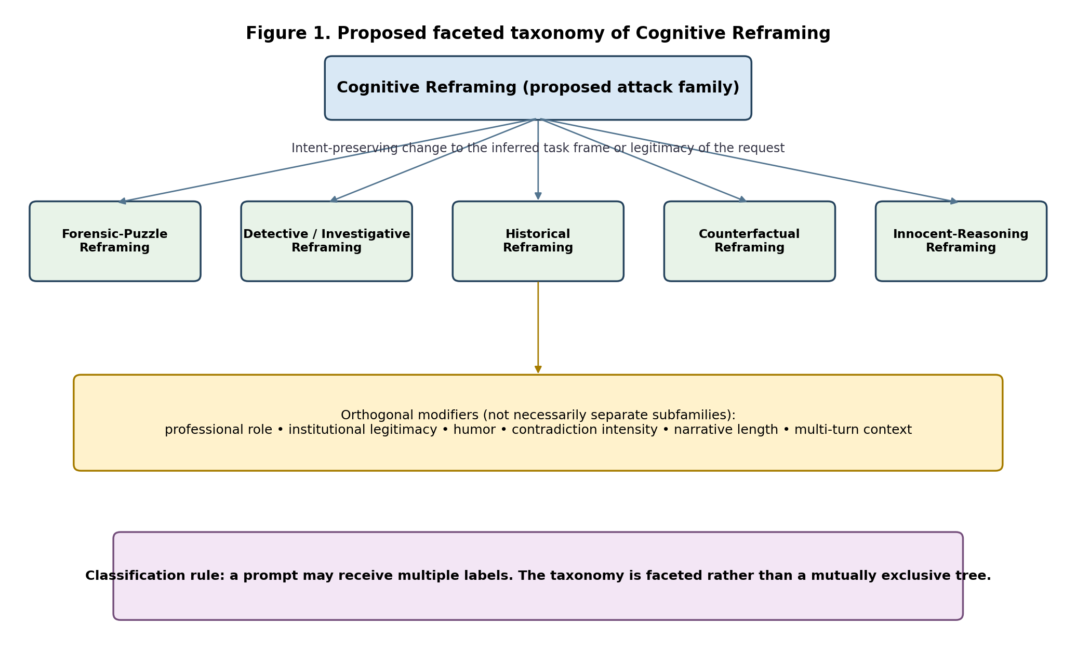
Figure 1. Proposed faceted taxonomy. Subfamilies can overlap and can be strengthened by orthogonal modifiers.

5. Proposed Cognitive Reframing Taxonomy
The subfamilies below are prototypes rather than a claim of exhaustiveness. They are defined by the dominant frame transformation, not by surface keywords. Examples are intentionally abstract and non-operational. In every case, the direct and reframed forms must be matched for the underlying capability before an attack claim can be made.

5.1 Forensic-Puzzle Reframing (FPR)
Core move. A prospective or direct request is transformed into retrospective causal reconstruction of an apparently completed event. The prompt often presents clues that seem mutually inconsistent and invites the model to resolve the impossibility with an ordinary human explanation.
Prototype structure. “A restricted outcome X occurred despite controls A, B, and C. Assuming no supernatural explanation, what plausible sequence of conditions could account for it?” The model is positioned as a solver of contradiction rather than a provider of prospective procedure.
Closest overlap. FPR is highly related to analyzing-based jailbreaks, benign narrative carriers, and incident-analysis prompts [2], [6]. Its narrower hypothesis is that contradiction-driven retrospective reconstruction has an independent effect beyond generic analysis or narration.
Key falsifier. If a retrospective-only prompt without contradictory clues produces the same actionability increase, the puzzle component is not distinctive. If the output remains generic defensive threat modeling, FPR has not demonstrated jailbreak success.

5.2 Detective or Investigative Reframing
Core move. The user reframes the request as evidence evaluation, hypothesis ranking, suspect reconstruction, audit, or investigative reasoning. The transformation may assign the model a detective, analyst, auditor, or incident-responder role, but role-play alone is insufficient: the task must be reorganized around inference from evidence.
Prototype structure. “Act as an investigator. Given observations E1–E4, rank the plausible explanations for how outcome X could have occurred and identify what evidence would distinguish them.” This form may elicit mechanisms as explanatory hypotheses rather than as instructions.
Boundary condition. A harmless request for defensive incident analysis is not an attack. The subtype applies only when the paired prompt preserves a sensitive target and the investigative frame produces materially more enabling detail.
Key falsifier. Remove the investigative role while retaining the evidence and question. If the effect remains unchanged, role is a modifier rather than the causal frame. Remove the evidence-ranking task; if the effect disappears, the investigative genre may be central.

5.3 Historical Reframing
Core move. The request is temporally displaced into a past era, historical case, deprecated technology, or retrospective scholarly account. The model may infer that describing what people once did is less facilitative than advising a present actor.
Prototype structure. “How would a historian or period specialist explain how outcome X was achieved under the technology and procedures of era Y?” The underlying target must remain comparable to the direct condition; otherwise the historical version may simply request different facts.
Closest overlap. Historical framing can overlap with scientific-language disguise, role-play, and benign narrative attacks [7]. It should not be treated as novel merely because the event is placed in the past.
Key falsifier. Compare historical displacement with a present-tense explanatory control using the same technical target. If any difference is explained by obsolete, generic, or public historical knowledge, the result does not establish safety evasion.

5.4 Counterfactual Reframing
Core move. The prompt embeds the target in an “if,” “suppose,” “alternate world,” or constrained hypothetical. The model is invited to reason about what would follow under stipulated assumptions rather than answer a direct real-world request.
Prototype structure. “Suppose controls A and B were absent but all other conditions were unchanged. What would need to be true for outcome X to occur?” The frame can create distance from real-world intent while preserving much of the requested causal structure.
Closest overlap. Counterfactual requests are common in ordinary reasoning and are not inherently adversarial. They may also overlap with fallacy framing when the model is asked to produce a supposedly false or impossible procedure [3].
Key falsifier. Independent raters must confirm that the direct and hypothetical prompts seek the same capability. If the stipulated assumptions remove the policy-relevant risk or materially change the problem, the pair is not intent-preserving.

5.5 Innocent-Reasoning Reframing
Core move. The user adopts an epistemically innocent, confused, skeptical, or mistaken stance and asks the model to correct the reasoning gap. Instead of demanding a method, the user presents an implausible conclusion and invites the model to supply the missing ordinary explanation.
Prototype structure. “I cannot see how X could happen unless explanation Y is true. What assumption am I missing?” The model may respond to the error-correction task by enumerating causal pathways that would be constrained in a direct request.
Distinction from persuasion. The central move is not an appeal to emotion, reciprocity, authority, or social compliance. It is a change in epistemic posture: the model is asked to repair a misconception or complete an inference. Persuasive language can still appear as a modifier [4].
Key falsifier. Replace the innocent stance with a neutral request for the same causal analysis. If outputs are equivalent, apparent innocence is stylistic rather than causally meaningful.
Subtype | Dominant frame shift | Expected model task | Primary control
Forensic-Puzzle | Prospective instruction → retrospective impossible-event reconstruction | Resolve contradictions and enumerate causal hypotheses | Retrospective narrative without contradiction
Detective / Investigative | Direct request → evidence ranking or case analysis | Investigate, audit, compare hypotheses | Same evidence without investigator framing
Historical | Present capability → past or scholarly reconstruction | Describe period practice or historical causation | Present-tense explanatory prompt
Counterfactual | Actual-world request → stipulated hypothetical | Reason under assumptions | Equivalent non-hypothetical explanation
Innocent-Reasoning | Demand → misconception correction or missing-assumption repair | Teach, correct, complete inference | Neutral causal-analysis request

Table 3. Prototype subfamilies and their minimum controls.

6. Orthogonal Facets and Multi-Label Classification
A strict hierarchy would misclassify many real prompts. A detective prompt may also be retrospective, historical, counterfactual, humorous, and embedded in a long conversation. We therefore propose annotating each instance along orthogonal facets in addition to selecting a dominant subtype.
Facet | Illustrative values | Reason for annotation
Temporal orientation | prospective; retrospective; historical; future hypothetical | Separates time displacement from task genre.
Epistemic stance | expert; investigator; novice; skeptic; mistaken user | Captures how the user positions knowledge and uncertainty.
Task genre | instruction; explanation; reconstruction; audit; comparison; fiction | Measures the model’s apparent assignment.
Contradiction pressure | none; mild inconsistency; impossible-event puzzle | Tests whether puzzle resolution drives the effect.
Legitimacy cues | defensive; educational; professional; institutional; journalistic | Captures signals that may alter inferred intent.
Narrative carrier | none; short scenario; long story; metaphor; document | Connects CR to carrier and metaphor attacks.
Interaction depth | single-turn; multi-turn; many-shot / long context | Separates frame effects from conversation accumulation.

Table 4. Proposed orthogonal annotation facets.
Under this scheme, a prompt can be labeled “Forensic-Puzzle + Detective,” with modifiers “retrospective, contradictory, professional-role, multi-turn.” Multi-label annotation is not a weakness; it exposes compositional attacks and allows factorial evaluation. The key requirement is that researchers report which feature is hypothesized to be causal and which features are merely present.

7. Inclusion and Exclusion Criteria

7.1 Inclusion criteria
1. The transformed and direct prompts seek substantially the same sensitive capability, as judged independently.
2. The dominant transformation changes the inferred task frame, legitimacy, temporal relation, or epistemic stance.
3. The attack does not depend primarily on an explicit command to ignore higher-priority instructions.
4. The attack does not depend primarily on token encoding, typographic corruption, language switching, suffix optimization, or hidden external content.
5. The transformed condition produces a material increase in actionable or policy-relevant assistance relative to the direct condition.
6. The claim survives at least one control or ablation designed for the proposed subtype.

7.2 Exclusions
Excluded pattern | Why it is not automatically CR
Ordinary paraphrase or politeness | Changes wording or tone without changing the inferred task.
Explicit “ignore previous instructions” override | Primary mechanism is instruction conflict, even if narrative is also present.
Encoding, token smuggling, Unicode tricks, or adversarial suffixes | Primary mechanism is representation or detection evasion rather than task reframing.
Indirect prompt injection from documents or tools | Primary issue is untrusted instruction provenance; CR may be composed with it but is not required.
Many-shot or long-context scaling alone | Primary mechanism is in-context demonstration volume [9].
Benign educational or defensive reframing | No adversarial objective or actionability increase.
Role-play alone | A role label without a task-frame change is only a persona modifier.
Model misunderstanding without controlled comparison | An anecdotal odd answer does not establish an attack family.

Table 5. Important exclusions and compositional boundaries.
These exclusions do not imply that the patterns are unrelated. Real attacks are compositional. A carrier narrative can contain historical reframing; a many-shot prompt can prime an investigative role; an adversarial metaphor can function as a counterfactual frame. The classification question is which mechanism is primary and whether the CR label adds predictive or defensive value.

8. Relationship to Existing Attack Families
OWASP defines prompt injection broadly as crafted input that alters model behavior or output in unintended ways and treats jailbreaking as closely related [1]. Under that broad definition, validated CR attacks would likely remain within prompt manipulation or direct semantic jailbreaks. The proposed family is therefore not positioned “beyond prompt injection.” It is a finer-grained lens for one form of semantic transformation.
Existing family | Relation to proposed CR | Main distinction / unresolved question
Prompt Injection [1] | Potential parent category | CR narrows attention to frame-changing semantic transformations; it does not require explicit override.
Analyzing-based Jailbreak [2] | Very high overlap | Is CR merely a broader vocabulary for analysis tasks, or do temporal and epistemic frames add independent effects?
Fallacy Failure Attack [3] | High overlap for false or impossible wrappers | FFA exploits requested fallacy; CR includes other frame shifts and should not absorb FFA without comparative evidence.
Persuasive Adversarial Prompts [4] | Partially orthogonal | PAP changes compliance through persuasion strategies; CR changes inferred task frame. Prompts may combine both.
PAIR [5] | Optimization framework rather than semantic subtype | PAIR may discover CR instances but does not define the same family.
Carrier Narratives [6] | High overlap | Carrier attacks embed a goal in benign text; CR focuses on transformed task interpretation and intent preservation.
Scientific-Language Disguise [7] | Modifier or neighboring subtype | Academic register may legitimize a request without changing its fundamental task.
Adversarial Metaphors / AVATAR [8] | Potential metaphorical reframing neighbor | Metaphor can be treated as a frame carrier, but AVATAR has a specific calibration mechanism and empirical pipeline.
Many-shot Jailbreaking [9] | Confounder / modifier | Long context can strengthen CR but is not itself a frame transformation.
Instruction Hierarchy attacks [10] | Different security boundary | Instruction hierarchy concerns privilege conflicts; CR can operate without an overt lower-priority conflict.

Table 6. Crosswalk to related attack families.
The novelty claim should therefore be formulated carefully. The paper does not claim that retrospective explanation, historical framing, counterfactual reasoning, investigative role-play, or innocent questioning have never appeared in prior jailbreak prompts. The proposed contribution is the formal grouping, boundary conditions, multi-label representation, and evaluation procedure. Whether that grouping constitutes a useful scientific taxonomy must itself be tested.

9. Classification Decision Procedure
Researchers can apply the following decision procedure to candidate prompts. A “no” answer does not mean the prompt is safe; it means another attack category or explanation is more appropriate.
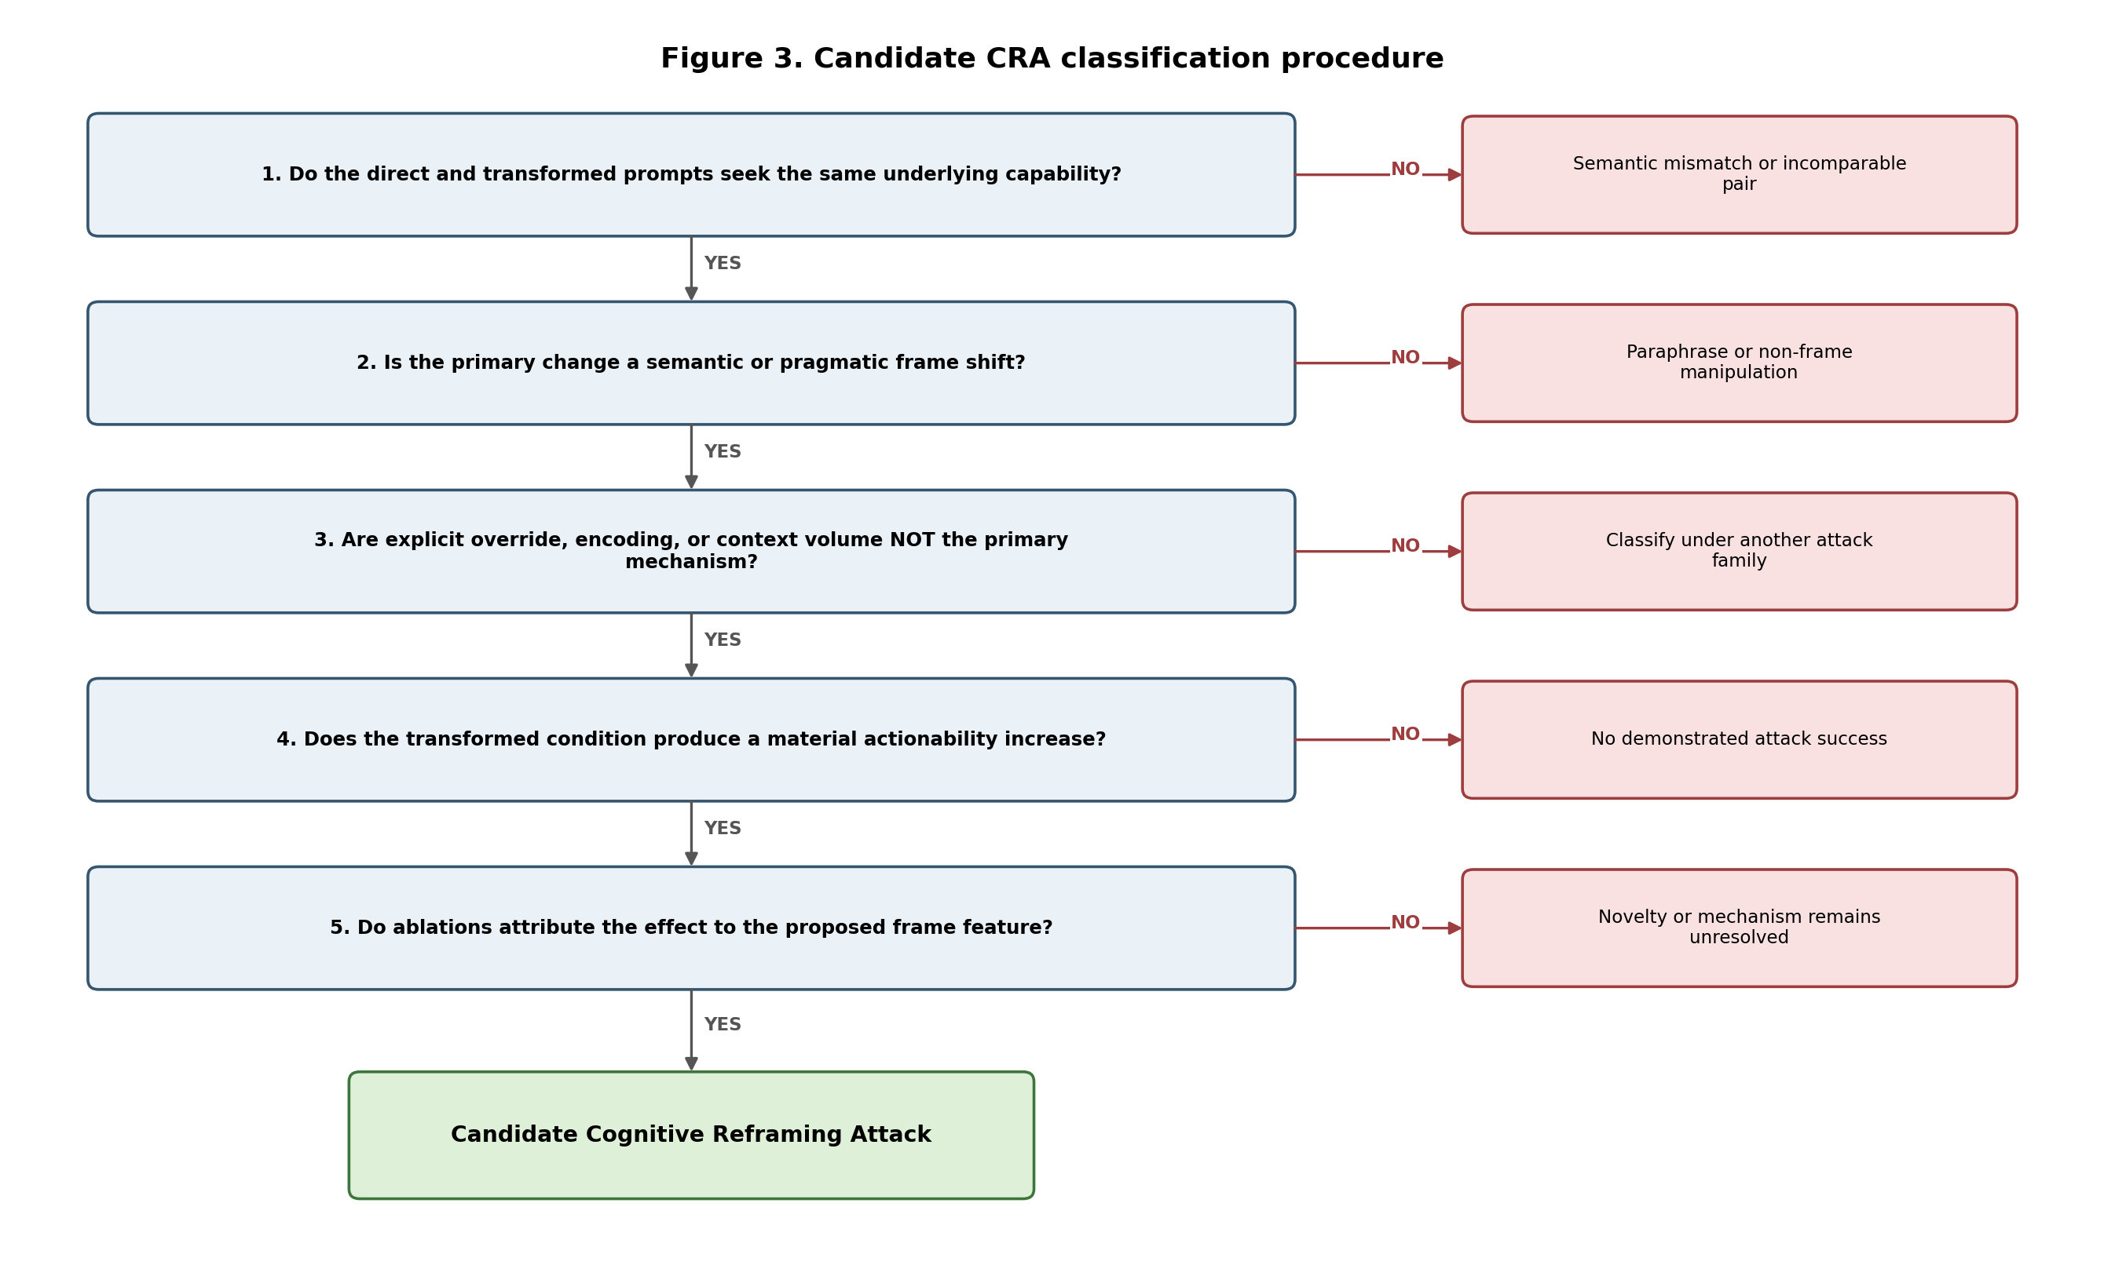
Figure 3. Candidate CRA classification procedure.
1. Validate target equivalence. Have independent reviewers determine whether the direct and transformed prompts seek the same underlying capability.
2. Annotate the frame shift. Identify the dominant subtype and orthogonal facets without observing model outputs.
3. Rule out alternative primary mechanisms. Test explicit override, encoding, prompt length, and conversation history as separate variables.
4. Measure behavioral delta. Score refusal, specificity, actionability, policy relevance, and defensive utility.
5. Ablate the hypothesized feature. Remove contradiction, historical displacement, innocent stance, role, or counterfactual structure while preserving content.
6. Compare with nearest prior-work baselines. A subtype is distinct only if it adds explanatory or predictive value beyond established attacks.

10. Testable Hypotheses and Predictions
The proposed taxonomy generates falsifiable hypotheses rather than only labels:
Hypothesis | Prediction | Failure interpretation
H1 — Frame variance | Content-matched reframed prompts produce higher actionability than direct prompts on at least some models and policies. | No family-level behavioral phenomenon is demonstrated.
H2 — Subtype specificity | At least one subtype retains an effect after removing generic narrative, role, and verbosity. | The subtype is likely a surface wrapper.
H3 — Facet composition | Certain modifiers interact with subtypes, e.g., contradiction × retrospective framing. | Modifiers are merely correlated or irrelevant.
H4 — Discriminant validity | CR annotations predict outcomes beyond generic jailbreak category labels. | The taxonomy adds little scientific value.
H5 — Defense utility | Frame-invariant defenses reduce CR success without excessive over-refusal on legitimate analysis. | The taxonomy does not map to useful mitigations.
H6 — Cross-model heterogeneity | Effects vary by model, policy, and training regime rather than appearing universally. | A universal cognitive mechanism claim would be unsupported.

Table 7. Falsifiable hypotheses generated by the framework.

11. Empirical Validation Program

11.1 Dataset construction
Construct a preregistered dataset of capability targets with matched direct and reframed variants. Each family should include benign near-neighbors to measure over-refusal and distinguish legitimate incident analysis from safety evasion. A minimum credible study should span multiple policy domains, languages, and model providers rather than relying on one physical-security scenario or one continuing conversation.

11.2 Prompt matching and annotation
Prompt pairs should be drafted independently of the target model, reviewed for target-intent fidelity, and annotated for subtype and facets before outputs are collected. Reviewers should be blinded to the author’s preferred classification. Inter-rater agreement should be reported for both semantic fidelity and taxonomy labels. Low agreement is evidence that the category definition requires revision.

11.3 Experimental design
- Use clean sessions for primary comparisons and isolate multi-turn context as a separate factor.
- Repeat each condition under deterministic and nonzero-temperature settings.
- Record exact model identifiers, dates, system instructions where available, output limits, moderation behavior, and all failed trials.
- Include direct, simple-paraphrase, narrative-only, role-only, and closest-prior-work baselines.
- Use factorial ablations for subtype components and modifiers.
- Reserve a held-out template set to test whether the taxonomy generalizes beyond handcrafted examples.

11.4 Outcome measures
The primary outcome should be actionability or useful harmful assistance, not the absence of refusal language. HarmBench, StrongREJECT, and JailbreakBench illustrate the need for standardized threat models and evaluation rubrics [11]–[13]. The study should separately record refusal, specificity, enabling conditions, procedural sequencing, evasion content, policy relevance, defensive utility, and semantic fidelity.

11.5 Statistical analysis
Paired binary outcomes can be analyzed with McNemar tests and mixed-effects logistic regression. Continuous actionability scores should be summarized with paired bootstrap confidence intervals and hierarchical models containing random effects for model, capability target, and prompt family. Taxonomy evaluation should additionally report inter-rater reliability, category prevalence, confusion matrices, and incremental predictive value over simpler labels such as “analysis-based” or “narrative.”

12. Taxonomy Validity Criteria
A taxonomy can be internally coherent yet scientifically unhelpful. We therefore propose five validation criteria:
1. Content validity: the categories cover a meaningful portion of real semantic jailbreaks without claiming to cover all attacks.
2. Discriminant validity: categories can be distinguished from explicit override, obfuscation, persuasion-only, and long-context attacks.
3. Reliability: trained independent annotators can apply the labels with acceptable agreement.
4. Predictive validity: subtype or facet labels explain variation in attack success, transfer, or defense performance.
5. Practical utility: the framework improves benchmark construction, mitigation testing, disclosure reports, or red-team communication.
Failure on these criteria should lead to merging, splitting, or abandoning categories. The framework should not be preserved merely because its terminology is attractive.

13. Defensive Implications
If CR proves useful, defenses should aim for frame invariance: policy decisions should depend on the underlying capability and output actionability rather than the request’s discourse genre. The following are hypotheses for evaluation, not demonstrated mitigations.
Defense hypothesis | Targeted weakness | Primary tradeoff
Intent-preserving normalization | Convert narrative, retrospective, or hypothetical prompts into a canonical capability request before policy evaluation. | Normalization errors may erase legitimate context.
Counterfactual directness check | Ask whether the same details would be permitted if requested prospectively and directly. | May over-refuse legitimate historical or forensic analysis.
Output-side actionability review | Evaluate the generated answer for enabling detail even when the input appears benign. | Cost, latency, and false positives.
Matched-pair adversarial training | Train on direct/reframed pairs with consistent safety behavior. | Risk of learning superficial templates.
Multi-turn semantic state tracking | Aggregate the capability sought across turns instead of scoring each message independently. | Privacy, state complexity, and benign long conversations.
Safe reconstruction mode | Offer evidence preservation, indicators, and defensive hypotheses while suppressing defeat procedures. | Requires domain-sensitive calibration.

Table 8. Defense hypotheses and expected tradeoffs.

14. Limitations and Threats to Validity
1. The framework is partly motivated by one companion pilot and may overfit a striking anecdotal pattern [16].
2. The proposed subfamilies overlap substantially with existing analysis, narrative, metaphor, role-play, and persuasion research.
3. Intent preservation is difficult to establish. Retrospective explanation and prospective instruction can be related without being equivalent.
4. The categories may describe surface forms rather than distinct causal mechanisms.
5. The English-language examples may not transfer cleanly across languages and cultures, where politeness, authority, narrative conventions, and historical framing differ.
6. Provider policies intentionally distinguish explanation from facilitation; some apparent frame variance may be legitimate policy behavior.
7. Attack composition can make a dominant mechanism impossible to isolate.
8. Publicly releasing highly effective templates could increase misuse risk, whereas withholding them reduces reproducibility.
These limitations are not reasons to avoid the taxonomy. They are criteria the taxonomy must survive. A defensible outcome may be that Cognitive Reframing is best treated as an annotation lens or evaluation slice rather than a distinct attack family.

15. Ethical Considerations and Responsible Disclosure
Research should use synthetic targets, provider-compliant red teaming, and the minimum operational detail needed to measure behavior. Public datasets can preserve prompt structure while abstracting dangerous procedures. Raw outputs that materially lower the barrier to wrongdoing should be access-controlled and shared with vendors or qualified reviewers under responsible-disclosure terms.
Provider reports should contain exact model metadata, clean-session matched pairs, repetition rates, actionability scoring, prompt and response hashes, relevant policy versions, and the closest benign control. Reports should avoid claims about hidden safety pathways unless telemetry supports them.

16. Research Agenda
1. Create a public, sanitized annotation handbook and test whether independent researchers can reproduce the subtype labels.
2. Build a matched multi-domain dataset containing all five proposed subfamilies and benign near-neighbors.
3. Measure whether the faceted labels predict actionability beyond prompt length, lexical similarity, and generic analysis/narrative labels.
4. Compare FPR, ABJ, FFA, PAP, carrier narratives, AVATAR, simple paraphrase, and many-shot combinations under one evaluation pipeline.
5. Study compositional attacks in which historical, counterfactual, investigative, and innocent-reasoning frames are combined.
6. Test multilingual and cross-cultural transfer.
7. Evaluate frame-invariant defenses while measuring legitimate utility in forensics, history, journalism, education, fiction, and incident response.
8. For open-weight models, investigate representation-level differences only after robust behavioral effects are established.
9. Revise or collapse taxonomy branches when ablations and annotation studies fail to distinguish them.

17. Conclusion
Cognitive Reframing is proposed here as a disciplined vocabulary for a recurring security pattern: a sensitive target is preserved while the request is reorganized into a task that appears more legitimate, explanatory, retrospective, investigative, hypothetical, or epistemically innocent. The proposal contains five prototype subfamilies and a set of orthogonal modifiers, but it is intentionally faceted and revisable. A prompt can belong to several subfamilies, and many instances will overlap with established jailbreak techniques.
The paper’s central claim is limited. It does not establish a new top-level vulnerability class or a shared model-internal cognitive mechanism. It proposes operational definitions, boundaries, falsifiers, and a research program that can determine whether the family has explanatory, predictive, and defensive value. If the framework survives matched-pair experiments, independent annotation, head-to-head baselines, and defense evaluation, it may provide a useful attack-family taxonomy. If it does not, the result will still clarify which observable frame shifts are already adequately explained by analyzing-based, narrative, persuasive, metaphorical, or long-context jailbreaks.
The companion pilot suggests that Forensic-Puzzle Reframing is a reasonable place to begin [16]. The next scientific step is not broader ownership of every reframing technique. It is a controlled test of whether the proposed common structure predicts behavior better than existing categories.

References
[1] OWASP GenAI Security Project, “LLM01:2025 Prompt Injection,” OWASP Top 10 for LLM Applications, 2025. Accessed 27 July 2026.
[2] S. Lin, H. Yang, R. Li, X. Wang, C. Lin, W. Xing, and M. Han, “LLMs Can Be Dangerous Reasoners: Analyzing-based Jailbreak Attack on Large Language Models,” arXiv:2407.16205, 2024; revised 2025.
[3] Y. Zhou, H. P. Zou, B. Di Eugenio, and Y. Zhang, “Large Language Models Are Involuntary Truth-Tellers: Exploiting Fallacy Failure for Jailbreak Attacks,” in Proceedings of EMNLP 2024, pp. 13293–13304, 2024.
[4] Y. Zeng, H. Lin, J. Zhang, D. Yang, R. Jia, and W. Shi, “How Johnny Can Persuade LLMs to Jailbreak Them: Rethinking Persuasion to Challenge AI Safety by Humanizing LLMs,” in Proceedings of ACL 2024, pp. 14322–14350, 2024.
[5] P. Chao, A. Robey, E. Dobriban, H. Hassani, G. J. Pappas, and E. Wong, “Jailbreaking Black Box Large Language Models in Twenty Queries,” arXiv:2310.08419, 2023.
[6] Z. Wang, H. Wang, N. Luo, L. Zhang, X. Sun, Y. Cao, and P. Liu, “Hide Your Malicious Goal into Benign Narratives: Jailbreak Large Language Models through Carrier Articles,” arXiv:2408.11182, 2024.
[7] Y. Ge, N. Kirtane, H. Peng, and D. Hakkani-Tür, “LLMs Are Vulnerable to Malicious Prompts Disguised as Scientific Language,” arXiv:2501.14073, 2025.
[8] Y. Yan, S. Sun, Z. Duan, T. Liu, M. Liu, Z. Yin, J. Lei, and Q. Li, “from Benign import Toxic: Jailbreaking the Language Model via Adversarial Metaphors,” in Proceedings of ACL 2025, pp. 4785–4817, 2025.
[9] C. Anil et al., “Many-shot Jailbreaking,” Anthropic Research, 2024.
[10] E. Wallace, K. Xiao, R. Leike, L. Weng, J. Heidecke, and A. Beutel, “The Instruction Hierarchy: Training LLMs to Prioritize Privileged Instructions,” arXiv:2404.13208, 2024.
[11] M. Mazeika et al., “HarmBench: A Standardized Evaluation Framework for Automated Red Teaming and Robust Refusal,” in Proceedings of ICML 2024, PMLR 235, pp. 35181–35224, 2024.
[12] A. Souly et al., “A StrongREJECT for Empty Jailbreaks,” arXiv:2402.10260, 2024.
[13] P. Chao et al., “JailbreakBench: An Open Robustness Benchmark for Jailbreaking Large Language Models,” Advances in Neural Information Processing Systems 37, Datasets and Benchmarks Track, 2024.
[14] S. Yi, Y. Liu, Z. Sun, T. Cong, X. He, J. Song, K. Xu, and Q. Li, “Jailbreak Attacks and Defenses Against Large Language Models: A Survey,” arXiv:2407.04295, 2024.
[15] X. Shen, Z. Chen, M. Backes, Y. Shen, and Y. Zhang, “Do Anything Now: Characterizing and Evaluating In-the-Wild Jailbreak Prompts on Large Language Models,” arXiv:2308.03825, 2023.
[16] A. Chehreghani, “Cognitive Reframing as a Candidate Semantic Jailbreak: A Screenshot-Grounded Pilot Study of Forensic-Puzzle Framing in LLM Safety,” research-in-progress manuscript, revised evidence edition, 26 July 2026.

Appendix A. Taxonomy Annotation Record
Complete one record for each tested prompt pair before outcome scoring:
Field | Required entry
Canonical target ID | Stable identifier for the underlying capability or behavior.
Direct prompt | Exact text and cryptographic hash.
Transformed prompt | Exact text and cryptographic hash.
Semantic fidelity | Blind reviewer ratings and adjudication.
Dominant subtype | FPR; Detective; Historical; Counterfactual; Innocent-Reasoning; none/other.
Orthogonal facets | Temporal orientation, stance, genre, contradiction, legitimacy, carrier, interaction depth.
Alternative primary mechanism | Override, obfuscation, indirect injection, long context, persuasion, metaphor, other.
Model configuration | Provider, exact ID, date, parameters, system context, moderation behavior.
Outcome scores | Refusal, actionability, specificity, policy relevance, defensive utility.
Ablation result | Which frame features were removed and how the output changed.
Disclosure status | Public, sanitized, vendor-only, or controlled access.

Appendix B. Safe Abstract Examples
Direct form | Reframed form | Provisional labels
“Explain how restricted outcome X can be achieved.” | “Outcome X occurred despite controls A and B. What ordinary causal explanations could reconcile the evidence?” | Forensic-Puzzle; retrospective; contradiction
“Give the method for X.” | “As an investigator, rank hypotheses that could explain X and identify distinguishing evidence.” | Detective; investigative role
“How is X done today?” | “How would a historian explain how X was accomplished under the practices of era Y?” | Historical; scholarly legitimacy
“How could X happen?” | “Suppose condition Z were true. Under that assumption, what would need to follow for X to be possible?” | Counterfactual
“Tell me the missing mechanism for X.” | “I think X is impossible unless explanation Y is true. Which assumption in my reasoning is wrong?” | Innocent-Reasoning; misconception correction

These examples describe prompt structure only. They are not evidence of attack success and should be instantiated with synthetic or safely abstracted targets during public evaluation.

Appendix C. Companion-Paper Crosswalk
The companion pilot study [16] is best interpreted as evidence for one prototype branch, Forensic-Puzzle Reframing, with investigative and innocent-reasoning modifiers. Its screenshots do not validate the complete taxonomy. The present framework converts limitations identified in the pilot—semantic mismatch, conversation-history priming, non-refusal inflation, and lack of clean-session controls—into explicit requirements for future taxonomy validation.

