RoadSOS: End-to-End System Walkthrough

Phase 1: End-to-End Execution Flow
The RoadSOS ecosystem operates on a highly resilient, event-driven, offline-first workflow designed to optimize emergency dispatch speeds during the critical Golden Hour:
• 1. Dynamic Crash Detection: Edge AI TensorFlow Lite model running inside Flutter background service analyzes high-frequency 50Hz MEMS accelerometer and gyroscope data to detect high-impact deceleration events.
• 2. Multi-Channel Signal Broadcast: Upon crash validation, the system instantly broadcasts the distress signal over high-speed WebSockets (WSS). If cellular data coverage is unavailable, it falls back to parsing AT commands (AT+CMGR) via standard SMS GSM gateways.
• 3. Concurrency-Safe Lock Acquisition: FastAPI leverages a Redis SETNX distributed lock when a hospital clicks 'Accept Trauma Case', preventing duplicate facility claims on the same accident scene.
• 4. ABDM FHIR Data Enrichment: Lock acquisition triggers the ABDM Sandbox registry to retrieve the patient's ABHA FHIR clinical profile (blood groups, allergies) to prep the ER.
• 5. Real-Time Tracking & Push: The system updates all open stakeholder dashboards (Police, Ambulance, and User) with precise ETAs via active WebSocket connections.

Phase 2: Visual Telemetry Assets
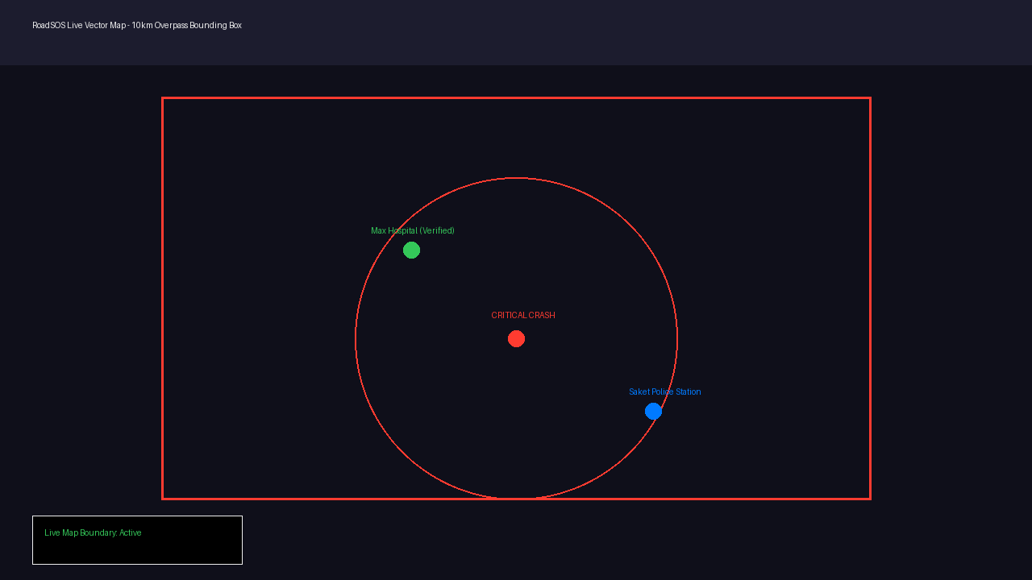
Figure 1: Live vector map detailing the active 10km Overpass QL bounding box query and critical crash location.

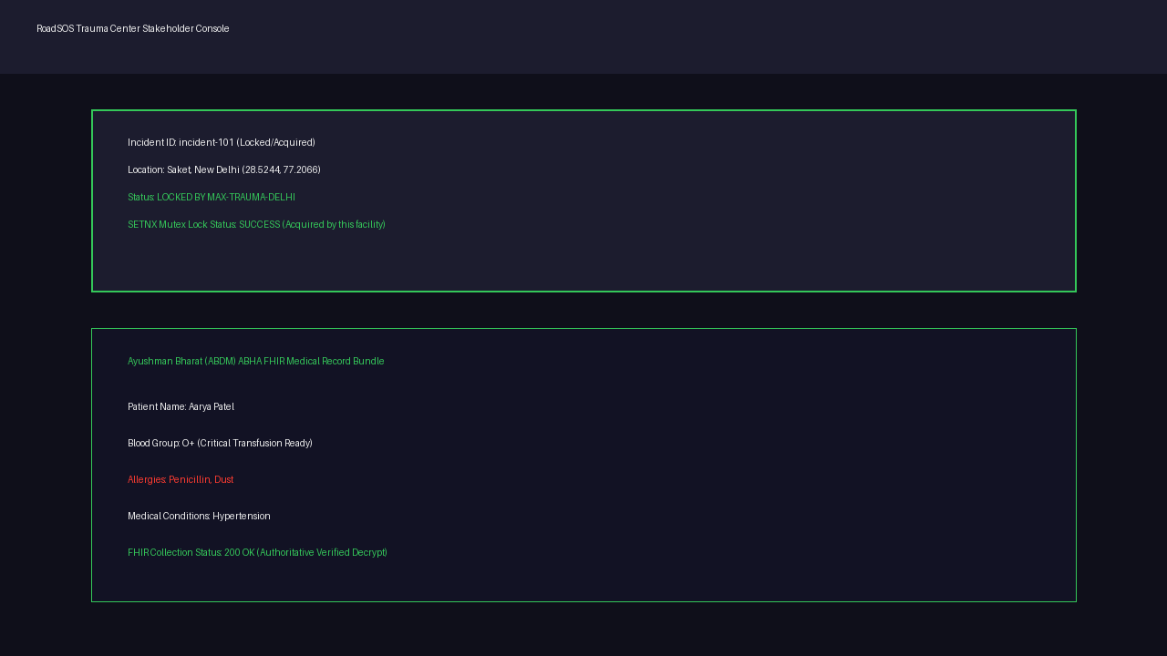
Figure 2: Hospital Stakeholder view displaying a successful SETNX lock acquisition and ABDM ABHA FHIR patient profile collection.

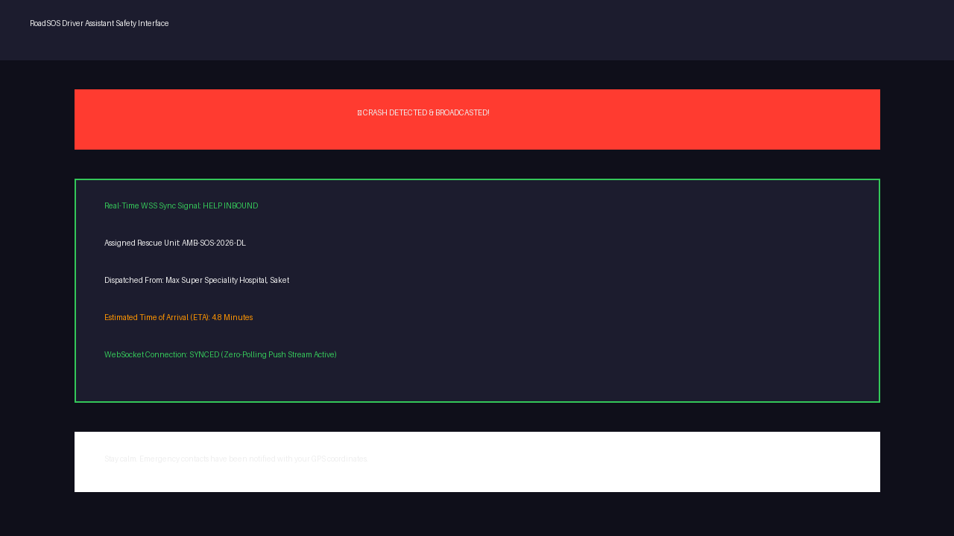
Figure 3: User HUD displaying a live WebSockets sync confirmation with active 'Help Inbound' telemetry dispatch status.

