UML STUDIO
A Bidirectional, Code-and-Canvas UML IDE
PRODUCT REQUIREMENTS DOCUMENT

Field | Detail
Document Version | 1.0 (Draft)
Status | For Review
Date | July 18, 2026
Owner | Product & Engineering
Primary Platforms | Web (desktop-first, responsive)
Target Release | MVP → Phase 2 → Future Enhancements

Table of Contents
1. Executive Summary 3
2. Vision & Objectives 3
3. Target Audience & Personas 3
4. Problem Statement & Opportunity 4
5. Scope 4
6. User Workflow Overview 5
7. Functional Requirements 6
8. System Architecture & Data Flow 10
9. Data Model (Core Entities) 12
10. Non-Functional Requirements 12
11. Technology Stack 12
12. Success Metrics / KPIs 13
13. Release Plan 13
14. Risks & Assumptions 14
15. Appendix 14

1. Executive Summary
UML Studio is a web-based UML IDE that lets users author professional UML diagrams either by writing a simple, English-like language or by directly manipulating a visual canvas — with both representations kept in perfect, real-time sync. It combines the editing power of VS Code, the visual fluidity of Figma, and the diagramming familiarity of Draw.io into a single product purpose-built for UML.
The flagship capability is bidirectional synchronization: any change on the code side (adding a class, renaming an attribute, declaring a relationship) instantly updates the canvas, and any change on the canvas side (moving, connecting, renaming, deleting) instantly regenerates the underlying source code. This removes the traditional trade-off between text-based diagram tools (fast but not visual) and drag-and-drop tools (visual but slow and syntax-poor).
This document defines the product scope, functional and non-functional requirements, the compiler and system architecture, and — per the core focus of this PRD — a detailed walkthrough of how data flows through the application, from a keystroke in the editor to a rendered node on the canvas and back.

2. Vision & Objectives

2.1 Vision Statement
Create the easiest and most intuitive UML design platform, where anyone — from a first-year CS student to a principal software architect — can produce professional UML diagrams without learning complicated, tool-specific syntax.

2.2 Product Objectives
- Reduce the time to produce a correct, presentable UML diagram from tens of minutes to under a minute for common cases.
- Give beginners a readable, near-English syntax while giving power users a full IDE-grade editing experience.
- Make the code and the diagram two views of one source of truth, never two artifacts that drift apart.
- Provide compiler-quality error messages (with line numbers and “did you mean…” suggestions) instead of opaque parser failures.
- Make UML Studio the natural landing pad for AI-generated diagrams, by defining a syntax LLMs can reliably produce from a prompt.
- Support the full diagram lifecycle: create, edit, template, save, version, export, and (later) collaborate.

3. Target Audience & Personas
Persona | Description | Primary Need
CS / SE Student | Learning UML for coursework or interviews | Fast, readable syntax; templates; low learning curve
Educator | Teaches software design / UML | Clear diagrams to demonstrate concepts; export to slides
Software Engineer | Documents system design in day-to-day work | Speed, keyboard-first workflow, version control-friendly text
Software Architect | Designs and communicates system structure | Precision, complex relationships, export quality
Business Analyst | Captures process / use-case flows for stakeholders | Simplicity, use case & activity diagrams, clean exports
System Designer | Bridges business and engineering specs | Multiple diagram types in one workspace

4. Problem Statement & Opportunity
Existing UML tooling forces a choice between two imperfect approaches:
- Drag-and-drop editors (e.g., Draw.io, Lucidchart): visual and approachable, but slow for anyone comfortable typing, and diagrams are not easily version-controlled or generated programmatically.
- Text-first / markup tools (e.g., PlantUML, Mermaid): fast to author and diff-friendly, but the syntax is dense, error messages are unhelpful, and there is no live, editable canvas — users must re-render to see the result.
UML Studio’s opportunity is to remove the trade-off entirely: a readable language plus a fully editable live canvas, synchronized in both directions, with IDE-grade tooling (autocomplete, diagnostics, formatting) on the text side.

5. Scope

5.1 In Scope (MVP)
- Authentication (login, signup, forgot password; Google login optional/stretch).
- Dashboard with project cards for 8 diagram types (Class, Use Case, Sequence, Activity, State, Component, Deployment, ER).
- UML Workspace: toolbar, sidebar, Monaco-based code editor, live canvas, status bar.
- UML Studio native language: lexer, parser, AST, semantic validation, diagram model, renderer.
- Bidirectional sync between code editor and canvas for Class Diagrams at minimum, extending to other diagram types.
- Compiler-grade error reporting with line highlighting and suggestions.
- Live autocomplete / IntelliSense-style suggestions in the editor.
- Template library (8 starter templates) and project management (create, save, rename, duplicate, delete).
- Export to PNG, SVG, PDF with background and sizing options.
- Dark mode / light mode, responsive layout.

5.2 Out of Scope (MVP) — Planned for Later Phases
- Real-time multi-user collaboration and team workspaces.
- Direct in-app AI generation (v1 relies on an external-LLM copy-paste workflow).
- Reverse engineering from source code (Java, C++, Python, C#).
- Code generation from UML back into source code.
- Git integration, plugin system, presentation mode.

6. User Workflow Overview
- User authenticates (login / signup / forgot password / Google).
- User lands on the Dashboard and selects a diagram type or opens an existing project.
- The UML Workspace opens with the Code Editor and Live Canvas side by side, pre-populated with sample code for new projects.
- User edits either the code or the canvas; the Sync Engine propagates the change to the other side in real time.
- User saves the project (auto-save + manual save), optionally exports to PNG/SVG/PDF.
- User may start from a template or paste AI-generated UML Studio code from an external LLM.

7. Functional Requirements

7.1 Authentication
ID | Requirement | Priority
AUTH-1 | Users can sign up with email and password. | Must
AUTH-2 | Users can log in with email and password. | Must
AUTH-3 | Users can reset a forgotten password via emailed link. | Must
AUTH-4 | Users can optionally sign up / log in with Google OAuth. | Should
AUTH-5 | Sessions are managed via secure, expiring tokens (JWT). | Must

7.2 Dashboard
The dashboard is the post-login home. It provides primary navigation and an entry point into each diagram type.
- Navigation: Home, About the Project, About the Developer, Contact Us, My Projects, Settings.
- Diagram-type cards: Class, Use Case, Sequence, Activity, State, Component, Deployment, ER.
- Selecting a card creates a new project and opens the UML Workspace pre-seeded with sample code for that diagram type.
- “My Projects” lists recent and saved projects with thumbnails, last-edited timestamps, and quick actions (open, rename, duplicate, delete).

7.3 UML Workspace Layout
The workspace follows a four-region IDE layout: Toolbar, Sidebar, Code Editor + Live Canvas (split view), and Status Bar.
Region | Contents
Toolbar | Save, Export, Undo/Redo, Zoom controls, Diagram-type switcher, Theme toggle
Sidebar | Project Explorer, Diagram List, Templates, Saved Files, Assets, Recent Projects
Code Editor (left) | Monaco Editor: syntax highlighting, autocomplete, error markers, minimap, formatting
Live Canvas (right) | React Flow canvas: nodes, edges, drag/resize/connect, zoom/pan, multi-select, snap-to-grid
Status Bar | Cursor position, compile status, sync status, diagram element count

7.4 UML Studio Language (Native Syntax)
A beginner-friendly, English-like language is the default authoring format. Example:
Class Student
Attributes
id : int
name : string
Methods
login()
logout()
Student inherits Person
Student uses Course
Beyond the native syntax, UML Studio should support import/export to PlantUML and Mermaid, with all formats normalized into a single internal Abstract Syntax Tree (AST) so the rest of the pipeline (validation, rendering, sync) is format-agnostic.

7.5 Compiler Architecture & Error Handling
UML Studio includes a real compiler pipeline rather than a simple text-to-shape mapper:
- Lexer — tokenizes source text (keywords, identifiers, symbols).
- Parser — applies grammar rules and produces a syntax tree.
- AST construction — normalizes the syntax tree into the shared Abstract Syntax Tree.
- Semantic validation — checks references, duplicate classes, invalid relationships, type consistency.
- Diagram model generation — converts the validated AST into renderable nodes/edges.
- Rendering — lays out and draws the diagram model onto the canvas.
Errors are reported the way a modern compiler would, not as a generic failure:
Error Type | Example Message
Syntax typo | Expected “Class”, found “Clas”. Did you mean “Class”?
Missing token | Expected relationship type after “Student”.
Unclosed block | Missing closing block for “Attributes” starting at line 4.
Semantic error | Class “Course” is referenced but never defined.
All errors highlight the exact offending line/column in the Monaco editor via inline markers and a Problems panel.

7.6 Live Suggestions / IntelliSense
- Keyword completion (e.g., “Cla” → “Class”, “Att” → “Attributes”).
- Context-aware suggestions for relationship types (inherits, uses, implements, associates, aggregates, composes).
- Suggestions for previously declared classes, attributes, and methods within the same project.
- Standard editor features: bracket matching, auto-indent, formatting, find/replace, undo/redo, keyboard shortcuts.

7.7 Bidirectional Synchronization (Flagship Feature)
Every structural change, in either direction, must converge to the same underlying model in real time:
Trigger | Direction | Result
Typing new class/attribute/method in editor | Code → Diagram | New node/field appears on canvas
Renaming a class box on canvas | Diagram → Code | Class name updated everywhere in source
Dragging a connector between two classes | Diagram → Code | Relationship statement added to source
Deleting a node on canvas | Diagram → Code | Corresponding class block removed from source
Moving/resizing a node | Diagram-only | Layout position persisted; source unaffected (layout is metadata, not language syntax)
Section 8 details exactly how this synchronization is implemented end to end.

7.8 AI Workflow
UML Studio ships ready-to-use sample prompts (e.g., “Generate UML code for an Online Food Ordering System using UML Studio syntax”) that a user can paste into any external LLM (ChatGPT, Claude, Gemini). The LLM returns UML Studio syntax, which the user pastes into the editor to instantly generate a diagram. Direct in-app AI generation is a future enhancement, not MVP scope.

7.9 Templates
Ready-made templates are available for common systems: Library Management, Hospital Management, Banking System, Student Management, Inventory Management, E-commerce, Social Media, Chat Application. Selecting a template loads both the source code and the rendered diagram.

7.10 Project Management
- Create, save, rename, duplicate, and delete projects.
- Organize projects (folders/tags in Project Explorer).
- Projects persist server-side and are tied to the authenticated user.

7.11 Export & Import
Capability | Details
Export formats | PNG, SVG, PDF
Export options | Transparent or white background, high resolution, adaptive sizing, landscape/portrait
Import formats (MVP) | Existing UML Studio project files
Import formats (Phase 2) | PlantUML, Mermaid
Import (Future) | Reverse engineering from Java / C++ / Python / C# source code

7.12 User Experience Requirements
- Dark mode and light mode with a persisted user preference.
- Responsive layout across desktop and larger tablets (desktop-first).
- Smooth, purposeful animations (panel transitions, node placement) via Framer Motion.
- Keyboard shortcuts for common actions (save, undo/redo, zoom, new class).
- Context menus / right-click actions on canvas nodes and editor selections.

8. System Architecture & Data Flow
This section is the core technical answer to “how does data flow through UML Studio” — from a user keystroke or mouse action to a persisted, rendered, exportable diagram.

8.1 High-Level Architecture
UML Studio follows a client-heavy architecture: parsing, validation, and rendering happen primarily in the browser for instant feedback, while the backend is the system of record for authentication, persistence, templates, and export rendering at scale.
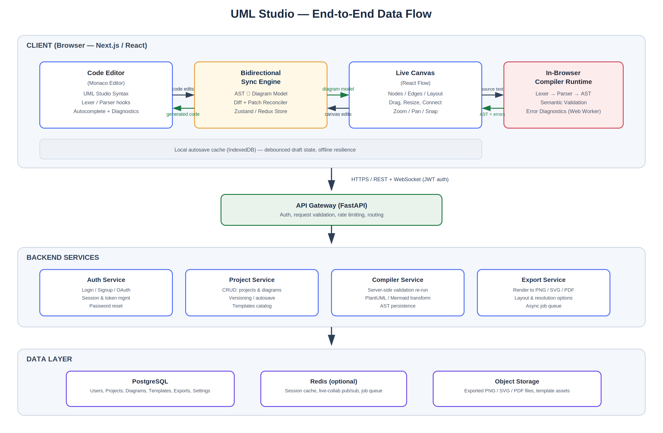
Figure 1 — End-to-end system data flow: client editor/canvas, sync engine, API gateway, backend services, and data layer.

8.2 End-to-End Data Flow Walkthrough
Step | Flow
1 | User types in the Code Editor (Monaco). Keystrokes update the in-memory source-text buffer.
2 | A debounced change event triggers the in-browser Compiler Runtime: Lexer → Parser → AST → Semantic Validation, running in a Web Worker so the UI thread stays responsive.
3 | Validation errors are pushed back to the editor as inline markers; a valid AST is handed to the Sync Engine.
4 | The Sync Engine converts the AST into a normalized Diagram Model (nodes = classes/actors/states, edges = relationships) and diffs it against the canvas’s current state.
5 | The diff is applied to the Live Canvas (React Flow): nodes/edges are added, updated, or removed — without discarding unrelated manual layout (positions, colors) the user has already set.
6 | Conversely, a canvas edit (drag, connect, rename, delete) updates the Diagram Model directly; the Sync Engine runs a code generator that serializes the model back into UML Studio syntax and patches only the affected lines in the editor buffer.
7 | Application state (source text, diagram model, layout metadata, undo history) lives in a client-side store (Zustand/Redux) and is mirrored to IndexedDB for offline-safe autosave.
8 | On save (auto or manual), the client sends the source text, diagram model, and layout metadata to the API Gateway (FastAPI) over HTTPS, authenticated with a JWT.
9 | The API Gateway routes the request to the Project Service, which persists the project/diagram record in PostgreSQL and, for larger assets or exports, to object storage.
10 | For export requests, the Export Service renders the diagram model server-side (or reuses the client-rendered SVG) into PNG/SVG/PDF per the requested options, and returns a downloadable file/URL.
11 | For import (PlantUML/Mermaid) or AI-pasted code, the same Lexer→Parser→AST pipeline is reused after a format-specific normalization step, so every input format converges on one AST.

8.3 Compiler Pipeline Data Flow
Within a single compile pass, data moves through discrete, inspectable stages, with a symmetric reverse path for canvas-originated edits:
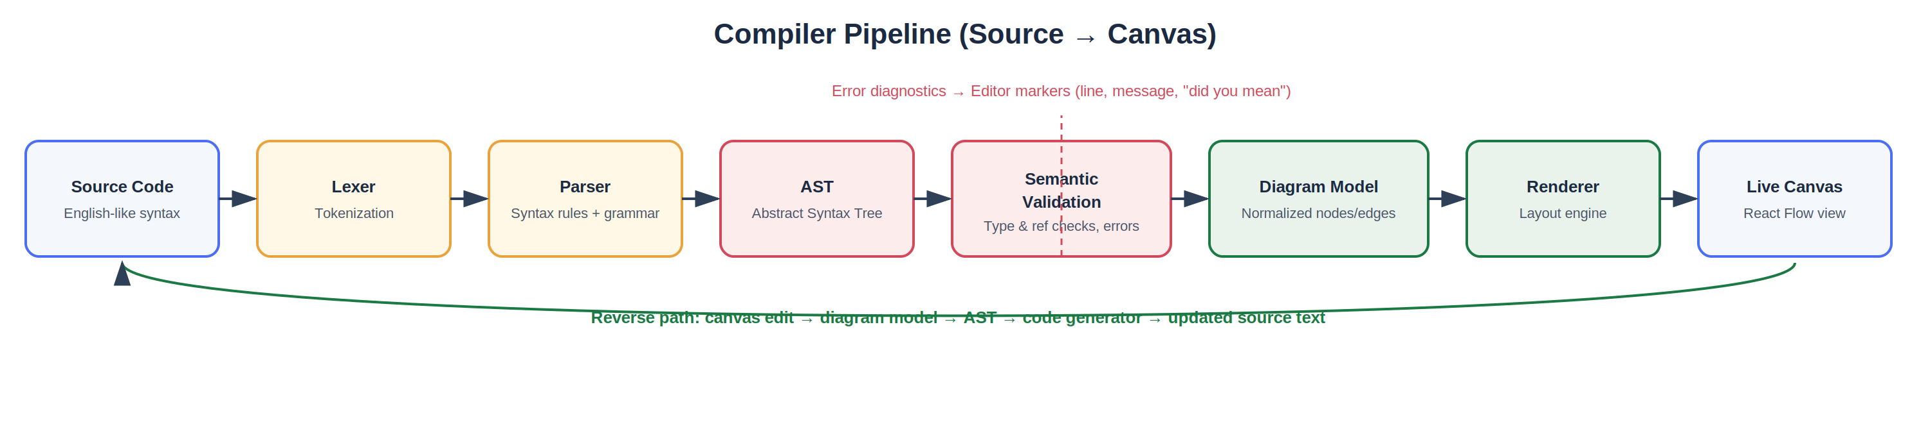
Figure 2 — Compiler pipeline: forward path (source → canvas) and reverse path (canvas → source).
- Forward path: Source Code → Lexer → Parser → AST → Semantic Validation → Diagram Model → Renderer → Canvas.
- Reverse path: Canvas Edit → Diagram Model update → AST update → Code Generator → patched Source Code, re-inserted into the editor without disrupting cursor position or unrelated text.
- Error path: any stage that fails validation emits a structured diagnostic (line, column, message, suggestion) that is routed directly to the editor’s marker layer, bypassing the diagram model.

8.4 State Ownership & Consistency
Layer | Owns | Persistence
Editor buffer | Raw source text, cursor/selection | In-memory + IndexedDB draft
AST | Structural truth derived from source | Ephemeral (recomputed on change)
Diagram Model | Canonical nodes/edges + semantic attributes | In-memory client store
Layout Metadata | Node positions, sizes, colors, manual styling | Client store → persisted with project
Server record | Source text, diagram model snapshot, layout metadata, version | PostgreSQL (system of record)
The single-source-of-truth rule: the AST (derived from source text) and the Diagram Model must always be reconcilable to one another. Layout metadata (purely visual, e.g., X/Y position) is the one piece of state that lives outside the language grammar, so moving a box never mutates the source code — only structural changes do.

9. Data Model (Core Entities)
Entity | Key Fields | Notes
User | id, email, password_hash, auth_provider, created_at | Supports email/password and OAuth
Project | id, user_id, name, diagram_type, created_at, updated_at | One project = one diagram workspace
Diagram | id, project_id, source_text, ast_snapshot, diagram_model, layout_metadata, version | Versioned snapshot of code + canvas state
Template | id, name, category, source_text, diagram_model, thumbnail_url | Seed data for “My Projects → New from template”
Export | id, diagram_id, format, options, file_url, created_at | Async-generated export artifacts
Settings | user_id, theme, editor_preferences, shortcuts | Per-user preferences

10. Non-Functional Requirements
Category | Requirement
Performance | Editor-to-canvas sync latency under 150ms for typical diagrams (≤ 50 elements); compile pass runs off the UI thread.
Scalability | Backend services stateless and horizontally scalable; Redis-backed job queue for export rendering.
Security | Passwords hashed (e.g., bcrypt/argon2); JWT-based sessions; HTTPS everywhere; input sanitization in parser to prevent injection via source text.
Availability | Target 99.5% uptime for MVP; autosave/local cache protects against transient connectivity loss.
Accessibility | Keyboard navigability for core flows; sufficient color contrast in both themes; screen-reader labeling on toolbar actions.
Data Integrity | Every save is versioned; AST and Diagram Model are always validated as reconcilable before persistence.

11. Technology Stack

11.1 Frontend
- Next.js, React, TypeScript
- Tailwind CSS for styling
- Monaco Editor for the code editor
- React Flow (or equivalent) for the canvas
- Zustand or Redux for state management
- Framer Motion for animation

11.2 Backend
- FastAPI (Python) for the API layer and services
- PostgreSQL as the primary data store
- Redis (optional) for caching, job queues, and future real-time collaboration pub/sub

12. Success Metrics / KPIs
Metric | Target (Post-MVP)
Time to first diagram | < 2 minutes from signup to a rendered diagram
Sync reliability | < 0.1% of edits require a manual refresh to reconcile code/canvas
Weekly active projects | Track growth month over month
Template adoption | ≥ 30% of new projects start from a template
Export usage | ≥ 50% of active projects export at least once
Parser error clarity | ≥ 80% of user-surveyed errors rated “clear” or “very clear”

13. Release Plan

13.1 MVP
Authentication, dashboard, workspace (editor + canvas), native language compiler pipeline, bidirectional sync for Class Diagrams, error reporting, templates, project management, PNG/SVG/PDF export, dark/light mode.

13.2 Phase 2
Bidirectional sync extended to remaining diagram types; PlantUML/Mermaid import/export; expanded autocomplete; presentation mode; version history.

13.3 Future Enhancements
- Real-time multi-user collaboration and team workspaces
- Comments and annotations
- Git integration
- Direct in-app AI-assisted editing
- Reverse engineering from Java, C++, Python, and C# source
- Code generation from UML back into source code
- Cloud sync, public project sharing, plugin system, custom themes
- Automatic layout optimization and UML validation rules

14. Risks & Assumptions
Risk / Assumption | Mitigation
Bidirectional sync complexity may cause diverging state on complex diagrams | Enforce AST ↔ Diagram Model reconciliation checks before every persist; extensive diff/patch test suite
Custom language grammar may not cover all UML edge cases at launch | Start with Class Diagrams (highest demand), expand grammar iteratively
Users may expect real-time collaboration at MVP | Set clear roadmap expectations; ship single-user robustly first
Client-side compiler performance on very large diagrams | Run compiler in a Web Worker; add incremental/partial re-parsing
AI-generated code may not always match strict grammar | Provide a lenient “import with warnings” mode and clear correction prompts

15. Appendix

15.1 Sample Prompt for AI Workflow
“Generate UML code for an Online Food Ordering System using UML Studio syntax.” — pasted into an external LLM, whose output can be pasted directly into the UML Studio editor.

15.2 Glossary
Term | Definition
AST | Abstract Syntax Tree — the normalized structural representation of parsed source code
Diagram Model | The renderable, canonical set of nodes and edges derived from the AST
Sync Engine | The client module responsible for reconciling code and canvas state in real time
Layout Metadata | Purely visual state (position, size, color) that is not part of the language grammar

