UML STUDIO
A Bidirectional, Code-and-Canvas UML IDE
SOFTWARE REQUIREMENTS SPECIFICATION (SRS)
Prepared in conformance with IEEE 830-1998 SRS structure

Field | Detail
Document Version | 1.0 (Draft)
Status | For Review
Date | July 18, 2026
Owner | Product & Engineering
Source Document | UML Studio — Product Requirements Document (PRD) v1.0
Primary Platform | Web (desktop-first, responsive)

Revision History
Version | Date | Description | Author
0.1 | 2026-07-18 | Initial draft derived from PRD v1.0 | Product & Engineering
1.0 | 2026-07-18 | First review-ready release | Product & Engineering

Table of Contents
1. Introduction 3
2. Overall Description 5
3. System Features (Functional Requirements) 7
4. System Models & Data Flow 12
5. External Interface Requirements 14
6. Data Requirements 15
7. Non-Functional Requirements 17
8. Use Case Specifications 19
9. Requirements Traceability Matrix 21
10. Appendices 22

1. Introduction

1.1 Purpose
This Software Requirements Specification (SRS) defines the functional and non-functional requirements for UML Studio, a web-based UML IDE combining a Monaco-based code editor with a live, bidirectionally synchronized diagram canvas. This SRS translates the product intent captured in the UML Studio Product Requirements Document (PRD) v1.0 into verifiable, traceable, engineering-ready requirements suitable for design, implementation, and testing.

1.2 Document Conventions
- Functional requirements are identified with the prefix FR-<module>-<number> (e.g., FR-AUTH-01).
- Non-functional requirements use the prefix NFR-<category>-<number> (e.g., NFR-PERF-01).
- Data flow requirements use the prefix DF-<number>.
- Priority levels follow MoSCoW: Must, Should, Could, Won’t (this release).
- The keywords “shall” and “must” denote mandatory requirements; “should” denotes recommended behavior.

1.3 Intended Audience and Reading Suggestions
Audience | Suggested Focus
Engineering (Frontend/Backend) | Sections 3, 4, 5, 6, 7
QA / Test Engineers | Sections 3, 7, 8, 9 (traceability for test-case design)
Product Managers | Sections 1, 2, 9
UX / Design | Sections 3.2, 3.3, 3.11, Section 5
DevOps / SRE | Section 6, Section 7 (performance, availability, security)

1.4 Product Scope
UML Studio enables users to author UML diagrams via a beginner-friendly, English-like language and/or direct canvas manipulation, with both views kept synchronized in real time through an in-browser compiler pipeline (lexer, parser, AST, semantic validation) and a Sync Engine. The system covers authentication, a project dashboard, an IDE-style workspace, a template library, project persistence, and export/import capabilities. Out-of-scope items for this release (real-time multi-user collaboration, in-app AI generation, reverse engineering from source code) are listed in Section 2.5 and the PRD Section 5.2.

1.5 References
- UML Studio — Product Requirements Document (PRD), v1.0, July 18, 2026.
- IEEE Std 830-1998, IEEE Recommended Practice for Software Requirements Specifications.
- PlantUML Language Reference Guide (for import/export compatibility).
- Mermaid Syntax Documentation (for import/export compatibility).

2. Overall Description

2.1 Product Perspective
UML Studio is a new, standalone, browser-based product. It is architecturally a client-heavy single-page application (Next.js/React) backed by a FastAPI service layer and a PostgreSQL data store. It is conceptually positioned between text-first diagram-as-code tools (PlantUML, Mermaid) and drag-and-drop visual editors (Draw.io, Lucidchart), unifying both interaction models over one shared internal representation (the AST / Diagram Model).

2.2 Product Functions (Summary)
- User authentication and session management.
- Project dashboard and navigation across 8 UML diagram types.
- IDE-style workspace: toolbar, sidebar, code editor, live canvas, status bar.
- Native English-like UML language with a full compiler pipeline and compiler-grade diagnostics.
- Real-time bidirectional synchronization between source code and canvas.
- Editor IntelliSense: keyword, relationship, and identifier autocomplete.
- Template library and project CRUD with persistence.
- Export to PNG/SVG/PDF; import from UML Studio files (MVP) and PlantUML/Mermaid (Phase 2).
- Dark/light theming and responsive UX.

2.3 User Classes and Characteristics
User Class | Technical Proficiency | Primary Use | Frequency
CS/SE Student | Low–Medium | Coursework diagrams, learning UML | Occasional/Weekly
Educator | Medium | Teaching aids, example diagrams | Weekly
Software Engineer | High | Design documentation, technical specs | Frequent
Software Architect | High | System-level design communication | Frequent
Business Analyst | Medium | Use case / activity diagrams for stakeholders | Occasional

2.4 Operating Environment
- Client: modern evergreen browsers (Chrome, Edge, Firefox, Safari — latest two major versions), desktop-first responsive layout, minimum 1280×800 viewport recommended.
- Server: containerized FastAPI services, PostgreSQL 14+, optional Redis 6+, deployed on cloud infrastructure with HTTPS termination.
- No native desktop or mobile application in this release; mobile browsers receive a read-mostly responsive view.

2.5 Design and Implementation Constraints
- The code editor must use Monaco Editor; the canvas must use React Flow (or a functionally equivalent graph-rendering library).
- State management must use Zustand or Redux; UI must be built with Next.js, React, TypeScript, and Tailwind CSS.
- The compiler (lexer/parser/validator) must execute client-side inside a Web Worker to avoid blocking the UI thread.
- Backend services must be implemented in FastAPI with PostgreSQL as the system of record.
- Out of scope for this release: real-time multi-user collaboration, in-app AI generation, reverse engineering from Java/C++/Python/C# source, UML-to-code generation, Git integration, plugin system.

2.6 Assumptions and Dependencies
- Users have a stable internet connection for authentication, save, and export; local autosave provides short-term offline resilience only.
- External LLM interaction (ChatGPT, Claude, Gemini) happens outside the system boundary via manual copy-paste; UML Studio has no contractual or API dependency on any specific LLM provider.
- Google OAuth availability is a soft dependency (Should, not Must) for social login.
- Email delivery (password reset) depends on a transactional email provider being configured and operational.

3. System Features (Functional Requirements)
Each subsection below states the feature, its priority, and the discrete, testable functional requirements that implement it. Requirement IDs are referenced later in the Traceability Matrix (Section 9).

3.1 User Authentication
Priority: Must. Allows users to securely create an account, sign in, and recover access.
Req. ID | Requirement Statement | Priority
FR-AUTH-01 | The system shall allow a new user to register using an email address and password. | Must
FR-AUTH-02 | The system shall validate password strength at registration (minimum length and complexity). | Must
FR-AUTH-03 | The system shall allow a registered user to log in with email and password. | Must
FR-AUTH-04 | The system shall issue a secure, expiring session token (JWT) upon successful authentication. | Must
FR-AUTH-05 | The system shall allow a user to request a password-reset email and set a new password via a time-limited link. | Must
FR-AUTH-06 | The system should allow a user to register/log in via Google OAuth. | Should
FR-AUTH-07 | The system shall log out a user and invalidate the active session token on request. | Must
FR-AUTH-08 | The system shall display a clear, field-level error when login or registration fails (e.g., invalid credentials, duplicate email). | Must

3.2 Dashboard & Navigation
Priority: Must. Provides the authenticated landing experience and entry points into diagram creation.
Req. ID | Requirement Statement | Priority
FR-DASH-01 | The system shall present navigation links for Home, About the Project, About the Developer, Contact Us, My Projects, and Settings. | Must
FR-DASH-02 | The system shall display a card for each of the 8 supported diagram types: Class, Use Case, Sequence, Activity, State, Component, Deployment, ER. | Must
FR-DASH-03 | Selecting a diagram-type card shall create a new project pre-seeded with sample source code for that diagram type and open the UML Workspace. | Must
FR-DASH-04 | The “My Projects” view shall list the user’s projects with name, thumbnail, diagram type, and last-modified timestamp. | Must
FR-DASH-05 | The “My Projects” view shall support quick actions: open, rename, duplicate, delete. | Must

3.3 UML Workspace
Priority: Must. The core editing environment composed of Toolbar, Sidebar, Code Editor, Live Canvas, and Status Bar.
Req. ID | Requirement Statement | Priority
FR-WS-01 | The workspace shall display a Toolbar with Save, Export, Undo/Redo, Zoom controls, diagram-type switcher, and theme toggle. | Must
FR-WS-02 | The workspace shall display a Sidebar with Project Explorer, Diagram List, Templates, Saved Files, Assets, and Recent Projects. | Must
FR-WS-03 | The Code Editor shall provide syntax highlighting, line numbers, a minimap, bracket matching, auto-indentation, code formatting, search, replace, and undo/redo. | Must
FR-WS-04 | The Live Canvas shall support moving, resizing, connecting, deleting, multi-selecting, aligning, zooming, panning, and snap-to-grid for diagram elements. | Must
FR-WS-05 | The Status Bar shall display cursor position, compile status, synchronization status, and diagram element count. | Should
FR-WS-06 | The workspace shall support standard keyboard shortcuts for save, undo, redo, zoom, and new-element creation. | Should
FR-WS-07 | The Live Canvas shall support right-click context menus for node- and edge-level actions. | Should

3.4 UML Studio Language & Compiler
Priority: Must. The native English-like language and its compiler pipeline (lexer, parser, AST, semantic validation).
Req. ID | Requirement Statement | Priority
FR-LANG-01 | The system shall define a native, English-like grammar for declaring classes, attributes, methods, and relationships (inherits, uses, and equivalent UML relationship types). | Must
FR-LANG-02 | The Lexer shall tokenize source text into a stream of typed tokens (keywords, identifiers, symbols, literals). | Must
FR-LANG-03 | The Parser shall construct a syntax tree from the token stream according to the defined grammar, and reject input that violates it. | Must
FR-LANG-04 | The system shall construct a normalized Abstract Syntax Tree (AST) from the syntax tree, decoupled from the specific input syntax used. | Must
FR-LANG-05 | Semantic Validation shall detect undefined references, duplicate class definitions, and invalid relationship declarations. | Must
FR-LANG-06 | The system shall report syntax and semantic errors with line number, column, a human-readable message, and — where applicable — a “did you mean…” suggestion. | Must
FR-LANG-07 | Errors shall be reflected as inline markers in the Code Editor at the exact offending location. | Must
FR-LANG-08 | The compiler pipeline shall execute in a Web Worker so that editor responsiveness is not blocked during compilation. | Must
FR-LANG-09 | The system should support import/export conversion between the native syntax, PlantUML, and Mermaid, normalized through the shared AST. | Should

3.5 Bidirectional Synchronization
Priority: Must. The flagship capability keeping the Code Editor and Live Canvas as two views of one source of truth.
Req. ID | Requirement Statement | Priority
FR-SYNC-01 | A valid, semantically-checked AST shall be converted into a Diagram Model and reflected on the canvas within the performance target defined in NFR-PERF-01. | Must
FR-SYNC-02 | Canvas-originated structural edits (create, rename, delete node; create, delete edge/relationship) shall regenerate the corresponding source code and patch the editor buffer without disrupting unrelated text or cursor position. | Must
FR-SYNC-03 | Moving or resizing a canvas node shall update layout metadata only and shall not modify the source code. | Must
FR-SYNC-04 | The Sync Engine shall apply a diff/patch strategy so that unrelated, previously placed canvas elements retain their manual layout across a code-originated update. | Must
FR-SYNC-05 | If a canvas edit would produce an invalid AST (e.g., duplicate class name), the system shall reject the edit and present an inline error rather than silently corrupting state. | Must
FR-SYNC-06 | The system shall maintain a single reconciled state such that the AST derived from source text and the live Diagram Model are always consistent with one another after each change. | Must

3.6 Live Suggestions / IntelliSense
Priority: Should. Editor assistance that reduces syntax-learning overhead.
Req. ID | Requirement Statement | Priority
FR-INT-01 | The editor shall suggest keyword completions as the user types (e.g., “Cla” → “Class”). | Should
FR-INT-02 | The editor shall suggest valid relationship types in context (inherits, uses, implements, associates, aggregates, composes). | Should
FR-INT-03 | The editor shall suggest previously declared class names, attributes, and methods within the current project. | Should
FR-INT-04 | The editor shall support bracket/block matching and auto-indentation consistent with the native grammar. | Should

3.7 AI Workflow Integration
Priority: Should. Supports an external-LLM-assisted authoring workflow without a direct API integration in this release.
Req. ID | Requirement Statement | Priority
FR-AI-01 | The system shall provide ready-to-use sample prompts that a user can copy and submit to an external LLM to generate UML Studio syntax. | Should
FR-AI-02 | The system shall accept pasted, LLM-generated source text into the Code Editor and process it through the standard compiler pipeline. | Should
FR-AI-03 | If pasted AI-generated code contains errors, the system shall surface standard compiler diagnostics (FR-LANG-06) rather than a generic failure. | Should

3.8 Templates
Priority: Must. Ready-made starting points for common systems.
Req. ID | Requirement Statement | Priority
FR-TMPL-01 | The system shall provide at least 8 starter templates: Library Management, Hospital Management, Banking System, Student Management, Inventory Management, E-commerce, Social Media, Chat Application. | Must
FR-TMPL-02 | Selecting a template shall load both its source code and its corresponding rendered diagram into a new project. | Must

3.9 Project Management
Priority: Must. Persistence and organization of user work.
Req. ID | Requirement Statement | Priority
FR-PROJ-01 | The system shall allow a user to create, save, rename, duplicate, and delete a project. | Must
FR-PROJ-02 | The system shall persist projects server-side, associated with the authenticated user’s account. | Must
FR-PROJ-03 | The system shall autosave in-progress changes to a local cache and reconcile with the server on next successful save. | Should
FR-PROJ-04 | The system should support organizing projects (e.g., folders or tags) within the Project Explorer. | Should

3.10 Export & Import
Priority: Must (export), Should/Could (import formats beyond native).
Req. ID | Requirement Statement | Priority
FR-EXP-01 | The system shall export the current diagram as PNG, SVG, or PDF. | Must
FR-EXP-02 | Export shall support transparent or white background, high resolution, adaptive sizing, and landscape/portrait orientation. | Must
FR-EXP-03 | The system shall import previously saved UML Studio project files. | Must
FR-EXP-04 | The system should import PlantUML and Mermaid source, normalized through the shared AST. | Should
FR-EXP-05 | Reverse engineering of UML from Java/C++/Python/C# source is out of scope for this release (Won’t — see PRD Section 5.2 and 13.3). | Won't

3.11 User Experience & Theming
Priority: Should. Cross-cutting UX requirements.
Req. ID | Requirement Statement | Priority
FR-UX-01 | The system shall provide dark mode and light mode, with the user’s preference persisted across sessions. | Should
FR-UX-02 | The layout shall be responsive across desktop and larger-tablet viewports. | Should
FR-UX-03 | The system should use purposeful, non-blocking animations for panel transitions and node placement. | Could

4. System Models & Data Flow
This section specifies how data moves through UML Studio at increasing levels of detail: a system context diagram, a first-level process/data-store decomposition, and the compiler’s internal pipeline. These models are the authoritative basis for the data-flow requirements (DF-xx) that follow.

4.1 Context Diagram (DFD Level 0)
The context diagram defines the system boundary and every external entity that exchanges data with UML Studio.
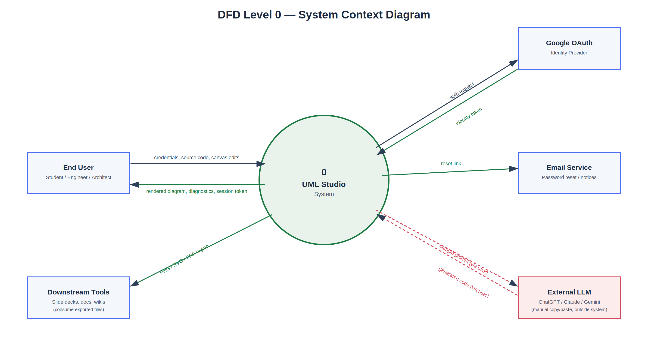
Figure 1 — DFD Level 0: UML Studio system context and external entities.
External Entity | Data Into System | Data Out of System
End User | Credentials, source code, canvas edits, project actions | Rendered diagram, compiler diagnostics, session token
Google OAuth | Identity token | Authentication request
Email Service | — | Password-reset link / notifications
External LLM (indirect, via user) | Generated source text (pasted by user) | Sample prompt text (copied by user)
Downstream Tools | — | Exported PNG / SVG / PDF files

4.2 Data Flow Diagram — Level 1
Level 1 decomposes the system into its major processes and the persistent data stores they read from or write to.
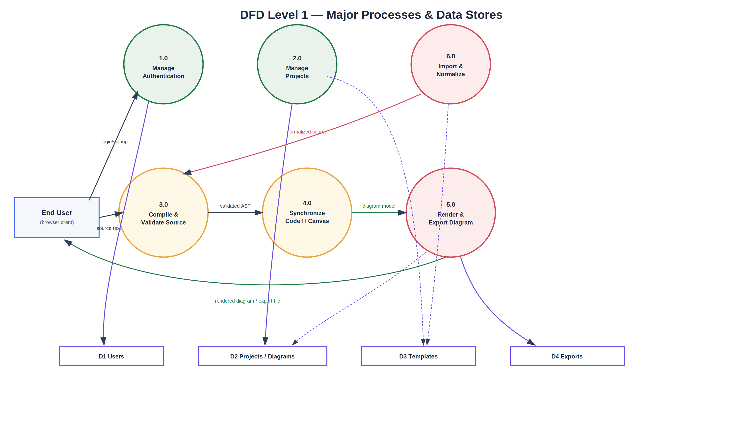
Figure 2 — DFD Level 1: major processes (1.0–6.0) and data stores (D1–D4).
Process | Reads | Writes
1.0 Manage Authentication | D1 Users (credential lookup) | D1 Users (new account, session record)
2.0 Manage Projects | D2 Projects/Diagrams, D3 Templates | D2 Projects/Diagrams
3.0 Compile & Validate Source | — (in-memory AST only) | — (passes validated AST to 4.0)
4.0 Synchronize Code ⇄ Canvas | — (in-memory Diagram Model) | — (passes model to 5.0; patches editor buffer)
5.0 Render & Export Diagram | Diagram Model | D2 (snapshot), D4 Exports
6.0 Import & Normalize | User-supplied file / pasted text, D3 Templates | Normalized source passed to 3.0

4.3 Compiler Pipeline (Process 3.0 – Detail)
Process 3.0 (Compile & Validate) and its interaction with Process 4.0 (Synchronize) are further detailed as a forward and reverse data pipeline, reused here from the architecture baseline for traceability to FR-LANG and FR-SYNC requirements.
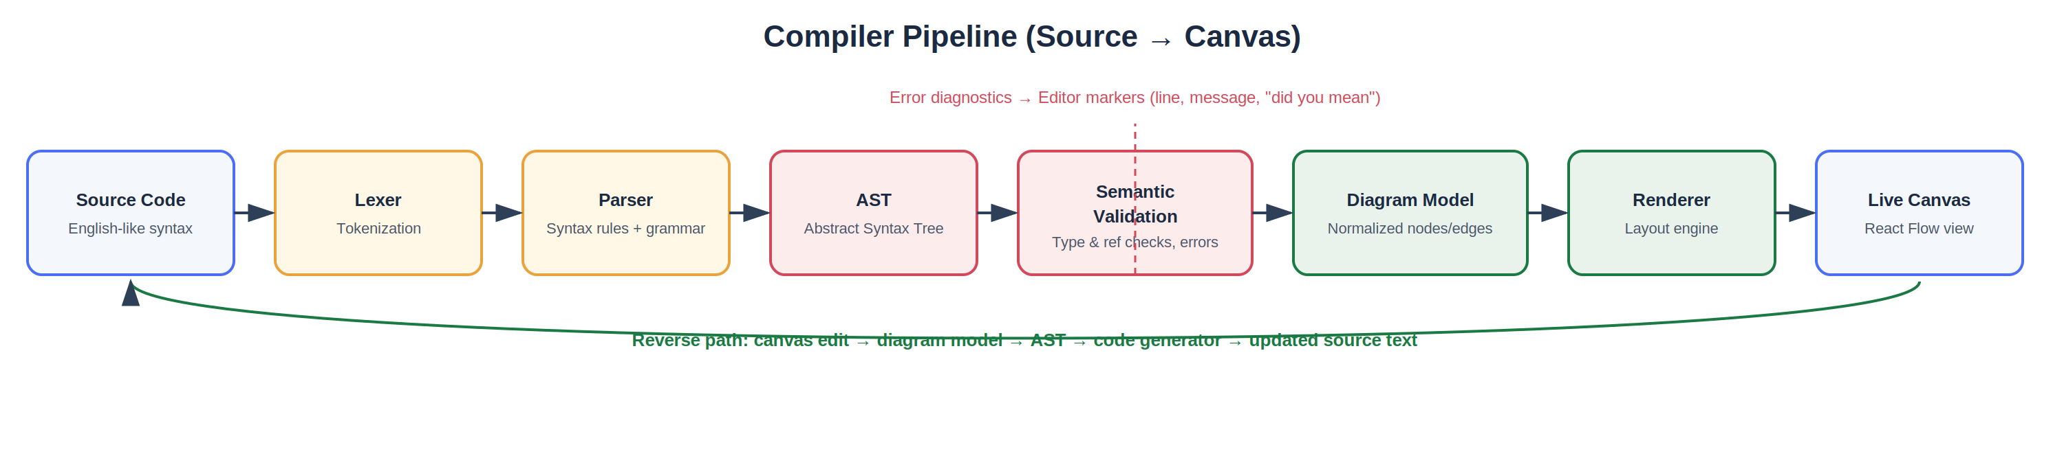
Figure 3 — Compiler pipeline forward path (source → canvas) and reverse path (canvas → source).

4.4 Data Flow Requirements
Req. ID | Requirement Statement | Priority
DF-01 | Every keystroke-driven source change shall flow through Lexer → Parser → AST → Semantic Validation before any Diagram Model update is produced (see FR-LANG-01–FR-LANG-08). | Must
DF-02 | Every canvas structural edit shall flow through Diagram Model update → AST update → Code Generator before the editor buffer is patched (see FR-SYNC-02). | Must
DF-03 | Layout metadata (position, size, color) shall flow and persist independently of the language grammar and shall never trigger a source-code regeneration (see FR-SYNC-03). | Must
DF-04 | On save, the client shall transmit source text, Diagram Model snapshot, and layout metadata as a single atomic payload to the Project Service (Process 2.0). | Must
DF-05 | Export requests shall flow from the Diagram Model (client- or server-held) into the Export Service (Process 5.0), producing a file written to Object Storage and referenced by a D4 Exports record. | Must
DF-06 | Imported PlantUML/Mermaid text shall flow through a format-specific normalization step (Process 6.0) before entering the shared compiler pipeline (Process 3.0), so downstream processes remain format-agnostic. | Should
DF-07 | Compiler error diagnostics shall flow directly from Process 3.0 to the Code Editor’s marker layer, bypassing the Diagram Model (see FR-LANG-07). | Must

5. External Interface Requirements

5.1 User Interfaces
- UI-1: The application shall present a four-region IDE layout (Toolbar, Sidebar, Editor+Canvas, Status Bar) as specified in FR-WS-01–FR-WS-05.
- UI-2: All interactive controls shall have a minimum touch/click target consistent with WCAG 2.1 AA guidance.
- UI-3: The application shall support both dark and light themes with consistent contrast ratios in each (see FR-UX-01).

5.2 Hardware Interfaces
None beyond a standard keyboard, pointing device, and display; no specialized hardware is required.

5.3 Software Interfaces
Interface | Purpose | Protocol/Format
Monaco Editor | Code editing surface | JavaScript library, embedded in client
React Flow (or equivalent) | Canvas rendering and interaction | JavaScript library, embedded in client
FastAPI backend | Auth, project CRUD, export jobs | REST over HTTPS, JSON payloads
PostgreSQL | System-of-record persistence | SQL over internal network, TLS
Redis (optional) | Caching, job queue | Redis protocol, internal network
Google OAuth | Social login | OAuth 2.0 / OpenID Connect
Transactional email provider | Password reset delivery | SMTP / provider API

5.4 Communication Interfaces
- All client–server communication shall occur over HTTPS.
- Authenticated requests shall carry a JWT bearer token issued at login (see FR-AUTH-04).
- Real-time-adjacent features (status updates, future collaboration) are reserved for a WebSocket channel in a later phase; MVP uses request/response REST only.

6. Data Requirements

6.1 Logical Data Model
The following entities constitute the system’s persistent data model, aligned with the data stores identified in Section 4.2 (D1–D4).

User (D1)
Field | Type | Constraints
id | UUID | Primary key
email | string | Unique, required, indexed
password_hash | string | Required unless auth_provider is external
auth_provider | enum | local | google
created_at | timestamp | Required

Project (D2)
Field | Type | Constraints
id | UUID | Primary key
user_id | UUID | Foreign key → User.id
name | string | Required, max 120 chars
diagram_type | enum | Class | UseCase | Sequence | Activity | State | Component | Deployment | ER
created_at / updated_at | timestamp | Required

Diagram (D2)
Field | Type | Constraints
id | UUID | Primary key
project_id | UUID | Foreign key → Project.id
source_text | text | Required; native language, PlantUML, or Mermaid per project setting
ast_snapshot | JSON | Derived, cached for fast reload
diagram_model | JSON | Nodes/edges canonical structure
layout_metadata | JSON | Positions, sizes, colors
version | integer | Incremented per save

Template (D3)
Field | Type | Constraints
id | UUID | Primary key
name | string | Required
category | string | e.g., “E-commerce”, “Banking”
source_text | text | Required
diagram_model | JSON | Pre-rendered model
thumbnail_url | string | Optional

Export (D4)
Field | Type | Constraints
id | UUID | Primary key
diagram_id | UUID | Foreign key → Diagram.id
format | enum | PNG | SVG | PDF
options | JSON | Background, resolution, orientation
file_url | string | Object storage reference
created_at | timestamp | Required

Settings
Field | Type | Constraints
user_id | UUID | Primary key, foreign key → User.id
theme | enum | dark | light
editor_preferences | JSON | Font size, keybindings, etc.

6.2 Data Dictionary Notes
- AST and Diagram Model are treated as derived/cache data: they must always be regenerable from source_text and, conversely, source_text must always be regenerable from Diagram Model + layout_metadata (round-trip integrity, see FR-SYNC-06).
- layout_metadata is explicitly excluded from the language grammar (DF-03) and is stored/versioned alongside, not inside, source_text.
- All timestamps are stored in UTC.

7. Non-Functional Requirements

7.1 Performance Requirements
Req. ID | Requirement Statement | Priority
NFR-PERF-01 | The editor-to-canvas synchronization latency shall not exceed 150ms (P95) for diagrams with ≤ 50 elements. | Must
NFR-PERF-02 | The compiler pipeline shall execute off the main UI thread (Web Worker) so that typing latency in the editor is not perceptibly affected. | Must
NFR-PERF-03 | Dashboard project listings shall load within 2 seconds for a user with up to 200 projects. | Should
NFR-PERF-04 | Export generation for a standard diagram (≤ 50 elements) shall complete within 5 seconds (P95). | Should

7.2 Security Requirements
Req. ID | Requirement Statement | Priority
NFR-SEC-01 | Passwords shall be stored using a salted, industry-standard hashing algorithm (e.g., bcrypt or argon2); plaintext passwords shall never be persisted or logged. | Must
NFR-SEC-02 | All client–server traffic shall be encrypted via HTTPS/TLS. | Must
NFR-SEC-03 | Session tokens (JWT) shall have a finite expiry and be revocable on logout. | Must
NFR-SEC-04 | The parser shall treat all source text as untrusted input and shall not permit injection or execution of arbitrary code through diagram source. | Must
NFR-SEC-05 | Project data shall be access-controlled so that only the owning user (or explicitly shared collaborators, in a future phase) can read or modify it. | Must

7.3 Reliability & Availability
Req. ID | Requirement Statement | Priority
NFR-REL-01 | The production system shall target 99.5% monthly uptime for MVP. | Should
NFR-REL-02 | Client-side autosave (IndexedDB) shall preserve unsaved edits across a transient network loss or browser refresh. | Must
NFR-REL-03 | A failed save shall be retried automatically and shall not silently discard local changes. | Must

7.4 Usability
Req. ID | Requirement Statement | Priority
NFR-USE-01 | A first-time user shall be able to produce a rendered diagram within 2 minutes of account creation, using a template or sample code. | Should
NFR-USE-02 | At least 80% of surveyed compiler error messages shall be rated “clear” or “very clear” by users (see PRD Section 12). | Should
NFR-USE-03 | Core interactive elements shall meet WCAG 2.1 AA color-contrast requirements in both themes. | Should

7.5 Maintainability & Portability
Req. ID | Requirement Statement | Priority
NFR-MAINT-01 | The compiler pipeline stages (Lexer, Parser, Validator, Renderer) shall be implemented as independently testable modules with defined input/output contracts. | Must
NFR-MAINT-02 | Backend services shall be stateless and containerized to support independent deployment and horizontal scaling. | Should
NFR-MAINT-03 | The system shall run on any evergreen, standards-compliant browser without browser-specific code paths, where practicable. | Should

7.6 Scalability
Req. ID | Requirement Statement | Priority
NFR-SCAL-01 | Export rendering shall be handled via an asynchronous job queue (Redis-backed) to absorb bursts without degrading interactive request latency. | Should
NFR-SCAL-02 | The Project Service shall support horizontal scaling behind the API Gateway without shared in-process state. | Should

8. Use Case Specifications

UC-01: Create a Diagram via Code
Field | Detail
Actor | Authenticated User
Precondition | User is in the UML Workspace with an empty or sample project open.
Main Flow | 1. User types UML Studio syntax in the Code Editor. 2. System tokenizes, parses, and validates the input (FR-LANG-01–FR-LANG-05). 3. System converts the AST into a Diagram Model. 4. System renders the model on the Live Canvas (FR-SYNC-01).
Alternate Flow | If validation fails, the system displays inline error markers with line/column and a suggestion (FR-LANG-06–FR-LANG-07); the canvas retains its last valid state.
Postcondition | The canvas reflects the current valid source code; source and canvas are reconciled (FR-SYNC-06).

UC-02: Edit a Diagram via Canvas
Field | Detail
Actor | Authenticated User
Precondition | A valid diagram is rendered on the Live Canvas.
Main Flow | 1. User renames a class, adds/removes an attribute or method, or draws a relationship on the canvas. 2. System updates the Diagram Model. 3. System regenerates the AST and patches the Code Editor buffer at the affected lines only (FR-SYNC-02).
Alternate Flow | If the edit would create an invalid model (e.g., duplicate class name), the system rejects the change and shows an inline error (FR-SYNC-05).
Postcondition | Source code reflects the canvas change; layout of unrelated elements is unaffected (FR-SYNC-04).

UC-03: Import AI-Generated Code
Field | Detail
Actor | Authenticated User
Precondition | User has copied a UML Studio sample prompt into an external LLM and received generated syntax.
Main Flow | 1. User pastes the generated text into the Code Editor. 2. System compiles the pasted text through the standard pipeline (FR-AI-02). 3. System renders the resulting diagram.
Alternate Flow | If the pasted text contains errors, standard compiler diagnostics are shown (FR-AI-03); user corrects and re-submits.
Postcondition | A new diagram exists in the workspace, indistinguishable in structure from a manually authored one.

UC-04: Export a Diagram
Field | Detail
Actor | Authenticated User
Precondition | A valid diagram is open in the workspace.
Main Flow | 1. User selects Export from the Toolbar and chooses format (PNG/SVG/PDF) and options (background, resolution, orientation). 2. System renders the Diagram Model into the requested format (FR-EXP-01–FR-EXP-02). 3. System returns a downloadable file.
Postcondition | An Export record (D4) is created and the file is available to the user.

UC-05: Recover from a Compile Error
Field | Detail
Actor | Authenticated User
Precondition | User has introduced a syntax or semantic error while editing source code.
Main Flow | 1. System detects the error during Lexer/Parser/Semantic Validation. 2. System displays an inline marker at the exact line/column with a message and, where applicable, a “did you mean…” suggestion (FR-LANG-06–FR-LANG-07). 3. User corrects the code. 4. System re-validates and, on success, updates the canvas.
Postcondition | The canvas reflects the corrected, valid diagram; no partial or corrupted state is shown.

9. Requirements Traceability Matrix
This matrix maps functional and data-flow requirement groups to their originating PRD sections, and to the primary artifact(s) that verify them.
Requirement Group | PRD Section | Primary Verification
FR-AUTH-01 – FR-AUTH-08 | PRD §7.1 Authentication | UC-01 precondition; auth integration tests
FR-DASH-01 – FR-DASH-05 | PRD §7.2 Dashboard | Dashboard UI test suite
FR-WS-01 – FR-WS-07 | PRD §7.3 UML Workspace Layout | Workspace component tests
FR-LANG-01 – FR-LANG-09 | PRD §7.4–7.5 Language & Compiler | UC-01, UC-05; compiler unit test suite
FR-SYNC-01 – FR-SYNC-06 | PRD §7.7 Bidirectional Synchronization | UC-01, UC-02; sync engine integration tests
FR-INT-01 – FR-INT-04 | PRD §7.6 Live Suggestions | Editor autocomplete test suite
FR-AI-01 – FR-AI-03 | PRD §7.8 AI Workflow | UC-03
FR-TMPL-01 – FR-TMPL-02 | PRD §7.9 Templates | Template load test suite
FR-PROJ-01 – FR-PROJ-04 | PRD §7.10 Project Management | Project CRUD integration tests
FR-EXP-01 – FR-EXP-05 | PRD §7.11 Export & Import | UC-04; export format test suite
FR-UX-01 – FR-UX-03 | PRD §7.12 UX Requirements | Accessibility & theming audit
DF-01 – DF-07 | PRD §8 System Architecture & Data Flow | Data flow / architecture integration tests
NFR-PERF-01 – NFR-PERF-04 | PRD §10 Non-Functional Requirements | Performance benchmark suite
NFR-SEC-01 – NFR-SEC-05 | PRD §10 Non-Functional Requirements | Security review / penetration test

10. Appendices

10.1 Glossary
Term | Definition
AST | Abstract Syntax Tree — the normalized structural representation of parsed source code.
Diagram Model | The renderable, canonical set of nodes and edges derived from the AST.
Sync Engine | The client module responsible for reconciling code and canvas state in real time.
Layout Metadata | Purely visual state (position, size, color) that is not part of the language grammar.
DFD | Data Flow Diagram — a graphical representation of how data moves through a system.
JWT | JSON Web Token — a compact, signed token used for stateless session authentication.

10.2 Analysis Models Referenced
- Figure 1 — DFD Level 0 (System Context).
- Figure 2 — DFD Level 1 (Major Processes & Data Stores).
- Figure 3 — Compiler Pipeline (forward and reverse data paths).

10.3 Open Issues / To Be Determined
- TBD-1: Exact grammar EBNF for the native UML Studio language (owner: Compiler team; needed before FR-LANG-01 implementation).
- TBD-2: Final list and JSON schema for layout_metadata fields (owner: Frontend team).
- TBD-3: Rate limits and quota policy for export job queue under NFR-SCAL-01 (owner: Backend/DevOps).
- TBD-4: Password complexity policy specifics for FR-AUTH-02 (owner: Security).

