Research Proposal: Forecasting AI Data Center Power Demand
A Benchmark of Classical, Foundation, and Hybrid Quantum Models with Uncertainty Quantification and Grid-Aware Control
Oct 1, 2026 · @aryan

1. Motivation
AI data centers are becoming a large, fast-changing grid load. The IEA projects global data center electricity use to rise from about 415 TWh in 2024 to about 945 TWh in 2030, with accelerated (mostly AI) servers growing roughly 30% per year.
Their demand also moves quickly. Synchronized training over tens of thousands of GPUs alternates between compute-heavy and communication-light phases, producing large power swings, and NERC has documented load-loss events of 100 to 1,500 MW. Operators therefore need short-term forecasts that stay accurate during ramps and come with calibrated uncertainty. Grid-side studies note that a battery is suited to the minute-to-hour scale, which is where a good forecast turns into an engineering decision.

2. Research Questions
The project is built so that it succeeds whatever the quantum result turns out to be.
 | Question | Pillar
RQ1 | How well do statistical, machine-learning, deep and time-series foundation models forecast data center GPU power, especially at load ramps? | Classical benchmark
RQ2 | Do hybrid quantum–classical models reach competitive accuracy with fewer parameters or less training data? | Fair quantum evaluation
RQ3 | Can the forecasts carry calibrated prediction intervals, including during ramps? | Uncertainty
RQ4 | How much does forecast quality reduce the ramp rate delivered to the grid by a battery under model predictive control? | Grid-aware control

3. Data
The main dataset is the MIT Supercloud GPU traces (February to October 2021, 448 V100 GPUs, aggregate peak about 45 kW), summed over all jobs and resampled to one minute. This gives about 330,000 steps (about 238 days) with covariates such as utilization, temperature and memory use, and active and queued job counts from the Slurm log.
PM100 (Marconi100, node-level power at 20 s resolution) is the backup and a second dataset for testing whether model rankings generalize.
Two limitations are stated up front. The series is job-attributed GPU power, not facility power, so idle GPUs, CPUs, networking and cooling are excluded. The cluster is university-scale, not a megawatt AI data center. The dataset is licensed CC BY-NC-ND 4.0, so only scripts are published, never the processed data.

4. Methods
Every model goes through one shared evaluation module, and each experiment has its own configuration file.
Pillar | Models and procedures
Baselines (RQ1) | Naive and seasonal naive; AutoETS and AutoARIMA; LightGBM; LSTM and GRU; DLinear and NLinear; PatchTST and N-HiTS
Foundation models (RQ1) | Chronos, TimesFM and Toto, zero-shot, reported as secondary with a data-leakage caveat
Hybrid quantum (RQ2) | Hybrid QCNN (linear encoder, 4 to 8 qubit circuit, linear decoder) and Quantum Reservoir Computing, run in PennyLane on a simulator
Quantum controls (RQ2) | Same-architecture classical control with the circuit replaced by a small classical layer; entanglement ablation; Elastic Net and a classical random-feature reservoir for QRC
Uncertainty (RQ3) | Static split conformal, rolling-window split conformal, and adaptive conformal inference (ACI)
Control (RQ4) | Battery model with model predictive control in cvxpy over a 15-minute horizon; scenarios: oracle, best model, naive, no forecast
Quantum experiments vary the training-data fraction (1%, 5%, 20%, 100%), the number of qubits (2, 4, 6, 8) and the noise level, and every quantum variant tried is logged.

5. Evaluation Protocol
These decisions are fixed before any model is run and change only with a reason recorded in the meeting notes.
Item | Value
Resolution | 1 minute (10 seconds as a supplementary experiment)
Input window | 60 steps (60 minutes), with a longer look-back as a side experiment
Horizons | 1, 5 and 15 minutes
Split | Chronological 70/15/15, no shuffling; Min-Max scaling fitted on training data only
Ramp definition | Steps where the absolute change in power exceeds the 95th percentile of the training data
Metrics | MAE, RMSE, sMAPE, R²; MAE in ramp periods; ramp-rate error
Repetition | At least 3 seeds; report mean and standard deviation
Fairness rules | Equal tuning budget for all models; every quantum variant logged; Diebold–Mariano tests between the best models
Uncertainty metrics | Target coverage 90%; empirical and rolling coverage, interval width, separately for normal and ramp steps

6. Positioning in Related Work
Two papers forecast GPU power on the same MIT Supercloud data. The Alberta group (arXiv 2503.07756) reports LSTM, GRU and 1D-CNN at 1-second resolution, and PI-DLinear (arXiv 2605.04074) adds physics-based loss terms to DLinear at 1-minute resolution. Neither reports a naive baseline in the parts we read, ramp-specific metrics, foundation models, quantum models, calibrated uncertainty or a control application.
On the quantum side, we found no work applying quantum machine learning to data center power forecasting. Because large benchmarks find that out-of-the-box classical models usually win (Bowles et al., arXiv 2403.07059), and because many circuits without barren plateaus appear classically simulable (Cerezo et al., Nature Communications 2025), we frame RQ2 as a fair benchmark rather than a search for quantum advantage.

7. Timeline
The project runs for eight weeks as four two-week sprints.
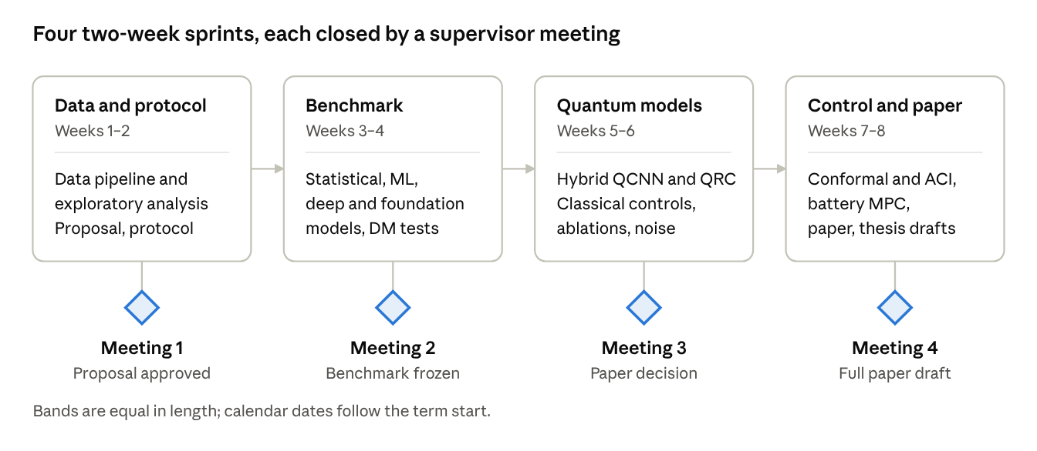
roadmap · 4 sprints, 4 supervisor meetings
Each sprint ends with a supervisor meeting that fixes one decision before the next sprint begins. Supplementary items start only once the core items of that week are done.

8. Expected Outputs
- A data report and exploratory analysis, with a one-command pipeline from raw files to the final series
- A benchmark table of all classical and foundation models by horizon and metric, including ramp-period errors
- Quantum results: three main figures (accuracy against data fraction, parameter count and qubit count) and an ablation table
- Conformal interval results and a battery-control comparison across the four forecast scenarios
- A 6 to 8 page paper draft in IEEE format, a public GitHub repository with a full README, and draft thesis chapters
A negative quantum result is still a publishable outcome if the comparison is fair and documented.

9. Open Questions for the Supervisor
- ☐ Are the four research questions and the project scope approved?
- ☐ Are 1-minute resolution and 1, 5 and 15-minute horizons appropriate?
- ☐ Our test period precedes every foundation model's pre-training cutoff, so zero-shot results carry a leakage caveat. Is reporting them as secondary acceptable?
- ☐ For 5 and 15-minute horizons, labels arrive late, so adaptive conformal inference runs with delayed updates that its published guarantee does not cover. Is an empirical-coverage report enough?
- ☐ How should the quantum comparison be framed given that parameter matching alone is not considered a fair control?
- ☐ Who is a co-author, and which conference or journal is the target?
- ☐ What are the thesis format and requirements of the university?

