Aryan Garg
Reg no. 2648511
Class – 1MSAIM
Sub – Advanced database technologies
Domain – Travel and Tourism

Questions
1. Select an existing relation/table from your project database that contains redundancy or
dependency issues.
Selected Relation: Travel_Record
The Travel_Record relation is selected because it stores customer, package, guide, hotel, transport, tourist place, booking, and payment details in a single table. This results in repeated data and dependency issues. The relation suffers from redundancy and update, insertion, and deletion anomalies. Therefore, it is chosen for normalization up to Third Normal Form (3NF).
2. Analyze the selected relation and identify:
o Primary key
o Candidate key (if applicable)
o Functional dependencies
o Data redundancy and update anomalies
Primary Key - Package_ID
Candidate Key - Package_ID
Functional Dependencies
- Package_ID → Package_Name, Destination, Guide_Name, Experience, Hotel_Name, Hotel_Type, Transport_Type, Fare, Place_Name, Customer_Name, Phone_No, Email, Booking_Date, Travel_Date, Payment_Method, Amount
- Guide_Name → Experience
- Hotel_Name → Hotel_Type
- Transport_Type → Fare
- Customer_Name → Phone_No, Email
Data Redundancy - Package, guide, hotel, transport, tourist place, and customer information are stored repeatedly for every booking, leading to unnecessary duplication of data.
Update Anomaly - Changing information such as a hotel name or guide experience requires updating multiple rows. Failure to update every occurrence results in inconsistent data.
Perform normalization of the selected relation:
o Convert the relation into First Normal Form (1NF).
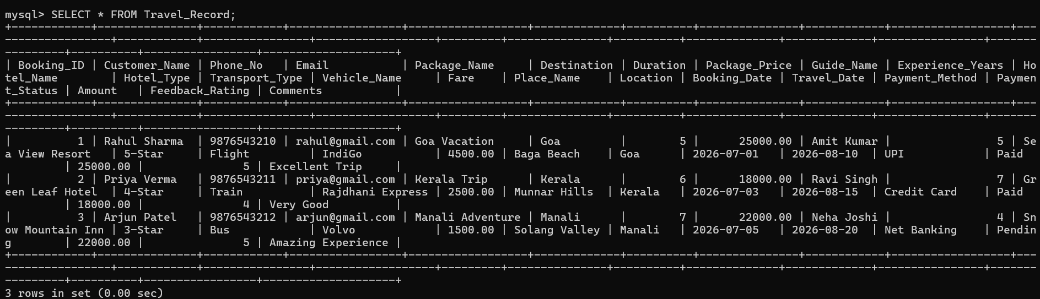

o Convert the 1NF relation into Second Normal Form (2NF) by removing partial dependencies.
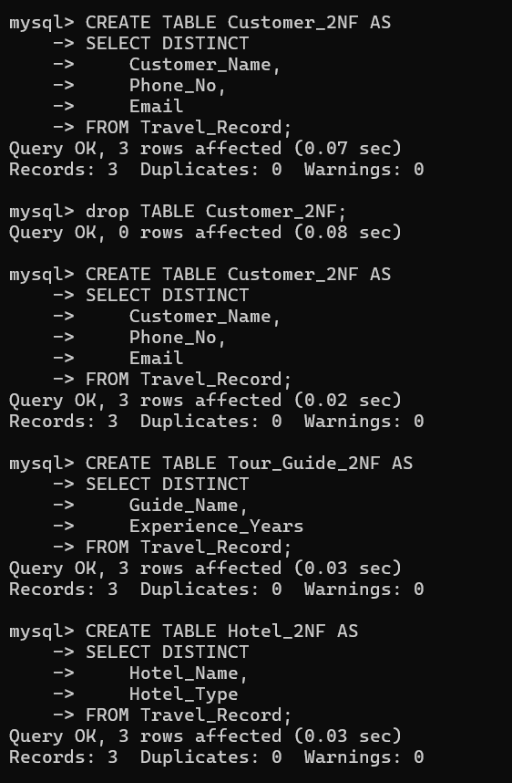

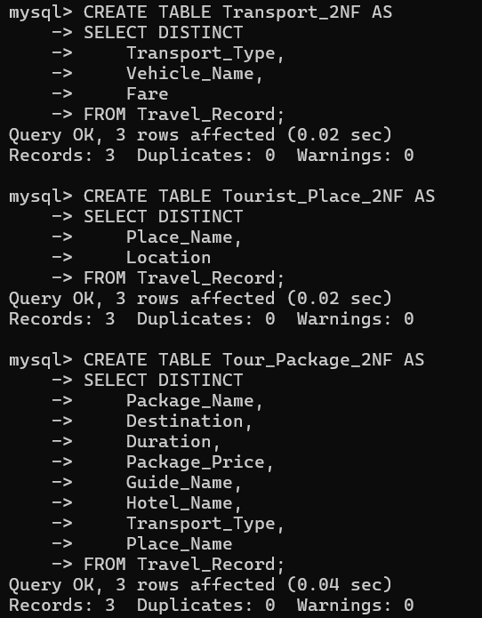
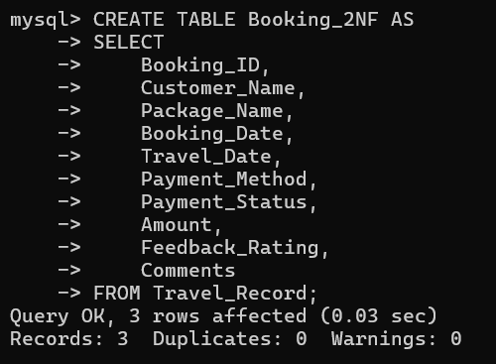

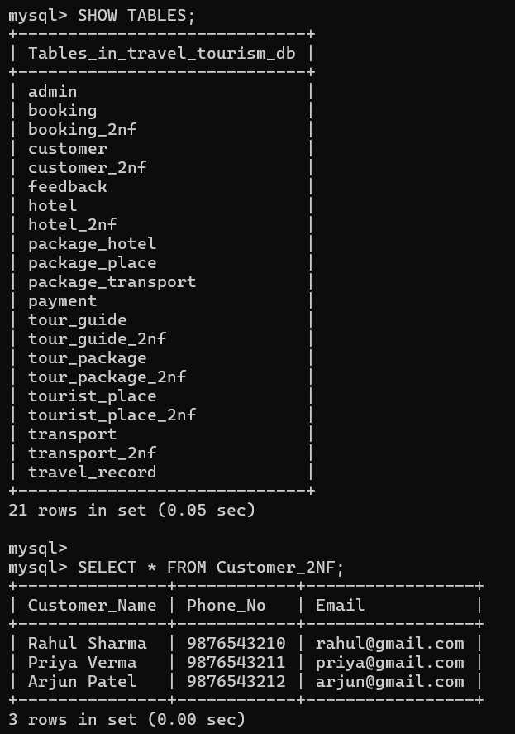
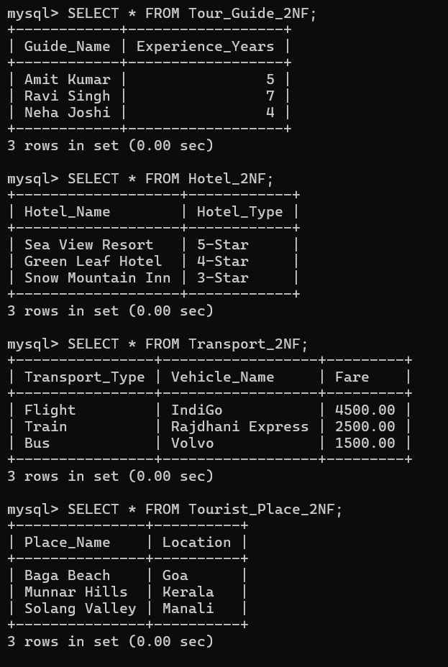
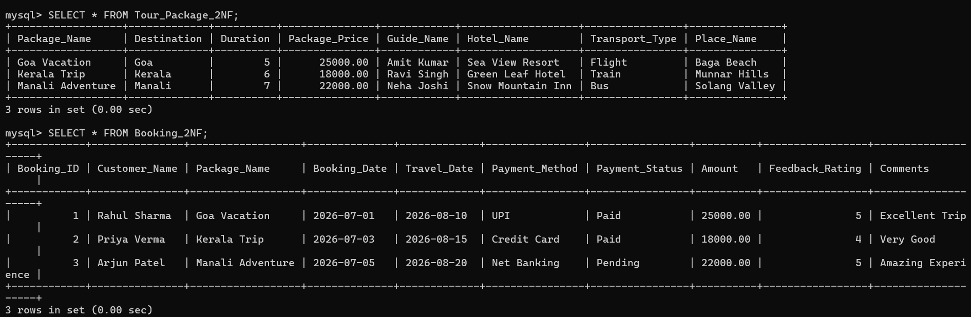
o Convert the 2NF relation into Third Normal Form (3NF) by removing transitive
dependencies.
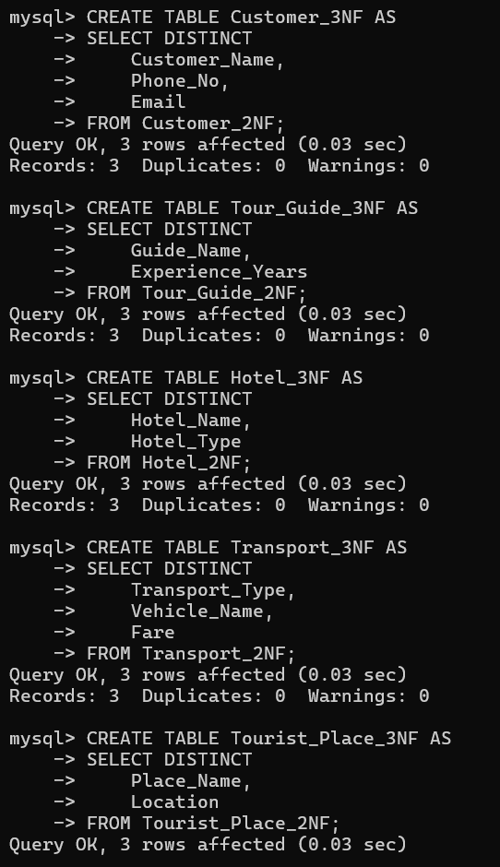
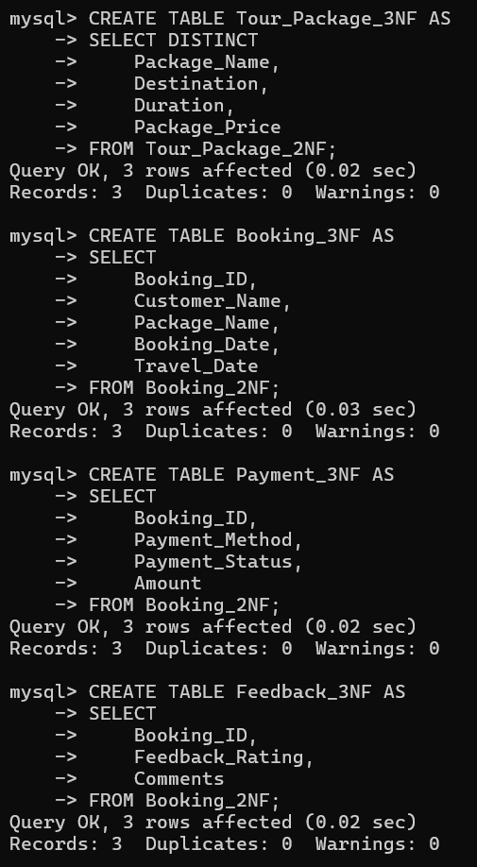
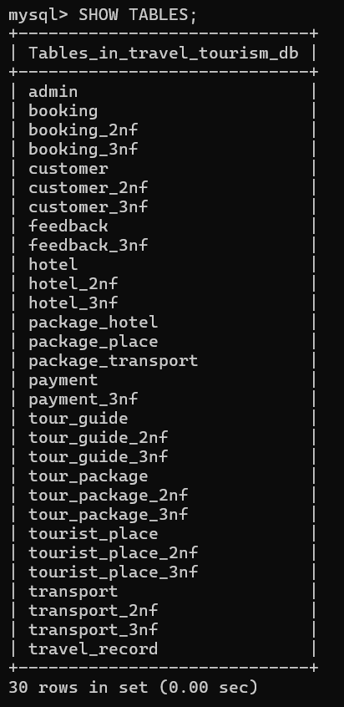
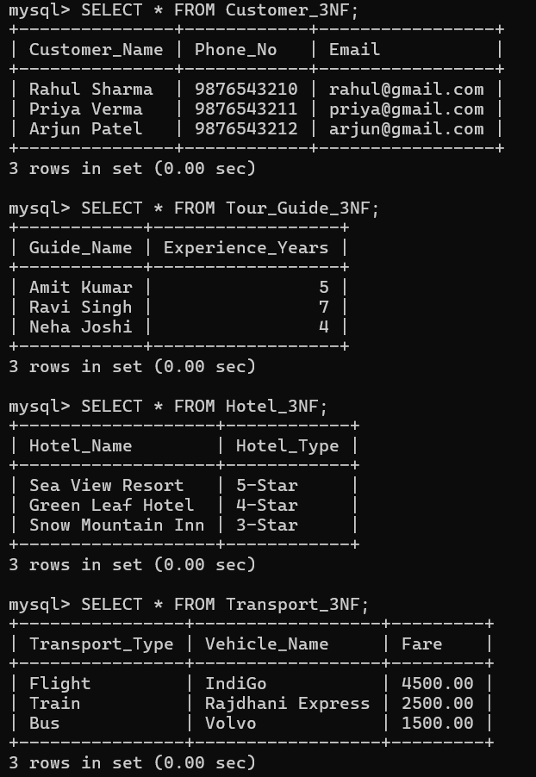
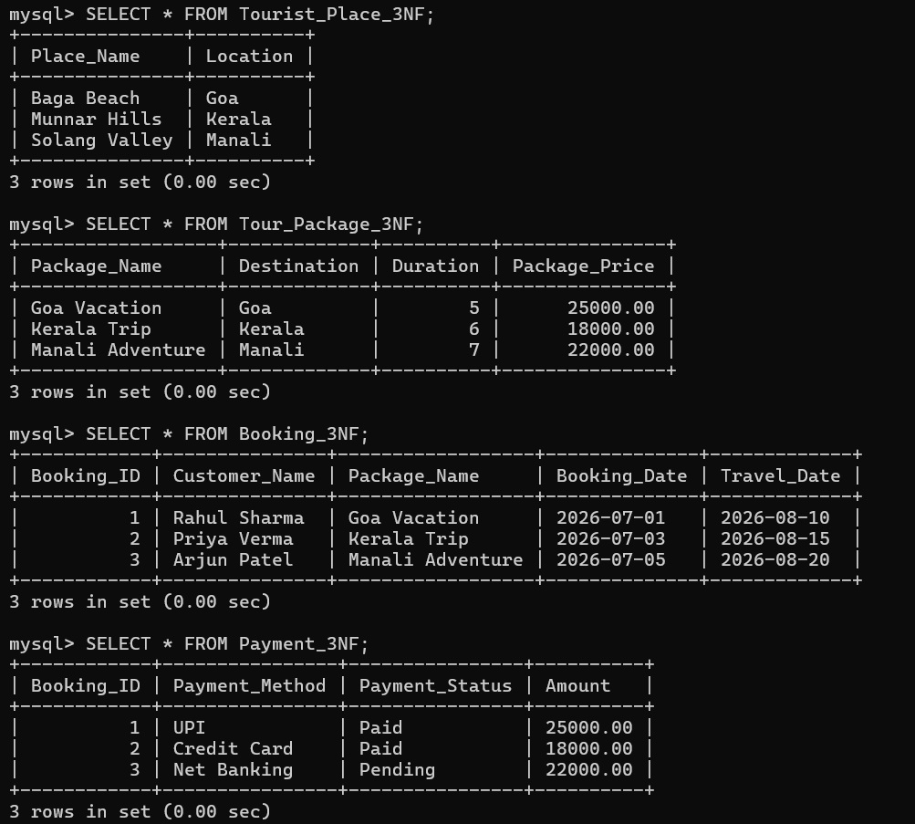
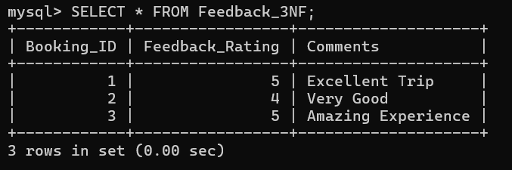

4. Implement both:
o Original (unnormalized) database design
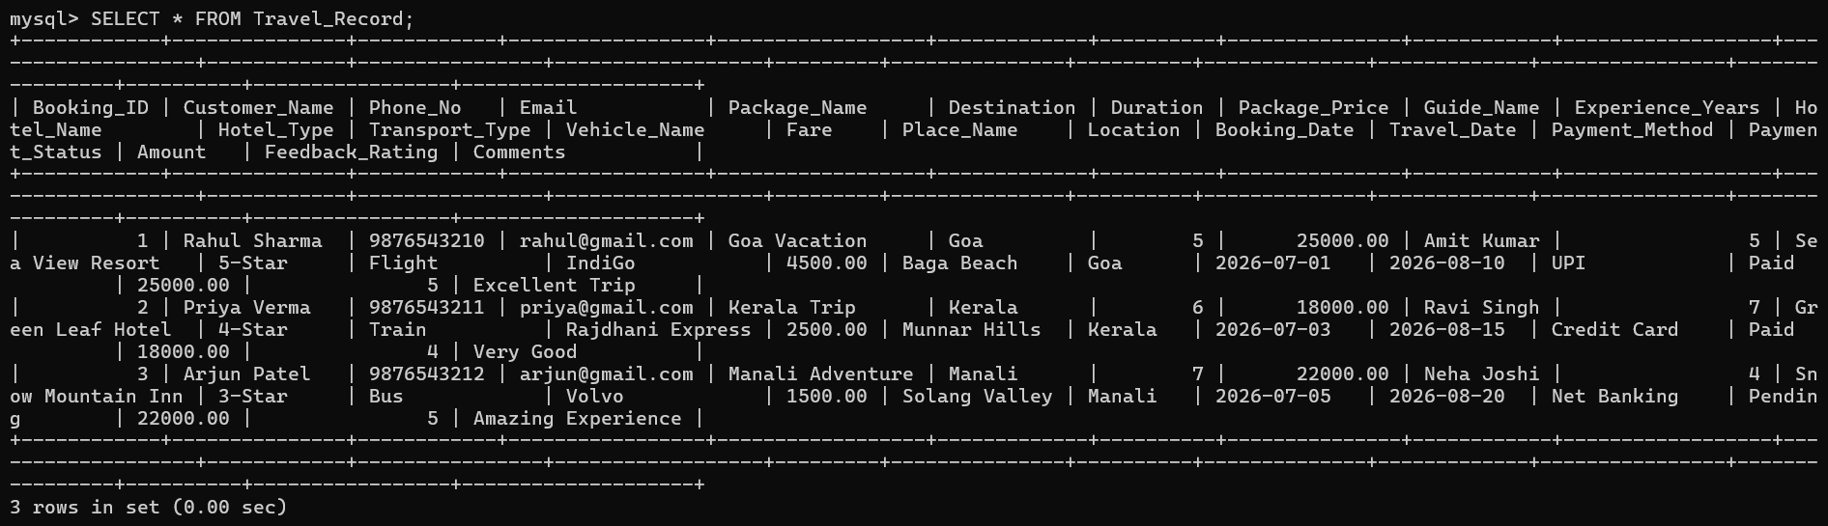
o Normalized (3NF) database design
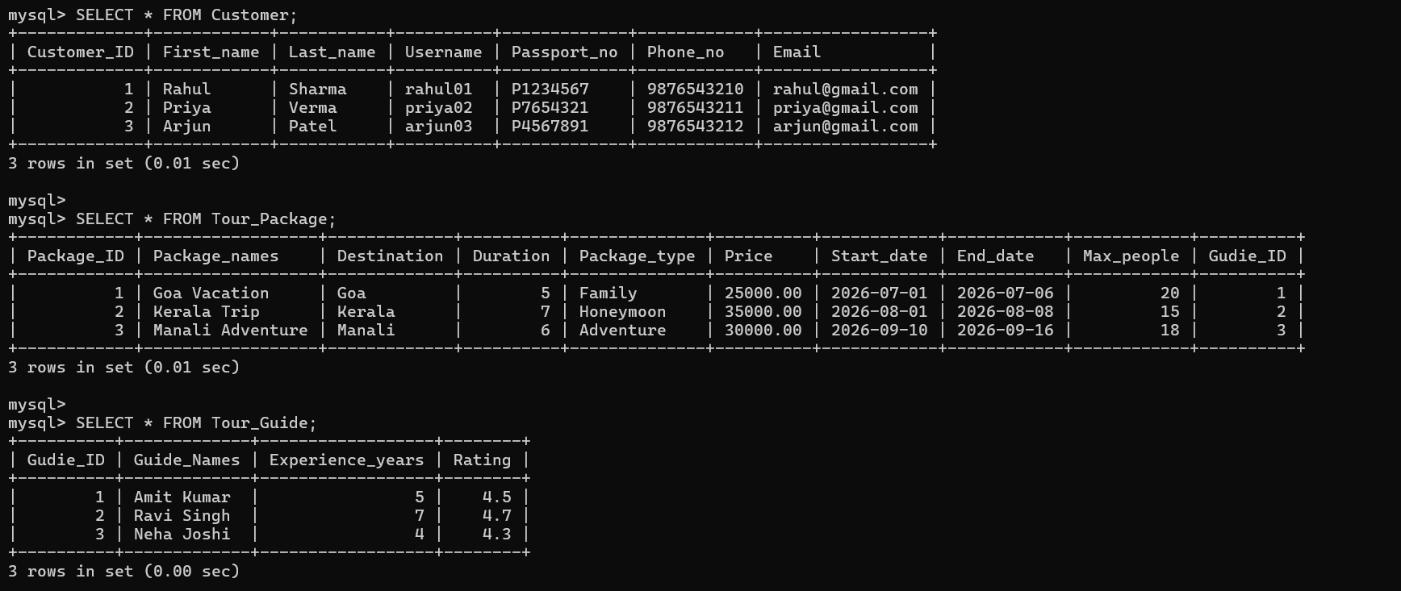

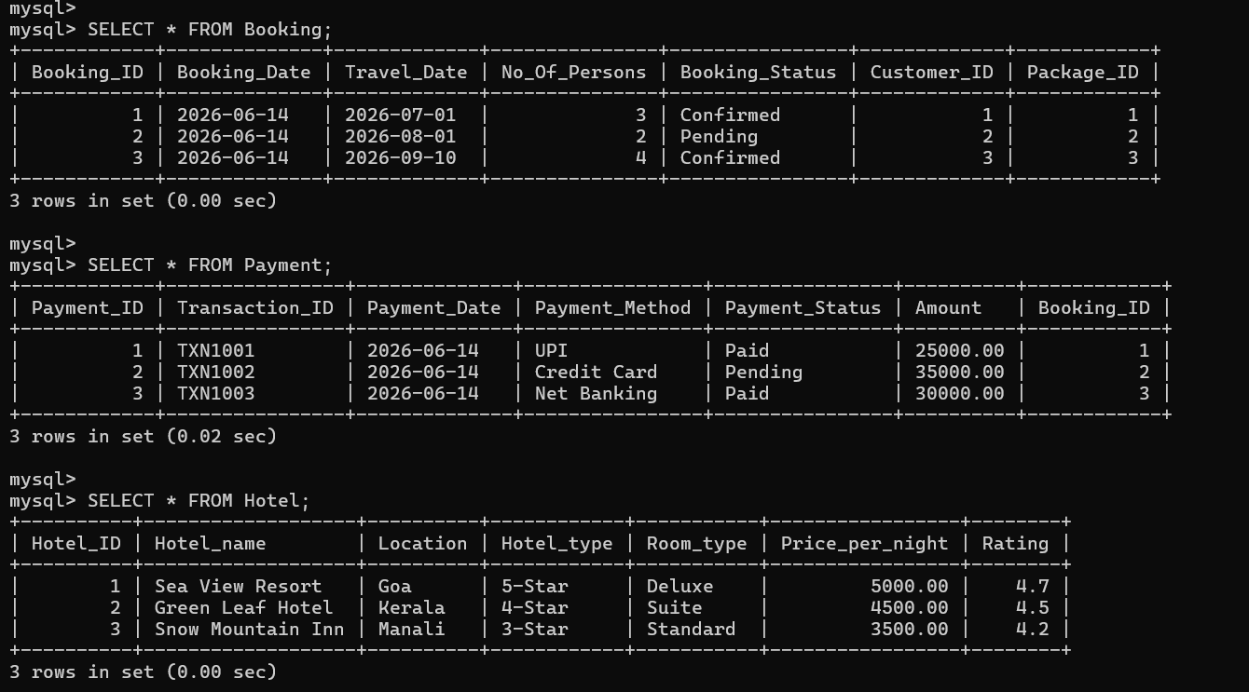

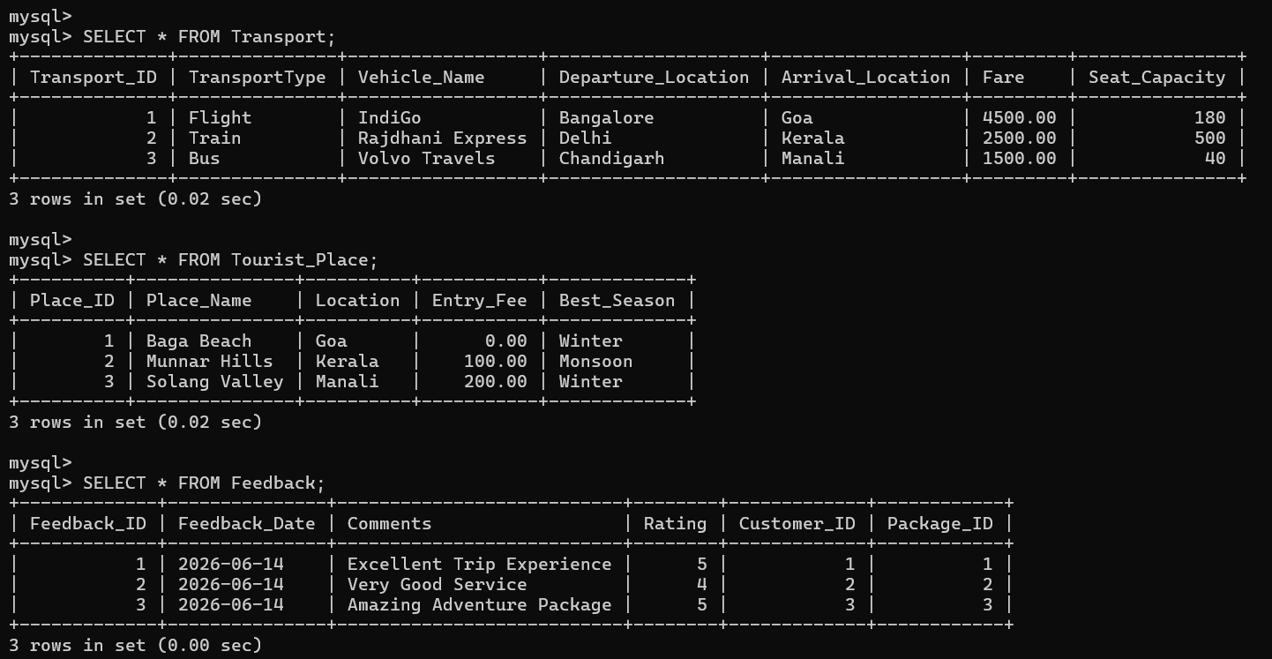

5. Execute SQL queries on both designs and compare the results:
o Insert operation
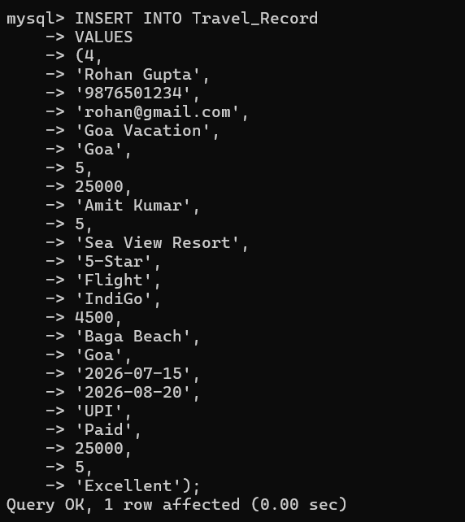
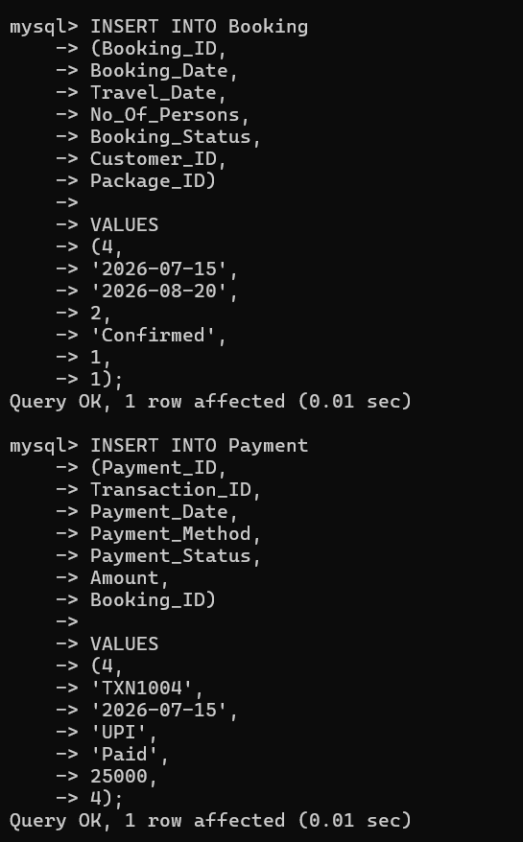

o Update operation
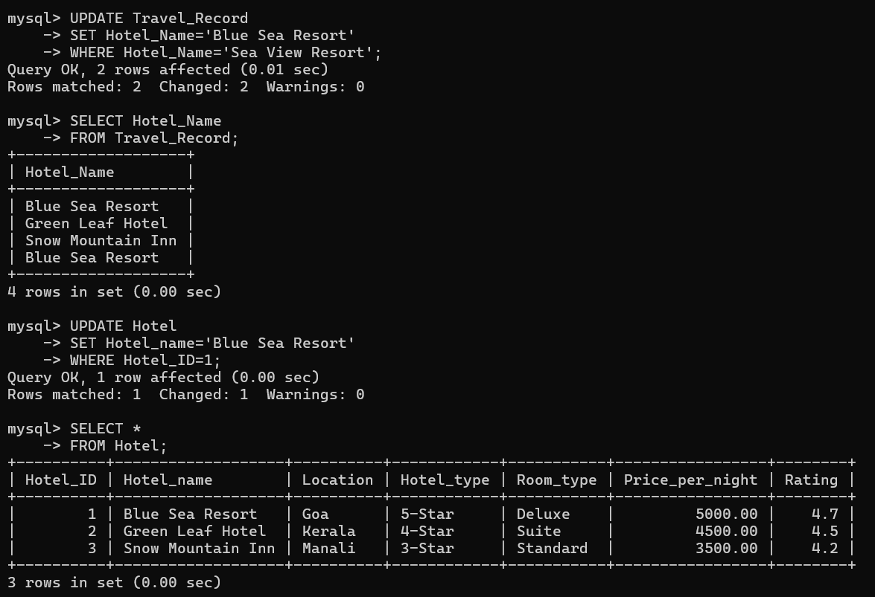
o Delete operation
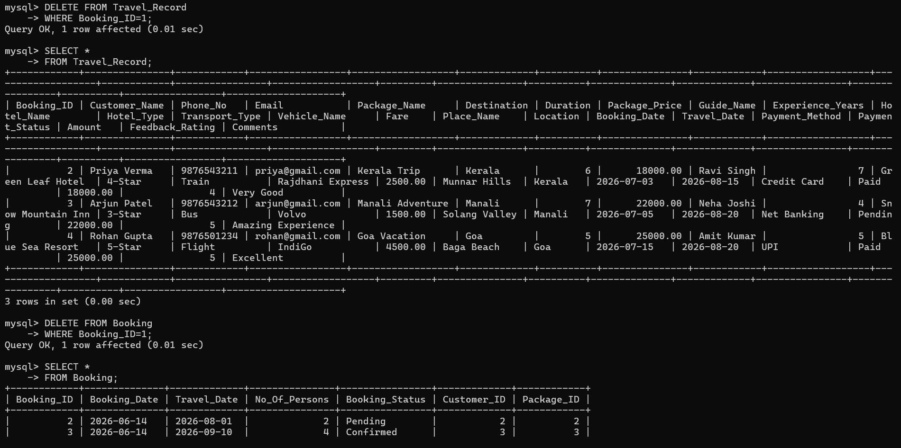

o Retrieval using JOIN queries
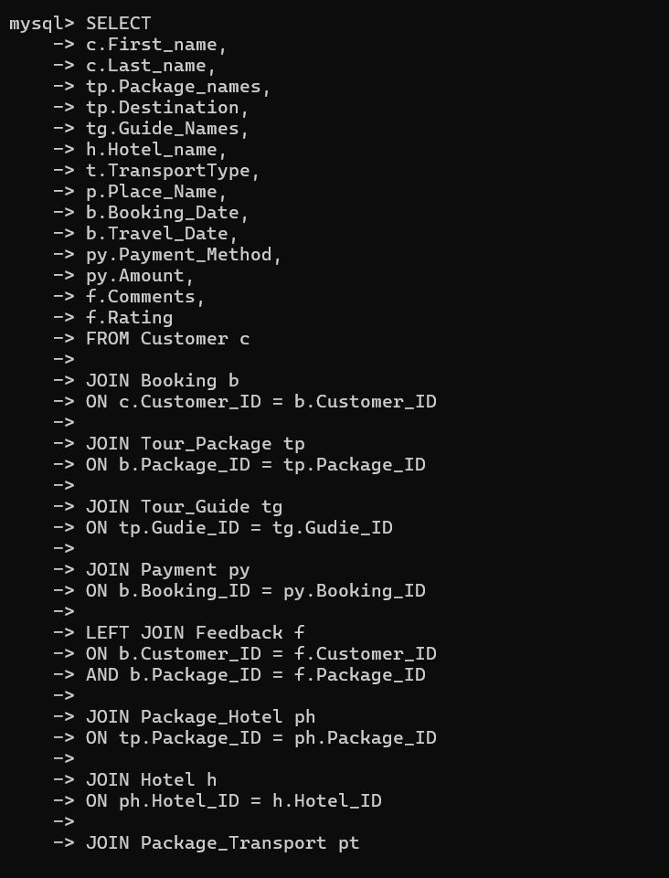
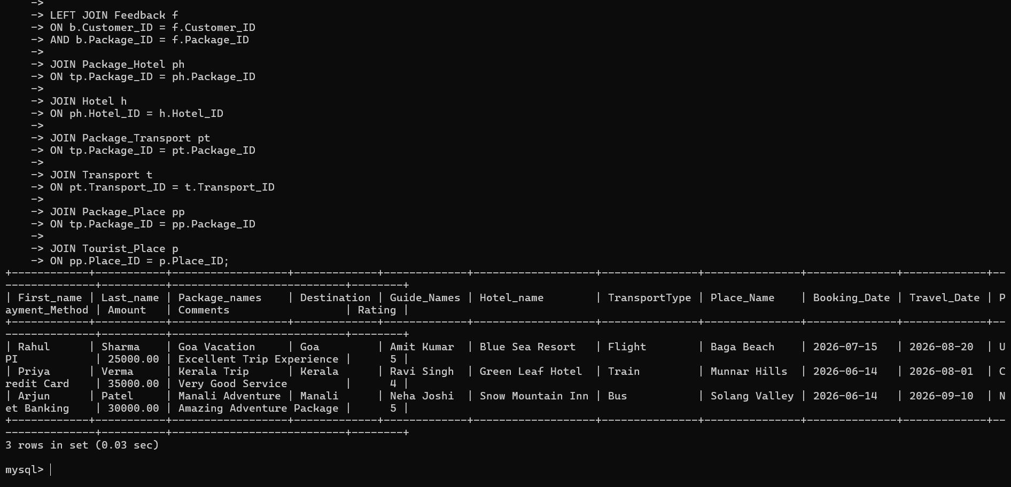

o Prepare a Efficiency comparison table
Parameter | Before Normalization | After Normalization (3NF)
Number of Tables | 1 | 13
Data Redundancy | High | Very Low
Storage Usage | High | Optimized
Update Anomaly | Present | Eliminated
Insert Anomaly | Present | Eliminated
Delete Anomaly | Present | Eliminated
Data Consistency | Low | High
Query Complexity | Simple (Single Table) | Moderate (Uses JOINs)

