ADT assignment
Aryan Garg
Reg no. 2648511
Domain -: Travel and tourism Database

1. Write SQL statements to demonstrate the following JOIN operations on the tables created for your application domain. INNER, LEFT, RIGHT, and FULL OUTER JOINS.
Specifications:
a. The Operations should be performed on tables with logical sense and mention
valid justification.
b. What is the difference between each JOIN?

Inner join
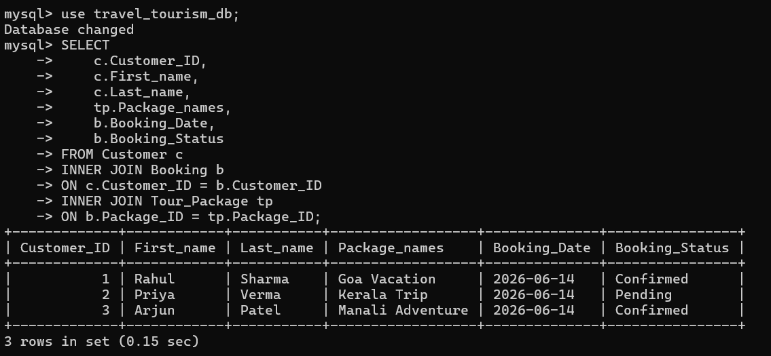
Justification: Shows only customers who have made bookings.

Left join
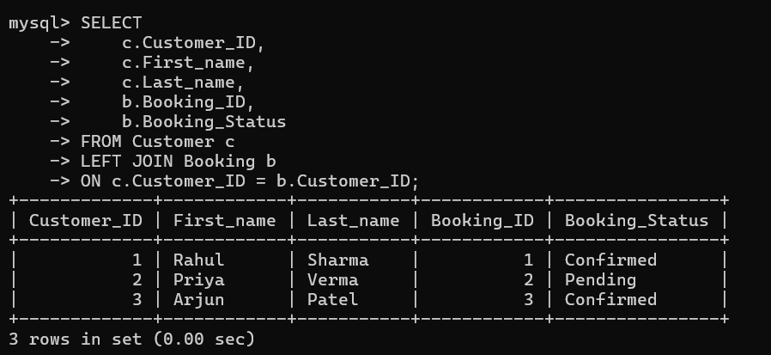
Justification: Lists every customer, including those without bookings.

Right Join
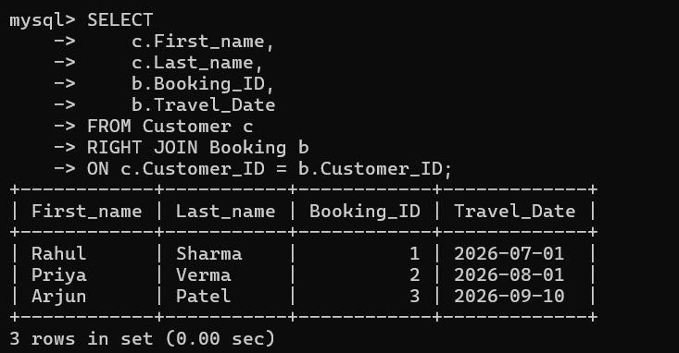
Justification: Displays all bookings, even if customer details are unavailable.

Full outer join
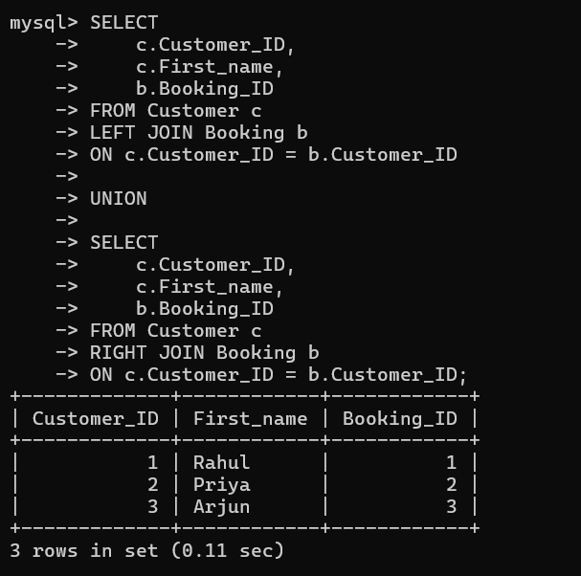
Justification: Combines LEFT and RIGHT JOIN results to simulate a FULL OUTER JOIN.
SUBQUERIES
Subquery 1
Find customers who booked the most expensive package.
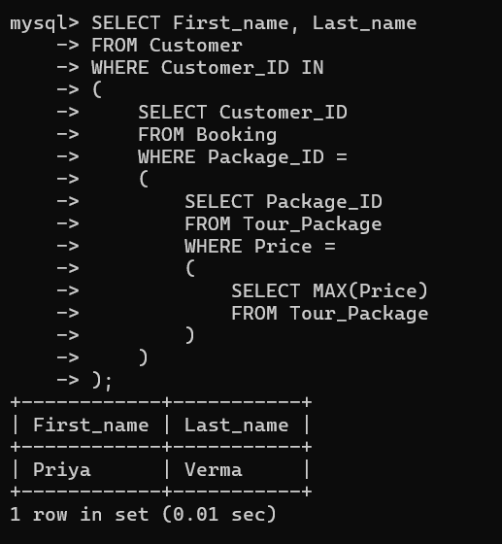
Subquery 2
Find packages whose price is greater than the average package price.
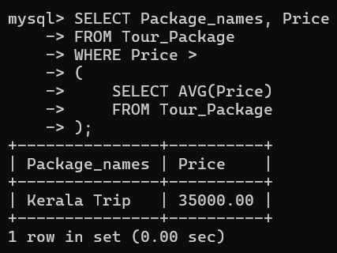
Subquery 3
Find hotels included in the Goa Vacation package.
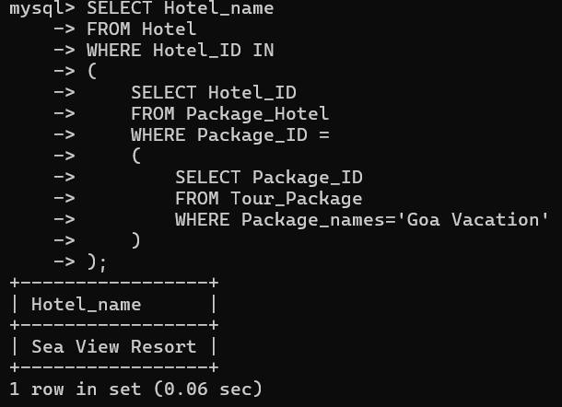

Subquery 4
Find customers who have given a 5-star rating.
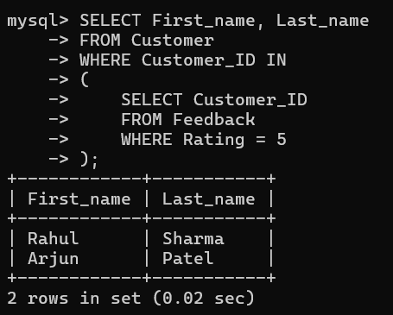
Subquery 5
Find the tour guide assigned to the most expensive package.
