Name -: Aryan Garg
Reg. no 2648511
Class – 1MSAIM
Database -: Travel and tourism

Using the database developed for your selected application domain, implement and demonstrate the
ACID properties of a transaction by performing a suitable transaction operation.
The implementation should demonstrate:
Atomicity
Execute a transaction involving multiple SQL operations.
Demonstrate the successful execution of all operations using COMMIT.
Demonstrate failure handling using ROLLBACK.

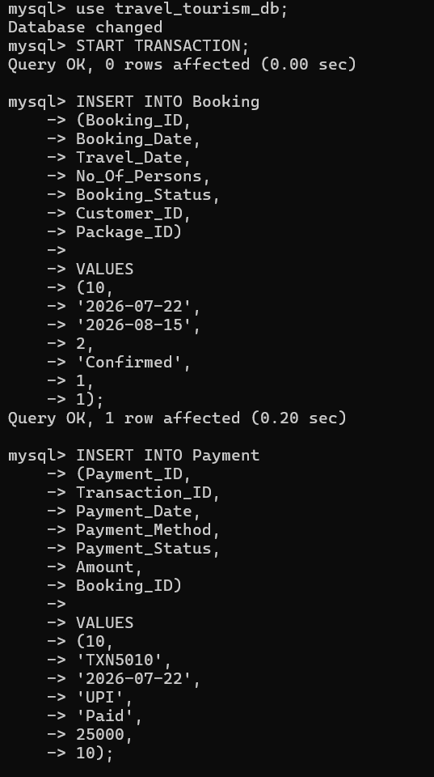
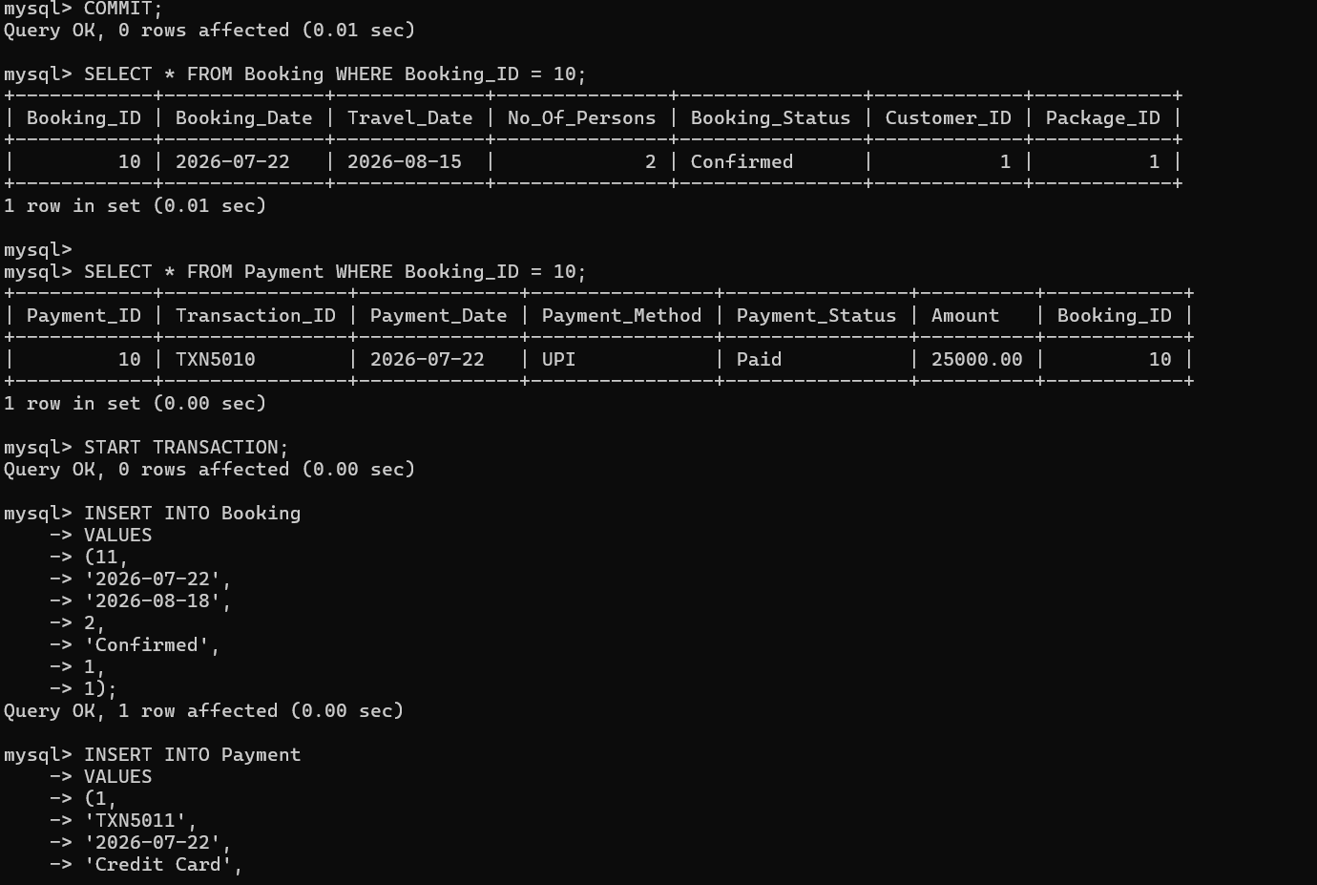
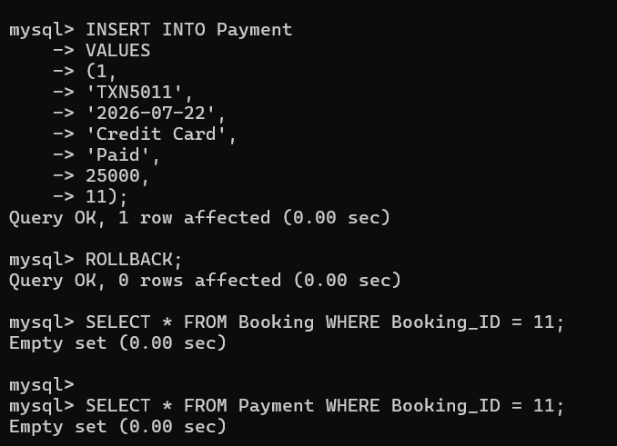

Consistency
Ensure that the transaction maintains database integrity by applying appropriate constraints such as
primary key, foreign key, and domain constraints.

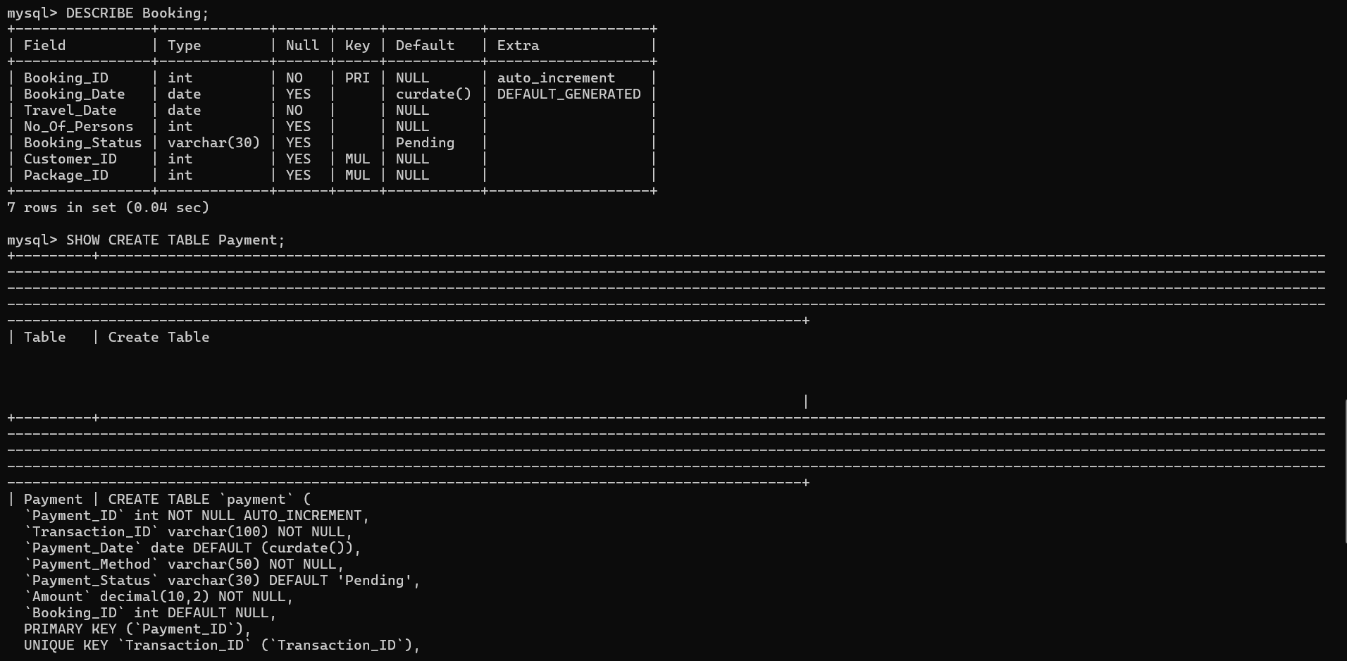
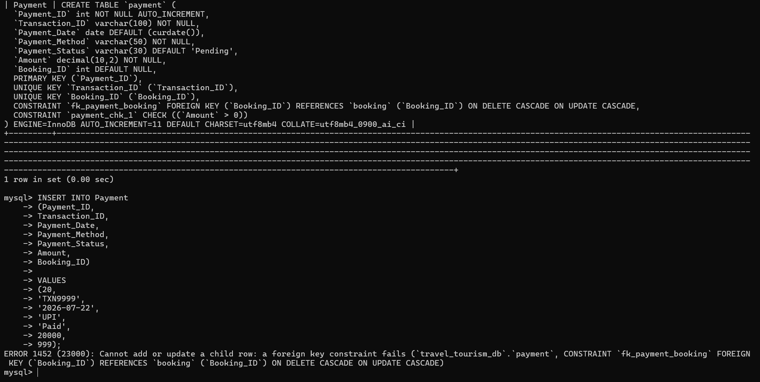

Isolation
Demonstrate how concurrent transactions are handled using appropriate transaction isolation levels.
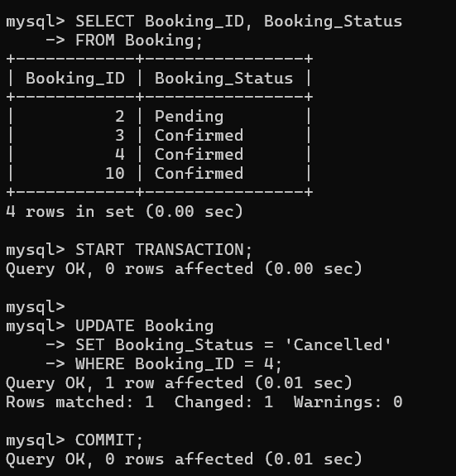
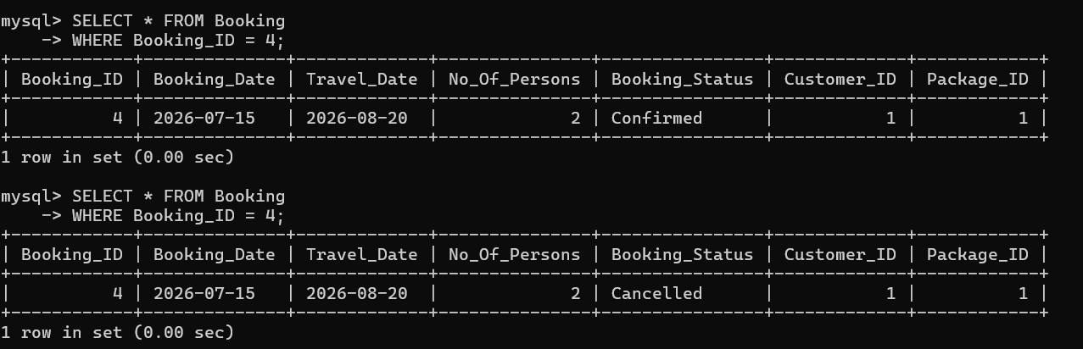

Durability
Verify that committed transactions are permanently stored in the database even after closing and
reopening the database session.
Select a meaningful transaction scenario related to their application domain and implement the
required SQL transaction commands.

