ADT Assignment
Aryan Garg
1MSAIM
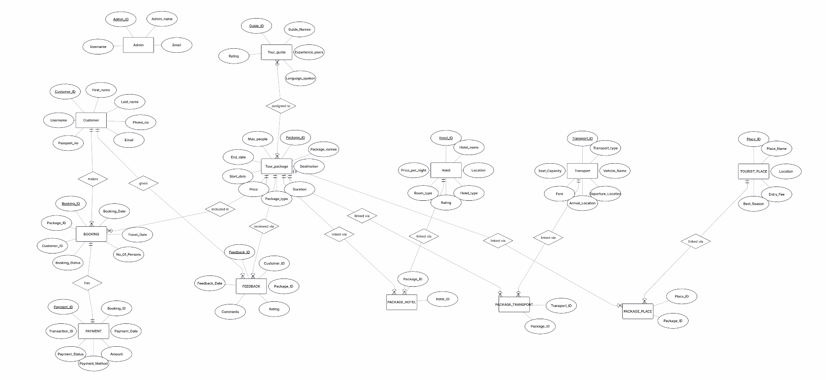
Travel and Tourism management – ER Diagram

Business Case: Travel & Tourism Management System
1. Introduction
The Travel & Tourism Management System is designed to manage tourism-related activities through a centralized digital platform. The system enables customers to register, explore tour packages, make bookings, reserve hotels and transportation, complete payments, and provide feedback after travel. Tour guides and administrators are also managed within the system to ensure smooth coordination of tourism services. The database system supports efficient storage, management, and retrieval of tourism-related information while maintaining data consistency and reducing redundancy.

2. Objective
To develop a structured database application that manages travel and tourism operations efficiently. The database is designed to store, organize, and access essential information related to customers, bookings, tour packages, hotels, transport services, tourist places, payments, guides, and feedback. The system supports both operational management and analytical processing for tourism agencies and customers.

3. System Requirements
User Management
- Customers can register and manage their profiles
- Admin manages customers, bookings, and tourism services
- Customer details include personal and contact information
Tour Package Management
- Admin creates and manages tour packages
- Packages contain destination, duration, price, and package type
- Packages are linked with hotels, transport, tourist places, and guides
Booking Management
- Customers can book tour packages
- Bookings store travel date, number of persons, and booking status
- Each booking is associated with a customer and a tour package
Payment Management
- Customers can make online or offline payments
- Payment details include transaction ID, payment method, amount, and status
- Every booking has corresponding payment information
Hotel Management
- Hotels associated with tour packages are maintained in the system
- Hotel information includes room type, rating, location, and price per night
Transport Management
- Transport services such as buses, trains, and flights are managed
- Transport records contain fare, seat capacity, departure, and arrival locations
Tourist Place Management
- Tourist destinations included in packages are stored in the system
- Information includes location, entry fee, and best visiting season
Tour Guide Management
- Guides are assigned to tour packages
- Guide information includes experience, languages spoken, and ratings
Feedback Management
- Customers can provide reviews and ratings after completing their trips
- Feedback helps improve tourism service quality

4. Database Design Highlights
- The system contains multiple entities such as Customer, Booking, Payment, Tour Package, Hotel, Transport, Tourist Place, Tour Guide, Admin, and Feedback
- Primary keys uniquely identify each entity record
- Foreign keys establish relationships between related entities
- The design supports one-to-one, one-to-many, and many-to-many relationships
- Associative entities such as PACKAGE_HOTEL, PACKAGE_TRANSPORT, and PACKAGE_PLACE are used to manage many-to-many relationships
- Customer feedback and package reviews improve service transparency
- Tour packages act as the central entity connecting tourism services

5. ER Diagram Explanation
The ER diagram of the Travel & Tourism Management System represents the relationship between different tourism-related entities and their attributes. The Admin entity manages the complete system operations, while the Customer entity stores tourist details such as name, passport number, phone number, and email. Customers can make bookings for different tour packages, and each booking stores information such as booking date, travel date, number of persons, and booking status.
The Booking entity is connected with the Payment entity, which stores transaction details including payment amount, payment method, transaction ID, and payment status. The Tour Package entity is the main component of the system and contains package details such as destination, duration, package type, start date, end date, price, and maximum number of people allowed.
Each tour package can be assigned to a Tour Guide, whose information includes guide name, experience, languages spoken, and ratings. Packages are also connected with Hotel, Transport, and Tourist Place entities through associative tables such as PACKAGE_HOTEL, PACKAGE_TRANSPORT, and PACKAGE_PLACE. These entities maintain information about accommodation, transportation facilities, and tourist attractions included in each package.
The Feedback entity stores customer reviews and ratings related to tour packages. This helps the organization improve tourism services based on customer experiences. Overall, the ER diagram provides a clear and organized representation of the Travel & Tourism Management System and ensures efficient data management, reduced redundancy, and proper relationship handling among entities.

6. Benefits
- Efficient management of tourism records and customer information
- Easy tracking of bookings, payments, and travel activities
- Improved coordination between customers, guides, hotels, and transport services
- Reduced data redundancy and improved database consistency
- Better customer service through feedback and review management
- Scalable structure for future tourism service expansion
- Transparent management of travel packages and tourism resources

7. Conclusion
The Travel & Tourism Management System is a database-driven application that automates and simplifies tourism operations. The ER diagram helps organize and manage tourism-related data systematically by defining entities, attributes, keys, and relationships. The system improves efficiency in handling bookings, payments, accommodations, transportation, and customer services while ensuring accurate and consistent data management within the tourism industry.

