Advance database technologies
Aryan Garg
1MSAIM
2648511
Lab-6

Q1 Schema Design (Table to simulate the data items and track transaction)
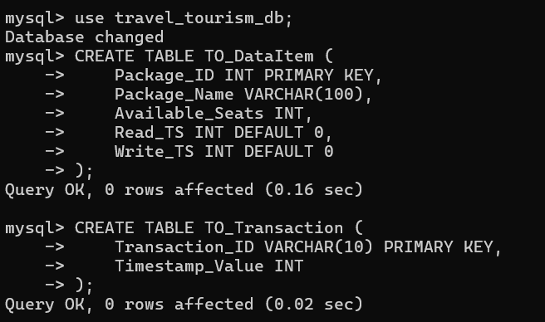
Two tables were created to simulate the Timestamp Ordering protocol
- TO_DataItem stores the travel package information along with Read Timestamp (Read_TS) and Write Timestamp (Write_TS).
- TO_Transaction stores the transaction ID and its logical timestamp.
This setup allows the database to determine whether a transaction should be allowed to read or write a data item based on its timestamp.

Q2 Insert a data item with initial values, timestamp and Insert two transactions with logical timestamps.
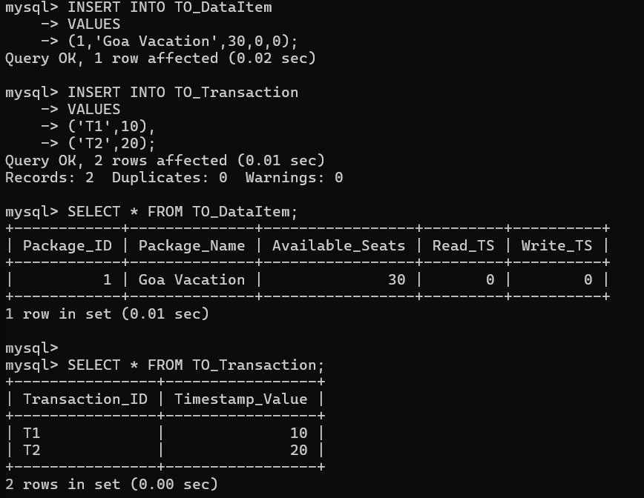
A travel package named "Goa Vacation" was inserted into the TO DataItem table with 30 available seats. Initially, both Read_TS and Write_TS were set to 0. Two transactions, T1 (timestamp = 10) and T2 (timestamp = 20), were then inserted into the TO Transaction table to simulate concurrent transactions.

Q3 Simulate the read operation with timestamp ordering logic.

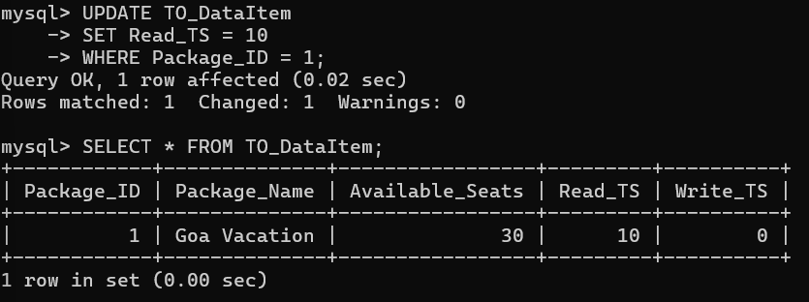
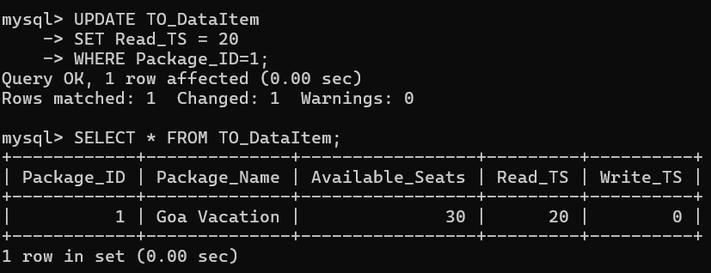
Transaction T1 attempted to read the travel package. Since its timestamp (10) was greater than the current Read_TS (0), the read operation was allowed and Read_TS was updated to 10.
Next, transaction T2 performed a read operation. Its timestamp (20) was greater than the current Read_TS (10), so the read was also allowed and Read_TS was updated to 20.
This demonstrates that the Timestamp Ordering protocol allows read operations only when the transaction timestamp is not older than the current read timestamp.
Q4 Simulate the write operation with timestamp ordering logic.
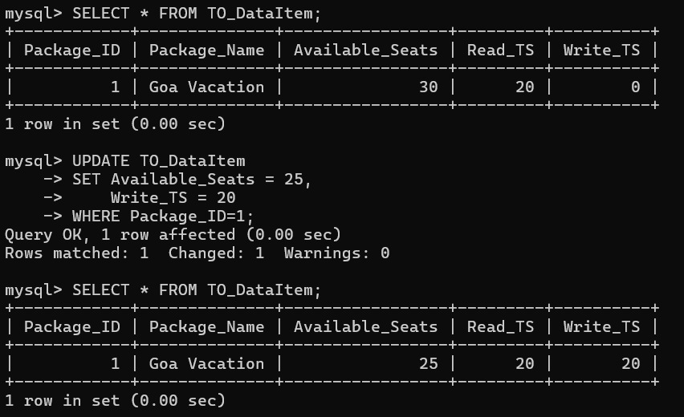
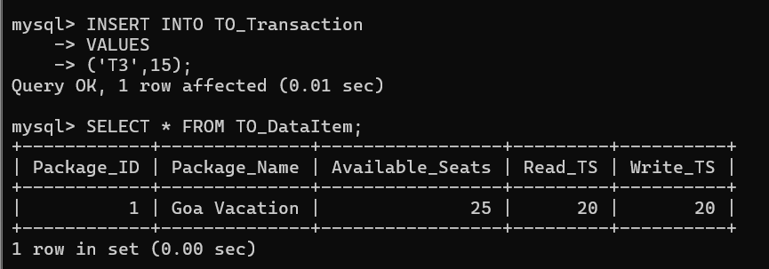
Transaction T1 then attempted to update the available seats. However, its timestamp (10) was less than the current Read_TS (20). According to the Timestamp Ordering protocol, allowing this write would overwrite data that had already been read by a newer transaction. Therefore, the write operation was rejected, and T1 was rolled back.
Transaction T2 then attempted to write to the same data item. Since its timestamp (20) was greater than or equal to both the current Read_TS (20) and Write_TS (0), the write operation was allowed. The available seats were updated, and Write_TS was changed to 20.
Finally, transaction T3 with timestamp 15 attempted to write. Since 15 was less than the current Write_TS (20), the write was rejected because an older transaction cannot overwrite changes made by a newer transaction.

