**Aim:**

Learn about real time object detection.

**Observations:**

Darknet prints out the objects it detected, its confidence and how long it took to find them.

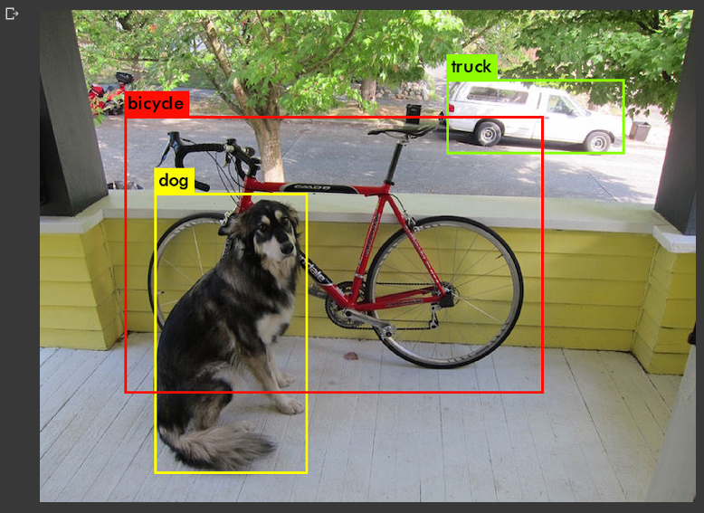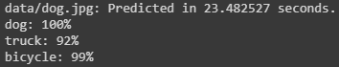

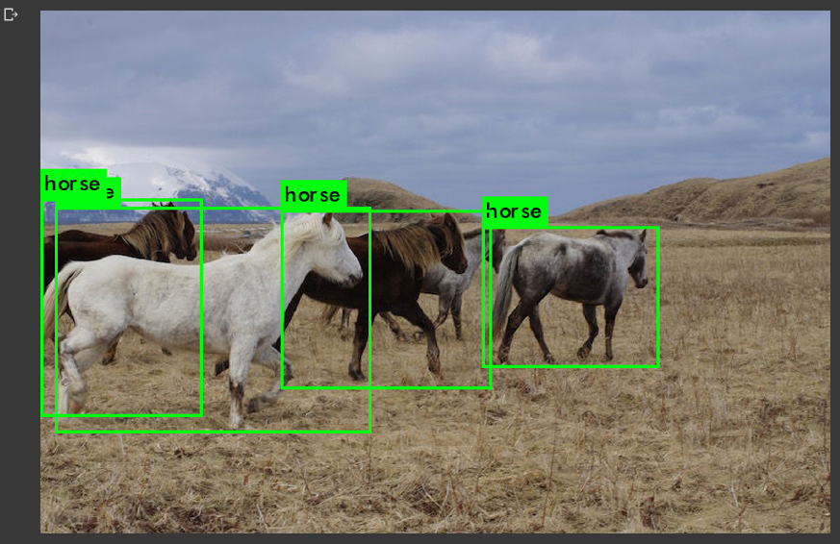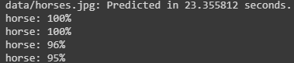

**Conclusion:**

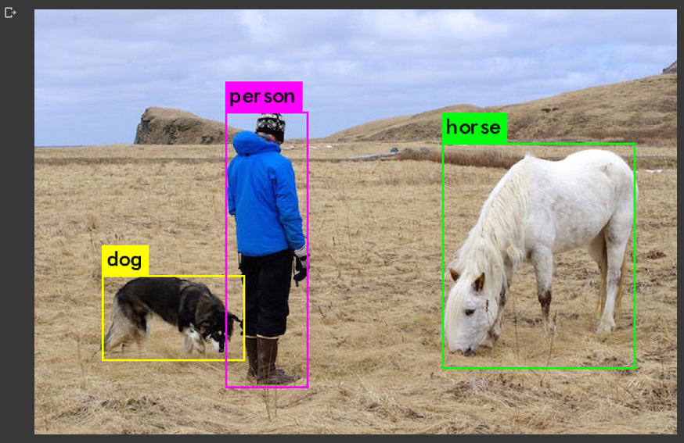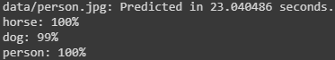

The predicted image by the model is as given above. It can successfully predict the objects such as person, horse & dog.

**Colab Sheet Link:**

<https://colab.research.google.com/drive/1aqKtHMLCpwh-9NHZjNhCYIST86G07jQD#scrollTo=wZcVbaqSHkh9>