Smart Mushroom Toxicity Analysis System
Project Report

Name – Aryan Gupta and Shashwat Rana

Registration No. – 23FE10CSE00284 and 23FE10CSE00101

Section – C

Subject – Machine Learning Lab

Faculty – Dr. Neelam Chaplot

- Introduction

The Smart Mushroom Toxicity Analysis System is a full-stack machine learning project built to estimate mushroom toxicity risk from observable mushroom traits. The central idea is simple: a user observes a mushroom in the field (for example, cap shape, odor, gill color, and habitat), enters those observations into a guided web form, and receives a structured risk output from a trained model. However, behind this simple user experience is a complete engineering pipeline that includes dataset ingestion, feature standardization, model training, model comparison, explainability logic, API orchestration, history storage, and frontend visualization.

This project was designed as a production-style system, not as a notebook-only experiment. Many machine learning projects stop after a model reaches good accuracy on a local script. In contrast, this system goes further: model artifacts are saved, inference is served through FastAPI endpoints, the UI is connected to live backend responses, and prediction history is stored in SQLite so results are auditable over time. This separation of concerns (frontend, backend, model services, data storage) reflects real software architecture patterns used in product environments.

A core project goal was to make model outputs understandable for first-time users. Instead of only returning a binary label, the system outputs: toxicity probability, normalized risk score (0-1 00), risk level bucket (Low/Medium/High), top influencing features, recommendations, and reliability warnings for rare-value inputs. This helps users understand both the decision and its confidence context. The platform also includes model switching and what-if simulation so users can compare how changes in traits affect the prediction. These features transform the system from a raw classifier into an educational decision-support interface.

Technically, the project uses a robust stack. The backend is built with FastAPI, Pydantic, scikit-learn, SHAP, and SQLAlchemy/SQLite. The frontend is built with Vite + React + TypeScript, with Tailwind CSS and shadcn/ui for clean interface design, plus Recharts for visual analytics. The model training script is modular and reproducible, using a saved metadata layer that powers both backend logic and frontend reporting. This architecture ensures consistency between offline training and online prediction.

From an academic perspective, this project demonstrates multiple competencies together: ML pipeline design, software API engineering, schema validation, feature explainability, user-centered UI/UX, and documentation discipline. It is suitable for portfolio demonstration, viva presentation, and mentor evaluation because each component is connected to real code and real data artifacts.

- Abstract

This project presents a complete machine learning web platform for mushroom toxicity estimation using structured morphological traits. The system ingests user-selected mushroom features and predicts the likelihood of toxicity, returning interpretable and actionable outputs. Unlike minimal ML demos, this platform integrates full lifecycle capabilities: dataset loading, preprocessing, multi-model training, evaluation, model serialization, inference API, frontend dashboards, what-if analysis, and prediction history persistence.

The machine learning core is trained on the OpenML/UCI mushroom dataset (8,124 records, 22 categorical input features). Target labels are mapped to binary toxicity classes (poisonous vs edible). The training pipeline applies category normalization, one-hot encoding through scikit-learn ColumnTransformer, and a stratified 80/20 train-test split. Five supervised models are trained and compared: Logistic Regression, Decision Tree, Random Forest, K-Nearest Neighbors, and Support Vector Machine. Evaluation metrics include Accuracy, Precision, Recall, F1 Score, and ROC-AUC. Trained pipelines are persisted as .joblib artifacts and accompanied by a metadata.json report containing model metrics, feature statistics, value frequencies, and target-rate distributions.

The inference service is implemented via FastAPI and typed request/response schemas in Pydantic. For each prediction request, the backend validates category codes, selects the active model, computes probability and score, generates explanations, and returns recommendations. Explainability is implemented using SHAP for tree-based estimators, with coefficient/importance and value-rate fallback strategies to ensure robust factor output across model types. A recommendation service applies rule logic based on observed feature risk patterns and probability bands. A warning module flags low-frequency input values to highlight reduced confidence conditions.

The frontend provides six user-facing views: overview, prediction dashboard, model comparison, what-if analysis, history, and about. It translates model outputs into simple language and visual components (gauge, bars, trend charts, tables). The system emphasizes transparency by exposing both model-level and sample-level insights.

This report explicitly distinguishes benchmark accuracy from guaranteed real-world certainty and proposes stronger future validation (cross-validation, grouped OOD splits, calibration, and external dataset checks). Overall, the project demonstrates a robust end-to-end ML application that balances technical depth, engineering quality, and user readability.

- Background Study
Mushroom toxicity classification is an important and challenging domain due to high visual similarity across edible and poisonous types. Traditional identification relies on expert mycology knowledge, local ecological context, and cautious field verification. In many practical scenarios, non-expert users may observe mushrooms without enough domain confidence, creating the need for educational support systems. Machine learning can assist by identifying statistical relationships between visible traits and toxicity labels.
From a machine learning perspective, this problem belongs to supervised binary classification over mostly categorical features. The UCI mushroom dataset has historically been used for studying category-encoded model behavior because it includes a rich set of symbolic descriptors such as cap structure, odor, gill spacing, stalk properties, ring type, and habitat. Since feature values are discrete and semantically meaningful, one-hot encoding is a natural preprocessing strategy that allows classical classifiers to model interactions effectively.
Model families used in this project represent different learning assumptions:
- Logistic Regression: linear decision boundary in transformed feature space; strong baseline and stable probabilities.
- Decision Tree: hierarchical rule splits; intuitive for path-style reasoning.
- Random Forest: ensemble of trees; robust against individual tree variance.
- KNN: instance-based local similarity; useful for neighborhood behavior.
- SVM (RBF): non-linear margin-based classifier; effective for separable transformed spaces.
Modern ML systems require explainability to improve trust and debugging. SHAP methods are widely adopted because they approximate local contribution of each feature to a prediction. However, SHAP compatibility can vary by model structure and runtime constraints. Therefore, robust systems often include fallback explanation layers (coefficients, importances, or statistical heuristics). This project adopts such a multi-tier explanation design for stability.
Validation strategy is another critical background topic. High score on one holdout split can occur when a dataset is highly structured or separable, but this does not automatically imply field robustness. Best practices include stratified cross-validation, grouped split testing for distribution shift, calibration analysis, and external-source evaluation. This project currently uses stratified holdout as the primary benchmark and documents future validation expansion explicitly.
Finally, software architecture background is equally important. Deployable ML systems must manage model files, metadata, API contracts, frontend integration, and data persistence. This project reflects that pattern through modular services (train.py, model service, route handlers, recommendation service, history service), making it closer to real product engineering than isolated model scripts.

- Methodology
The project methodology follows an end-to-end ML engineering lifecycle with explicit offline and online phases.

1) Data and Schema Preparation
The training process begins by loading the mushroom dataset from OpenML. Raw columns are mapped to canonical snake_case names for consistency across backend and frontend. A fixed feature list (22 fields) is enforced to prevent accidental schema drift. Target labels are transformed to binary integers: poisonous (p) as 1, edible (e) as 0. Feature values are normalized as trimmed strings.

2) Preprocessing Strategy
Since all active features in this project are categorical, preprocessing uses: missing-value imputation with most-frequent strategy, and one-hot encoding with unknown-category tolerance. This is implemented in scikit-learn ColumnTransformer and embedded directly in each model pipeline. By saving preprocessing together with the estimator, the same transformation logic is guaranteed during inference.

3) Training and Evaluation
The dataset is split using stratified train-test partitioning (80/20) to preserve class proportions. Five classifiers are trained under controlled hyperparameter settings. For each model: pipeline is fitted on training data, predictions and probabilities are generated on holdout data, metrics are computed (Accuracy, Precision, Recall, F1, ROC-AUC), and the trained pipeline is serialized to .joblib. The best model is selected by highest holdout accuracy in metadata.

4) Metadata Generation
After model training, the system generates metadata.json containing: dataset and feature overview, metric blocks for each model, best model name, feature statistics and descriptions, per-value target rates, and per-value frequencies. This metadata acts as a bridge between training, backend explainability, reliability warnings, and frontend presentation.

5) Inference Method
At API runtime: input payload is validated by Pydantic schema, model is selected via request query or configuration fallback, model pipeline computes toxicity probability, probability maps to risk score and risk level bucket, explanation logic returns top factors, rule engine returns recommendations, and frequency-based warnings are added for rare values. Final response is structured JSON consumed by frontend cards/charts.

6) Explainability Method
The project uses layered explainability: SHAP for tree-based models, coefficient/importance-based contributions where available, and metadata rate-delta fallback when required. This avoids missing explanations and ensures consistent user-facing outputs.

7) User-Facing Method
The frontend follows a human-readable approach: labeled feature groups and hints, model selector for comparative inference, generated plain-language mushroom description paragraph, risk summary visuals and factor table, what-if dual-profile comparison, and a history page with trend visualization. This methodology combines statistical rigor with user comprehension.

- Requirement Specifications
Functional Requirements
- Accept 22 mushroom feature inputs from user interface.
- Validate all category codes strictly before inference.
- Produce prediction output including probability, score, and level.
- Return feature-level explanation factors.
- Return recommendation and warning messages.
- Provide model performance endpoint and training summary endpoint.
- Support what-if analysis between baseline and modified inputs.
- Persist prediction history and expose history API.
- Support runtime model selection by query parameter.

Non-Functional Requirements
- Modular code structure for maintainability.
- Reproducible training workflow and saved artifacts.
- Clear separation of frontend and backend concerns.
- Typed API contracts and robust input validation.
- Human-readable UI text for non-developer users.
- Responsive layout and professional dashboard quality.
- Transparent outputs with explainability and warnings.

Performance and Reliability Requirements
- Load model artifacts at startup or auto-train if enabled.
- Return API responses quickly for single-row inference.
- Maintain schema stability between training and runtime.
- Prevent invalid category inputs from reaching model pipeline.
- Preserve prediction logs for auditability and trend tracking.
Security and Safety-Oriented Requirements
- CORS configuration for controlled frontend origins.
- Input validation through typed schemas.
- Explicit caution language in recommendation outputs.
- Reliability warning for low-frequency feature values.
- Clear messaging that model output is support, not absolute truth.

Technology Requirements
- Backend: Python, FastAPI, Pydantic, scikit-learn, SHAP, SQLite.
- Frontend: Vite, React, TypeScript, Tailwind, shadcn/ui, Recharts.
- Artifacts: .joblib model files and metadata.json.
- Configuration: environment variables for model behavior and training options.

Deployment Requirements
- Local development workflow with venv and npm.
- Optional Dockerized backend.
- Model artifacts mount and persistence.
- Training runnable independently of serving process.

- Proposed Framework
The proposed framework is a layered architecture where each service has a specific role and communicates via typed contracts. This design improves maintainability, debuggability, and extensibility.
Framework Components
- Frontend Layer – Collects user observations, validates form fields, and visualizes backend responses.
- API Layer (FastAPI Routes) – Handles request parsing, validation, and endpoint orchestration.
- Model Service Layer – Loads trained pipelines, runs inference, computes explainability factors.
- Recommendation Layer – Applies domain-informed rules for actionable user guidance.
- History Layer – Stores and retrieves prediction records from SQLite.
- Artifact Layer – Persists trained models and metadata generated by training pipeline.
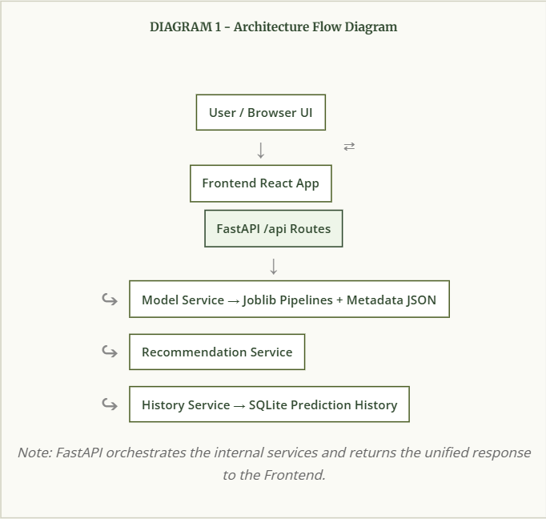

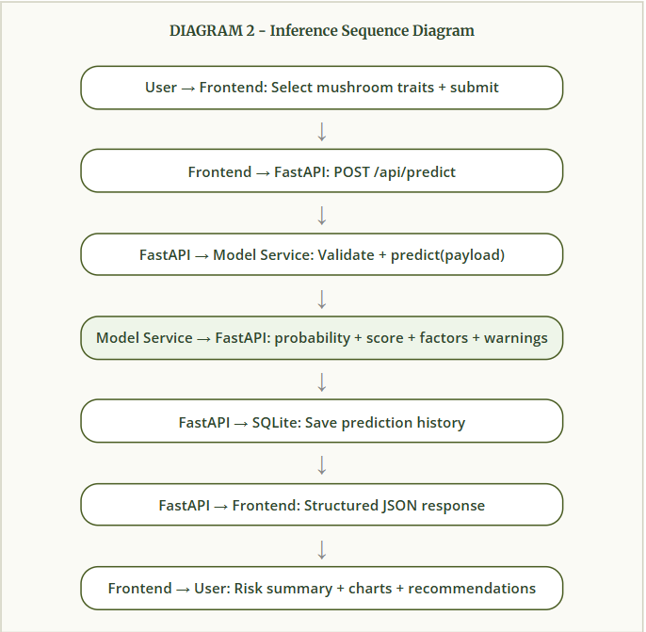
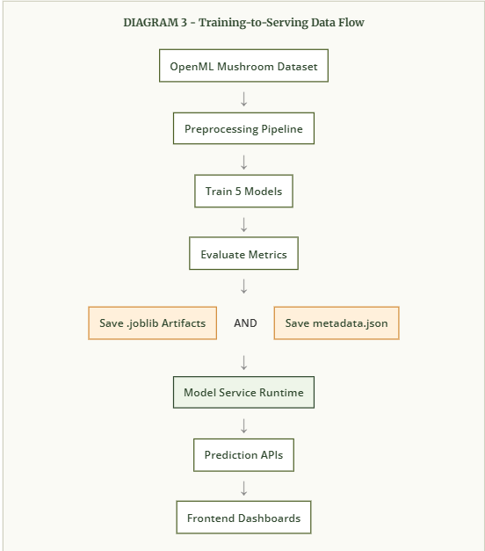
Framework Rationale
This framework was chosen because it supports: clear ownership of responsibilities, easier debugging (model, API, UI are separable), reusable components for future dataset extensions, explainability and recommendation hooks without changing model artifacts, and an audit trail through history persistence.

- Results
Dataset and Training Context
- Dataset source: OpenML Mushroom (UCI)
- Rows used: 8,124
- Input features: 22 categorical attributes
- Split: stratified 80% train / 20% test
- Models trained: Logistic Regression, Decision Tree, Random Forest, KNN, SVM

Metric Summary Table
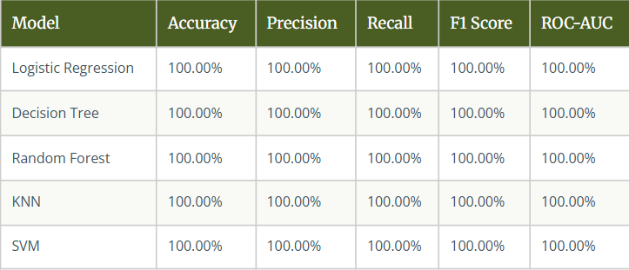

Interpretation
These results indicate very strong separability in the benchmark dataset under the current holdout split. This is not uncommon for this dataset family because some feature combinations are highly informative for class boundaries. However, these values must be interpreted responsibly: benchmark perfection on one split does not automatically imply real-world certainty under all ecological and observational conditions.

Product-Level Results
- End-to-end input-to-prediction pipeline is operational.
- Model switching at inference is functional.
- Explainability and recommendation outputs are integrated.
- What-if simulation is available and quantified by delta.
- Prediction history is persisted and visualized.
- UI language is simplified for non-technical usage.
Analytical Observations
- Metadata-driven warning logic helps surface low-frequency inputs.
- Explainability fallback ensures no blank factor output.
- API schema validation prevents invalid category payloads.
- System remains stable under repeated prediction requests.

- Conclusion
The Smart Mushroom Toxicity Analysis System successfully demonstrates a complete full-stack machine learning product with real training, real inference, and real user interaction. The project is not limited to model experimentation; it provides a reliable backend architecture, clean API contracts, explainability integration, user-focused frontend design, and persistent historical logging. This aligns well with the expectations of portfolio-grade and product-oriented ML engineering.

From a technical standpoint, the project confirms that classical ML pipelines can deliver strong performance on structured categorical datasets when preprocessing and schema control are implemented properly. The use of shared feature catalogs, saved metadata, and model artifacts creates consistency between offline training and online serving. This is a key property of robust ML systems and an important learning outcome of this project.

From a usability standpoint, the project moves beyond binary output by providing contextual interpretation: risk score, risk level, top factors, recommendations, and reliability warnings. This layered output significantly improves user trust and comprehension compared with plain labels. The addition of what-if analysis and model comparison supports both educational and analytical use cases.

At the same time, the conclusion remains balanced and responsible. High benchmark metrics in a structured dataset should not be interpreted as universal field certainty. The project explicitly communicates that outputs are decision support signals and should not replace expert identification or safety protocols for wild mushroom consumption.

Overall, this project achieves its core objective: build a connected, explainable, and deployable ML system with clear architecture and professional quality. It provides a strong base for future research enhancements and real-world robustness improvements.

- Future Scope
- Validation Expansion - Stratified K-fold cross-validation, grouped validation by ecological context, confidence interval reporting for metrics.
- Calibration and Threshold Engineering - probability calibration curves, Brier score analysis, threshold optimization for different safety policies.
- Dataset and Domain Expansion - integrate additional mushroom datasets from different sources, normalize schema across sources, evaluate performance under distribution shifts.
- Explainability Enhancement - richer local explanation visual components, confidence overlays for each factor, educational tooltips tied to biological trait meaning.
- MLOps and Product Hardening - model version registry, automated retraining/validation workflows, CI checks for API and inference regressions, cloud deployment with monitoring and logging.
- Human-in-the-Loop Safety Workflow - Add expert review mechanisms where uncertain or high-risk cases can be escalated for manual confirmation.

- References
- Bache, K., & Lichman, M. (2013). UCI Machine Learning Repository. University of California, Irvine.
- OpenML. Mushroom Dataset (Version 1). Retrieved from OpenML dataset catalog.
- Pedregosa, F., et al. (2011). Scikit-learn: Machine Learning in Python. JMLR, 12, 2825-2830.
- Lundberg, S. M., & Lee, S.-I. (2017). A Unified Approach to Interpreting Model Predictions (SHAP). NeurIPS.
- FastAPI Documentation. https://fastapi.tiangolo.com/
- Pydantic Documentation. https://docs.pydantic.dev/
- scikit-learn Documentation. https://scikit-learn.org/stable/
- React Documentation. https://react.dev/
- TanStack Query Documentation. https://tanstack.com/query/latest
- SQLite Documentation. https://www.sqlite.org/docs.html

