Title : Comparative Performance Evaluation of COVID Research Search
Students Name | Registration No. | Email-id
Aryan Gupta | 23FE10CSE00284 | ARYAN.23FE10CSE00284@MUJ.MANIPAL.EDU
Shashwat Rana | 23FE10CSE00101 | SHASHWAT.23FE10CSE00101@MUJ.MANIPAL.EDU
Rudra Pratap Singh | 23FE10CSE00469 | RUDRA.23FE10CSE00469@MUJ.MANIPAL.EDU

Abstract — This project implements Project 7, COVID Research Search, using the BEIR TREC-COVID / CORD-19 collection. We compare cosine-normalized TF-IDF, BM25, Sentence Transformer retrieval with all-MiniLM-L6-v2, and Hybrid Reciprocal Rank Fusion (RRF). The local experiment indexes 20,000 of 171,332 corpus records and evaluates all 50 judged queries against the original relevance judgments. Performance is measured using Precision@10, Recall@100, full-ranking Mean Average Precision (MAP), and nDCG@10, with a four-model Precision–Recall graph. BM25 achieves the highest Precision@10, MAP, and nDCG@10, while RRF achieves the highest Recall@100. The findings demonstrate complementary ranking behavior rather than a universal advantage for hybrid fusion. The interactive application supports model selection, ranked papers, cross-model rank evidence, and downloadable experiment results. Because the index is a corpus subset, missing relevant papers remain in evaluation denominators; the reported values are subset measurements rather than full-corpus benchmark scores.
Keywords: Information Retrieval · COVID Research Search · TREC-COVID · BM25 · Sentence Transformers · Hybrid RRF
1. Introduction
Scientific research produced during an outbreak can be difficult to navigate because useful findings are distributed across many papers. Project 7 addresses this retrieval problem by indexing COVID-19 and coronavirus research records from TREC-COVID / CORD-19. A user enters a research question, selects a retrieval method, and inspects ranked source documents. The system retrieves papers; it does not generate medical advice or infer that every retrieved result is relevant [1, 2].
Our objective is to compare three distinct ranking methods and their fusion within one reproducible pipeline. TF-IDF and BM25 use lexical evidence, while the Sentence Transformer scores learned semantic representations. RRF combines rank positions without requiring the raw scores to share a scale. Relevance judgments allow this comparison to be measured rather than inferred from a visually convincing search result.
The frontend is implemented with React and Vite, while FastAPI serves indexing, search, and evaluation. Figure 1 shows the working application with a query, retrieval controls, ranked papers, and the comparison table. Scores and rankings come from the backend rather than static examples.

Figure 1. Live COVID Research Search interface with Hybrid RRF results and model comparison.
2. About Dataset
2.1 Dataset visualization and example
The project uses the BEIR-formatted TREC-COVID collection derived from CORD-19. Corpus records provide identifiers, titles, and abstract text; query records provide research questions; qrels associate queries and documents with graded relevance labels. Positive labels define relevance for binary metrics, while nDCG uses the grades themselves. The official TREC-COVID resources describe the topics and relevance judgments used for scientific retrieval evaluation [1, 2].
Table 1 summarizes the actual loaded data. The first 20,000 source-order records are indexed for a local demonstration. This selection does not use qrels, but it is not random and may be unrepresentative of the full collection.
Table 1. Dataset and evaluation scope of the implemented experiment.
Dataset component | Actual experiment
Available corpus records | 171,332
Indexed records | 20,000 (11.67% of the corpus)
Research queries evaluated | 50 of 50
Queries with a relevant indexed paper | 47
Queries with no relevant indexed paper | 3; retained with zero retrieval scores
Retrieval fields | Title and abstract text
Judgments | Original test qrels
2.2 Example search record
For the query “coronavirus transmission in children”, the current Hybrid RRF ranking returns “Laboratory-Confirmed Human Coronavirus Infections Among Children: Does Type Matter?” first. Its cross-model positions are TF-IDF #7, BM25 #2, and dense #1, with an RRF score of 0.04745. These values illustrate how a strong result in more than one ranker can rise in the fused list; this example is separate from the aggregate judged-query evaluation.
2.3 Coverage and interpretation
Original judgments are not reduced to papers present in the subset. Relevant papers outside the index remain in recall and average-precision denominators and in the ideal nDCG ranking. All 50 queries participate, including the three with no relevant indexed paper. This prevents overstating coverage by discarding difficult queries or missing relevant documents. A separate full-corpus run is supported by setting IR_MAX_DOCS=0 and regenerating the embeddings and results.
3. Methodology
The pipeline separates lexical preprocessing from natural-language encoding. TF-IDF and BM25 operate on a shared inverted index, while MiniLM searches document embeddings independently. The complete rankings then feed RRF. Figure 2 summarizes the implemented data paths from the research query to ranked papers.
[ Research question / User query ]
|
+-------------+----------------+
| |
[ Lexical query ] [ Raw query ]
Cleaning / tokens / stems MiniLM encoder
| |
Inverted postings Normalized vector
TF-IDF cosine + BM25 All document vectors
| |
[ Complete sparse lists ] [ Complete dense list ]
+-------------+----------------+
|
[ Reciprocal Rank Fusion, k = 60 ]
|
[ Ranked papers / Scores / Evidence ]
Figure 2. Independent sparse and dense retrieval followed by complete-list RRF.
3.1 Preprocessing and Indexing
Lexical text is lowercased, tokenized with a regular expression, filtered by an English stop-word list, and processed by a simple suffix-removal stemmer. Internal digits and hyphens are retained for scientific terms; tokens shorter than three characters are omitted. The same operations are applied to lexical queries. This is a custom stemmer, not the Porter algorithm. Raw text is retained for display and transformer input.
For each document, the backend stores a term-frequency counter and document length. Posting lists map terms to document positions and frequencies, while document-frequency counts provide IDF statistics. The dense index stores one normalized 384-dimensional vector per indexed title and abstract. Figure 3 shows the actual controls used to select the four ranking modes.
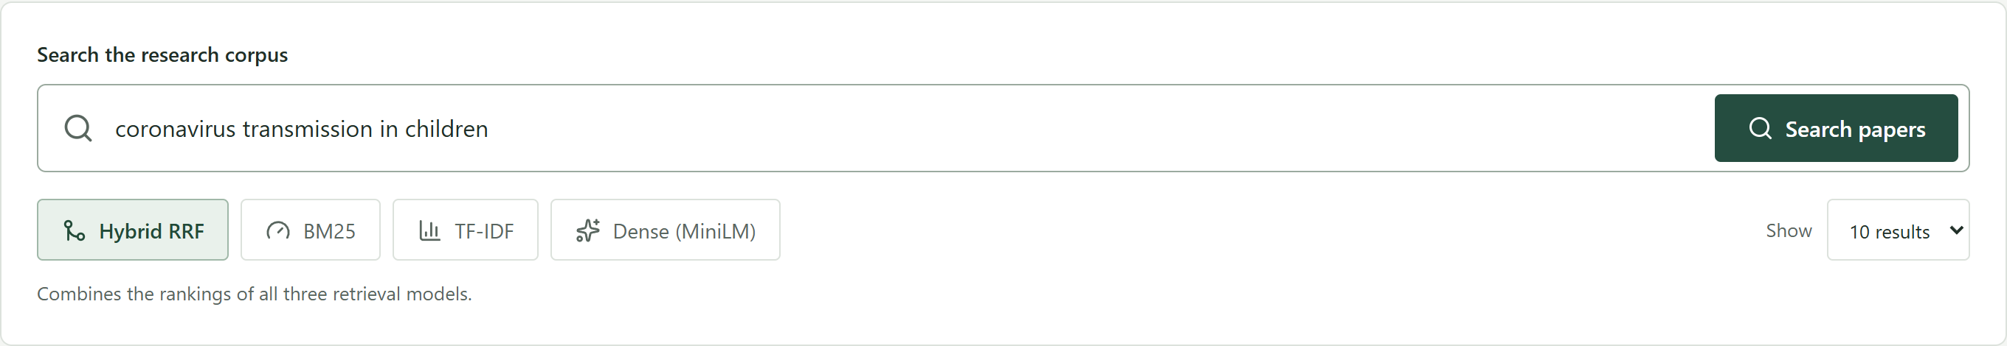
Figure 3. Search command, model selection, and result-limit controls in the application.
3.2 Ranking Models
The following models use the same indexed documents and research questions. Sparse and dense scores are not directly comparable; comparison is based on judged retrieval metrics and rank evidence.
- TF-IDF Vector Space Model: We use sublinear term frequency, 1 + ln(tf), and smoothed IDF, ln((1 + N)/(1 + df)) + 1. Query-document dot products are divided by both vector norms to obtain cosine similarity. The convention matches sublinear TF with L2 normalization in TfidfTransformer. All papers matching an indexed query term participate in the returned sparse ranking [7].
- Okapi BM25: BM25 uses k1=1.5 and b=0.75 with term-frequency saturation and document-length normalization. Its positive IDF is ln(1 + (N − df + 0.5)/(df + 0.5)). Term contributions are summed over query occurrences. BM25 and TF-IDF deliberately use separate IDF definitions [3].
- Sentence Transformer Dense Search: all-MiniLM-L6-v2 encodes raw titles and abstracts into normalized 384-dimensional vectors. Inputs are truncated by the tokenizer at 256 tokens. Every indexed paper is scored by cosine similarity, independently of sparse candidates. The pretrained model is used without fine-tuning on test judgments [4, 6].
- Hybrid Reciprocal Rank Fusion: Complete TF-IDF, BM25, and dense lists are fused using one-based rank positions. This combines lexical and semantic ranking evidence without averaging incompatible model scores [5].
3.3 Reciprocal Rank Fusion Formulation
For document d and the three rankers M, the fused score is:
RRF(d) = Σ[m ∈ M] 1 / (60 + rank_m(d))
A missing document contributes zero for that ranker. Scores are sorted in descending order and ties are resolved by corpus order. The interface displays the first 10, 20, or 50 papers, but MAP uses complete returned rankings. Sparse lists contain all matching papers; dense ranking contains all 20,000 indexed papers.
3.4 Implementation and model provenance
The encoder is pinned to revision 1110a243fdf4706b3f48f1d95db1a4f5529b4d41. CPU batches produce content-identified NumPy caches, with checkpoints every 256 papers for resumable indexing. Normal startup requires the real transformer. A separately invoked lightweight demo is explicitly labeled and is not used for this experiment. The evaluation artifact records model identity, scope, per-query scores, and experiment ID for reproducibility.
3.5 Implementation verification
Ten reference tests verify the ranking formulas, original-qrels denominators, full-ranking AP, and interpolation. Playwright checks cover live search, model controls, downloads, recovery, and five screen sizes. These checks validate implementation behavior; they do not establish statistical significance between models.
3.6 Worked query and fusion example
Consider the application query “coronavirus transmission in children”. The lexical path removes the stop word “in” and applies the project’s suffix rules, producing coronaviru, transmission, and children. The removal of the final s in coronavirus illustrates a limitation of simple stemming: the resulting token need not be a dictionary word. Consistent processing of queries and documents nevertheless allows the same surface form to match in the inverted index.
The semantic path receives the original natural-language query, including its word order. MiniLM encodes this text and compares its normalized vector against every indexed document vector. It therefore supplies an independent ranking rather than reranking only documents already selected by TF-IDF or BM25.
The exported first result is “Laboratory-Confirmed Human Coronavirus Infections Among Children: Does Type Matter?”. Table 2 reconstructs its fusion score directly from the recorded rank evidence. Each ranker has equal weight; a better position gives a larger reciprocal contribution.
Table 2. Reconstruction of the first result’s Hybrid RRF score.
Ranking source | Position | 60 + position | Contribution
TF-IDF cosine | 7 | 67 | 0.01492537
BM25 | 2 | 62 | 0.01612903
Sentence Transformer | 1 | 61 | 0.01639344
Combined RRF score | — | — | 0.04744785
Adding the three contributions gives 0.04744785, displayed as 0.04745 in the application. The calculation uses positions rather than the original cosine or BM25 scores. It explains why a paper that is seventh in one list can still lead the fused ranking when the other two methods place it near the top.
3.7 Reading the result evidence
The result title, source link, snippet, and model positions allow a user to inspect the returned paper and compare ranking behavior. The RRF score is a ranking value, not a probability of relevance. A convincing title or high score alone cannot establish a correct scientific answer. This worked example demonstrates the mechanics of retrieval; the separate judged-query experiment assesses effectiveness across the benchmark topics.
4. Experimental Setup and Performance Analysis
We evaluate the four models on the same 20,000-paper index using all 50 judged queries and original qrels. The experiment was generated on 3 November 2026 and has identifier 024ac8ffbc9b667bf50f. No test judgments are used to select documents or tune model weights. The Sentence Transformer is the actual MiniLM model, not the deterministic demo fallback.
4.1 Evaluation metrics
Precision@10 is relevant hits in the first ten divided by ten. Recall@100 is relevant hits in the first hundred divided by all judged relevant documents. Average precision sums precision at each relevant hit in the complete returned ranking and divides by the original number of relevant documents; MAP is its mean across queries. Thus MAP includes hits beyond rank 100.
nDCG@10 uses graded gain 2^relevance − 1, discounted by log2(rank + 1), and is normalized by the ideal top-ten ranking from original judgments. Missing relevant papers remain in the ideal ranking. Queries with no retrieved relevant document contribute zero to all metrics.
Table 3. Measured model comparison for the 20,000-paper subset; bold values mark column maxima.
Ranking Model | Precision@10 | Recall@100 | MAP | nDCG@10
TF-IDF | 0.058000 | 0.003222 | 0.001220 | 0.051184
BM25 | 0.100000 | 0.005501 | 0.001890 | 0.072378
Sentence Transformer | 0.080000 | 0.005382 | 0.001742 | 0.070707
Hybrid RRF | 0.080000 | 0.005742 | 0.001826 | 0.068359
4.2 Performance interpretation
BM25 leads in Precision@10 (0.100000), MAP (0.001890), and nDCG@10 (0.072378). Hybrid RRF leads in Recall@100 (0.005742), exceeding BM25’s 0.005501 by 0.000241, approximately 4.38% relative to the rounded exported values. RRF’s MAP is about 3.39% below BM25. These results do not support a claim that fusion improves every metric.
Small recall and MAP values are meaningful here: the denominator includes relevant documents across the original collection, while only 11.67% of corpus records are searchable. The source-order subset also has limited relevance coverage. These results describe the declared subset and should not be compared as if they were full-corpus benchmark scores.
4.3 Precision–Recall graph
Figure 4 plots recall on the horizontal axis and interpolated precision on the vertical axis for all four models. For each query and recall level r, interpolated precision is the maximum precision at a retrieved prefix reaching at least r. If no prefix reaches the threshold, that query contributes zero. Results are macro-averaged at eleven recall levels from zero to one.
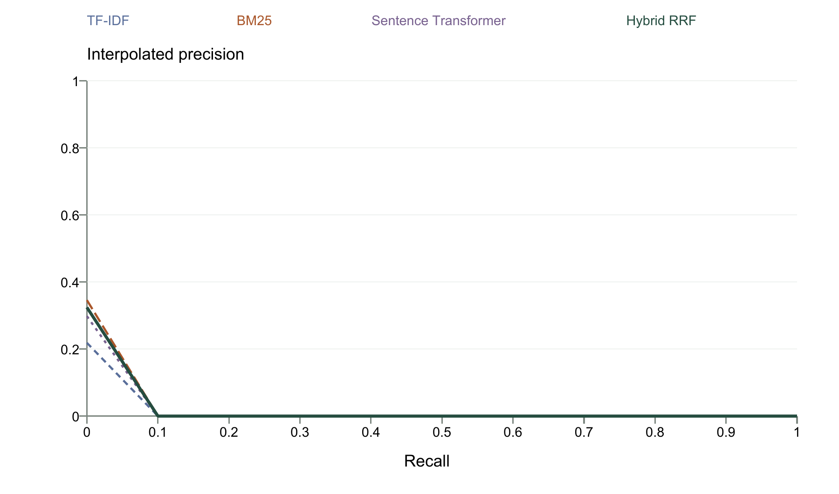
Figure 4. Macro-averaged 11-point interpolated Precision–Recall comparison from the exported experiment.
At recall level zero, BM25 has the largest interpolated precision (0.345857), followed by RRF (0.324137), the Sentence Transformer (0.297973), and TF-IDF (0.218411). This point represents each query’s best precision at a retrieved prefix; it does not describe a search returning no documents.
All four curves are zero at recall thresholds of 0.1 and above. The indexed subset cannot reach those thresholds under the original relevance denominators, so the graph should not be interpreted as evidence of high-recall retrieval. An index covering more of the collection and a finer recall grid would support a more informative follow-up comparison.
4.4 Reproducibility and verification
The experiment directory stores evaluation.json, score and PR CSV files, status, and an example search. Aggregate scores match the per-query means. The report and application use the same experiment. Caches identify their implementation and inputs; changed scope or model settings require new results. Lightweight-demo scores remain separate.
4.5 Query coverage and error analysis
Aggregate scores combine ranking quality with the availability of relevant documents. To separate these effects, Table 4 compares the original number of judged relevant papers with those present in the index for five topics and one zero-coverage topic. The final column is the maximum possible recall over the selected index: relevant indexed papers divided by all judged relevant papers. It is a coverage bound, not an achieved model score.
Table 4. Selected query-level coverage and maximum attainable recall.
Topic ID | Relevant in qrels | Relevant in index | Recall ceiling
1 | 644 | 15 | 2.33%
2 | 317 | 11 | 3.47%
3 | 635 | 20 | 3.15%
4 | 540 | 3 | 0.56%
5 | 618 | 6 | 0.97%
24 | 408 | 0 | 0.00%
For topic 1, even a ranking that finds all 15 indexed relevant papers reaches only 15/644, or 2.33% recall. Topic 24 has 408 judged relevant papers but none in the selected index; every retrieval method must therefore score zero on its relevance-based metrics. Topics 32 and 49 also have no indexed relevant papers. Keeping these topics in the evaluation makes the coverage limitation visible.
Across all 50 queries, the mean attainable recall is 1.86%. The index contains 428 of 24,920 positive query–document judgment pairs, approximately 1.72%; these pairs can include the same document for different queries. This pooled percentage differs from the mean per-query ceiling because the two calculations weight topics differently. Neither is the 11.67% fraction of corpus records indexed.
4.6 Failure modes and follow-up experiments
Missing relevant documents cannot be recovered by changing a ranker on the same index. Among available documents, ranking errors may instead reflect vocabulary mismatch, overly simple stemming, broad semantic similarity, or lost abstract content beyond the encoder’s token limit. These are plausible explanations to investigate, not measured causal findings from the current aggregate scores.
A follow-up should first expand corpus coverage and regenerate all four rankings under the same qrels. Controlled comparisons can then vary one factor at a time, such as stemming or the encoder. Per-query differences and source-paper inspection would help distinguish real retrieval gains from changes in coverage. Timing, memory, and statistical significance require additional measurements before making efficiency or reliability claims.
5. Conclusion
We built a working COVID research search engine aligned with Project 7. It implements preprocessing, epidemic-corpus indexing, TF-IDF cosine retrieval, BM25, independent Sentence Transformer retrieval, and Hybrid RRF. The application provides ranked papers, source links, cross-model positions, a comparison table, a Precision–Recall graph, and downloadable results. Its experiment evaluates all 50 judged queries with original relevance judgments.
BM25 performs best on Precision@10, MAP, and nDCG@10 in the measured subset, while RRF retrieves slightly more judged relevant material within the first hundred results. Fusion is therefore useful as an alternative ranking strategy rather than an automatic replacement for the strongest baseline. The final choice depends on the evaluation objective.
The main limitations are incomplete corpus coverage, source-order sampling, a general-purpose pretrained encoder, simple suffix stemming, and truncation of dense input at 256 tokens. Future work should evaluate the full corpus, compare biomedical encoders and stronger preprocessing, and measure latency and memory systematically. Such changes should be assessed as separate experiments rather than used to reinterpret the present scores.
References
1. NIST. TREC-COVID Data and Evaluation Resources. https://ir.nist.gov/trec-covid/data.html (accessed 3 November 2026).
2. BEIR project. TREC-COVID dataset distribution. https://public.ukp.informatik.tu-darmstadt.de/thakur/BEIR/datasets/trec-covid-beir.zip
3. Robertson, S., Zaragoza, H. The Probabilistic Relevance Framework: BM25 and Beyond. Foundations and Trends in Information Retrieval 3(4), 333–389 (2009).
4. Reimers, N., Gurevych, I. Sentence-BERT: Sentence Embeddings using Siamese BERT-Networks. EMNLP-IJCNLP, 3982–3992 (2019).
5. Cormack, G. V., Clarke, C. L. A., Buettcher, S. Reciprocal Rank Fusion outperforms Condorcet and individual Rank Learning Methods. SIGIR, 758–759 (2009).
6. Sentence Transformers. all-MiniLM-L6-v2 model card. https://huggingface.co/sentence-transformers/all-MiniLM-L6-v2
7. Scikit-learn. TfidfTransformer documentation. https://scikit-learn.org/stable/modules/generated/sklearn.feature_extraction.text.TfidfTransformer.html

