Citrix Test Automation Runner
User Guide, How-To Kit, and Operational Reference
Version 2.0.0 | Generated 26 Jun 2026
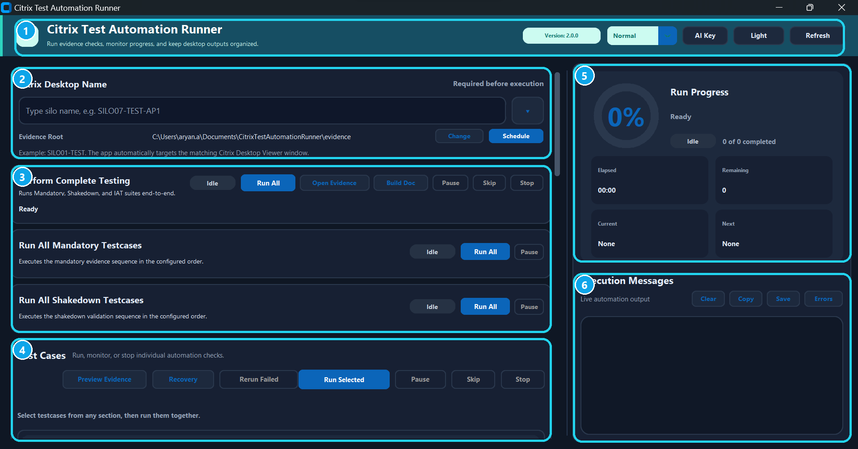
Figure 1: Main application areas and control groups.
Callout | Area | What It Covers
1 | Header | Version, runtime mode, AI Key, Light/Dark theme, and Refresh.
2 | Desktop configuration | Citrix Desktop Name, recent dropdown, Evidence Root, Change, and Schedule.
3 | Suite cards | Complete Testing, Mandatory, and Shakedown run controls.
4 | Testcase actions | Preview Evidence, Recovery, Rerun Failed, Run Selected, Pause, Skip, and Stop.
5 | Run Progress | Percent complete, elapsed time, remaining count, current testcase, and next testcase.
6 | Execution Messages | Live logs plus Clear, Copy, Save, and Errors tools.

1. Executive Overview
Citrix Test Automation Runner is an internal Windows desktop tool for running Citrix evidence checks, capturing desktop-scoped screenshots, validating evidence, and generating Word reports for client or internal review. It is designed for repeatable testing across TEST, RING0, Silo 43, shakedown, IAT, and post-complete Zscaler flows.
- Runs full Complete Testing or smaller mandatory, shakedown, selected, and individual testcase flows.
- Captures screenshots with Silo and Hostname overlays so evidence remains attributable.
- Stores screenshots, logs, reports, and manifest files under desktop-specific evidence folders.
- Uses OCR validation first and OpenAI Vision fallback only when configured and required.
- Supports pause, skip, stop, rerun failed, evidence preview, failed-test recovery, custom evidence root, and scheduled desktop lists.
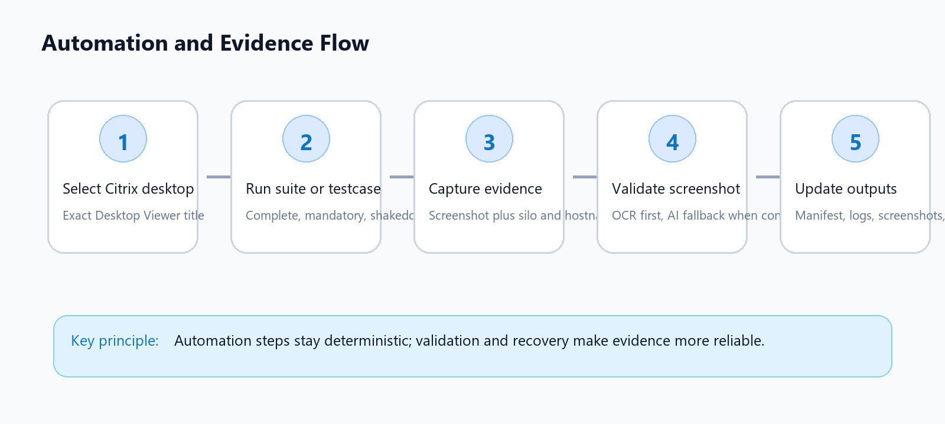
Figure 2: High-level automation and evidence lifecycle.

2. UI Walkthrough

Header Controls
Header controls: version, runtime mode, AI Key, theme toggle, and Refresh.
Control | Purpose | Keep In Mind
Version | Shows the packaged application version. | Use this when reporting issues or confirming release level.
Normal / mode selector | Controls runtime mode exposed by the app. | Keep Normal for standard testing unless a specific mode is requested.
AI Key | Opens masked OpenAI API key management for AI fallback validation. | The key is stored locally under the Windows user profile, not in the repo or ZIP.
Light / Dark | Switches the app theme. | Does not affect automation behavior.
Refresh | Refreshes UI state, desktop lists, and execution message display. | Use after reruns or if the UI looks stale.

Desktop Configuration Card
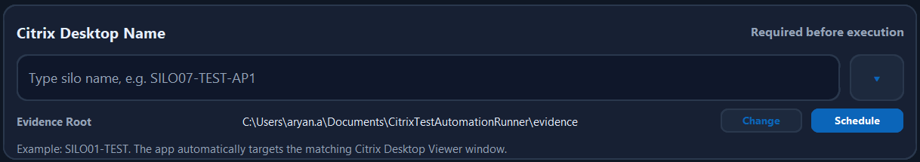
Desktop configuration: target desktop, dropdown, evidence root, Change, and Schedule.
- Enter the exact Citrix Desktop Viewer window title, for example: SILO01-TEST - Desktop Viewer.
- Use the dropdown for recent desktop names, then edit manually if the title changed.
- Evidence Root controls where screenshots, logs, manifests, and reports are stored.
- Change lets an operator choose another evidence root, such as Downloads or a project folder.
- Schedule is available for multiple desktops, but only use it when all target Citrix sessions remain logged in and active.

Suite Cards
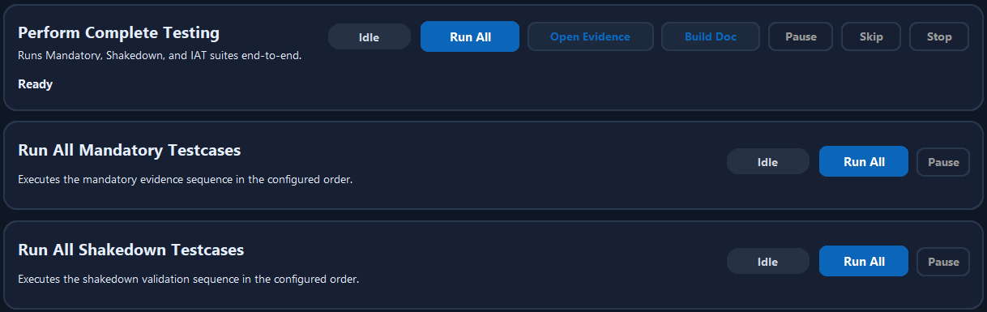
Suite cards for Complete Testing, Mandatory, and Shakedown runs.
Button | Use For | Behavior
Run All - Complete Testing | Full evidence run. | Runs mandatory, conditional Silo 43, shakedown, IAT, and post-complete steps as applicable.
Open Evidence | Quick navigation. | Opens the latest desktop-specific evidence location.
Build Doc | Report regeneration. | Rebuilds the Word report from the latest manifest and screenshots.
Pause | Temporary hold. | Pauses cooperative run flow where supported.
Skip | Move past current testcase. | Useful when a known external blocker exists.
Stop | Immediate operator stop. | Requests cooperative cancellation without force-killing the app.

Testcase Actions
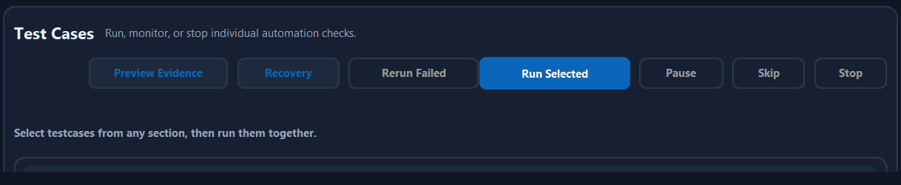
Testcase-level actions: preview, recovery, rerun failed, selected run, pause, skip, stop.
- Preview Evidence opens a visual review panel for the latest screenshots and manifest entries.
- Recovery focuses on failed/manual items and helps rerun the exact failed testcase instead of the entire suite.
- Rerun Failed is useful after a report is generated and only specific evidence needs correction.
- Run Selected supports running a custom mix of mandatory, shakedown, IAT, and Silo 43 items.
- Individual testcase buttons preserve standalone behavior and do not depend on grouped Complete Testing optimizations.

Run Monitor and Execution Messages
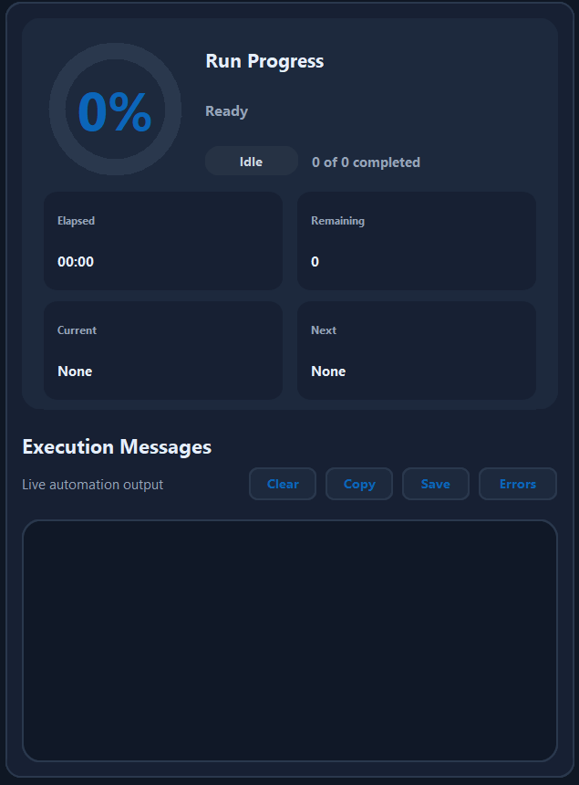
Right-side run monitor, progress metrics, execution messages, and log tools.
- Run Progress shows percentage, suite state, completed count, elapsed time, remaining count, current testcase, and next testcase.
- Execution Messages are live automation logs. They are the first place to check when a testcase fails.
- Clear clears visible UI logs only; it does not delete saved log files.
- Copy copies the visible log text for chat or ticket updates.
- Save writes UI execution messages into the current evidence logs folder.
- Errors filters or highlights error-focused output when troubleshooting.

3. How-To Kit

Install and Launch
- Download the approved release ZIP from the internal share location.
- Extract it locally, recommended: C:\Users\<user>\Documents\CitrixTestAutomationRunner.
- Open the extracted folder and launch CitrixTestAutomationRunner.exe.
- Do not run the EXE directly from inside the ZIP file.

Run Complete Testing
- Open the required Citrix Desktop Viewer session and keep it signed in.
- Copy the exact Desktop Viewer title into Citrix Desktop Name.
- Confirm Evidence Root is correct.
- Click Run All under Perform Complete Testing.
- Avoid interacting with the Citrix session while automation is running.
- Watch Run Progress and Execution Messages until the completion dialog appears.
- Use Download Report or Build Doc to generate the final evidence report if needed.

Run Selected or Rerun Failed
- Expand the required testcase section.
- Select one or more testcase checkboxes.
- Click Run Selected to execute only those items.
- For already failed runs, use Recovery or Rerun Failed so the report and manifest can be refreshed.
- After rerun, use Build Doc if a Word report already exists and needs to reflect the corrected result.

Configure AI Key
- Click AI Key in the header.
- Paste the OpenAI API key into the masked input.
- Click Test Key to confirm connectivity.
- Click Save Key to store it locally for the current Windows user.
- Use Clear Saved if the key is expired or should be removed from that laptop.
The saved key lives at %APPDATA%\CitrixTestAutomationRunner\openai_settings.json. The app never commits it to the repository or packages it inside the release ZIP.

4. Evidence and Report Output
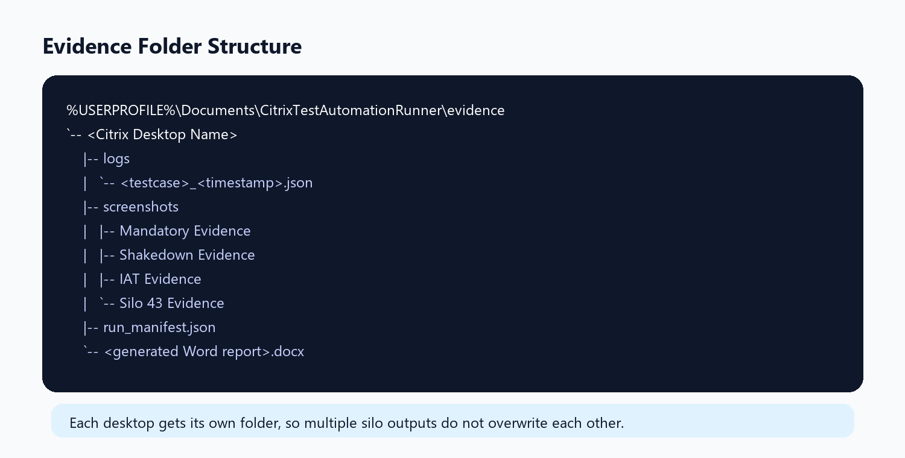
Desktop-scoped evidence output structure.
Artifact | What It Contains | When To Share
Screenshots | Pass/fail evidence PNGs with overlay. | Share for manual validation or report support.
JSON logs | Step-by-step automation status, failures, and validation messages. | Share when troubleshooting a failed testcase.
run_manifest.json | Latest known testcase status and artifact mapping. | Use when report status looks stale.
Word report | Client-friendly evidence report generated from latest valid screenshots. | Share as final evidence package.
UI execution log | Visible app execution messages saved on demand. | Share for quick timeline review.

5. Test Suite Reference
Suite | Purpose | Notes
Mandatory | Core evidence required for most desktop validation. | Includes hostname/IP, Edge/WebView version, Zscaler, browser access, PowerPoint launch, Applist where applicable.
Shakedown | Desktop health checks after base mandatory validation. | Includes Windows, OneDrive, temp folder, local network drives, Edge policy/sync, FSLogix and related checks.
IAT | IAT core application validation. | Runs as part of Complete Testing where configured.
Post-complete Zscaler | Confirms Zscaler state after main testing. | Independently recoverable and rerunnable if it fails after other tests pass.
Silo 43 | Silo 43 only checks. | Oracle PATH, NICE variables, VLS warning, ping prod.dvfs.com, BAD folder date validation.

6. Validation Model
- OCR validation is attempted first because it is local and faster.
- AI fallback is used only if OCR is inconclusive and an API key is configured.
- Some tests retry capture or relaunch the target window once before saving fail evidence.
- Hostname/IP evidence can use AI-extracted hostname to correct Unknown overlays when OCR cannot read the hostname reliably.
- Validation results are logged so operators can see whether OCR, AI, retry, or manual review was involved.

7. Things To Keep In Mind
- Keep the target Citrix Desktop Viewer session open, signed in, and visible before starting a run.
- Do not type, click, resize, or switch windows inside the Citrix session during automation.
- Use exact desktop names. A small mismatch can cause automation to run locally instead of inside Citrix.
- If a report exists and a testcase is rerun, refresh or rebuild the report before sharing it.
- Silo 43 tests should only be executed against Silo 43 desktops; the app blocks them for other desktops.
- Scheduled multiple-desktop testing only works reliably when the other sessions do not log out while idle.
- If OpenAI calls fail on corporate network, the app should preserve the screenshot and logs for manual review.
- Always share the latest JSON log and screenshot path when escalating an issue.

8. Troubleshooting Quick Reference
Symptom | Likely Cause | Action
App opens but automation runs on local PC | Desktop name does not match active Citrix window. | Copy the exact Desktop Viewer title and retry.
Screenshot looks early or blank | Citrix page/app did not finish rendering. | Rerun the specific testcase; check logs for wait/retry messages.
AI validation unavailable | No key, expired key, proxy/firewall issue, or TLS reset. | Use AI Key > Test Key; fall back to OCR/manual review if blocked.
Word report status looks stale | Rerun occurred after report generation. | Click Build Doc to regenerate from the latest manifest.
Zscaler post-complete failed | ZCCVDI not visible, not healthy, or screenshot capture failed. | Use Recovery to rerun only Zscaler_Services_Evidence_Post_Complete.
Silo 43 Oracle/NICE false fail | OCR misread path text. | Rerun after latest OCR normalization changes; review latest screenshot and log.

9. Support Package To Share
- Citrix Desktop Name used for the run.
- App version shown in the header.
- Latest Word report path.
- Latest JSON log path for the failed testcase or suite.
- Screenshot path for the failed or manually reviewed evidence.
- A short note on whether OCR, AI fallback, retry, or manual intervention was involved.

