IMPLEMENTATION OF LOAD BALANCER ON MICROSOFT AZURE
Name: Aryan Jamwal
Course: MCA – Cloud Computing & Dev ops

1. Introduction
Cloud computing provides scalable and highly available infrastructure. In this project, Microsoft Azure Load Balancer is used to distribute incoming HTTP traffic across multiple virtual machines to achieve high availability and fault tolerance.

2. Objective
- To create multiple Azure Virtual Machines
- To configure Apache Web Server
- To implement Azure Load Balancer
- To test traffic distribution between virtual machines

3. Architecture Overview
The architecture consists of two backend Ubuntu virtual machines running Apache Web Server. An Azure Standard Load Balancer is used to distribute incoming HTTP traffic across both virtual machines based on health probes.

4. Implementation Steps
- Created Resource Group in Azure Portal
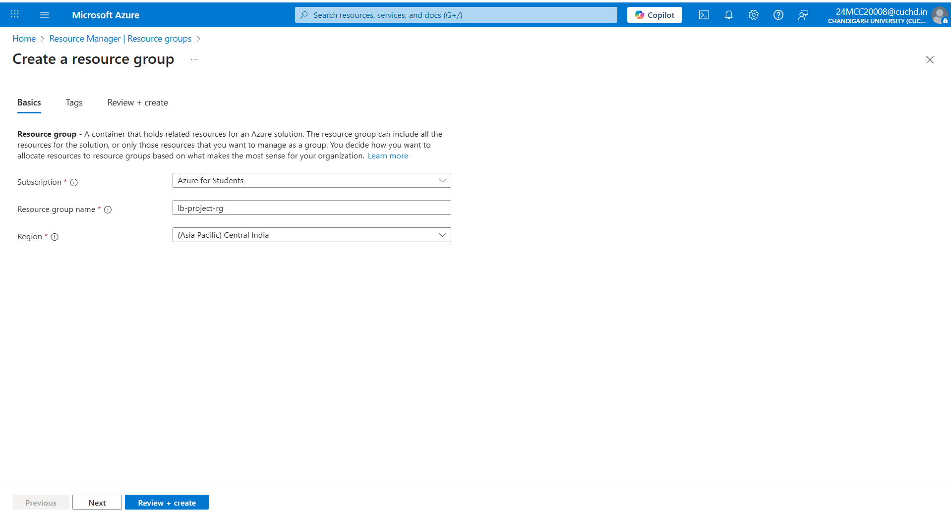
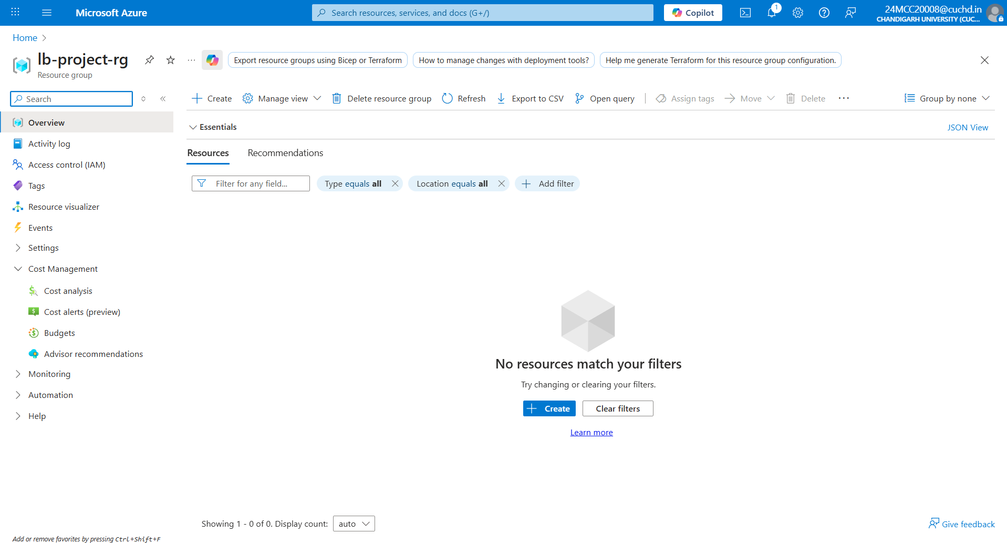
- Created two Ubuntu Virtual Machines (webvm1 and webvm2)
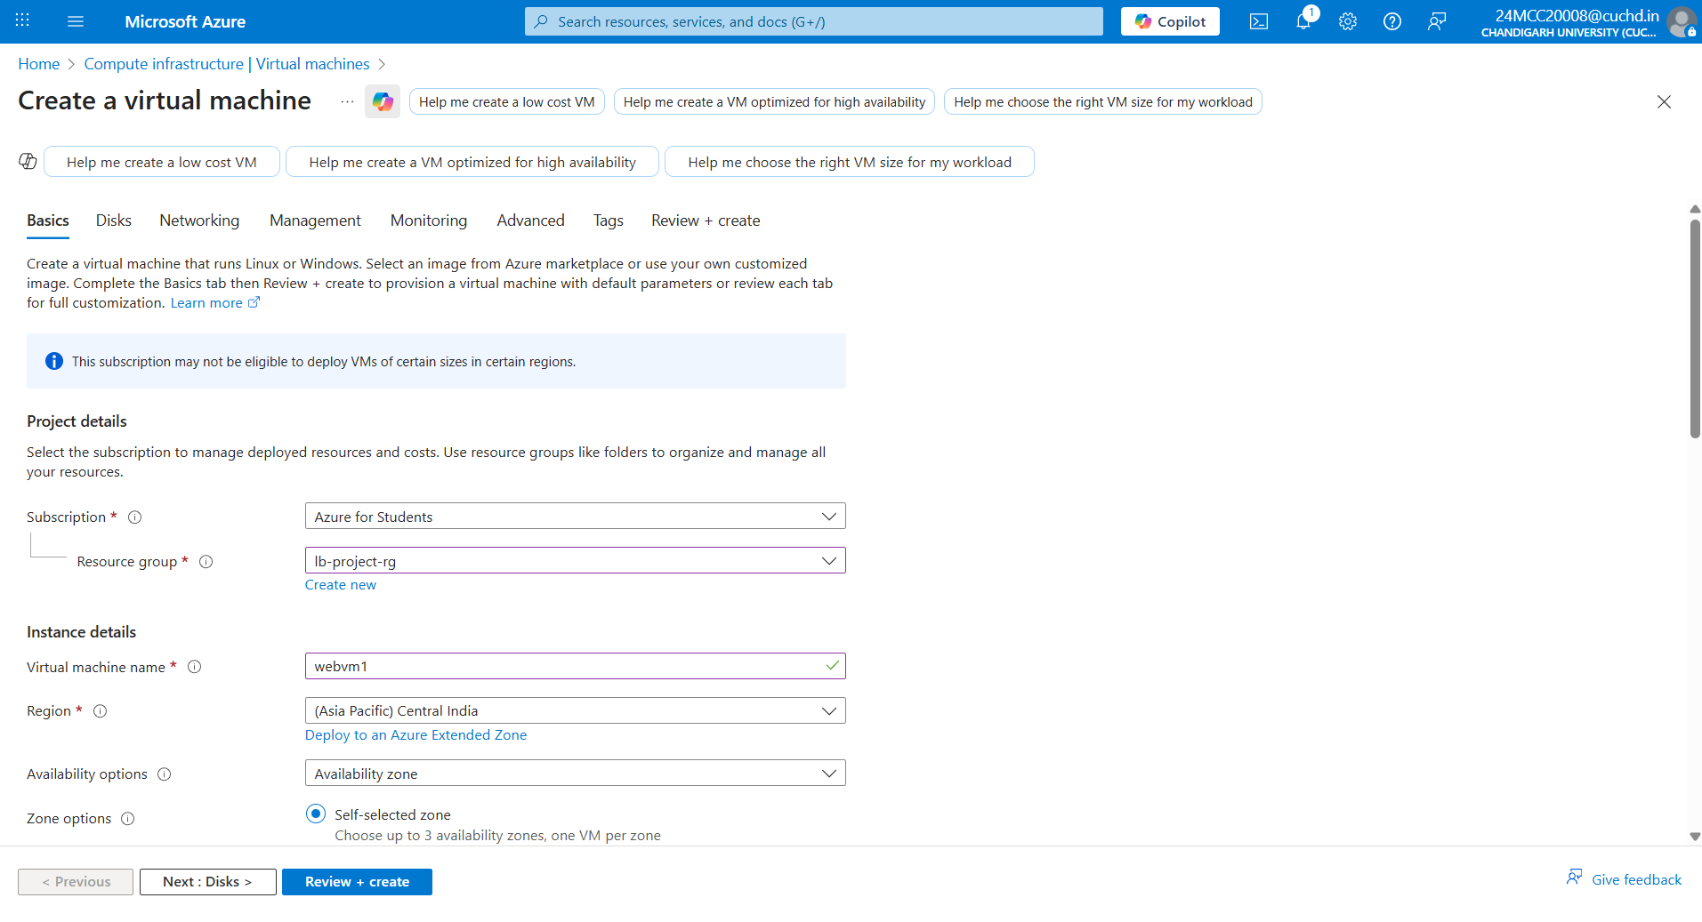
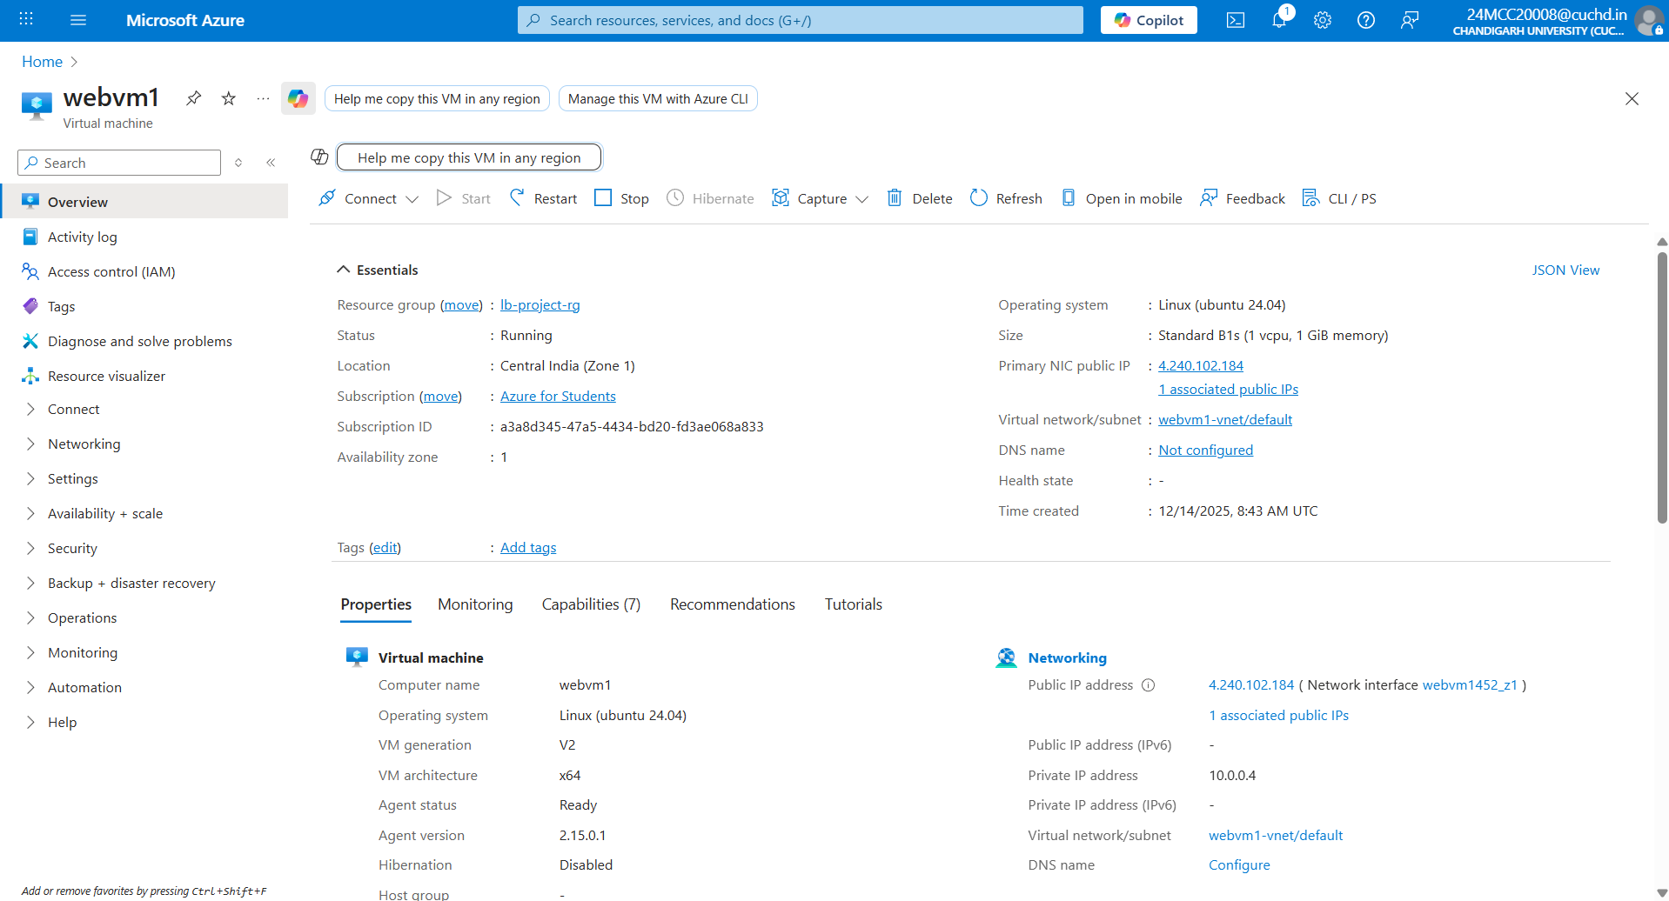
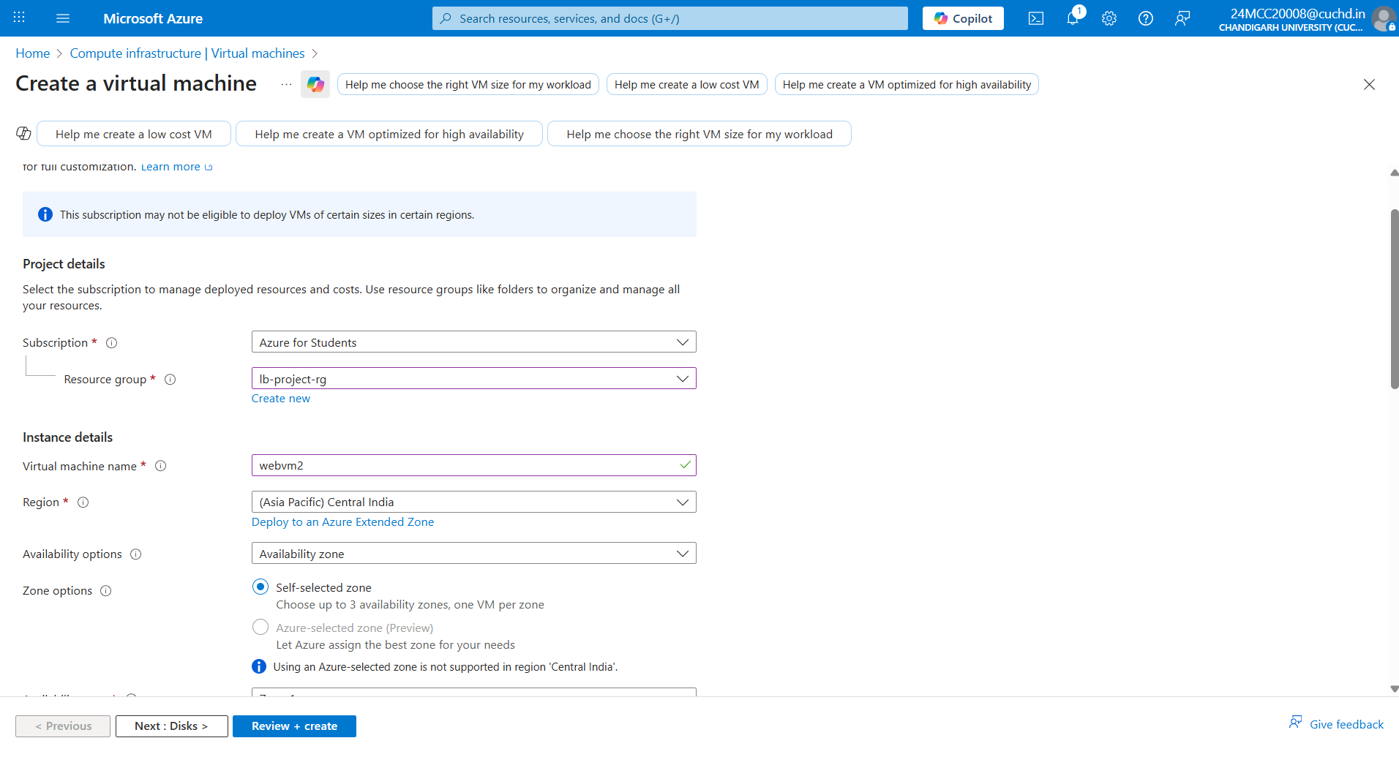
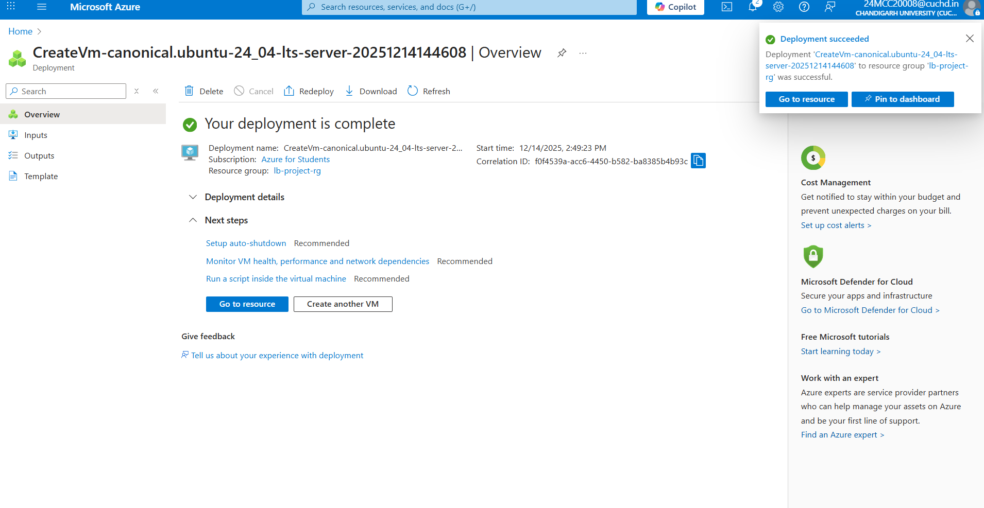

- Installed and configured Apache Web Server on both VMs
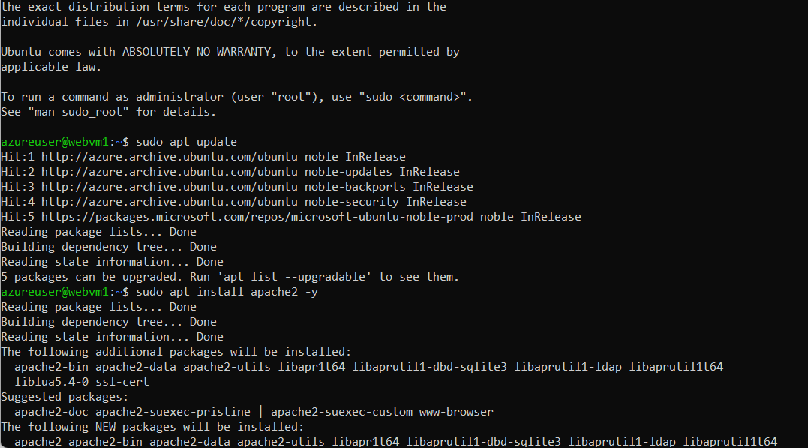
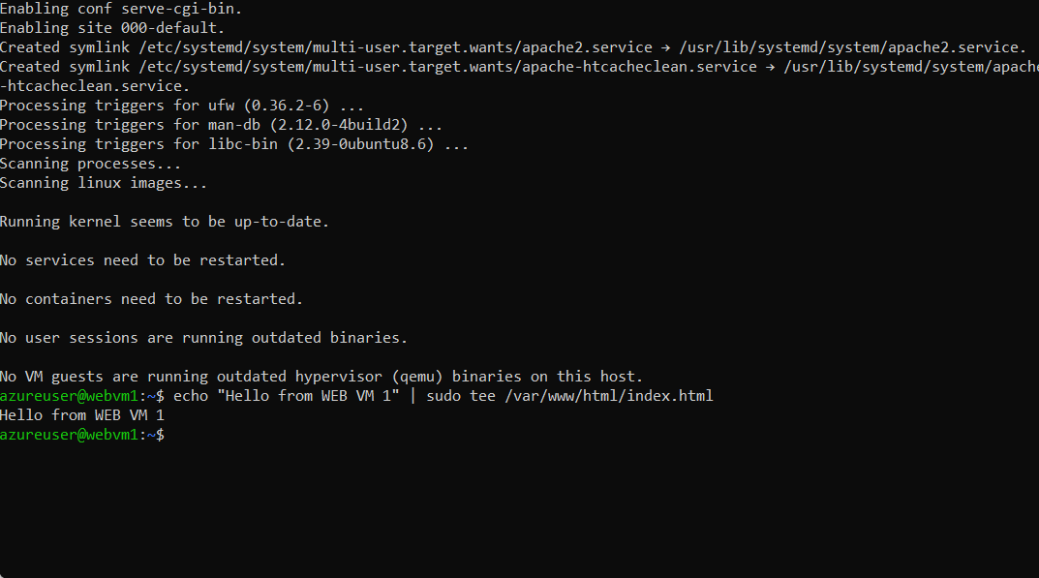

For Second VM2
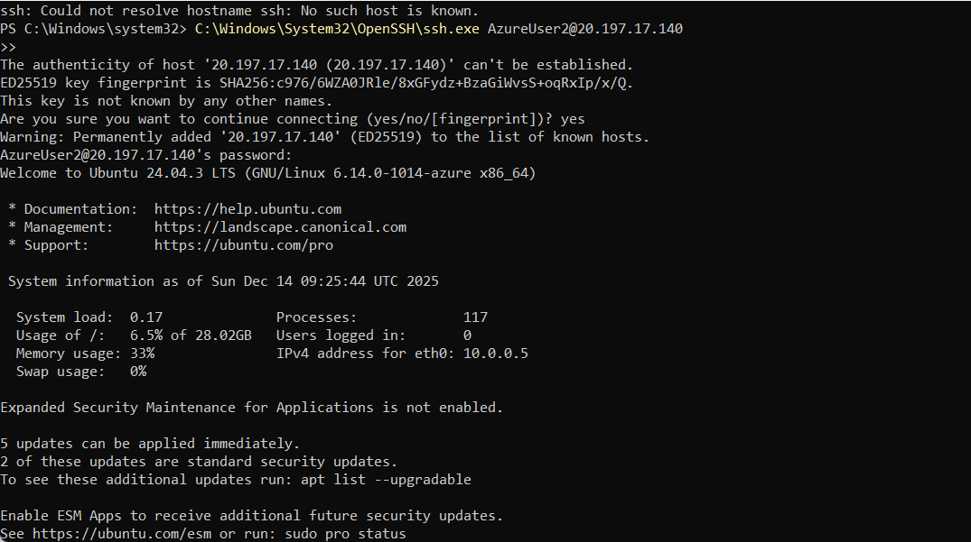
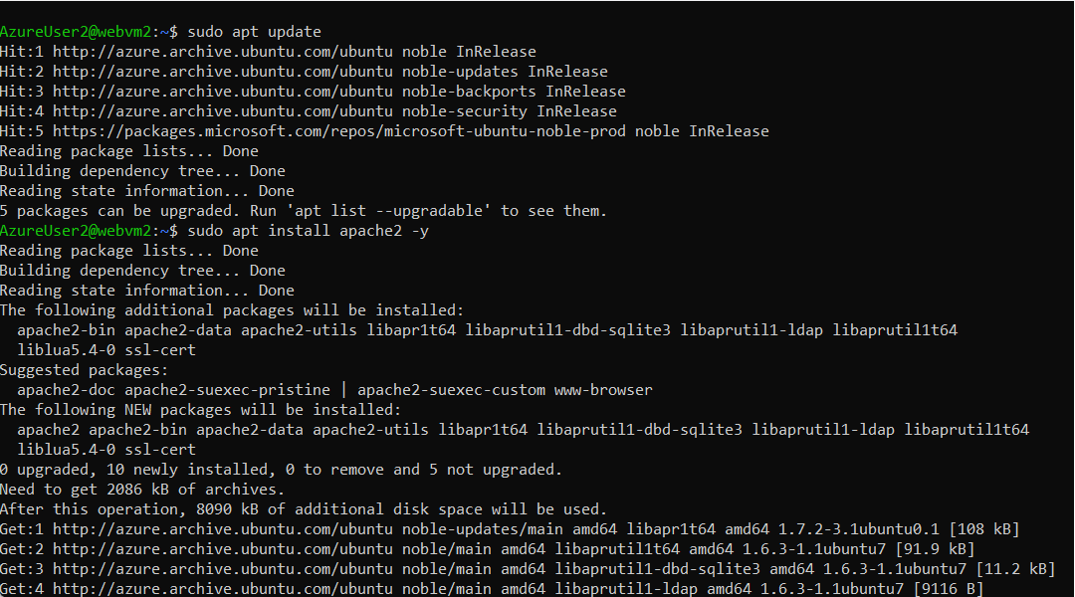
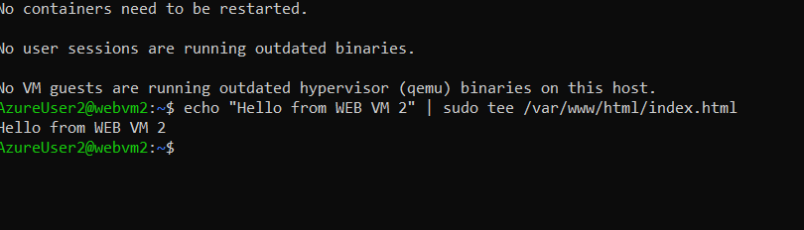
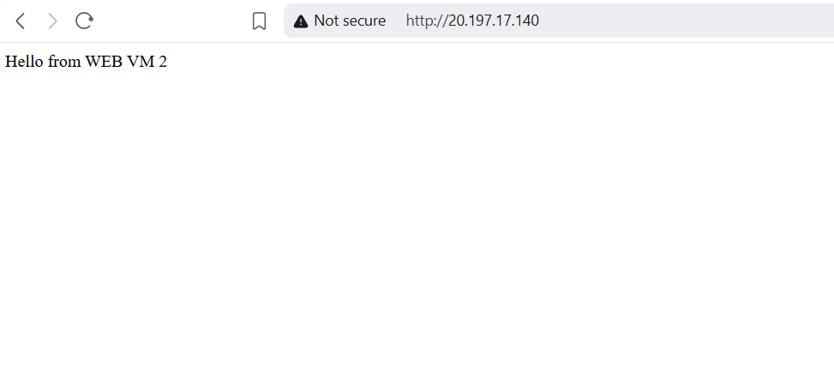

- Created Azure Standard Load Balancer
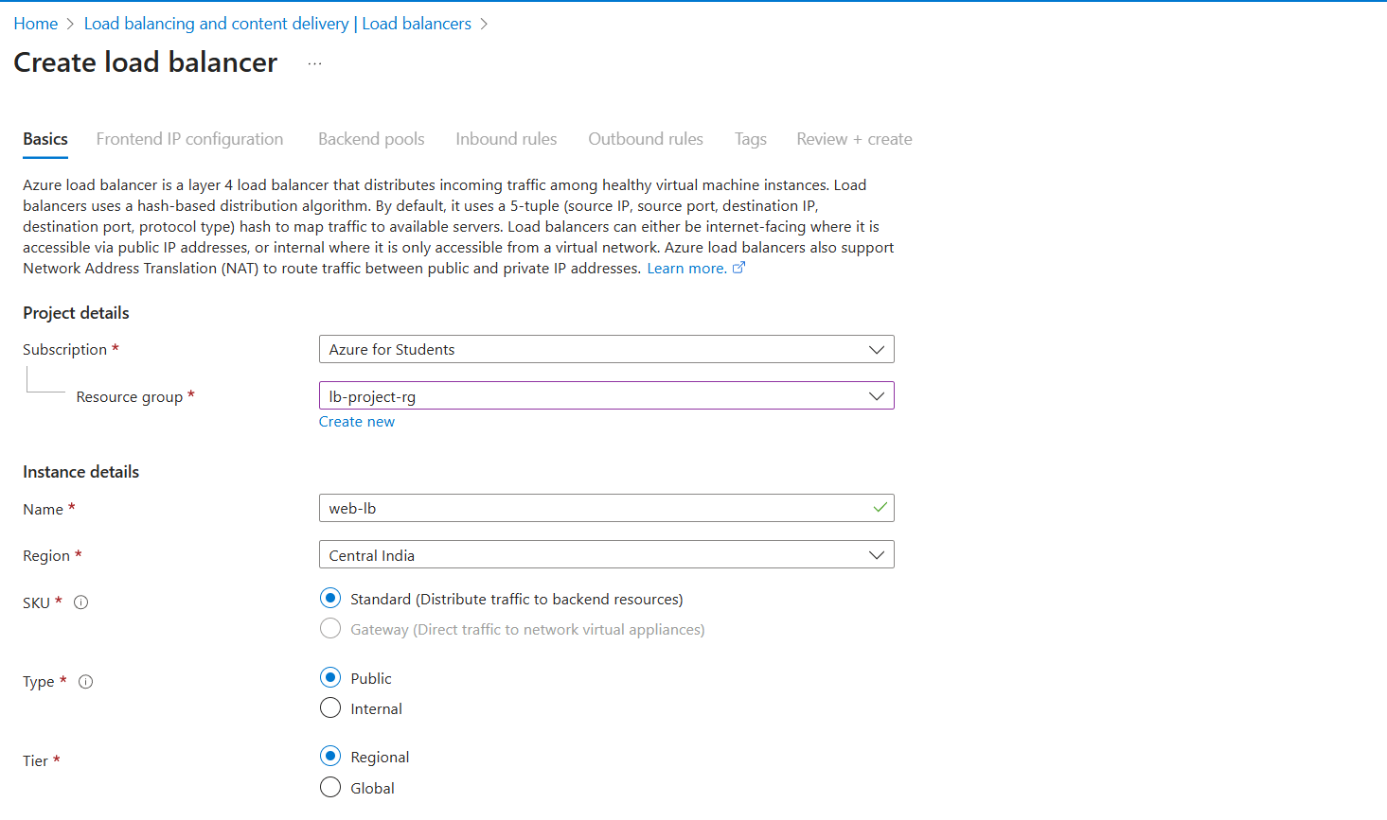

- Configured Frontend IP configuration
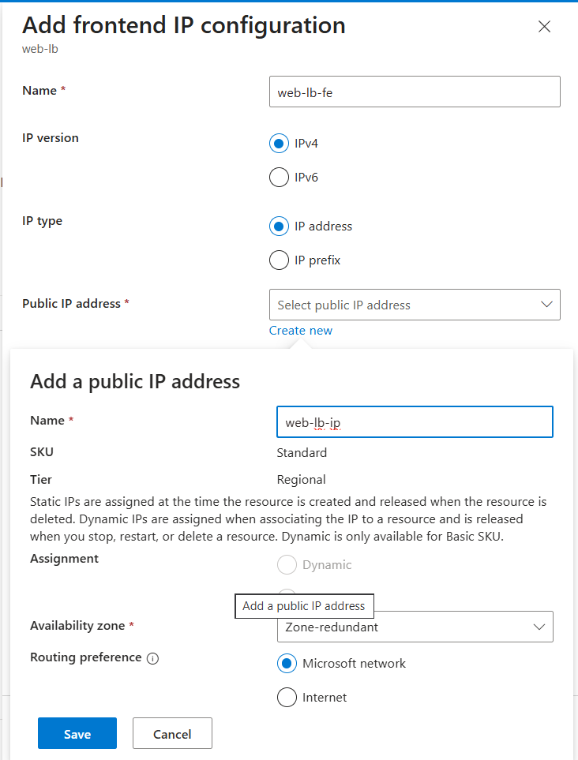
- Created Backend Pool and added both VMs
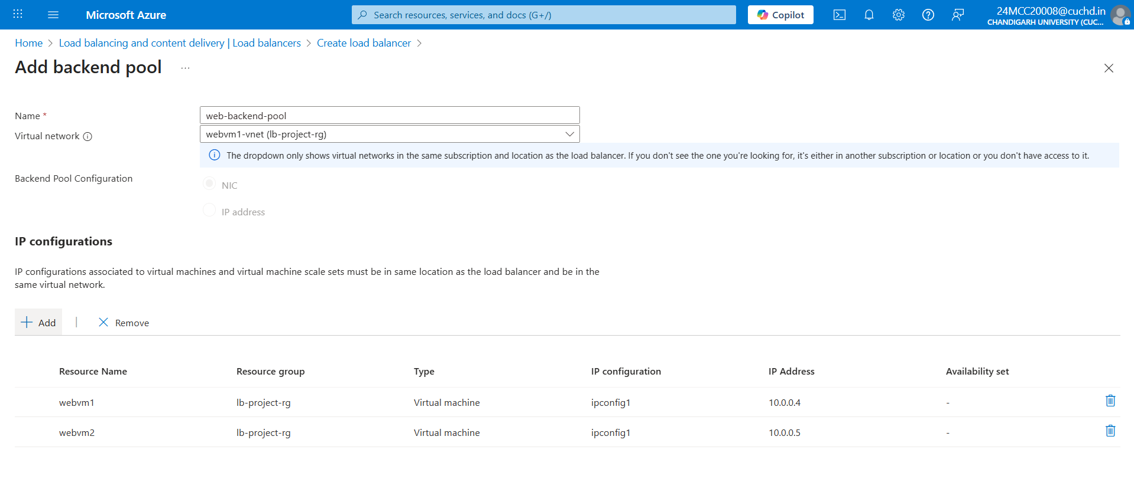

- Configured Health Probe on port 80 & Created Load Balancing Rule for HTTP traffic

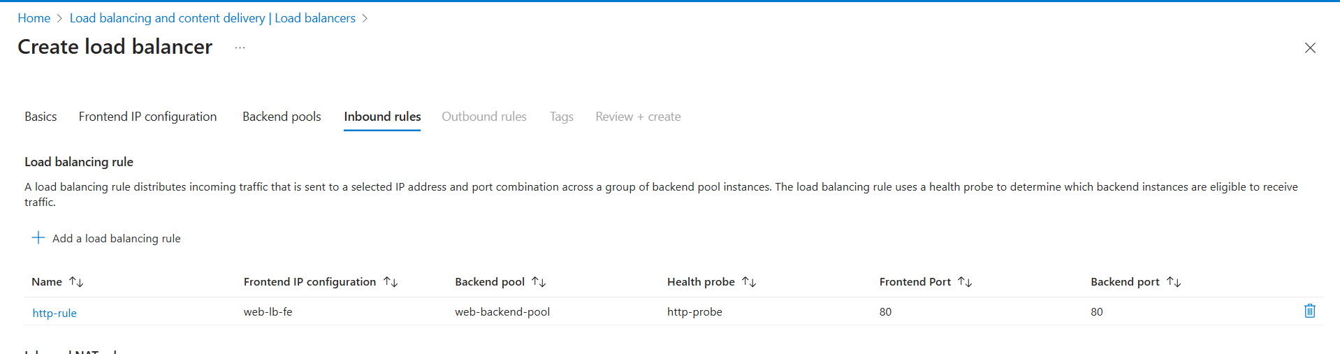
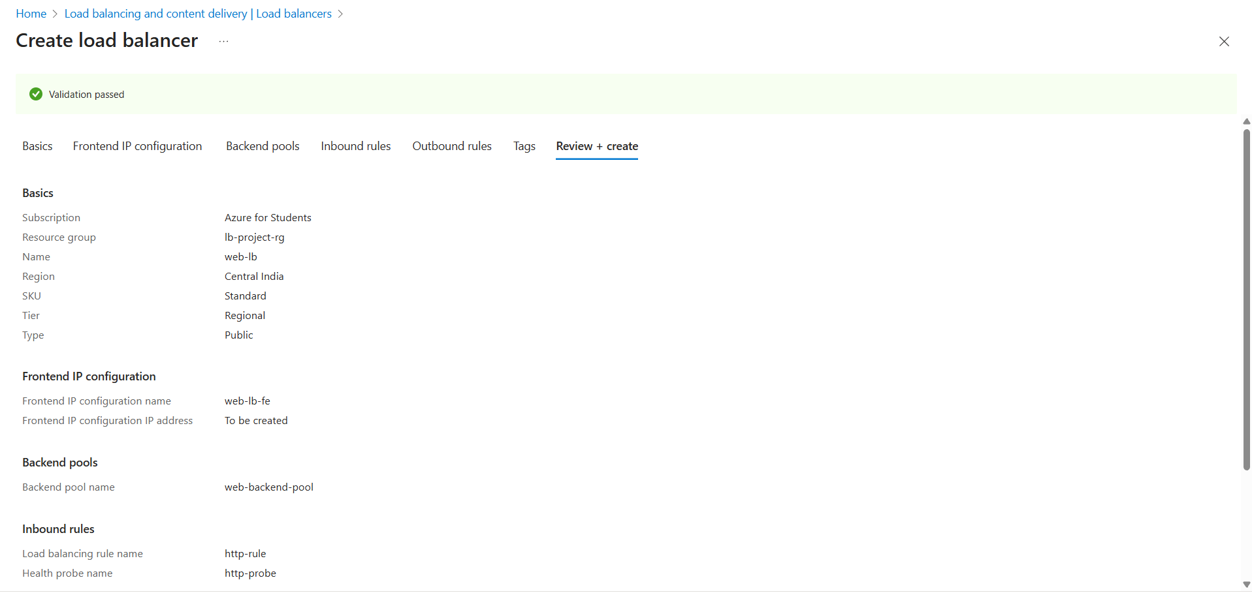
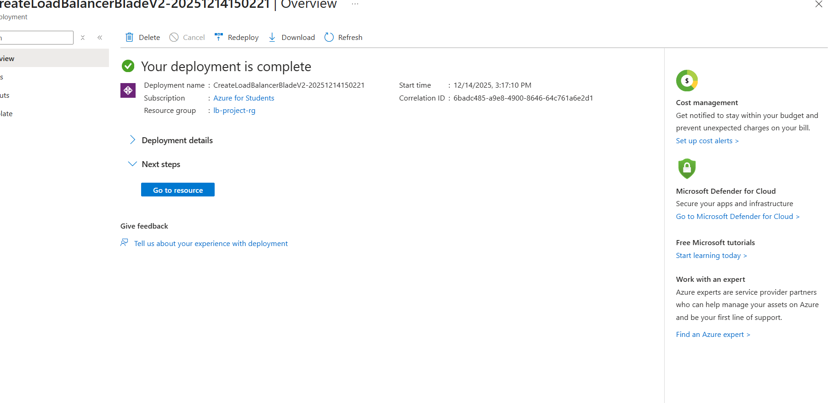

- Tested load balancing using browser
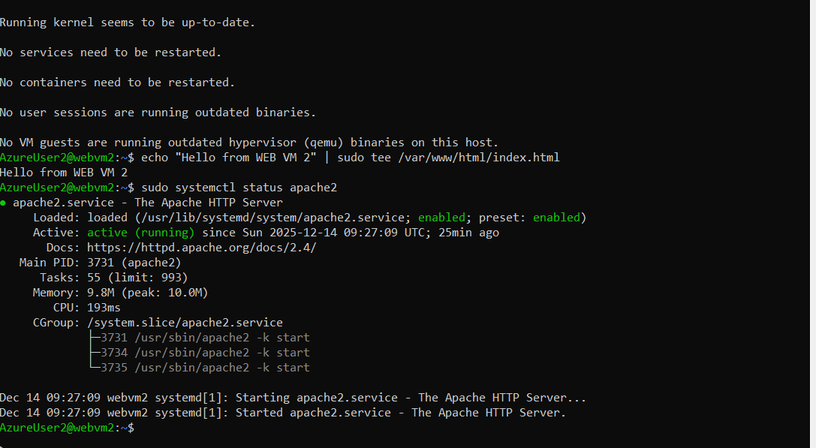

5. Output / Result
When accessing the Load Balancer public IP from a browser, the response alternates between 'Hello from VM1' and 'Hello from VM2', confirming successful load balancing.

6. Conclusion
This project successfully demonstrates the implementation of Azure Load Balancer to achieve high availability and fault tolerance. It ensures uninterrupted service by distributing traffic across multiple backend virtual machines.

