A

Project Report

On

**TempZone**

Submitted By:

**Aryan joshi**

**keval savaliya**

**bhagyesh bhalodiya**

B.C.A [SEM – 5]

Guided By;

**PROF.: nilam kathrotia**

Submitted To:

**BHAKTA KAVI NARSINH MEHTA UNIVERSITY**

**JUNAGADH**



**SHRI PATEL KELAVANI MANDAL**

**COLLEGE OF TECHNOLOGY**

**COLLEGE ROAD, JUNAGADH – 362001.**

**Academic year : 2023**



Prof. Nilam Kathrotia

Keval Savaliya

Bhagyesh Bhalodiya

Aryan Joshi

TempZone

**Abstract**

* **"TempZone"** is the result of our 5th semester project during the B.C.A. at Patel Kelavani Mandal College of Technology Junagadh, under Bhakta Kavi Narsinh Mehta University.
* In today’s crowded job market, a well-designed resume immediately grabs the attention of hiring managers. It serves as your initial introduction and allows you to make a positive first impression.
* On the other hand, visiting cards, often known as business cards, play a crucial role in networking and personal branding. They encapsulate one's contact information and professional identity in a compact, easily shareable format.
* TempZone is a user-friendly web-based platform developed for efficient template management. It simplifies the process of creating and updating templates, including resumes and visiting cards.
* Our main goal was to develop an easy to use web-tool that runs on every browser, so that users can seamlessly create and manage their templates or explore templates created by others.
* We store your templates, eliminating the need for you to carry them physically. With a simple browser access, you can effortlessly select your desired template and proceed to print it whenever the need arises

**Acknowledgement**

We extend our heartfelt gratitude to all those who have contributed to the successful completion of this project. Their support and inspiration have been invaluable in our journey.

* We are deeply thankful to Prof. Nilam Kathrotia, our project guide, for her unwavering guidance and mentorship. Her expertise in web application development and insightful suggestions have steered us in the right direction throughout this project.
* Our sincere thanks to Prof. Nilam Kathrotia, the Head of the Department, for imparting valuable knowledge in the field of software development. Her expertise has been instrumental in our project's success.
* We express our gratitude to our esteemed Principal, whose support and encouragement provided us with the opportunity to present and execute this project.
* A special mention to our dedicated team members and developers who have put in their hard work, time, and expertise to bring this project to fruition. Your commitment has been crucial to our success.

**Declaration**

We, Aryan Joshi, Keval Savaliya and Bhagyesh Bhalodiya, hereby declare that this project report, titled "**TempZone**" has been prepared by us as students of Patel Kelavani Mandal College of Technology for the fulfilment of the requirements of the B.C.A program, under the guidance of Prof. Nilam Kathrotia. The work presented in this report is the result of our own efforts and research, and all sources of information, including data, images, text, and ideas, used in the report have been duly acknowledged and cited.

|  |
| --- |
|  |
|  |
| (Signature of students) |

**Index**

**Project Profile** 1

**Timeline Chart** 2

**Feasibility Study** 3

**Operational Feasibility** 3

**Technical Feasibility** 5

**Economic Feasibility** 7

**Normalization** 8

**First Normal Form (1NF)** 8

**Second Normal Form (2NF)** 10

**Third Normal Form (3NF)** 11

**Database Dictionary** 13

**Registered Users** 13

**User Templates** 14

**Category** 15

**Admin** 16

**Data Flow Diagram** 17

**0 Level DFD** 17

**Admin Level DFD** 18

**Client Level DFD** 19

**E.R Diagram** 20

**Use Case Diagram** 22

**Use case for Admin** 22

**Use case for Client** 23

**Activity Diagram** 24

**Admin Activity Diagram** 24

**Client Activity Diagram** 25

**System Design** 26

**Client Design** 26

**Landing Page** 26

**Login Page** 27

**Register Page** 28

**Dashboard Page** 29

**Explore Page** 30

**Create New Template Dialog** 31

**Editor Page** 32

**Template View Page** 33

**Admin Design** 34

**Login Page** 34

**Dashboard Page** 35

**Users Page**  36

**Templates Page** 37

**Categories Page** 38

**Delete Confirmation Dialog**  39

**Conclusion** 40

**Bibliography** 40

**Testing** 41

**Project Report** 42

# **Project Profile**

|  |  |
| --- | --- |
| Project Name | TempZone |
| Project duration | 3 months |
| Project guide | Prof. Nilam Kathrotia |
| Tools used | IDE – VS Code  Web server – Apache, Nginx  Browser – Google Chrome, Mozilla Firefox |
| Front-end | HTML, CSS, JavaScript |
| Back-end | PHP |
| Database | MySQL |
| Project team members | Aryan Joshi  Bhagyesh Bhalodiya  Keval Savaliya |

# **Timeline Chart**

|  |  |  |  |
| --- | --- | --- | --- |
| **No.** | **Start date** | **End date** | **Tasks** |
| 1 | 07/07/2023 | 15/07/2023 | Information Gathering |
| 2 | 16/07/2023 | 23/07/2023 | Data Analysis |
| 3 | 24/07/2023 | 01/08/2023 | Requirement Analysis |
| 4 | 02/08/2023 | 15/08/2023 | Database Design |
| 5 | 16/08/2023 | 03/09/2023 | System Design and Developing |
| 6 | 04/09/2023 | 10/09/2023 | Implementation and Testing |
| 7 | 11/09/2023 | 14/09/2023 | Documentation |

# **Feasibility Study**

* A feasibility analysis usually involves a thorough assessment of the operational (need), financial and technical aspects of a proposal.
* The feasibility study concluded that the project would be able to be implemented to success as it was carefully planned.
* There are three types of feasibility…

1. Operational Feasibility

2) Technical Feasibility

3) Economic Feasibility

## **Operational Feasibility**

* Whether the problem can be solved in the users’ environment with existing and proposed system workings.
* **Tasks performed by Admin:**

|  |  |  |  |
| --- | --- | --- | --- |
| **Page** | **Process** | **Effected Table** | **Operations** |
| Login | Check for the admin | admin | SELECT |
| Dashboard | Fetch site information | registered_users  category  user_templates | SELECT |
| Users | Manage users | registered_users | SELECT  DELETE |
| Templates | Manage templates | user_templates | SELECT  DELETE |
| Categories | Manage categories | category | SELECT  DELETE |

* **Tasks performed by Client:**

|  |  |  |  |
| --- | --- | --- | --- |
| **Page** | **Process** | **Effected Table** | **Operations** |
| Login | Check for the user | registered_users | SELECT |
| Register | Register user | registered_users | INSERT |
| Dashboard | Fetch registered user’s templates | user_templates | SELECT |
| Explore | Fetch templates of other users | user_templates | SELECT |
| Editor | Fetch selected template and edit it | user_templates | SELECT  UPDATE |
| Template view | Fetch selected template | user_templates | SELECT |

## **Technical Feasibility**

* Weather it is technical possible with the existing technology or with the planned new technology.
* **Hardware and software specification:**
* **Minimum Hardware Requirement:**

|  |  |
| --- | --- |
| **Component** | **Minimum requirements** |
| Processor | 1.6ghz processor or above |
| Supported Architecture | 32bit (*86)  64bit (*64) |
| Memory | 1gb or above |
| Hard disk | Total space: 250gb  Installing space in single drive: 20gb |

* **Minimum Software Requirement:**

|  |  |
| --- | --- |
| **Component** | **Minimum requirements** |
| Operating System | Windows XP professional SP3 or higher version |
| MySQL server | Database |
| Web server | IIS Apache friend |
| XAMPP | XAMPP control v1.0 |
| Web browsers | Chrome, Mozilla Firefox, Microsoft IE 9.0, Safari and Opera |

## **Economic Feasibility**

* The purpose of an economic feasibility is to determine the net benefit of the project.
* **Hardware economic study:**

|  |  |  |  |
| --- | --- | --- | --- |
| **Component** | **Minimum requirement** | **Price** | **Website/Shop** |
| Processor | Intel Pentium D Processor 820 | ₹799 | www.amazon.com |
| Hard disk | 150GB | ₹1815 | www.amazon.com |
| Memory | 2gb DDR3 RAM | ₹717 | www.amazon.com |

* **Software economic study:**

|  |  |  |
| --- | --- | --- |
| **Component** | **Price** | **Website/Shop** |
| Microsoft window XP | ₹ 7040 | www.shoponline.com |
| XAMPP (Include PHP & MYSQL) | FREE | www.apachefriends.org |
| VS Code | FREE | www.code.visualstudio.com |

# **Normalization**

* Database Normalization is the process of organizing the columns and tables of a relational database to minimize data redundancy.
* Normalization usually involves dividing a database into two or more tables and defining relationship between the tables.

## **First Normal Form (1NF)**

In the First Normal Form, a table is organized in such a way that it meets the following criteria:

* Each column (attribute) must contain atomic (indivisible) values
* Each column must have a unique name.
* The order in which data is stored does not matter

|  |
| --- |
| **Unnormalized Table** |
| user_id |
| user_name |
| user_email |
| user_password |
| user_registered_at |
| user_updated_at |
| template_id |
| template_name |
| template_tags |
| template_category |
| template_owner |
| template_created_at |
| template_updated_at |
| category_id |
| category_name |
| category_created_at |
| category_updated_at |
| admin_id |
| admin_name |
| admin_email |
| admin_password |

## **Second Normal Form (2NF)**

To achieve the Second Normal Form, a table must first satisfy the criteria for 1NF. Additionally, the following conditions should be met:

* There should be no partial dependencies. In other words, non-prime attributes (attributes not part of the primary key) should be fully functionally dependent on the entire primary key.

|  |  |
| --- | --- |
| **registered_users** | |
| id | Primary key |
| user_name | |
| user_email | |
| password | |
| registered_at | |
| updated_at | |

|  |  |
| --- | --- |
| **user_templates** | |
| id | Primary key |
| template_name | |
| template_tags | |
| template_category | Foreign key to category |
| template_owner | Foreign key to registered_user |
| created_at | |
| updated_at | |

|  |  |
| --- | --- |
| **category** | |
| id | Primary key |
| category_name | |
| created_at | |
| updated_at | |

|  |  |
| --- | --- |
| **admin** | |
| id | Primary key |
| username | |
| email | |
| password | |

## **Third Normal Form (3NF)**

To achieve the Third Normal Form, a table must first satisfy the criteria for 2NF. Additionally, the following condition should be met:

* There should be no transitive dependencies. This means that non-prime attributes should not depend on other non-prime attributes.

|  |  |
| --- | --- |
| **registered_users** | |
| id | Primary key |
| user_name | |
| user_email | |
| password | |
| registered_at | |
| updated_at | |

|  |  |
| --- | --- |
| **user_templates** | |
| id | Primary key |
| template_name | |
| template_tags | |
| template_category | Foreign key to category |
| template_owner | Foreign key to registered_user |
| created_at | |
| updated_at | |

|  |  |
| --- | --- |
| **category** | |
| id | Primary key |
| category_name | |
| created_at | |
| updated_at | |

|  |  |
| --- | --- |
| **admin** | |
| id | Primary key |
| username | |
| email | |
| password | |

# **Database Dictionary**

## **Registered Users**

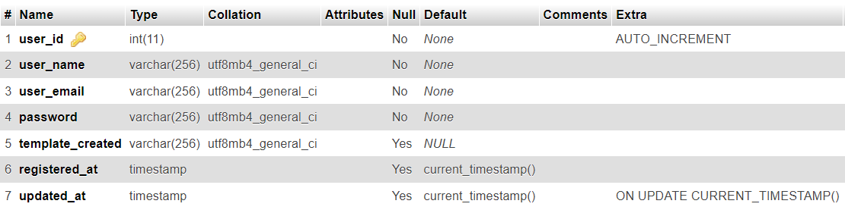

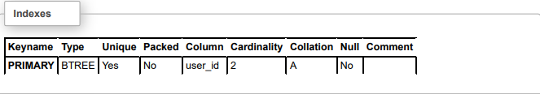

## **User Templates**

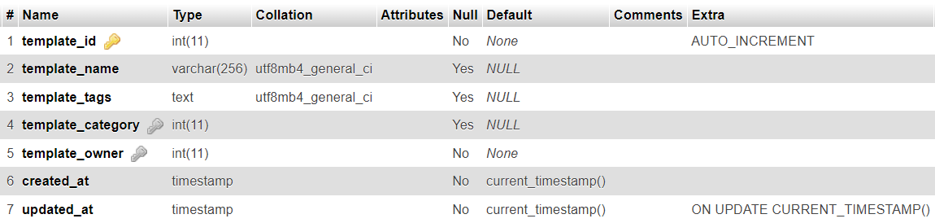

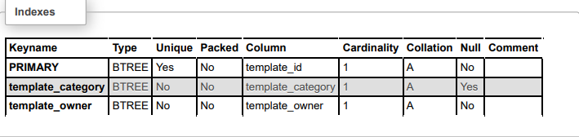

## **Category**

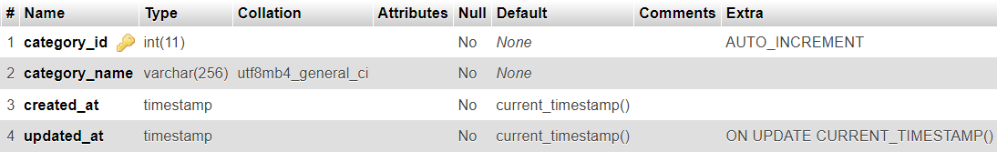

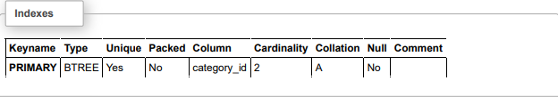

## **Admin**

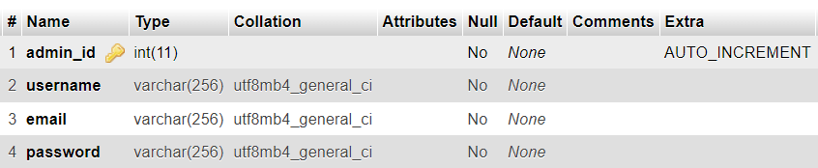

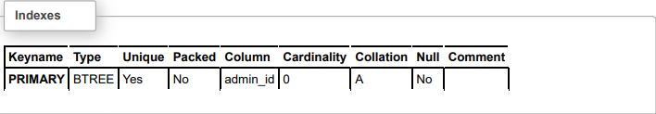

# **Data Flow Diagram**

* Data flow diagrams shows the way information flows through a process or systems. It includes data inputs and output, data store, and various sub process the data move through. DFD are built using standardized symbols and notations to describe various entities and their relationship.
* Data flow diagrams visually represent system and process that would be hard to describe in the chunk of text you can use this diagram to map out an existing system and make it better or to plan out a new system for implementation. Visualizing each element make it easy to identify inefficiencies and produce best possible systems.

## **0 Level DFD**

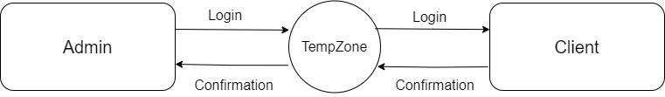

## **Admin Level DFD**

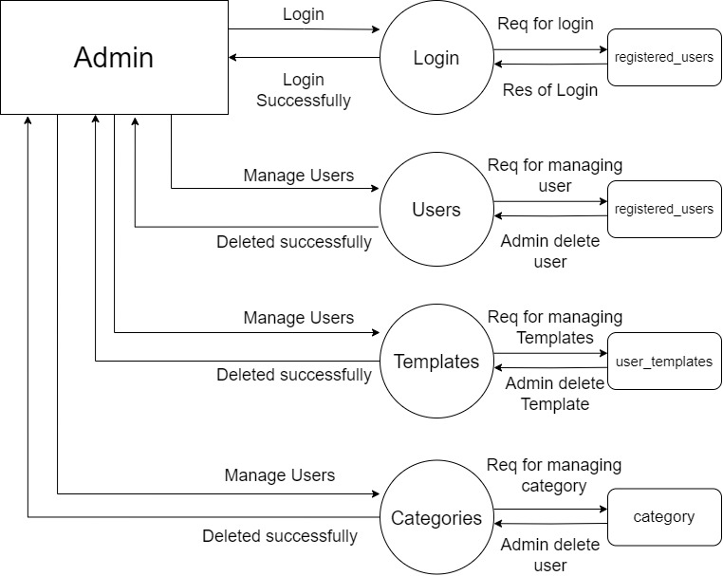

## **Client Level DFD**

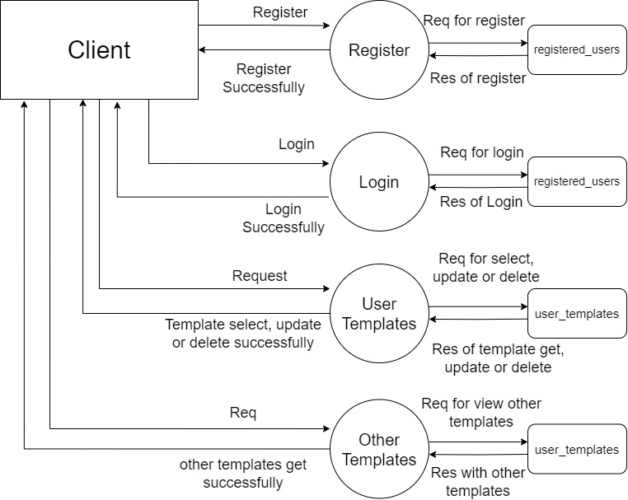

# **E.R Diagram**

* Entity relationship diagram, also an ER Diagram or ER model, is a chart that visually represents the relationship between database entities. An ER Diagram contains different symbols and connector that visualize two information. The major entities within the systems scope and the inter relationship among these entities.

**Symbols:**

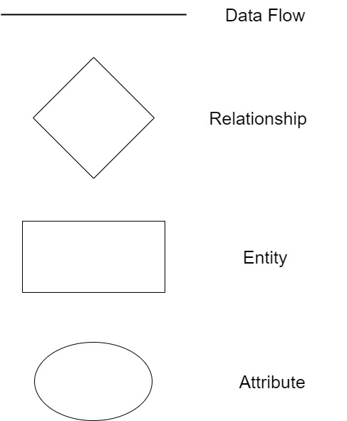

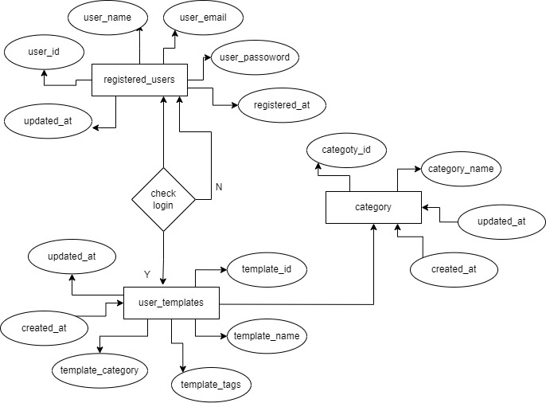

# **Use Case Diagram**

## **Use case for Admin**

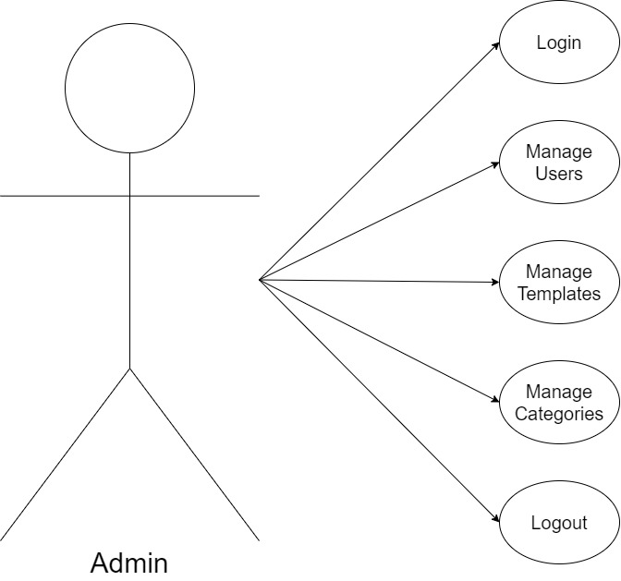

## **Use case for Client**

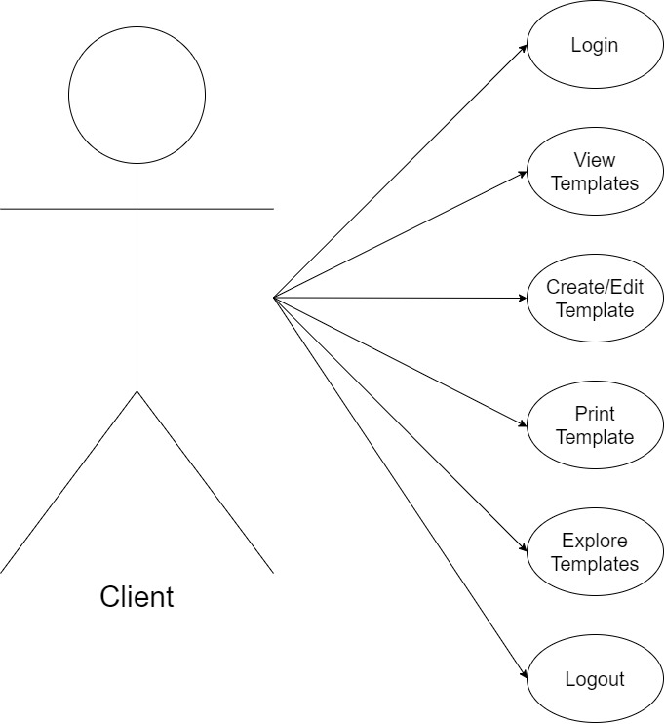

# **Activity Diagram**

## **Admin Activity Diagram**

## **Client Activity Diagram**

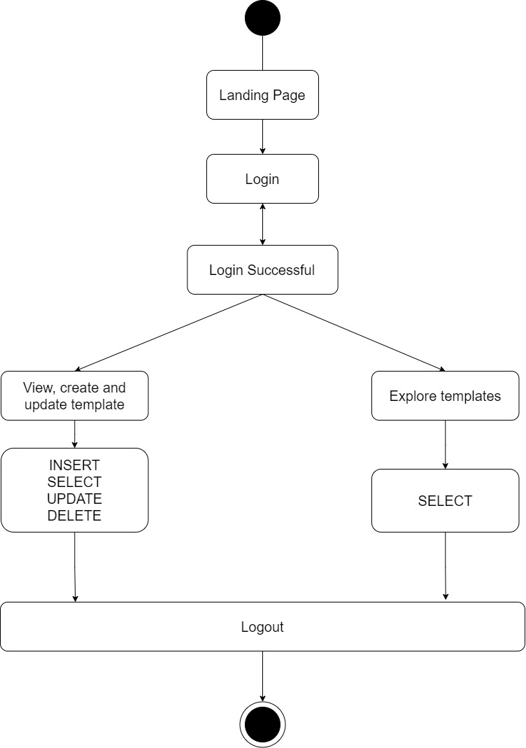

# **System Design**

## **Client Design**

### **Landing Page**

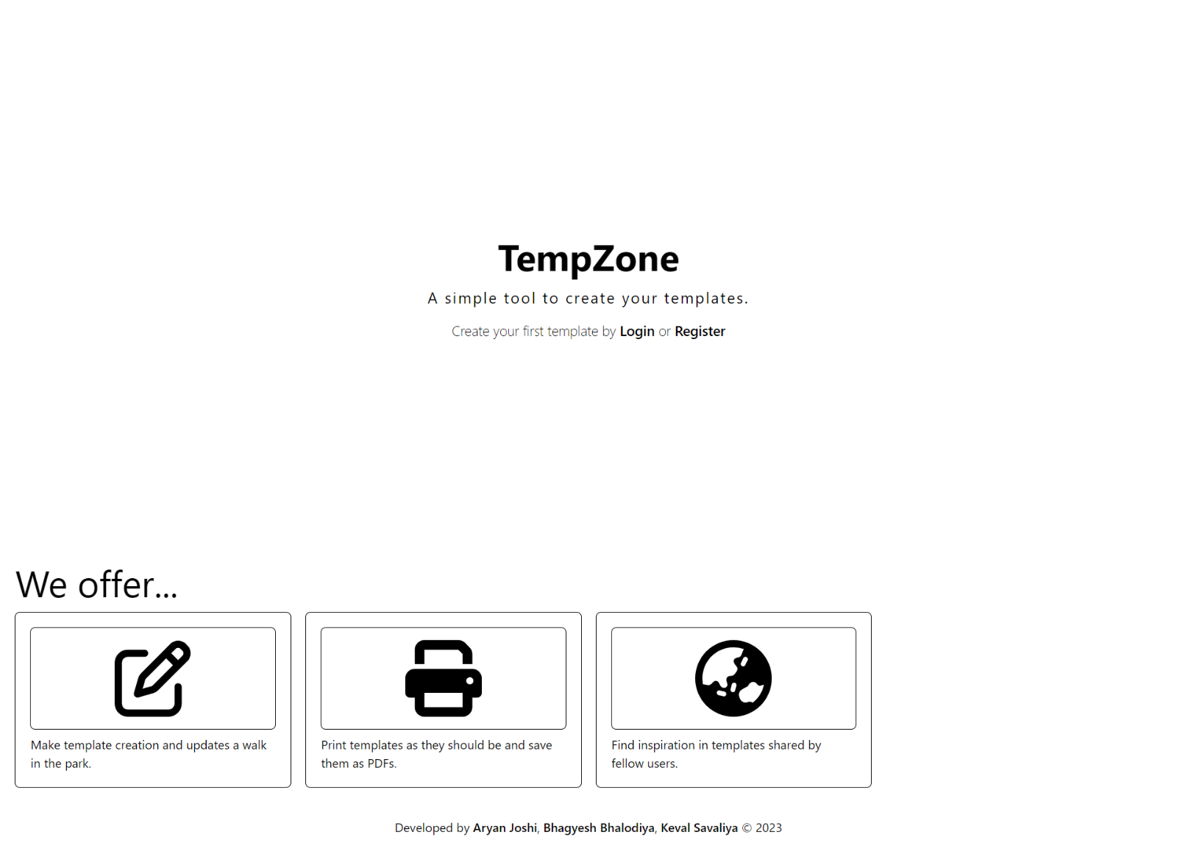

### **Login Page**

### **Register Page**

### **Dashboard Page**

### **Explore Page**

### **Create New Template Dialog**

### **Editor Page**

### **Template View Page**

## **Admin Design**

### **Login Page**

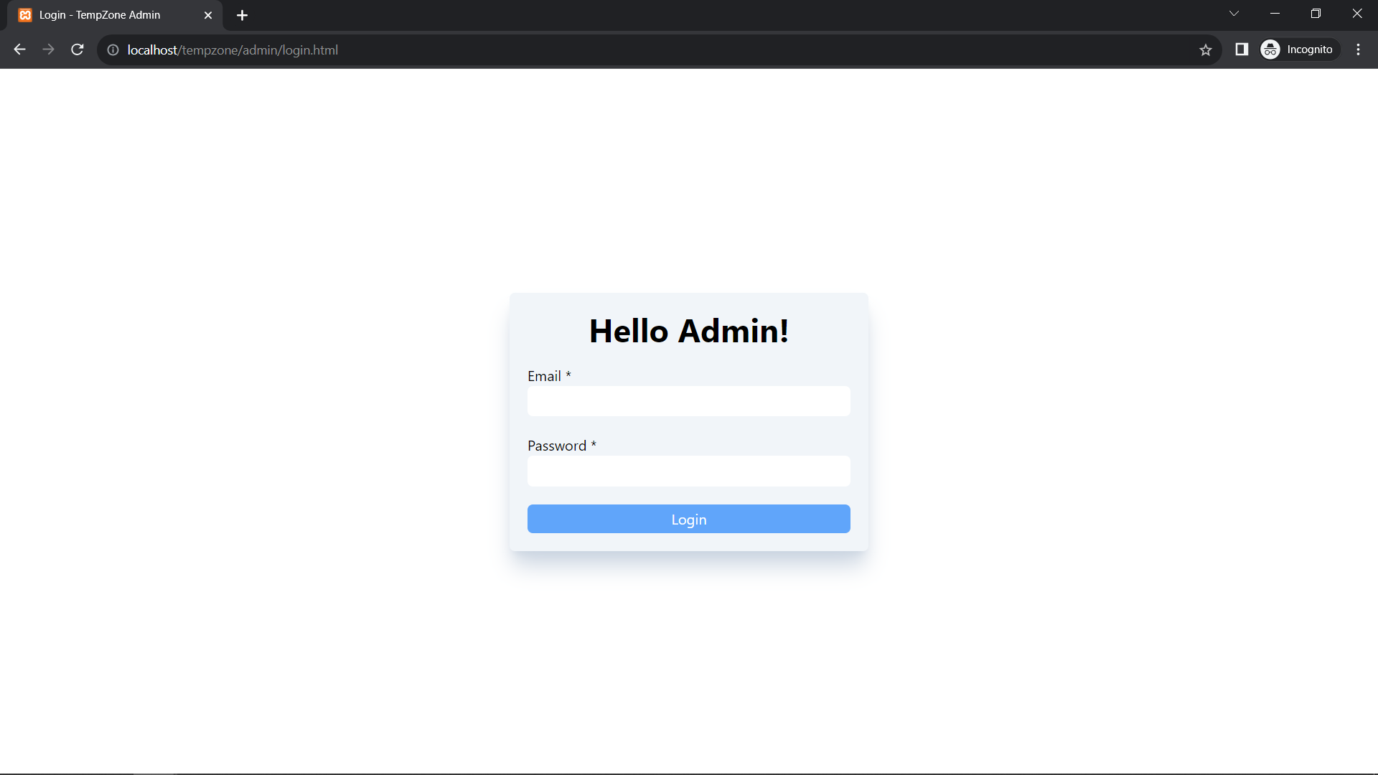

### **Dashboard Page**

### **Users Page**

### **Templates Page**

### **Categories Page**

### **Delete Confirmation Dialog**

# **Conclusion**

TempZone is a user-centric web platform designed for streamlined template management. It simplifies the creation and modification of templates, including resumes and business cards. It incorporates user-friendly features like drag-and-drop elements and a printing function, making template editing and printing hassle-free. The Explore page allows users to browse through others' resumes for inspiration and guidance.

# **Bibliography**

I would like to express my sincere gratitude to several websites that played an invaluable role throughout the development process. First and foremost, a big thank you to Canva, whose highly inspiring platform served as a model and source of inspiration as we built a tool similar to it. Additionally, MDN Web Docs, Stack Overflow, GitHub, and Font Awesome were constant companions, providing essential guidance, resources, and tools that streamlined our development journey. Together, these online resources were instrumental in the success of this project, and I am deeply thankful for their support and contribution.

<https://www.canva.com/>

<https://stackoverflow.com/>

<https://github.com/>

<https://developer.mozilla.org/>

<https://fontawesome.com/icons>

# **Testing**

Testing is the critical element of software quality assurance & represents the ultimate review of specifications design and code generation.

|  |  |  |  |  |  |
| --- | --- | --- | --- | --- | --- |
| **No.** | **Scenario** | **Action** | **Expected output** | **Actual output** | **Result** |
| 1 | Login | User forgets to enter credentials | Response with error code 403 and message “Please provide credentials” | Response with error code 403 and message “Please provide credentials” | PASS |
|  |  | User enters right credentials | Success response and redirect to dashboard | Success response and redirect to dashboard | PASS |
| 2 | Register | User forgets to enter credentials | Response with error code 403 and message “Please provide credentials” | Response with error code 403 and message “Please provide credentials” | PASS |
|  |  | User enters existing username/email | Response with error code 303 and message “Username/Email already exists” | Response with error code 303 and message “Username/Email already exists” | PASS |
|  |  | User enters right credentials | Success response and redirect to dashboard | Success response and redirect to dashboard | PASS |
| 3 | Access | User tries to access API without authorization token | Response with error code 401 and message “Unauthorized” | Response with error code 401 and message “Unauthorized” | PASS |

# **Project Report**

|  |  |
| --- | --- |
| **Project Name** | TempZone |
| **Faculty Name** | Prof. Nilam Kathrotia |
| **Team Members Name** | Aryan Joshi  Bhagyesh Bhalodiya  Keval Savaliya |

|  |  |  |  |  |  |
| --- | --- | --- | --- | --- | --- |
| **No.** | **Start date** | **End date** | **Tasks** | **Faculty sign** | **Student sign** |
| 1 | 07/07/2023 | 15/07/2023 | Information Gathering |  |  |
| 2 | 16/07/2023 | 23/07/2023 | Data Analysis |  |  |
| 3 | 24/07/2023 | 01/08/2023 | Requirement Analysis |  |  |
| 4 | 02/08/2023 | 15/08/2023 | Database Design |  |  |
| 5 | 16/08/2023 | 03/09/2023 | System Design and Developing |  |  |
| 6 | 04/09/2023 | 10/09/2023 | Implementation and Testing |  |  |
| 7 | 11/09/2023 | 14/09/2023 | Documentation |  |  |