Q1
#include <iostream>
using namespace std;
struct Node {
int data;
Node* prev;
Node* next;
};

class DoublyCircularLinkedList {
private:
Node* head;
Node* searchNode(int value) {
if (!head) return nullptr;

Node* current = head;
do {
if (current->data == value) {
return current;
}
current = current->next;
} while (current != head);

return nullptr;
}

public:
DoublyCircularLinkedList() : head(nullptr) {}

void insertAtBeginning(int newData) {
Node* newNode = new Node{newData, nullptr, nullptr};

if (!head) {
newNode->next = newNode;
newNode->prev = newNode;
head = newNode;
} else {
Node* tail = head->prev;

newNode->next = head;
newNode->prev = tail;

head->prev = newNode;
tail->next = newNode;

head = newNode;
}
cout << "Node " << newData << " inserted at the beginning." << endl;
}

void insertAtEnd(int newData) {
Node* newNode = new Node{newData, nullptr, nullptr};

if (!head) {
newNode->next = newNode;
newNode->prev = newNode;
head = newNode;
} else {
Node* tail = head->prev;
newNode->next = head;
newNode->prev = tail;

tail->next = newNode;
head->prev = newNode;
}
cout << "Node " << newData << " inserted at the end." << endl;
}

void insertAfterNode(int newData, int targetValue) {
Node* targetNode = searchNode(targetValue);

if (!targetNode) {
cout << "Node with value " << targetValue << " not found. Insertion failed." << endl;
return;
}

Node* newNode = new Node{newData, nullptr, nullptr};

newNode->next = targetNode->next;
newNode->prev = targetNode;

targetNode->next->prev = newNode;
targetNode->next = newNode;

cout << "Node " << newData << " inserted after node " << targetValue << "." << endl;
}

void insertBeforeNode(int newData, int targetValue) {
Node* targetNode = searchNode(targetValue);

if (!targetNode) {
cout << "Node with value " << targetValue << " not found. Insertion failed." << endl;
return;
}

if (targetNode == head) {
insertAtBeginning(newData);
return;
}

Node* newNode = new Node{newData, nullptr, nullptr};
Node* prevNode = targetNode->prev;

newNode->next = targetNode;
newNode->prev = prevNode;

prevNode->next = newNode;
targetNode->prev = newNode;

cout << "Node " << newData << " inserted before node " << targetValue << "." << endl;
}

void deleteNode(int deleteValue) {
if (!head) {
cout << "List is empty. Deletion failed." << endl;
return;
}

Node* toDelete = searchNode(deleteValue);

if (!toDelete) {
cout << "Node with value " << deleteValue << " not found. Deletion failed." << endl;
return;
}

if (toDelete == head && toDelete->next == head) {
delete toDelete;
head = nullptr;
cout << "Node " << deleteValue << " deleted. List is now empty." << endl;
return;
}

toDelete->prev->next = toDelete->next;
toDelete->next->prev = toDelete->prev;

if (toDelete == head) {
head = toDelete->next;
}

delete toDelete;
cout << "Node " << deleteValue << " deleted successfully." << endl;
}

void search(int searchValue) {
Node* found = searchNode(searchValue);
if (found) {
cout << "Node with value " << searchValue << " **found** in the list." << endl;
} else {
cout << "Node with value " << searchValue << " **not found** in the list." << endl;
}
}
void display() {
if (!head) {
cout << "List is empty." << endl;
return;
}

cout << "Doubly Circular Linked List: ";
Node* current = head;
do {
cout << current->data;
if (current->next != head) {
cout << " <-> ";
}
current = current->next;
} while (current != head);
cout << " (-> head)" << endl;
}
~DoublyCircularLinkedList() {
if (!head) return;

Node* current = head->next;
Node* temp = nullptr;

head->prev->next = nullptr; // Break the circular link

while (current != nullptr) {
temp = current;
current = current->next;
delete temp;
}
delete head;
head = nullptr;
}
};
void displayMenu() {
cout << "\n--- Doubly Circular Linked List Operations ---" << endl;
cout << "1. Insertion" << endl;
cout << "2. Deletion of a Specific Node" << endl;
cout << "3. Search for a Node" << endl;
cout << "4. Display List" << endl;
cout << "5. Exit" << endl;
cout << "Enter your choice: ";
}

void insertionMenu(DoublyCircularLinkedList& list) {
int subChoice, data, target;
cout << "\n--- Insertion Menu ---" << endl;
cout << "1. Insert as First Node" << endl;
cout << "2. Insert as Last Node" << endl;
cout << "3. Insert After a Specific Node" << endl;
cout << "4. Insert Before a Specific Node" << endl;
cout << "Enter your choice: ";
cin >> subChoice;

cout << "Enter the data value to insert: ";
cin >> data;

switch (subChoice) {
case 1:
list.insertAtBeginning(data);
break;
case 2:
list.insertAtEnd(data);
break;
case 3:
cout << "Enter the value of the node *after* which to insert: ";
cin >> target;
list.insertAfterNode(data, target);
break;
case 4:
cout << "Enter the value of the node *before* which to insert: ";
cin >> target;
list.insertBeforeNode(data, target);
break;
default:
cout << "Invalid insertion choice." << endl;
}
}

int main() {
DoublyCircularLinkedList list;
int choice, data, target;

do {
list.display();
displayMenu();
cin>>choice;

switch (choice) {
case 1:
insertionMenu(list);
break;
case 2:
cout << "Enter the value of the node to **delete** (e.g., 60): ";
cin >> target;
list.deleteNode(target);
break;
case 3:
cout << "Enter the value of the node to **search**: ";
cin >> target;
list.search(target);
break;
case 4:
// Display already called before menu, but here for explicit call option
list.display();
break;
case 5:
cout << "Exiting program. Goodbye!" << endl;
break;
default:
cout << "Invalid choice. Please try again." << endl;
}
} while (choice != 5);

return 0;
}

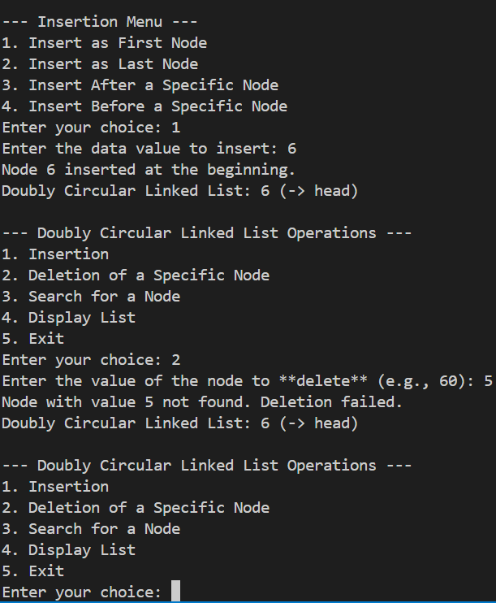

Q2

void displayCircularList(Node* head) {
if (head == nullptr) {
cout << "The circular linked list is empty." << endl;
return;
}

cout << "Circular Linked List Nodes: ";

Node* current = head;

do {
cout << current->data;

if (current->next != head) {
cout << " -> ";
}
current = current->next;
} while (current != head);
cout << " -> " << head->data << endl;
}

Q3
int DLL_size(DoublyNode* head) {
int count = 0;
DoublyNode* current = head;
while (current != nullptr) {
count++;
current = current->next;
}
return count;
}

int CLL_Size(CircularNode* head) {
if (head == nullptr) {
return 0;
}
int count = 0;
CircularNode* current = head;
do {
count++;
current = current->next;
} while (current != head);

return count;
}

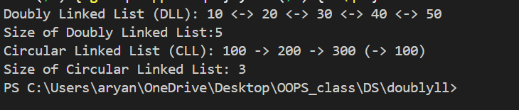
Q4
bool isPalindrome(Node* head) {
if (!head) {
return true;
}
Node* tail = head;
while (tail->next != nullptr) {
tail = tail->next;
}
Node* front = head;
Node* back = tail;

while (front != back && front->prev != back) {
if (front->data != back->data) {
return false;
}
front = front->next;
back = back->prev;
}
return true;
}

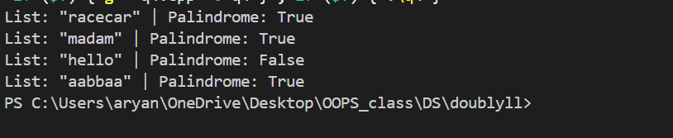

Q5
bool isCircular(Node* head) {
if (head == nullptr) {
return false;
}

Node* slow = head;
Node* fast = head;

while (fast != nullptr && fast->next != nullptr) {

slow = slow->next;
fast = fast->next->next;
if (slow == fast) {
return true;
}
}

