**EECS 1012**

**Section N**

**TEAM ECHO**

**Rahul Verma**

**221076039**

**rv05@my.yorku.ca**

**Angad Ahluwalia**

**220997193**

**angada05@my.yorku.ca**

**Aryan Kishor Kansagara**

**221008883**

**aryankk@my.yorku.ca**

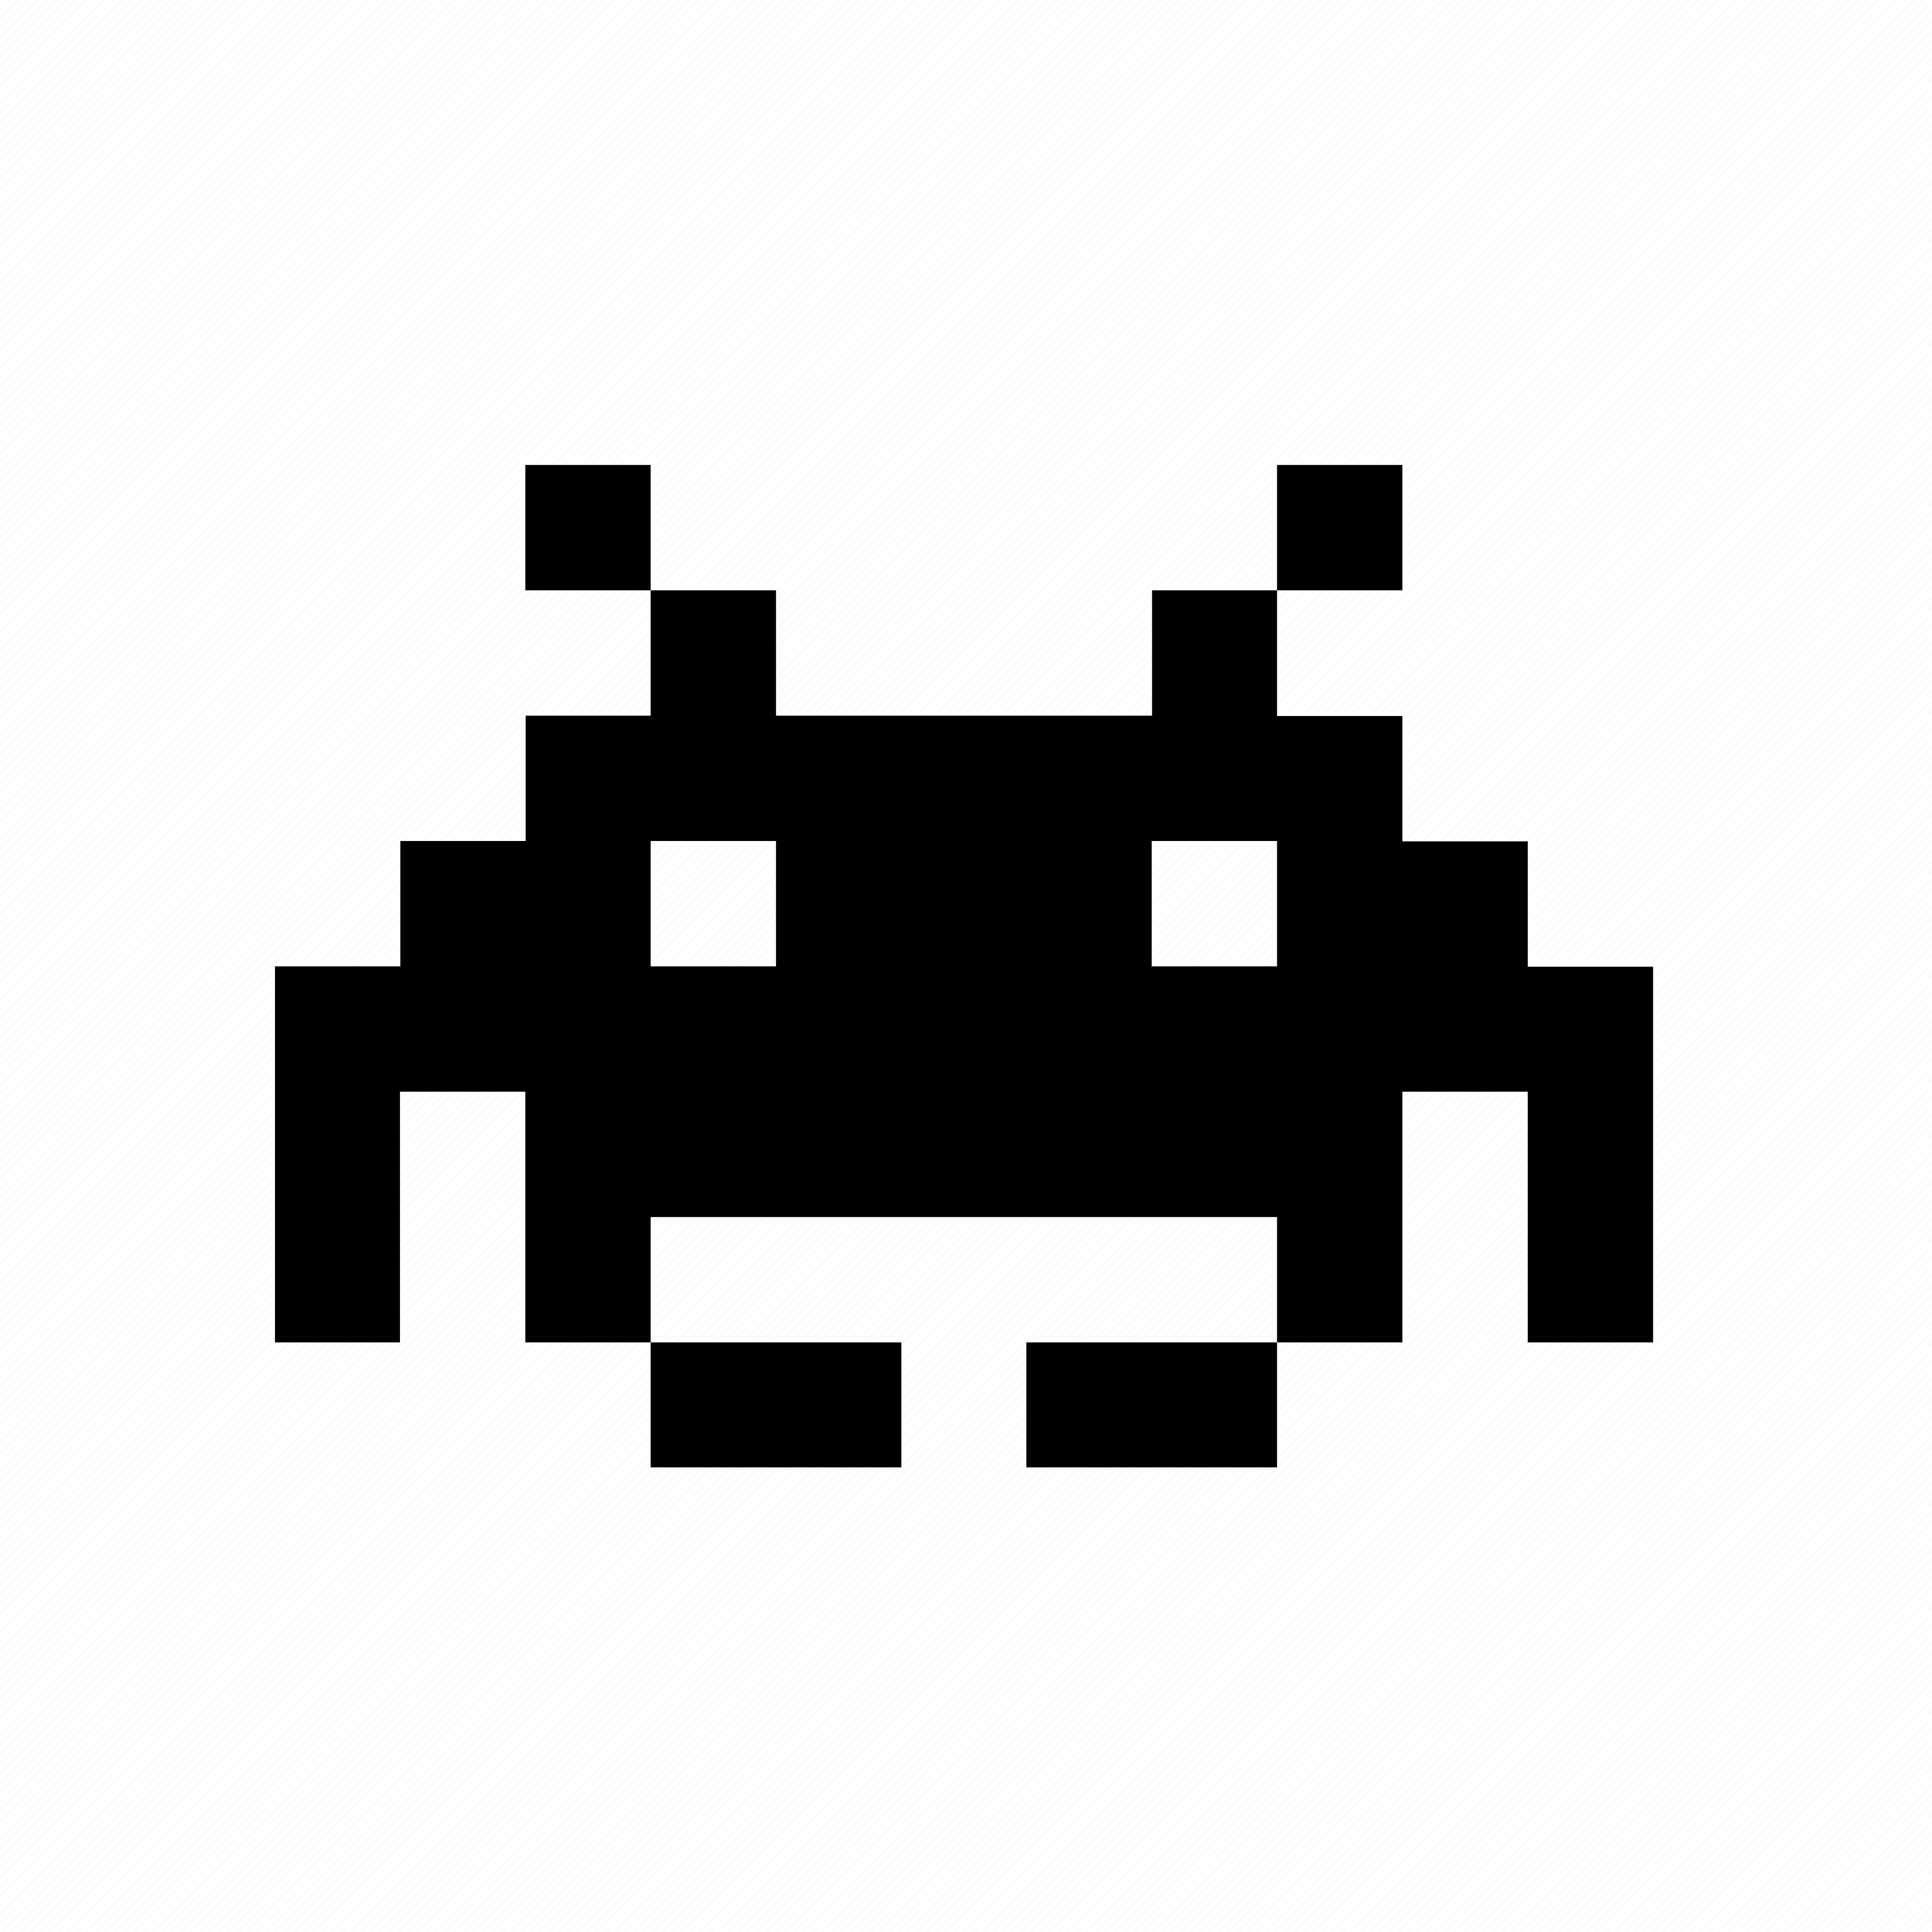**SPACE INVADERS**

Space Invaders is a classic arcade game where players take control of a spaceship defending Earth from an alien invasion. Armed with a laser cannon, your mission is to eliminate swarms of descending alien invaders before they reach the ground. As each wave of enemies is defeated, a new one automatically appears. Be strategic, as you can only fire a special type of missile once you consecutively kill targets. Get ready to save the planet in this nostalgic HTML5 version inspired by the original game! 🚀👾

**SOFTWARE REQUIREMENTS**

* As a player, I want to control a spaceship using keyboard inputs (left and right arrows) so that I can manoeuvre and defend against invading enemies.
* As a player, I want to shoot projectiles (bullets) from my spaceship to eliminate enemy invaders, ensuring Earth’s safety.
* As a player, I want to face increasing difficulty levels as I progress, with faster enemy movement and challenging formations.
* As a player, I want to collect power-ups for temporary advantages, like enhanced firepower or shields.
* As a player, I want to experience responsive gameplay across different devices and screen sizes.
* As a player, I want to hear sound effects for actions like shooting, enemy destruction, and game over.
* As a player, I want to track my score based on the number of enemy invaders I destroy.
* As a player, I want to see a user interface with start and game-over screens, as well as a score display.
* As a player, I want to pause and resume the game during gameplay.
* As a player, I want to compete for the highest score, which persists across different game sessions.
* As a developer, I want to implement a canvas element using HTML5 to serve as the game viewport.
* As a developer, I want to generate multiple rows of enemy invaders at the top of the canvas.
* As a developer, I want to detect collisions between projectiles and enemy invaders or the player’s spaceship.
* As a developer, I want to design and code enemy movement patterns (horizontal motion, direction changes).
* As a developer, I want to store and manage high scores for players.