PS 647: Group Project

Digital Financial Infrastructure and Financial Inclusion in India
A state-level panel study of the access-usage gap
Yuvraj Parekh
Roll No. 23B2708
Avani Gala
Roll No. 23B2405
Aryan Kashyap
Roll No. 23B0741
Sahil Jana
Roll No. 23BXXXX
Kashish Jain
Roll No. 23BXXXX

PS647: Data Analytics for Public Policy
Course instructor: Prof. Ashish Desai
Ashank Desai Centre for Policy Studies (ADCPS)
September 12, 2026

Contents
Abstract
1 Introduction, Background and Literature
1.1 The puzzle
1.2 Background
1.3 Literature
1.4 Hypotheses
1.5 Contribution and roadmap
2 Data and Panel Construction
2.1 Unit of analysis and coverage
2.2 Sources
2.3 The year-alignment rule
2.4 State harmonisation
2.5 Validation
2.6 The digital payment series
2.7 Known limitations of the data
2.8 What the hypothesis chapters draw from this panel
3 Hypothesis 1: Infrastructure and the Access-Usage Gap
3.1 Hypothesis and pre-commitment
3.2 Variables and specification
3.3 The diagnostic that governs everything
3.4 Tracks 1 and 2: physical infrastructure
3.5 Track 3: substituting the infrastructure that moved
3.6 Verdict
3.7 Limitations
4 Hypothesis 2: [Title to be supplied]
5 Hypothesis 3: Digital Literacy and Income as Complements
6 Discussion and Conclusion
6.1 Synthesis
6.2 Implications for policy
6.3 Implications for method
6.4 Directions for further work
6.5 Conclusion
A Decision Log
Acknowledgement of AI Assistance

Chapter 1

Introduction, Background and Literature

1.1 The puzzle
Between 2011 and 2017 the share of Indian adults holding a bank account rose from 35 to 80 per cent (Demirgüç-Kunt et al., 2022), reaching roughly 89 per cent by the 2025 Global Findex round (World Bank, 2025). Much of that movement came from a single programme: the Pradhan Mantri Jan Dhan Yojana (PMJDY), launched in August 2014, under which more than 56 crore accounts had been opened by August 2025 (Press Information Bureau, Government of India, 2025). Measured by the indicator that dominates international league tables, India solved financial exclusion inside a decade.
The same surveys record a second fact that sits uncomfortably beside the first. India has the largest share of inactive accounts of any country measured: roughly 35 per cent of Indian adults who own an account report that it is dormant, some seven times the 5 per cent average across other developing economies (Demirgüç-Kunt et al., 2022). Official figures point the same way: about 26 per cent of PMJDY accounts, some 15 crore, are reported inoperative, with an average balance of roughly Rs. 4,808 (Press Information Bureau, Government of India, 2025). Among adults holding a dormant account, 49 per cent cite distance to the institution and 46 per cent say they did not need an account (Demirgüç-Kunt et al., 2022).
An account that exists but is never used counts as inclusion in every headline statistic while delivering none of the consumption-smoothing, risk-pooling, or credit benefits that justify the policy effort. The gap between having an account and using one is the central empirical object of this report, and we refer to it throughout as the access-usage gap.
The gap could arise from low incomes, informality, distrust, poor financial literacy, or the simple fact that many accounts were opened to receive a one-off transfer. This report examines a candidate that policy can actually move: the infrastructure through which banking is delivered. The reasoning is asymmetric in an important way. Opening an account is largely a supply-side decision: banks can be given targets and audited against them, and Indian branch licensing has been used this way since the 1970s. Using an account is a demand-side decision shaped by income, informality, and trust. Infrastructure relaxes the first constraint directly; whether it relaxes the second is an empirical question. If the asymmetry is real, expanding infrastructure should raise measured access more than measured usage, and the gap should widen as infrastructure expands. Expansion would be, in a phrase used throughout, formal rather than functional.

1.2 Background
Three policy waves have shaped Indian financial inclusion, and this study's sample period sits inside the third. Following bank nationalisation in 1969, the RBI operated a licensing rule under which a bank could open a branch in an already-banked location only if it also opened four in unbanked ones (Burgess and Pande, 2005); the resulting 1977-1990 expansion remains the most studied episode in the Indian financial-development literature. From the mid-2000s financial inclusion became an explicit objective, bringing the no-frills account, the business correspondent model, and the Rangarajan Committee report (Committee on Financial Inclusion, 2008), together with measurement frameworks (Sarma, 2008; Sarma and Pais, 2012). From 2014, PMJDY drove ownership toward saturation while the technology stack sometimes called “India Stack”, biometric identity, interoperable real-time payments, and consented data sharing, rewired how retail payments are made (D’Silva et al., 2019). The Unified Payments Interface processed roughly 83.7 billion transactions in calendar 2023, 131.1 billion in 2024, and 228.3 billion in 2025 (National Payments Corporation of India, 2025). This report’s sample window sits almost exactly on top of that transition, a point taken up in Section 3.5.
India also measures inclusion officially. The RBI’s composite Financial Inclusion Index rose from 64.2 in March 2024 to 67.0 in March 2025 (Reserve Bank of India, 2025a), and is built from three parameters with fixed weights: Access 35 per cent, Usage 45 per cent, Quality 20 per cent. Two observations follow. First, the RBI’s own scheme weights usage above access, an implicit acknowledgement that account counts overstate inclusion. Second, those weights exist to collapse three dimensions into one number, whereas this report does the opposite: it holds Access and Usage apart precisely so their difference can be estimated and tested. The weights are therefore not applicable here, and Section 3.2 records why applying them would have been an error rather than a refinement.

1.3 Literature
Access as a supply-side lever. The foundational result is Burgess and Pande (2005), who exploit the 1977-1990 licensing rule as policy-driven variation in rural branch openings and find that branch expansion reduced rural poverty. The paper established both a substantive claim, that physical banking infrastructure has real welfare consequences, and a methodological template: administrative state panels, with infrastructure variation that is not simply a response to local prosperity. The broader literature is consistent: Beck et al. (2007) find financial development disproportionately raises the incomes of the poor, and Allen et al. (2016) document that cost and proximity are among the strongest correlates of both ownership and use. One caution prefigures our own conclusion. Buliskeria and Baxa (2022) revisit Burgess and Pande (2005) and find the poverty effect does not survive once additional policy breaks are accounted for. The lesson is not that branches do not matter, but that in this literature the identifying variation is often thinner and more fragile than it appears, and claims should be stress-tested against perturbations of the sample. Chapter 3 does exactly that, and the stress test produces its most informative result.
Access is not usage. A large experimental literature establishes that removing the barriers to opening an account does not reliably produce use of it. The clearest statement is Dupas et al. (2018), who randomly offered free basic accounts in Uganda, Malawi, and Chile: over two years only 17, 10, and 3 per cent of treated individuals respectively made five or more deposits, and intention-to-treat effects on savings were indistinguishable from zero. Their conclusion is the proposition this report takes to Indian administrative data: policies focused merely on expanding access to basic accounts are unlikely to improve welfare noticeably on average. Karlan et al. (2014) reach a compatible position, finding the binding constraints frequently behavioural and transactional rather than a matter of account availability. This report’s contribution to the strand is one of scale and setting: the experimental evidence is individual-level and drawn from three countries, and we ask whether the same wedge is visible in the administrative aggregates of a country of 1.4 billion people, and whether it responds to the infrastructure variable Indian policy actually controls.
Measuring inclusion. How inclusion is measured determines what can be found. Sarma (2008); Sarma and Pais (2012) construct a multidimensional index combining penetration, availability, and usage; the RBI’s FI-Index follows the same logic. Composite indices suit ranking and monitoring, but they are poorly suited to the question asked here: if access and usage are averaged into one index, the wedge between them becomes unobservable by construction, and the wedge is the object of interest. This report therefore departs from the index tradition deliberately.
Digital payments and the substitution of channels. The final strand asks whether physical infrastructure is still the relevant infrastructure. Suri and Jack (2016) show that expanded mobile-money access in Kenya produced long-run poverty reductions operating through risk-sharing and occupational change rather than account ownership as such. Crouzet et al. (2023) show how India’s 2016 demonetisation triggered durable adoption of electronic payments, shaped by network effects rather than infrastructure stock. D’Silva et al. (2019) argue that the design of India’s digital public infrastructure, rather than the density of physical bank premises, is what changed the cost of a transaction. These matter for interpretation: if the marginal channel for financial activity shifted from the branch to the phone during our window, a null result for branches and ATMs may be a substantive statement about channel substitution rather than a measurement failure.
Where this report sits. The experimental literature establishes the access-usage wedge at the individual level but cannot speak to national infrastructure policy; the Indian panel literature establishes that infrastructure has real effects but treats inclusion as a single dimension. We combine the two: an administrative state panel, with access and usage held apart as separate outcomes, so that the differential effect of infrastructure can be estimated directly.

1.4 Hypotheses
The report tests three hypotheses. The first is developed and estimated in full in Chapter 3; the remaining two are reported in Chapters 4 and 5.
Hypothesis 1 (Chapter 3)
Greater financial infrastructure raises financial inclusion, but its effect on access is stronger than its effect on usage.
Rationale. Opening an account is a supply-side decision that banks can be pushed to make. Using an account is a demand-side decision shaped by income, trust, and informality. Infrastructure removes the first constraint, not the second.
Expected: βaccess > βusage > 0, with the difference statistically significant.
To be completed: State Hypothesis 2 in the same format and develop it in Chapter 4.
Hypothesis 2 (Chapter 4)
[Statement to be supplied.]
Hypothesis 3 (Chapter 5)
The positive effect of digital financial infrastructure on financial inclusion is stronger in states with higher levels of digital literacy, and stronger in states with higher incomes. Digital literacy and income act as complements to infrastructure rather than as substitutes for it.
Rationale. Opening an account asks nothing of the holder beyond identity documents; a bank can be given a target and audited against it. Using an account asks the holder to operate the channel through which it is used. Infrastructure therefore relaxes the access constraint wherever it is built, but relaxes the usage constraint only where the ability to use it already exists. Income is the rival explanation and is tested alongside, because the two are correlated and either can be mistaken for the other.
Expected: a positive interaction between infrastructure and each of the two moderators. If either is genuinely a complement to infrastructure rather than a marker of general development, the interaction should be larger on usage outcomes than on access outcomes, and the difference should be distinguishable from zero.

Chapter 2

Data and Panel Construction

2.1 Unit of analysis and coverage
Table 2.1: Panel coverage
Panel | Window | Years | States | N | Infrastructure measured
Track 1 | FY2018-FY2023 | 6 | 33 | 198 | Branches and ATMs
Track 2 | FY2012-FY2023 | 12 | 32 | 384 | Branches only
Track 3 | FY2019-FY2023 | 5 | 33 | 165 | Branches, ATMs and UPI
All three panels are balanced and complete: every state appears in every year, with no missing cells and no non-positive values in any series. The state counts differ for one documented reason given in Section 2.4. ATMs cannot be extended before 2018, because RBI’s state-wise release begins there, which is why Track 2 carries branches alone; Track 3 starts at FY2019 because that is the first complete financial year of digital payment data. Track 3’s banking columns are asserted identical to Track 1’s, so the earlier results remain reproducible from an untouched file and the tracks stay directly comparable.

2.2 Sources
Nine series are used. Eight are official publications of the RBI or the Government of India, with one academic redistribution filling a single year; the ninth is the digital payment series introduced for Track 3.
Table 2.2: Source of each series
Series | Publication | Table / report | Role
Bank branches | RBI Handbook of Statistics on Indian States, 2024-25 | Table 152, bank offices of scheduled commercial banks, end-March | Independent
ATMs | RBI State-wise and Region-wise Deployment of ATMs | Standalone quarterly release; end-March files 2018-2024 | Independent
Deposit accounts | RBI Basic Statistical Returns (BSR-2), via DBIE/CIMS | Report 853, Annual BSR-2 Table 2.3; 31 March 2018 from India Data Portal | Access
Credit accounts | RBI Basic Statistical Returns (BSR-1), via India Data Portal | Derived state-year credit accounts 2010-2023, including RRBs | Access
Deposits outstanding | RBI Handbook | Table 155, deposits of SCBs (Rs. crore) | Usage
Credit outstanding | RBI Handbook | Table 156, credit of SCBs (Rs. crore) | Usage
Per-capita NSDP | RBI Handbook | Table 19, per-capita NSDP, current prices | Control
Adult population | Technical Group on Population Projections (2020) | Annual totals with quinquennial age structure; 1 March series | Denominator
Digital payments | PhonePe Pulse open data release | Registered users, transaction count and value, by state and quarter | Independent
Digital literacy | NFHS-5 (2019-21), IIPS | State fact sheets, indicators 18 and 19: women and men who have ever used the internet | Moderator
Mobile-phone ownership | NFHS-4 (2015-16), IIPS | State fact sheets, indicator 123, women owning a mobile phone they themselves use | Moderator, pre-window
ICT skills | NSS 75th round (2017-18), MoSPI | Tables 13 and 14, persons aged 5+ able to operate a computer or use the internet; 22 major states | Moderator, robustness
Household consumption | HCES 2022-23, MoSPI | Fact Sheet, Statement 8, average MPCE by State/UT, rural and urban | Moderator, robustness
Education and inclusion baselines | NFHS-5 and NFHS-4, IIPS | Indicators 1, 16 and 17 (schooling); indicator 122 (women's own bank account) | Placebo controls
General literacy | Census of India 2011 | State literacy rate | Placebo control

2.3 The year-alignment rule
Three year conventions are in play, and they disagree on labels even when they agree on dates. This is the easiest place in the project to introduce a silent one-year offset, an error that produces no missing value, no warning, and no implausible number, and simply biases every estimate. The Handbook banking tables and the ATM release label a stock as at 31 March 2018 as 2018; the Handbook NSDP tables call the same financial year 2017-18; the population projections date their stock 1 March 2018.
Alignment rule (D5, D9)
Banking year Y ≡ NSDP financial year (Y − 1)-Y ≡ population at 1 March Y.
All three are recorded in one canonical column, fy_end, added to all eight input files. Merging and filtering use fy_end only, and it supplies the year fixed effect.
Of the eight files only the income file required conversion; native labels were retained alongside fy_end so the original coding stays auditable. The 1 March population series is used rather than 1 July or 1 October: every numerator is a stock at 31 March, so the denominator must be a stock at approximately the same instant, one month away rather than six. The rule was verified against published figures rather than assumed, as Section 2.5 records.

2.4 State harmonisation
Fixed effects require each unit to denote the same thing in every year. India’s boundaries changed inside both windows and, more awkwardly, different sources record the same change in different years. Three adjustments follow.
Units dropped (D1). Lakshadweep and the combined Dadra & Nagar Haveli and Daman & Diu are dropped: no per-capita NSDP is published for either in any year, so neither can carry the income control. Both are very small; the panel goes from 35 units to 33.
Units merged (D2). Jammu & Kashmir with Ladakh, and Dadra & Nagar Haveli with Daman and Diu, in every year. Merging only from the year of the formal change fails because the sources disagree about when that was: in the Handbook, Daman & Diu goes blank from 2020 exactly as Dadra & Nagar Haveli jumps from 59 to 110 branches, whereas the ATM files keep three separate columns until 2021. Summing all components in all years is the only rule producing a continuous series in both sources simultaneously.
Andhra Pradesh and Telangana, twelve-year panel only (D13). Telangana was carved out of Andhra Pradesh in June 2014, so in the twelve-year panel it shows zero branches, deposits and credit for 2012-2014, its activity being recorded inside Andhra Pradesh. Branches confirm the mechanism exactly: Andhra Pradesh falls from 9,900 in 2014 to 6,290 in 2015 as Telangana appears with 4,721, and the combined series runs continuously from 9,900 to 11,011. The two are therefore summed in every year, which is why Track 2 has 32 units. The failure mode is instructive: had the merge been missed, three state-years would have entered recording zero infrastructure alongside zero deposits, outliers positioned precisely to manufacture a spurious positive association between infrastructure and inclusion, the sign the hypothesis predicts. It was caught by a completeness check flagging zeros, not by inspecting results.
General rule
Merges are performed on raw levels, branches, ATMs, deposits, credit, account counts, population, before any ratio is computed. Ratios are never averaged across merged units.
After upper-casing and standardising “AND” to “&”, 34 of 37 units match exactly across sources; the exceptions are Delhi, Jammu & Kashmir, and Daman & Diu, each named differently in the population or ATM files. Matching uses word boundaries rather than substrings: a naive substring test folds ANDAMAN into the Daman group, an error that occurred once during preparation and is now guarded by an explicit assertion.

2.5 Validation
The panel was checked against independently published aggregates rather than accepted on trust. All-India ATM totals recomputed from the state columns match RBI’s published national figures exactly in every year 2018-2024 (222,066 in 2018 through 257,654 in 2024; the 2024 decline is genuine decommissioning, not a parsing error). State-by-year deposit amounts differ from Handbook Table 155 by a median of 0.0001 per cent, and credit amounts from Table 156 by 0.001 per cent. Population totals reproduce from the sum of age bands, and the published 18+ figure reproduces from a residual identity, for all 23 states that print it. On year alignment, Maharashtra at fy_end = 2018 returns 12,545 branches, 25,651 ATMs and per-capita income of Rs. 172,663, all matching RBI’s published values exactly, confirming no offset was introduced. Completeness is asserted in code: 198 and 384 rows, balanced, no nulls, no zeros.

2.6 The digital payment series
Track 3 requires a measure of digital financial infrastructure at state level. India has no official state-wise UPI release covering the full window, so the series used is PhonePe Pulse (PhonePe, 2026), the open data release of one of the two largest UPI applications: registered users, transaction counts and transaction value, by state and calendar quarter.
Conversion to the panel’s year convention follows the same rule as everything else. Transactions and value are flows, summed over the four quarters making up each financial year; registered users is a stock, taken at the quarter ending 31 March and verified monotone across all quarter transitions. Denominators follow the same access/usage distinction as the banking series: registered users per adult, transactions and value per capita. Coverage is complete, 36 raw states across 34 quarters with no gaps and no missing amounts, and every one of the 33 panel states is present in every year.
Four independent validations were run rather than taking the release on trust. The transaction-type split (peer-to-peer, retail, utility) reproduces the aggregate total to 0.000000 per cent across all 1,224 state-quarters, meaning two independently maintained trees within the release agree exactly. Registered users reach 45.5 crore at 31 March 2023, against PhonePe’s own publicly stated figure of over 45 crore. Transactions total 44.3 billion in FY2023 against roughly 84 billion for all of UPI that year (National Payments Corporation of India, 2025), consistent with the firm’s approximately 50 per cent market share. And the implied mean ticket size of Rs. 1,593 confirms amounts are denominated in rupees rather than paise.
Three caveats follow the series into the analysis and are revisited in Section 3.7. PhonePe is one firm, not the market, so this measures PhonePe penetration as a proxy for digital payment penetration, and because market share varies by state, cross-state levels are noisier than within-state growth, which is fortunate, since within-state growth is what the estimator uses. Registered users are accounts, not people, so one person with two numbers counts twice. And transactions are attributed to the user’s registered state, a third attribution rule alongside the branch-location and place-of-sanction rules already in the panel.

2.7 Known limitations of the data
Three defects are carried openly rather than silently repaired, and each is revisited where it bears on results.
A break in RBI’s own deposit-account series (D7). The savings-account column of BSR-2 is discontinuous for three states: Delhi runs 35.5, 38.7, 106.1, 130.9, 159.4 million accounts, breaking from 2023 and persisting; Haryana runs 47.7, 52.6, 102.1, breaking from 2024; Chandigarh runs 2.98, 5.03, 3.25, spiking in 2023 and reverting. This is an error in RBI’s published source, not in extraction, the component columns reproduce the published total exactly wherever both are printed, and the likely cause is a bank reclassifying savings accounts to a head-office location. The symptom is visible downstream: deposit accounts per adult reaches 7.99 for Delhi in 2023 and 7.69 for Chandigarh in 2023, against roughly 1 to 3.5 elsewhere. Two of the four affected cells fall inside FY2018-FY2023. The decision, taken before estimation, was to retain them in the main specification and re-run without them as a robustness check; Section 3.4.2 reports what happened, and it is the most consequential result in the report. Goa sits at 5.45-5.73 across all six years and Chandigarh at 5.1-5.4 outside 2023, high but flat, so genuine levels rather than defects.
Adult population is interpolated, not published (D6). The projections publish annual totals for 2011-2036 but age structure only at five-year anchors, so there is no published annual adult count. The 18+ series is derived: the adult share is linearly interpolated between anchors and applied to the published annual total. Totals are official; adult counts are ours. Of the 266 state-years in the underlying file, 243 rest on an interpolated share. The consequence goes beyond ordinary measurement error, as Section 3.3 develops: being near-linear, the series is unusually smooth, and as the denominator of every per-adult ratio it contributes almost no independent variation, it deflates a trend without adding movement to it. A further caveat attaches to a few units: the source excludes Goa from its age-structure exercise and reports the seven smaller north-eastern states only in combination, so proxy shares were assigned and flagged.
Universe and basis of the credit-account series (D8). The two halves of Access initially rested on different bank universes: deposit accounts from BSR-2 include regional rural banks, while the quarterly BSR-1 credit series excludes them and records loans by place of sanction rather than utilisation. Excluding RRBs removes a median of roughly 18 per cent of credit accounts nationally, but unevenly, 65 per cent in Mizoram, 39 in Tripura, 33 in Uttar Pradesh, and the share drifts within states over time, so state fixed effects do not absorb it. Critically, it bites hardest in exactly the rural, lower-income states the hypothesis is about. The series was therefore switched to an RRB-inclusive, place-of-utilisation file covering 2010-2023. The two could not be reconciled arithmetically, differencing them produced impossible negative values for Maharashtra, because they differ on where a loan is counted as well as on which banks, so this is a replacement, not an adjustment. The cost is FY2024, which fixes FY2018-FY2023 at six years; the incidental benefit is that the last missing cell, Gujarat’s FY2023-24 income, falls outside the window, leaving the panel perfectly balanced. One asymmetry remains: deposit accounts are recorded by branch location and credit accounts by place of utilisation, and neither corresponds to depositor or borrower residence.
Coverage of the pre-window ICT measure (D20). The published NSS 75th round state tables cover 22 major states only; every north-eastern state and small union territory is absent. Using that series as the primary moderator would have dropped 11 of 33 states and removed most of the upper tail of the digital-literacy distribution, so it is reported as a robustness measure at n = 22 and the primary moderator is taken from NFHS-5, which covers all 33. Where both exist they correlate 0.87 on computer ability and 0.90 on internet ability, so the substitution is between two measurements of the same quantity rather than between two quantities.
The survey values were verified, not assumed. The NFHS-5 figures were taken from a compiled mirror whose author flags it as not extensively cross-checked, and were tested against eight independently published fact sheet figures before use; all eight matched exactly. The check runs on every build and aborts on any mismatch.
Urbanisation is derived, not published. No verifiable machine-readable Census 2011 state urbanisation table was obtained, so the urban share used as a placebo control is derived from the NFHS-5 urban, rural and total decomposition. It tracks Census 2011 closely where both are known (Delhi 98.2 against 97.5, Kerala 48.6 against 47.7, Maharashtra 46.7 against 45.2) but it is a survey-sample quantity and is labelled as such. It is never used as a headline variable. Census 2011 literacy, used in the same role, conflates Andhra Pradesh and Telangana, which did not exist separately in 2011.
Two income measures, and they are not interchangeable (D25). Per-capita NSDP is a production measure: output books to the state where a firm is registered, the same attribution problem recorded above for deposits held at branch location. MPCE from HCES 2022-23 is household consumption collected from households. The two correlate 0.844, and Chapter 5 shows that the choice between them changes the result, so both are reported. MPCE is published separately for rural and urban areas and the two are combined at each state's derived urban share.

2.8 What the hypothesis chapters draw from this panel
Chapter 3 uses all nine series: the eight banking and demographic series across all three tracks, and the digital payment series for Track 3.
Chapter 5 uses the same nine series and adds six state-level cross-sections that carry no time dimension: digital literacy and general education from NFHS-5, their 2015-16 counterparts from NFHS-4, ICT skills from the NSS 75th round, household consumption from HCES 2022-23, and Census 2011 literacy. None enters as a time-varying regressor. Each is one number per state, interacted with the digital payment measure already described in Section 2.6, and each is harmonised onto the same 33 units by the rules in Section 2.4.

Chapter 3

Hypothesis 1: Infrastructure and the Access-Usage Gap
The hypothesis is tested on three panels, built in the order they appear here. Tracks 1 and 2 measure infrastructure physically, as branches and ATMs; both fail, and Section 3.3 shows they were always going to. Track 3 substitutes the infrastructure that actually moved over the sample window, digital payments, and recovers the pattern the hypothesis predicts. The distinction between what was pre-committed and what came afterwards is load-bearing throughout, and Section 3.6.2 states it plainly rather than leaving it to a footnote.
Table 3.1: The three tracks
Track | Window | N | Infrastructure measured | Outcome
1 | FY2018-FY2023 | 198 | Branches, ATMs | Fails; cannot be tested
2 | FY2012-FY2023 | 384 | Branches only | Fails; fragility removed
3 | FY2019-FY2023 | 165 | Branches, ATMs, UPI | Predicted pattern recovered

3.1 Hypothesis and pre-commitment
Hypothesis 1
Greater financial infrastructure raises financial inclusion, but its effect on access is stronger than its effect on usage.
Rationale. Opening an account is a supply-side decision that banks can be pushed to make. Using an account is a demand-side decision shaped by income, trust, and informality. Infrastructure removes the first constraint, not the second.
Expected: βaccess > βusage > 0, with the difference statistically significant.
The hypothesis is directional twice over: both effects should be positive, and the access effect should be larger. Positive and equal effects would reject it while remaining a substantive result, genuine deepening rather than formal expansion. Both effects at zero would be uninformative until the identifying variation had been examined. These readings were tabulated in advance, and Section 3.6 returns to that table.
Before any coefficient was estimated, a rule was fixed in writing for what would count as support.
Decision rule, fixed before any result was seen (D10)
Hypothesis 1 is fully supported only if βaccess > βusage > 0 holds for branches and for ATMs. If it holds for only one, that is reported as partial support, naming which. This is pre-committed; it is not to be revised after the coefficients are seen.
Two features of that rule matter for everything below. It names branches and ATMs specifically: UPI is not in it, because UPI was not in the design when it was written. And it was not revised: the physical verdict reported in Section 3.6 is the verdict the rule returns.
A second pre-commitment was recorded after the pre-estimation diagnostic failed and before estimation proceeded: a null result does not license the conclusion “infrastructure does not raise access”, being indistinguishable from “the regressors moved too little to detect an effect”; any null must be reported with the within-state variation figures attached (D11).

3.2 Variables and specification

3.2.1 Independent variables
Infrastructure enters in natural units, with no composite index:
Branch_it = (branches_it / adults_it) × 10⁵, ATM_it = (ATMs_it / adults_it) × 10⁵, UPI_it = (registered users_it / adults_it).
An earlier design combined branches, ATMs and PMJDY accounts into one normalised index. It was abandoned for three reasons (D3, D10). PMJDY had to go, and its removal proved load-bearing: PMJDY accounts are an account count, so placing them among the regressors while deposit and credit account counts sit among the outcomes would put an account count on both sides of the equation, manufacturing exactly the mechanical correlation the design warns against. Separating branches from ATMs is statistically safe: their raw correlation is 0.904, but that is almost entirely cross-sectional, and after state and year demeaning, the variation the model actually uses, it falls to 0.305, with a variance inflation factor of 1.10. Separating them makes a prediction an index cannot: a branch is where an account is opened, an ATM where it is used. Abandoning the index also removed two arbitrary choices, the 0-1 rescaling of the regressors and the branches-versus-ATMs weighting, and left coefficients in interpretable units.
For Track 3, the digital measure is registered UPI users per adult, in levels. Three candidates existed. Transactions per capita and value per capita were rejected as regressors because they are themselves usage of the digital channel, and using a flow to explain a flow of the same kind would be close to circular. Registered users is an adoption stock, whether the channel is available and taken up at all, which is the role branches and ATMs play on the physical side. Levels rather than logs keeps all three infrastructure regressors in the same kind of unit (D16).

3.2.2 Dependent variables
Four indicators form two constructs, with denominators the design distinguishes deliberately: access is measured per adult, usage per capita.
Table 3.2: Construction of the dependent variables
Construct | Indicator | Denominator | Entangled with UPI?
Access | Deposit accounts per adult | Population 18+ | Yes (see §3.5.2)
Access | Credit accounts per adult | Population 18+ | No
Usage | Deposits per capita (Rs.) | Total population | No
Usage | Credit per capita (Rs.) | Total population | No
Each indicator is rescaled by pooled min-max normalisation, x̃_it = (x_it − min x)/(max x − min x), with the extremes taken over all state-years rather than within each year, so that genuine growth over time, which is what the fixed-effects model estimates from, is preserved rather than erased. The constructs are the simple average of their two components, and the gap is their difference: Access = ½(d̃ + c̃), Usage = ½(D̃ + C̃), AUG = Access − Usage. The normalisation for Track 3 is held at the Track 1 scaling, so the dependent variables are identical across tracks and the results stay comparable (D15).

3.2.3 Specification
Three equations are estimated by two-way fixed effects with standard errors clustered by state. Writing X_it for the infrastructure regressors, branches and ATMs in Tracks 1 and 3, branches alone in Track 2, with UPI added in Track 3:
Access_it = α_i + λ_t + β’X_it + γ ln NSDP_it + ε_it (3.1)
Usage_it = α_i + λ_t + δ’X_it + γ ln NSDP_it + ε_it (3.2)
AUG_it = α_i + λ_t + θ’X_it + γ ln NSDP_it + ε_it (3.3)
State effects α_i absorb everything fixed within a state, geography, banking legacy, 2011 baselines, and year effects λ_t absorb national shocks common to all states, which over this window include COVID-19, PMJDY account opening, and the national growth of UPI. Estimates are therefore identified from within-state variation over time, relative to the national trend in that year; all cross-sectional variation is discarded. That is the right specification for the causal question and, as Section 3.3 shows, the source of the study’s central difficulty. With 33 clusters, cluster-robust standard errors sit at the lower end of the range in which the asymptotic approximation is reliable (Cameron and Miller, 2015).
Equation (3.3) is not a third finding. Since AUG is defined as Access − Usage and all three equations share a right-hand side, linearity gives θk = βk − δk exactly. It contains no information beyond the first two equations; its purpose is to supply the standard error on the difference, which is the formal test of the hypothesis. The claim is not merely that β > δ in point estimates, but that the gap is distinguishable from zero. The identity is asserted numerically at every estimation.

3.3 The diagnostic that governs everything
The design specifies this diagnostic first, and specifies it as a gate rather than as description: if infrastructure barely moves within states, fixed effects have nothing to estimate from. Thresholds were fixed before the numbers were computed: a within-state share of variation below 10 per cent is a FAIL, below 25 per cent WEAK, at or above 25 per cent a PASS.
Table 3.3: Variance decomposition. Thresholds fixed before computation: FAIL < 10%, WEAK < 25%, PASS ≥ 25%
Variable | Overall SD | Between SD | Within SD | Within share | Verdict
Physical regressors, FY2018-FY2023
Branches per lakh adults | 11.455 | 11.574 | 0.805 | 7.0% | FAIL
ATMs per lakh adults | 18.925 | 19.097 | 1.651 | 8.7% | FAIL
Outcomes and control, same panel
Access | 0.172 | 0.167 | 0.049 | 28.4% | n/a
Usage | 0.200 | 0.201 | 0.029 | 14.4% | n/a
AUG | 0.128 | 0.127 | 0.029 | 22.9% | n/a
ln(NSDP per capita) | 0.541 | 0.528 | 0.147 | 27.1% | n/a
Digital regressors, FY2019-FY2023 (Track 3)
UPI users per adult | n/a | n/a | n/a | 67.1% | PASS
UPI transactions per capita | n/a | n/a | n/a | 79.9% | PASS
UPI value per capita | n/a | n/a | n/a | 78.8% | PASS
The gate failed for physical infrastructure, and only for physical infrastructure
Roughly 93 per cent of the variation in branches and ATMs is between states, which is exactly what two-way fixed effects discard. The digital series clear the PASS threshold by a factor of three to eight.
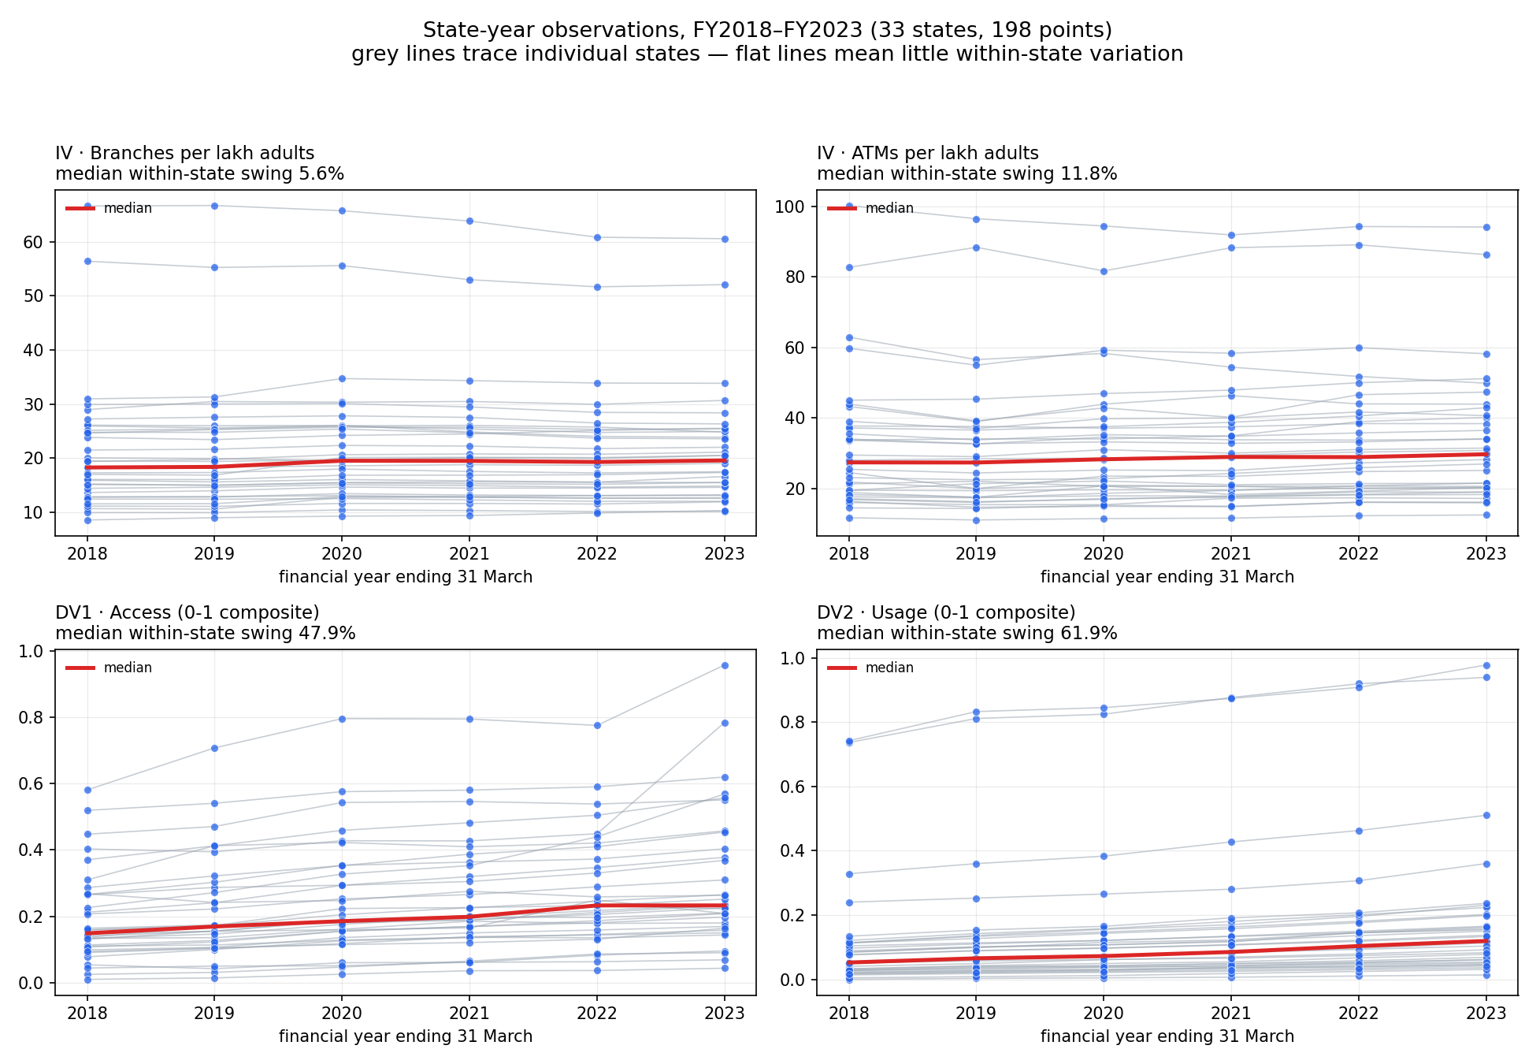
Figure 3.1: The identification problem. Each grey line traces one state across FY2018-FY2023; the red line is the cross-state median. Top row, the regressors: state lines run flat, with median within-state swings of 5.6 per cent (branches) and 11.8 per cent (ATMs). Bottom row, the outcomes: the same states climb steadily, swinging 47.9 and 61.9 per cent. Fixed effects use only the vertical movement of individual lines, and there is very little of it in the top row.

3.3.1 Why the physical variation is so thin
Three mechanisms compound, diagnosed before any coefficient was examined. Infrastructure stocks are slow-moving: raw branch counts swing a median of only 10.7 per cent within a state across six years, 3.6 per cent in Chandigarh, 3.7 in Punjab. The denominator cancels much of what remains: adult population grows a median 10.2 per cent within states over the window, in the same direction as branches, so branches per lakh adults swing only 5.6 per cent; because the adult series is interpolated (Section 2.7) it is almost perfectly smooth and contributes no independent variation, merely deflating a trend. The outcomes move five to ten times more than the regressors: credit accounts have a 30.0 per cent within share against 7.0 for branches. Wide standard errors are guaranteed by construction, whether or not an effect exists.
The problem is confined to the regressors, the outcomes and the control have ample within-state variation. The panel is not too short in general; it is too short for physical infrastructure. Lengthening the window helps but does not cure: the within share for branches rises from 7.0 per cent over six years to 13.4 over ten, 20.1 over twelve, and 23.2 over thirteen, still short of the PASS line. ATMs cannot follow at all, since the state-wise release begins in 2018. This is what motivates Track 2, and ultimately what motivates Track 3.

3.4 Tracks 1 and 2: physical infrastructure
Table 3.4: Two-way fixed-effects estimates, physical infrastructure. State and year effects throughout; standard errors clustered by state. Track 2 drops ATMs, which cannot be extended before 2018.
Equation | Regressor | Track 1 Coef. | Track 1 SE | Track 1 p | Track 2 Coef. | Track 2 SE | Track 2 p
(1) Access | Branches | −0.00897 | 0.00699 | 0.201 | −0.00483 | 0.00645 | 0.455
 | ATMs | −0.00164 | 0.00377 | 0.664 | n/a
(2) Usage | Branches | −0.01264 | 0.00363 | 0.001 | −0.01032 | 0.00570 | 0.071
 | ATMs | −0.00109 | 0.00263 | 0.678 | n/a
(3) AUG | Branches | +0.00367 | 0.00558 | 0.512 | +0.00549 | 0.00385 | 0.155
 | ATMs | −0.00055 | 0.00159 | 0.731 | n/a
Within-R², Track 1: 0.069, 0.042, 0.111. Track 2: −0.172, −0.478, 0.215.
Joint test (Track 1, Branch = ATM = 0): Access p = 0.374; Usage p = 0.0005; AUG p = 0.710.
The identity θ = β − δ holds exactly throughout: for Track 1 branches, −0.00897 − (−0.01264) = +0.00367. Track 2’s negative within-R² values are reported rather than suppressed; with two-way fixed effects the measure can go negative, and here it indicates the regressors add nothing over the fixed effects alone.
Read before interpretation: nothing is significant in the Access equation on either track, and every coefficient there is negative. Exactly one coefficient is significant, branches on Usage, and it is negative. AUG is not significant for any regressor on either track, so the formal test of the hypothesis returns nothing. ATMs are insignificant everywhere. Explanatory power is very low throughout, exactly as the gate forecast.
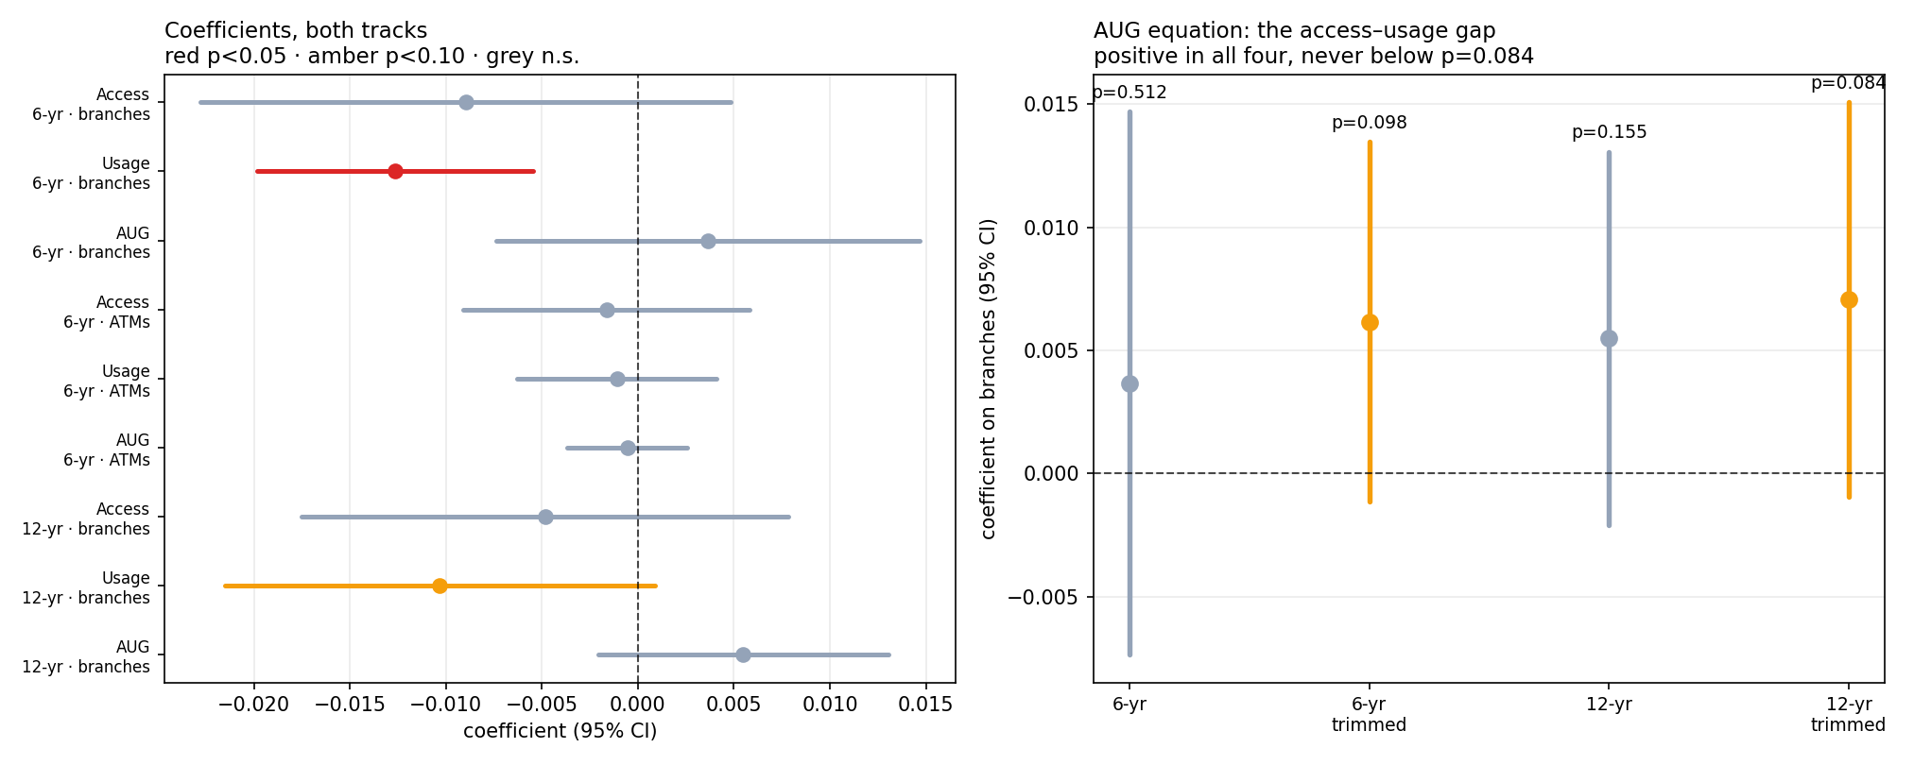
Figure 3.2: Left: every physical-infrastructure coefficient across both tracks, with 95 per cent confidence intervals. Exactly one, branches on Usage in Track 1, is significant at the 5 per cent level, and it is negative. Right: the coefficient on branches in the AUG equation across all four physical specifications. It is positive in every one, in the direction the hypothesis predicts, but never attains conventional significance: p runs 0.512, 0.098, 0.155, 0.084. Reporting this as a finding would mean loosening the pre-committed rule after seeing the coefficients, so it is recorded as a suggestive pattern only.

3.4.1 Random effects is not an escape
Random effects would use both within- and between-state variation, and so appears to solve the problem. The Hausman test asks whether doing so is consistent, under the null that state effects are uncorrelated with the regressors (Hausman, 1978). On Track 1 the null is rejected decisively in all three equations (χ² = 108.3, 73.2 and 12.4; p < 0.0001, < 0.0001 and 0.006). State effects are correlated with branches and ATMs, the “wealthier states attract more infrastructure” channel, confirmed rather than assumed. On Track 2 the evidence is weaker: Access now favours random effects (p = 0.164), while Usage and AUG still favour fixed effects.
The bind
The Hausman test says fixed effects are required. The variance decomposition says fixed effects have almost nothing to work with. Dropping the state fixed effects to recover precision is not available, the data itself rejects that specification. The design cannot be rescued by changing estimator.

3.4.2 Two observations decide the ATM result
All equations were re-estimated dropping the two known-defective observations identified in Section 2.7, Delhi 2023 and Chandigarh 2023, two cells out of 198.
Table 3.5: Track 1 estimates against estimates excluding Delhi 2023 and Chandigarh 2023
Equation | Regressor | Main Coef. | Main p | Trimmed Coef. | Trimmed p | Change
Access | Branches | −0.00897 | 0.201 | −0.00570 | 0.078
Access | ATMs | −0.00164 | 0.664 | +0.00331 | 0.004 | sign flip; becomes significant
Usage | Branches | −0.01264 | 0.001 | −0.01185 | 0.000 | stable
Usage | ATMs | −0.00109 | 0.678 | +0.00011 | 0.957 | sign flip
AUG | Branches | +0.00367 | 0.512 | +0.00615 | 0.098
AUG | ATMs | −0.00055 | 0.731 | +0.00319 | 0.148 | sign flip
This is what the gate predicted. When a regressor carries only 7 to 9 per cent within-state variation, individual observations acquire enormous leverage. The two dropped cells are moreover known defects in RBI’s published source, not outliers chosen for being inconvenient, so the headline ATM result had been riding on data already established as wrong. On Track 2, with the window doubled and within-state variation at 15.3 per cent, the same trim produces no sign flips anywhere: the fragility disappears with more data, though the verdict does not change.

3.5 Track 3: substituting the infrastructure that moved

3.5.1 Why
Over FY2018-FY2023, physical banking infrastructure in India was flat while retail payments moved onto phones. If financial infrastructure was doing anything over this window, it was not doing it through branches. Figure 3.3 states that premise in numbers.
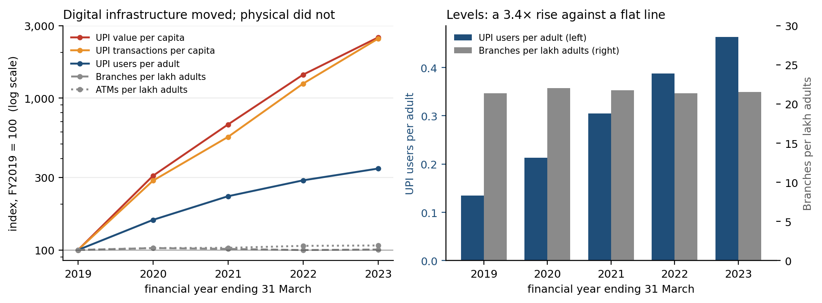
Figure 3.3: Left: unweighted state means indexed to FY2019, on a log scale. UPI value and transactions per capita rise roughly twenty-five-fold in five years; branches and ATMs per lakh adults are flat. Right: the same in levels, UPI users per adult rise from 0.135 to 0.464 while branches per lakh adults sit between 21.4 and 22.0 throughout.
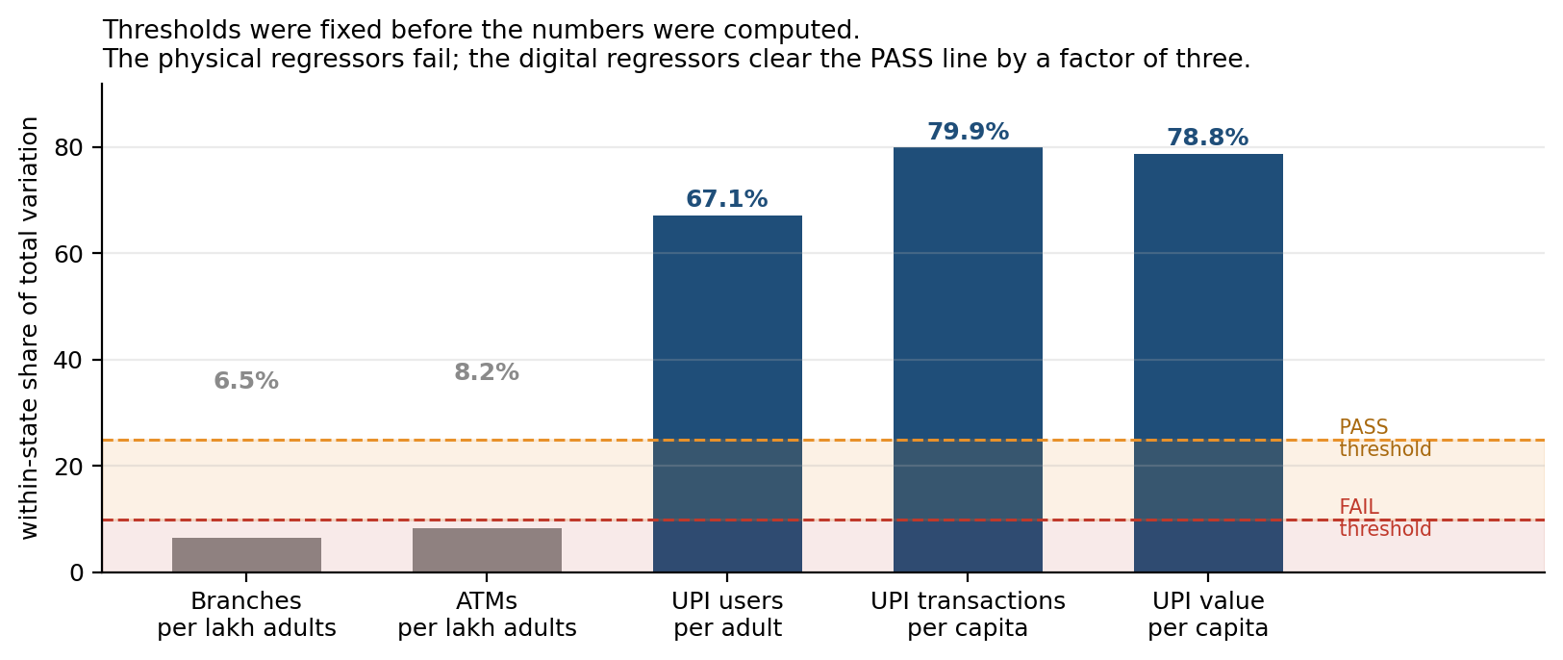
Figure 3.4: Within-state share of total variation, against thresholds fixed before the numbers were computed. The reason Tracks 1 and 2 could not test the hypothesis does not apply to Track 3.
The consequence for estimation is immediate. Within-state variation in UPI users per adult is 67.1 per cent, against 6.5 for branches and 8.2 for ATMs on the same sample. Explanatory power rises correspondingly: within-R² goes from 0.069 to 0.609 for Access and from 0.042 to 0.863 for Usage. Fixed effects plus branches and ATMs explained essentially nothing; one digital variable explains most of it.

3.5.2 The test that mattered
One objection has to be dealt with before any digital coefficient can be read. PhonePe registration requires a KYC-linked bank account, so UPI adoption and deposit-account counts are entangled by accounting rather than by economics, the same trap that dropping PMJDY was meant to avoid, and deposit accounts are half of the Access construct. Credit accounts are not entangled the same way: a bank loan account is neither required for nor created by PhonePe registration.
The outcome was therefore decomposed into its four underlying indicators, with the reading fixed before the regressions were run (D17): if UPI → credit accounts is large and significant, the Access result is not merely definitional; if credit is null while deposits are large, the Access coefficient is the accounting relationship and Access must be reported credit-only thereafter; if both are large, only the credit result gets a substantive reading.
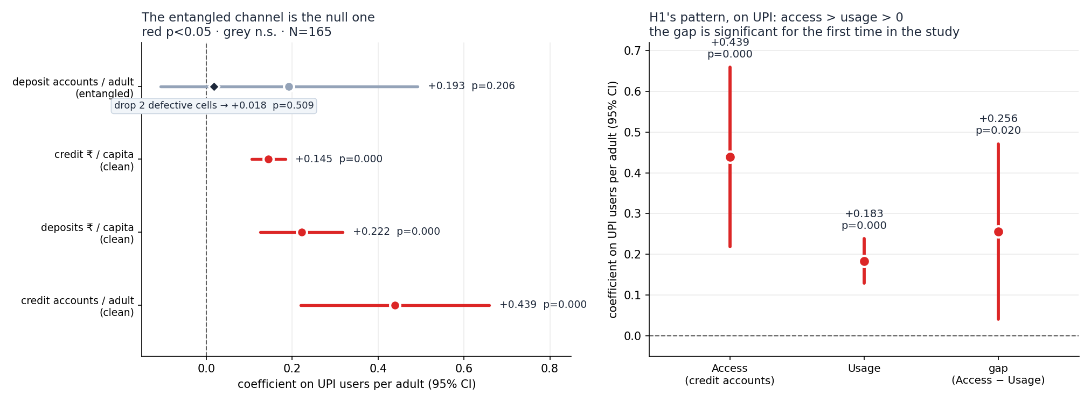
Figure 3.5: Left: the coefficient on UPI users per adult for each of the four outcome components. The entangled channel is the null one, and collapses further when the two defective cells are dropped. Right: the hypothesis pattern on the credit-only specification.
Table 3.6: Component decomposition: coefficient on UPI users per adult, N = 165, and the same estimate excluding Delhi 2023 and Chandigarh 2023
Component | Status | Coef. | p | Coef. (trimmed) | p (trimmed)
Deposit accounts per adult | entangled | +0.193 | 0.206 | +0.018 | 0.509
Credit accounts per adult | clean | +0.439 | 0.0001 | +0.445 | 0.0003
Deposits Rs. per capita | clean | +0.222 | < 0.001 | n/a | n/a
Credit Rs. per capita | clean | +0.145 | < 0.001 | n/a | n/a
Access (composite) | mixed | +0.316 | 0.0004 | +0.231 | 0.0005

3.5.3 The hypothesis pattern, on the credit-only specification
Table 3.7: Track 3, credit-only Access. Two-way fixed effects, N = 165, standard errors clustered by state
Regressor | Access (credit accounts) | Usage | Gap (AUG)
UPI users per adult | +0.439 (p < 0.001) | +0.183 (p < 0.001) | +0.256 (p = 0.020)
Branches per lakh adults | +0.0091 (p = 0.085) | −0.0062 (p = 0.020) | +0.0153 (p = 0.018)
ATMs per lakh adults | −0.0007 (p = 0.773) | −0.0002 (p = 0.868) | −0.0005 (p = 0.884)
Four things follow. For UPI, βaccess > βusage > 0 and the gap is significant at 5 per cent, the pattern the hypothesis predicts, and the first time in this study that the access-usage gap is distinguishable from zero. Branches turn positive on access for the first time, once Access is credit-only and digital adoption is controlled for, though only at p = 0.085. ATMs are null on everything, and the ATM coefficient that looked significant under trimming in Track 1 is revealed as a composite-outcome artefact. Physical infrastructure still fails the pre-committed rule, and that verdict never changed.

3.5.4 Robustness
The headline coefficient was refit 33 times, dropping each state in turn.
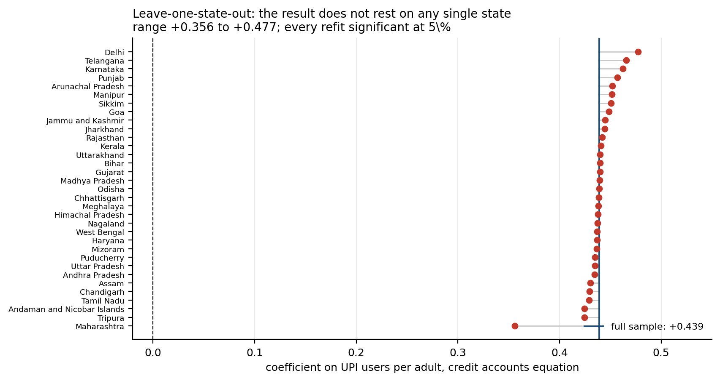
Figure 3.6: Leave-one-state-out estimates of the coefficient on UPI users per adult in the credit accounts equation. The estimate stays between +0.356 and +0.477, and no refit loses significance at the 5 per cent level. Maharashtra is the most influential single state, and the result is stronger without it.
The contrast with Track 1 is the point: there, two cells out of 198 flipped every ATM sign; here, removing an entire state moves the coefficient by at most 19 per cent and never changes the conclusion. The result is also unmoved by the D7 data defects, which affect savings accounts and therefore cannot touch a credit-only outcome.

3.5.5 A mechanism that fits
Digital payment history feeding credit underwriting, cash-flow-based lending, and the account aggregator framework, is a documented development in India over exactly this window, and the wider literature finds digital payment adoption spreading through network effects rather than infrastructure stock (Crouzet et al., 2023; D’Silva et al., 2019). It predicts precisely what is observed: UPI moving loan accounts while leaving deposit accounts alone. That the data is consistent with a mechanism is suggestive of it, not proof.

3.6 Verdict

3.6.1 Against the pre-committed rule
The rule requires βaccess > βusage > 0 for branches and ATMs. For branches on Track 1, the ordering holds (−0.00897 > −0.01264) but both coefficients are negative, so the positivity condition fails; the difference is insignificant (p = 0.512). For ATMs the ordering does not hold, nothing is significant, and every sign reverses on a two-cell trim. Track 2 reproduces the branch result with twice the power and none of the fragility.
Verdict on the pre-committed hypothesis
Hypothesis 1 is not supported for physical infrastructure. This is not partial support: the positivity condition fails for branches, and the ordering condition fails for ATMs. The same conclusion is reached on all three tracks, and it never changed.
Mapping onto the outcomes tabulated in advance, the row that applies is both effects ≈ 0, check within-state variation before concluding anything. The diagnostic was run first, as instructed, and returned 7.0 and 8.7 per cent. The correct conclusion is therefore not that infrastructure fails to raise financial inclusion, but that Tracks 1 and 2 cannot test the question: the regressors barely move, the estimator the Hausman test requires discards the variation that does exist, and the estimates are unstable to two observations. The null is uninformative, exactly as fixed in advance that it would be.

3.6.2 What the digital result is, and what it is not
The digital result is exploratory by construction
The pre-committed rule named branches and ATMs, and it failed. UPI was added after seeing that null. The digital finding therefore cannot be reported as a hypothesis that was tested and passed, it is a hypothesis generated by this data, for a future design to test. Stating it any other way is exactly the retro-fitting that pre-committing was meant to prevent.
This is the first thing a careful reader will test, so it is stated here rather than buried. What can be said is bounded but not trivial: on a measure of financial infrastructure that genuinely moved within states, the access-usage gap widens significantly, the effect runs entirely through the channel that is not definitionally entangled with the regressor, and the result survives the removal of any single state. The identification problem that defeated Tracks 1 and 2 is solved. The causal problem is not, fixed effects remove fixed state differences and the common national trend, but not state-specific time-varying confounders, and smartphone penetration, fintech entry and youth share all rose alongside both UPI adoption and credit accounts over these five years.

3.6.3 The persistent puzzle
One physical coefficient is significant and robust across specifications: branches on Usage, negative (p = 0.001 on Track 1, 0.071 on Track 2, 0.020 on Track 3). Within a state, years with more branches per lakh adults show lower Usage. It is the opposite sign to anything the hypothesis anticipated, and it is treated as a puzzle rather than a result: the variation problem applies to it as much as to the nulls, Usage is severely compressed by the pooled normalisation, and a negative within-state relationship is at least as consistent with branches being placed where deposit growth is weak as with branches causing it. Nothing here identifies direction.

3.7 Limitations
Ordered by how much damage each does to the conclusions.
1. Identification, the binding limitation. On the physical tracks the regressors barely move: 7.0 and 8.7 per cent within-state variation, below the FAIL threshold fixed before looking. The null on branches and ATMs cannot be distinguished from “not enough variation to detect anything”, and any such null must be reported with these numbers attached. On the digital track variation is ample and that objection does not apply, but fixed effects do not remove state-specific time-varying confounders, so the digital result is a within-state correlation between two co-trending series and no causal claim is available. Reverse causality is live rather than hypothetical: the Hausman test rejecting random effects is direct evidence that state effects are correlated with the regressors.
2. The digital result is exploratory by construction. UPI was added after seeing the physical null (Section 3.6.2).
3. Known data defects. The deposit-account breaks in RBI’s source (Delhi 2023, Chandigarh 2023 inside the window) were enough to move the deposit-account coefficient from +0.193 to +0.018. Adult population is interpolated rather than published for 243 of 266 state-years, and being near-linear it suppresses within-state variation in the per-adult regressors, making the first limitation worse than it looks. Two units are dropped for want of income data, and boundary changes forced merges, so nothing state-specific can be said about either half of a merged unit.
4. Measurement. Attribution differs three ways: bank deposits and credit are recorded at branch location, loan accounts by place of sanction, and PhonePe by the user’s registered state, three different definitions of “where”, merged into one panel. The first inflates Maharashtra and Delhi, where lending is booked. PhonePe is one firm, roughly 45-50 per cent of UPI, with market share varying by state, so cross-state levels are noisier than within-state growth; NPCI’s total UPI series would fix this. Usage is severely right-skewed after normalisation, 85 per cent of observations below 0.20, so βaccess and βusage were never on fully equivalent scales, a direct threat to the comparison itself, left unfixed deliberately in order to test the specification as written. And the study is state-level, not person-level: nothing here can show that individuals hold unused accounts, which is the mechanism the hypothesis describes.
5. Scope. The physical panel stops at FY2023, FY2024 having been traded away for a consistent bank universe; the digital panel is five years, since PhonePe data begin in 2018; ATMs cannot extend before 2018; and dropping PMJDY, though necessary, left the physical measure with nothing digital in it until PhonePe was added.
What survives all of this
The physical null, reported as uninformative rather than as evidence of no effect. Branches → Usage negative (p ≤ 0.020 across three specifications and two samples), robust but with no causal reading available. UPI → credit accounts positive (+0.439), robust to dropping any single state and to the known data defects, but correlational. And UPI → deposit accounts ≈ 0, which is the asymmetry the whole digital finding rests on.

Chapter 4

Hypothesis 2: [Title to be supplied]

4.1 Hypothesis and pre-commitment
Hypothesis 2
[Statement to be supplied.]
Rationale. [The mechanism, not the expectation.]
Expected: [The sign pattern that would constitute support.]
To be completed: Fix the decision rule before estimating, as D10 does in Section 3.1: what counts as full support, what counts as partial support, and that it will not be revised after the coefficients are seen. Log it in Appendix A with its own D-number.

4.2 Variables and specification
To be completed: Define the independent, dependent and control variables with units and denominators, then state the estimating equation(s), fixed-effects structure, and clustering. Chapter 2 documents the shared panel, reference it rather than repeating it, and add any series not in Table 2.2.

4.3 Descriptives and diagnostics
To be completed: Means, standard deviations and ranges, flagging anything bearing on the specification, skew, compression, extreme values, before presenting estimates. Then run the within-state variance decomposition first, with thresholds fixed before the numbers are computed (Section 3.3), and report the verdict whether or not it is favourable.

4.4 Results and robustness
To be completed: Main estimates, reported before they are interpreted. Then re-estimate excluding the known-defective cells of Section 2.7, plus any perturbation specific to this hypothesis, reporting sign and significance changes explicitly.

4.5 Verdict, implications and limitations
To be completed: Apply the pre-committed rule as written; state whether the hypothesis is supported, partially supported or not supported, and what the result does not license concluding. Then substantive, policy and methodological implications, carrying the cross-cutting ones to Chapter 6; then limitations, referencing rather than restating the shared data limitations of Section 2.7.

Chapter 5

Hypothesis 3: Digital Literacy and Income as Complements

5.1 Hypothesis and pre-commitment
Hypothesis 3
The positive effect of digital financial infrastructure on financial inclusion is stronger in states with higher levels of digital literacy, and stronger in states with higher incomes. Digital literacy and income act as complements to infrastructure rather than as substitutes for it.
Rationale. Chapter 3 established that UPI adoption raises credit accounts per adult more than it raises the rupees moving through them, and that the gap is significant. That is an average across 33 states, and the average conceals a question policy needs answered: the same national rollout reaches every state, so does it convert into inclusion at the same rate everywhere? The digital-divide literature says it should not. Opening an account asks nothing of the holder beyond identity documents, and banks can be pushed to open them. Using an account asks the holder to operate the channel. Infrastructure therefore relaxes the access constraint wherever it is built, and the usage constraint only where the ability to use it already exists. Digital literacy is therefore a candidate complement to infrastructure rather than a substitute for it.
Research question. Do digital literacy and income moderate the relationship between digital financial infrastructure and financial inclusion in India?
Two complements are candidates, and they are each other's principal confounder: digitally literate states are also richer states. Estimated separately, a skills result can be income wearing a costume and an income result can be skills wearing one. Entering both in the same equation is not a convenience but the identification strategy, and the comparison between them is the contribution.
Expected: a positive interaction between infrastructure and each moderator, and a larger interaction on usage outcomes than on access outcomes. Opening an account is the margin least likely to reward a complement, since it asks least of the account holder, so a moderator that raises both margins equally is behaving like a development proxy rather than like a complement. The two moderators enter together throughout, each as the rival explanation for the other.
Decision rule, fixed before any result was seen (D18-D28)
Support requires the moderation to be specific to usage. A moderator that conditions access and usage alike is a general development gradient, not a complement to it, and is reported as such whatever its own p-value.
The placebo test outranks the main estimates. If general education or urbanisation reproduce the digital-literacy interaction at similar magnitude and significance, the interaction is not separately identified and is reported as not identified.
Where two measures of the same construct disagree, the one with the better construct validity governs, named in advance rather than chosen afterwards.
Three features of that rule matter below. It is directional in a way that can fail: a moderator that raises both margins equally counts against the hypothesis rather than for it. It subordinates the headline estimates to a falsification test, which is run first and reported whether or not it is favourable. And it fixes in advance which of two income measures governs if they disagree, which they do.
One further pre-commitment, recorded because the temptation to breach it arose later: the specification reported as the headline is the one fixed before the data were assembled. Section 5.4.5 finds a larger and equally significant estimate on a subset of the outcomes. It is reported as a decomposition of the headline, not promoted to replace it, for the same reason Section 3.6.2 refuses to present the digital result of Chapter 3 as a tested hypothesis.

5.2 Variables and specification
The panel, the infrastructure measure and the outcomes are those of Chapter 3, Track 3, unchanged: 33 states over FY2019-FY2023, N = 165, with UPI measured as PhonePe registered users per adult. Every column carried across was asserted identical to the file behind Chapter 3, and the baseline specification here reproduces Table 3.7's coefficients to five decimal places. That is a check on the merge, not a result. What is new is the moderators and the way the outcomes are compared.
Access is measured credit-only, following the rule fixed in Section 3.5.2: deposit accounts are definitionally entangled with UPI registration, and Section 5.4.5 shows that entanglement is not a hypothetical concern here.

5.2.1 The moderators
Digital literacy is the percentage of women in a state who have ever used the internet, from NFHS-5 (2019-21). It is preferred to the NSS ICT battery on coverage grounds alone (Section 2.7); the two correlate 0.87 to 0.90 where both exist, which is reassurance that the substitution is between measurements rather than between constructs. Resources are measured two ways, per-capita NSDP and household consumption, for the reason given in Section 2.7, and the disagreement between them turns out to matter.
Both moderators are one number per state and are standardised across the 33 states, so each coefficient reads as the change in the infrastructure effect per standard deviation of the moderator. Making the income moderator time-invariant is deliberate: the skills measure comes from a single survey wave and cannot vary over time, and allowing income to vary while skills could not would decide the comparison by that asymmetry rather than by the data. Time-varying per-capita income remains in the equation as a control, exactly as in Chapter 3.

5.2.2 Specification
The simple form interacts infrastructure with each moderator in turn and then with both together, on each outcome separately:
Y_it = α_i + λ_t + β₁ UPI_it + β₃ (UPI_it × DigLit_i) + β₄ (UPI_it × Income_i) + γ′X_it + ε_it (5.1)
where X carries branches, ATMs and log per-capita income, and infrastructure is mean-centred so that β₁ reads as the effect at average conversion levels of both moderators rather than at an out-of-support zero. Standard errors are clustered by state, as in Chapter 3.
Equation (5.1) cannot answer the hypothesis, because it asks only whether the effect is larger. The hypothesis is about which margin the effect appears on, and that requires the outcomes in one equation. Each outcome is standardised within itself and the three are stacked, giving 495 rows:
Y_itk = β₁ UPI_it + β₂ (UPI_it × Intensive_k) + β₃ (UPI_it × DigLit_i) + β₅ (UPI_it × DigLit_i × Intensive_k) + β₄ (UPI_it × Income_i) + β₆ (UPI_it × Income_i × Intensive_k) + γ′X_it + μ_ik + λ_tk + ε_itk (5.2)
Intensive_k is zero for credit accounts per adult and one for the two rupee outcomes. β₅ is the coefficient the hypothesis is about: it asks whether digital literacy moves the effect between margins rather than simply scaling it. β₆ asks the same of income. Because β₅ is a difference between outcomes measured on the same state in the same year, any confounder acting equally on both margins differences out of it; that is the sense in which equation (5.2) is a sharper test than (5.1) rather than merely a more complicated one.
β₂ is Hypothesis 1's test, estimated here on the same stacked data. The two hypotheses are adjacent coefficients in one equation rather than two separate studies, and Section 5.4.3 reports them together.
Two further points on the fixed effects. Every outcome carries its own state effect and its own year effect, μ_ik and λ_tk, rather than sharing one set across outcomes. That is a more demanding specification and it is not a matter of taste: the restricted form is nested inside it and is rejected, F(72, 375) = 89.2, p below 10⁻¹⁵, so the restricted form is misspecified. With 33 clusters and 72 restrictions no cluster-robust version of that test exists, so it is the classical F-test and it licenses the fixed-effect structure, not the standard errors.
Those standard errors carry their own qualification. Section 3.2.3 notes that 33 clusters sit at the lower end of the range where cluster-robust inference is reliable. Here the difficulty is sharper, because each moderator is a single number per state, which is the case the asymptotics handle worst. Every p-value reported in this chapter is therefore a wild cluster bootstrap with the null imposed, 9,999 replications, rather than a cluster-robust t-test.

5.3 Descriptives and diagnostics
The diagnostic that governs Chapter 3 is run again here, and this time it passes. The question is whether the interaction terms have anything for the fixed effects to work with, and whether each moderator can be told apart from the infrastructure measure it modifies.
Table 5.1: Diagnostics, against thresholds fixed before the moderator data were assembled
 | Correlation with UPI adoption | Within-state share of variation | Verdict
Digital literacy × UPI | 0.243 | 65.9% | PASS
Income × UPI | 0.687 | 70.8% | PASS
UPI users per adult (reference) | n/a | 67.1% | PASS
Branches per lakh adults (reference) | n/a | 6.5% | FAIL
Digital literacy is very nearly orthogonal to UPI adoption, at 0.243, so the collinearity that would have made the interaction unreadable is absent. Income is closer at 0.687 but still inside the threshold fixed in advance. Variance inflation factors on the two interaction terms are 2.2 and 2.6. The last two rows are the contrast with Chapter 3: the physical regressors that failed the gate there still fail it, and the terms this chapter relies on do not.
The two moderators must also be separable from each other, or the comparison between them is undefined. They correlate 0.682 and disagree by up to 23 rank positions out of 33: Telangana is 28th on digital literacy and 5th on income, Manipur 15th and 30th. Seventeen of the 33 states sit off the diagonal of the two tercile rankings, and those states are what identifies the comparison.
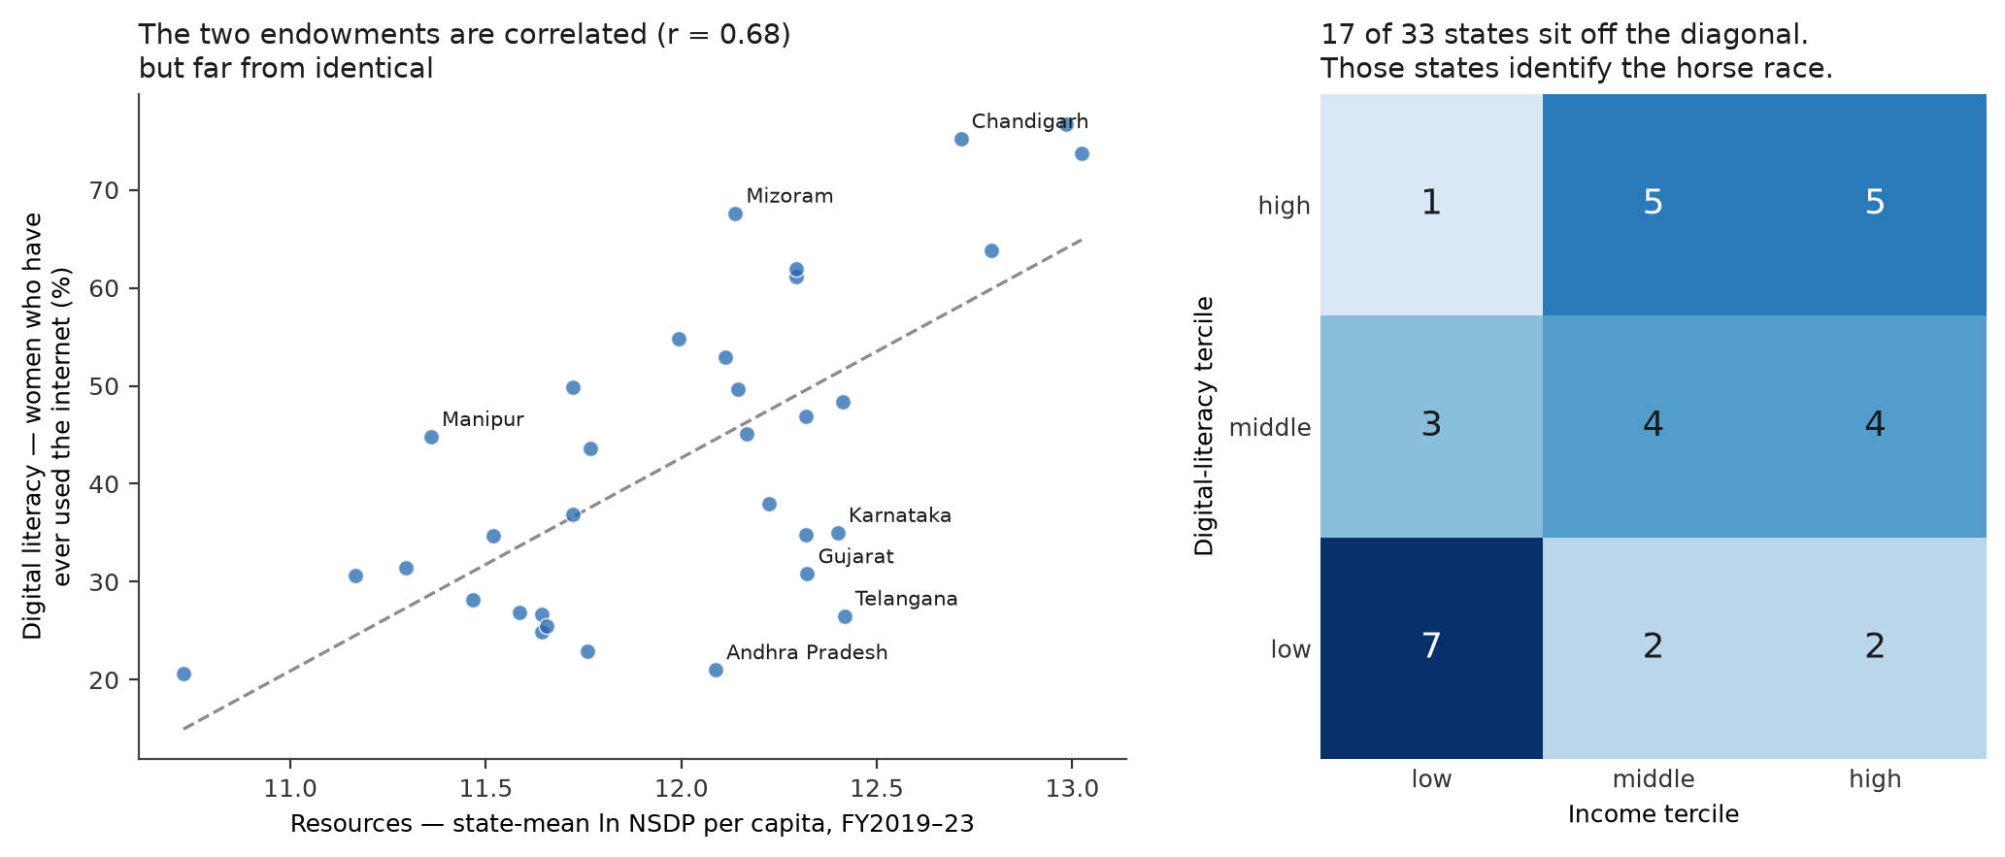
Figure 5.1: Left: the two endowments across the 33 states, with the states furthest from the fitted line labelled. They are correlated but far from identical. Right: the two tercile rankings cross-tabulated. The 17 states off the diagonal are what separates a skills explanation from an income one; the corners are sparse, and claims about them are correspondingly weak.
One feature of the outcomes bears directly on the specification and is reported before any estimate. Section 3.7 records that Usage is severely right-skewed after the pooled normalisation. That compression is inherited here and it is not uniform: 46.7 per cent of the credit-account observations sit below 0.20, against 83.0 per cent for deposits per capita and 86.1 per cent for credit per capita, with skew of 1.10 against 2.50 and 3.13. The two margins were therefore never being compared on equivalent scales. Standardising each outcome within itself before stacking, as equation (5.2) does, removes that problem; it is a repair of a limitation Chapter 3 had to leave open rather than a convenience.

5.4 Results and robustness
Results are reported in the order they were produced: the simple model first, then the test that separates the two hypotheses, then the falsification tests that decide whether either can be believed.

5.4.1 The simple interaction model, and why it misleads
Equation (5.1), both moderators entered together, with income measured both ways. Bootstrap p-values throughout.
Table 5.2: Interaction estimates from equation (5.1). Two-way fixed effects, N = 165, wild cluster bootstrap p-values in parentheses
Outcome | UPI | × digital literacy | × income (NSDP) | × income (MPCE)
Credit accounts per adult | +0.374 (0.017) | −0.061 (0.104) | +0.035 (0.391) | +0.019 (0.625)
Deposits ₹ per capita | +0.132 (0.003) | +0.056 (0.061) | +0.045 (0.013) | +0.056 (0.423)
Credit ₹ per capita | +0.044 (0.186) | −0.029 (0.044) | +0.053 (0.0002) | +0.000 (0.998)
Read on the NSDP column alone, this table says resources moderate and skills do not, which is the classical result that prices move demand for financial services further than knowledge does. Two things undercut that reading, and both are visible in the table itself.
First, the skills interaction fails its own falsification test exactly where it looks strongest. On deposits per capita, substituting urban share for digital literacy produces a larger interaction, +0.065 against +0.056. Under the rule fixed in Section 5.1, digital literacy is therefore not separately identified on that outcome, whatever its own p-value.
Second, and more damaging, the income result does not survive the change of measure.

5.4.2 Which income is being measured
Per-capita NSDP is a production measure: output books to the state where a firm is registered. That is the same attribution problem Section 2.7 records for deposits held at branch location, and it inflates the same states. MPCE is household consumption, collected from households. For a moderator standing in for household resources, MPCE is the better construct and NSDP is the more convenient one, which is why the rule governing a disagreement between them was fixed in advance rather than after the fact.
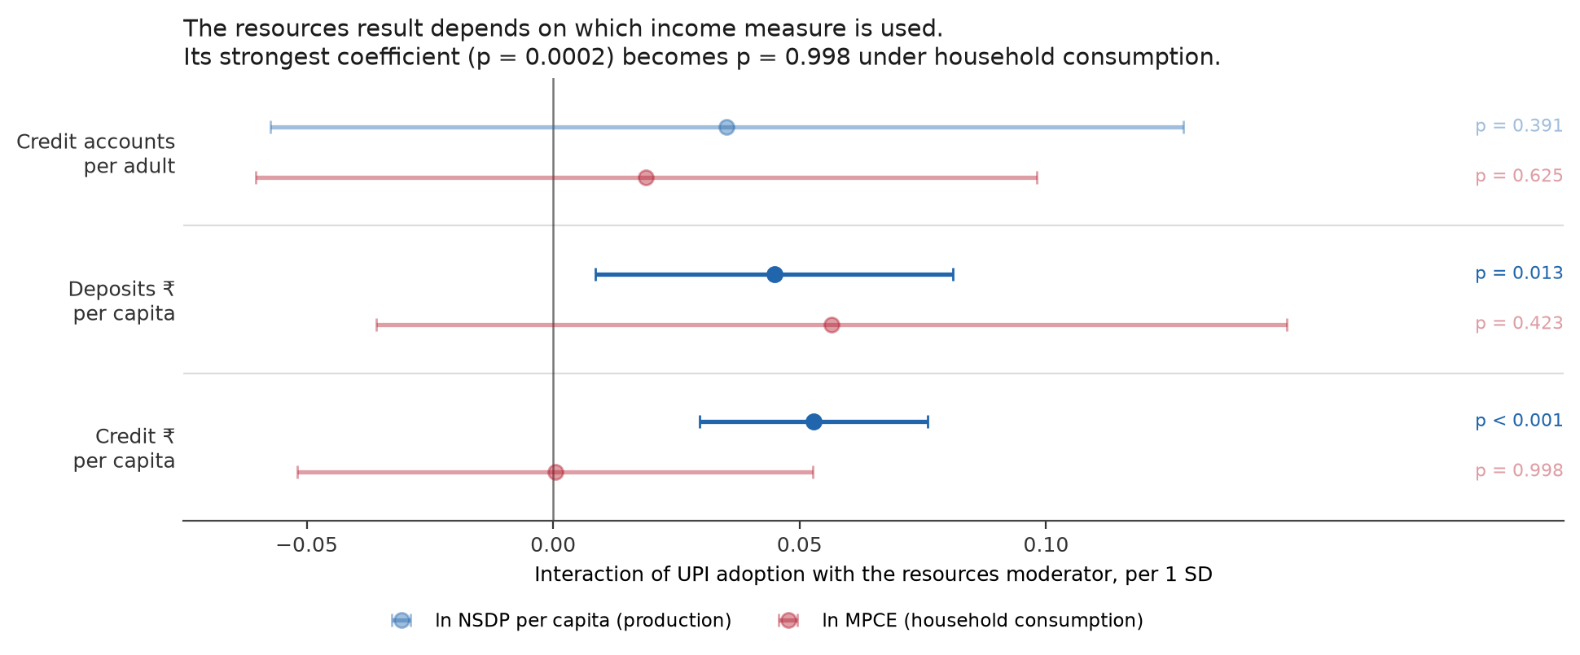
Figure 5.2: The resources interaction under the two income measures, with 95 per cent confidence intervals and bootstrap p-values. The strongest income coefficient in the chapter, p = 0.0002 on credit per capita, becomes p = 0.998 when household consumption replaces state production. Faded markers are not significant at 5 per cent.
The interaction that carried the resources channel disappears entirely. The honest reading is that the apparent support for an income mechanism in Table 5.2 was riding on the measure with the known attribution artefact, and it is reported as measure-specific rather than as a finding.

5.4.3 The test that separates the two hypotheses
Equation (5.2), on 495 rows and 33 state clusters.
Table 5.3: The stacked specification, equation (5.2). Wild cluster bootstrap p-values, 9,999 replications
Coefficient | Term | Estimate | p
β₂ | UPI × intensive (Hypothesis 1's test) | −0.906 | 0.081
β₃ | UPI × digital literacy | −0.345 | 0.008
β₅ | UPI × digital literacy × intensive | +0.452 | 0.0008
β₄ | UPI × income | +0.196 | 0.223
β₆ | UPI × income × intensive | +0.013 | 0.936
Read before interpretation. β₅ is positive and precisely estimated: digital literacy moves the infrastructure effect away from the extensive margin and toward the intensive one. β₆ is indistinguishable from zero, and remains so under household consumption (+0.039, p = 0.805) and under every placebo substituted into the same slot, including women's own bank account in 2015-16, which is baseline financial inclusion itself (+0.247, p = 0.543). Income's failure to discriminate between margins is a property of the channel and not an artefact of the proxy. β₂ reproduces Hypothesis 1's pattern on the same data.
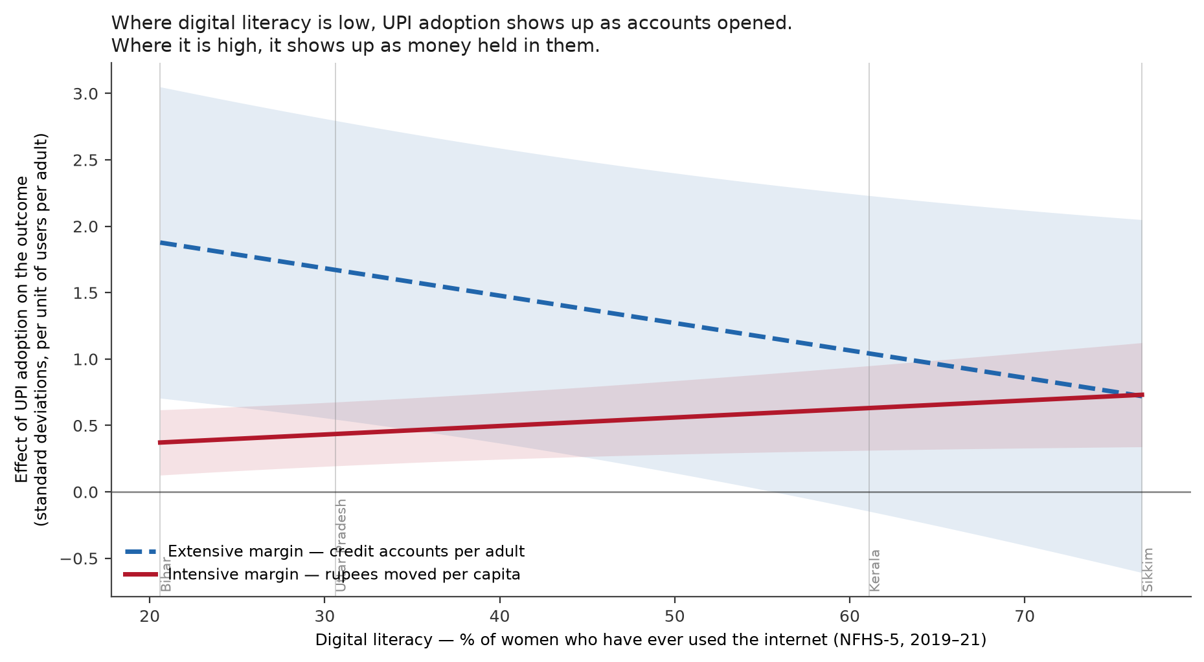
Figure 5.3: The effect of UPI adoption on each margin across the observed range of digital literacy, from equation (5.2), with 95 per cent confidence bands. The two lines have opposite slopes and converge: in the least literate states infrastructure shows up as accounts, in the most literate as balances. The difference between the slopes is β₅.
The substantive statement is not that infrastructure works better in more literate states. It is that it produces something different there. In the least digitally literate states a unit of UPI adoption is worth roughly 1.9 standard deviations on account counts and 0.4 on rupees moved; in the most literate, roughly 0.7 on both.

5.4.4 The falsification test
The obvious objection is that digital literacy is simply development, and any development proxy would produce the same coefficient. That objection is testable directly, by substituting each candidate into the moderator slot one at a time and re-estimating equation (5.2). Under the rule in Section 5.1 this test outranks Table 5.3.
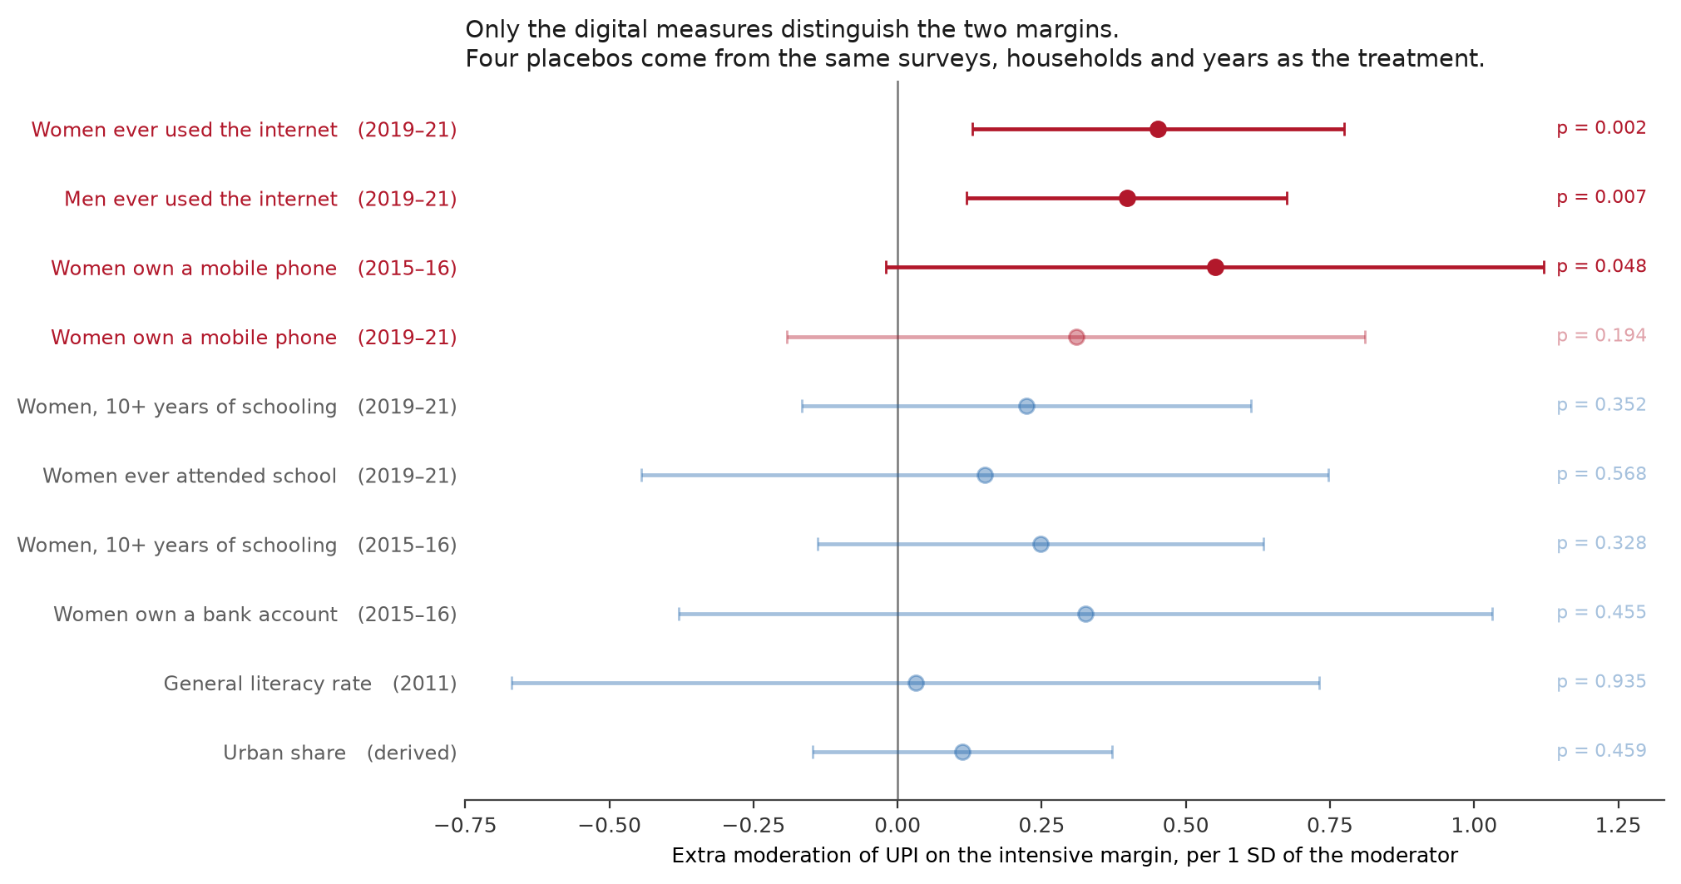
Figure 5.4: β₅ with each moderator substituted in turn, with 95 per cent confidence intervals and bootstrap p-values. Red marks measures of digital skill, blue general human capital and urbanisation. Faded markers are not significant at 5 per cent. Four of the placebos are drawn from the same surveys, the same households and the same fieldwork years as the treatment.
The table does three things. It rules out a generic development gradient: schooling, ever having attended school, general literacy and urbanisation all return nothing, and three of them come from the same NFHS-5 questionnaire and the same households as the treatment, so no difference in sampling, instrument or fieldwork can explain why one produces β₅ and the others do not.
It addresses reverse causality with a moderator that cannot be subject to it. Women's mobile-phone ownership in 2015-16 is measured three and a half years before the panel opens and before UPI's April 2016 launch, and it produces β₅ = +0.550, p = 0.049, while its two counterparts from the same survey round return nothing. A moderator measured before the treatment existed cannot have been caused by the outcome.
And it rules out the sharpest confound available, which concerns the outcome rather than development: states that were already more banked in 2015-16 do not convert infrastructure differently. One result in Table 5.2 points the same way. On credit per capita the digital-literacy interaction is negative and significant while the two schooling placebos from the same instrument are positive and significant. Opposite signs, same survey, same respondents: these are not the same construct.

5.4.5 What the estimate rests on
β₅ averages two intensive outcomes against one extensive outcome, so it is worth asking which pairing carries it. Re-estimating equation (5.2) one pair at a time gives +0.749 (p = 0.002) for credit accounts against deposits per capita and +0.155 (p = 0.324) for credit accounts against credit per capita. The reported figure is a dilution of the first rather than a summary of two comparable estimates, and the decisive pair clears its own placebo battery. The interpretive claim narrows accordingly: digital literacy moves the effect toward deposit balances specifically, not toward the intensive margin in general.
Following the pre-commitment in Section 5.1, the larger estimate is not promoted to the headline. It was found by decomposition after the fact, and reporting it as the result would be the retro-fitting Section 3.6.2 refuses elsewhere in this report.
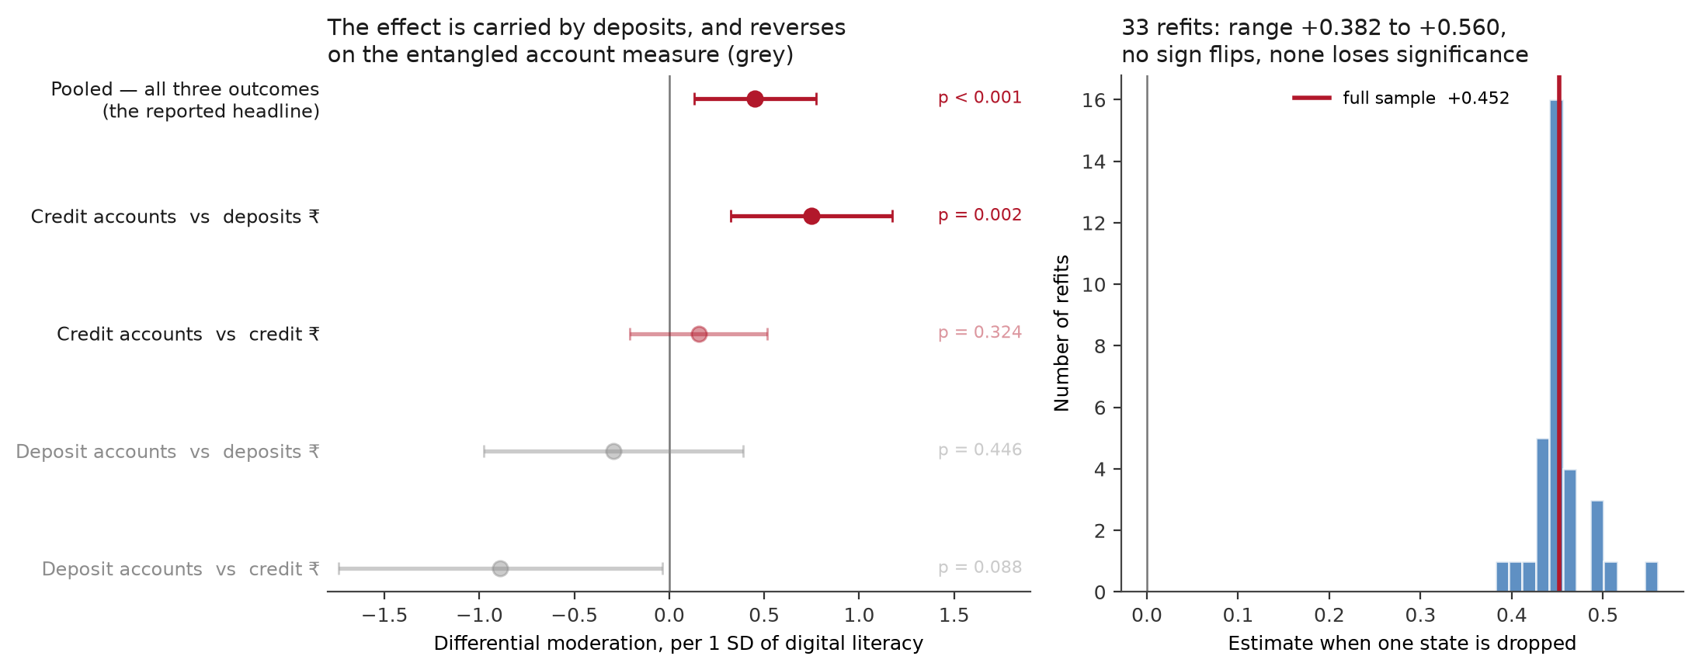
Figure 5.5: Left: β₅ estimated one outcome pair at a time. The effect is carried by deposits, and reverses when the entangled deposit-account measure replaces credit accounts on the extensive side (grey). Right: the distribution of β₅ across 33 refits, each dropping one state.
The grey rows locate a robustness failure rather than hiding it. When the entangled deposit-account indicator is used on the extensive side, β₅ does not merely weaken; it turns negative and the income coefficient becomes significant (+0.420, p = 0.014 and +0.576, p = 0.040). Substituting the entangled measure replaces a skills result with an income result, which is what an accounting relationship looks like: registration requires a bank account, richer states register more, and account counts follow mechanically. The credit-only rule of Section 3.5.2 is doing real work, and this is the clearest evidence for it in the report.

5.4.6 Thresholds, with no functional form assumed
The interaction in equation (5.2) assumes the returns to digital literacy are linear. Grouping states into terciles drops that assumption.
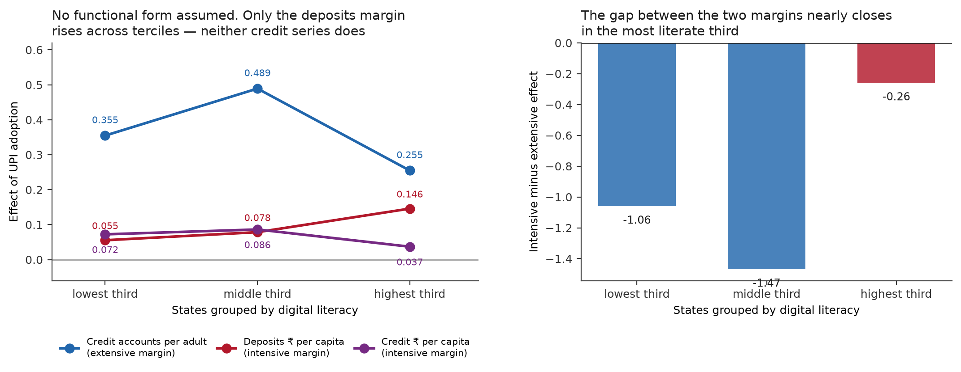
Figure 5.6: Left: the effect of UPI adoption on each outcome, with states grouped into thirds by digital literacy. Right: the difference between the intensive and extensive effects by tercile. The gap is −1.06 in the least literate third and −0.26 in the most literate, with the difference significant at p = 0.021.
The tercile pattern agrees with β₅ without assuming its shape, and it sharpens the reading of Section 5.4.5: deposits rise monotonically across the three groups while neither credit series does. The gap between the two margins is wide where digital literacy is scarce and nearly closed where it is not.

5.4.7 Robustness
Table 5.4: Robustness of β₅. Wild cluster bootstrap p-values
Specification | β₅ | p
Reported estimate | +0.452 | 0.0008
Digital literacy residualised on UPI adoption | +0.358 | 0.004
Excluding Delhi 2023 and Chandigarh 2023 (Section 2.7) | +0.427 | 0.003
Excluding the four small union territories | +0.462 | 0.045
Excluding the three highest and three lowest literacy states | +0.602 | 0.013
Deposit accounts added to the extensive side | −0.070 | 0.691
Dropping each state in turn and refitting 33 times gives a range of +0.382 to +0.560, a worst p-value of 0.029, no sign flips and no refit that loses significance. The contrast with Section 3.4.2 is the point: there, two observations out of 198 reversed the sign of every ATM coefficient; here, removing an entire state moves the estimate by at most a quarter and never changes the conclusion. The final row is the failure diagnosed in Section 5.4.5 and is reported as a failure.

5.5 Verdict, implications and limitations
The hypothesis claims that infrastructure works better where digital literacy is higher and where incomes are higher, and that the two act as complements to it. Both claims are assessed against the rule fixed in Section 5.1, which subordinates the estimates to the falsification test. The answer to the research question is yes for digital literacy and no for income, but not in the direction the claim anticipated, and the difference between the two is the finding.
Verdict on the pre-committed hypothesis
Not supported as stated for digital literacy, and supported in a different and more informative form. Infrastructure is not uniformly more effective where digital literacy is higher: the effect on account creation is if anything weaker there. What digital literacy changes is which margin the effect appears on, β₅ = +0.452, p = 0.0008, and no placebo reproduces it. Digital literacy is a complement at the usage margin and not at the access margin.
Not supported for income. The moderation is significant on one income measure and absent on the better-constructed one, and under either measure income fails the test that separates a genuine complement from general prosperity. Income raises both margins together, which is what a level effect looks like.
The claim is narrower than the coefficient. It concerns deposit balances specifically (Section 5.4.5), it is an association rather than a causal effect, and it does not hold when the entangled account measure is used.
What the result means substantively is a statement about measurement as much as about policy. The same national rollout, reaching two states equally, leaves one with more bank accounts and the other with more money held in them. Account counts are the indicator financial inclusion is scored on, internationally and in the schemes described in Section 1.2, and they will record the less digitally literate state as the larger success when what it has gained is the thinner outcome. The access-usage gap that motivates this report reappears inside the digital result, distributed by skill.
The finding also bears on the mechanism proposed in Section 3.5.5, that UPI moves credit accounts through payment history feeding cash-flow underwriting. Digital literacy does not moderate that channel: the credit pairing is null and the skills interaction on credit accounts is negative. That is consistent with the proposed mechanism rather than against it. If underwriting reads a borrower's payment trail algorithmically, the borrower's own digital literacy is not the binding input. Digital literacy matters where the user has to act, which is accumulating a balance, and not where an algorithm acts on their behalf.
For policy the implication is narrower than the framing in Section 1.1 would suggest, and firmer for being narrower. Digital skilling is not what makes infrastructure spending work: the main effect is positive everywhere, and the least literate states record the largest gains in account creation. Skilling determines whether those accounts are used. That is a claim about sequencing at the usage margin specifically, and it is defensible in a way that a general 'train people first' recommendation would not be. The corresponding caution is that uniform national infrastructure, evaluated on account counts, will appear to be closing gaps at the moment it is widening them on the measure that matters.
Limitations. The shared data limitations of Section 2.7 apply unchanged and are not restated. Four are specific to this chapter. First and binding, this chapter interacts a main effect that Section 3.6.2 establishes as a within-state correlation between two co-trending series, added after a pre-registered hypothesis failed; the interaction inherits that, and no causal claim is available. β₅ is partially insulated, since it is a difference between outcomes measured on the same state in the same year and any confounder acting equally on both margins differences out of it, but a confounder that moves the two margins differently and correlates with digital literacy would still contaminate it. The placebo battery is evidence against that; it is not proof.
Second, the estimate rests on one outcome pairing rather than two (Section 5.4.5) and reverses on the entangled account measure. Third, the analysis is state-level and cannot show that individuals with more digital literacy use their own accounts more; a district-level design was examined and is not available, because the district fact sheets of the source survey do not carry the internet-use item. Fourth, the moderator is self-reported ever-use rather than tested skill, and the payment measure remains one firm's rather than the market's, with market share that varies by state; if that share is higher in more digitally literate states, part of β₅ is measurement.

Chapter 6

Discussion and Conclusion

6.1 Synthesis
Hypothesis 1. The claim was that financial infrastructure raises access more than usage, that expansion is formal rather than functional. Measured physically, as branches and ATMs, it is not supported, and the more consequential result is why. Only 7.0 per cent of the variation in branches per lakh adults, and 8.7 per cent of that in ATMs, occurs within states; roughly 93 per cent is cross-sectional, which is precisely what fixed effects discard. The Hausman test then rejects random effects, closing off the specification that would have used that variation, and two defective observations out of 198 prove enough to reverse the sign of every ATM coefficient. Doubling the window to twelve years doubles the usable variation and removes the fragility, but leaves the verdict unchanged.
Measured digitally, the picture reverses. UPI adoption varies 67.1 per cent within states over the same window, explanatory power rises roughly ninefold, and the predicted pattern appears: Access +0.439, Usage +0.183, gap +0.256 at p = 0.020. The effect runs entirely through credit accounts and not at all through deposit accounts, the opposite of what an accounting artefact would produce, since deposit accounts are the component entangled with UPI registration by construction. The asymmetry is the finding. But UPI entered the design after the physical null was seen, so this is a hypothesis generated by the data rather than one tested and passed.
To be completed: Summarise the verdicts on Hypotheses 2 and 3 here in the same form, what was claimed, what was found, what the result does not license, then add a short paragraph on whether the three point in a common direction. If they share the panel of Chapter 2, note explicitly whether the within-state variation problem of Section 3.3 affects them too: it is a property of the data, not of Hypothesis 1.

6.2 Implications for policy
Measure usage, not ownership. Account ownership is near saturation, and the marginal account opened now is very likely to be dormant: roughly 35 per cent of Indian adults with an account hold an inactive one (Demirgüç-Kunt et al., 2022), and about 26 per cent of PMJDY accounts are reported inoperative (Press Information Bureau, Government of India, 2025). The RBI’s Financial Inclusion Index already weights usage (45 per cent) above access (35 per cent) (Reserve Bank of India, 2025a), and the evidence here supports that ordering. Targets expressed in accounts opened measure the dimension that is no longer binding.
The binding infrastructure has changed, and measurement should follow. Branches per lakh adults move a median of 5.6 per cent within a state over six years; UPI adoption moved by orders of magnitude over the same period. Whatever the long-run effect of physical premises, they are not the margin on which annual variation in financial inclusion was determined over FY2019-FY2023. A framework that monitors branch and ATM density while treating digital payment adoption as background is measuring the stationary part of the system.
If the credit channel is real, it is a policy object. The digital result is correlational, but the association it identifies, digital payment adoption moving loan accounts while leaving deposit accounts untouched, is consistent with payment history entering credit underwriting, which is a deliberate feature of Indian financial architecture over this period. That makes it a testable and governable channel rather than an incidental one, and it sharpens what an evaluation should look for.
Data quality is itself a policy variable. A discontinuity in one column of one RBI return, affecting three states, was enough to reverse the sign of every ATM coefficient in Track 1 and to inflate a null deposit-account coefficient tenfold in Track 3. Series used for programme evaluation warrant the revision and documentation discipline applied to headline aggregates.

6.3 Implications for method
Diagnose the identifying variation before estimating. The variance decomposition was specified as a gate, with thresholds fixed before the numbers were computed, and it correctly forecast the instability the robustness checks later demonstrated. Had coefficients been examined first, the null on Access would have read as a substantive finding about infrastructure, and the significant ATM coefficient under trimming as a discovery. Both readings would have been wrong, and neither obviously so. The same statistic then did positive work: it is what identified digital adoption as a regressor capable of answering the question, rather than merely another variable to try. A wide confidence interval is ambiguous between “there is no effect” and “there is no variation from which to detect one”, and this distinction carries the whole report.
Decompose a composite outcome when any component is entangled with the regressor. The headline Access coefficient on UPI would have been reportable as it stood. Splitting it revealed that the entangled component was null and the clean component carried everything, so the composite was averaging a real effect with a defect-driven artefact, and the naive concern about mechanical correlation pointed the wrong way. The rule for reading that decomposition was fixed before it was run, which is what made the outcome interpretable either way.
Pre-registration is most valuable when results are ambiguous. Had the estimates been clean, the rule fixed in advance would have been redundant. They were not. It is also what forces the honest statement of the digital result’s status: the rule named branches and ATMs, so no reading of the UPI finding can claim the hypothesis was tested and passed.
Slow-moving regressors and short panels are a recurring trap. Infrastructure, institutions and capital stocks all move slowly; two-way fixed effects is the default estimator; and the Hausman test will typically forbid retreat to random effects in exactly the settings where between-state variation is most correlated with the outcome. The reconsideration of Burgess and Pande (2005) by Buliskeria and Baxa (2022) makes the same point from the other direction. The remedy applied here, find the infrastructure that actually moved, is more generally available than it looks.

6.4 Directions for further work
Three things would strengthen this, in order of value. An identification strategy for UPI is the first and largest: the current digital result is a within-state correlation between two co-trending series, and candidate instruments include state-level 4G rollout timing or the staggered geography of Jio’s 2016-17 entry. Total UPI rather than one firm would remove the varying-market-share problem, since NPCI publishes state-level aggregates that would replace the PhonePe proxy. Extending the digital panel would take it from five years to eight, the PhonePe series running to FY2026 while the banking series stop at FY2023. Beyond these, sub-state disaggregation would raise precision substantially, and three measurement problems are tractable: replacing the interpolated adult denominator with Census-based age shares, estimating on logs or ranks rather than pooled min-max levels to address the compression of Usage, and reconciling the three attribution rules currently merged into one panel.

6.5 Conclusion
This report asked whether the expansion of financial infrastructure in India has been formal rather than functional, whether it opens accounts faster than it puts them to use. The question is well motivated: India has effectively solved account ownership while recording the highest rate of account dormancy in the world.
Asked of physical infrastructure, the question cannot be answered with these data. Hypothesis 1 is not supported, but the null is uninformative: branches and ATMs do not move enough within Indian states over six years, or even twelve, for a fixed-effects panel to detect their effect, and the specification test that would license using cross-sectional variation instead rejects that estimator decisively. Two observations out of 198 reverse the sign of every ATM coefficient, which demonstrates the point rather than merely asserting it.
Substituting the infrastructure that actually moved changes the picture. UPI adoption varies abundantly within states, and on that measure the predicted pattern appears: access rises more than usage, and the gap between them is significantly different from zero for the first time in the study. It does so entirely through credit accounts rather than deposit accounts, an asymmetry that is the reverse of what a mechanical artefact would generate, and one that fits a documented channel, digital payment history feeding credit underwriting.
The honest headline
A state panel cannot identify the effect of physical banking infrastructure on financial inclusion, because branches and ATMs barely move within states. Substituting the infrastructure that actually moved, digital payments, the picture reverses: UPI adoption predicts access more strongly than usage, significantly so, and it does it entirely through credit accounts rather than deposit accounts. The identification problem is solved; the causal one is not.
Two boundaries must travel with that. The pre-committed hypothesis named branches and ATMs and it failed; UPI was added afterwards, so the digital finding is a hypothesis this data generated and not one it tested. And fixed effects remove fixed state differences and the common national trend, not state-specific time-varying confounders, smartphone penetration, fintech entry and youth share all rose alongside both UPI adoption and credit accounts.
What remains is a clear direction rather than a closed question. The variation this design needed and did not have exists in abundance on the digital side; what it now lacks is exogeneity, not power. That is a more tractable problem than the one it started with, and the discipline that made this report’s negative result legible, fixing the decision rule and the diagnostic thresholds before seeing the numbers, is what should be carried into solving it.

Appendix A

Decision Log
Every non-obvious choice taken during data preparation and estimation was recorded when it was taken, with its rationale and consequences, in an append-only log, reproduced here in full. Its purpose is auditability: each choice can be verified as made for a stated reason and, for the decisions constraining interpretation, as made before the results it constrains were seen.
Table A.1: Decision log, D1-D17
# | Decision | Rationale and consequence
D1 | Drop Lakshadweep and Dadra & Nagar Haveli and Daman & Diu | No per-capita NSDP published for either in any year, so neither can carry the income control. 35 units become 33; both are very small.
D2 | Merge J&K with Ladakh, and DNH with Daman and Diu, in every year | Boundaries changed mid-sample and fixed effects require each unit to mean the same thing throughout. Sources record the change in different years, so summing all components in all years is the only rule that works for every source at once.
D3 | Drop PMJDY; infrastructure is branches and ATMs only | Removes the only digital component, so the measure is physical banking infrastructure. Later found load-bearing rather than cosmetic: PMJDY accounts are an account count, and retaining them would have put an account count on both sides of the regression.
D4 | Keep Gujarat; leave its FY2023-24 income cell missing | Not sourceable, Gujarat is absent from every Handbook income table that year. Superseded by D8, which moves the cell outside the window.
D5 | Year alignment: banking Y ≡ income (Y−1)-Y ≡ population 1 March Y | All stocks at 31 March; the easiest place to introduce a silent one-year offset. Implemented as a canonical column in D9.
D6 | Disclose that adult population is interpolated | Age structure is published only every five years; 243 of 266 state-years use an estimated 18+ share applied to published annual totals.
D7 | Keep Delhi, Haryana and Chandigarh despite defective deposit-account values | The savings-account column jumps discontinuously (Delhi 39m to 106m in 2023; Haryana 53m to 102m in 2024; Chandigarh spikes in 2023 and reverts). Extraction is correct, the break is in RBI’s source. Retain in the main specification, then re-run without them as a robustness check.
D8 | Switch loan accounts to the RRB-inclusive file; panel becomes FY2018-FY2023 | Fixes a bank-universe mismatch so every variable counts the same banks. The files could not be merged arithmetically, they also differ on where a loan is counted, and differencing gave impossible negative values for Maharashtra. Cost: FY2024. Benefit: removes the Gujarat gap, leaving 198 balanced rows.
D9 | Add one canonical year column, fy_end, to all eight files | fy_end is the calendar year of the 31 March a row refers to; merge, filter and take the year fixed effect on it. Only the income file needed converting; native labels retained so the original coding stays auditable. Not named plain year, because a bare 2018 is exactly the ambiguity that causes the bug.
D10 | No composite index; branches and ATMs enter as two separate regressors. Final | Raw correlation 0.904 is almost entirely cross-sectional; after demeaning it falls to 0.305, VIF 1.10. Removes two arbitrary choices and puts coefficients in real units. Fixes the pre-committed decision rule: full support only if βaccess > βusage > 0 for branches and ATMs; one only is partial support, naming which; not to be revised after the coefficients are seen.
D11 | Proceed to estimation despite the diagnostic gate failing | Within-state shares of 7.0 and 8.7 per cent fall below the 10 per cent FAIL threshold fixed in advance. Proceeding was directed explicitly. Consequence fixed now so it cannot be revised later: a null does not license the conclusion “infrastructure does not raise access”, and every null must be reported with the 7.0 and 8.7 per cent figures attached. A significant result, by contrast, would be strong. The known skew in Usage is not repaired, so the specification tested is the one originally written.
D12 | Extended panel FY2012-FY2023, branches only. Revises D10 | The six-year panel could not test the hypothesis and was unstable to two observations; extending the window is the only remedy in these data. The binding constraint is per-capita income, published from 2011-12. ATMs are dropped (the release begins in 2018), so the branches-versus-ATMs comparison is no longer possible; no composite index is reintroduced. Deposit accounts are spliced at 2018, verified exact at the overlap (1,911,503,615 from both sources). The six-year results are not discarded, this is an additional specification, not a replacement.
D13 | Merge Andhra Pradesh and Telangana in all years. Extends D2; twelve-year panel only | Telangana shows zero branches, deposits and credit for 2012-2014, having been carved out of Andhra Pradesh in June 2014. Branches confirm it: AP falls 9,900 to 6,290 in 2015 as Telangana appears with 4,721, the combined series running continuously 9,900 to 11,011. Panel becomes 32 × 12 = 384; the six-year results are unaffected. Had this been missed, three state-years would have entered with zero infrastructure and zero deposits, an outlier positioned precisely to manufacture a spurious positive coefficient.
D14 | New direction: add PhonePe Pulse digital-payment data | The physical-infrastructure results came back null or negative. Working interpretation: branches and ATMs are the wrong infrastructure for this period, since digital payments boomed over exactly this window while the physical footprint was flat to declining. Nothing estimated is discarded; the contrast between the tracks is the point. Caveat: PhonePe is one firm, roughly 45-50 per cent of UPI volume, so a proxy for digital-payment penetration. How it enters is an open decision, to be logged before anything is estimated.
D15 | Build the merged digital panel: 33 states × FY2019-FY2023, 165 rows | FY2018 is dropped, since the first complete financial year of digital data is FY2019. Denominators follow the existing rule: registered users (a stock) per adult; transactions and value (flows) per capita. Access, Usage and AUG are not recomputed on the 165 rows, they keep the scaling pooled over the original 198, so the dependent variables are identical across tracks and the results stay comparable. Every banking column is asserted identical to the six-year panel. Left open deliberately: whether the digital series enters as a regressor, a second outcome, or an interaction, recorded so the choice is made on reasoning rather than on whichever specification returns stars.
D16 | Resolves D15: UPI enters as a third regressor, measured as registered users per adult, in levels | Three candidate measures existed. Transactions and value per capita were rejected because they are themselves usage of the digital channel, so using them to predict the Usage equation would be close to circular, a flow explaining a flow of the same kind. Registered users is an adoption stock, the role branches and ATMs play on the physical side. Levels rather than logs keeps all three infrastructure regressors in the same kind of unit. Model, diagnostics and clustering are otherwise identical to the earlier specification. Note: because the sample is one year shorter, the branches and ATMs coefficients here are not directly comparable to those from the six-year panel, same regressors, different sample.
D17 | Decompose Access and Usage into their four indicators and re-run, to test whether the UPI result is an accounting relationship | PhonePe registration requires a KYC-linked bank account, so UPI adoption and deposit-account counts, half of Access, are definitionally entangled: the same problem dropping PMJDY was meant to remove. Credit accounts are not entangled the same way, a loan account being neither required for nor created by PhonePe registration. Rule fixed before running: if UPI → credit accounts is large and significant, the Access result is not merely definitional; if credit is null while deposits are large, the Access coefficient is the accounting relationship and Access must thereafter be reported credit-only; if both are large, only the credit result gets a substantive reading, with no averaging of the two conclusions. Outcome: the rule returned “credit-only survives”. The entangled channel is null, the clean channel carries the whole effect and is unmoved by the data-defect check. Access is reported credit-only from there, not because the rule forced it, but because the defect check showed the composite was averaging a real credit effect with an artefact.
Every decision above was recorded when it was taken, before the result it constrains was known. Three are load-bearing for how the findings must be read: D10 fixes the criterion for Hypothesis 1 and names branches and ATMs, which is why the digital result cannot be reported as a test that was passed; D11 fixes in advance that a null on physical infrastructure is uninformative rather than evidence of no effect; and D17 fixes how the component decomposition is to be read, before it was run.
The decisions taken for Chapter 5 continue the same numbering. Three are worth reading before the chapter rather than after it: D25, which fixed in advance which income measure would govern if the two disagreed, and they do; D26, which replaced a judgement about the fixed-effect structure with a test of it; and D27, which refused to promote a larger estimate found after the fact to the headline.
Table A.2: Decision log, D18-D28
# | Decision | Rationale and consequence
D18 | Run on the Track 3 panel unchanged | Same 165 rows, outcomes, estimator and clustering as Chapter 3, so the baseline must reproduce Table 3.7 to five decimals. It does; that is a build check, not a result.
D19 | No district-level design | District-level payment data exist, but the district fact sheets of the moderator survey do not carry the internet-use item, so there would be nothing to interact. Checked and rejected rather than overlooked.
D20 | NFHS-5 as the primary skills measure, NSS 75th as robustness | The published NSS state tables cover 22 of 33 states and omit most of the upper tail. The two correlate 0.87 to 0.90 where both exist.
D21 | Moderators standardised; the income moderator held time-invariant | The skills measure is a single survey wave. Letting income vary while skills could not would decide the comparison by that asymmetry rather than by the data.
D22 | Outcome-specific fixed effects | Every outcome carries its own state and year effect. Superseded in part by D26.
D23 | Report the robustness failure rather than explain it away | Adding the entangled account measure to the extensive side reverses the estimate. Reported, and diagnosed in Section 5.4.5.
D24 | All claims are heterogeneity claims, not causal ones | The main effect being moderated is not causal, so the moderation cannot be. Fixed in advance so no result could be written up more strongly than the design allows.
D25 | MPCE added as the second income measure, and named in advance as the better one | Per-capita NSDP is a production measure carrying the same attribution artefact as branch-located deposits. The two disagree, and the rule is applied as written: the income result is reported as measure-specific.
D26 | The fixed-effect structure is tested, not argued | The restricted form is nested and rejected, F(72, 375) = 89.2. Converts a judgement call into a data requirement. Classical F-test; it licenses the fixed effects, not the standard errors.
D27 | The pre-specified headline is not replaced by the larger estimate | Decomposition finds +0.749 on one outcome pairing against +0.452 reported. The larger figure was found after the fact and is reported as a decomposition, not promoted.
D28 | A strictly pre-window moderator added for reverse causality | Mobile-phone ownership in 2015-16, before the payment system launched, with its same-round counterparts as controls. A weaker construct, used only for this check.

Acknowledgement of AI Assistance
In the interest of transparency, we want to record the following use of an AI assistant in the preparation of this report.
Claude, an AI assistant developed by Anthropic, was used through the Claude Code command-line interface (Anthropic, 2026) at three points in this project:
1. Coding. Assistance with writing and debugging the Python code used to retrieve, parse, and reconcile the source data, in particular the RBI Handbook HTML parsers, the ATM workbook parser, the DBIE/CIMS retrieval client, and the population-projection PDF extraction, together with the panel-construction, variable-construction, estimation, diagnostic, and plotting scripts.
2. Formalising the hypothesis and the decision rule. Assistance with translating the hypothesis into the three-equation specification in Section 3.2.3, with articulating the pre-committed decision rule recorded as D10, and with identifying the consequences that had to be fixed in advance of estimation (D11).
3. Drafting the report. Assistance with structuring and drafting the text of this document.
All data retrieval was from the official sources cited in Chapter 2, and all figures reported here were produced by the analysis scripts and checked against independently published aggregates as described in Section 2.5. The choice of hypotheses, the interpretation of the results, the decision to report the negative finding as the study’s headline, and the conclusions drawn are the authors’ own, and the authors take full responsibility for the contents of this report.

Bibliography
Franklin Allen, Asli Demirgüç-Kunt, Leora Klapper, and Maria Soledad Martinez Peria. The foundations of financial inclusion: Understanding ownership and use of formal accounts. Journal of Financial Intermediation, 27:1-30, 2016.
Anthropic. Claude (Claude Code): Large Language Model Assistant. AI assistant, accessed via the Claude Code command-line interface, 2026. Used for assistance with analysis code, formalising the hypothesis and pre-committed decision rule, and drafting this report, as described in the Acknowledgement of AI Assistance. https://claude.com/claude-code
Thorsten Beck, Asli Demirgüç-Kunt, and Ross Levine. Finance, inequality and the poor. Journal of Economic Growth, 12(1):27-49, 2007.
Nino Buliskeria and Jaroslav Baxa. Do rural banks matter that much? Burgess and Pande (2005) reconsidered. Journal of Applied Econometrics, 37(5):1076-1085, 2022. https://onlinelibrary.wiley.com/doi/abs/10.1002/jae.2922
Robin Burgess and Rohini Pande. Do rural banks matter? Evidence from the Indian social banking experiment. American Economic Review, 95(3):780-795, 2005. https://www.aeaweb.org/articles?id=10.1257/0002828054201242
A. Colin Cameron and Douglas L. Miller. A practitioner’s guide to cluster-robust inference. Journal of Human Resources, 50(2):317-372, 2015.
Committee on Financial Inclusion. Report of the Committee on Financial Inclusion. Technical report, Government of India (Chairman: C. Rangarajan), 2008.
Nicolas Crouzet, Apoorv Gupta, and Filippo Mezzanotti. Shocks and technology adoption: Evidence from electronic payment systems. Journal of Political Economy, 131(11):3003-3065, 2023.
Asli Demirgüç-Kunt, Leora Klapper, Dorothe Singer, and Saniya Ansar. The Global Findex Database 2021: Financial inclusion, digital payments, and resilience in the age of COVID-19. Technical report, World Bank, 2022. https://www.worldbank.org/en/publication/globalfindex
Derryl D’Silva, Zuzana Filková, Frank Packer, and Siddharth Tiwari. The design of digital financial infrastructure: Lessons from India. BIS Papers 106, Bank for International Settlements, 2019. https://www.bis.org/publ/bppdf/bispap106.pdf
Pascaline Dupas, Dean Karlan, Jonathan Robinson, and Diego Ubfal. Banking the unbanked? Evidence from three countries. American Economic Journal: Applied Economics, 10(2):257-297, 2018. https://www.aeaweb.org/articles?id=10.1257/app.20160597
Jerry A. Hausman. Specification tests in econometrics. Econometrica, 46(6):1251-1271, 1978.
India Data Portal. Banking data: Redistribution of RBI basic statistical returns. Bharti Institute of Public Policy, Indian School of Business, 2024. https://indiadataportal.com
Dean Karlan, Aishwarya Lakshmi Ratan, and Jonathan Zinman. Savings by and for the poor: A research review and agenda. Review of Income and Wealth, 60(1):36-78, 2014
National Payments Corporation of India. UPI product statistics. Monthly transaction statistics, 2025. https://www.npci.org.in/what-we-do/upi/product-statistics
PhonePe. PhonePe Pulse: The beat of progress, open transaction data. Public data repository, 2026. https://github.com/PhonePe/pulse
Press Information Bureau, Government of India. Pradhan mantri jan dhan yojana completes 11 years of transformative impact. Press release, Ministry of Finance, 2025. https://www.pib.gov.in/PressReleasePage.aspx?PRID=2161401
Reserve Bank of India. State-wise and region-wise deployment of ATMs. Quarterly data release, 2024a. End-March releases, 2018-2024. https://www.rbi.org.in/Scripts/StateRegionATMView.aspx
Reserve Bank of India. Basic statistical returns of scheduled commercial banks in India (BSR-1 and BSR-2). Database on Indian Economy / Centralised Information Management System, 2024b. Report 853 (Annual BSR-2, Table 2.3) and Report 943 (Quarterly BSR-1, Table 1.3). https://data.rbi.org.in
Reserve Bank of India. Financial inclusion index for March 2025. Press release, 22 July 2025, 2025a. FI-Index 67.0, up from 64.2 in March 2024; parameters Access 35 per cent, Usage 45 per cent, Quality 20 per cent. https://www.pib.gov.in/PressNoteDetails.aspx?NoteId=154980&ModuleId=3
Reserve Bank of India. Handbook of statistics on Indian states, 2024-25. Annual publication, 2025b. Tables 19, 152, 155, 156. https://www.rbi.org.in/Scripts/AnnualPublications.aspx?head=Handbook+of+Statistics+on+Indian+States
Mandira Sarma. Index of financial inclusion. Indian Council for Research on International Economic Relations, Working Paper No. 215, 2008.
Mandira Sarma and Jesim Pais. Financial inclusion and development. Journal of International Development, 23(5):613-628, 2012.
Tavneet Suri and William Jack. The long-run poverty and gender impacts of mobile money. Science, 354(6317):1288-1292, 2016.
Technical Group on Population Projections. Population projections for India and States 2011-2036. Technical report, National Commission on Population, Ministry of Health and Family Welfare, Government of India, 2020. https://nhm.gov.in/New_Updates_2018/Report_Population_Projection_2019.pdf
World Bank. The Global Findex Database 2025: Connectivity and financial inclusion in the digital economy. Technical report, World Bank, 2025. https://www.worldbank.org/en/publication/globalfindex

