

**Synopsis**

**On**

**ChatBot**

**Submitted in partial fulfillment of the requirement**

**For the award of the degree of**

**B.TECH.**

**In**

**Information Technology**

**Submitted By**

**ARYAN KUMAR RANA(2100680130019)**

**AKSHAT KUMAR KAKRAN(2100680130010)**

**JATIN KUMAR(2100680130019)**

**Under the Guidance**

**Mr. Rakesh Sambyal (Assistant Professor)**

**PROBLEM STATEMENT**

1. Eliminates the added costs to meet global customer demands.
2. Automates repeat customer support enquiries.
3. Ends sales activity only taking place during working hours
4. Reduces abandoned carts.
5. Gives customers an accessible channel to find answers to their questions.

**Why is this particular Topic chosen??**

1. **Support and customer service**

One of the main reasons for why use chatbots in general is because many support questions can be easily answered with a chatbot. Chatbots allow live support people to handle difficult questions that require a human touch. More importantly, the user is immediately satisfied by getting an answer to their question 24X7.  If a question is too difficult for the chatbot to answer, the bot can switch the user to a live chat with a human or transfer the user to a live phone call. A virtual assistant chatbot answers these questions in a conversational way, and the user’s questions are collected and evaluated to improve your customer support department.

The sales process for any product or service can be, in fact is, complex. From the prospect’s view, they want to know if the product or service will match their use case and price. From the company’s viewpoint, the sales person wants to qualify the prospect to understand if the prospect’s use case and budget are a good match for their product or service. Good lead generation support ask questions to fill out a traditional form in a conversational way then send the lead to the companies CRM.

‍

1. **Surveys**

To know what your customers are thinking, you must ask them questions. A survey is a useful tool for this type of data collection. You can use it inside a chatbot to engage users by asking questions in a conversational way such that the user does not know they are part of a survey. The user responds to the questions and the response is collected and stored to reveal new information about user preferences and behaviour. The data collected from a survey chatbot is useful for future marketing and sales campaigns.

Please note. This process is not to deceive the customer but to collect information that they readily want to provide. Businesses can use this customer information to improve the customer experience.

‍

1. **eCommerce sales**

There are two conversion funnels on an e-commerce site. They are:

* Home page, category page, product page and cart
* Cart, checkout, order completed

Both of these conversion funnels have areas with high drop rates where users leave the site. In the first funnel, the user may have questions about the product. This process is solved with e-commerce support directing the user to a product quickly, as well as up-selling other products that go along with it. Over time, the bot can track what was purchased in the past and provide suggestions that coincide with the user’s likes and desires.  In the second funnel, the user may have questions about taxes, shipping, coupons, return policy, etc.

eCommerce sites have higher conversion rate when chatbots are answering questions and overcoming obstacles.

Overall website conversion rate is improved because the user experience is more engaging and helpful than a list of pages on a website. A chatbot works like a store employee who comes up to you at the store and offers assistance.

As more and more websites start using chatbots, your customers and prospects will expect a certain level of service from a site and chatbot. This is especially true because the number of mobile users is still increasing and viewing large sites on a phone is difficult. The concept of clicking multiple pages on a site to find information compared to asking a question and immediately getting an answer will soon be outdated.

**OBJECTIVES AND SCOPE**

**1. Customer Support:** Chatbots are frequently used in customer service to provide assistance and answer commonly asked questions.

**2. Automation:** They are designed to automate tasks and processes that would otherwise require human intervention.

**3. Information Retrieval:** They can search databases, provide real-time updates, and deliver relevant information based on user queries.

**4. Entertainment:** These chatbots may offer games, quizzes, or virtual companionship.

**5. Data Collection and Analysis**

**METHODOLOGY**

* The present Methodology provides an entry-level knowledge about the chatbot technologies and how they could be used in adult education, with a focus on online and blended learning environments. This way, we want to equip educators and training professionals with general theoretical knowledge about the specifics of applying such digital tools in the educational process and how to incorporate them into classrooms.
* The Methodology consists of three parts. The first one is dedicated to the basic terms and definitions, purposes and fields of use of chatbot technologies. The second part is focused on chatbot-based learning and how to incorporate chatbot technologies into the educational process and for self-learning. The last part includes links to additional resources and references on the topic.
* Although some authors distinguish ‘chatbots’ and ‘bots’, as the first ones are based on text-message interaction with users, while latter might include voice or even video-based communication and inclusion of artificial intelligence, for the purposes of the present Methodology, we will use these two terms as interchangeable.

**DFD’S / FLOW CHART/GENERAL ARCHITECTURE OF PROJECT**

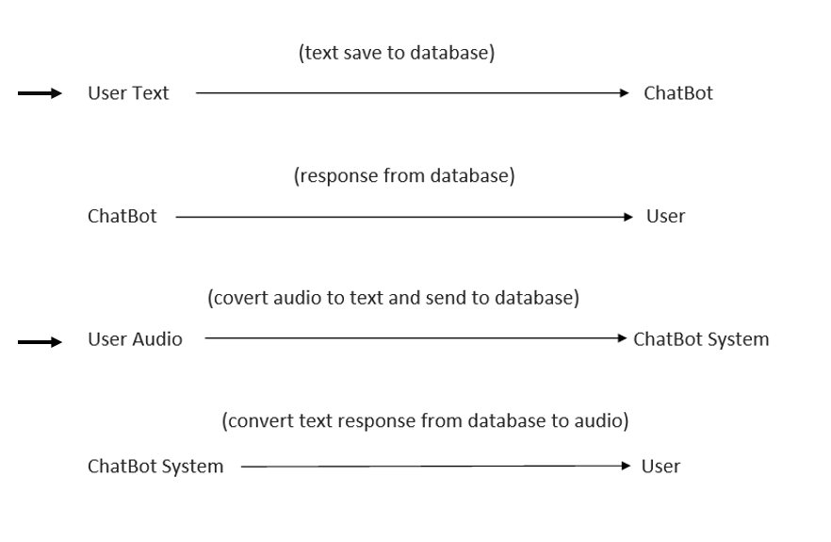

**HARDWARE SPECIFICATION**

* Processor P IV
* RAM 250 MB
* Minimum space required 90 MB
* Display 15.6 bit color

**SOFTWARE SPECIFICATION**

* + Operating Environment Win 2000/XP
  + Platform .Net Framework & IIS Visual Studio 2008
  + Languages used: HTML/CSS, JS, PHP
  + Database: MySql

**REFERENCES**

1. W3SCHOOLS
2. GeekForGeeks
3. YOUTUBE