Project Synopsis
OmniShield AI
An AI-Driven Security Orchestration, Automation and Response (SOAR) Platform for Real-Time Network Threat Detection and Autonomous Containment
Project Title | OmniShield AI – AI-Driven SOAR Platform for Real-Time Network Threat Detection & Automated Response
Domain | Cybersecurity · Artificial Intelligence · Network Security Automation
SDG Alignment | SDG 9 – Industry, Innovation and Infrastructure; SDG 16 – Peace, Justice and Strong Institutions

1. Problem Statement
Modern organizations face a rapidly growing volume and sophistication of network intrusions, ranging from data exfiltration to credential compromise. Security Operations Centers (SOCs) still rely heavily on manual triage: an analyst must notice an alert, correlate it against threat intelligence, decide whether it is malicious, and then manually execute a containment action such as blocking an IP address. This human-in-the-loop bottleneck is too slow for time-critical attacks such as large-scale data exfiltration, where damage can occur within minutes.
Existing rule-based Intrusion Detection Systems (IDS) generate a high volume of false positives and provide little context on which specific adversarial technique an anomaly maps to, forcing analysts to manually cross-reference frameworks such as MITRE ATT&CK. There is a need for a system that can autonomously detect statistically significant network anomalies, reason about them using an AI model grounded in real threat-intelligence data, and take immediate, auditable containment action — while keeping a human analyst informed and in ultimate control.

2. Objectives
- To design and implement a real-time network traffic monitoring pipeline capable of streaming and visualizing live connection data to a security dashboard.
- To develop a statistical anomaly detection engine using rolling-window z-score analysis that flags abnormal byte-transfer volumes against a learned traffic baseline.
- To integrate a local large language model (via LangChain and Ollama) that classifies detected anomalies and maps them to specific MITRE ATT&CK Enterprise techniques using retrieval-augmented generation (RAG).
- To build a vector knowledge base (ChromaDB) of real MITRE ATT&CK technique descriptions for accurate, explainable technique attribution rather than generic classification.
- To implement an automated response module that isolates malicious hosts at the network level (Windows Firewall rule injection) upon confirmed detection, with full manual override.
- To maintain a persistent, queryable incident log (SQLite) that records every detection and containment action for audit and post-incident analysis.
- To evaluate the system's detection accuracy and response latency using a labeled benchmark intrusion dataset (NSL-KDD).

3. Proposed Methodology
The system is organized into five cooperating layers, illustrated in the block diagram in Section 7:
- Data Ingestion: Real labeled “normal” connection records from the NSL-KDD network intrusion benchmark dataset are used to synthesize a realistic baseline traffic stream, avoiding purely random simulated data.
- Application/Orchestration Layer: A FastAPI backend exposes a WebSocket endpoint that streams live traffic events to the React dashboard, and REST endpoints (protected by API-key authentication) for containment actions.
- Detection Engine: Each packet's byte-transfer size is evaluated against a rolling mean and standard deviation of recent baseline traffic; a z-score above a configured threshold flags the packet as anomalous.
- AI/Knowledge Layer: On detection, the packet context is passed to a locally hosted Llama 3.1 model through LangChain, which is grounded via RAG over a ChromaDB vector store built from the real MITRE ATT&CK Enterprise STIX dataset, returning a structured verdict — matched technique ID, technique name, confidence score, and a recommended containment action.
- Response/Persistence Layer: Confirmed threats trigger PowerShell-driven Windows Firewall rules that block the offending IP across TCP/UDP/ICMP in both directions; every action (block, unblock, or failure) is logged to a SQLite incident table with timestamp and status for full auditability.
Development will proceed iteratively: (1) baseline traffic simulation and streaming, (2) statistical anomaly detector, (3) MITRE knowledge base and RAG-based attribution, (4) automated firewall response and incident logging, (5) dashboard integration and end-to-end testing, (6) evaluation against benchmark attack scenarios.

4. Expected Outcomes
- A working end-to-end SOAR prototype that detects anomalous network behavior in real time and visualizes it on a live analyst dashboard.
- Automated, explainable mapping of detected anomalies to specific MITRE ATT&CK techniques rather than a generic “malicious/benign” label.
- Autonomous, reversible network-level containment of compromised hosts, reducing mean time to respond (MTTR) compared to manual triage.
- A complete, timestamped audit trail of all automated security actions suitable for compliance review.
- A reusable reference architecture demonstrating how local LLMs and RAG can be applied to security automation without depending on external cloud AI services, addressing data-sovereignty concerns.

5. Hardware / Software Requirements
Hardware | Windows-based host machine (for firewall integration testing), minimum 16 GB RAM and a modern multi-core CPU/GPU recommended for local LLM inference via Ollama
Backend | Python 3.11+, FastAPI, Uvicorn, LangChain, langchain-ollama, SQLite3
AI/ML | Ollama runtime with Llama 3.1 model, ChromaDB vector database
Frontend | React (Vite), Tailwind CSS, WebSocket client
Datasets | NSL-KDD Network Intrusion Detection dataset; MITRE ATT&CK Enterprise STIX bundle
Automation | Windows PowerShell (Netsh/NetFirewallRule cmdlets) for automated host isolation
Tools | Git/GitHub for version control, VS Code IDE

6. System Block Diagram
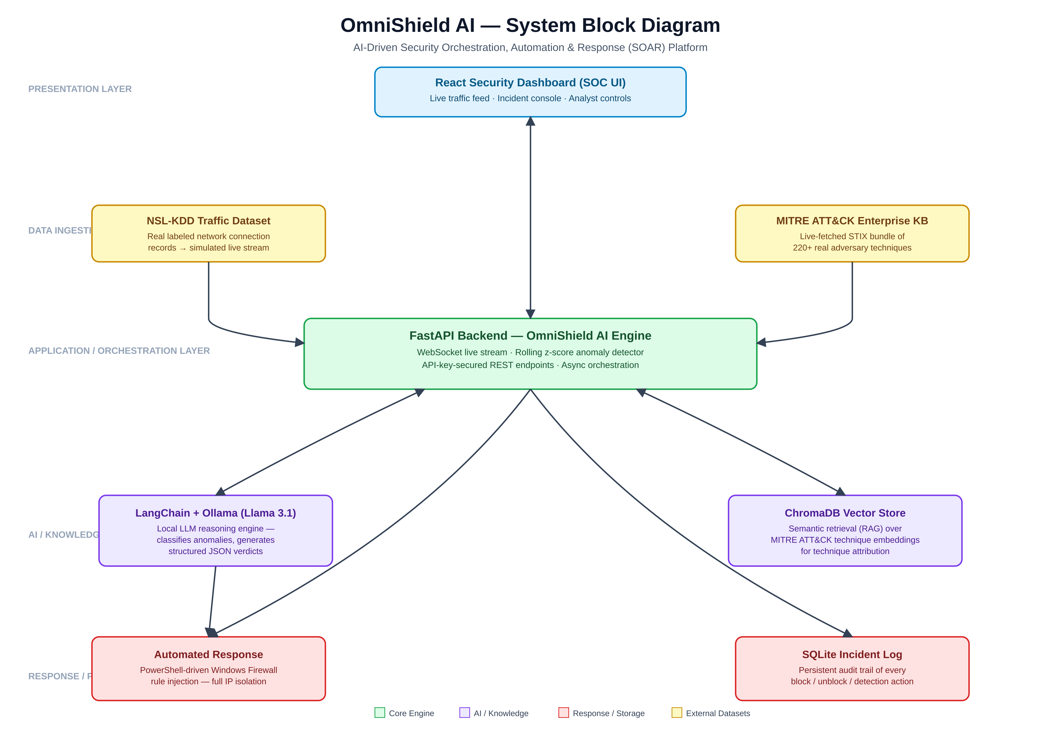
Fig. 1: OmniShield AI – layered system architecture

7. References
- MITRE ATT&CK® Enterprise Matrix, The MITRE Corporation, https://attack.mitre.org/
- NSL-KDD Dataset, University of New Brunswick Canadian Institute for Cybersecurity, https://www.unb.ca/cic/datasets/nsl.html
- Lewis, P. et al., “Retrieval-Augmented Generation for Knowledge-Intensive NLP Tasks,” NeurIPS, 2020.
- LangChain Documentation, https://python.langchain.com/
- Ollama Documentation, https://ollama.com/
- FastAPI Documentation, https://fastapi.tiangolo.com/
- ChromaDB Documentation, https://docs.trychroma.com/
- NIST SP 800-61 Rev. 2, “Computer Security Incident Handling Guide,” National Institute of Standards and Technology.

