

MINI PROJECT REPORT

NETWORK TRAFFIC ANALYZER
Packet Capture, Protocol Analysis and Suspicious-Traffic Detection using Python
Course: Computer Networks
Project Phase – 1 REPORT
Submitted by
Aryan Minish Kanjiraparambil [202407020024]
Roll No.: KU2407U024
in partial fulfilment for the award of the degree of
BACHELOR OF TECHNOLOGY
COMPUTER SCIENCE ENGINEERING (E)
Project Mentor
Ms. Pragya Vats
UNITEDWORLD INSTITUTE OF TECHNOLOGY
KARNAVATI UNIVERSITY
Uvarsad, Gandhinagar, Gujarat – 382422

July – November, 2026
Table of Contents
1. Abstract 1
2. Introduction 2
- Problem Statement
- Aim and Objectives
- Scope of the Project
3. System Requirements and Design 5
- Hardware Requirements
- Software Requirements
- System Architecture
- Diagrams
4. Implementation 14
- Technologies Used
- Screenshots and Outputs
5. Conclusion 28
6. Future Scope 29
7. References 30

1. Abstract
Computer networks carry thousands of packets every second, and understanding what is inside that traffic is essential for troubleshooting, capacity planning and security. This mini project presents the Network Traffic Analyzer (NTA), a packet capture and protocol analysis tool written in Python. The analyzer reads capture files in the standard pcap and pcapng formats (as saved by Wireshark and tcpdump) and can also capture live traffic directly from a network interface using raw sockets.
Every packet is decoded layer by layer – Ethernet and ARP at the link layer; IPv4, IPv6 and ICMP at the network layer; TCP and UDP at the transport layer; and DNS, HTTP, TLS, DHCP and NTP at the application layer. The decoder uses only Python’s standard library, so the header formats defined in the RFCs are implemented directly instead of being hidden inside a third-party library. From the decoded packets the tool computes traffic statistics (protocol distribution, top talkers, conversations, port usage, packet sizes and traffic rate over time) and applies six rule-based detectors for suspicious activity: TCP port scans, SYN floods, ICMP floods, ARP spoofing, DNS tunnelling and clear-text credentials. Results are presented as a console report, a Wireshark-style packet list, CSV and JSON exports, charts, a self-contained HTML report and a Flask web dashboard.
The tool was evaluated on a 116-second laboratory capture containing 4,676 packets of normal LAN traffic mixed with six simulated attacks. It decoded every packet without error, identified nine protocols, and flagged all six attacks with no false alarms on the normal traffic, completing the whole analysis in about 0.11 seconds. A live capture on a real interface confirmed that the capture mode works on genuine traffic, and a suite of 30 automated unit tests verifies the decoder, the statistics engine and every detection rule.
Keywords: packet capture, protocol analysis, pcap, TCP/IP, network monitoring, intrusion detection, port scan, ARP spoofing, Python.

2. Introduction
Modern networks are organised as a stack of layers. In the five-layer TCP/IP model used in this course, the application layer (HTTP, DNS, DHCP) produces messages, the transport layer (TCP, UDP) adds port numbers and reliability, the network layer (IP, ICMP) adds logical addresses and routing information, and the link layer (Ethernet, Wi-Fi, ARP) frames the data for the physical medium. Each layer wraps the data from the layer above in its own header – a process called encapsulation – so a single frame on the wire is really a set of nested headers followed by a payload.
Network traffic analysis is the practice of capturing these frames and decoding their headers to understand what is happening on a network. Network administrators use it to troubleshoot problems (a failing DNS lookup, a connection that is refused, a misconfigured DHCP server), to measure usage (which hosts and applications consume the most bandwidth) and to detect attacks such as port scans, denial-of-service floods and address spoofing. Professional tools such as Wireshark, tcpdump, Zeek and Snort perform these tasks, but they are large and complex, and the way they turn raw bytes into readable information is hidden from the student.
This project builds a compact traffic analyzer from first principles. Writing the decoder by hand for each protocol makes the header formats studied in class concrete: the 20-byte IPv4 header, the TCP flags that drive the three-way handshake, the DNS message format with name compression, and the ARP request/reply exchange. The same decoded data is then used for practical network management tasks – summarising traffic and spotting suspicious behaviour – so the project connects every unit of the Computer Networks syllabus, from application protocols down to the link layer and network security.

a) Problem Statement
Raw network traffic is not human-readable. A capture file is simply a stream of bytes, and even a small home or lab network produces thousands of packets per minute. Inspecting them manually to answer basic questions – Which hosts are using the most bandwidth? Which protocols and services are active? Is anyone scanning the network, flooding a server or impersonating the gateway? – is slow and error-prone.
Full-featured analyzers such as Wireshark can answer these questions, but they have a steep learning curve and do not summarise security-relevant patterns automatically, while dedicated intrusion detection systems need significant installation and configuration. There is therefore a need for a lightweight, easy-to-run tool that decodes the common Internet protocols, summarises traffic in a readable form and highlights suspicious behaviour – and whose source code is simple enough to show exactly how each protocol header is interpreted.

b) Aim and Objectives
Aim: To design and implement a Python-based network traffic analyzer that captures or reads network packets, decodes them across the TCP/IP layers, summarises the traffic and automatically flags common network attacks.
Objectives:
- To read standard capture files (pcap and pcapng) and to capture live packets from a network interface using raw sockets.
- To decode Ethernet, ARP, IPv4, IPv6, ICMP, TCP, UDP, DNS, HTTP, TLS (Server Name Indication), DHCP and NTP headers according to their RFC specifications.
- To compute traffic statistics: protocol distribution, top talkers, conversations (flows), destination ports, packet-size distribution and traffic rate over time.
- To detect suspicious activity – port scans, SYN floods, ICMP floods, ARP spoofing, DNS tunnelling and clear-text logins – using simple, explainable threshold rules.
- To present the results through a command-line report, CSV/JSON exports, charts, an HTML report and a web dashboard.
- To verify correctness with automated unit tests and a reproducible lab capture containing known normal and attack traffic.

c) Scope of the Project
In scope
- Offline analysis of .pcap and .pcapng files produced by Wireshark, tcpdump or the tool itself.
- Live capture on Linux (AF_PACKET raw socket, full Ethernet frames) and Windows (raw IP socket); capture can be saved to a pcap file for later analysis.
- Decoding of the twelve protocols listed in the objectives; other services are identified by their well-known port numbers.
- Traffic statistics and six rule-based detectors whose thresholds can be changed from the command line.
- Use in home, laboratory and classroom networks for learning, troubleshooting and basic security monitoring.
Out of scope (limitations)
- Decrypting encrypted traffic – for HTTPS only metadata such as the server name (SNI), ports, sizes and timing are visible.
- Reassembling complete TCP streams or extracting transferred files.
- Blocking or preventing attacks – the tool detects and reports; it is not a firewall or an intrusion prevention system.
- Very high-speed links (multi-gigabit) where an interpreted language cannot keep up with the packet rate.
Ethical use. Capturing packets can expose other people’s private data, so the tool must only be used on networks that the user owns or is authorised to monitor. For this reason the project ships with a generated lab capture that uses the documentation IP address ranges reserved by RFC 5737, and the analyzer never stores passwords: for a clear-text login it records only the fact that one occurred.

3. System Requirements and Design
This chapter lists the hardware and software needed to run the analyzer and describes its design – the overall architecture, the modules, the protocols decoded, the detection rules and the main diagrams.

a) Hardware Requirements
Table 3.1: Hardware requirements
Component | Minimum | Recommended
Processor | Any dual-core x86-64 or ARM64 CPU | Quad-core, 2 GHz or faster
Memory (RAM) | 4 GB | 8 GB for captures of more than about one million packets
Storage | 200 MB free (Python and project) | 1 GB or more for saved captures and reports
Network interface | Any Ethernet or Wi-Fi adapter (live capture only) | Wired Ethernet adapter; switch with a mirror (SPAN) port to monitor other hosts
Display | 1366 × 768 | 1920 × 1080 for the dashboard

No special hardware is needed for analysing capture files. For capturing other devices’ traffic on a switched network a mirror (SPAN) port is required, because a switch normally forwards to the capturing computer only the frames addressed to it, plus broadcasts.

b) Software Requirements
Table 3.2: Software requirements
Software | Version | Purpose
Operating system | Windows 10/11, Linux (Ubuntu 22.04+), macOS 12+ | Runs the analyzer; live capture is supported on Linux and Windows
Python | 3.9 or newer (developed and tested on 3.13) | Core language; standard-library modules struct, socket, ipaddress, argparse, csv, json
matplotlib | 3.x (optional) | Charts in the reports
Flask | 3.x (optional) | Browser-based dashboard
pytest | 7 or newer (optional) | Running the unit tests (they also run with Python’s built-in unittest)
Wireshark / tcpdump | Any recent version (optional) | Creating capture files and cross-checking results
Web browser | Chrome, Edge or Firefox | Viewing the HTML report and the dashboard
Git and GitHub | Any recent version | Version control and publishing the source code

The core analyzer (capture, decoding, statistics, detection and console/CSV/JSON output) has no third-party dependencies. matplotlib and Flask are only needed for charts and the web dashboard, and live capture needs administrator (Windows) or root (Linux) privileges because it opens a raw socket.

c) System Architecture
The analyzer follows a layered pipeline architecture (Figure 3.1). Packets enter from one of three sources, are turned into raw byte records by the capture/file layer, decoded into structured Packet objects, analysed, and finally presented to the user in several formats. Each stage is a separate Python module with a single responsibility, which keeps the code easy to test and extend.
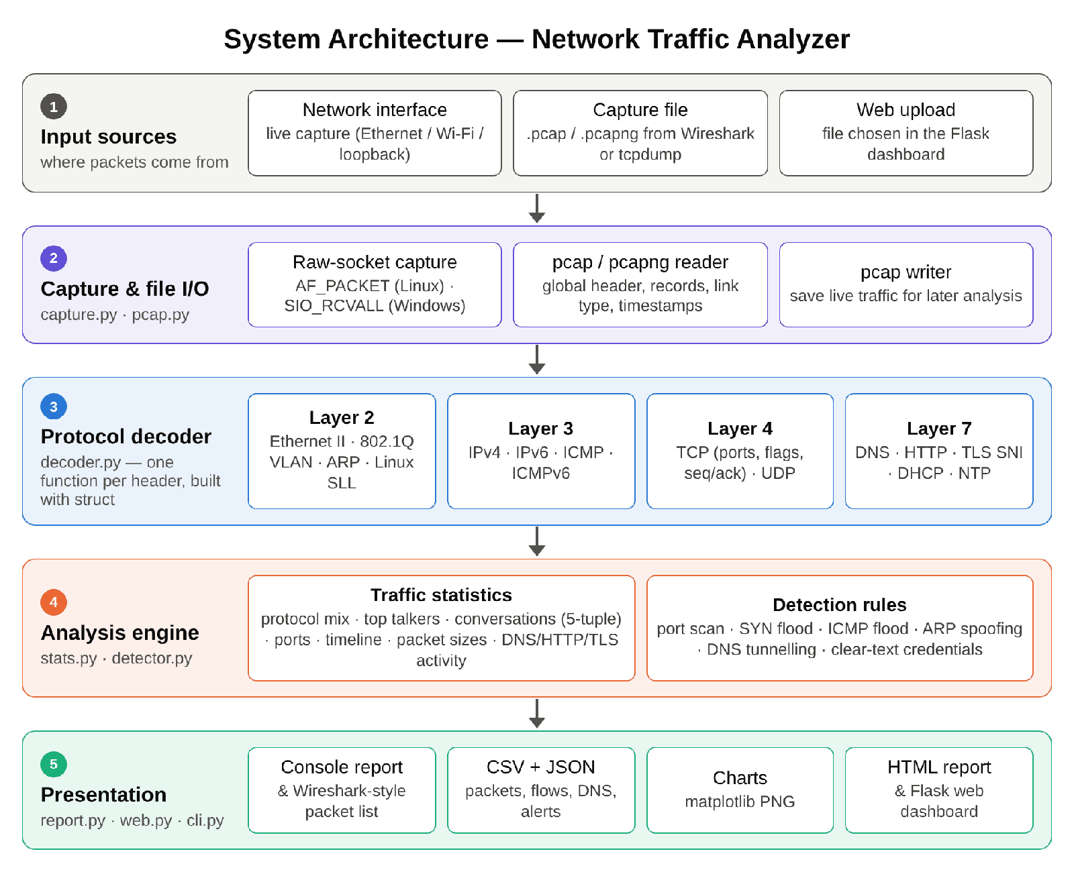
Figure 3.1: System architecture of the Network Traffic Analyzer
- Input sources – a live network interface, a capture file saved by Wireshark/tcpdump, or a file uploaded through the web dashboard.
- Capture and file I/O – capture.py opens a raw socket and receives frames; pcap.py reads and writes pcap/pcapng files.
- Protocol decoder – decoder.py walks down the headers of each frame (layer 2 → 3 → 4 → 7) and fills a Packet record.
- Analysis engine – stats.py aggregates the packets into statistics and conversations; detector.py applies the detection rules.
- Presentation – report.py prints the console report and writes CSV, JSON, charts and the HTML report; web.py serves the dashboard; cli.py provides the commands.
Table 3.3: Module structure of the source code
Module | Responsibility | Lines
nta/pcap.py | Read pcap and pcapng files; write pcap files | 167
nta/capture.py | Live capture with raw sockets (Linux / Windows) | 99
nta/decoder.py | Decode Ethernet, ARP, IPv4/IPv6, ICMP, TCP, UDP, DNS, HTTP, TLS, DHCP, NTP | 516
nta/stats.py | Traffic statistics, conversations (flows), timeline | 235
nta/detector.py | Six rule-based detectors and alert records | 254
nta/report.py | Console report, packet list, CSV/JSON, charts, HTML report | 506
nta/cli.py, web.py | Command-line interface and Flask dashboard | 241
nta/craft.py | Packet builder used by tests and the lab-capture generator | 170
scripts/make_sample_pcap.py | Generates the reproducible lab capture | 357
tests/ | 30 unit and end-to-end tests | 287

Protocols decoded. Table 3.4 lists the header fields that the decoder extracts at each layer, together with the standard that defines the format. All multi-byte fields are read in network byte order (big-endian) using struct.unpack with the ! format prefix.
Table 3.4: Protocols and header fields decoded
Layer | Protocol | Fields extracted | Standard
Link | Ethernet II, 802.1Q | Destination/source MAC, EtherType, VLAN ID | IEEE 802.3, 802.1Q
Link | ARP | Operation, sender MAC/IP, target IP | RFC 826
Network | IPv4 | IHL, total length, TTL, protocol, addresses, fragment offset | RFC 791
Network | IPv6 | Next header, hop limit, addresses, extension headers | RFC 8200
Network | ICMP / ICMPv6 | Type, code, identifier, sequence number | RFC 792 / 4443
Transport | TCP | Ports, sequence/ack numbers, data offset, flags, window | RFC 9293
Transport | UDP | Ports, length | RFC 768
Application | DNS | ID, QR flag, rcode, question name/type, A/AAAA/CNAME answers | RFC 1035
Application | HTTP/1.x | Method, URI, Host, status code, Basic-auth presence | RFC 9112
Application | TLS | Record type, ClientHello Server Name Indication (SNI) | RFC 8446, 6066
Application | DHCP | Transaction ID, message type (option 53) | RFC 2131
Application | NTP | Mode (client request / server response) | RFC 5905

Detection rules. Each rule is a small, explainable heuristic of the kind used by threshold-based intrusion detection systems. Sliding time windows are used so that a slow trickle of normal connections is not mistaken for an attack. The default thresholds (Table 3.5) can be changed with command-line options.
Table 3.5: Detection rules and default thresholds
Rule | Logic | Default threshold | Severity
TCP port scan | One source sends SYN (without ACK) to many different ports of one host | ≥ 20 distinct ports within 60 s | High
SYN flood | Many SYNs to one host:port while few three-way handshakes are completed | ≥ 200 SYNs in 10 s and < 20 % completed | Critical
ICMP flood | Burst of ICMP Echo Requests to one host | ≥ 100 requests in 10 s | Medium
ARP spoofing | The same IP address is claimed in ARP replies by two or more MAC addresses | 2 MAC addresses for 1 IP | High
DNS tunnelling | Many long or random-looking (high-entropy) query names under one parent domain | Name > 50 chars or label entropy > 3.5 bits/char; ≥ 10 queries | Medium
Clear-text credentials | HTTP Basic Authorization header, or an FTP/Telnet session carrying data | Any occurrence | Low

d) Diagrams
Data Flow Diagram – Level 0. The context diagram (Figure 3.2) shows the analyzer as a single process. It receives commands, thresholds and filters from the user, raw frames from a network interface and stored packets from capture files, and it returns statistics, charts, alerts and reports to the user.
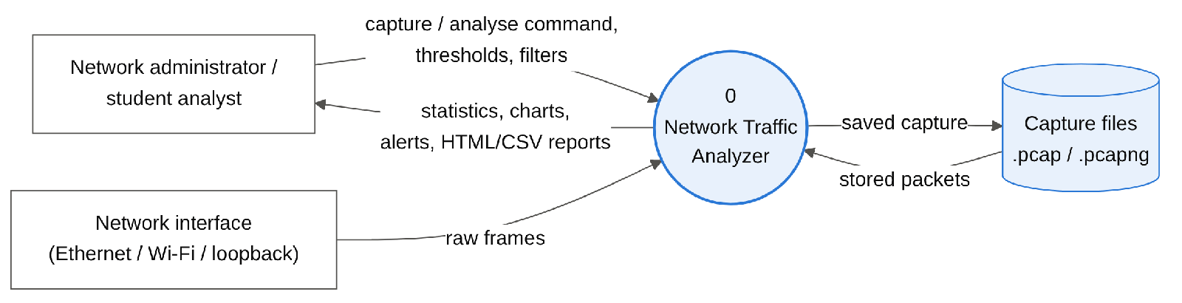
Figure 3.2: Data Flow Diagram – Level 0 (context diagram)
Data Flow Diagram – Level 1. Figure 3.3 expands the system into five processes: (1.0) capture or read packets, (2.0) decode protocol headers, (3.0) compute statistics, (4.0) detect suspicious patterns and (5.0) generate reports, together with the three data stores – the capture file, the decoded packet list and the output folder.
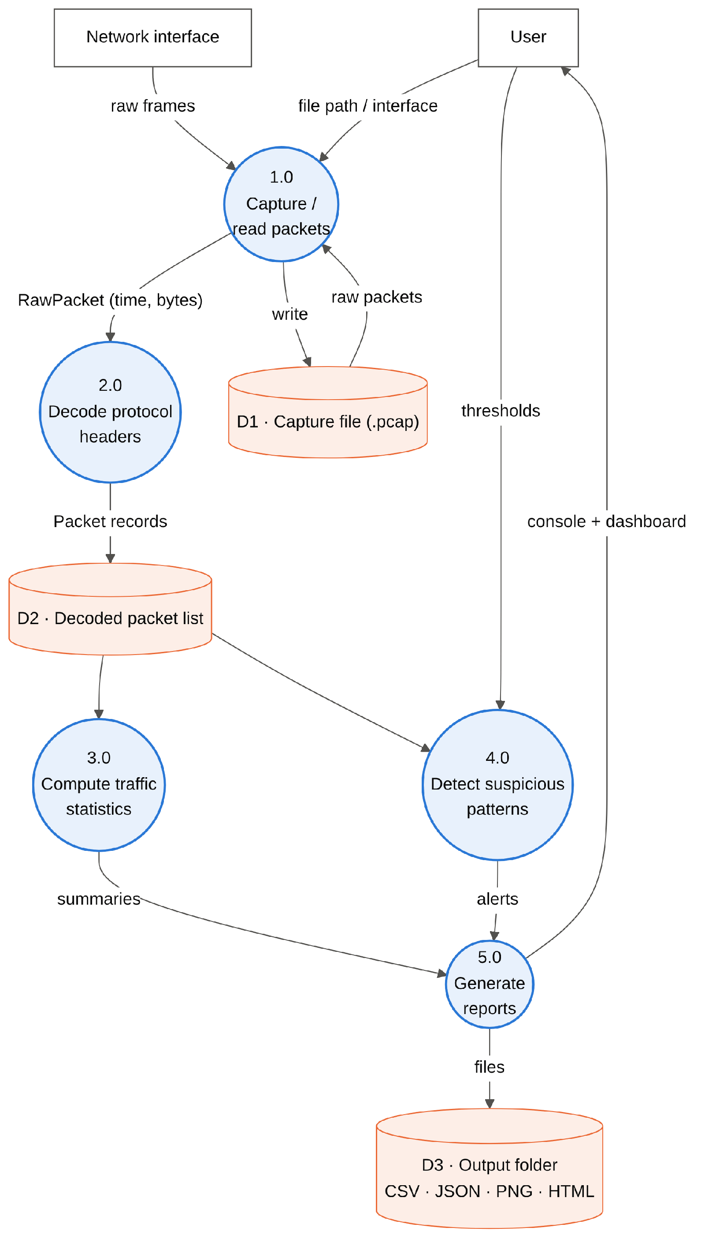
Figure 3.3: Data Flow Diagram – Level 1
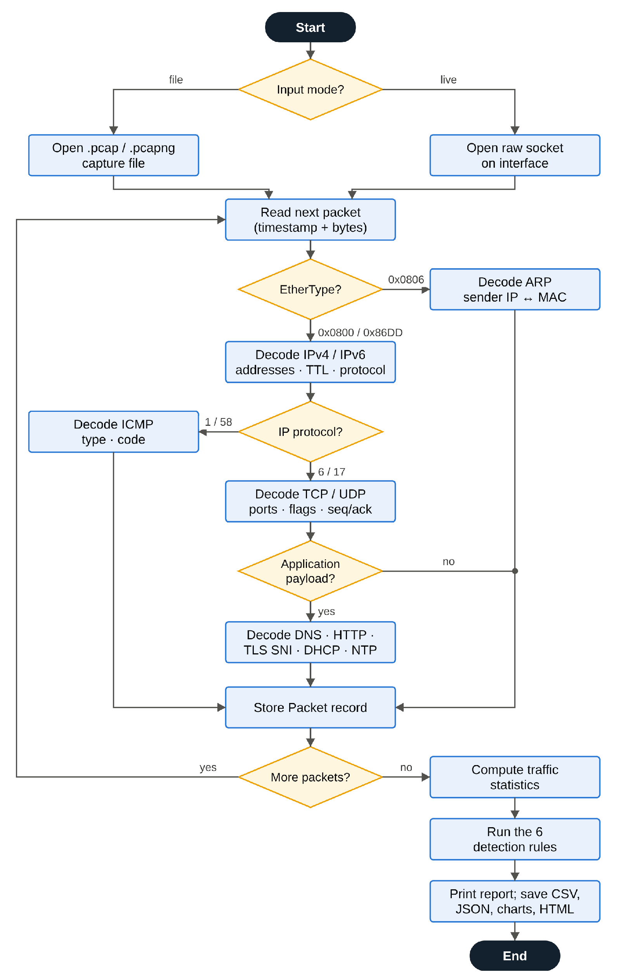
Figure 3.4: Flowchart of packet processing
Flowchart. Figure 3.4 shows the processing logic for each packet. The decoder chooses the next header to parse from the field that identifies it in the current header: the EtherType selects ARP, IPv4 or IPv6; the IP protocol number selects ICMP (1), TCP (6) or UDP (17); and the port number or payload signature selects the application protocol. After the last packet, statistics are computed, the detection rules are run and the reports are written.
Use Case Diagram. Figure 3.5 shows what the main actor – a network administrator or student analyst – can do with the system. Capturing traffic, analysing files and uploading files all include protocol decoding; viewing statistics includes the statistics computation; and tuning thresholds extends the detection rules.
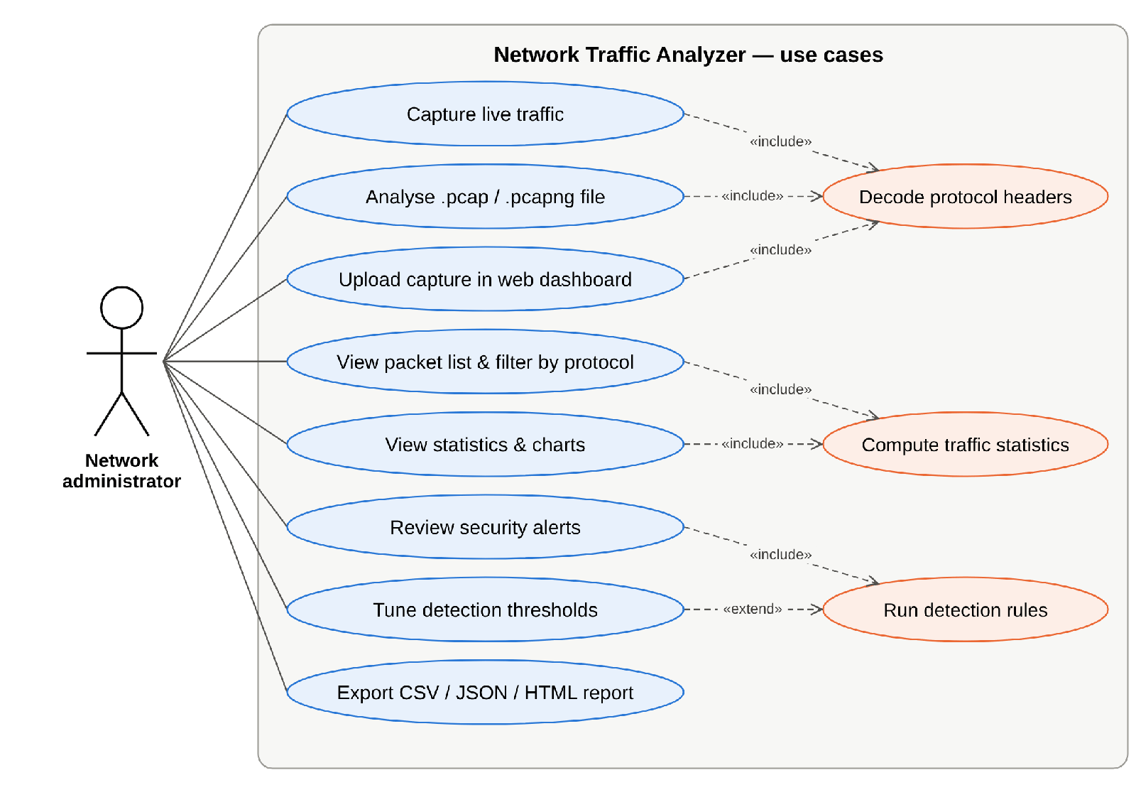
Figure 3.5: Use case diagram

4. Implementation
The analyzer was implemented as a Python package named nta with a command-line entry point (python -m nta). This chapter describes the technologies used, explains how the key parts were implemented, and presents the outputs obtained. The complete source code, sample capture, tests and documentation are published at https://github.com/AryanMinish/network-traffic-analyzer.

a) Technologies Used
Table 4.1: Technologies used
Technology | Where it is used | Why it was chosen
Python 3 | Whole project | Readable, cross-platform, rich standard library for binary data and networking
struct module | decoder.py, pcap.py, craft.py | Unpacks header fields from bytes in network byte order
socket module | capture.py | Raw sockets (AF_PACKET / SIO_RCVALL) for live capture without libpcap
ipaddress module | decoder.py, craft.py | Converts 4- and 16-byte addresses to dotted / colon notation
dataclasses, collections | decoder.py, stats.py | Structured packet records and fast counting (Counter)
argparse | cli.py | Sub-commands: analyze, packets, capture, dashboard, interfaces
matplotlib | report.py | Timeline, protocol, talker, port and packet-size charts
Flask | web.py | Upload page and HTML report in the browser
unittest / pytest | tests/ | Automated verification of decoder, statistics and detection rules
Git and GitHub | Repository | Version control and publishing the project

Project structure
network-traffic-analyzer/
├── nta/ # the analyzer package
│ ├── pcap.py # pcap / pcapng reader and writer
│ ├── capture.py # live capture with raw sockets
│ ├── decoder.py # protocol decoder (L2 → L7)
│ ├── stats.py # traffic statistics and conversations
│ ├── detector.py # six detection rules
│ ├── report.py # console, CSV, JSON, charts, HTML
│ ├── cli.py / web.py # command line and Flask dashboard
│ └── craft.py # packet builder (tests, sample capture)
├── scripts/make_sample_pcap.py # builds samples/lab_traffic.pcap
├── samples/lab_traffic.pcap # 2-minute lab capture
├── tests/ # 30 unit tests
├── docs/ # report, slides, diagrams, screenshots
└── README.md, requirements.txt, LICENSE

Reading capture files
A classic pcap file starts with a 24-byte global header whose magic number (0xA1B2C3D4, or 0xA1B23C4D for nanosecond timestamps) also reveals the byte order of the file; the header also stores the link-layer type (1 = Ethernet). Each packet is then stored as a 16-byte record header – seconds, fractional seconds, captured length and original length – followed by the packet bytes. The newer pcapng format used by Wireshark is a sequence of blocks; the reader handles the Section Header, Interface Description (which carries the link type and timestamp resolution) and Enhanced/Simple Packet blocks, and skips the rest.

Decoding headers layer by layer
Each protocol is decoded by one small function that unpacks the fixed header with struct, stores the useful fields in the Packet record and passes the remaining bytes to the next layer. The IPv4 decoder below is taken directly from decoder.py; it computes the real header length from the IHL field (so IP options are skipped correctly), trims Ethernet padding using the total-length field, and does not try to parse a transport header inside a non-first fragment.
def _ipv4(pkt: Packet, data: bytes) -> None:
ver_ihl, _tos, total_len, _ident, frag, ttl, proto = struct.unpack("!BBHHHBB", data[:10])
ihl = (ver_ihl & 0x0F) * 4
if ihl < 20:
raise ValueError("bad IHL")
pkt.network = pkt.protocol = "IPv4"
pkt.src_ip = str(ipaddress.IPv4Address(data[12:16]))
pkt.dst_ip = str(ipaddress.IPv4Address(data[16:20]))
pkt.ttl, pkt.ip_proto = ttl, proto
end = total_len if 0 < total_len <= len(data) else len(data)
payload = data[ihl:end]
if frag & 0x1FFF: # not the first fragment: no transport header here
pkt.info = f"Fragmented IP protocol (proto={proto}, off={(frag & 0x1FFF) * 8})"
return
_transport(pkt, proto, payload)
TCP flags are decoded from the low bits of the offset/flags word into a compact string such as S (SYN), SA (SYN-ACK) or AF (ACK-FIN), which makes the handshake logic in the detectors easy to read. DNS names are decoded with full support for message compression (pointers with the top two bits set), and the TLS decoder walks the ClientHello – version, random, session ID, cipher suites, compression methods – to reach the extensions and read the server_name extension, which reveals the website being visited even though the content is encrypted.

Statistics and conversation tracking
Statistics are gathered in a single pass over the packets using Counter objects: packets and bytes per protocol, bytes sent and received per host, connection attempts per destination port, TCP flag counts and a packet-size histogram. Packets are grouped into bidirectional conversations by their 5-tuple (protocol, source and destination address and port); the two endpoints are sorted to form the key, so both directions of a flow map to the same conversation. For TCP the observed flags are used to label each conversation as ESTABLISHED, CLOSED, RESET, REJECTED (answered by RST) or NO REPLY (a SYN that was never answered).

Detection logic
The flood detectors count events inside a sliding time window with a two-pointer scan, which finds the busiest window in linear time after sorting:
def _max_in_window(times: list[float], window: float) -> tuple[int, float, float]:
"""Largest number of events inside any sliding window (two-pointer scan)."""
times = sorted(times)
best, best_start, best_end, lo = 0, 0.0, 0.0, 0
for hi, t in enumerate(times):
while t - times[lo] > window:
lo += 1
if hi - lo + 1 > best:
best, best_start, best_end = hi - lo + 1, times[lo], t
return best, best_start, best_end
The port-scan rule applies the same idea to the set of distinct destination ports probed by one source, and also reports which ports answered with SYN-ACK (that is, which ports the attacker discovered to be open). The DNS tunnelling rule measures the Shannon entropy H = −Σ pᵢ log₂ pᵢ of the longest label of each query name: ordinary names such as karnavatiuniversity have low entropy, whereas encoded data such as base32 text is close to random and has high entropy. The ARP-spoofing rule keeps a table of which MAC addresses have claimed each IP address in ARP replies and raises an alert when a second MAC claims an address that is already known.

Live capture
On Linux the capture module opens an AF_PACKET/SOCK_RAW socket bound to the chosen interface, which delivers complete Ethernet frames. On the loopback interface Linux delivers every packet twice (once outgoing and once incoming), so the outgoing copy is discarded – the same behaviour as tcpdump. On Windows an AF_INET raw socket is put into promiscuous receive mode with SIO_RCVALL, which delivers IP packets without the Ethernet header. Captured packets can be analysed immediately and optionally written to a pcap file.

Lab capture and testing method
To test the analyzer reproducibly without capturing anyone’s private traffic, the script scripts/make_sample_pcap.py uses the packet builder craft.py to generate a two-minute capture of a small LAN (192.168.1.0/24) with a router, a laptop, a phone, a desktop, a local web server, a newly joining device and an intruder. The builder computes real IPv4, TCP, UDP and ICMP checksums (RFC 1071), so the file is also valid in Wireshark. Normal activity – DHCP, ARP, DNS, 21 HTTPS/HTTP website visits, NTP, ping, mDNS over IPv6 and a 1.2 MB file download – is mixed with the six simulated attacks listed in Table 4.2. Because the attack times are known, the detector output can be checked exactly.
Table 4.2: Simulated attacks injected into the lab capture
Time (s) | Simulated event | Hosts involved
39.7 | SYN (half-open) scan of TCP ports 1–200 | 192.168.1.66 → 192.168.1.12
57.7 | Router admin page opened with HTTP Basic authentication | 192.168.1.10 → 192.168.1.1
59.7 | 12 forged ARP replies claiming to be the gateway | de:ad:be:ef:00:66 → laptop, desktop
74.7 | SYN flood from 450 spoofed source addresses | 198.18.0.0/15 → 192.168.1.20:80
89.7 | Burst of 180 ICMP Echo Requests (1,000-byte payload) | 192.168.1.66 → 192.168.1.20
99.7 | 28 DNS TXT queries with encoded data in the names | 192.168.1.15 → *.exfil-lab.example

Running the project
git clone https://github.com/AryanMinish/network-traffic-analyzer.git
cd network-traffic-analyzer
pip install -r requirements.txt # matplotlib + Flask (optional extras)
python -m nta analyze samples/lab_traffic.pcap --out output
python -m nta packets samples/lab_traffic.pcap -p DNS -n 20
sudo python -m nta capture -i eth0 -c 500 -w my.pcap # Linux (root)
python -m nta dashboard # then open http://127.0.0.1:5000
python -m pytest -v # run the 30 unit tests

b) Screenshots and Outputs
The screenshots below were produced by running the commands above. Figures 4.1 to 4.5 show the analysis of the lab capture, Figure 4.6 shows a live capture on a real interface, Figures 4.7 to 4.10 show the HTML report and web dashboard, and Figure 4.11 shows the test results.
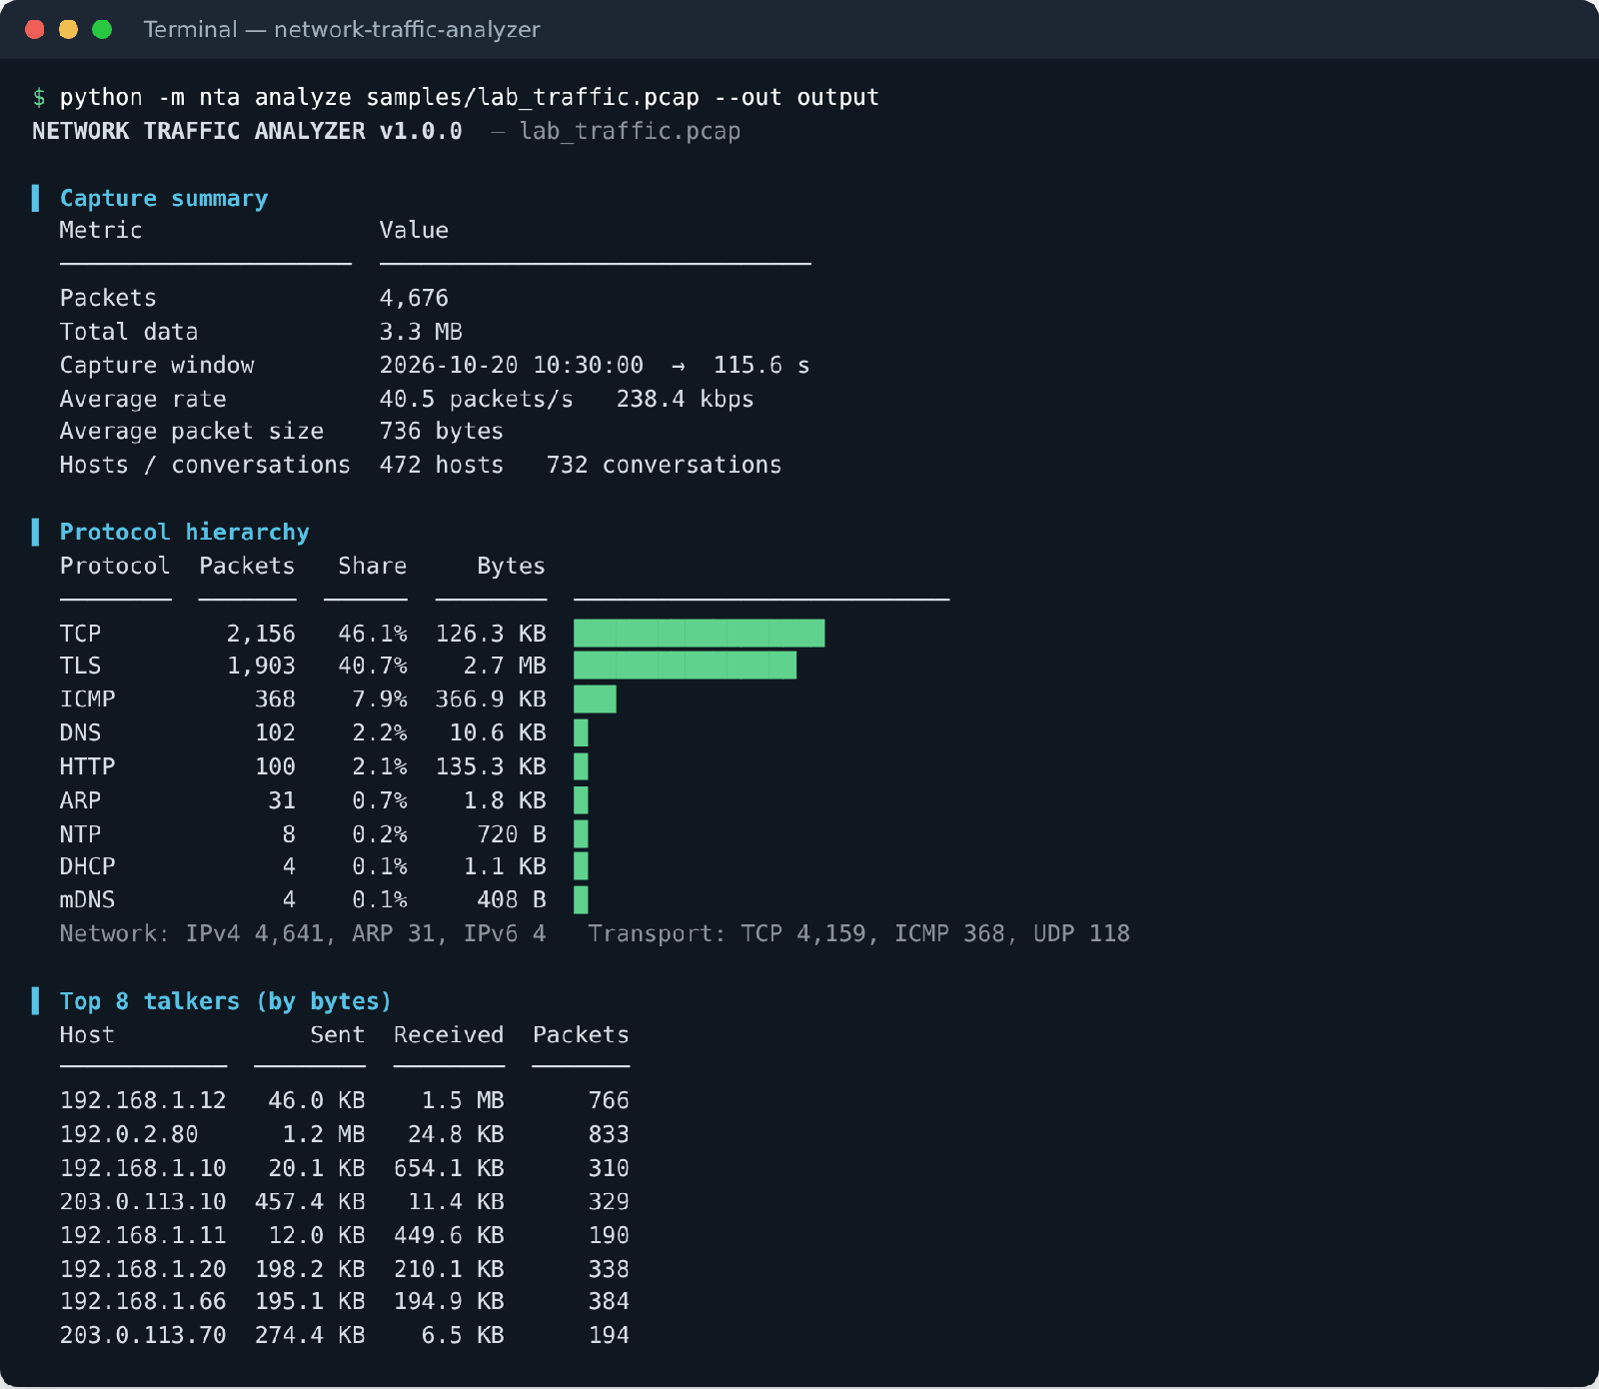
Figure 4.1: Console report – capture summary, protocol hierarchy and top talkers
The capture lasted 115.6 s and contained 4,676 packets (3.3 MB), an average of 40.5 packets/s or 238.4 kbps. Nine protocols were identified. TLS carried most of the data (2.7 MB), while plain TCP segments – handshakes, acknowledgements and the scan/flood packets – were the most numerous. The host count of 472 is high because the SYN flood used 450 spoofed source addresses.
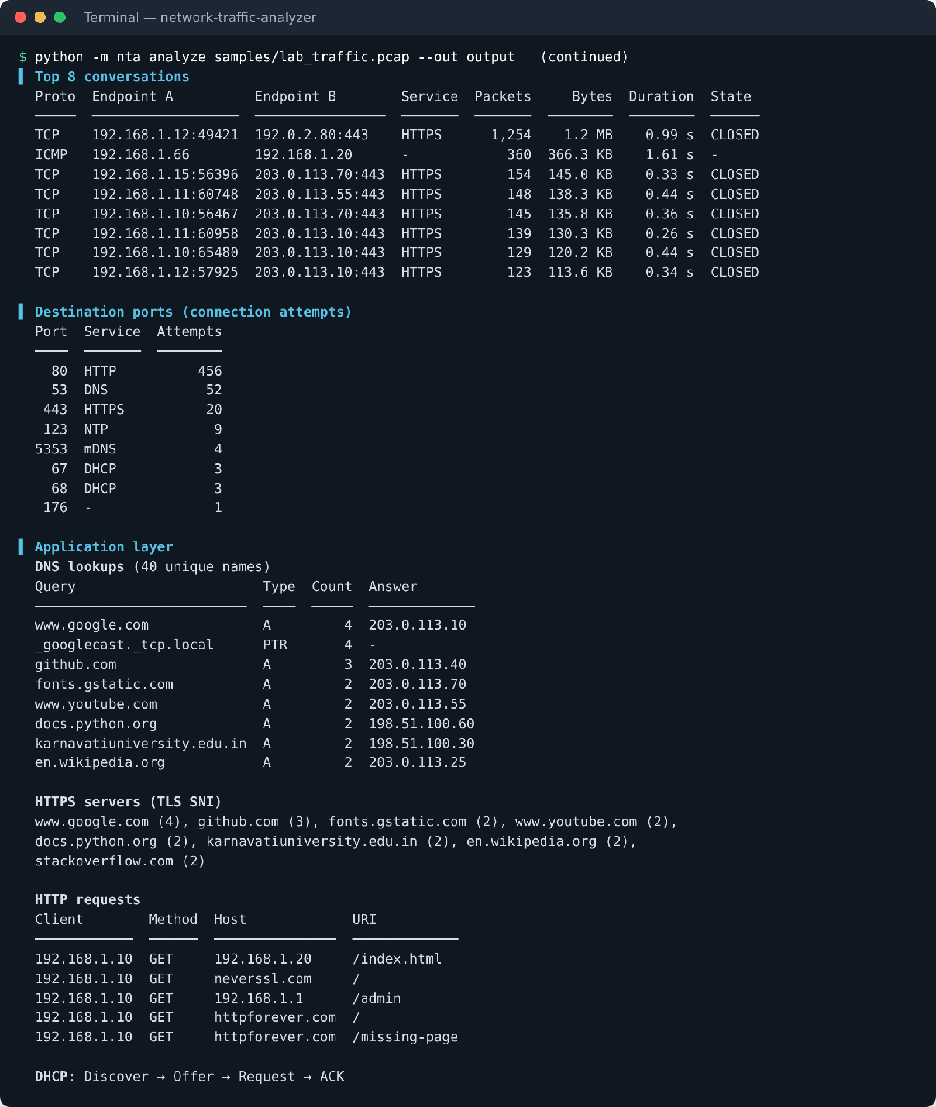
Figure 4.2: Console report – conversations, destination ports and application-layer activity
The largest conversation is the 1.2 MB HTTPS download by 192.168.1.12. The application-layer section lists the DNS lookups with their answers, the HTTPS servers identified from the TLS Server Name Indication, the five plain HTTP requests (including the request for /missing-page) and the complete DHCP Discover → Offer → Request → ACK exchange of the device that joined the network.
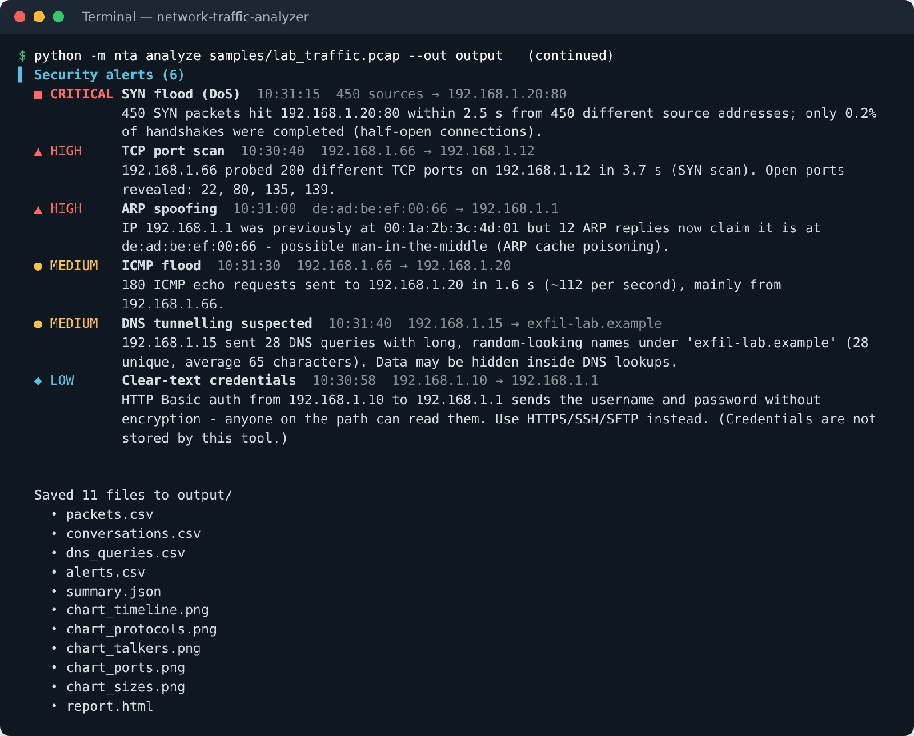
Figure 4.3: Console report – security alerts and saved output files
All six simulated attacks were detected and ranked by severity. Each alert explains what was seen, the hosts involved and the evidence – for example, that the port scan revealed open ports 22, 80, 135 and 139, and that only 0.2 % of the SYN-flood handshakes were completed.
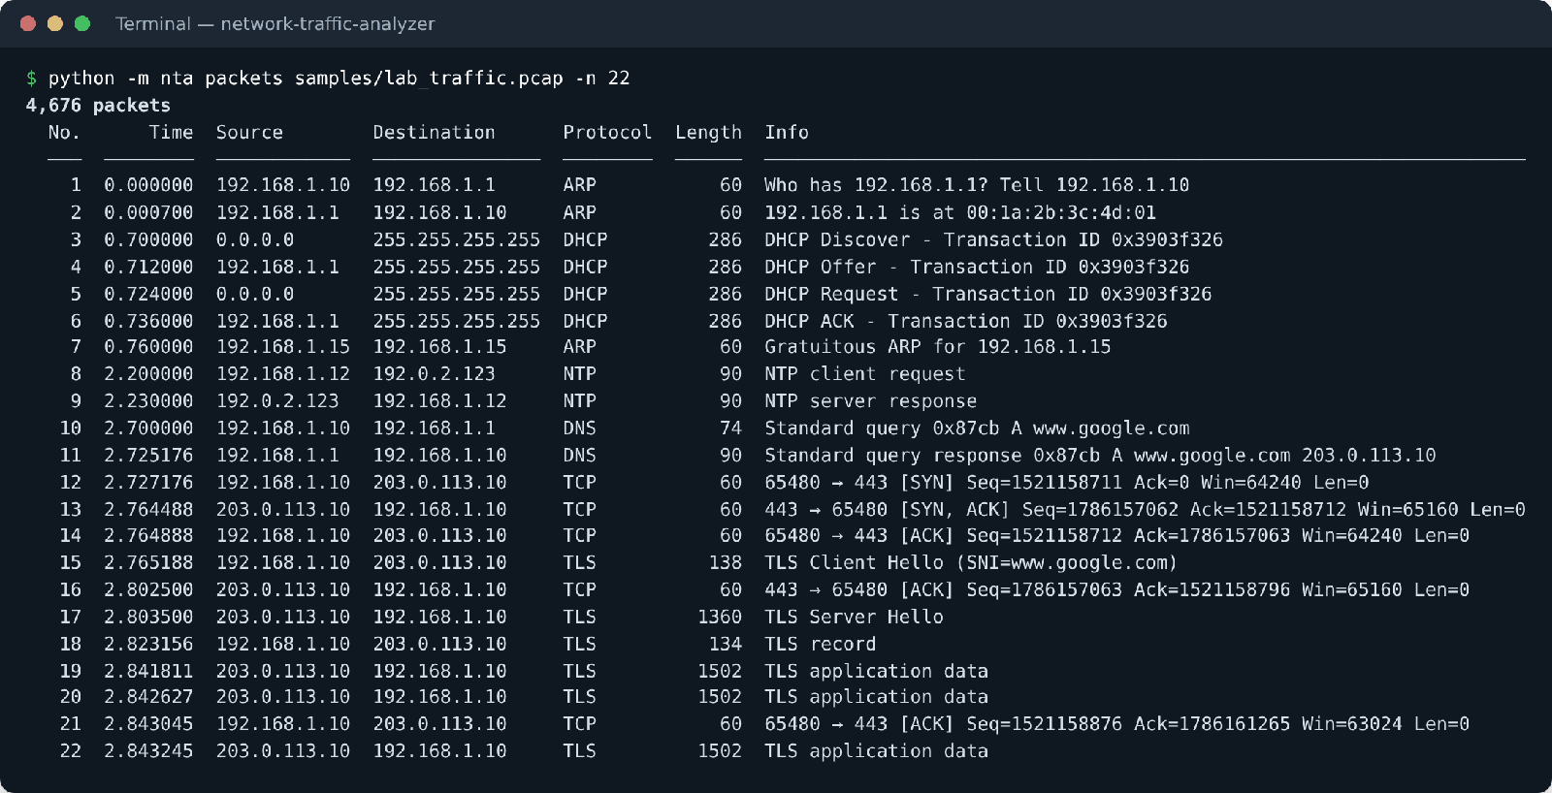
Figure 4.4: Wireshark-style packet list (first 22 packets)
The packet list shows the decoder output for individual packets: an ARP request and reply, the four DHCP messages, an NTP exchange, a DNS query and response for www.google.com, the TCP three-way handshake (SYN → SYN-ACK → ACK) to port 443, the TLS Client Hello carrying the server name, and the encrypted application data that follows – the same information Wireshark shows in its Info column.
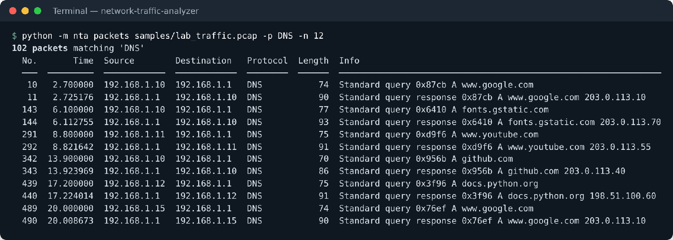
Figure 4.5: Packet list filtered to DNS traffic only
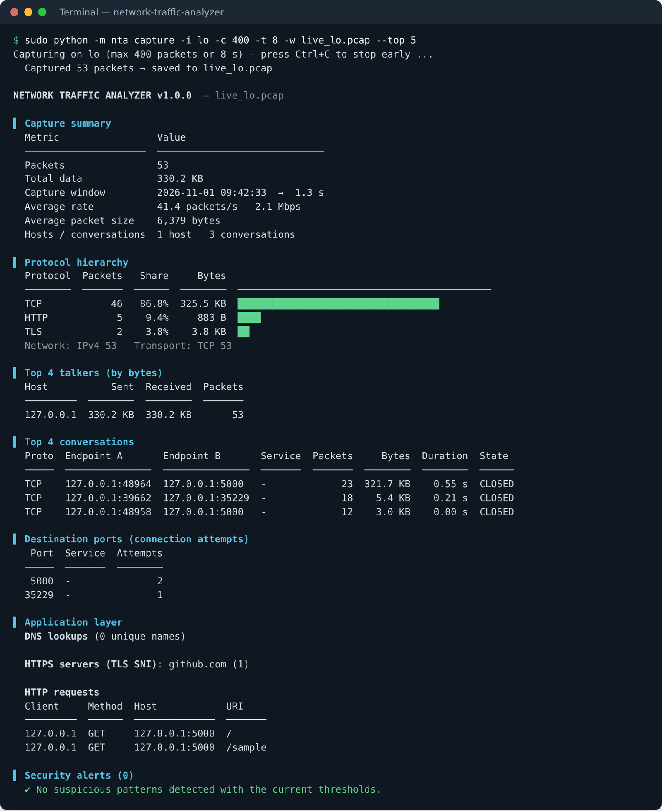
Figure 4.6: Live capture on the loopback interface of a Linux test machine
Figure 4.6 shows the capture mode working on genuine traffic. While capturing, the web dashboard was opened twice and an HTTPS request was made to github.com. The analyzer decoded both real HTTP requests (GET / and GET /sample) and extracted the server name github.com from the real TLS handshake.
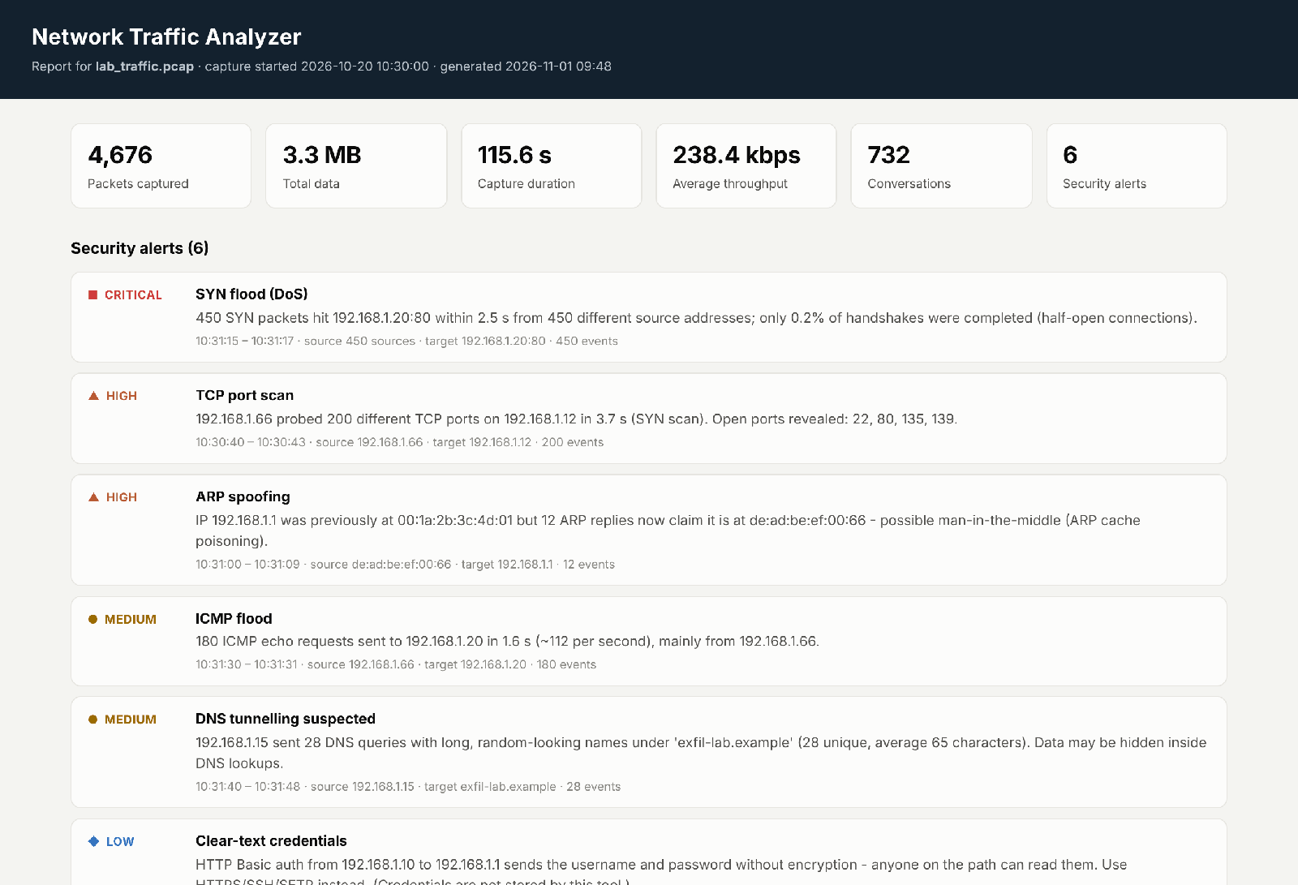
Figure 4.7: HTML report – summary tiles and security alerts
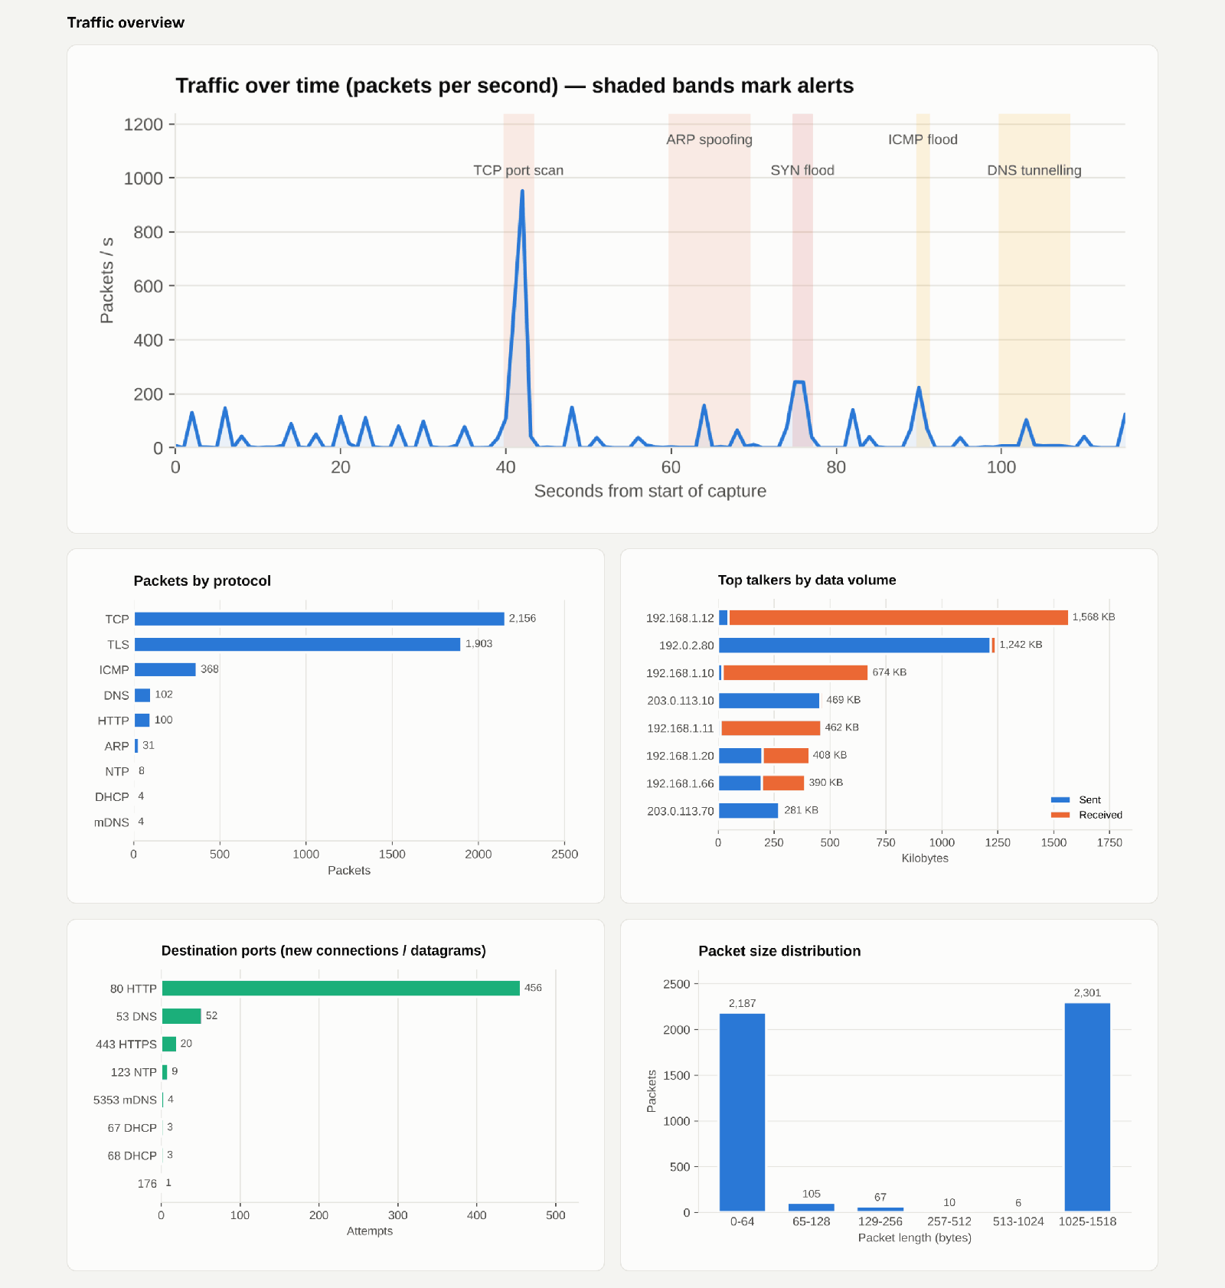
Figure 4.8: HTML report – traffic charts
In the traffic timeline the shaded bands mark the alert windows. The tallest spike (952 packets in one second, at second 42) is the port scan, and the SYN and ICMP floods appear as short bursts. The packet-size chart is strongly bimodal – 2,187 packets of 64 bytes or less (ACKs, SYNs and RSTs) and 2,301 full-size packets of 1,025–1,518 bytes (data segments) – which is typical of TCP bulk transfer. Port 80 tops the destination-port chart only because of the 450 SYN-flood packets.
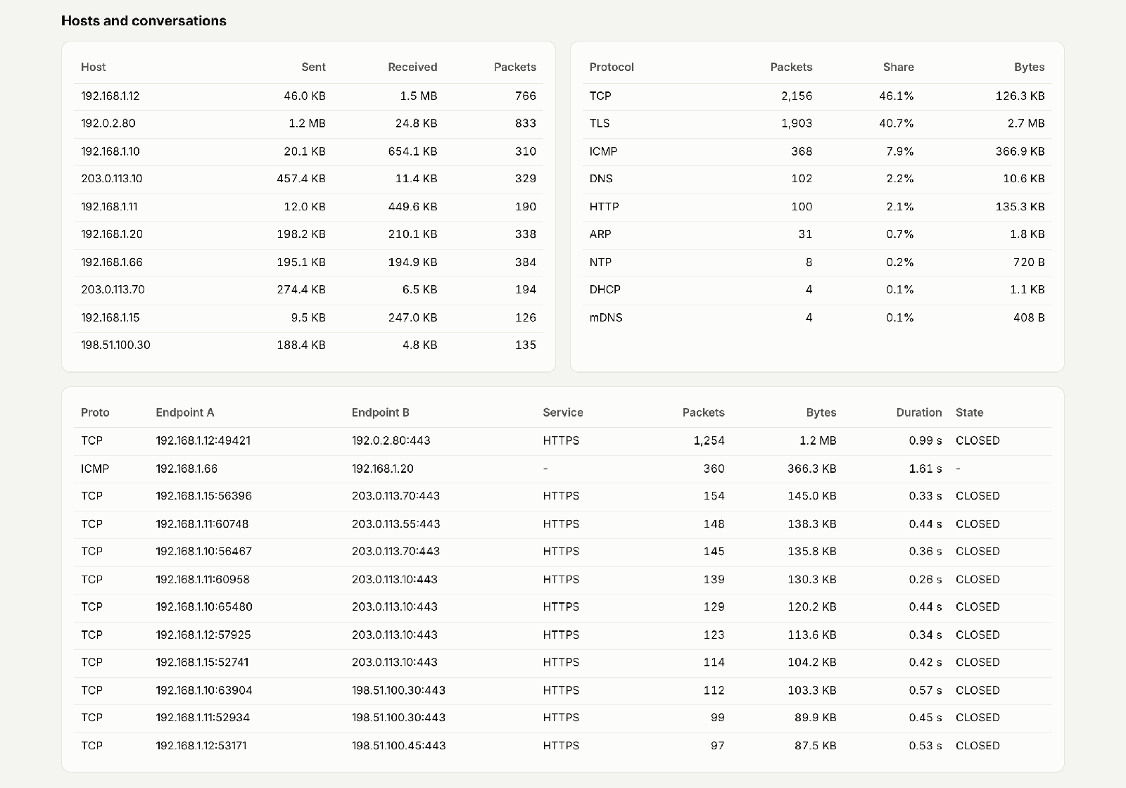
Figure 4.9: HTML report – hosts, protocol table and conversations
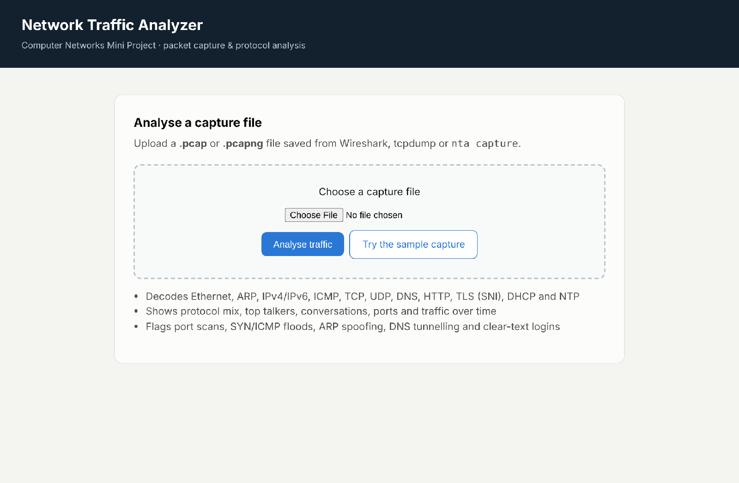
Figure 4.10: Flask web dashboard – upload page
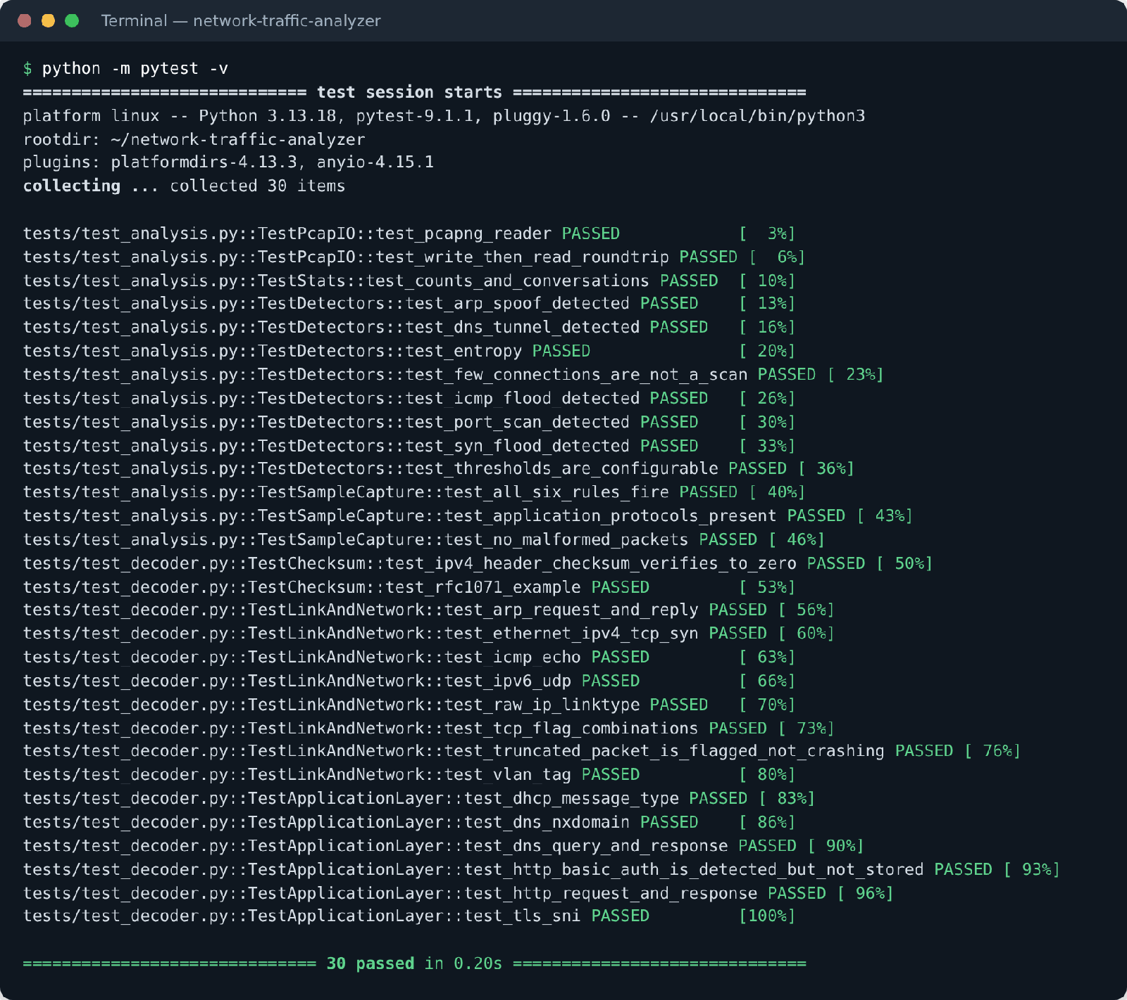
Figure 4.11: Result of the automated unit tests (30 passed)

Results summary
Table 4.3: Results of analysing the lab capture
Metric | Value
Capture duration / packets / data | 115.6 s / 4,676 packets / 3,443,711 bytes
Average rate and packet size | 40.5 packets/s, 238.4 kbps, 736.5 bytes
Protocols identified | 9 – TCP, TLS, ICMP, DNS, HTTP, ARP, NTP, DHCP, mDNS
Network layer | IPv4 4,641 · ARP 31 · IPv6 4
Transport layer | TCP 4,159 · ICMP 368 · UDP 118
Conversations | 732 (675 TCP)
DNS / HTTPS / HTTP | 40 unique names (28 NXDOMAIN) · 9 servers by SNI · 5 HTTP requests
Malformed packets | 0
Alerts raised / false alarms | 6 / 0
Processing time | ≈ 0.11 s for the capture (≈ 39,000 packets/s on a 2-core test machine)

Table 4.4: Detection results
Simulated attack | Detected | Severity | Evidence reported by the tool
TCP port scan | Yes | High | 200 ports probed in 3.7 s; open ports 22, 80, 135, 139
Clear-text login | Yes | Low | HTTP Basic auth 192.168.1.10 → 192.168.1.1 (password not stored)
ARP spoofing | Yes | High | Gateway IP claimed by de:ad:be:ef:00:66 in 12 replies
SYN flood | Yes | Critical | 450 SYNs in 2.5 s from 450 sources; 0.2 % handshakes completed
ICMP flood | Yes | Medium | 180 echo requests in 1.6 s (≈ 112 per second)
DNS tunnelling | Yes | Medium | 28 queries, all unique, average name length 65 characters

Table 4.5: Summary of unit tests
Test group | What is checked | Tests | Result
Checksum | RFC 1071 example; IPv4 header checksum | 2 | Pass
Link / network decoding | Ethernet, TCP flags, ARP, ICMP, raw IP, IPv6, VLAN, truncated packet | 8 | Pass
Application decoding | DNS query/answer, NXDOMAIN, HTTP, Basic auth, TLS SNI, DHCP | 6 | Pass
pcap I/O | pcap write/read round trip; pcapng reader | 2 | Pass
Statistics | Protocol counts, conversations, TCP state | 1 | Pass
Detection rules | Each rule fires on attack data and stays silent on normal data; thresholds; entropy | 8 | Pass
End-to-end | All six rules fire on the lab capture; no malformed packets; protocols present | 3 | Pass

5. Conclusion
The Network Traffic Analyzer meets all the objectives set for the project. It reads pcap and pcapng files and captures live traffic, decodes twelve protocols across the link, network, transport and application layers, summarises the traffic in a readable form, and detects six common types of suspicious activity. On the lab capture it decoded all 4,676 packets without error, detected every simulated attack with no false alarms on normal traffic, and completed the analysis in a fraction of a second; a live capture confirmed that it works on real network traffic as well.
Building the decoder from scratch was the most valuable part of the project from a learning point of view. It required working directly with the header formats defined in the RFCs – byte order, header-length fields, TCP flags, DNS name compression and the structure of a TLS handshake – and it showed in practice how encapsulation lets each layer be handled independently. The detection rules showed how simple, well-chosen thresholds on decoded header fields can reveal port scans, floods and spoofing, and also why such rules must be tuned to the network in which they are used.
The project also gave experience with good software practice: a modular design, a command-line interface, automated tests, reproducible test data and publication of the code on GitHub. Because the core has no external dependencies, the tool can be run on almost any computer with Python, which makes it suitable both as a learning aid for Computer Networks and as a lightweight first-look tool for network troubleshooting.

6. Future Scope
The current version provides a solid base that can be extended in several directions:
- More protocols – QUIC/HTTP-3, SMB, SSH key exchange details, DHCPv6, ICMPv6 neighbour discovery and VLAN/VXLAN tunnels.
- TCP stream reassembly – rebuild complete TCP streams to measure retransmissions, round-trip time and throughput per connection, and to follow HTTP conversations.
- Real-time dashboard – stream live-capture statistics to the browser with WebSockets and show alerts as they happen.
- Machine-learning detection – train an anomaly-detection or classification model (for example Random Forest on flow features) to complement the threshold rules and detect unknown attacks.
- Faster capture – use libpcap/Npcap with BPF filters, or a compiled extension, to keep up with gigabit links.
- Alerting and integration – send alerts by e-mail or messaging apps and export them in Syslog or JSON for a SIEM.
- GeoIP and threat intelligence – show the country of external addresses and flag connections to known malicious hosts.
- Long-term storage – store flow summaries in a database (SQLite) to show trends over days and weeks.

7. References
- J. F. Kurose and K. W. Ross, Computer Networking: A Top-Down Approach, 8th ed. Pearson, 2021.
- B. A. Forouzan, Data Communications and Networking, 5th ed. McGraw-Hill, 2013.
- J. Postel, “Internet Protocol,” RFC 791, IETF, 1981.
- W. Eddy, Ed., “Transmission Control Protocol (TCP),” RFC 9293, IETF, 2022.
- J. Postel, “User Datagram Protocol,” RFC 768, IETF, 1980.
- J. Postel, “Internet Control Message Protocol,” RFC 792, IETF, 1981.
- D. C. Plummer, “An Ethernet Address Resolution Protocol,” RFC 826, IETF, 1982.
- S. Deering and R. Hinden, “Internet Protocol, Version 6 (IPv6) Specification,” RFC 8200, IETF, 2017.
- P. Mockapetris, “Domain Names – Implementation and Specification,” RFC 1035, IETF, 1987.
- R. Droms, “Dynamic Host Configuration Protocol,” RFC 2131, IETF, 1997.
- E. Rescorla, “The Transport Layer Security (TLS) Protocol Version 1.3,” RFC 8446, IETF, 2018; and D. Eastlake 3rd, “TLS Extensions: Extension Definitions,” RFC 6066, IETF, 2011.
- R. Fielding, M. Nottingham and J. Reschke, Eds., “HTTP/1.1,” RFC 9112, IETF, 2022.
- R. Braden, D. Borman and C. Partridge, “Computing the Internet Checksum,” RFC 1071, IETF, 1988.
- J. Arkko, M. Cotton and L. Vegoda, “IPv4 Address Blocks Reserved for Documentation,” RFC 5737, IETF, 2010.
- G. Harris and M. Richardson, “PCAP Capture File Format” and “PCAP Next Generation (pcapng) Capture File Format,” IETF OPSAWG Internet-Drafts.
- Wireshark Foundation, Wireshark User’s Guide, https://www.wireshark.org/docs/
- The Tcpdump Group, tcpdump and libpcap documentation, https://www.tcpdump.org/
- Python Software Foundation, The Python Standard Library – struct, socket and ipaddress modules, https://docs.python.org/3/
- Cisco, Snort 3 User Manual, https://www.snort.org/documents; and The Zeek Project, Zeek Documentation, https://docs.zeek.org/
- J. D. Hunter et al., Matplotlib documentation, https://matplotlib.org/; Pallets Projects, Flask documentation, https://flask.palletsprojects.com/
- A. M. Kanjiraparambil, Network Traffic Analyzer – source code repository, GitHub, 2026. https://github.com/AryanMinish/network-traffic-analyzer

