**SCM LAB ASSIGNMENT**

**To Open a Pull Request –

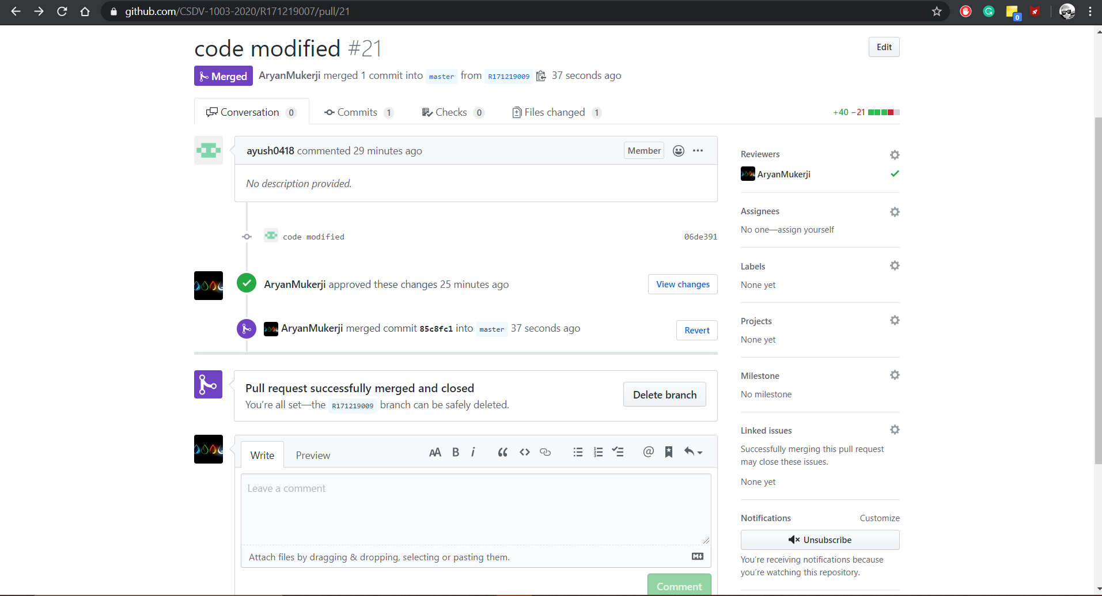To Close a Pull Request –