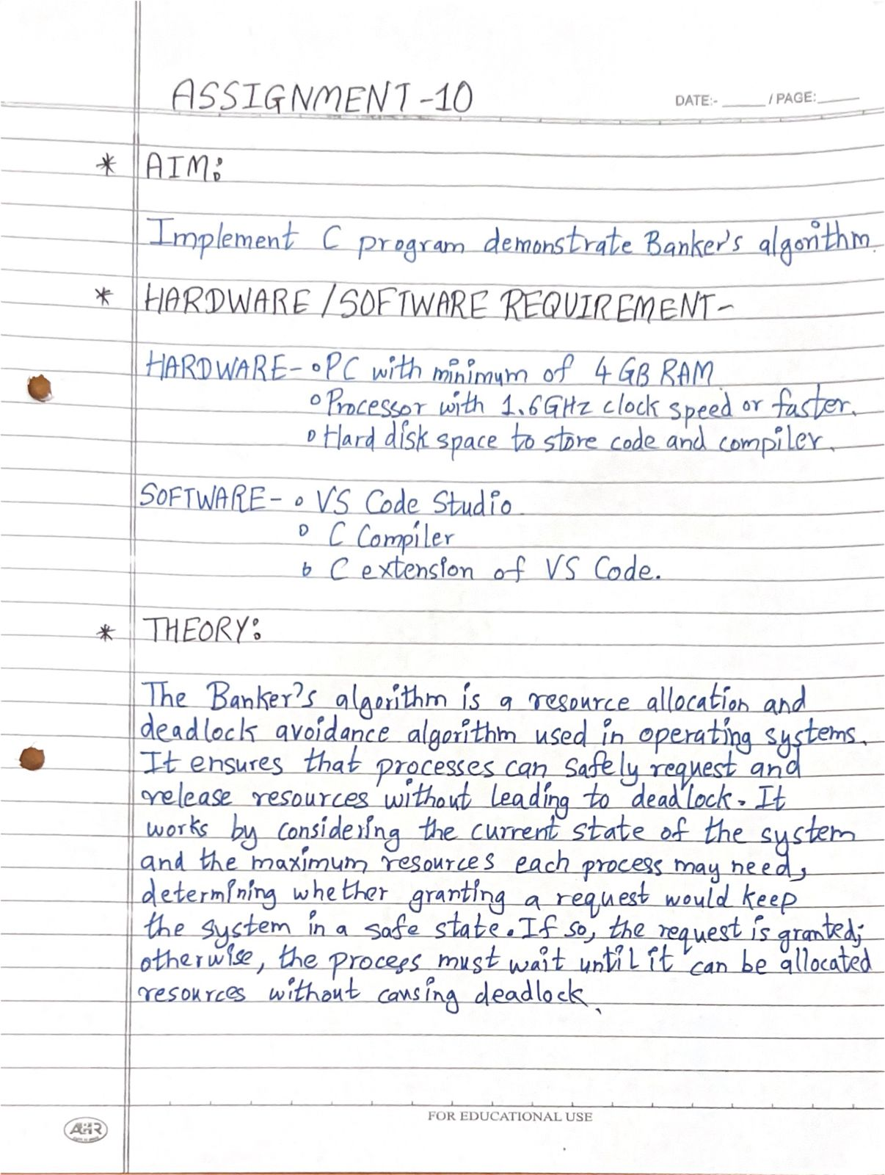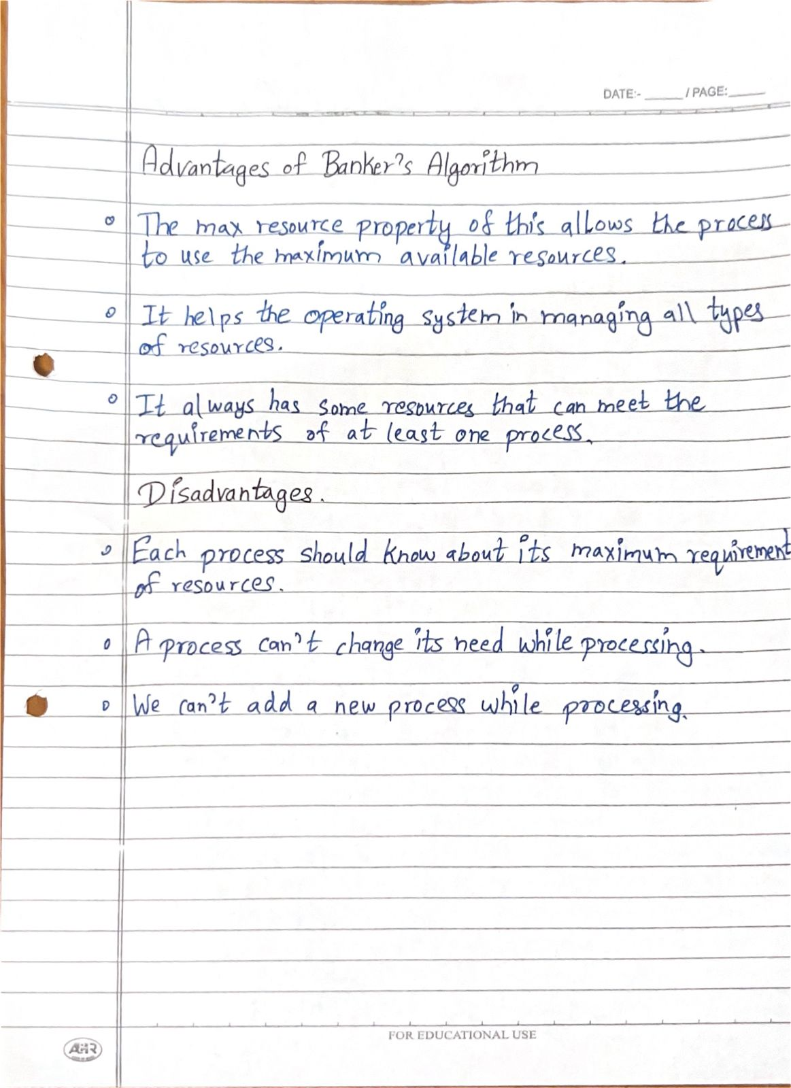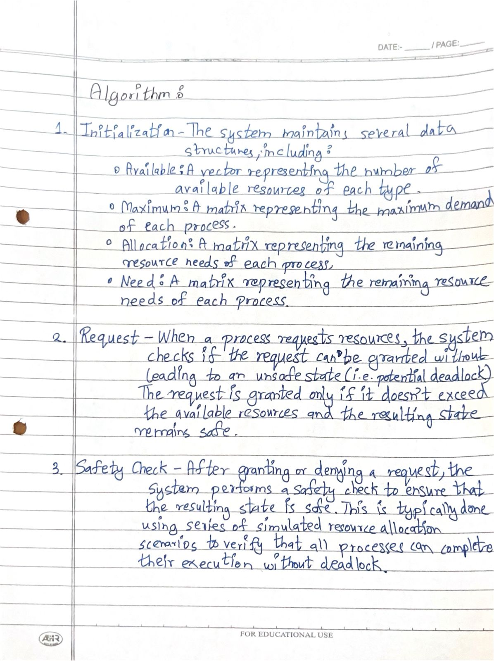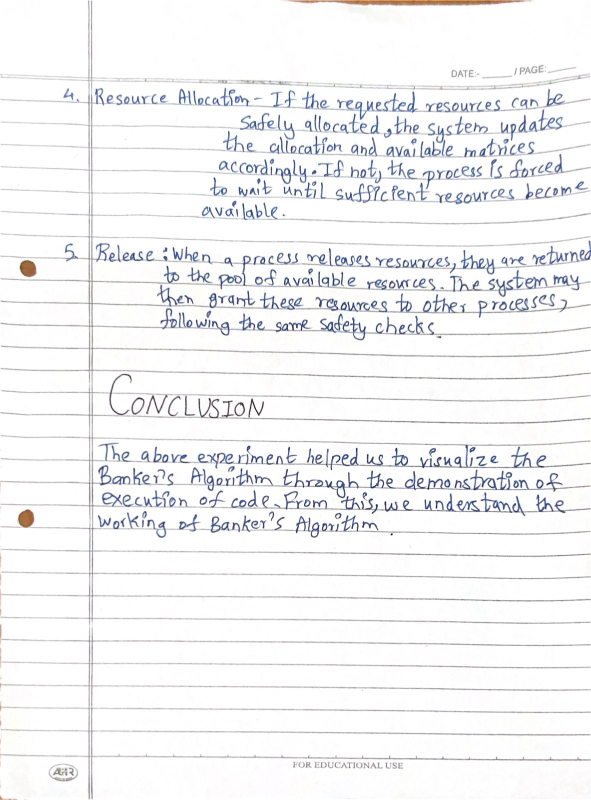

**PROGRAM :**

#include <stdio.h>

int main()

{

int n, m, i, j, k;

printf("Enter the number of Processes: ");

scanf("%d",&n);

printf("Enter the number of Resources: ");

scanf("%d",&m);

int alloc[n][m];

int max[n][m];

int avail[m];

printf("Enter Allocation Matrix \n");

for(i=0;i<n;i++)

{

printf("For P%d",i+1);

printf("\n");

for(j=0;j<m;j++)

{

scanf("%d",&alloc[i][j]);

}

}

printf("Enter Max Matrix \n");

for(i=0;i<n;i++)

{

printf("For P%d",i+1);

printf("\n");

for(j=0;j<m;j++)

{

scanf("%d",&max[i][j]);

}

}

printf("Enter Available Resources");

printf("\n");

for(i=0;i<m;i++)

{

scanf("%d",&avail[i]);

}

int need[n][m];

for (i = 0; i < n; i++) {

for (j = 0; j < m; j++)

need[i][j] = max[i][j] - alloc[i][j];

}

printf("\n\nNEED MATRIX\n");

for (i = 0; i < n; i++) {

for (j = 0; j < m; j++) {

printf("%d\t", need[i][j]);

}

printf("\n");

}

int f[n], ans[n], ind = 0;

for (k = 0; k < n; k++) {

f[k] = 0;

}

int y = 0;

for (k = 0; k < n; k++) {

for (i = 0; i < n; i++) {

if (f[i] == 0) {

int flag = 1;

for (j = 0; j < m; j++) {

if (need[i][j] > avail[j]) {

flag = 0;

break; // Exit the loop if any resource is unavailable

}

}

if (flag) {

ans[ind++] = i;

for (y = 0; y < m; y++)

avail[y] += alloc[i][y];

f[i] = 1;

}

}

}

}

// Check if all processes are finished

int flag = 1;

for(i=0;i<n;i++)

{

if(f[i]==0)

{

flag=0;

printf("The following system is not safe");

break;

}

}

// Output Safe Sequence

if(flag==1)

{

printf("Following is the SAFE Sequence\n");

for (i = 0; i < n -1 ; i++)

printf(" P%d ->", ans[i]+1);

printf(" P%d", ans[n - 1 ]+1);

}

}

**OUTPUT :**

