LAB Manual

|  |  |  |
| --- | --- | --- |
| Name of Student : Aryan Mulik |  | PRN : 23070122518 |
| **Semester : IV** |  | **Year AY 23-24** |
| **Subject Title: Operating Systems Lab** | | |
| EXPERIMENT No : 2 | Assignment No: 2 |  |
| TITLE : Basic Shell commands | DoP : 28/01/24 |  |

***Aim :*** Demonstrate the use of basic Shell commands

***Learning Outcome:*** *1. To understand the shell command*

*2. To Demonstrate the shell command*

Hardware/Software : (It should be handwritten)

Theory: (It should be handwritten)

pwd, ls, cd, Touch, mkdir, cat, Rm, Bc, Tty, Who, Man, Date, History, ps, time, Head, Tail, cp, sort, wc, chmod

***Output:*** snapshots of commands demonstration

Conclusion: (It should be handwritten)

assessment schemes.

|  |  |  |  |  |  |  |
| --- | --- | --- | --- | --- | --- | --- |
| Attendance | Discipline | Short oral | Correctness of Lab Report | Timely  completion of Lab Report | Total marks  (10) | Signature of Teacher with Date |
|  |  |  |  |  |  |  |

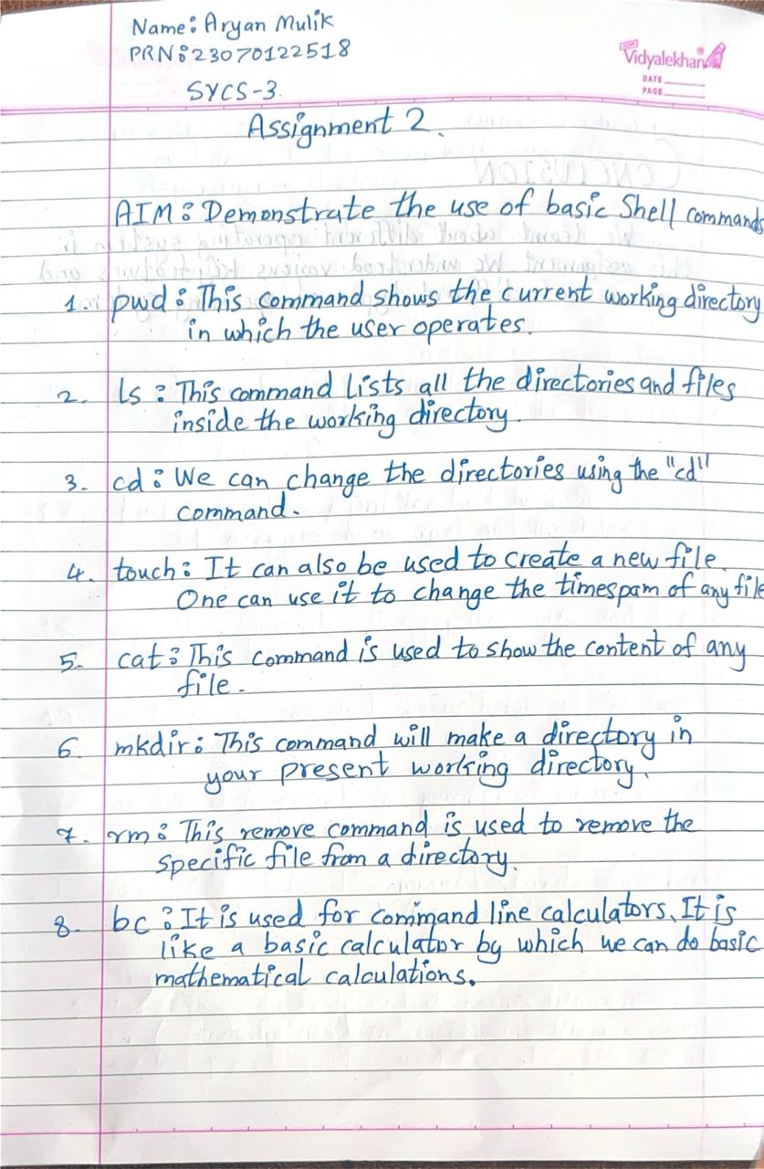

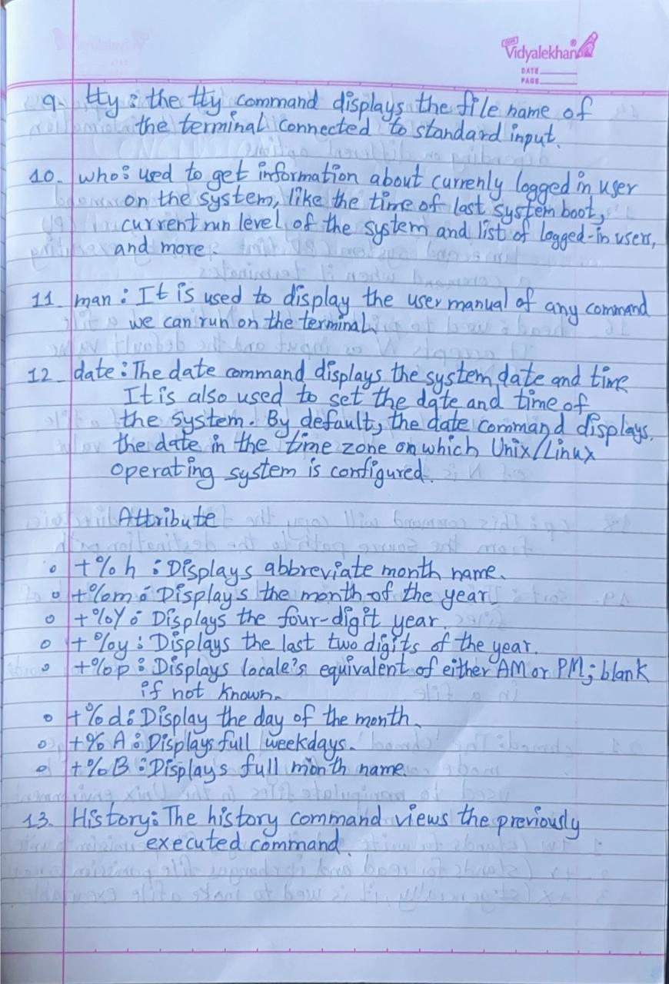

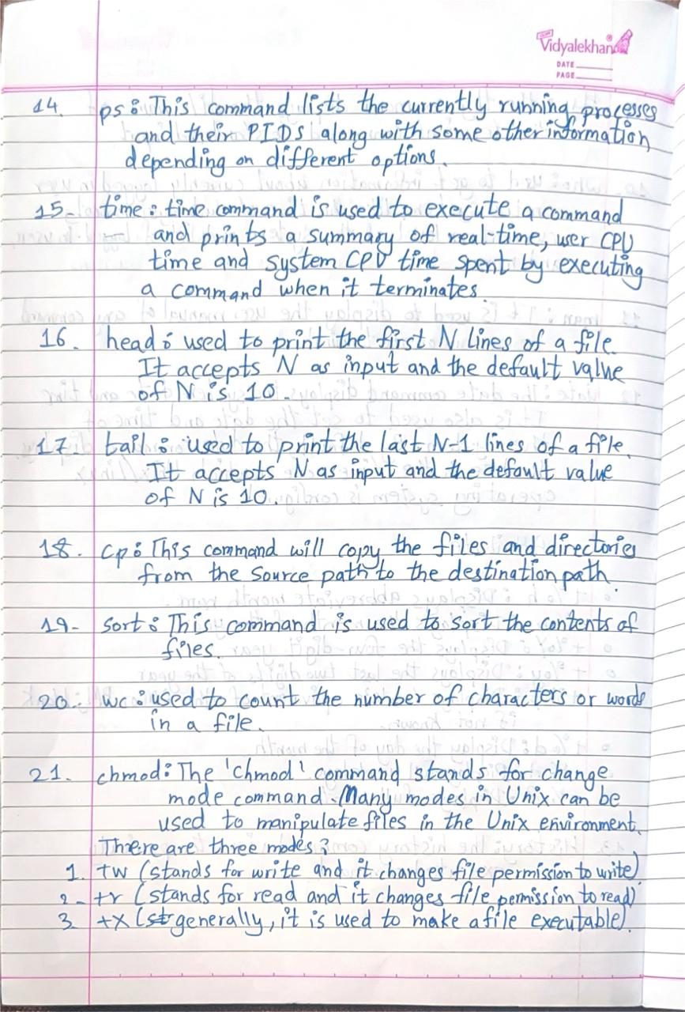

**BASIC SHELL COMMANDS**

**1.pwd**



**2. ls**



**3. cd**

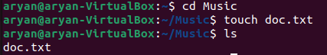

**4. touch**



**5. cat**

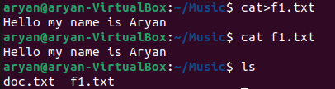

**6. mkdir**



**7. rm**



**8. bc**

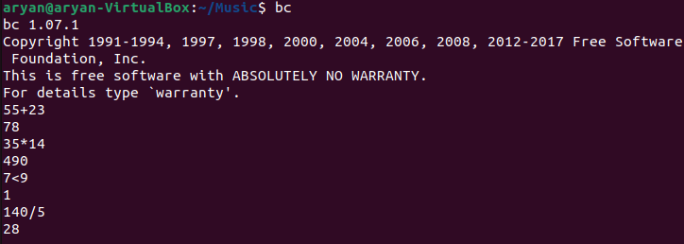

**9. tty**



**10. who**



**11. man**



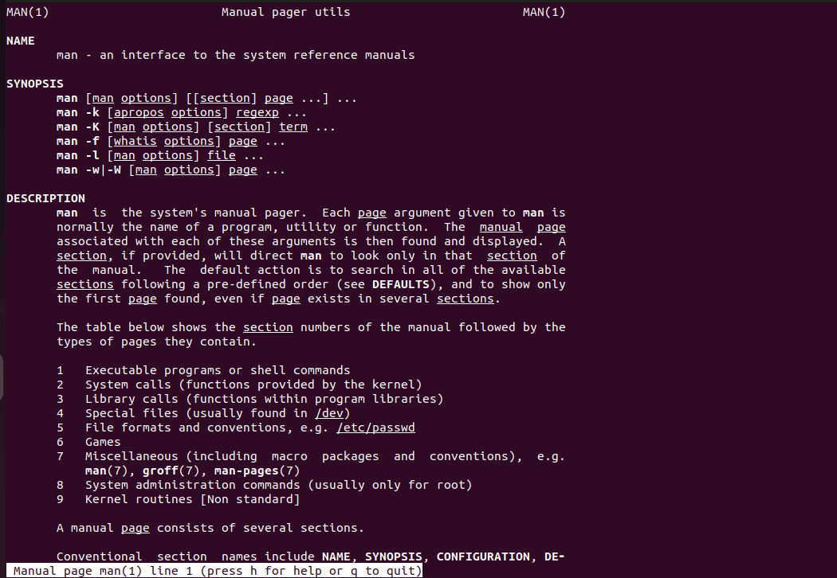

**12. Date**

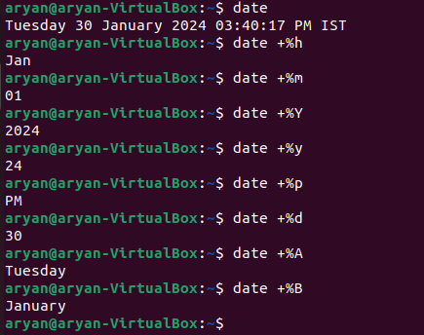

**13. History**

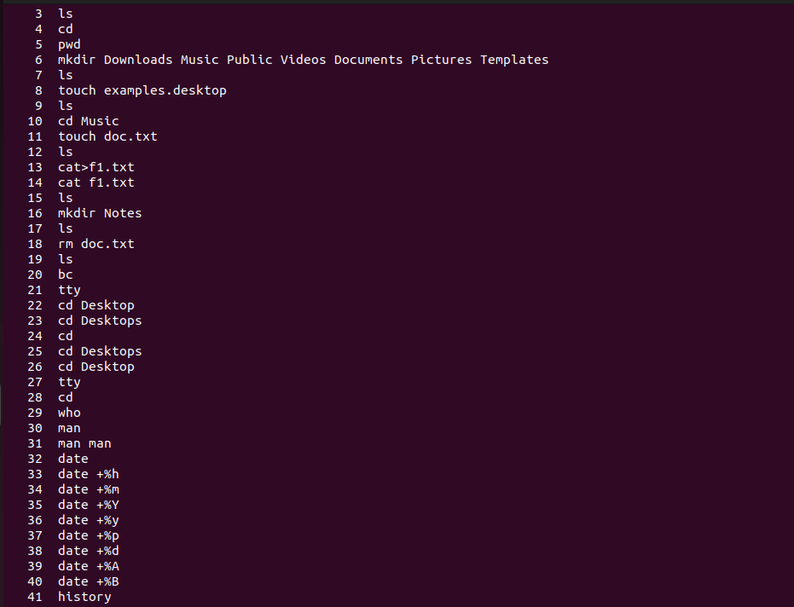

**14. ps**

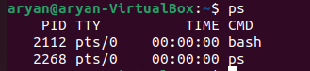

**15. time**

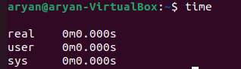

**16. head**



**17. tail**

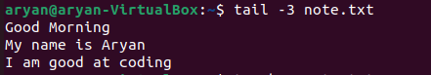

**18. cp**

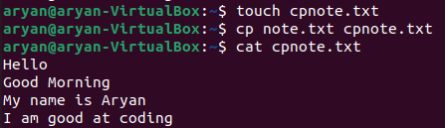

**19. sort**

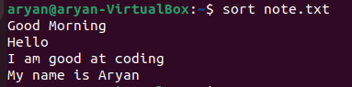

**20. wc**



**21. chmod**



