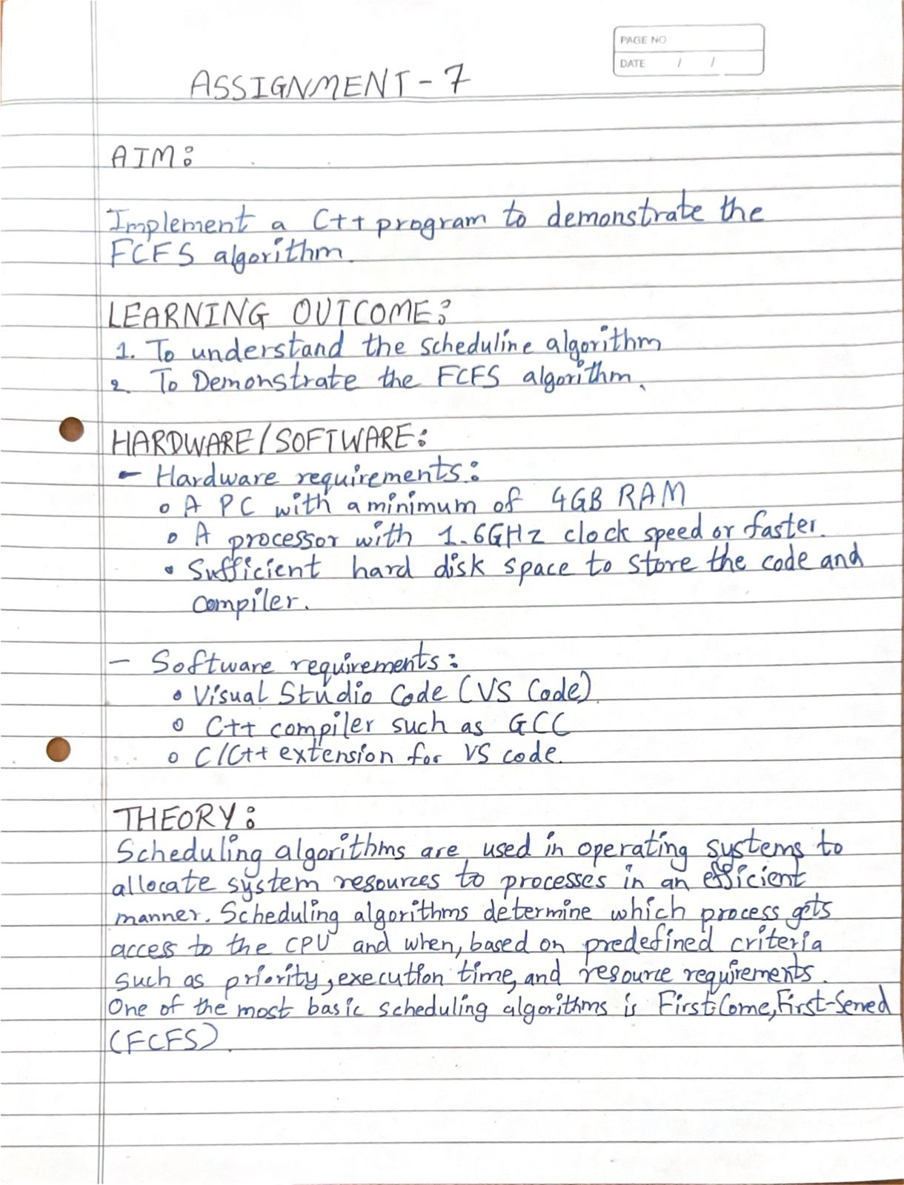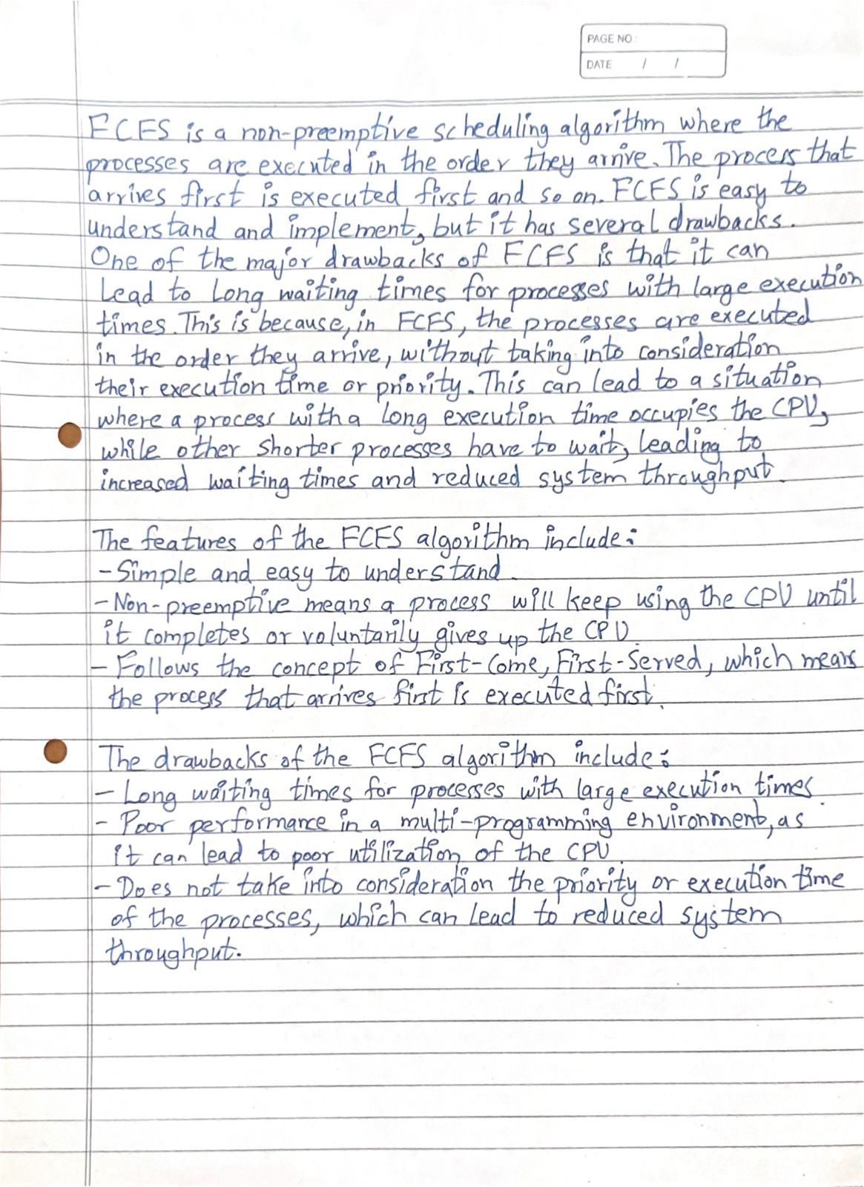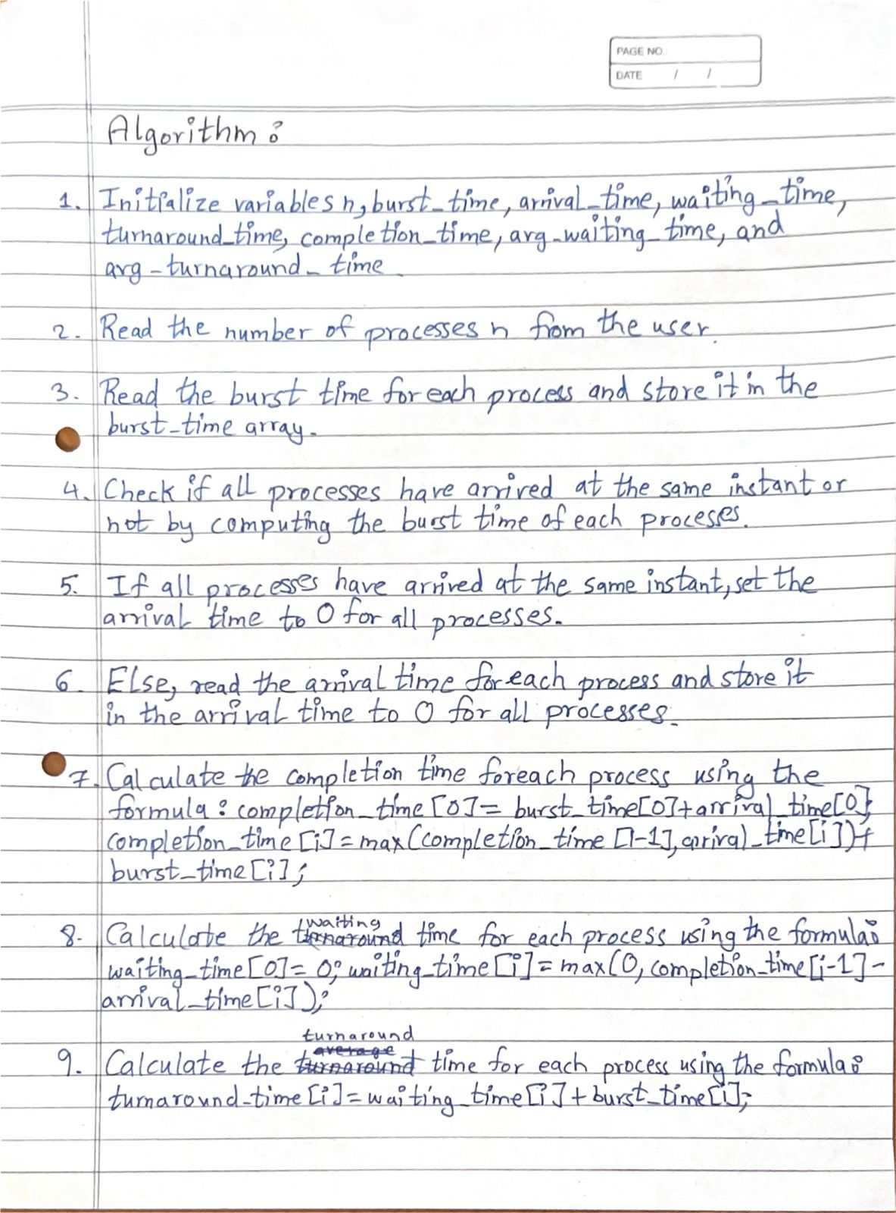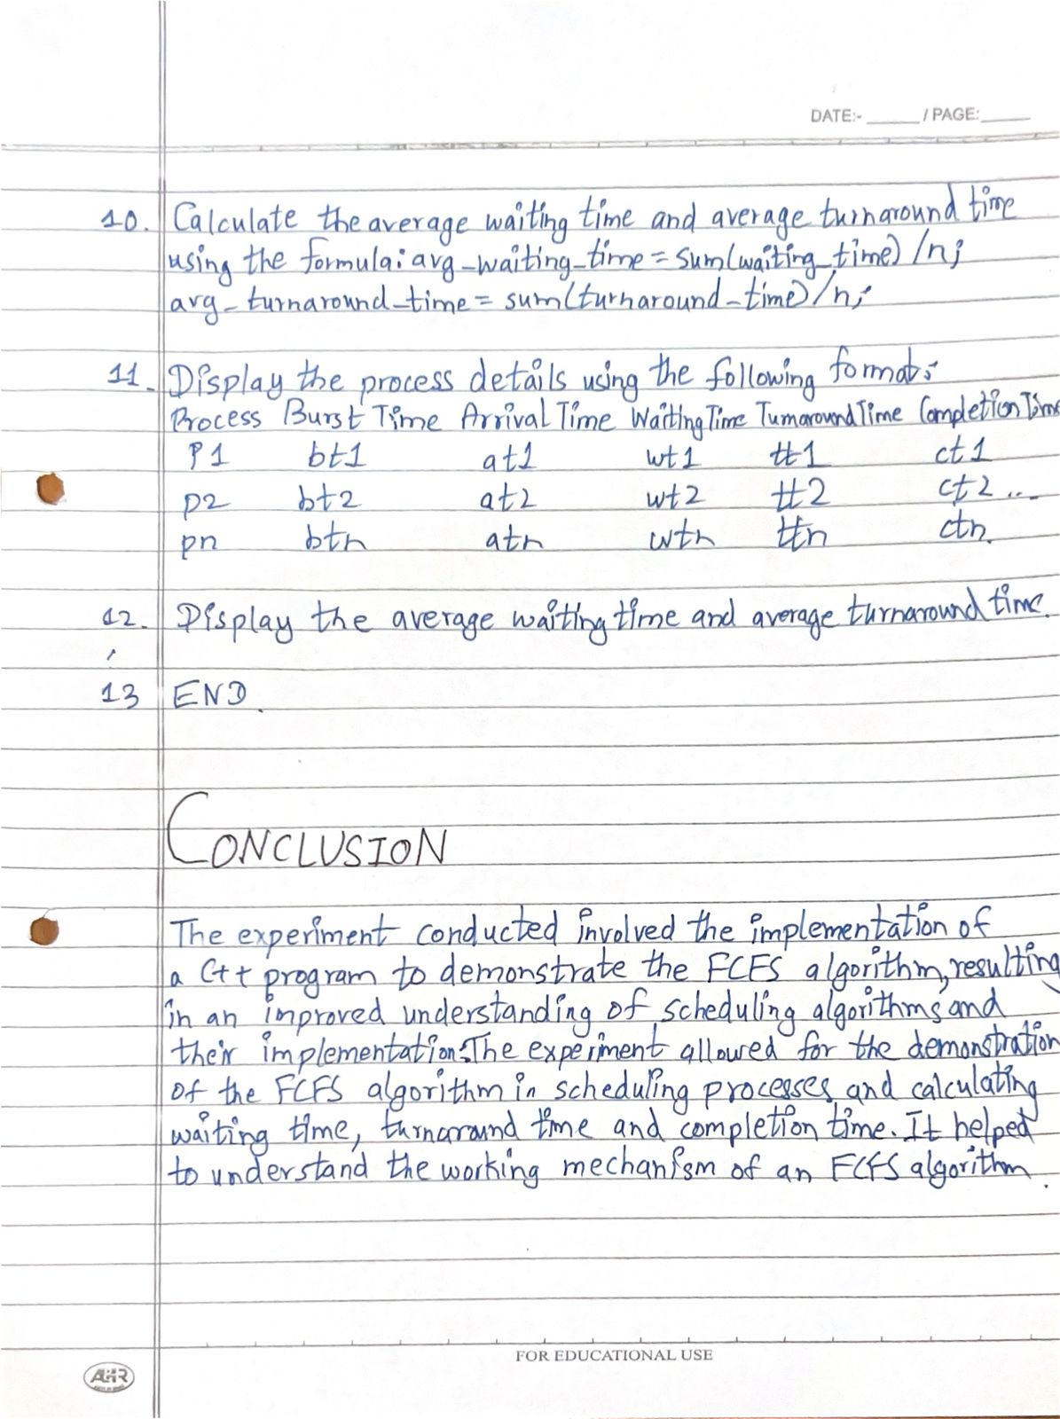

**PROGRAM :**

#include <iostream>

using namespace std;

int main() {

int n, burst_time[10], arrival_time[10], waiting_time[10], turnaround_time[10], completion_time[10];

float avg_waiting_time = 0, avg_turnaround_time = 0;

cout << "Enter the number of processes: ";

cin >> n;

cout << "Enter burst time and arrival time for each process:\n";

for (int i = 0; i < n; i++) {

cout << "Burst Time for process " << i + 1 << ": ";

cin >> burst_time[i];

cout << "Arrival Time for process " << i + 1 << ": ";

cin >> arrival_time[i];

}

completion_time[0] = burst_time[0] + arrival_time[0];

waiting_time[0] = 0;

for (int i = 1; i < n; i++) {

completion_time[i] = (completion_time[i - 1] > arrival_time[i]) ? completion_time[i - 1] + burst_time[i] : arrival_time[i] + burst_time[i];

waiting_time[i] = (completion_time[i - 1] > arrival_time[i]) ? completion_time[i - 1] - arrival_time[i] : 0;

}

for (int i = 0; i < n; i++) {

turnaround_time[i] = waiting_time[i] + burst_time[i];

avg_waiting_time += waiting_time[i];

avg_turnaround_time += turnaround_time[i];

}

avg_waiting_time /= n;

avg_turnaround_time /= n;

cout << "\nProcess Burst Time Arrival Time Waiting Time Turnaround Time Completion Time\n";

for (int i = 0; i < n; i++) {

cout << "P" << i + 1 << "\t" << burst_time[i] << "\t" << arrival_time[i] << "\t" << waiting_time[i] << "\t" << turnaround_time[i] << "\t" << completion_time[i] << endl;

}

cout << "\nAverage Waiting Time: " << avg_waiting_time;

cout << "\nAverage Turnaround Time: " << avg_turnaround_time << endl;

return 0;

}

**OUTPUT :**

