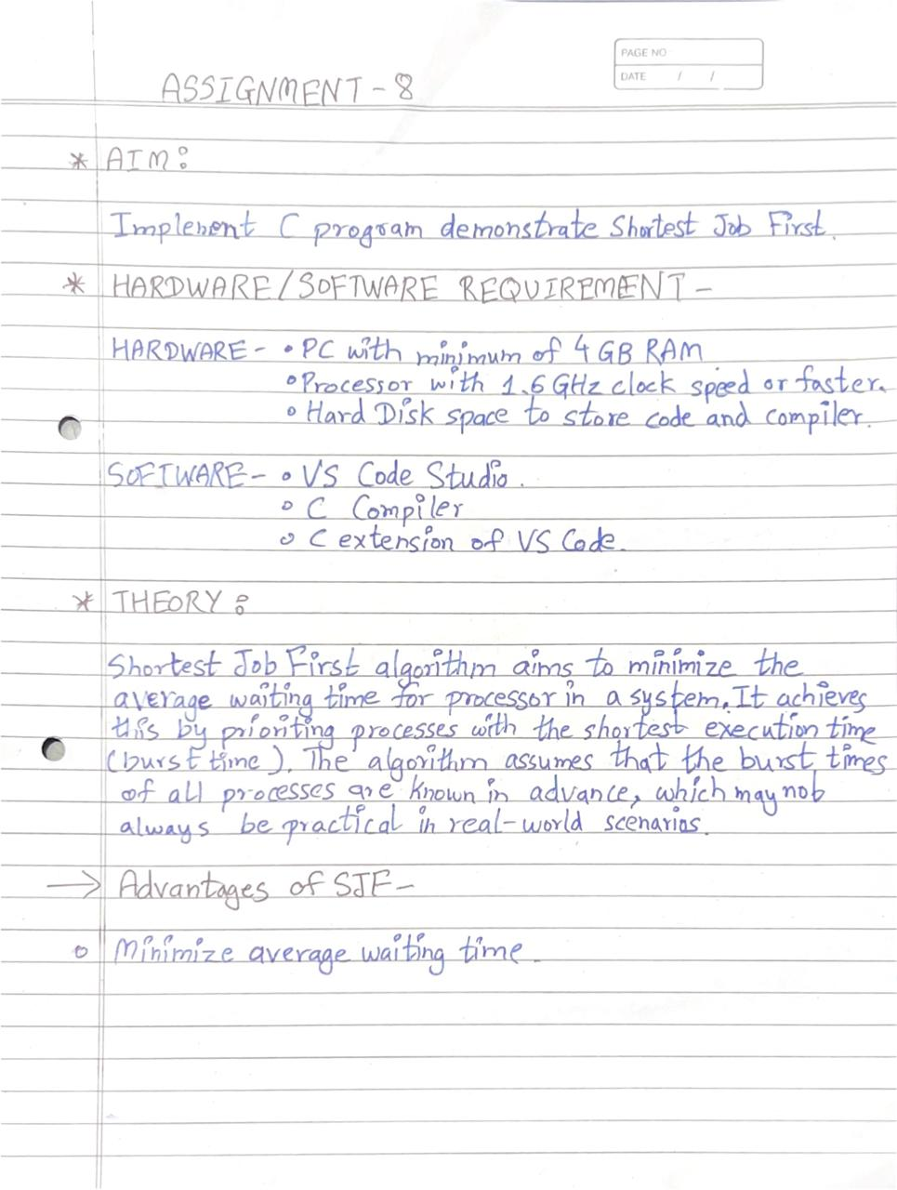

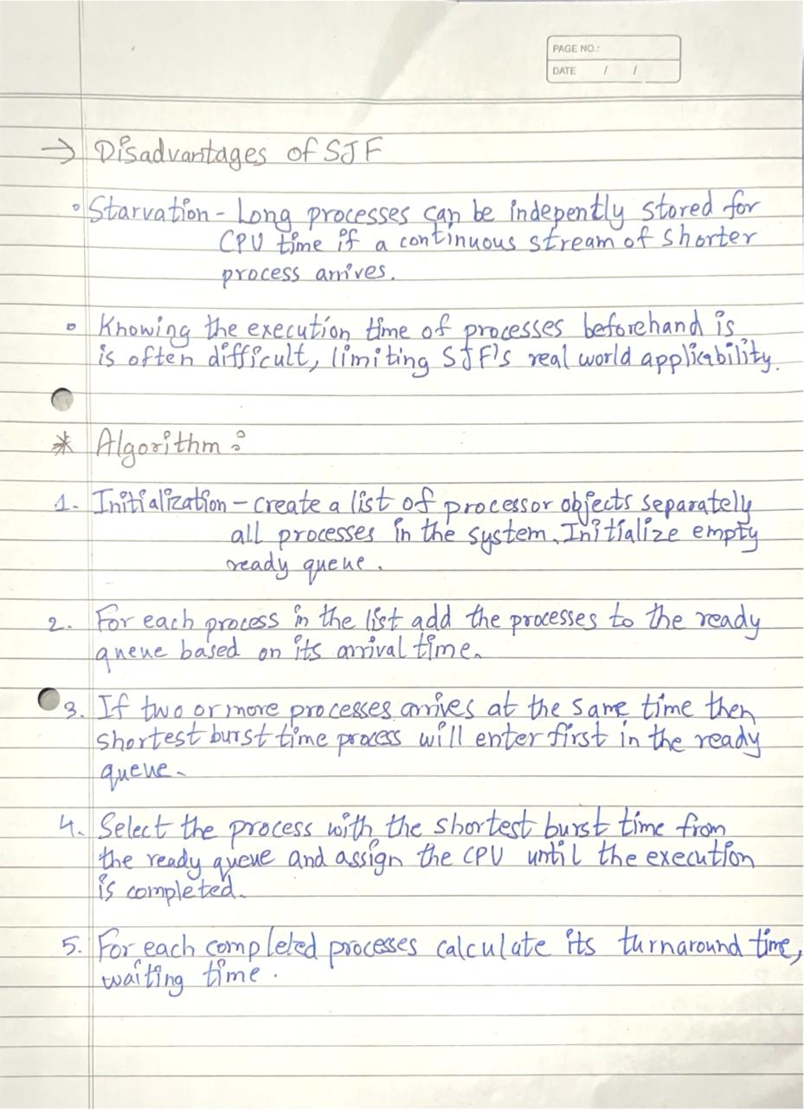

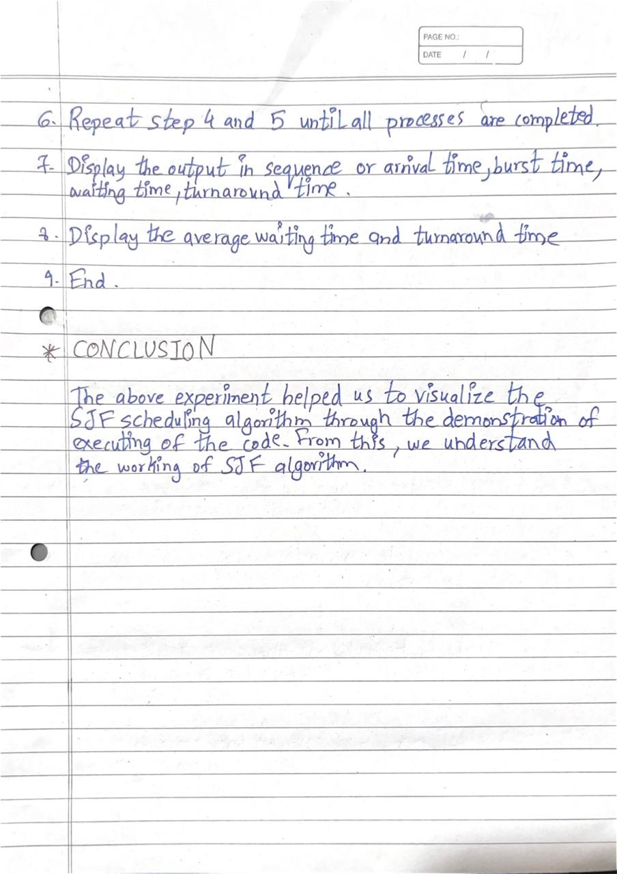

**PROGRAM:**

#include <stdio.h>

struct Process {

int pid;

int at;

int bt;

int ct;

int tat;

int wt;

};

void findSJF(struct Process proc[], int n) {

int remt[5];

int i;

for (i = 0; i < n; i++) {

remt[i] = proc[i].bt;

}

int currentTime = 0;

int complete = 0;

int shortest = 0;

int minBurst = 9999;

while (complete < n) {

minBurst = 9999;

for (i = 0; i < n; i++) {

if (proc[i].at <= currentTime && remt[i] < minBurst && remt[i] > 0) {

minBurst = remt[i];

shortest = i;

}

}

remt[shortest]--;

if (remt[shortest] == 0) {

complete++;

proc[shortest].ct = currentTime + 1;

proc[shortest].tat = proc[shortest].ct - proc[shortest].at;

proc[shortest].wt = proc[shortest].tat - proc[shortest].bt;

}

currentTime++;

}

}

void display(struct Process proc[], int n) {

int i;

float ttat=0,twt=0;

printf("Process\tArrival Time\tBurst Time\tCompletion Time\tTurnAround Time\tWaiting Time\n");

for (i = 0; i < n; i++) {

printf("P%d\t\t%d\t\t%d\t\t%d\t\t%d\t\t%d\n", proc[i].pid + 1, proc[i].at, proc[i].bt, proc[i].ct, proc[i].tat, proc[i].wt);

twt+=proc[i].wt;

ttat+=proc[i].tat;

}

printf("Average Waiting Time = %.2f\n",twt/n);

printf("Average TurnAround Time = %.2f\n",ttat/n);

}

int main() {

int n, i;

printf("Enter the number of processors: ");

scanf("%d", &n);

struct Process proc[n];

printf("Enter Process Details: \n");

for (i = 0; i < n; i++) {

proc[i].pid = i;

printf("For Process P%d:\n", i + 1);

printf("Arrival Time = ");

scanf("%d", &proc[i].at);

printf("Burst Time = ");

scanf("%d", &proc[i].bt);

}

findSJF(proc, n);

displayProcess(proc, n);

}

**OUTPUT:**

