SmartPizzaAI
Project Documentation
AI-enabled Pizza Ordering, Payment, Delivery Tracking and Admin Analytics System

Name – Aryan Parihar
Batch – Java Full Stack React

Project Type | Full-stack microservices capstone project
Frontend | React, Bootstrap, Axios, Formik/Yup
Backend | Spring Boot microservices, API Gateway, Eureka, OpenFeign
Database | MySQL with Spring Data JPA
Roles | Customer, Admin, Delivery Partner

Table of Contents
1. Project Overview
2. Problem Statement and Objectives
3. Technology Stack
4. Modules and Functional Scope
5. Architecture and High Level Design
6. Design Patterns Used
7. Database Design and ER Diagram
8. UML Diagrams
9. Use Case Diagram
10. Data Flow Diagram
11. API and Workflow Summary
12. Logging and Observability
13. Future Enhancements
14. Conclusion

1. Project Overview
SmartPizzaAI is a full-stack food ordering platform designed around microservices. The system simulates a real-world pizza ordering ecosystem where customers can browse pizzas, get recommendations, manage carts, place orders, make payments and track delivery. Admin users can manage the menu and view analytics such as revenue, GST, top-selling pizzas and category-wise revenue. Delivery partners can load assigned deliveries and update delivery progress without manually entering tracking IDs.

1.1 Key Features
- Role-based authentication and authorization for Customer, Admin and Delivery Partner.
- Pizza menu and category management with availability control.
- Cart management with add, update, remove and clear cart operations.
- Order placement with coupon validation, GST-aware payment flow and invoice support.
- Automatic delivery partner assignment for Bengaluru delivery partners.
- AI-style recommendation based on top ordered pizzas from customer order history.
- Admin dashboard analytics for revenue, GST collected, top pizzas and category revenue.
- Service-level logging using application.properties and dedicated log files.

2. Problem Statement and Objectives
Basic pizza ordering applications often provide only menu browsing and order placement. They generally lack personalization, delivery operational visibility, GST transparency and admin-level business analytics. SmartPizzaAI addresses these gaps by combining modular backend services, role-specific frontend screens and practical analytics.

2.1 Objectives
- Build a scalable microservices-based backend using Spring Boot.
- Provide a responsive React frontend with protected routes and role-based UI rendering.
- Support personalized recommendations based on previous orders.
- Provide transparent payment amount calculation including GST and invoice generation.
- Support automatic delivery assignment and controlled delivery status progression.
- Provide admin analytics for business decision-making.
- Maintain observability using service-specific log files.

3. Technology Stack
Layer | Technology | Purpose
Frontend | React, Bootstrap, Axios | Responsive UI, API calls and role-based navigation
Validation | Formik and Yup | Frontend form management and validation
Backend | Spring Boot, Java 17 | Microservice and REST API implementation
Security | JWT, Spring Security | Authentication and role-based authorization
Discovery | Eureka Server | Service registry and discovery
Gateway | Spring Cloud Gateway | Central routing and token filtering
Communication | OpenFeign | Service-to-service REST calls
Fault Tolerance | Resilience4j | Circuit breaker and fallback behavior
Database | MySQL, Spring Data JPA | Persistence and ORM
Documentation | Swagger/OpenAPI | API testing and documentation
Logging | SLF4J + Spring Boot logging | Application logs and debugging

4. Modules and Functional Scope

Auth Service
- User registration and login
- JWT generation
- Role assignment
- Delivery partner creation when role is DELIVERY

Menu Service
- Pizza category management
- Pizza CRUD operations
- Availability and vegetarian/non-vegetarian flag
- Pizza details for recommendation/order services

Order Service
- Cart operations
- Order placement
- Coupon validation
- Automatic delivery assignment
- Admin analytics
- Top ordered pizza IDs for recommendations

Payment Service
- Payment simulation
- GST calculation
- Payment status
- Invoice generation

Recommendation Service
- Fetch top ordered pizza IDs from Order Service
- Fetch pizza details from Menu Service
- Return personalized pizza recommendations

Admin Dashboard
- Revenue metrics
- GST collected
- Top 3 sold pizzas
- Category-wise revenue
- Pizza edit/delete

Delivery Module
- Load assigned delivery
- Update delivery status
- ETA display
- Customer tracking view

API Gateway and Eureka
- Central API entry
- JWT validation
- Service routing
- Service discovery

5. Architecture and High Level Design
SmartPizzaAI follows a microservices architecture. The React frontend communicates with the backend through API Gateway. The gateway validates JWT tokens and routes requests to registered services. Eureka Server provides service discovery, while OpenFeign enables service-to-service calls. Each business capability is kept in a separate service to improve maintainability and scalability.

5.1 Architecture Diagram
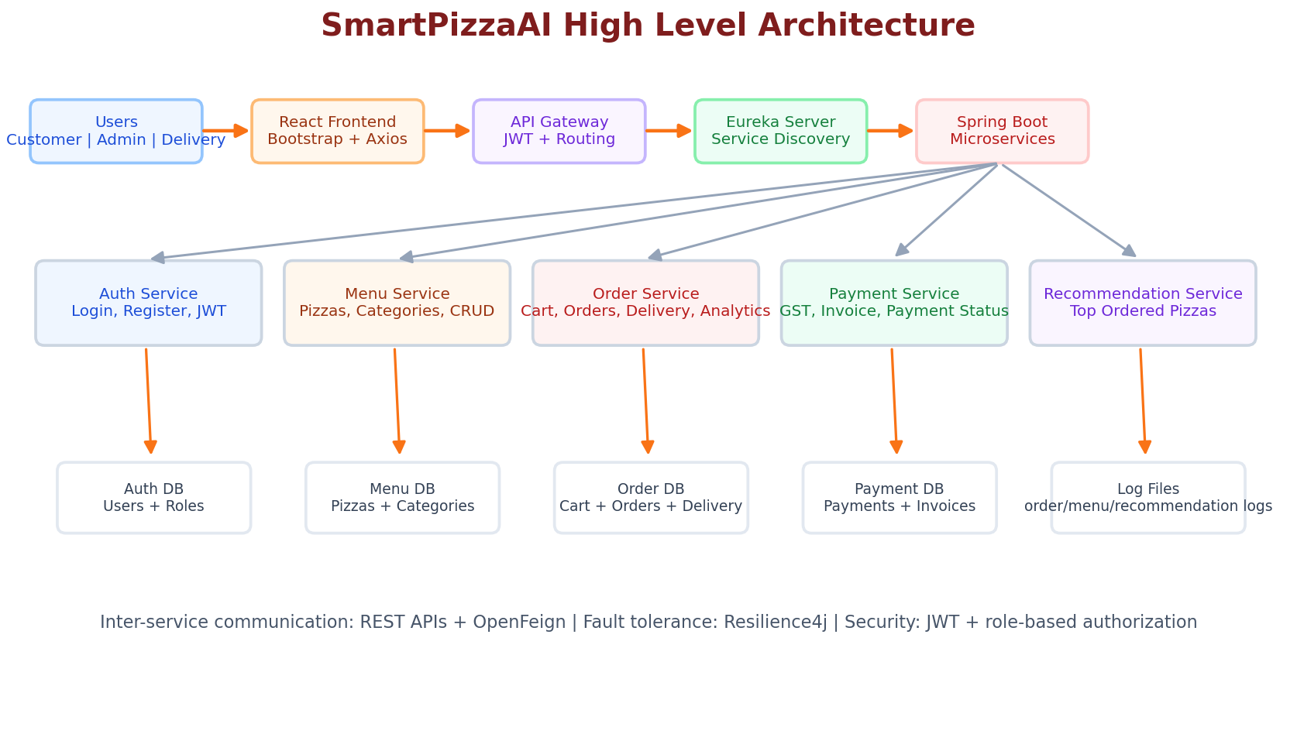

6. Design Patterns Used
Pattern | Usage in SmartPizzaAI
Microservices Architecture | The application is divided into independent services such as Auth, Menu, Order, Payment and Recommendation.
API Gateway Pattern | API Gateway acts as a single entry point for frontend requests and routes them to backend services.
Service Registry and Discovery Pattern | Eureka Server registers services and allows discovery without hardcoded URLs.
Repository Pattern | Spring Data JPA repositories abstract database operations for entities.
DTO Pattern | Request and response DTOs isolate API payloads from persistence entities.
Dependency Injection | Spring injects repositories, clients and services through constructors using RequiredArgsConstructor.
MVC / Layered Architecture | Controller, Service, Repository and Entity layers separate API, business logic and persistence.
Circuit Breaker Pattern | Resilience4j prevents cascading failures during inter-service communication.
Client Proxy Pattern | OpenFeign interfaces act as client proxies for remote service calls.
Role-Based Access Control | Features and routes are controlled using user roles such as CUSTOMER, ADMIN and DELIVERY.
State Transition Concept | Order and delivery statuses move through controlled states such as ASSIGNED, PICKED_UP, ON_THE_WAY and DELIVERED.

7. Database Design and ER Diagram
The main data model includes users, categories, pizzas, cart items, customer orders, order items, delivery partners, delivery tracking, payments and invoices. In a microservices deployment, each service can own its database schema or tables to maintain loose coupling.
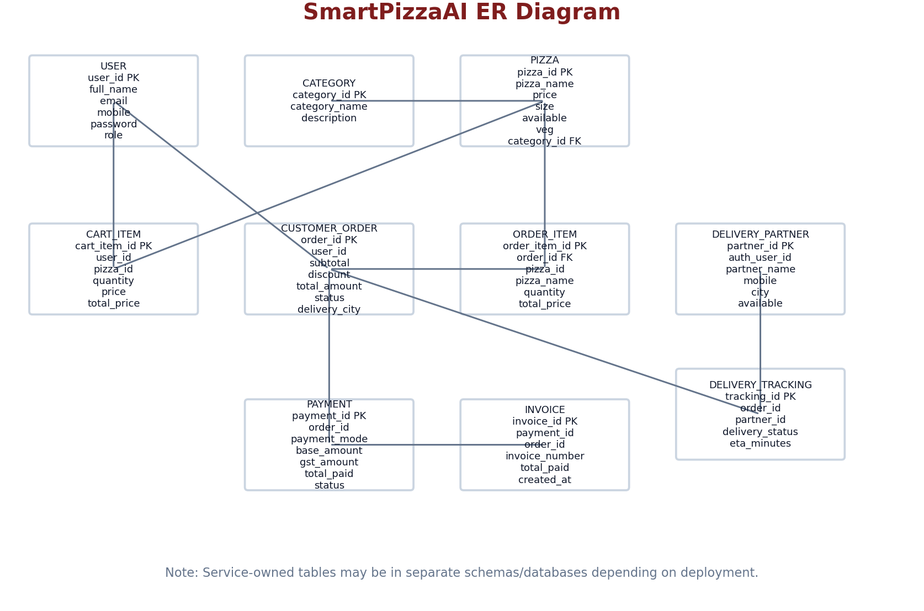

8. UML Diagrams

8.1 UML Class Diagram
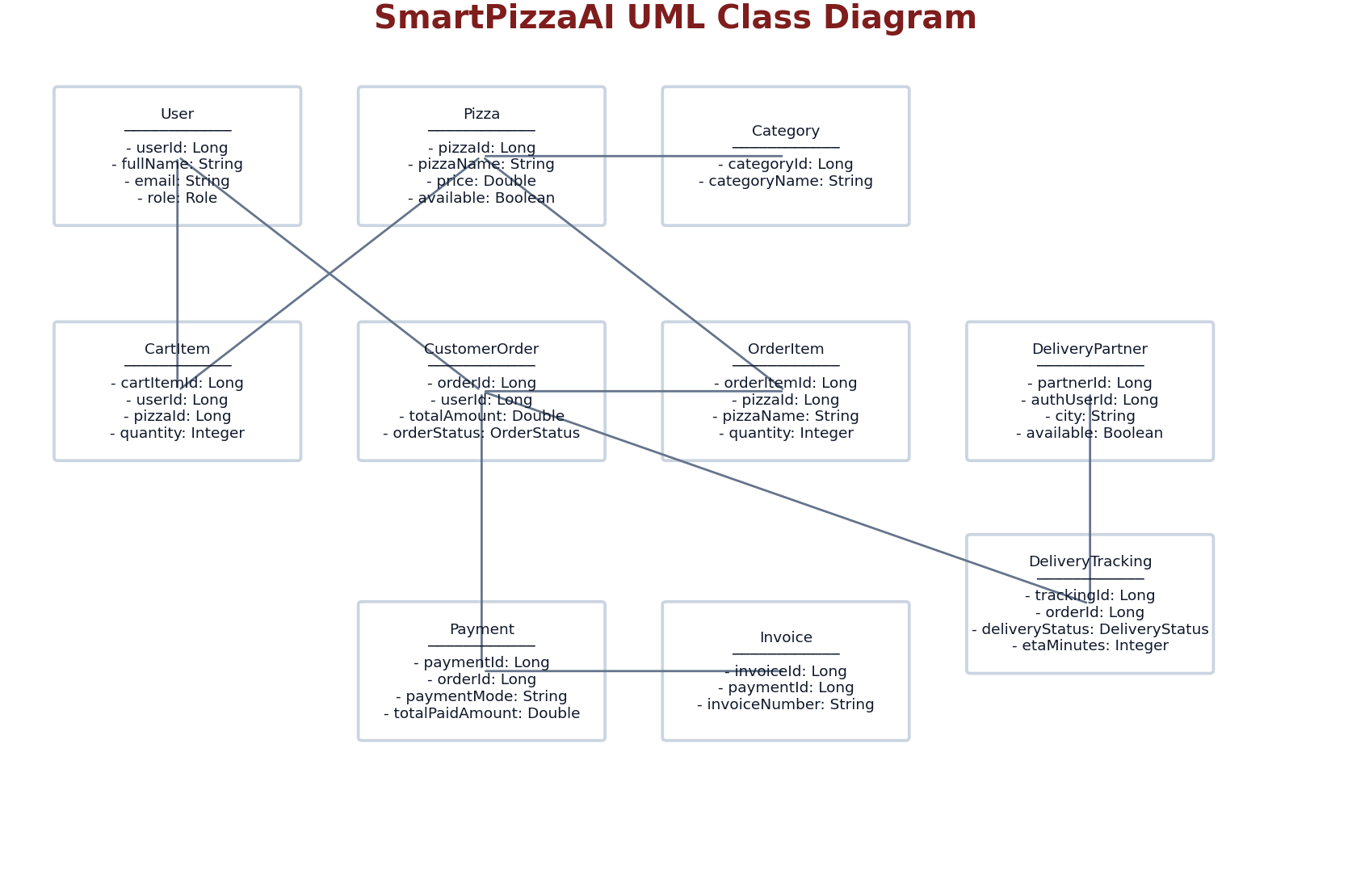

8.2 UML Sequence Diagram - Place Order Flow
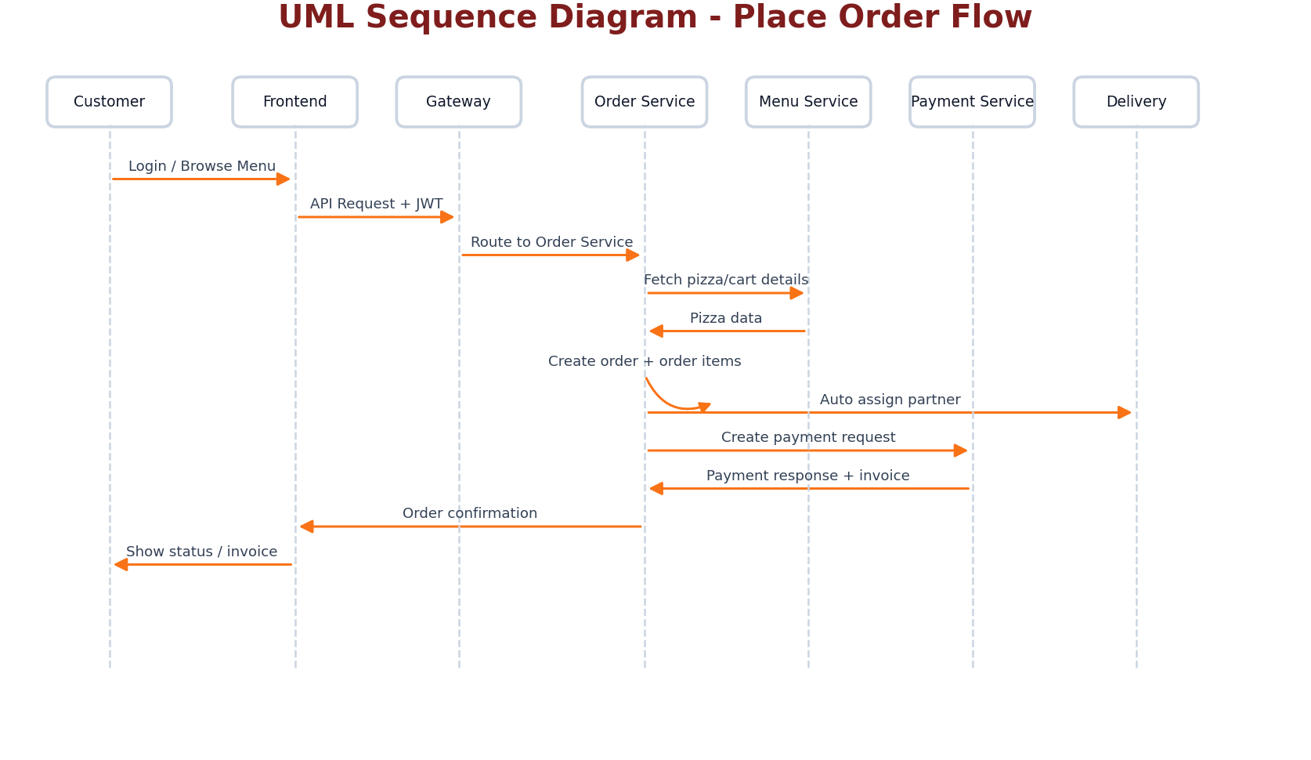

9. Use Case Diagram
The use case diagram shows how Customer, Admin and Delivery Partner interact with the SmartPizzaAI system.
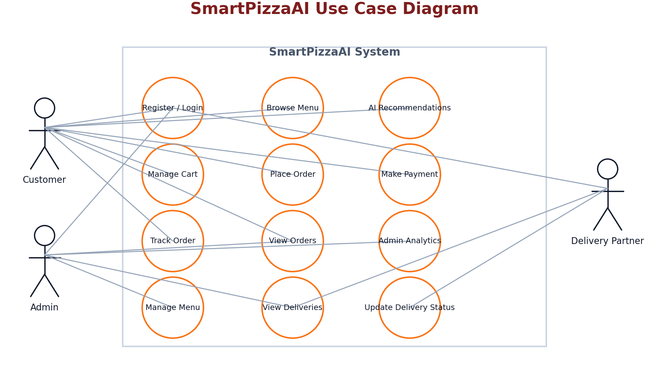

10. Data Flow Diagram
The DFD Level 1 diagram shows major data flows between external actors, system processes and data stores.
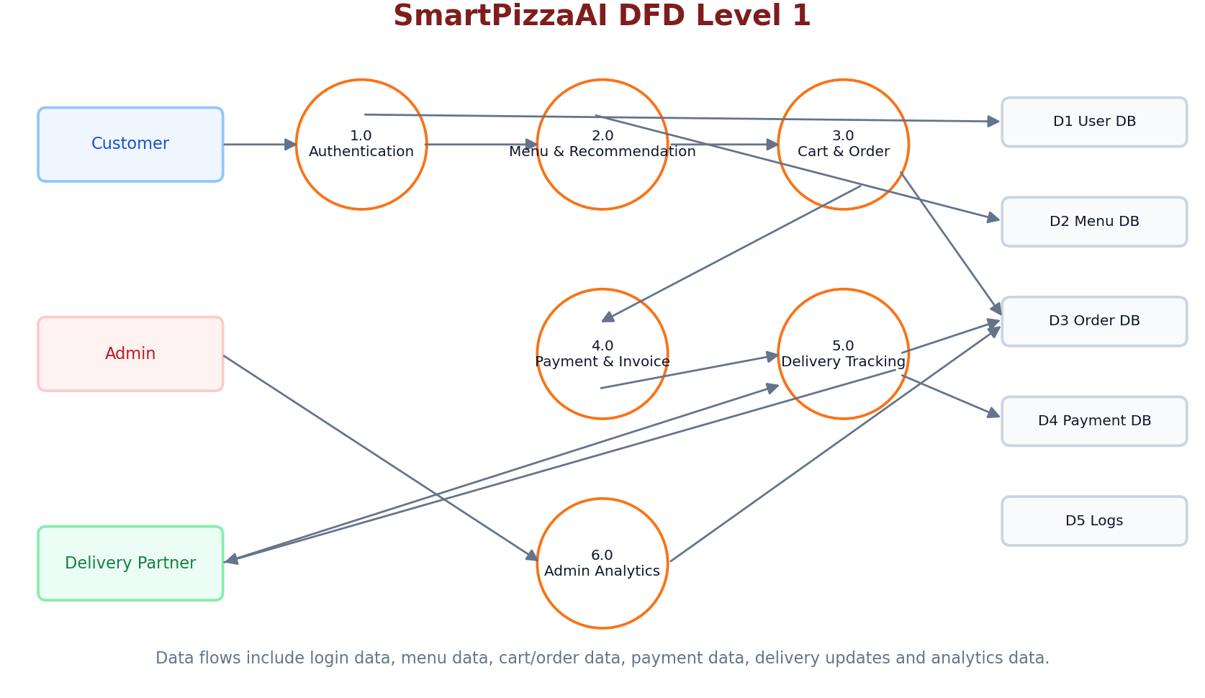

11. API and Workflow Summary

11.1 Customer Workflow
- Login or register as customer
- Browse menu and AI recommendations
- Add pizzas to cart
- Checkout with delivery address and mobile number
- Make payment with GST calculation
- Track order and view order history

11.2 Admin Workflow
- Login as admin
- View dashboard KPIs
- View business analytics
- Edit or delete pizzas
- Monitor orders and delivery partners

11.3 Delivery Partner Workflow
- Login as delivery partner
- Load assigned delivery
- Update status to picked up
- Update status to on the way
- Mark delivery as delivered

12. Logging and Observability
Logging is configured using application.properties. Each major service writes logs into a separate file to support debugging and review. Examples include order-service.log, menu-service.log and recommendation-service.log. Logs should include service startup, cart updates, order placement, coupon validation, delivery assignment and recommendation activity.
- Do not log passwords, JWT tokens or payment credentials.
- Use INFO for successful business operations.
- Use WARN for validation or business failures such as empty cart or unavailable partner.
- Use ERROR only for unexpected exceptions.

13. Future Enhancements
- Real GPS-based delivery tracking
- Razorpay/Stripe integration
- Inventory and stock management
- Docker and Kubernetes deployment
- Advanced ML-based recommendation engine
- Email/SMS notifications
- Admin export reports

14. Conclusion
SmartPizzaAI demonstrates a complete, practical and scalable pizza ordering platform. The project combines microservice architecture, role-based access, AI-style recommendations, GST-aware payment flow, delivery tracking and admin analytics. The design is suitable for capstone presentation, viva explanation and future extension into a production-grade application.

