Benchmarking data-integrity anomaly detection in blood-bank transaction records
Aryan Jain
Nellore, India

Abstract
Blood Establishment Computer Systems (BECS) operate under strict regulatory frameworks to ensure the traceability and safety of the blood supply. While unsupervised machine learning (ML) is increasingly used for healthcare anomaly detection, the suitability of purely data-driven anomaly detection for discrete, domain-specific blood-bank integrity constraints remains less explored than its use for general statistical outlier detection. This study evaluates a hybrid anomaly detection framework combining a deterministic rule engine with a Median Absolute Deviation (MAD) statistical detector, benchmarking it against unsupervised feature-space anomaly-detection baselines. We generated a reproducible synthetic dataset of 2000 blood-bank transactions and injected 300 mutually exclusive anomalies distributed across eight structural and one statistical taxonomic classes. The proposed framework was evaluated against out-of-sample Isolation Forest (IF) and Local Outlier Factor (LOF) models over 10 independent train-test seed pairs. The hybrid framework achieved complete coverage of the predefined synthetic anomaly taxonomy (F1 Score: 1.000). In contrast, the tested ML baselines conflated statistical rarity with data invalidity and were highly inconsistent across structural anomaly classes (IF F1: 0.265 ± 0.042; LOF F1: 0.367 ± 0.035). These results demonstrate the limitations of relying solely on unsupervised ML for compliance-driven medical informatics. The findings highlight the potential complementarity of deterministic domain validation and robust statistical detection for maintaining data integrity in highly regulated clinical environments.
Keywords: Data mining, anomaly detection, blood bank, health information systems, synthetic data.

1. Introduction

1.1 Background and Regulatory Framework
Modern blood banks rely on Blood Establishment Computer Systems (BECS) to systematically mitigate risks and maintain data integrity. BECS platforms must enforce validated workflows and time-stamped audit trails to maintain a reliable chain of custody (World Health Organization, 2011). The architectural requirements for data integrity in blood banking are dictated by strict regulatory mandates. Traceability requires systems capable of forward and backward tracking, linking donor intake records to final disposition. In the Indian clinical context, biological tracking requirements are codified by the Drugs and Cosmetics Act of 1940 and its subsequent Rules (Government of India, 1945). Blood centers must maintain exhaustive records for processing human blood, ensuring the chain of custody remains unbroken. Global systems often implement standards like ISBT 128 to provide international consistency for barcode labeling and traceability (ICCBBA, 2024).

1.2 The Broad Problem: Machine Learning in Healthcare Auditing
Data mining techniques are frequently deployed to audit healthcare information systems, identifying transactional anomalies indicative of human error or software glitches (Pimentel et al., 2014). Unsupervised machine learning (ML) models, such as Isolation Forests, are often favored due to their ability to detect novel patterns in high-dimensional data (Liu et al., 2012). However, ML models optimize for statistical variance and spatial distancing. This may limit their capacity to capture discrete regulatory violations, such as an issued unit lacking a valid donor reference.
From a data mining perspective, ensuring compliance requires verifying that clinical data conforms to a complex state machine. For the purposes of this benchmark, the blood-unit lifecycle is represented conceptually as COLLECTED → TESTED → AVAILABLE → ISSUED. Invalid transitions, such as COLLECTED → ISSUED (bypassing mandatory testing), are anomalous structural constraints that systems must structurally enforce. Currently, the suitability of unsupervised ML for detecting these discrete logic violations in transactional logs remains underexplored.

1.3 Scientific Question and Goals
The primary scientific question addressed in this study is whether a hybrid anomaly detection architecture combining deterministic rules with robust statistical methods can outperform purely unsupervised feature-space anomaly detection on discrete blood-bank integrity constraints. The hypothesis is that ML models will struggle with structural constraints due to the nature of categorical feature spacing, while a hybrid framework will provide complete predefined coverage. The goals of this paper are to 1) design a controlled synthetic benchmark containing distinct blood-bank data-integrity anomaly classes, 2) provide a robust out-of-sample comparison of deterministic and statistical detection alongside IF and LOF baselines, and 3) outline a hybrid design implication for blood-bank validation architectures.

2. Materials and Methods

2.1 Synthetic Data Generation and Materials
Due to the sensitive nature of protected health information, a synthetic dataset with known ground truth was generated to facilitate reproducible benchmarking (Chen et al., 2021). The engineering process initialized a registry of 500 synthetic donors. Blood-group assignments were generated using fixed probabilities chosen to produce a heterogeneous synthetic donor population. Using this registry, 2000 unit transactions were simulated over a 90-day operational window. The units were partitioned into four clinical components with configured shelf lives: Packed Red Blood Cells (42 days), Whole Blood (35 days), Fresh Frozen Plasma (365 days), and Platelets (5 days). The clean-data generation procedure was designed to satisfy the implemented integrity constraints prior to anomaly injection. All experiments were programmed and executed using Python 3.13.15, NumPy 2.1.3, pandas 2.2.3, and scikit-learn 1.6.1 to facilitate absolute reproducibility.

2.2 Controlled Error Taxonomy
To establish a rigorous mathematical benchmark, exactly 300 anomalies (15% anomaly ratio) were injected into the synthetic dataset. The injected anomalies were mutually exclusive at the transaction level, such that each anomalous transaction was assigned to exactly one taxonomic class. Duplicate injection mechanisms were strictly constrained to copy from verified clean records to preserve this mutual exclusivity. This taxonomy encompasses eight structural and one statistical failure modes:
Table 1. Controlled anomaly taxonomy.
Anomaly Class | n | Description
Missing Fields | 34 | Mandatory data points arbitrarily removed.
Duplicate Records | 34 | Unit identifier collisions.
Conflicting Records | 34 | Unit blood group contradicts the donor's historical data.
Impossible States | 33 | Units issued despite reactive/discard tests.
Expiry Violations | 33 | Issue timestamps succeeding the biological expiration limit.
Traceability Breaks | 33 | Transaction references an unresolved donor identifier.
Format Inconsistencies | 33 | Free-text corruptions of constrained enumerations.
Temporal Anomalies | 33 | Issue timestamps prior to collection timestamps.
Statistical Bursts (Extreme Univariate Numerical Deviations) | 33 | Extreme synthetic weight (188.5 kg) and hemoglobin (24.8 g/dL) outliers.

2.3 Algorithmic Implementations and Equations
The benchmark evaluates four individual detection methods and a hybrid integration. To quantify variability across independently generated synthetic train-test pairs, 10 seed pairs were evaluated. ML models and statistical parameters were exclusively fitted/calibrated on the training datasets and evaluated strictly out-of-sample (OOS) on independent test datasets.
Rule-Based Validator: A deterministic domain-integrity validator programmed with strict operational logic. It parses each transaction against verification layers: completeness, domain integrity, identifier uniqueness, referential integrity, issued-state constraints, and temporal logic.
Statistical Anomaly Detector: To capture numerical outliers, a statistical module utilized the Modified Z-Score based on the Median Absolute Deviation (MAD) (Leys et al., 2013). The modified Z-score Zᵢᴹᴬᴰ is formally defined as:
Zᵢᴹᴬᴰ = 0.6745 × |xᵢ − median(X)| / MAD(X)
MAD(X) = median(|xᵢ − median(X)|)
Machine Learning Baselines (IF and LOF): An Isolation Forest (Liu et al., 2012) and a Local Outlier Factor (LOF) model were deployed as unsupervised feature-space anomaly-detection baselines (contamination c=0.15). Input features comprised donor weight, donor hemoglobin, quantity issued, collection-to-issue lead time, and one-hot encoded categorical variables including blood group, state, test status, component, and storage location. To prevent feature-space mismatch between independent splits, a global OneHotEncoder was fitted to a predefined vocabulary.
Hybrid Detector: The central proposed framework formally integrates deterministic and statistical constraints. The final anomaly decision Hᵢ was defined as the logical OR of the rule-based decision (Rᵢ) and the MAD detector decision (Dᵢᴹᴬᴰ). A transaction is classified as anomalous if either component flags it:
Hᵢ = Rᵢ OR Dᵢᴹᴬᴰ
Performance was measured using precision (P), recall (R), false positive rate (FPR), and the F1 score, defined mathematically as:
F1 = 2PR / (P + R)

3. Results

3.1 Overall Out-of-Sample Performance
Table 2 presents the overall out-of-sample classification performance averaged across the 10 independent seed pairs.
Table 2. Overall Out-of-Sample Benchmark Results (Mean ± SD).
Method | Precision | Recall | F1 Score | FPR
Rule | 1.000 ± 0.000 | 0.890 ± 0.000 | 0.942 ± 0.000 | 0.000 ± 0.000
MAD | 1.000 ± 0.000 | 0.110 ± 0.000 | 0.198 ± 0.000 | 0.000 ± 0.000
IF | 0.262 ± 0.046 | 0.269 ± 0.046 | 0.265 ± 0.045 | 0.134 ± 0.014
LOF | 0.348 ± 0.037 | 0.390 ± 0.041 | 0.367 ± 0.035 | 0.130 ± 0.018
Hybrid | 1.000 ± 0.000 | 1.000 ± 0.000 | 1.000 ± 0.000 | 0.000 ± 0.000

Figure 1. Overall out-of-sample benchmark performance across the five detection methods.
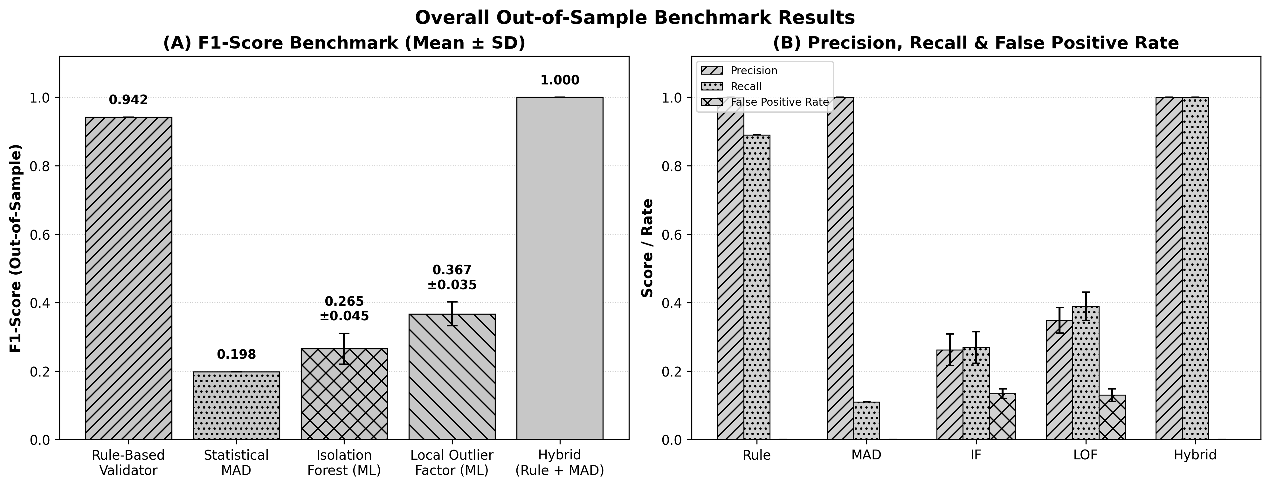

Table 3. Sensitivity Analysis: Isolation Forest (OOS).
Contam. | Recall | FPR | F1 Score
0.05 | 0.092 ± 0.024 | 0.047 ± 0.009 | 0.136 ± 0.036
0.10 | 0.188 ± 0.037 | 0.087 ± 0.013 | 0.224 ± 0.046
0.15 | 0.269 ± 0.043 | 0.134 ± 0.013 | 0.265 ± 0.042
0.20 | 0.341 ± 0.033 | 0.181 ± 0.012 | 0.288 ± 0.026

Table 4. Per-Class Recall Percentages (Mean ± SD %).
Anomaly Class | Rule | MAD | IF | LOF
Missing Fields | 100.0 ± 0.0 | 0.0 ± 0.0 | 19.4 ± 6.7 | 14.7 ± 4.4
Duplicate Records | 100.0 ± 0.0 | 0.0 ± 0.0 | 12.4 ± 3.7 | 11.5 ± 3.3
Conflicting Records | 100.0 ± 0.0 | 0.0 ± 0.0 | 16.8 ± 7.1 | 10.9 ± 3.7
Impossible States | 100.0 ± 0.0 | 0.0 ± 0.0 | 77.0 ± 20.6 | 78.5 ± 10.9
Expiry Violations | 100.0 ± 0.0 | 0.0 ± 0.0 | 19.7 ± 6.9 | 42.7 ± 23.8
Traceability Breaks | 100.0 ± 0.0 | 0.0 ± 0.0 | 8.8 ± 5.0 | 15.2 ± 5.4
Format Inconsistencies | 100.0 ± 0.0 | 0.0 ± 0.0 | 14.5 ± 5.2 | 11.5 ± 6.2
Temporal Anomalies | 100.0 ± 0.0 | 0.0 ± 0.0 | 3.0 ± 2.7 | 69.7 ± 14.1
Statistical Bursts | 0.0 ± 0.0 | 100.0 ± 0.0 | 71.2 ± 20.1 | 98.5 ± 3.6

Figure 2. Per-class anomaly detection recall across the nine predefined failure modes.
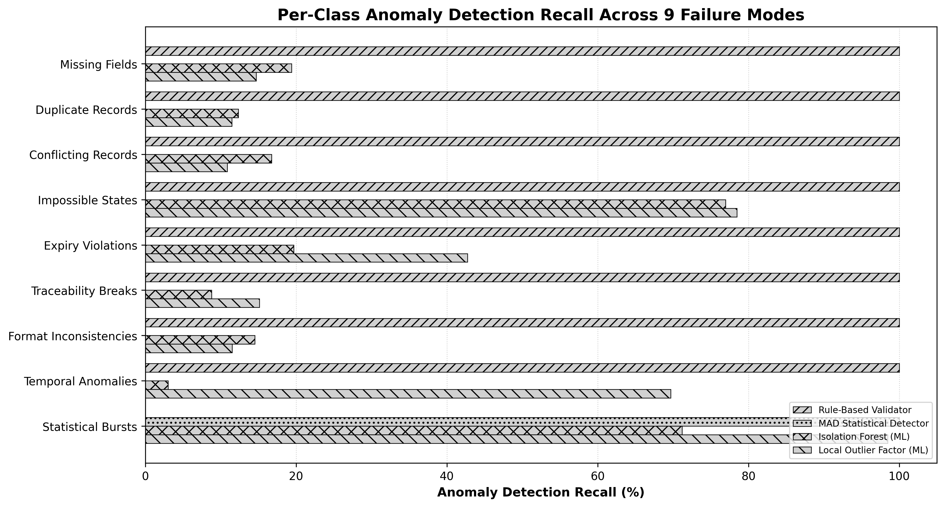

3.2 Interpretation and Sensitivity Analysis
The Rule-Based Validator achieved perfect precision on deterministic constraints but predictably missed the numerical outliers. The MAD detector successfully isolated the extreme univariate numerical deviations but bypassed structural violations. The Hybrid model successfully captured all 300 predefined anomalies without generating false positives.
Because unsupervised ML performance is highly sensitive to defined parameters, Table 3 details an IF sensitivity analysis evaluated out-of-sample. Using c=0.15 utilizes knowledge of the benchmark's injected anomaly proportion; evaluating across thresholds demonstrates the necessary trade-offs between recall and false-positive rates.
An independent sensitivity analysis of the MAD detector's magnitude parameters revealed that while it achieved 100.0% burst recall on extreme anomalies (188.5 kg, 24.8 g/dL), its recall dropped to 0.0% for moderate (115.0 kg) and subtle (98.0 kg) deviations. Table 4 details algorithm recall across the taxonomic classes. Both unsupervised feature-space anomaly-detection baselines (IF and LOF) were inconsistent; they reliably captured numerical bursts and impossible states, but were substantially weaker on several discrete integrity constraints than the deterministic validator. LOF outperformed IF on expiry violations (42.7% vs. 7.3%) and temporal anomalies (69.7% vs. 3.3%).

4. Discussion
The empirical results reveal that different anomaly classes exhibit distinct mathematical structures. Deterministic constraints are naturally captured by rules, while extreme univariate numerical deviations can be captured by robust statistical methods. The tested ML configurations struggled because structural violations, such as unresolved donor identifiers, are not naturally represented as large numerical deviations in the feature space used by IF and LOF.
A false-positive analysis indicated that the unsupervised ML baselines can conflate statistical rarity with data invalidity. In the designated 42→100 test split, the Isolation Forest generated 274 false positives out of 1700 clean records. Because these false positives arise from an unsupervised detector, they can increase the number of alerts requiring human review even when the underlying records are valid.
It is crucial to acknowledge the limitations of this experimental design. The dataset and anomalies were synthetically generated and explicitly engineered to trigger the deterministic and statistical rules. The MAD detector successfully identified the numerical anomalies because they were instantiated as massive univariate outliers; its ability to detect subtle multivariate drift remains fundamentally unsuited for this thresholding approach, as demonstrated by the magnitude sensitivity analysis. Because the injected taxonomy was deliberately partitioned into deterministic structural errors and extreme numerical deviations, the perfect hybrid result measures coverage of the predefined benchmark rather than general-world anomaly-detection performance.

5. Conclusion
The benchmark demonstrates complementary coverage of predefined structural and extreme numerical anomaly classes by deterministic and robust statistical detectors, evaluated out-of-sample across 10 independently generated datasets. The tested unsupervised feature-space anomaly-detection baselines showed inconsistent class-level performance, conflating statistical rarity with data invalidity. The results motivate further evaluation of hybrid validation architectures using independently generated and real-world datasets. As healthcare informatics continues to evolve, developers must recognize that advanced unsupervised machine-learning methods cannot blindly replace the rigid, deterministic logic required to keep patients safe.

References
Chen, R. J., Lu, M. Y., Chen, T. Y., Williamson, D. F., & Mahmood, F. (2021). Synthetic data in machine learning for medicine and healthcare. Nature Biomedical Engineering, 5(6), 493-497.
Government of India. (1945). Drugs and cosmetics act, 1940 and rules, 1945. Ministry of Health and Family Welfare, India.
ICCBBA. (2024). ISBT 128 standard technical specification. ICCBBA.
Leys, C., Ley, C., Klein, O., Bernard, P., & Licata, L. (2013). Detecting outliers: Do not use standard deviation around the mean, use absolute deviation around the median. Journal of Experimental Social Psychology, 49(4), 764-766.
Liu, F. T., Ting, K. M., & Zhou, Z. (2012). Isolation-based anomaly detection. ACM Transactions on Knowledge Discovery from Data, 6(1), 1-39.
Pimentel, M. A. F., Clifton, D. A., Clifton, L., & Tarassenko, O. (2014). A review of novelty detection. Signal Processing, 99, 215-249.
World Health Organization. (2011). WHO guidelines on good manufacturing practices for blood establishments. WHO Technical Report Series, Annex 4, TRS No. 961.

