**Mini Project Report on**



**STOCK PRICE PREDICTION PROJECT**



**Submitted in partial fulfillment of the requirement for the award of the degree of**

**BACHELOR OF TECHNOLOGY**

**IN**

**COMPUTER SCIENCE & ENGINEERING**

**Submitted by:**

**Aryan Rawat**  **2016680**

***Under the Mentorship of***

**Dr. Jyoti Agarwal**

**Assistant Professor**



**Department of Computer Science and Engineering**

**Graphic Era (Deemed to be University)**

**Dehradun, Uttarakhand**

**July 2023**



**CANDIDATE’S DECLARATION**

I hereby certify that the work which is being presented in the project report entitled **“Stock Price Prediction Project”** in partial fulfillment of the requirements for the award of the Degree of Bachelor of Technology in Computer Science and Engineeringof the Graphic Era (Deemed to be University), Dehradun shall be carried out by the under the mentorship of **Dr. Jyoti Agarwal, Assistant Professor**, Department of Computer Science and Engineering, Graphic Era (Deemed to be University), Dehradun.

Aryan Rawat 2016680

**Table of Contents**

|  |  |  |
| --- | --- | --- |
| **Chapter No.** | **Description** | **Page No.** |
| Chapter 1 | Introduction | **1-2** |
| Chapter 2 | Long Short-Term Memory | **3-4** |
| Chapter 3 | Methodology | **5-6** |
| Chapter 4 | Result and Discussion | **7** |
| Chapter 5 | Conclusion and Future Work | **8** |
|  | References | **9** |

**Chapter 1**

**Introduction**

In the following sections, a brief introduction and the problem statement for the work has been included.

* 1. **Introduction to Stock Markets**

Stock Market refers to the trading of shares from public companies. Stock Market provides an environment for concerned people to interact and exchange stocks. Companies allows their shares to be bought by public to raise money and increase the profits. This way investors gain a small portion of the companies’ profit and the reason they invest is in hope that the stock value will rise in future and they will receive their share.

The Stock Market has to endure that everyone participating in the exchange has access to the relevant data and prices of shares at current time, and also to help find the correct buyer with the best seller. A buyer can hold stocks for long periods of time or can release them in minutes after buying without any restriction. This is allowed by the rules of stock market to maintain a fair exchange.

* 1. **Importance of Stock Markets**

Stock Markets allow shares to be exchanged among companies and public. This encourages investment and creates more job opportunities in the sector. And since shares are transferred in a secure way, anyone who is interested can earn some money without any high education regarding the subject. Even companies can gain extra income to expend in some other beneficial projects. Stock Market is also a measure to judge the overall economy of a country.

* 1. **Problem Statement**

To create a model for predicting stock value prices with significant accuracy using Machine Learning Techniques.

* 1. **Why to Predict Stock Prices**

Stock Price Prediction refers to the process of predicting the future price of stocks based on data gathered from previous years. However, predicting stock prices is challenging since nature of market is irrational because of the difference in supply and demand. Other factors such as company’s recent investments, assets owned by them, current prices of their products, previous years’ data, etc. can also heavily influence the future value of stocks.

For this reason, Machine Learning techniques are employed in these areas to accurately predict the stock prices and gain significant profits. Popular models such as RNN (Recurrent Neural Networks) and LSTM (Long Short-Term Memory) are used. I have made use of the LSTM network in my project.

**Chapter 2**

**Long Short-Term Memory**

This Machine Learning Algorithm is used to perform the best prediction on the future stock prices. LSTM is capable of catching the modifications in the behavior of the stock price for the indicated period in this proposed system.

This project focuses on (LSTM) Long Short-Term Memory architecture. LSTM architecture is able to identify the changes in trends which show evident from the result. LSTM is identified as the best model for the proposed methodology. This shows that the proposed system is capable of identifying some interrelation within the data. In the stock market, they may not always follow the same cycle or may not always be in a regular pattern for the changes that are occurred. The period of the existence will differ and the existence of the trend is based on the companies and the sectors. For investors, this type of analysis of trends and cycles will obtain more profit. We must use networks like LSTM as they rely on the current information to analyze various information.

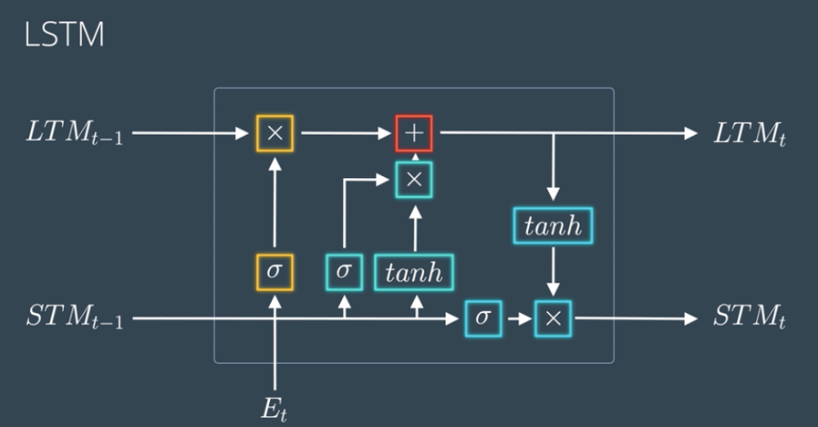

Long Short-Term Memory is a kind of Recurrent Neural Network. In RNN output from the last step is fed as input within the present step. It tackled the matter of long-term dependencies of RNN within which the RNN will not predict the word hold on within the long-term memory however can offer additional accurate forecasts from the recent info. Because the gap length will increase RNN does not offer an economical performance. LSTM will by default retain the knowledge for a long period of time. It is used for processing, predicting and classifying on the basis of time-series data.

Structure of LSTM:

* LSTM has a chain organization that contains four neural networks and different memory blocks called cells.
* LSTM has a new structure called a memory cell. The memory cell makes the decisions about what information to store, and when to allow reading, writing and forgetting.
* A memory cell contains three main gates:
* Input gate- a new value flows into the memory cell.
* Forget gate- a value remains in the memory cell.
* Output gate- value in the memory cell is used to compute the output.

Applications of LSTM includes:

* Language Modelling
* Machine Translation
* Image Captioning
* Handwriting generation
* Question Answering Chatbot

**Chapter 3**

**Methodology**

Dataset

Predict Result

Build LSTM & Model Training

Data Splitting

Data Pre-Processing

The system presented here composes of six modules -

1. Input as Dataset (Pandas, Numpy)
2. Pre-processing (Scikit learn)
3. Data splitting
4. Build & Model train LSTM (Tensor-flow)
5. Output as Predicted Result (matplotlib for visualization)

Attribute such as: price of open, high, low, close, adjusted close price taken from huge dataset are fed as input to the models for training to pre-process the data techniques like normalization & one hot encoding in applied on dataset. After this data is divided in two sets namely training & testing which are ratio of 80:20 respectively. Then, this set are used to train a model using 3 different approaches: LSTM, CNN and Hybrid approach of LSTM+CNNS. Finally, all these modules are evaluated using Root mean square error.

**Chapter 4**

**Result and Discussion**

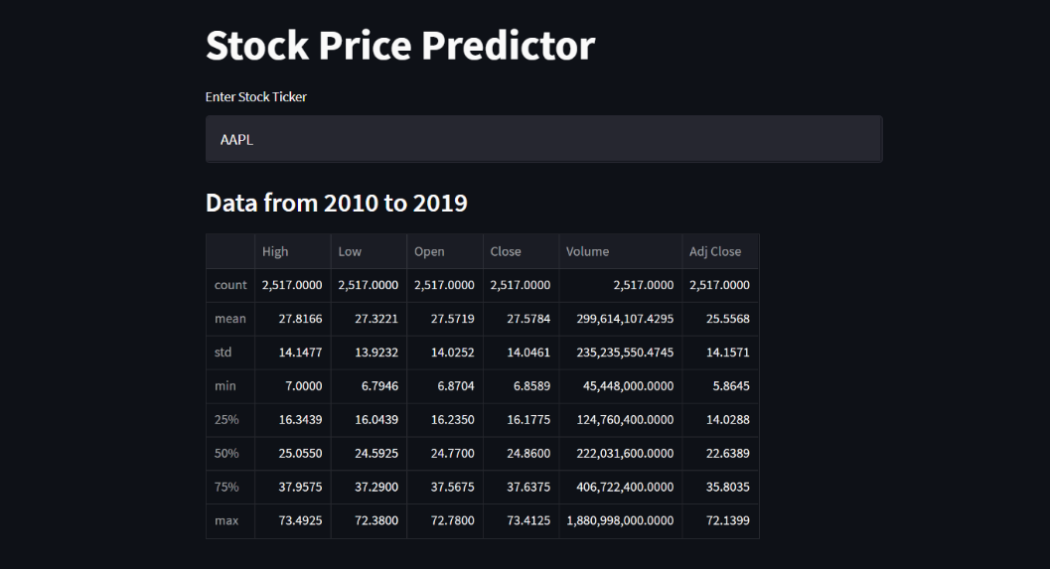

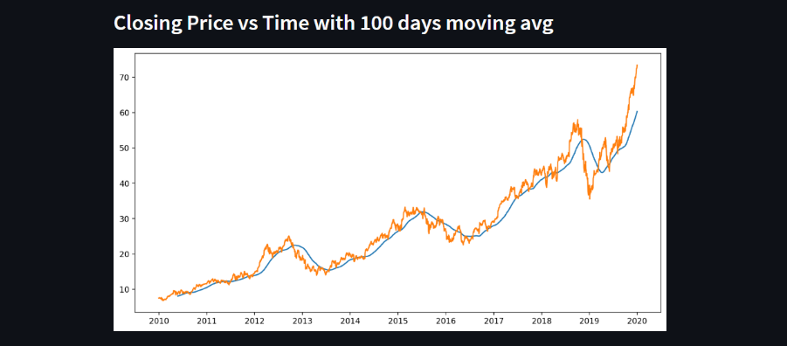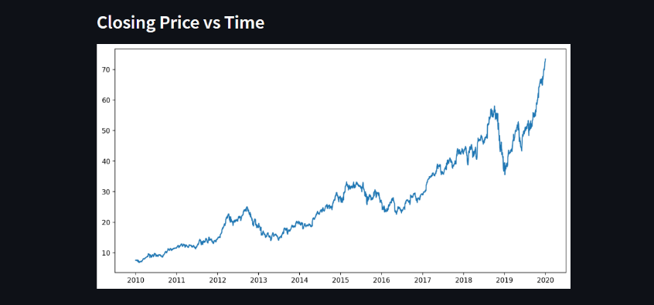

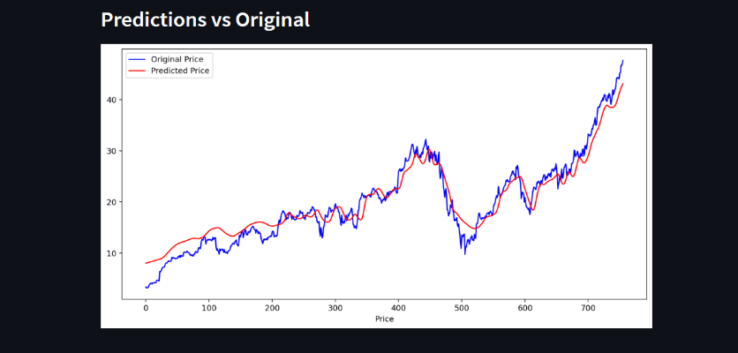

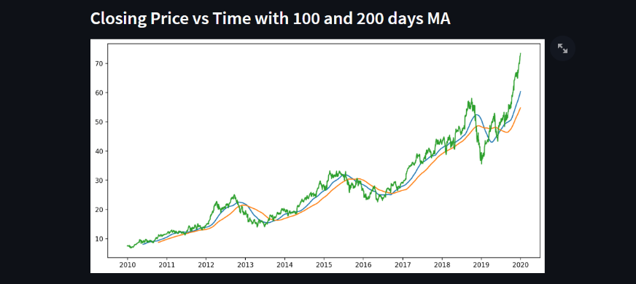

**Chapter 5**

**Conclusion and Future Work**

In this project, the LSTM based model is used in predicting future prices of stocks. The dataset utilized for analysis was selected from Amazon.The data reflected the stock price at some time intervals for every day of the year. It contains various data like date, symbol, open price, close price, low price, high price and volume. Here, the data for any company can be considered. All the data was available in a file of CSV format which was first read and transformed into a data frame using the Pandas library in Python. The normalization of the data was performed through the sk-learn library in Python and the data were divided into training and testing sets. The testing data set was kept as 30% of the available dataset.

One thing to note is that although this model tries its best to accurately predict future prices of stocks, the unpredictable nature of stock market poses a big challenge. So, this model has much room for improvement and additional changes can be made when more effective techniques are discovered in the future.

**References**

[1] “Stock price prediction using LSTM, RNN and CNN-sliding window model - IEEE Conference Publication.” https://ieeexplore.ieee.org/document/8126078 (accessed Nov. 27, 2022).

[2] J. Jagwani, M. Gupta, H. Sachdeva, and A. Singhal, “Stock Price Forecasting Using Data from Yahoo Finance and Analysing Seasonal and Nonseasonal Trend,” in 2018 Second International Conference on Intelligent Computing and Control Systems (ICICCS), Madurai, India, Jun. 2018, pp. 462–467, doi: 10.1109/ICCONS.2018.8663035.

[3] “Home - Keras Documentation.” https://keras.io/ (accessed Nov. 21, 2022).

[4] “Project Jupyter.” https://www.jupyter.org (accessed Nov. 19, 2022).

[5] K. Team, “Keras documentation: Search Keras documentation.” https://keras.io/search.html?query=lstm (accessed Nov. 07, 2022).

[6] K. Team, “Keras documentation: The Sequential model.” https://keras.io/guides/sequential_model/ (accessed Nov. 07, 2022). Market Prediction Using Machine Learning,” in 2018 First International Conference on Secure Cyber Computing and Communication (ICSCCC).