Idea of rate-limiter
Rate limiter has two important things,
1. Time window
2. Request allowed in a window
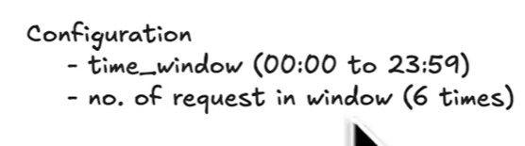
This is an example taken… here the backend server has set the rate limiter with 1 day window and for a whole day, you can submit a request only 6 times. Then ur other requests will be blocked

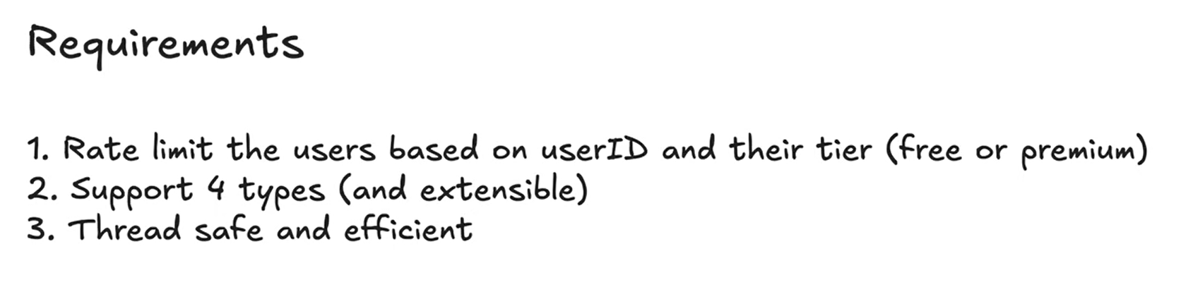
The requirement 2 says, that we should support 4 types of technique.
- Token bucket strategy
- Fixed window
- Sliding window log
- Sliding window counter
- Design should be extensible that later we should be able to add more types
429 error code is for rate-limiter

Rate-limiter types:
- Fixed window
  - Here in the end of the window, you can have spike because if the window is for 5 mins then in the end of 5 mins and beginning of 6th min I can have 2X than the allowed one.
- Sliding window log
  - This solves fixed window issue. Here, we keep the request in queue and the moment queue reaches the limit of requests it will drop the new ones, and the queue will keep moving forward, the moment we pop one request from queue, we allow new requests to be accepted..
  - Disadvantage is we need to maintain queue for all the users..
- Token Bucket
  - Here for each user there will be a bucket, as one request comes the request first go to rate limiter and it will be checked if there is available token for this user or not.. if it is there, one token will be reduced and request will be allowed, if no token then request will be denied
  - Number of tokens in bucket should be equal to the number of request allowed for the window time… example 3 request per min, so 3 tokens should be there.
  - There is rifil_rate = window_time/number of allowed request.
    - Window_time = 1min/60seconds, allowed request = 3
    - Refile_rate = 20 seconds, means after every 20 seconds, 1 token will be added in the bucket.
    - Initially the bucket will have 1 request, and after every 20 seconds 1 more will be added so in total 1 min, 3 tokens will be there…

