**Contributing Limited/Specified storage to Hadoop cluster:**

**Initial NameNode GUIs view of the DataNode:**

1. **Creating/Adding a storage device to the DataNode.** 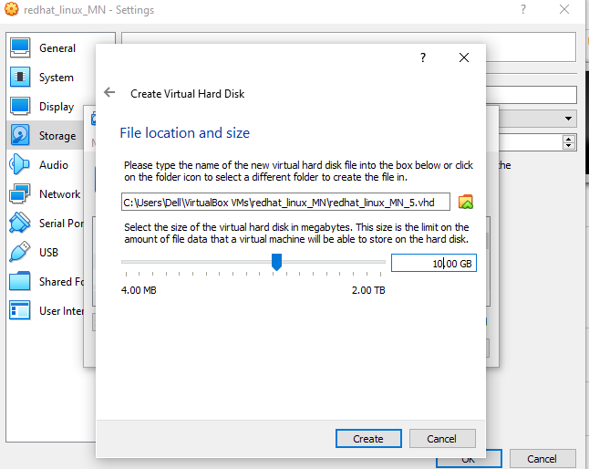

**2.Listing/Viewing the newly added storage device**

**Command:** *#fdisk -l*

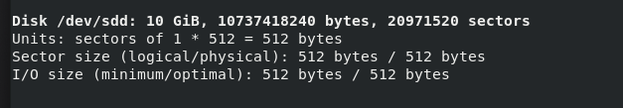

1. **Entering the newly added storage device menu:**

Command: *#fdisk disk_name* *(/dev/sdd)*

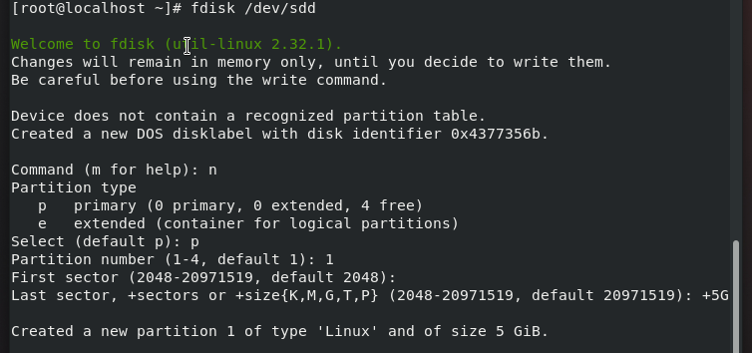

1. **Adding the driver to partition and formatting it:**

Command: *#udevadm settle*

*#mkfs.ext4 /dev/sdd1 8G*

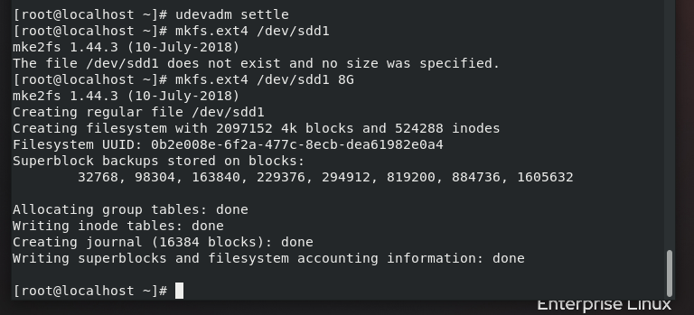

1. **Removing the older DataNode Storage Contributing directory**:

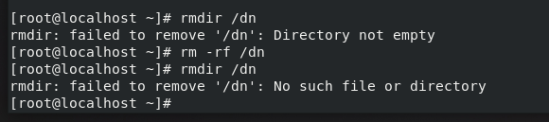

1. **Making a new directory and mounting it to the newly created partition:**

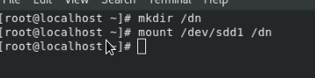

1. **Starting the DataNode service:**

1. **Refreshing the Namenode GUI(:50070):**

