**EXPERIMENT-1**

**AIM**-To understand DevOps: Principles, Practices , and DevOps Engineers Role and Responsibilities.

**THEORY**-

What is DevOps?

DevOps can be best explained as people working together to conceive, build and deliver secure software at top speed. DevOps practices enable software development (dev) and operations (ops) teams to accelerate delivery through automation, collaboration, fast feedback, and iterative improvement.Stemming from an [Agile approach](https://about.gitlab.com/topics/agile-delivery/) to software development, a DevOps process expands on the cross-functional approach of building and shipping applications in a faster and more iterative manner. In adopting a DevOps development process, you are making a decision to improve the flow and value delivery of your application by encouraging a more collaborative environment at all stages of the development cycle.DevOps represents a change in mindset for IT culture. In building on top of Agile, lean practices, and systems theory, DevOps focuses on incremental development and rapid delivery of software. Success relies on the ability to create a culture of accountability, improved collaboration, empathy, and joint responsibility for business outcomes.

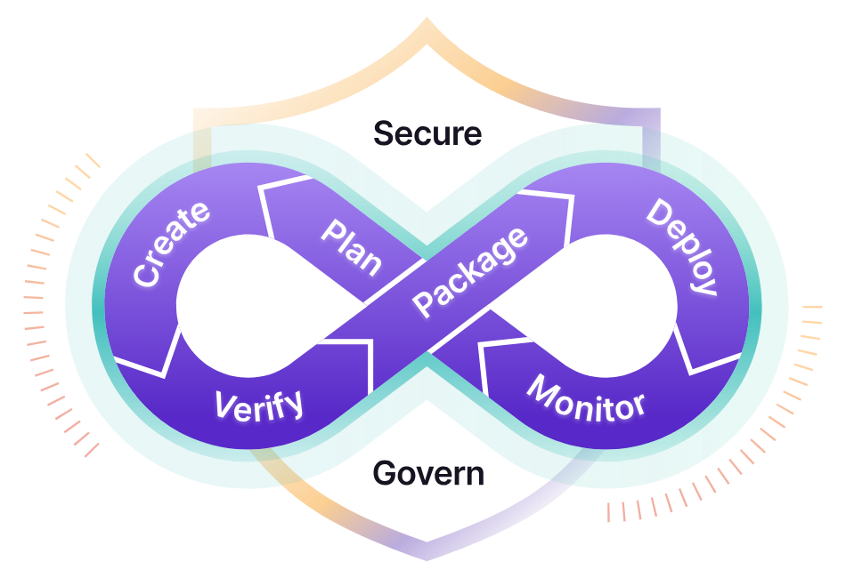

Principles of DevOps:

1. Develop and test in an environment similar to production.
2. Deploy builds frequently.
3. Validate operation quality continuously.

Practices of DevOps:

1. Collaboration:The key premise behind DevOps is collaboration. Development and operations teams coalesce into a functional team that communicates, shares feedback, and collaborates throughout the entire development and deployment cycle. Often, this means development and operations teams merge into a single team that works across the entire application lifecycle.The members of a DevOps team are responsible for ensuring quality deliverables across each facet of the product.

This leads to more ‘full stack’ development, where teams own the complete backend-to-frontend responsibilities of a feature or product. Teams will own a feature or project throughout the complete lifecycle from idea to delivery. This enhanced level of investment and attachment from the team leads to higher quality output.

1. Automation:An essential practice of DevOps is to automate as much of the software development lifecycle as possible. This gives developers more time to write code and develop new features. Automation is a key element of a [CI/CD pipeline](https://www.atlassian.com/continuous-delivery/principles/pipeline) and helps to reduce human errors and increase team productivity. With automated processes, teams achieve continuous improvement with short iteration times, which allows them to quickly respond to customer feedback.
2. Continuous Improvement:Continuous improvement was established as a staple of [agile practices](https://www.atlassian.com/agile), as well as lean manufacturing and [Improvement Kata](https://www.atlassian.com/agile/agile-at-scale/using-improvement-kata-to-support-lean). It’s the practice of focusing on experimentation, minimizing waste, and optimizing for speed, cost, and ease of delivery. Continuous improvement is also tied to [continuous delivery](https://www.atlassian.com/continuous-delivery), allowing DevOps teams to continuously push updates that improve the efficiency of software systems. The constant pipeline of new releases means teams consistently push code changes that eliminate waste, improve development efficiency, and bring more customer value.
3. Customer-centric action:DevOps teams use short feedback loops with customers and end users to develop products and services centered around user needs. DevOps practices enable rapid collection and response to user feedback through use of real-time live monitoring and rapid deployment. Teams get immediate visibility into how live users interact with a software system and use that insight to develop further improvements.
4. Create with the end in mind:This principle involves understanding the needs of customers and creating products or services that solve real problems. Teams shouldn’t ‘build in a bubble’, or create software based on assumptions about how consumers will use the software. Rather, DevOps teams should have a holistic understanding of the product, from creation to implementation.

Who is a DevOps Engineer?

A DevOps engineer is responsible for the smooth operation of a company's IT infrastructure. They work with developers to deploy and manage code changes, and with operations staff to ensure that systems are up and running smoothly. To be successful in this role, a DevOps engineer must have a deep understanding of both development and operations processes, as well as a strong technical background.

As the world of business becomes increasingly reliant on technology, the role of a DevOps engineer is becoming more and more important. Companies are looking for individuals who can help them to streamline their operations and make the most of their IT infrastructure. If you have a strong technical background and are interested in working with both development and operations staff, then a career as a DevOps engineer could be the perfect fit for you.

Some of the core [responsibilities of DevOps Engineer](https://www.simplilearn.com/devops-engineer-salary-roles-and-responsibilities-article) include –

* Understanding customer requirements and project KPIs
* Implementing various development, testing, automation tools, and IT infrastructure
* Planning the team structure, activities, and involvement in project management activities.
* Managing stakeholders and external interfaces
* Setting up tools and required infrastructure
* Defining and setting development, test, release, update, and support processes for DevOps operation
* Have the technical skill to review, verify, and validate the software code developed in the project.
* Troubleshooting techniques and fixing the code bugs
* Monitoring the processes during the entire lifecycle for its adherence and updating or creating new processes for improvement and minimizing the wastage
* Encouraging and building automated processes wherever possible
* Identifying and [deploying cybersecurity](https://www.simplilearn.com/introduction-to-cyber-security-article) measures by continuously performing vulnerability assessment and risk management
* Incidence management and root cause analysis
* Coordination and communication within the team and with customers
* Selecting and deploying [appropriate CI/CD tools](https://www.simplilearn.com/best-ci-cd-tools-article)
* Strive for continuous improvement and build continuous integration, continuous development, and constant deployment pipeline ([CI/CD Pipeline)](https://www.simplilearn.com/open-source-pipeline-tools-for-devops-article)
* Mentoring and guiding the team members
* Monitoring and measuring customer experience and KPIs
* Managing periodic reporting on the progress to the management and the customer

CONCLUSION: Thus we learnt about what is DevOps , DevOps Engineer and its responsibilities.