Theory of Computation
Questions with Worked Solutions
Finite Automata · Context-Free Grammars · Pushdown Automata Total: 36 marks

1. Finite Automata: Time-Machine Paradox Checker (12 marks)
A time machine logs every action over Σ = {p, f, h}:
- p: jump into the past
- f: jump into the future
- h: hold position
A trip log is paradox-free if all three rules hold:
- A jump into the past is never immediately followed by a jump into the future. There is no "pf" substring, because the machine suffers temporal whiplash.
- The number of past-jumps is even. Otherwise a copy of the traveller is stranded in the past.
- The log ends with h, because the machine must be stationary to land.
Valid: "h", "fh", "pph", "phph", "phfph"
Invalid: "", "ph", "ppfh", "pphf", "pphp"
(a) Construct a DFA for paradox-free logs. Label every state with what it remembers, and include the dead state. [4 marks]
ANSWER
To check the three rules, the DFA tracks three things: the parity of p's, whether the last symbol was p (to catch "pf"), and whether the last symbol was h (for the "must end with h" rule).
State | Meaning | on p | on f | on h
→ A | even #p, last symbol is neither p nor h (start, or just read f) | F | A | B
B (accepting) | even #p, last symbol is h | F | A | B
C | even #p, last symbol is p | F | G | B
D | odd #p, last symbol is f | C | D | E
E | odd #p, last symbol is h | C | D | E
F | odd #p, last symbol is p | C | G | E
G | dead (a "pf" has occurred) | G | G | G

Only B is accepting. Reading p flips the parity and moves to a "last was p" state. Reading f right after p goes to the dead state G.
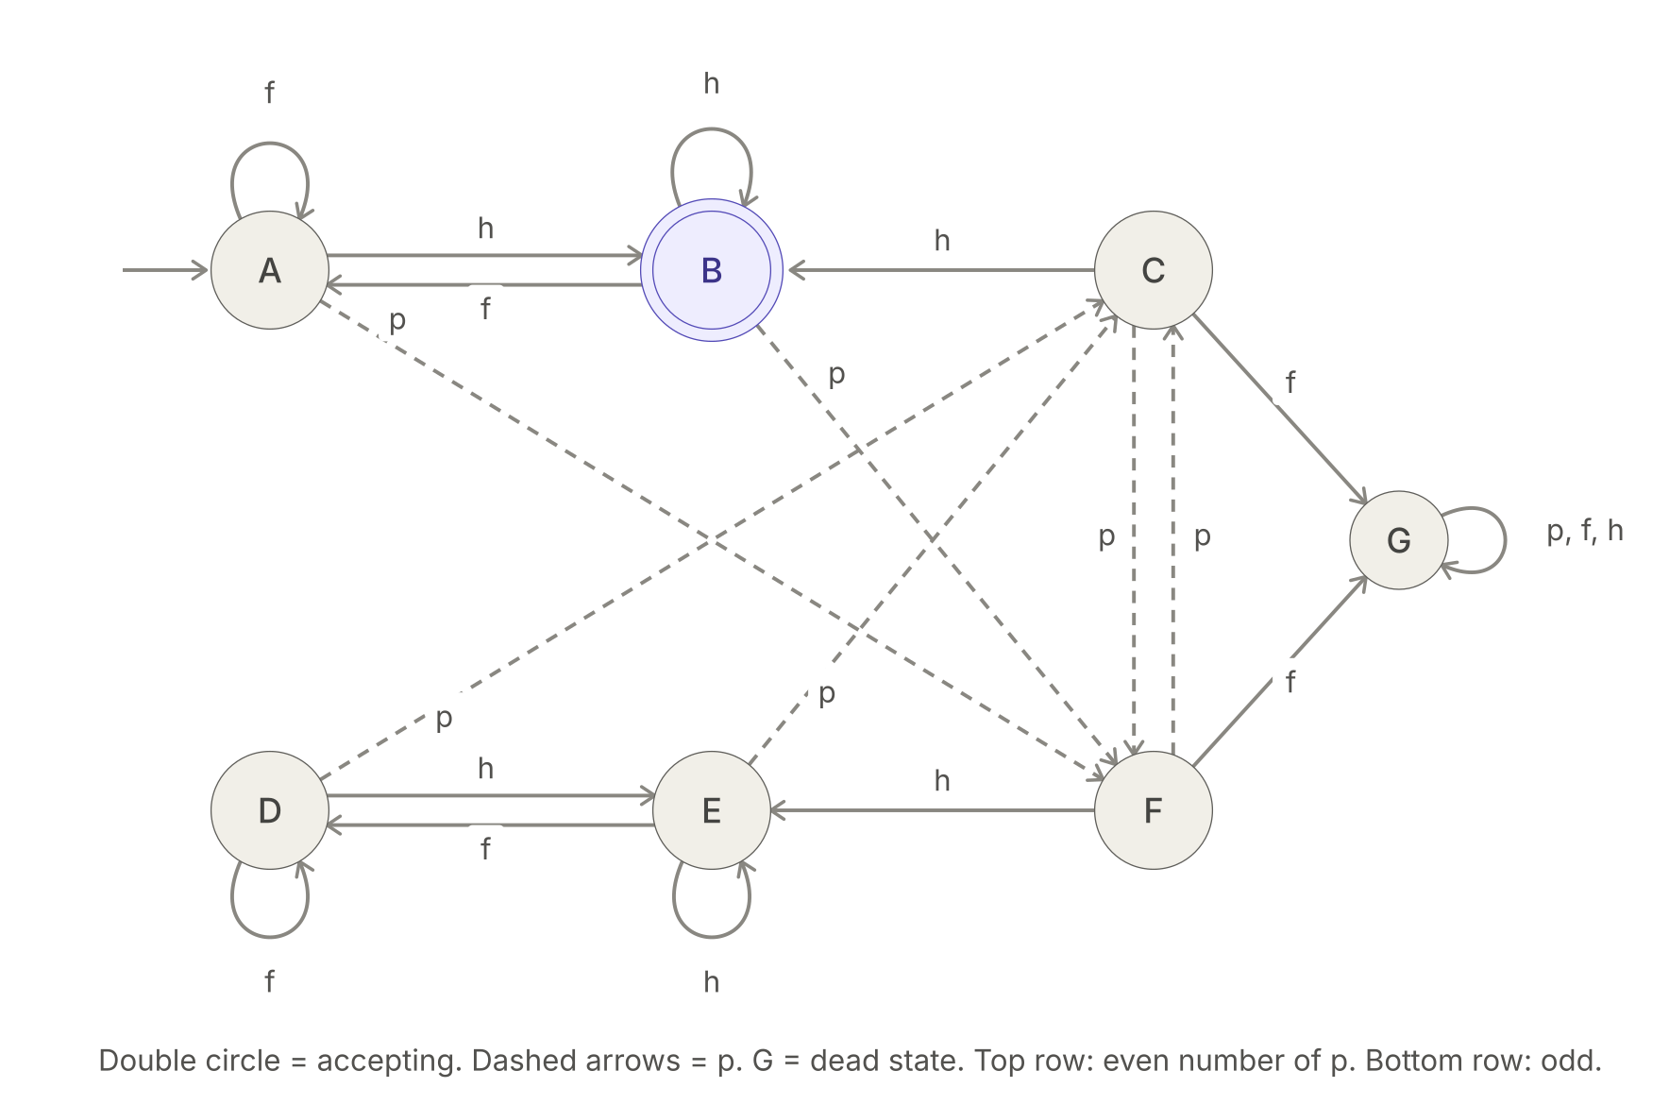
Figure 1. DFA for paradox-free logs (7 states, B accepting, G dead)
Trace of "phfph": A →p F →h E →f D →p C →h B. This is accepted ✓.
Trace of "ppfh": A →p F →p C →f G →h G. This is rejected ✓.
(b) Minimize your DFA using the table-filling method. How many states does the minimal DFA have? [2 marks]
ANSWER
- Round 0: B is accepting and everything else is not, so mark (B, every other state).
- Round 1: on h, the pairs (A,D), (A,E), (A,F), (A,G), (C,D), (C,E), (C,F) and (C,G) all lead to (B, non-B), which is already marked, so mark them.
- Round 2: (A,C) is marked, because on f it goes to (A,G). (D,G), (E,G) and (F,G) are marked, because on p they go to (C,G).
- Round 3: (D,F) and (E,F) are marked, because on f they go to (D,G) and (E,G).
- Left unmarked: only (D, E). They have identical transitions and are both non-accepting, so D ≡ E.
The minimal DFA has 6 states: A, B, C, F, {D,E}, G.
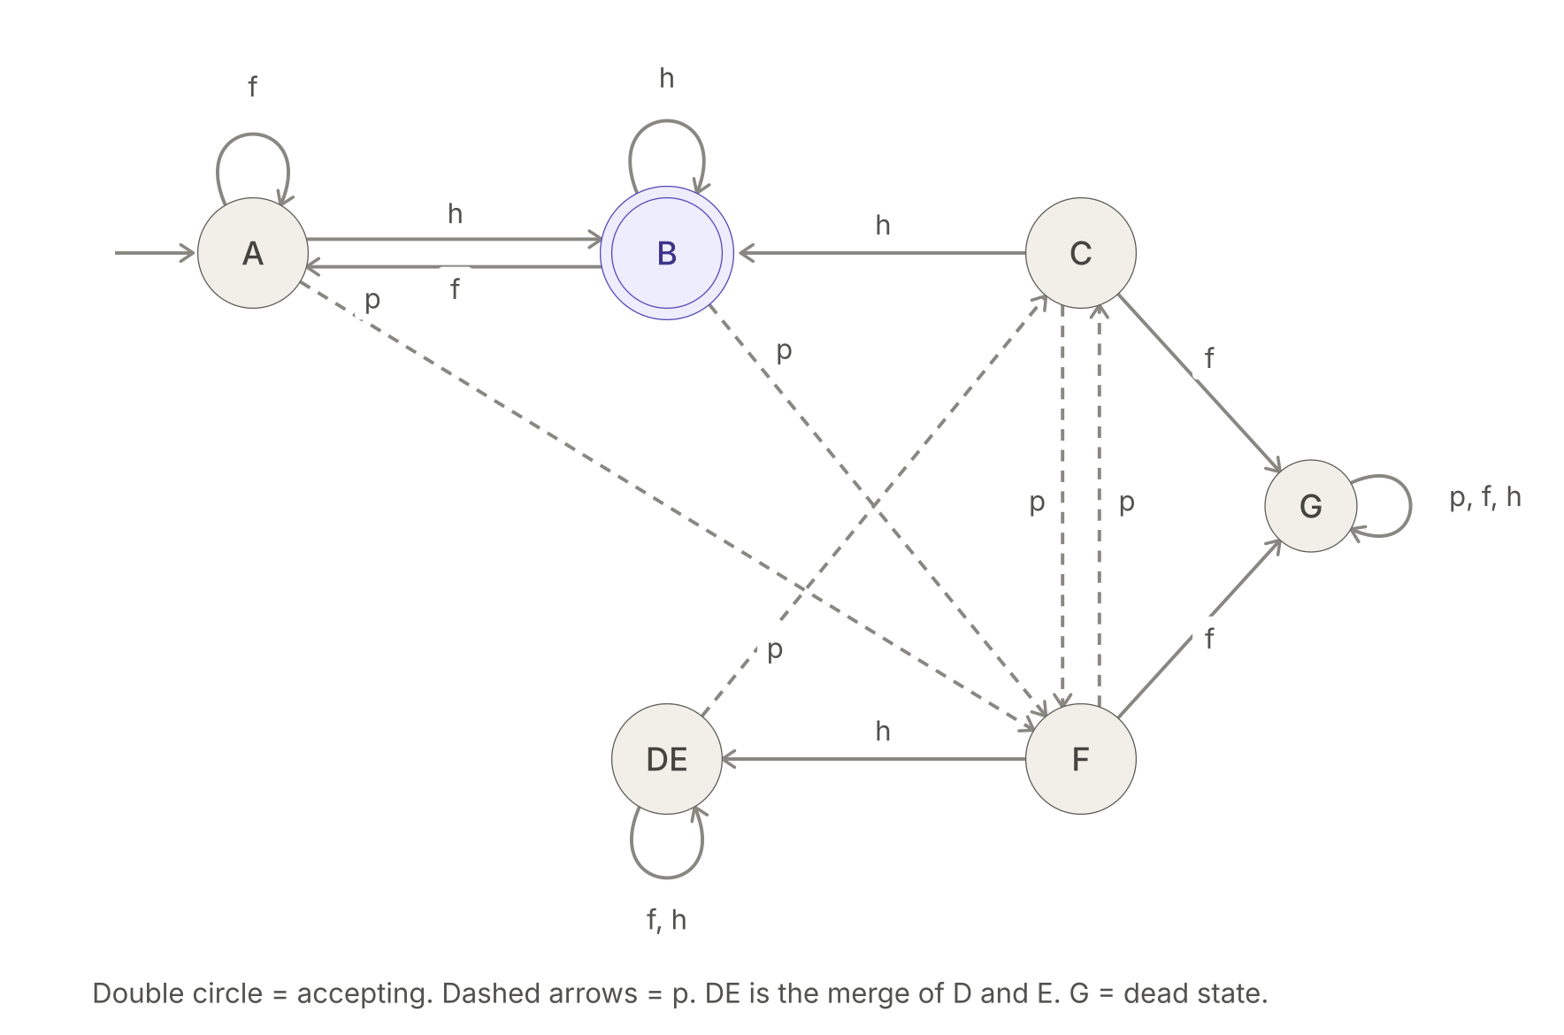
Figure 2. Minimal DFA (6 states) after merging D and E
(c) The regulator adds a stricter rule: every past-jump must be repaid by exactly one future-jump, with all past-jumps first, then all future-jumps, then a final hold. This gives L_rep = { pⁿ fⁿ h | n ≥ 1 }. Prove L_rep is not regular using the Pumping Lemma. [4 marks]
ANSWER
Assume L_rep is regular with pumping length m. Take w = pᵐfᵐh, so |w| ≥ m. Split w = xyz with |xy| ≤ m and |y| ≥ 1.
Since |xy| ≤ m, both x and y lie inside the p-block, so y = pᵏ with 1 ≤ k ≤ m. Pump with i = 2:
xy²z = pᵐ⁺ᵏ fᵐ h
This has more p's than f's, so it is not in L_rep. That contradicts the Pumping Lemma, so L_rep is not regular ∎
(d) A colleague claims L_bal = { w ∈ {p,f,h}* | #p(w) = #f(w) } is regular. Refute this using closure under intersection with p*f*. [2 marks]
ANSWER
Intersect L_bal with the regular language p*f*:
L_bal ∩ p*f* = { pⁿfⁿ | n ≥ 0 }
This language is not regular, by the same pumping argument as in (c). Regular languages are closed under intersection, and p*f* is regular. If L_bal were regular, the intersection would be regular too, which is a contradiction. So L_bal is not regular ∎

2. Context-Free Grammar: Treasure Hunter's Cave Diary (12 marks)
An explorer's diary is written over Σ = {e, x, t, m}:
- e: enter a cave
- x: exit the cave you are currently in
- t: find a treasure
- m: meet a monster
A diary is valid if all three rules hold:
- It consists of one or more complete caves in sequence. Every cave entered is exited, and you never exit without entering. Caves can be nested inside other caves.
- Treasures and monsters occur only inside a cave.
- Every cave contains at least one treasure found directly in it. A treasure found only inside a deeper nested cave doesn't count for the outer cave. Monsters can be met anywhere inside a cave.
Valid: "etx", "emtx", "etmtx", "etxetx", "eetxtx", "emetxtx"
Invalid: "", "ex", "emx", "eetxx", "tx", "etxx", "etxm"
(a) Construct a CFG for valid diaries. Explain the role of each non-terminal. [5 marks]
ANSWER
D → C D | C
C → e A t B x
A → m A | C A | ε
B → t B | m B | C B | ε
Non-terminal | Role
D | the whole diary, one or more complete caves in sequence
C | one cave: e, then contents, then x
A | the stuff before the cave's first direct treasure: monsters and whole nested caves, but no direct t
B | anything after that first direct treasure: t, m or whole caves

The "A t B" shape forces every cave to have a direct treasure. The nested caves inside A and B are whole C's, so their treasures are never counted for the outer cave. This grammar is also unambiguous, as part (c) shows.
(b) Give a leftmost derivation and a parse tree for "emetxtx". [2 marks]
ANSWER
Leftmost derivation
D ⇒ C (D → C)
⇒ e A t B x (C → e A t B x)
⇒ e m A t B x (A → m A)
⇒ e m C A t B x (A → C A)
⇒ e m e A t B x A t B x (C → e A t B x)
⇒ e m e t B x A t B x (A → ε)
⇒ e m e t x A t B x (B → ε)
⇒ e m e t x t B x (A → ε)
⇒ e m e t x t x (B → ε)
Parse tree
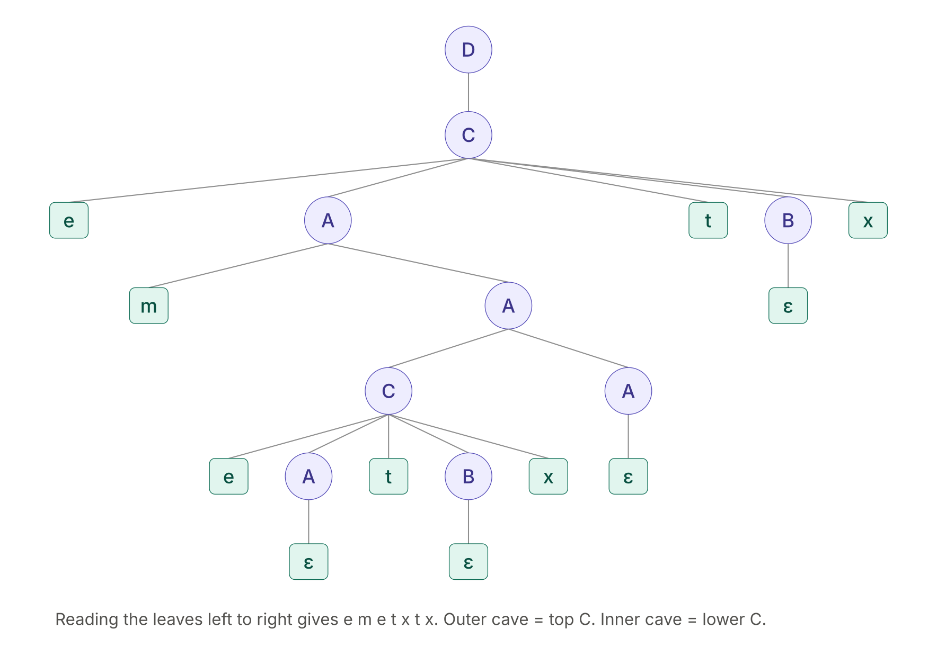
Figure 3. Parse tree for "emetxtx" (yield: e m e t x t x)
(c) A junior writes this grammar: [3 marks]
D → C D | C
C → e X t X x
X → C X | t X | m X | ε
Show that it is ambiguous by drawing two parse trees for "ettx". Then give an unambiguous grammar for the same language.
ANSWER
For "ettx", the grammar can't tell which t is "the required treasure".
Leftmost derivation 1 (first t is the required one):
D ⇒ C ⇒ e X t X x ⇒ e t X x ⇒ e t t X x ⇒ e t t x
Leftmost derivation 2 (second t is the required one):
D ⇒ C ⇒ e X t X x ⇒ e t X t X x ⇒ e t t X x ⇒ e t t x
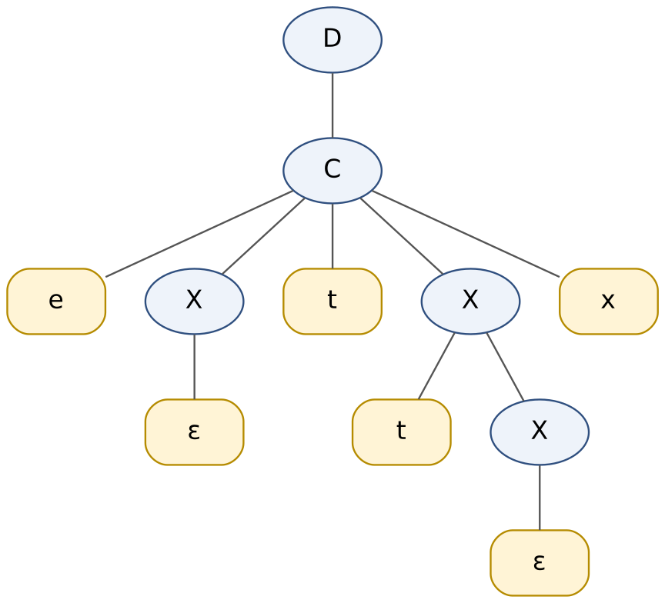  Tree 1: first t is the required treasure | 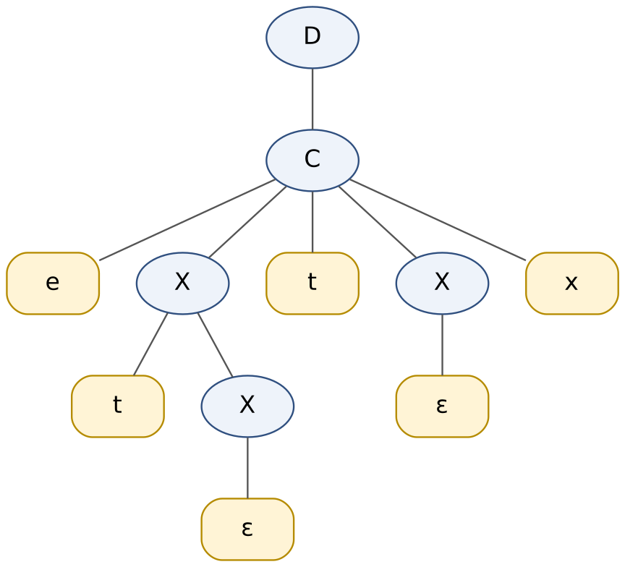  Tree 2: second t is the required treasure

The two derivations use different rules, so they give two different parse trees for the same string, and the grammar is ambiguous ∎
Unambiguous replacement: the grammar from (a). In "e A t B x", A can never produce a direct t, so the t in the middle is always the first direct treasure. A and B each split the contents into items (m, t or a whole cave) in only one way. So every valid diary has exactly one parse tree.
(d) Let L be the language of valid diaries. Prove L is not regular by intersecting it with e*(tx)* and applying the Pumping Lemma to the result. [2 marks]
ANSWER
Intersect L with the regular language e*(tx)*.
- A string e^a (tx)^b is balanced only when a = b, and a ≥ 1 is needed because the empty diary is invalid.
- Every such string is valid. In eⁿ(tx)ⁿ, the innermost cave contains a t, and each outer cave gets its own t right after the inner cave closes. For example, n = 2 gives "eetxtx".
So L ∩ e*(tx)* = { eⁿ(tx)ⁿ | n ≥ 1 }.
Assume this is regular with pumping length m, and take w = eᵐ(tx)ᵐ. Since |xy| ≤ m, y = eᵏ with k ≥ 1. Pumping gives eᵐ⁺ᵏ(tx)ᵐ, which has more e's than x's, so it is not in the language. That is a contradiction.
Regular languages are closed under intersection with regular languages. If L were regular, the intersection would be regular. So L is not regular ∎

3. Pushdown Automata: The Apothecary's Cauldron (12 marks)
An apothecary logs what goes into a cauldron over Σ = {h, m, a}:
- h: add a healing herb
- m: add a mandrake root
- a: add one drop of antidote
The cauldron is stable if every ingredient (h or m) is neutralised by exactly one antidote drop, i.e. #h + #m = #a. The order is free: the apothecary may pre-treat the cauldron with antidote before adding an ingredient, or add the antidote afterwards.
Valid: "ha", "ah", "hmaa", "aahm", "ahmaha"
Invalid: "h", "aa", "hma", "ahhm"
(a) Construct a PDA for stable logs and specify δ. Note that the stack must handle the cauldron being "ahead" of antidote (ingredients waiting) and "behind" (antidote waiting). [5 marks]
ANSWER
The stack holds the "debt" in whichever direction it currently runs. It holds X's when ingredients are waiting for antidote, and Y's when antidote is waiting for ingredients.
M = (Q, Σ, Γ, δ, q₀, Z₀, F), with Q = {q₀, q_X, q_Y}, Σ = {h, m, a}, Γ = {Z₀, X, Y}, F = {q₀}.
- q₀: balanced, stack = Z₀ only
- q_X: ingredients ahead
- q_Y: antidote ahead
Below, c stands for either h or m.
# | Transition | Meaning
1 | δ(q₀, c, Z₀) = {(q_X, X Z₀)} | first ingredient from balance
2 | δ(q₀, a, Z₀) = {(q_Y, Y Z₀)} | first antidote from balance
3 | δ(q_X, c, X) = {(q_X, X X)} | another ingredient, push
4 | δ(q_X, a, X) = {(q_X, ε)} | antidote cancels an ingredient, pop
5 | δ(q_X, ε, Z₀) = {(q₀, Z₀)} | last X popped, back to balanced
6 | δ(q_Y, a, Y) = {(q_Y, Y Y)} | another antidote, push
7 | δ(q_Y, c, Y) = {(q_Y, ε)} | ingredient cancels an antidote, pop
8 | δ(q_Y, ε, Z₀) = {(q₀, Z₀)} | last Y popped, back to balanced

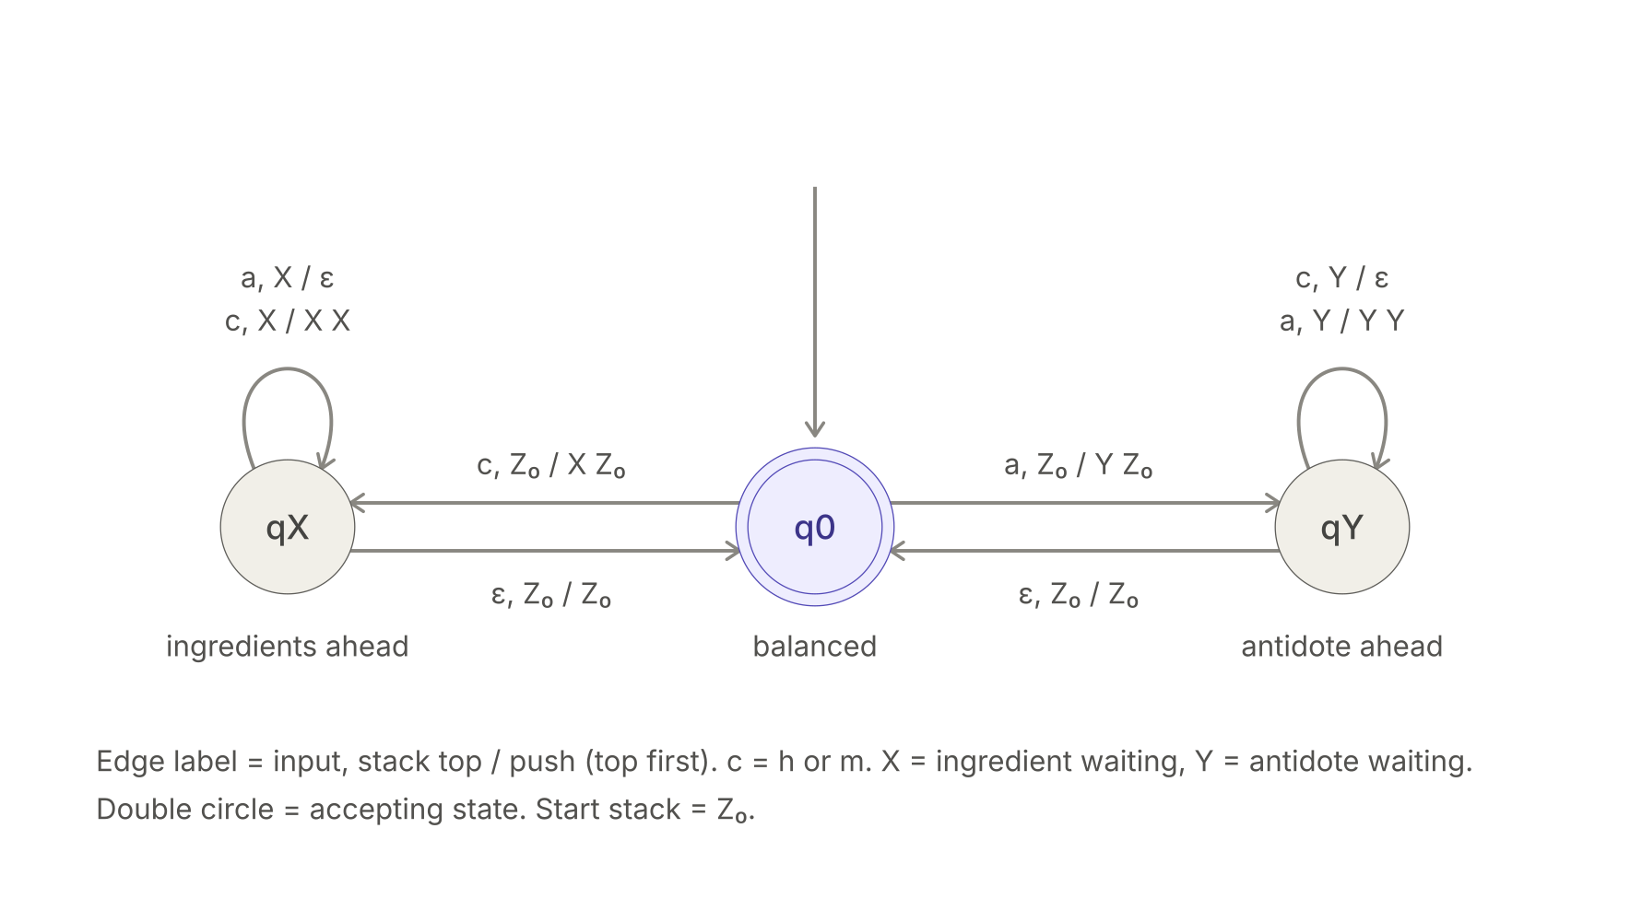
Figure 4. Transition diagram of the PDA (edge label: input, stack top / replacement)
(b) State whether your PDA accepts by final state or empty stack, and say whether it is deterministic. Justify both. [2 marks]
ANSWER
- It accepts by final state (q₀).
- Why not empty stack? The language is not prefix-free: "ha" ∈ L and "haha" ∈ L. A deterministic PDA that empties its stack after "ha" has nothing left to read the rest of "haha". Final-state acceptance avoids this.
- It is deterministic. For every (state, stack-top) pair, either only ε-moves exist or only input moves exist, with at most one move per symbol:
  - (q₀, Z₀) has input moves only.
  - (q_X, X) and (q_Y, Y) have input moves only.
  - (q_X, Z₀) and (q_Y, Z₀) have a single ε-move only.
(c) Show the sequence of instantaneous descriptions (IDs) for "ahmaha" (accepted) and "hma" (rejected). [3 marks]
ANSWER
Each ID is (state, remaining input, stack with top on the left).
"ahmaha" (accepted)
(q₀, ahmaha, Z₀)
⊢ (q_Y, hmaha, Y Z₀) rule 2
⊢ (q_Y, maha, Z₀) rule 7 (h cancels the antidote)
⊢ (q₀, maha, Z₀) rule 8 (ε)
⊢ (q_X, aha, X Z₀) rule 1
⊢ (q_X, ha, Z₀) rule 4
⊢ (q₀, ha, Z₀) rule 5 (ε)
⊢ (q_X, a, X Z₀) rule 1
⊢ (q_X, ε, Z₀) rule 4
⊢ (q₀, ε, Z₀) rule 5 (ε)
The input is consumed and the machine is in q₀ ∈ F, so it is accepted ✓.
"hma" (rejected)
(q₀, hma, Z₀)
⊢ (q_X, ma, X Z₀) rule 1
⊢ (q_X, a, X X Z₀) rule 3
⊢ (q_X, ε, X Z₀) rule 4
The input is consumed in q_X, which is not final, and no ε-move applies with X on top. So it is rejected ✓.
(d) A rival apothecary demands that the three counts be individually equal, so L′ = { w | #h(w) = #m(w) = #a(w) }. Prove L′ is not context-free by intersecting it with h*m*a* and applying the CFL Pumping Lemma to hᵖmᵖaᵖ. [2 marks]
ANSWER
Intersect L′ with the regular language h*m*a*:
L′ ∩ h*m*a* = { hⁿmⁿaⁿ | n ≥ 0 }
If L′ were context-free, this intersection would be too, because CFLs are closed under intersection with regular languages. Assume it is context-free with pumping length p, and take s = hᵖmᵖaᵖ. Split s = uvxyz with |vxy| ≤ p and |vy| ≥ 1.
- Between the last h and the first a there are p m's. A window of length ≤ p therefore cannot touch both an h and an a, so vxy misses at least one of the three letters.
- Pumping with i = 2 increases the count of at least one letter and leaves the count of the missed letter at p. The three counts are no longer equal.
So uv²xy²z ∉ the language, which is a contradiction. Hence L′ is not context-free ∎

