Deliverable 4
Student: Aryan Shrestha
Course: MSCS-634
Date: Dec 14, 2025

1. Introduction
This project applies the full data mining workflow—data preparation, feature engineering, regression, classification, clustering, and association rule mining—to derive actionable insights from a healthcare dataset.

2. Dataset and Rationale
The Breast Cancer Wisconsin (Diagnostic) dataset contains 569 instances and 30 real-valued features computed from digitized images of fine needle aspirates (FNA) of breast masses. It was chosen because it satisfies size/attribute requirements, is publicly available, and is clinically relevant for diagnostic support.

3. Data Preparation and Exploratory Data Analysis (Deliverable 1)
Data quality checks found no missing values and no duplicate rows. EDA revealed strong separation between benign and malignant classes for multiple size- and texture-related features. Correlation analysis showed multicollinearity among features like radius, perimeter, and area, motivating the use of regularization in later models.
Figure 1: Correlation heatmap of core features.
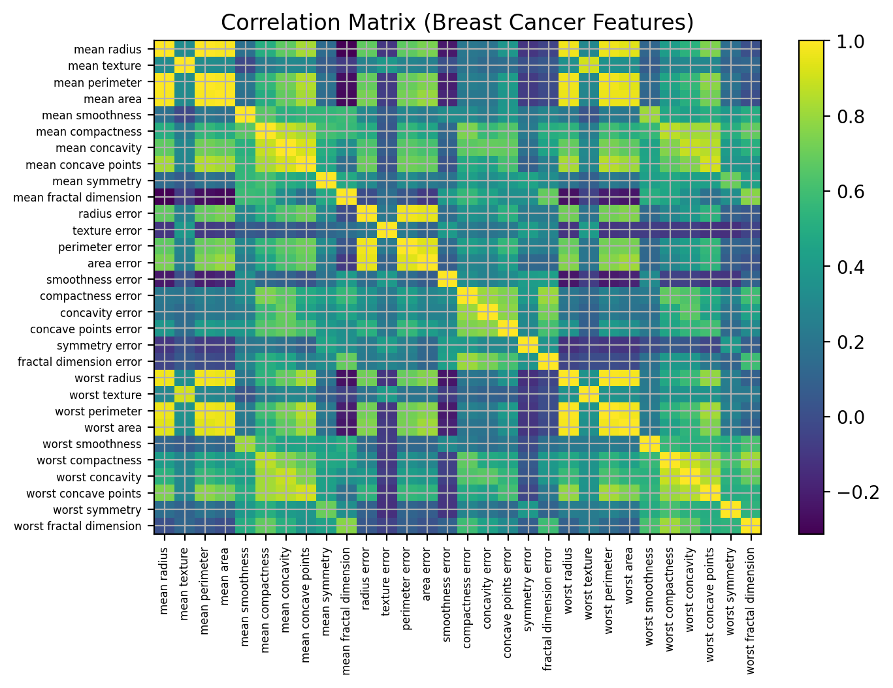
4. Feature Engineering
Two manual engineered features were introduced: (1) radius_area_ratio (mean radius divided by mean area) and (2) compactness_by_smoothness (mean compactness divided by mean smoothness). Standardization was used for scale-sensitive models. Polynomial feature expansion (degree 2) was used in regression to capture mild non-linear structure while regularization-controlled complexity.
5. Regression Modeling and Evaluation (Deliverable 2)
A regression task was defined to predict the continuous outcome mean area from the remaining features. Models compared included Linear Regression, Ridge, Lasso, and polynomial variants with regularization. Performance was evaluated via 5-fold cross-validation and a held-out test set using R², MSE, and RMSE.
Table 1: Regression test-set metrics.
Model | Test R² | RMSE | MSE
Poly2+Ridge | 0.9997 | 5.54 | 30.64
Poly2+Lasso | 0.9995 | 7.78 | 60.58
Lasso | 0.9986 | 12.66 | 160.23
LinearRegression | 0.9986 | 12.88 | 165.82
Ridge | 0.9985 | 13.27 | 176.21
Best regression model in this run: Poly2+Ridge.
Figure 2: Predicted vs actual mean area for the best regression model.
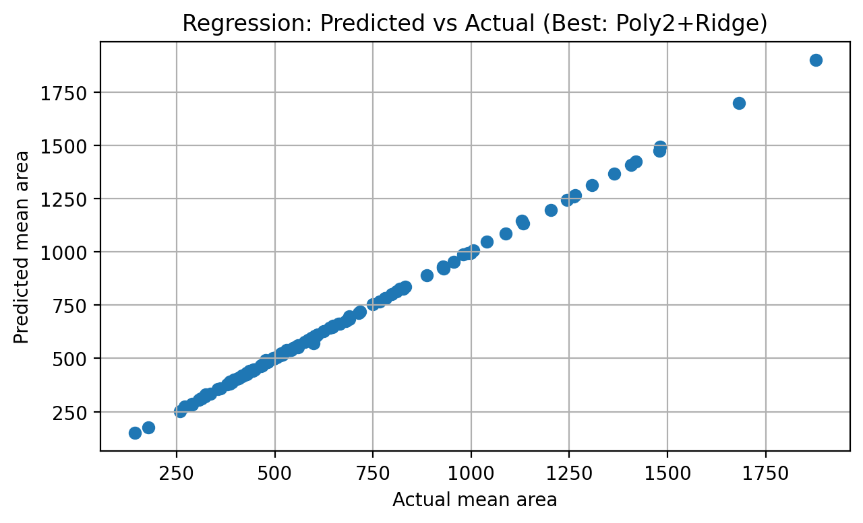
6. Classification, Clustering, and Pattern Mining (Deliverable 3)
6.1 Classification
Two classifiers were developed: Logistic Regression and an RBF-kernel SVM. GridSearchCV tuned SVM hyperparameters (C and gamma) using 5-fold CV. Models were evaluated via accuracy, F1-score, confusion matrix, and ROC AUC.
Tuned SVM best parameters: {'svc__C': 10, 'svc__gamma': 0.01}.
Logistic Regression — Accuracy: 0.982, F1: 0.986, AUC: 0.995.
Tuned SVM — Accuracy: 0.982, F1: 0.986, AUC: 0.997.
Figure 3: ROC curves comparing Logistic Regression vs tuned SVM.
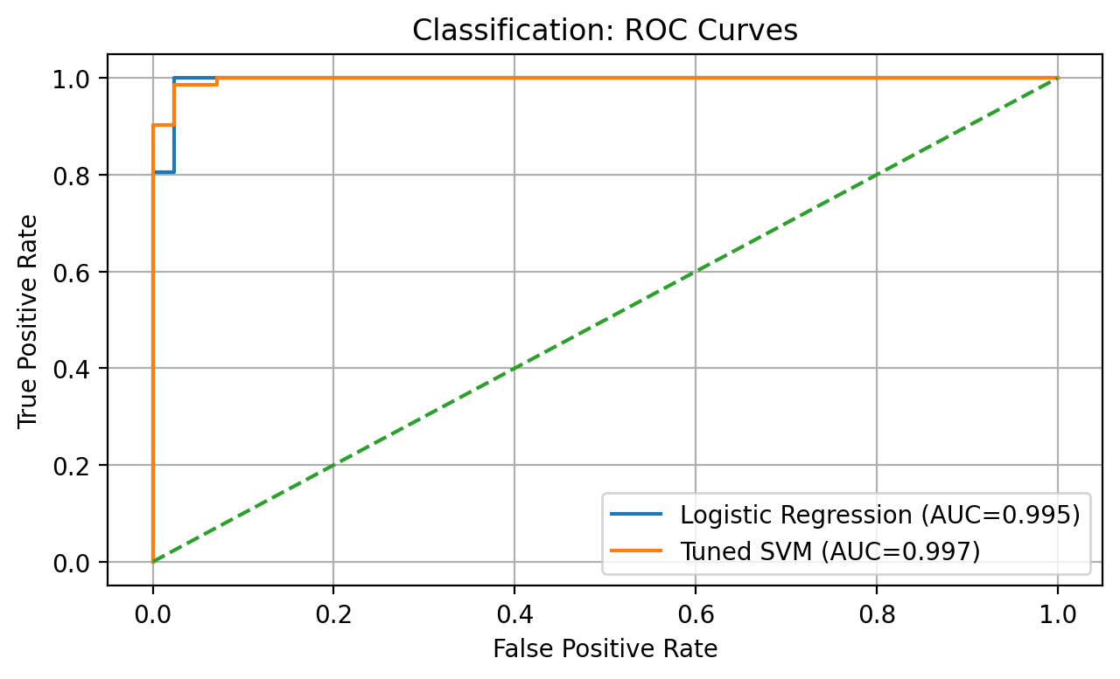
Figure 4: Confusion matrix for the tuned SVM.
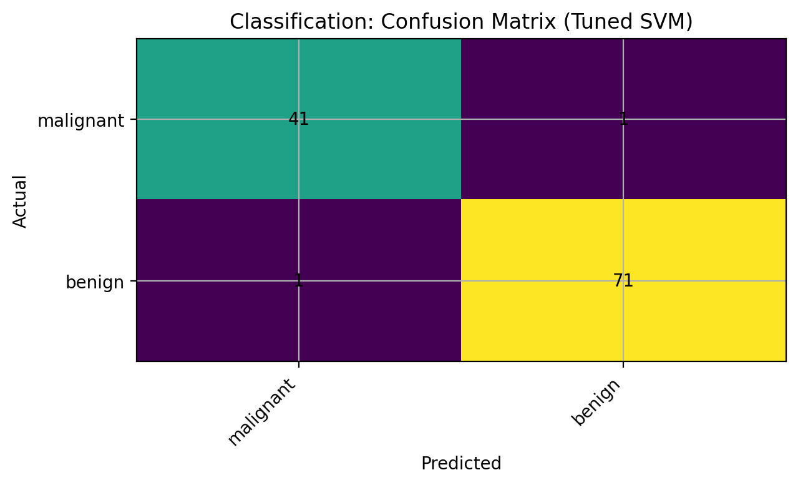
6.2 Clustering
K-Means clustering (k=2) was applied to the engineered feature space. PCA was used to visualize clusters in 2D. Despite being unsupervised, clusters aligned reasonably with true diagnosis labels, suggesting intrinsic separability in the feature space.
Figure 5: K-Means clusters visualized in PCA space.
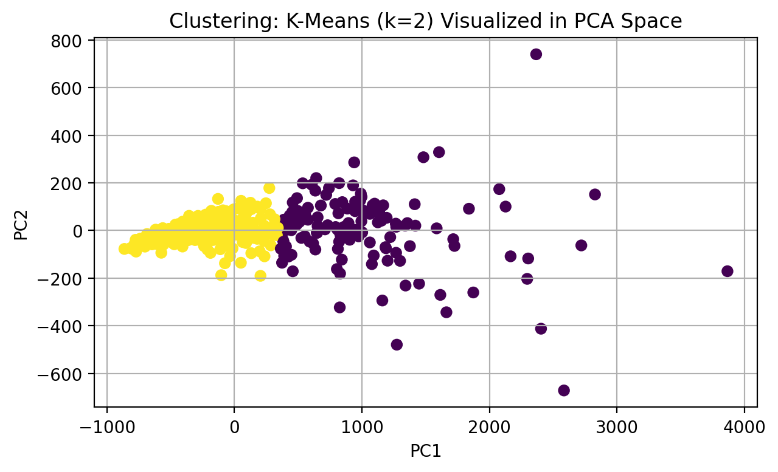
6.3 Association Rule Mining
Selected numeric features were discretized into high/low bins (median split) and combined with diagnosis indicators. Apriori-style frequent itemset mining and rule generation were then used to produce interpretable rules ranked by lift.
Figure 6: Top association rules (by lift).
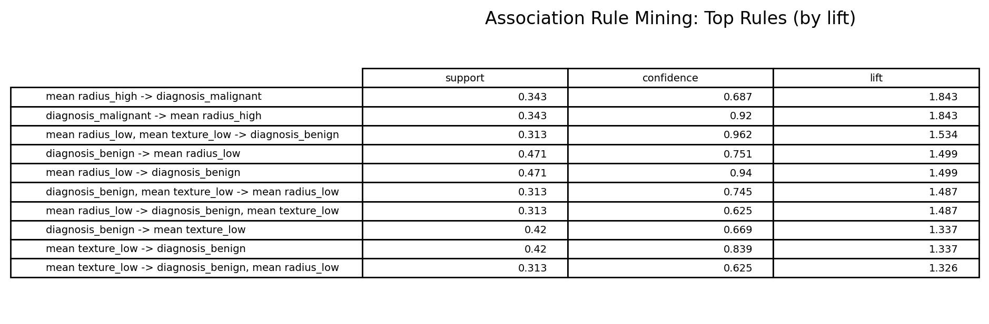
7. Practical Recommendations
- Use the tuned SVM as a decision-support component, prioritizing sensitivity and carefully managing false negatives via thresholding and calibration.
- Pair predictions with interpretable rule summaries to increase transparency and user trust.
- Validate performance on external datasets and across demographic subgroups prior to deployment.
- Maintain robust preprocessing steps to handle real-world data drift.

8. Ethical Considerations
Privacy: The dataset is anonymized and contains no personally identifying information. Fairness and bias: the dataset may not represent all populations equally; models can inherit sampling bias.
Clinical risk: algorithmic outputs should support not replace clinician judgment. Mitigations include transparent reporting, rigorous evaluation, and recommending external validation and fairness audits before any real-world use.

9. References
scikit-learn. load_breast_cancer documentation: https://scikit-learn.org/stable/modules/generated/sklearn.datasets.load_breast_cancer.html
UCI Machine Learning Repository. Breast Cancer Wisconsin (Diagnostic): https://archive.ics.uci.edu/dataset/17/breast%2Bcancer%2Bwisconsin%2Bdiagnostic

