# Software Requirements Specification

# PRJ566 – Final SRS before starting PRJ666

# PRJ566 – Team No: 2

# Name of Project:  Pets Crew Website

# Project Leader: Aryan Tuwar

**Last updated: 23/01/2025**

**Team Members:**

1. **Haroon Ahmed Bajwa**
2. **Vivian Zhonghui Liu**

**3. Mrinaal Nagpal**

**4. Mustafa Al-Obaidi**

# TABLE OF CONTENTS

1. **Introduction/Overview - Document Information**
   1. **Document Authors**
   2. **Revision History**
   3. **Document Conventions**
   4. **Document Purpose**
   5. **Intended Audience**
   6. **Group Agreement**
2. **Project Overview**
   1. **Project Proposal**
   2. **Stakeholders and Users**
   3. **Functional Requirements**
   4. **Nonfunctional Requirements**
   5. **Project Scope**
   6. **System risks**
   7. **Operating Environment**
   8. **UI/UXD Interface Mockups**
3. **Process & Data Modeling**
   1. **UML Modeling: DFDs & Activity Diagrams**
   2. **Use Case Specification** 
      1. **Business Rules**
      2. **System Use Case Diagrams**
      3. **Use Case Description Tables**
4. **Domain Class Diagram**
5. **Database (Select either 5.1 or 5.2)**
   1. **RDBMS Artifacts**
      1. Scripts to create, populate, delete tables
      2. Data Dictionary
   2. **NoSQL Artifacts**
6. **Work breakdown Structure (WBS)**
7. **Milestones & Acceptance Criteria**
8. **Implementation Schedule (Agile/Waterfall)**
9. **Client / Faculty Sign-off**

# 1 - Introduction/Overview - Document Information

## 1.1 Document Authors

**1. Aryan Tuwar**

**2. Haroon Ahmed Bajwa**

**3. Vivian Zhonghui Liu**

**4. Mrinaal Nagpal**

**5. Mustafa Al-Obaidi**

## 1.2 Revision History

|  |  |
| --- | --- |
| Week 03 | Sections of this document that were completed/updated this week, example: completed/updated  1. Introduction/Overview  1.1 Document Authors  1.2 Revision History (ongoing)  1.3 Document Conventions  1.4 Document Purpose  1.5 Intended Audience  1.6 Group Agreement  2. Project Overview  2.1 Project Proposal |
| Week 04 | 2.2 Stakeholders and Users  2.5 Project Scope  2.6 System Risks  2.7 Operating Environment |
| Week 05 | 2.3 Functional Requirements  2.3 Non-Functional Requirements  3.1 DFD |
| Week 06 | 2.8 UI/UXD Interface Mockups  3.1 Activity Diagrams |
| Week 07 | 3.2.1 Business Rules  3.2.2 System Use Case Diagrams  3.2.3 Use Case Descriptions |
| Week 08 | Group Presentation |
| Week 09 | 4. Domain Class Diagram |
| Week 10 | 5.1.1. ERD  5.1.2 Data Dictionary |
| Week 11 | 6. Work Breakdown Structure (WBS)  7. Milestones and Acceptance Criteria |
| Final |  |

## 1.3 Document Conventions

For example:

Any text in red indicates an exception or error.

Any text in blue is in-progress.

Any text highlighted in yellow is an important point.

Any text in green was recently added.

Any text *italicized* represents definitions.

Any text with ~~strike-through~~ is deleted.

## 1.4 Document Purpose

This document is our roadmap for creating the Pets Crew Website. It lays out everything we need to know to build the site, including the features it should have (like user accounts and pet adoption forms) and the qualities it must maintain (like security and user-friendliness).

For the development team, it is a detailed guide to ensure we are building the right things in the right way. It answers important questions about what needs to be done and why it matters, helping the team stay focused and efficient.

For stakeholders, it provides a clear picture of what the final product will look like and what it will include. It sets expectations, outlines the project's scope to prevent any misunderstandings, and ensures everyone is aligned with the overall vision and goals.

In short, this document keeps everyone informed, aligned, and on track, helping us all work together to create a fantastic website for Pets Crew that meets everyone’s needs and exceeds expectations.

## 1.5 Intended Audience

**1. Project Team Members**

* Developers: To understand the detailed functional and non-functional requirements, ensuring that they build the system to meet the specified criteria.

* Testers: To create comprehensive test plans and cases based on the requirements outlined in this document to verify and validate the system's functionality.

* Designers: To create system design and architecture that aligns with the specified requirements and user needs.

**2. Project Manager**

* To track the project’s progress against the defined requirements and ensure that the project stays within scope, budget, and timeline.

* To facilitate communication between different stakeholders and ensure everyone is aligned with the project goals.

**3. Stakeholders**

* Clients and Sponsors: To ensure their needs and expectations are accurately captured and addressed in the system.

* End Users: To understand how the system will meet their needs and what functionalities they can expect.

**4. Academic and Review Committees (Professor)**

* To evaluate the comprehensiveness and accuracy of the project’s requirements and ensure that it meets academic standards.

## 1.6 Group Agreement

**TEAM AGREEMENT**

**Team #: 2**

**Project Title: Pets Crew Website**

**Project Time Frame: 1 Semester**

**Team Members:**

**1. Aryan Tuwar**

**2. Haroon Ahmed Bajwa**

**3. Vivian Zhonghui Liu**

**4. Mrinaal Nagpal**

**5. Mustafa Al-Obaidi**

**Team Leadership: Aryan Tuwar**

**Team Functions:**

* *We will share information through MS Teams, OneDrive, WhatsApp, e-mail and meetings.*
* *Weekly Milestones will be due 11:59 Saturday of the wek that is due*
* *Each member will be assigned task based on their strengths and team requirements*

**Team Meetings: Weekly – Every Wednesday after Lecture**

**Team Problems:**

**In case of problems, the team will decide by voting.**

**Team Commitment: we commit to collaborative excellence, timely communication, and unwavering dedication to delivering a superior Pets Crew Website that exceeds expectations, fosters inclusivity, and enriches the lives of pet owners and service providers alike**

**The undersigned members agree to work together on the project until the end of the PRJ666 next Semester. They recognize that as a team and individually they are responsible for the quality of all deliverables.**

**Name Date**

|  |  |
| --- | --- |
| **Aryan Tuwar** | **23-01-2025** |
| **Haroon Ahmed Bajwa** | **23-01-2025** |
| Vivian Zhonghui Liu | **23-01-2025** |
| Mrinaal Nagpal | **23-01-2025** |
| Mustafa Al-Obaidi | **23-01-2025** |

ShapeShapeShapeShapeShapeShapeShapeShape

# 2 - Project Overview

## 2.1 Project Proposal

**Problem Statement**

|  |  |
| --- | --- |
| The Problem of: | Lack of a Centralized Platform for Pet Services |
| Affects: | Concerning Pet owners and pet service provider |
| The impact of which is: | Inefficiency and trust issues |
| A successful solution would: | Streamlined access, enhanced trust, efficient management. |

**Product Vision**

|  |  |
| --- | --- |
| For | Pet owners seeking convenience, service providers growth. |
| Who | Centralized platform for pet services management. |
| The Product Name | Pets Crew is a pet services provider and platform |
| That | Effortlessly connect with trusted pet services. |
| Unlike | Fragmented online directories lacking centralized booking and review systems. |
| Our product | Unified platform offering seamless booking, trusted reviews, and community engagement |

## 2.2 Stakeholders and Users

|  |  |  |
| --- | --- | --- |
| **Stakeholder Name/Identifier** | **Category** | **Needs** |
| CEO (Chief Executive Officer) | Administration, Sponsor | Needs accurate up-to-date information for costing and scheduling of project details |
| Construction Manager and Scheduler | Administration, User | Needs accurate up-to-date information for costing and scheduling of project details |
| Administrative Assistant | User | Needs access to scheduling and administrative tools |
| Schedulers | User | Needs accurate project timelines and resource allocation data |
| Cost Accountant | User | Needs detailed cost reports and financial tracking information |
| Project Leader | Developers | Needs clear project requirements, milestones, and team coordination tools |
| Developers | Developers | Needs technical specifications, development tools, and access to version control systems |
| QA Tester | Developers, User | Needs access to testing environments, test cases, and bug tracking systems |
| Marketing Manager | Administration, User | Needs access to customer feedback, usage data, and promotional tools |
| Customer Support | User | Needs access to customer queries, issue tracking systems, and resolution protocols |
| Pet Owners | Primary Users | Needs a user-friendly interface, reliable service directory, appointment management, and secure transaction system |
| Service Providers (Vets, Trainers, Groomers) | Primary Users | Needs profile management, booking system, rating and review features, and secure communication channels |

## 2.3 Functional Requirements

####User Registration and Profiles

1. Signing Up:

* Pet owners and service providers can easily sign up for our platform by creating an account with a username, email, and password. This straightforward registration process ensures that new users can join the community quickly and start benefiting from our services.
* Upon successful registration, a confirmation email is sent to the user’s provided email address. This email contains a verification link that users must click to verify their account. This process helps maintain the security and integrity of our platform by ensuring that all registered users have valid email addresses.

2. Managing Profiles:

* Users have the ability to update their profiles with all necessary details. Pet owners can add contact information and specifics about their pets, such as breed, age, and any special needs. This ensures that service providers have all the information they need to offer the best care.
* Service providers can manage their profiles by adding, editing, and removing their service offerings. This includes updating service descriptions, pricing, availability, and any other relevant information. This flexibility allows providers to keep their listings current and accurate, ensuring they attract the right clients.

#### Service Listings

1. Finding Services:

* Our platform features a comprehensive directory that lists all available pet services in a user-friendly manner. This directory is easy to navigate, allowing users to find the services they need quickly and efficiently.
* Service providers can list their services with detailed descriptions, pricing, and availability information. This ensures that pet owners have all the information they need to make informed decisions when selecting a service.

2. Detailed Listings:

* Each service listing on our platform includes essential details such as service descriptions, prices, ratings, reviews, and contact information for the provider. These detailed listings help pet owners understand what each service entails and what they can expect.
* Ratings and reviews from other users are prominently displayed in the listings, providing valuable insights and helping pet owners choose the best service providers based on real experiences.

#### Booking System

1. Scheduling Appointments:

* Pet owners can easily schedule appointments with their chosen service providers through our intuitive booking system. This feature allows users to select the service they need, choose a convenient time, and book the appointment all in one seamless process.
* Service providers have access to an integrated calendar system where they can manage their availability. This calendar allows providers to set their working hours, mark unavailable times, and update their schedules in real-time, ensuring accurate and up-to-date booking options for pet owners.

2. Managing Bookings:

* Users have full control over their bookings with the ability to view, edit, and cancel appointments as needed. This flexibility ensures that pet owners can manage their schedules effectively and make changes when necessary.
* Service providers can easily approve or decline booking requests through the platform. This functionality allows providers to manage their appointments efficiently and maintain control over their schedules. Notifications are sent to both pet owners and service providers to keep them informed about the status of their bookings.

#### Review and Rating System

1. Leaving Reviews:

* After utilizing any service offered on our platform, pet owners can leave comprehensive reviews and ratings. This system is designed to help fellow pet owners make informed decisions based on real experiences.
* The review system includes a star rating feature, allowing users to rate the service from 1 to 5 stars. In addition to the star rating, there is a comment section where users can provide detailed feedback about their experience. This can include praise for excellent service, suggestions for improvement, or any other relevant information.

2. Provider Responses:

* Service providers on our platform are encouraged to actively engage with their clients by responding to reviews. This feature allows providers to address any feedback, whether positive or negative, and demonstrate their commitment to customer satisfaction.
* By responding to reviews, providers can clarify misunderstandings, express gratitude for positive feedback, and show that they value their clients' opinions. This open line of communication fosters a trustworthy and transparent environment for both service providers and pet owners.

#### Search and Filter Functionality

1. Finding the Right Service:

* Our platform features a robust search functionality that allows users to quickly and efficiently find specific services by entering relevant keywords. Whether you're looking for a vet, pet trainer, groomer, or pet product, our search engine is designed to deliver accurate and relevant results.
* To enhance the search experience, users can filter their results based on several criteria, including location, type of service, ratings, and availability. This ensures that users can find services that meet their specific needs and preferences.

2. Advanced Filters:

**Precision and Customization**

* For users who require more precise search results, our platform offers advanced filtering options. These filters enable users to apply multiple criteria simultaneously, narrowing down the search to find exactly what they need.
* Advanced filters might include options like specific price ranges, service categories, distance from the user's location, and special features offered by the service providers. This level of customization ensures that users can find the perfect match for their pets' needs without any hassle.

#### Secure Payment System

1. Safe Payments:

* Our website integrates with a highly secure payment gateway to ensure that all transactions are handled with the utmost safety and reliability. This integration provides peace of mind for users when making payments for services or purchasing products.
* We support multiple payment methods to offer flexibility and convenience. Users can choose from various options, including credit and debit cards, as well as popular digital wallets, ensuring a seamless and hassle-free payment experience.

2. Managing Transactions:

* After a payment is made, users receive immediate payment confirmations and detailed receipts via email. This transparency helps users keep track of their transactions and ensures that all payment records are easily accessible.
* Our system is designed to securely handle refunds and cancellations when necessary. Users can request refunds or cancel bookings through the platform, and our secure system ensures that these transactions are processed efficiently and safely.

#### Communication Tools

1. In-Platform Messaging:

* Our platform features a secure messaging system that allows pet owners and service providers to communicate directly. This tool facilitates clear and efficient communication, ensuring that all parties are on the same page regarding services, appointments, and other important details.
* Messages exchanged through this system are stored securely and are accessible only to the intended recipients. This ensures privacy and confidentiality for all communications conducted on our platform.

2. Notifications:

* Users receive timely notifications for various events and updates related to their bookings. These include appointment confirmations, reminders, and any changes or updates to their scheduled services.
* Notifications help users stay informed and organized, ensuring that they never miss an appointment or important update related to their pet’s care.

#### Administrative Tools

1. Admin Control Panel:

* Our website features an extensive admin control panel that provides administrators with a powerful dashboard for managing various aspects of the site. This includes the ability to oversee user accounts, service listings, and overall site content, ensuring smooth and efficient operation.
* The control panel is equipped with advanced analytics and reporting tools. These tools enable administrators to track site performance, monitor user activity, and gain insights into usage patterns. This data is crucial for making informed decisions and optimizing the website’s functionality and user experience.

2. User Management:

* Administrators have full control over user accounts, with the ability to add new users, edit existing accounts, and deactivate accounts as necessary. This flexibility ensures that user management is both efficient and responsive to changing needs.
* For enhanced security and accountability, all administrative actions are logged. This logging mechanism allows for thorough security audits and helps in maintaining the integrity of the site by tracking all changes and actions performed by administrators.

These functional requirements ensure that the Pets Crew Website will be easy to use, secure, and efficient, providing a great experience for pet owners and service providers alike.

## 

## 2.4 Non-functional Requirements

Operational Requirements:

1. System Availability:

- Our website is designed to ensure high availability, with a goal of achieving 99.9% uptime. This means the site will be operational almost all the time, providing a reliable experience for users. Any necessary maintenance will be scheduled during off-peak hours to minimize disruption and ensure continuous service availability.

2. Scalability:

- The website architecture is built to handle growth efficiently. As the number of users and the volume of data increase, the system will scale smoothly without experiencing slowdowns or crashes. This involves using scalable infrastructure and performance optimization techniques to manage increased load effectively.

3. Compatibility:

- To ensure a seamless user experience, the website is optimized for compatibility with the latest versions of popular web browsers, including Chrome, Firefox, Safari, and Edge. Additionally, the site is designed to be responsive, offering an excellent user experience across various devices, from desktops to smartphones. This ensures that all users, regardless of their device, can access and navigate the site effortlessly.

4. Maintainability:

- The codebase follows best practices for maintainability, using clear and modular design principles. This approach ensures that the code is easy to update and maintain, allowing for seamless integration of new features and bug fixes without causing disruptions or introducing errors. Modular coding practices also facilitate collaboration among developers and make the codebase more understandable and manageable over time.

Performance Requirements:

1. Response Time:

- Actions on the website should happen quickly, ideally in under 2 seconds.

2. Throughput:

- The website should handle at least 1000 users at the same time without slowing down.

3. Load Handling:

- It should manage busy times, like during promotions, without a drop in performance.

Security Requirements:

1. Data Protection:

- Sensitive information, such as passwords and payment details, must be securely encrypted both when it's being sent and when it's stored.

2. Authentication and Authorization:

- Secure login processes should be in place, including multi-factor authentication for admins and service providers.

- Users should only have access to the parts of the system they're allowed to see and use.

3. Regular Security Audits:

- The system should be regularly checked for security issues and potential vulnerabilities.

4. Data Privacy:

- It must comply with data protection laws (like GDPR or CCPA) to ensure user privacy.

5. Incident Response:

- There should be a clear plan for responding to security breaches or data leaks to minimize damage and recover quickly.

These requirements ensure that the Pets Crew Website will be reliable, easy to use, and secure, providing a great experience for users while keeping their information safe.

## 2.5 Project Scope

The scope of the Pets Crew Website project encompasses the development of a comprehensive web platform dedicated to connecting pet owners with reliable pet service providers, including veterinarians, trainers, and groomers. The platform aims to streamline the process of finding, booking, and reviewing pet services, ensuring convenience and trust for all users.

**In-Scope**

**User Registration and Profiles:**

Pet owners and service providers can create and manage their profiles.

Users can update their information, such as contact details, pet details, and service offerings.

**Service Listings:**

A comprehensive directory of available pet services.

Service providers can list their services, including descriptions, pricing, and availability.

**Booking System:**

A robust booking system allowing pet owners to schedule appointments with service providers.

Integration of calendar management for service providers to manage their availability.

**Review and Rating System:**

Pet owners can leave reviews and ratings for service providers.

Service providers can respond to reviews to maintain transparency and trust.

**Search and Filter Functionality:**

Advanced search options for pet owners to find specific services.

Filters based on location, service type, ratings, and availability.

**Secure Payment System:**

Integration of a secure payment gateway for booking transactions.

Support for multiple payment methods, including credit/debit cards and digital wallets.

**User-Friendly Interface:**

Intuitive and responsive design for seamless user experience across devices.

Easy navigation and clear call-to-action buttons.

**Communication Tools:**

In-platform messaging system for pet owners and service providers to communicate.

Notification system for appointment reminders and updates.

**Administrative Tools:**

Dashboard for administrators to manage user accounts, service listings, and site content.

Analytics and reporting tools for tracking site usage and performance.

**Security Measures:**

Implementation of robust security protocols to protect user data.

Regular security audits and updates to ensure compliance with industry standards.

**Out of Scope**

**Mobile Application Development**:

The project will focus solely on the web platform. Mobile applications will not be developed within this scope.

**Offline Services:**

The project will not include offline support or services. All interactions and transactions will occur online.

**Third-Party Integrations Beyond Payment Gateways:**

Integration with external applications or services, other than the specified payment gateways, will not be included.

**Internationalization and Localization:**

The initial project scope will target a specific geographic region, with no immediate plans for multi-language support or international expansion.

**Custom Services and Features Beyond Initial Requirements:**

Custom features or services requested by individual users or service providers that are not part of the initial requirements will be considered for future phases.

**Conclusion**

This project aims to deliver a fully functional, secure, and user-friendly web platform that meets the needs of pet owners and service providers, fostering a trusted and efficient pet service ecosystem. By focusing on the outlined in-scope features and functionalities, the project will create a solid foundation for Pets Crew, with potential for future enhancements and expansions based on user feedback and evolving needs.

## 2.6 System Risks

|  |  |
| --- | --- |
| **Risk** | **Response** |
| The use of Voice Recognition adds complexity, introducing more ways to hack into your device | Implement various security measures and keep code modular to reduce complexity and increase security |
| Some of the team members are not familiar with Android Studio (IDE used to develop Android apps) | Hold team sessions to go over the IDE and how to initialize an APK for app testing /  or the whole team will meet twice a week to complete video tutorials related to . . . |
| Data Breach and Security Vulnerabilities | Implement robust security protocols such as encryption, secure authentication methods, regular security audits, and updates. |
| System Downtime or Failure | Develop a disaster recovery plan, maintain regular backups, and implement redundancy and failover mechanisms. |
| Inadequate User Adoption or Engagement | Conduct thorough user research, ensure intuitive design, and provide comprehensive user guides and support. |
| Third-Party Dependency Failures | Regularly monitor third-party services, have contingency plans in place, and choose reliable service providers with good SLAs. |

## 2.7 Operating Environment

1. Hardware Requirements:

**Computer/Laptops:** Modern processors (Intel i5/i7, AMD Ryzen 5/7), 8GB RAM minimum

**Smartphones:** iOS (iPhone) or Android phones with latest OS versions with sufficient processing

power and memory for smooth operation

**Internet:** High-speed internet connection for no interruptions.

2. Software Requirements:

**Operating System:** Windows (10 or later), macOS (Big Sur or later), Android (10 or later), iOS (14 or later).

**Web Browsers:** Latest versions of Google Chrome, Mozilla Firefox, Safari, Microsoft Edge

## 2.8 UI/UXD Interface Mock-ups

Sign In:-

Sign Up:-

Forget Password:-

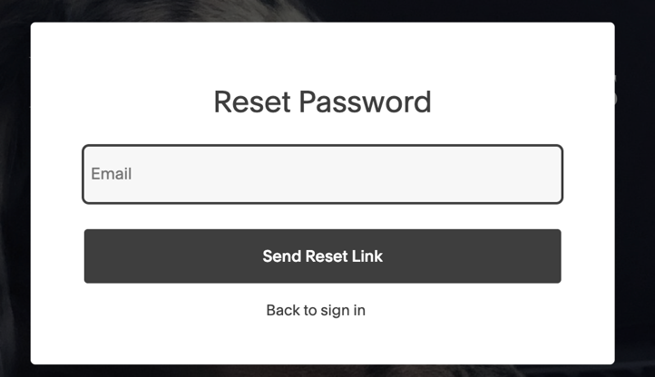

Search products/Service:-

Book Appointment:-

Check Appointment and Manage Profile:-  
  
Checkout:-  
  
# Process and Data Modeling

## **3.1 UML/DFD Modeling and Data Modeling**

Activity Diagrams: -

Signing In (User already has an account with Pets Crew): -

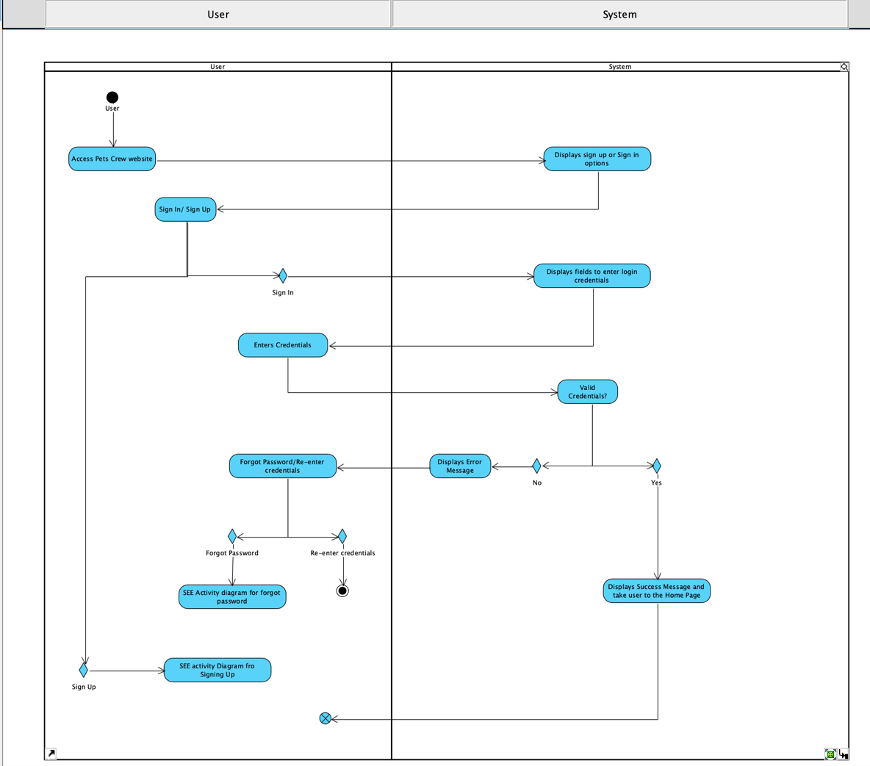

Sign Up (User does not have an account with Pets crew): -

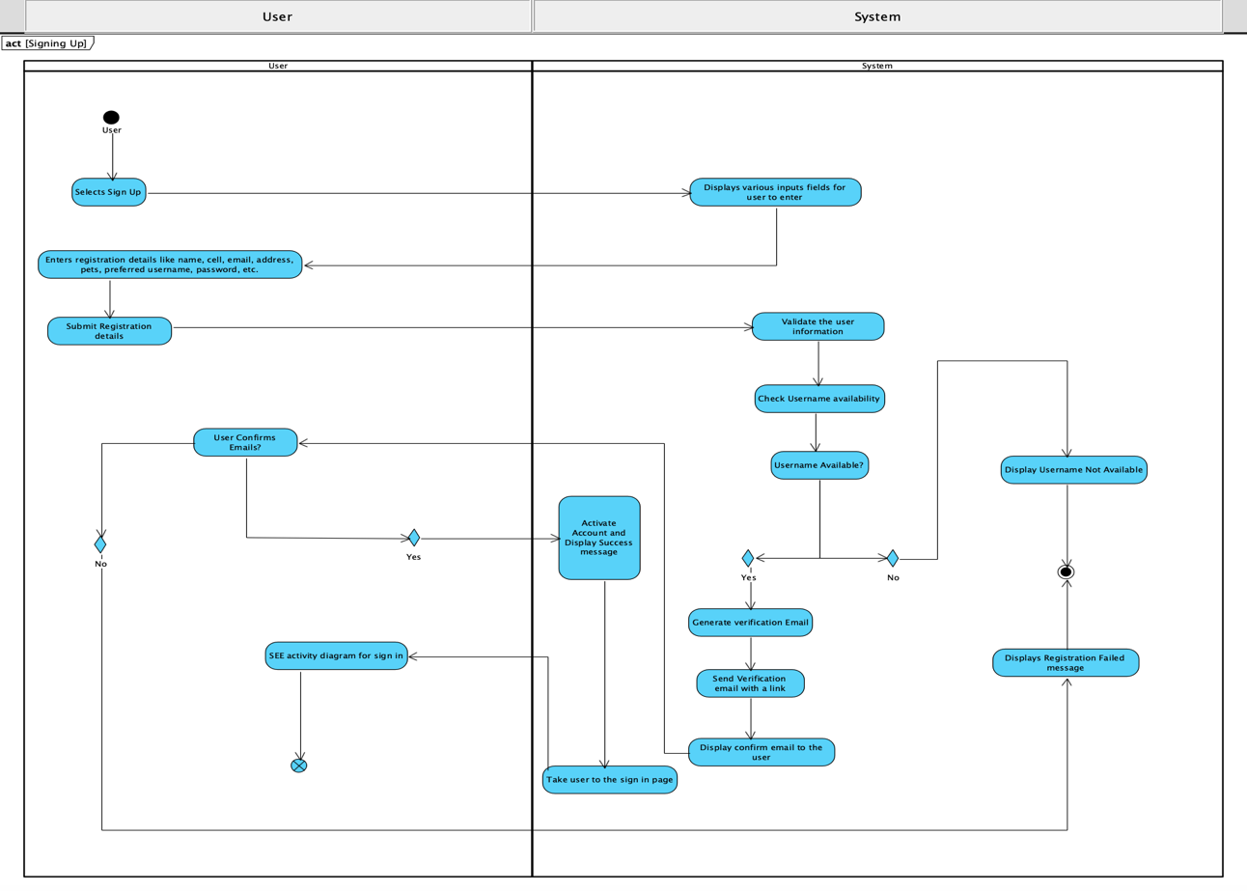

Forget Password (If while logging back into account, user forgets password): -

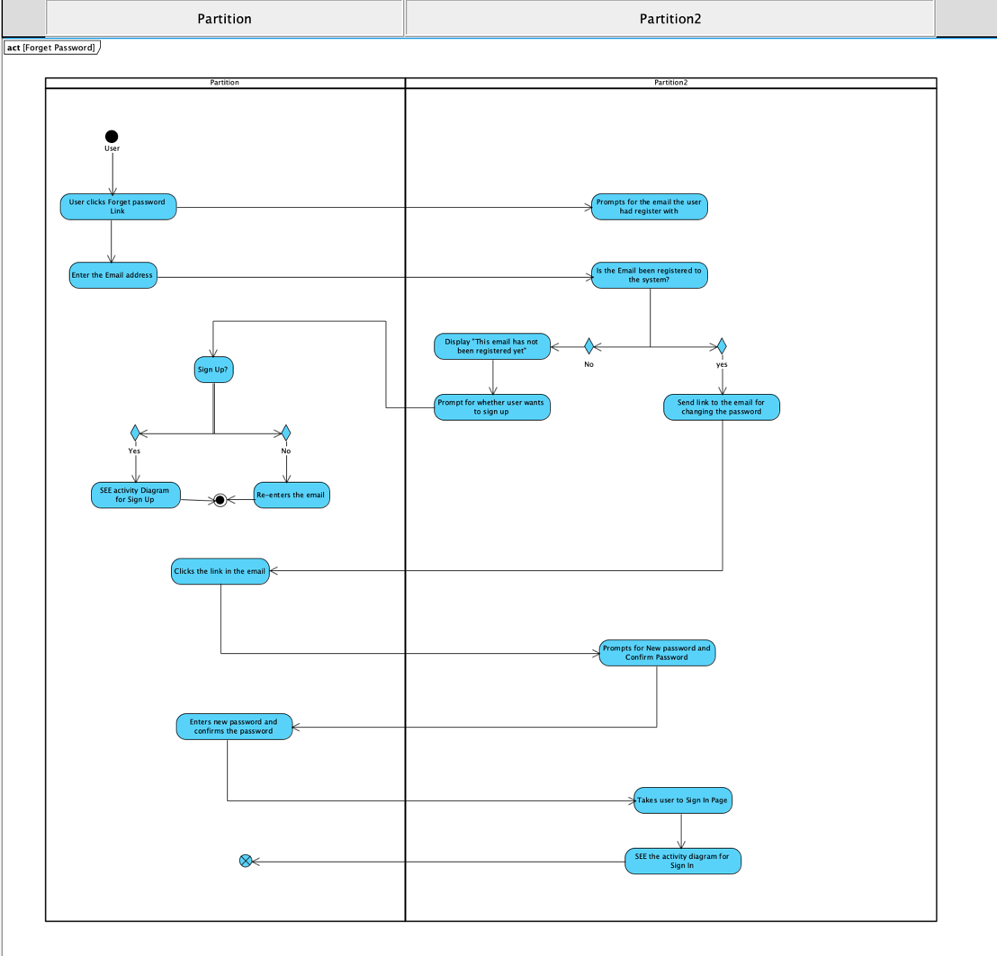

Search Service/Product: (User is logged in, and now user wants to search for a service/Product of their need)

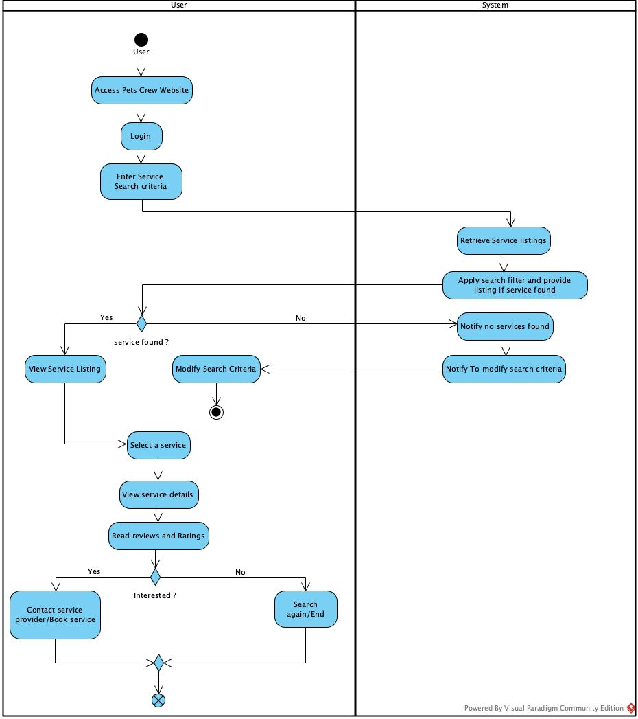

Booking Appointment: (User is logged in and has confirmed which service to choose, Now user wants to book the service)

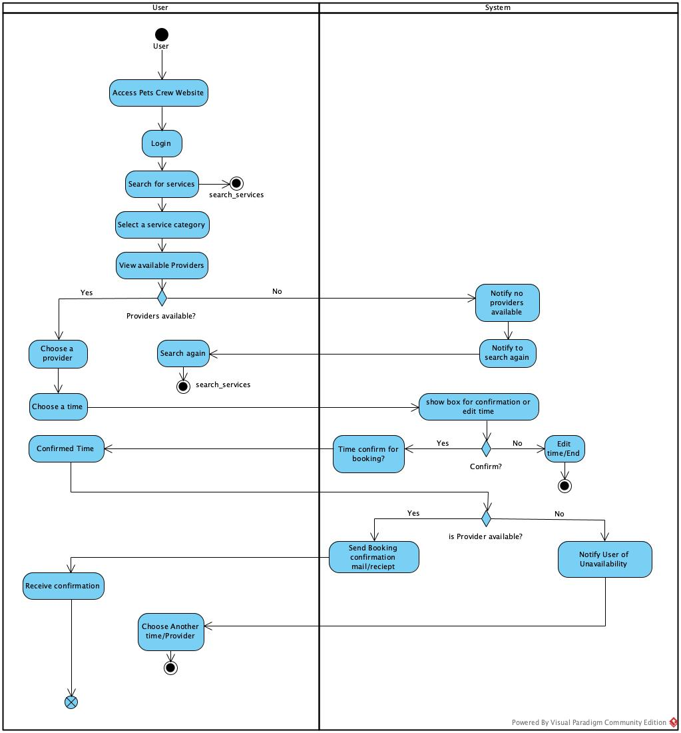

Manage Service: (User is logged in. User wants to Manage(Edit, Update, Delete) their services)

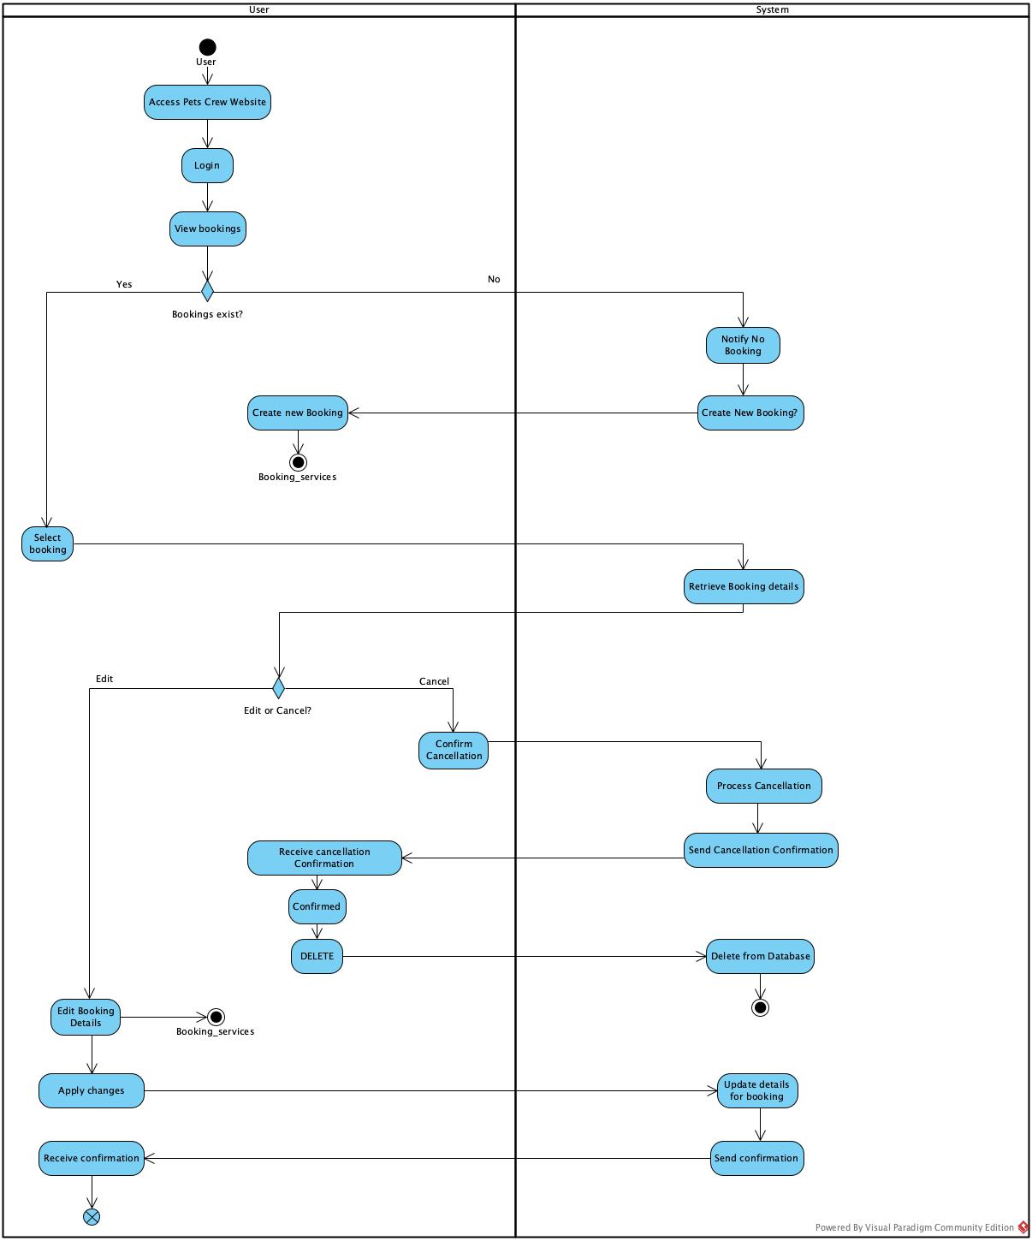

DATA FLOW DIAGRAM:-

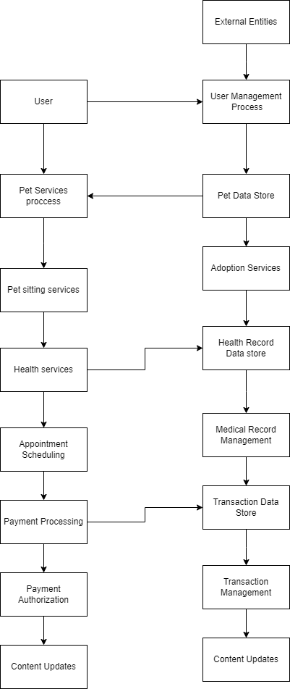

## **3.2 Business Rules**

|  |  |  |
| --- | --- | --- |
| Business Rule Number | Business Rule Description | Related UC |
| BR01 | User must provide a username, email and password to register for the app. | UC01 |
| BR02 | Post length can be no longer than 300 characters | UC02 |
| BR03 | Users can update their profiles with details such as contact information, pet specifics, and service offerings. |  |
| BR04 | Service providers can list their services with detailed descriptions, pricing, and availability. |  |
| BR05 | Pet owners can schedule appointments through an integrated booking system |  |
| BR06 | Service providers can manage their availability through an integrated calendar system. |  |
| BR07 | Users can leave reviews and ratings for service providers after utilizing their services. |  |
| BR08 | Service providers can respond to user reviews to maintain transparency and trust. |  |
| BR09 | Users can search for services using relevant keywords and apply filters such as location, service type, ratings, and availability. |  |
| BR10 | The platform must support multiple payment methods, including credit/debit cards and digital wallets. |  |
| BR11 | Users receive immediate payment confirmations and detailed receipts via email after a transaction. |  |
| BR12 | The platform must include a secure messaging system for communication between pet owners and service providers. |  |
| BR13 | Users receive timely notifications for various events related to their bookings. |  |
| BR14 | Administrators have full control over user accounts and service listings and can manage site content through an admin control panel. |  |
| BR15 | All administrative actions must be logged for security audits. |  |
| BR16 | Sensitive information such as passwords and payment details must be securely encrypted. |  |
| BR17 | The system should support secure login processes, including multi-factor authentication for admins and service providers. |  |

## **3.3 Use Case Specifications with corresponding interface mockups:**

**Each use case needs to have the following:**

1- **Business Rules.**

**2- System Use Case Diagrams.**

**3- Use Case Descriptions.**

|  |  |  |  |
| --- | --- | --- | --- |
| Use Case Name | Sign Up | | |
| Triggering Event | A new customer’s account details are being submitted | | |
| Brief Description | Allows customers to create account with Pets Crew website | | |
| Actors | Customer | | |
| Related Use Cases |  | | |
| Preconditions | Customer does not have an account and wants to get registered with Pets Crew website. | | |
| Post Conditions | A new account for the customer gets registered | | |
| Flow of activities | Actor | | System |
| DIALOGUE |  | Selects “Sign Up” | Prompts to input customer details like name, preferred username and password, email, date of birth, phone number, address, etc. |
| Always HD |  | Customer enters name, preferred username and password, email, date of birth, phone number, address, etc. | Requests to review and confirm the information, checks validity of the username, and sends a confirmation mail to the customer. |
|  |  | Confirms the mail via link sent in mail. | Based on the confirmation, a new account is created with Pets Crew website and “Success” message is displayed. Prompt the Sign in page. |
| Exception Conditions | Customer chooses to cancel. | | |

|  |  |  |  |
| --- | --- | --- | --- |
| Use Case Name | Sign In | | |
| Triggering Event | Existing Customer is logging into the website | | |
| Brief Description | Allows customers to sign in by entering username and password | | |
| Actors | Customer | | |
| Related Use Cases |  | | |
| Preconditions | Customer already has an account with Pets Crew website | | |
| Post Conditions | Customer has logged into the site and is at home page | | |
| Flow of activities | Actor | | System |
| DIALOGUE |  | Selects “Sign In” | Prompts to input customer credentials i.e., Username and Password |
| Always HD |  | Customer enters username and password. | Requests to review and confirm the information with the database and displays a success message. |
| Exception Conditions | Customer chooses to cancel. | | |

|  |  |  |  |
| --- | --- | --- | --- |
| Use Case Name | Forget Password | | |
| Triggering Event | Customer creates a new password for his/her account | | |
| Brief Description | Allows customers to change password if they forget their old one | | |
| Actors | Customer | | |
| Related Use Cases |  | | |
| Preconditions | Customer is not able to sign in due to invalid credentials | | |
| Post Conditions | A new password is created for the customer’s account | | |
| Flow of activities | Actor | | System |
| DIALOGUE |  | Selects “Forget Password” | Prompts to input the email the customer is registered with. |
| Always HD |  | Customer enters the mail with which he has account with. | Requests to review and confirm the email, if its already in the database send a link via mail to the customer. |
|  |  | Enters new password and confirm password after clicking the link in the mail. | Based on the confirmation, a new password is created and “Success” message is displayed. Prompt the Sign in page. |
| Exception Conditions | Customer chooses to cancel. | | |

|  |  |  |  |
| --- | --- | --- | --- |
| Use Case Name | Booking Services | | |
| Triggering Event | A user wants to book a service for their pet/pets | | |
| Brief Description | Allows users to select service provider and book a specific service time through the website | | |
| Actors | User | | |
| Related Use Cases |  | | |
| Preconditions | User has logged in the system and selected a service provider. | | |
| Post Conditions | User has booked for selected service | | |
| Flow of activities | Actor | | System |
| DIALOGUE |  | Selected a provider | Prompts to input time for service |
| Always HD |  | Confirms the selected time for booking | Checks the availability of the provider |
|  |  | If provider available for service, confirms the time | Confirms the time and check for providers time availability |
|  |  | If provider available for that time, confirm booking | Send Booking confirmation through mail/receipt. |
| Exception Conditions | Actor chooses to cancel.  Notifies user of unavailability if the provider is not available | | |

|  |  |  |  |
| --- | --- | --- | --- |
| Use Case Name | Manage Services | | |
| Triggering Event | A user wants to Manage (edit/delete) a service for their pet/pets | | |
| Brief Description | Allows users to edit or delete their booked services | | |
| Actors | User | | |
| Related Use Cases |  | | |
| Preconditions | User has logged in the system. | | |
| Post Conditions | User has successfully edited or deleted their service | | |
| Flow of activities | Actor | | System |
| DIALOGUE |  | Selects “View Bookings” | Retrieves booking Details and display them |
| Always HD |  | Selects a booking | Retrieve Booking and notify to Edit or Cancel the booking |
|  |  | If Edit: Edit booking details | Redirect to Booking page and process send confirmation |
|  |  | If cancel: Confirm cancellation | Delete booking details and information from database |
|  |  | Apply changes | Update details for “View Bookings” and send confirmation |
| Exception Conditions | Actor chooses to cancel.  Notifies user of unavailability if the provider is not available | | |

|  |  |  |  |
| --- | --- | --- | --- |
| Use Case Name | Search Services | | |
| Triggering Event | A user wants to Search a service for their pet/pets | | |
| Brief Description | Allows users to search service provider and read reviews for each services | | |
| Actors | User | | |
| Related Use Cases |  | | |
| Preconditions | User has logged in the system. | | |
| Post Conditions | User confirms to book for selected service | | |
| Flow of activities | Actor | | System |
| DIALOGUE |  | Selects “Search Services” | Prompts to input Search criteria |
| Always HD |  | Enter service name or specific provider for a particular service | Retrieve service listings and applies search filters to display services if found. |
|  |  | Selects a service based on their needs | Shows all possible service listings along with providers' ratings and reviews. |
|  |  | Read reviews and Contact service Provider/Book service | Redirects the user to the booking service page. |
| Exception Conditions | Actor chooses to cancel.  Notifies user of unavailability if the provider is not available | | |

Sequence Diagram:

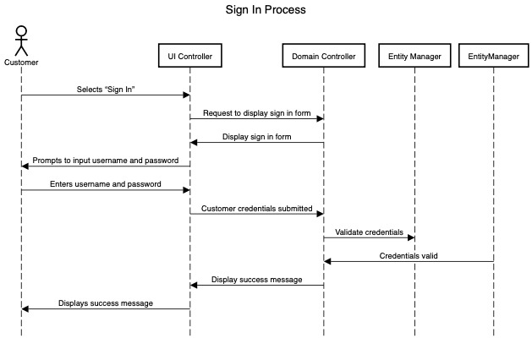

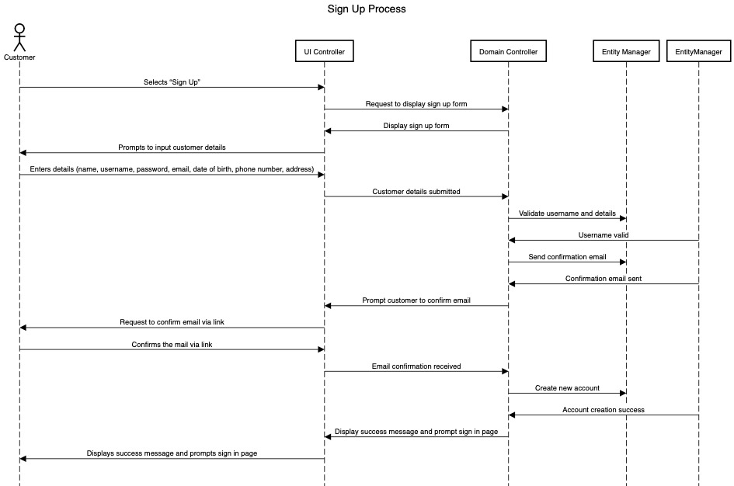

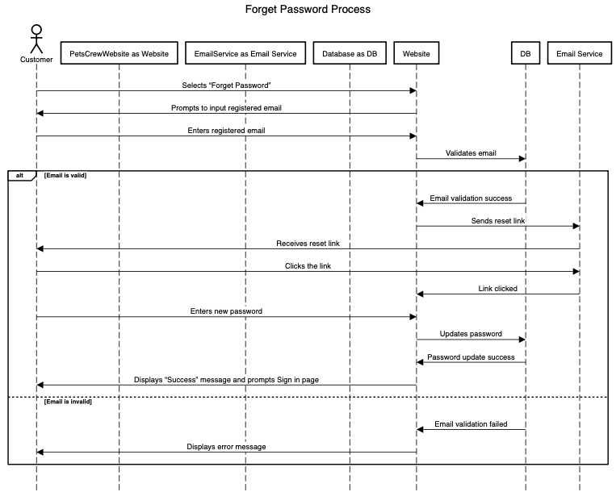

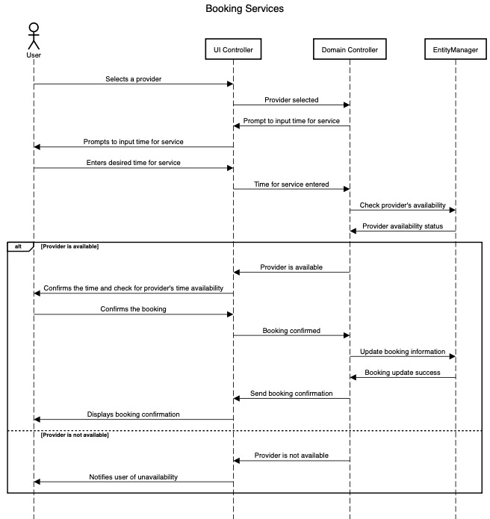

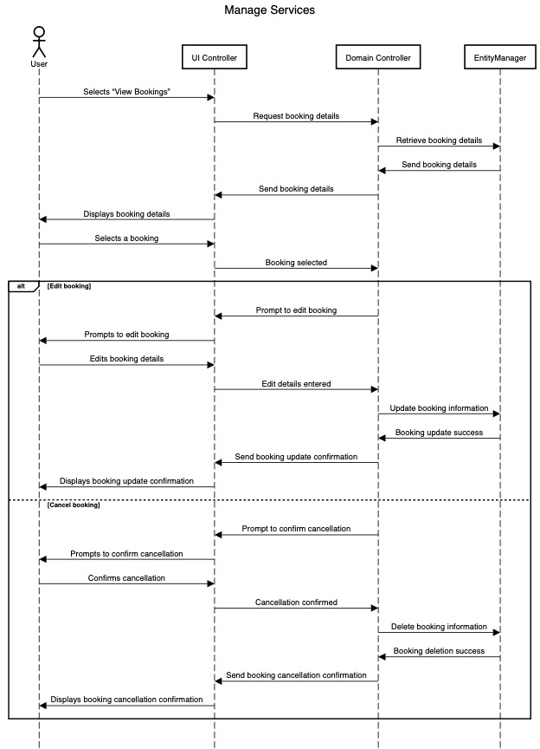

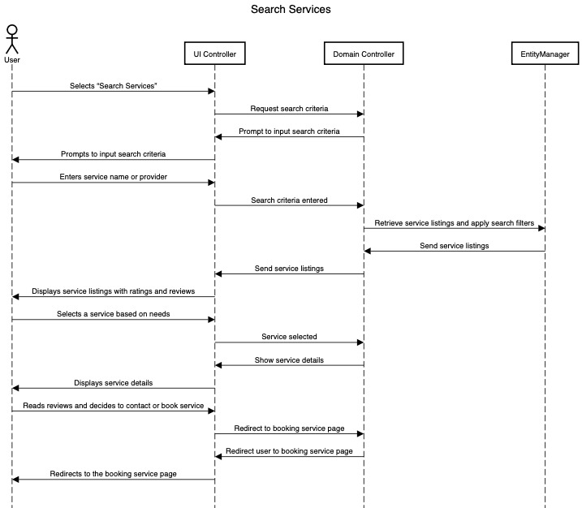

**Use Case Diagram**



**4- Corresponding Mockups**

# Domain Class Diagram

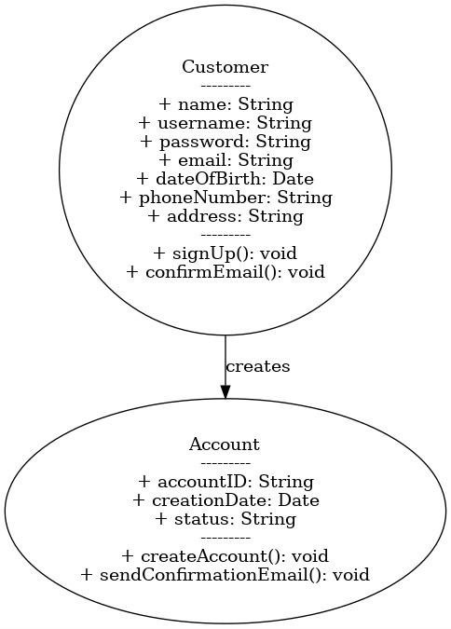

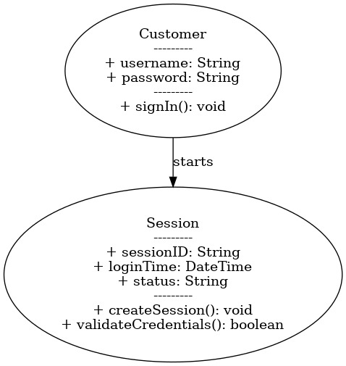

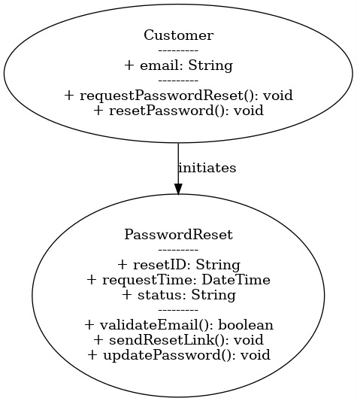

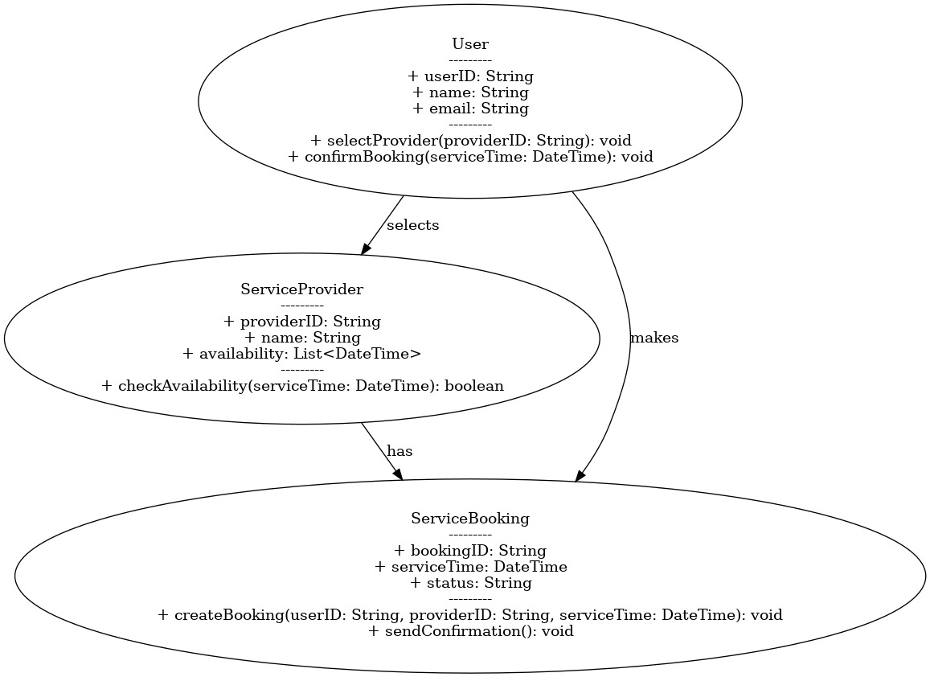

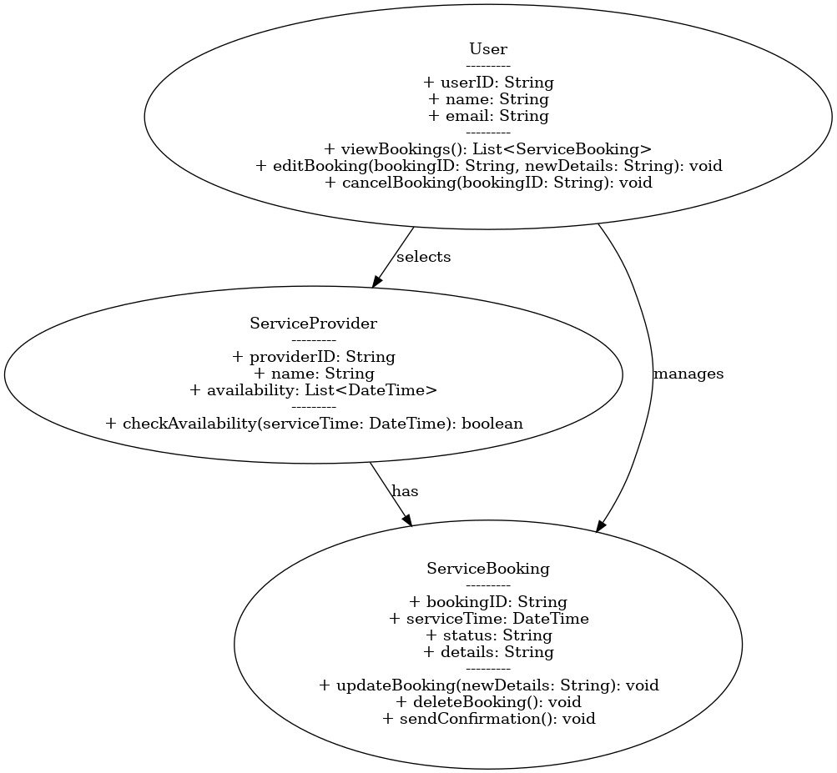

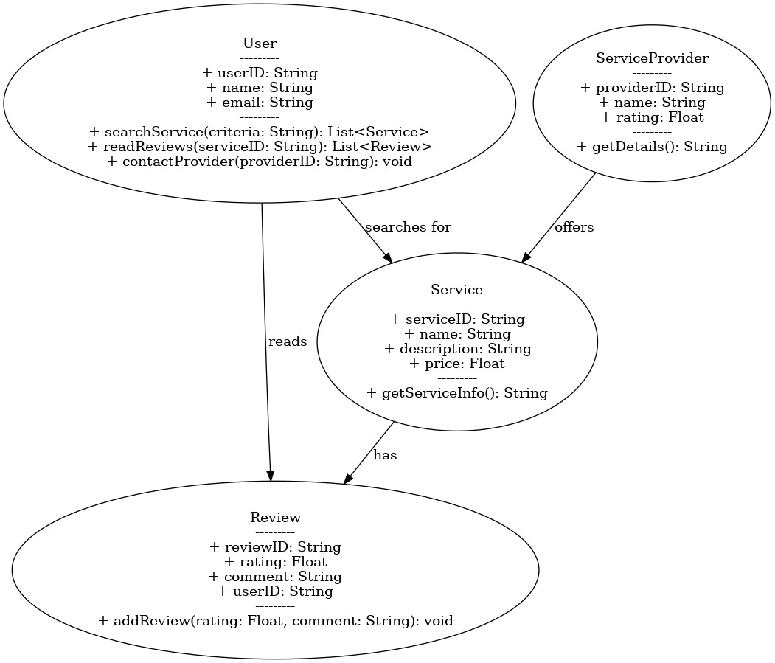

# Database

5.1.1 ERD  
 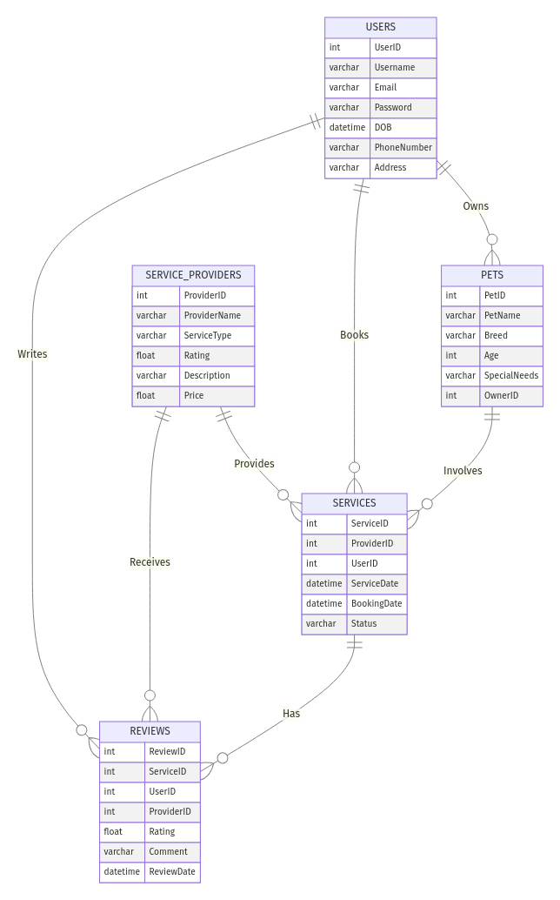

**5.1.2 Data Dictionary**

**/* Database Systems, Coronel/Morris */**

**/* Type of SQL : MySQL */**

**CREATE TABLE Users (**

**UserID INT AUTO_INCREMENT PRIMARY KEY,**

**Username VARCHAR(50) NOT NULL UNIQUE,**

**Email VARCHAR(100) NOT NULL UNIQUE,**

**Password VARCHAR(255) NOT NULL,**

**UserType VARCHAR(20) NOT NULL CHECK (UserType IN ('Pet Owner', 'Service Provider')),**

**ContactInfo VARCHAR(255)**

**);**

**INSERT INTO Users (Username, Email, Password, UserType, ContactInfo) VALUES**

**('john_doe', 'john@example.com', 'hashed_password', 'Pet Owner', '123-456-7890'),**

**('jane_smith', 'jane@example.com', 'hashed_password2', 'Service Provider', '987-654-3210');**

**CREATE TABLE Pets (**

**PetID INT AUTO_INCREMENT PRIMARY KEY,**

**UserID INT NOT NULL,**

**PetName VARCHAR(50) NOT NULL,**

**PetType VARCHAR(20) NOT NULL,**

**Breed VARCHAR(50),**

**Age INT,**

**SpecialNeeds VARCHAR(255),**

**FOREIGN KEY (UserID) REFERENCES Users(UserID) ON DELETE CASCADE**

**);**

**INSERT INTO Pets (UserID, PetName, PetType, Breed, Age, SpecialNeeds) VALUES**

**(1, 'Buddy', 'Dog', 'Golden Retriever', 3, 'Allergic to peanuts'),**

**(1, 'Mittens', 'Cat', 'Siamese', 2, NULL);**

**CREATE TABLE ServiceProviders (**

**ProviderID INT AUTO_INCREMENT PRIMARY KEY,**

**UserID INT NOT NULL,**

**ServiceType VARCHAR(50) NOT NULL,**

**Description TEXT,**

**Pricing VARCHAR(100),**

**Availability VARCHAR(255),**

**FOREIGN KEY (UserID) REFERENCES Users(UserID) ON DELETE CASCADE**

**);**

**INSERT INTO ServiceProviders (UserID, ServiceType, Description, Pricing, Availability) VALUES**

**(2, 'Vet', 'Experienced vet offering comprehensive pet care services.', '$50 per hour', 'Monday to Friday, 9 AM to 5 PM'),**

**(2, 'Trainer', 'Professional pet trainer with 10 years of experience.', '$30 per hour', 'Weekends, 10 AM to 4 PM');**

**CREATE TABLE Services (**

**ServiceID INT AUTO_INCREMENT PRIMARY KEY,**

**ProviderID INT NOT NULL,**

**ServiceName VARCHAR(100) NOT NULL,**

**Description TEXT,**

**Price DECIMAL(10, 2) NOT NULL,**

**Duration INT NOT NULL,**

**FOREIGN KEY (ProviderID) REFERENCES ServiceProviders(ProviderID) ON DELETE CASCADE**

**);**

**INSERT INTO Services (ProviderID, ServiceName, Description, Price, Duration) VALUES**

**(1, 'Basic Health Checkup', 'Comprehensive health checkup for your pet.', 50.00, 60),**

**(2, 'Obedience Training', 'Basic obedience training for dogs.', 30.00, 60);**

**CREATE TABLE Appointments (**

**AppointmentID INT AUTO_INCREMENT PRIMARY KEY,**

**UserID INT NOT NULL,**

**ServiceID INT NOT NULL,**

**AppointmentDate DATETIME NOT NULL,**

**Status VARCHAR(20) NOT NULL CHECK (Status IN ('Scheduled', 'Completed', 'Cancelled')),**

**FOREIGN KEY (UserID) REFERENCES Users(UserID) ON DELETE CASCADE,**

**FOREIGN KEY (ServiceID) REFERENCES Services(ServiceID) ON DELETE CASCADE**

**);**

**INSERT INTO Appointments (UserID, ServiceID, AppointmentDate, Status) VALUES**

**(1, 1, '2024-07-21 10:00:00', 'Scheduled'),**

**(1, 2, '2024-07-22 11:00:00', 'Scheduled');**

**CREATE TABLE Reviews (**

**ReviewID INT AUTO_INCREMENT PRIMARY KEY,**

**AppointmentID INT NOT NULL,**

**Rating INT NOT NULL CHECK (Rating BETWEEN 1 AND 5),**

**Comment TEXT,**

**ReviewDate DATETIME NOT NULL,**

**FOREIGN KEY (AppointmentID) REFERENCES Appointments(AppointmentID) ON DELETE CASCADE**

**);**

**INSERT INTO Reviews (AppointmentID, Rating, Comment, ReviewDate) VALUES**

**(1, 5, 'Excellent service and very friendly staff.', '2024-07-22 14:00:00'),**

**(2, 4, 'Good training session.', '2024-07-23 15:00:00');**

**CREATE TABLE Payments (**

**PaymentID INT AUTO_INCREMENT PRIMARY KEY,**

**AppointmentID INT NOT NULL,**

**PaymentDate DATETIME NOT NULL,**

**Amount DECIMAL(10, 2) NOT NULL,**

**PaymentMethod VARCHAR(50) NOT NULL CHECK (PaymentMethod IN ('Credit Card', 'PayPal', 'Debit Card')),**

**FOREIGN KEY (AppointmentID) REFERENCES Appointments(AppointmentID) ON DELETE CASCADE**

**);**

**INSERT INTO Payments (AppointmentID, PaymentDate, Amount, PaymentMethod) VALUES**

**(1, '2024-07-21 10:30:00', 50.00, 'Credit Card'),**

**(2, '2024-07-22 11:30:00', 30.00, 'PayPal');**

**Tables:**  
**Users**

|  |  |  |  |
| --- | --- | --- | --- |
| Attribute | Description | Type | Example |
| UserID | Unique identifier for each user. | Integer | 1 |
| Username | The username chosen by the user. | Varchar(50) | "john_doe" |
| Email | The user's email address. | Varchar(100) | "[john@example.com](mailto:john@example.com)" |
| Password | The user's password (hashed). | Varchar(255) | "hashed_password" |
| UserType | The type of user (Pet Owner or Service Provider). | Varchar(20) | "Pet Owner" |
| ContactInfo | Contact information for the user. | Varchar(255) | "123-456-7890" |

**Pets**

|  |  |  |  |
| --- | --- | --- | --- |
| Attribute | Description | Type | Example |
| PetID | Unique identifier for each pet. | Integer | 1 |
| UserID | Identifier of the user who owns the pet. | Integer | 1 |
| PetName | The name of the pet. | Varchar(50) | "Buddy" |
| PetType | The type of pet (e.g., Dog, Cat). | Varchar(20) | "Dog" |
| Breed | The breed of the pet. | Varchar(50) | "Golden Retriever" |
| Age | The age of the pet. | Integer | 3 |
| SpecialNeeds | Any special needs the pet may have. | Varchar(255) | "Allergic to peanuts" |

**ServiceProviders**

|  |  |  |  |
| --- | --- | --- | --- |
| Attribute | Description | Type | Example |
| ProviderID | Unique identifier for each service provider. | Integer | 1 |
| UserID | Identifier of the user who is the service provider. | Integer | 2 |
| ServiceType | The type of service provided (e.g., Vet, Trainer). | Varchar(50) | "Vet" |
| Description | A description of the services offered. | Text | "Experienced vet offering comprehensive pet care services." |
| Pricing | The pricing details for the services. | Varchar(100) | "$50 per hour" |
| Availability | The availability of the service provider. | Varchar(255) | "Monday to Friday, 9 AM to 5 PM" |

**Services**

|  |  |  |  |
| --- | --- | --- | --- |
| Attribute | Description | Type | Example |
| ServiceID | Unique identifier for each service. | Integer | 1 |
| ProviderID | Identifier of the service provider offering the service. | Integer | 1 |
| ServiceName | The name of the service. | Varchar(100) | "Basic Health Checkup" |
| Description | A description of the service. | Text | "Comprehensive health checkup for your pet." |
| Price | The price of the service. | Decimal(10, 2) | 50.00 |
| Duration | The duration of the service (in minutes). | Integer | 60 |

**Appointments**

|  |  |  |  |
| --- | --- | --- | --- |
| Attribute | Description | Type | Example |
| AppointmentID | Unique identifier for each appointment. | Integer | 1 |
| UserID | Identifier of the user who booked the appointment. | Integer | 1 |
| ServiceID | Identifier of the service booked. | Integer | 1 |
| AppointmentDate | The date and time of the appointment. | DateTime | "2024-07-21 10:00:00" |
| Status | The status of the appointment (e.g., Scheduled, Completed, Cancelled). | Varchar(20) | "Scheduled" |

**Reviews**

|  |  |  |  |
| --- | --- | --- | --- |
| Attribute | Description | Type | Example |
| ReviewID | Unique identifier for each review. | Integer | 1 |
| AppointmentID | Identifier of the appointment being reviewed. | Integer | 1 |
| Rating | The rating given by the user (1 to 5). | Integer | 5 |
| Comment | The review comment. | Text | "Excellent service and very friendly staff." |
| ReviewDate | The date the review was submitted. | DateTime | "2024-07-22 14:00:00" |

**Payments**

|  |  |  |  |
| --- | --- | --- | --- |
| Attribute | Description | Type | Example |
| PaymentID | Unique identifier for each payment. | Integer | 1 |
| AppointmentID | Identifier of the appointment for which the payment was made. | Integer | 1 |
| PaymentDate | The date the payment was made. | DateTime | "2024-07-21 10:30:00" |
| Amount | The amount paid. | Decimal(10, 2) | 50.00 |
| PaymentMethod | The method of payment (e.g., Credit Card, PayPal). | Varchar(50) | "Credit Card" |

# Work Breakdown Structure (WBS)

## 

## Work Breakdown Structure

Sample WBS:

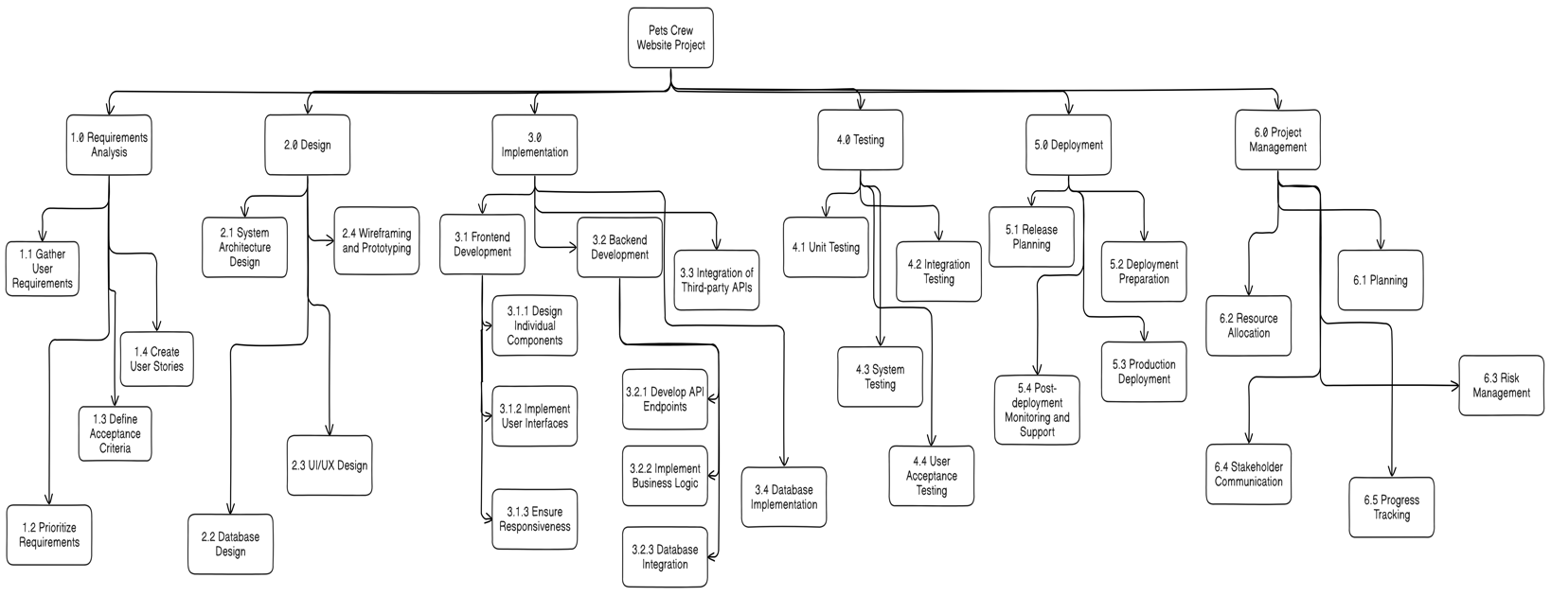

# Milestones and Acceptance Criteria

# Milestones and Acceptance Criteria

**Milestone 1:** Completion of Project Planning Phase

- **\*\*Definition**:** This milestone marks the completion of the project planning phase, where all project requirements, timelines, and resources are defined.

- **Acceptance Criteria**:

- Project plan document is completed and reviewed by all team members.

- All stakeholders have approved the project plan.

- Risk management plan is in place.

- Project schedule is created and agreed upon by the team.

**Milestone 2:** Completion of Requirements Gathering

- **\*\*Definition**:** This milestone signifies the end of the requirements gathering phase, where all functional and non-functional requirements are documented.

- **Acceptance Criteria**:

- All user stories and requirements are documented and validated.

- Requirements document is reviewed and approved by stakeholders.

- Any ambiguities or gaps in requirements are resolved.

- Requirements are prioritized for development.

**Milestone 3:** Design Approval

- **\*\*Definition**:** This milestone marks the approval of the design phase, including UI/UX designs, database schema, and system architecture.

- **Acceptance Criteria**:

- UI/UX mockups are completed and reviewed by stakeholders.

- Database schema and ERD are designed and approved.

- System architecture document is completed and reviewed.

- Design documents are signed off by all relevant parties.

**Milestone 4:** Prototype Development

- **\*\*Definition**:** This milestone represents the development of a working prototype of the Pets Crew website.

- **Acceptance Criteria**:

- Prototype includes basic functionality such as user registration, service listings, and booking system.

- Prototype is tested for major bugs and usability issues.

- Feedback from initial testing is collected and documented.

- Prototype is demonstrated to stakeholders and approved.

**Milestone 5:** Testing Phase Completion

- **\*\*Definition**:** This milestone signifies the completion of the testing phase, where the system is thoroughly tested for bugs, performance issues, and compliance with requirements.

- **Acceptance Criteria**:

- All functional and non-functional requirements are tested.

- Bugs and issues identified during testing are resolved.

- Performance testing is completed and meets specified criteria.

- User acceptance testing (UAT) is conducted, and feedback is positive.

**Milestone 6:** Client Acceptance of Deliverables

- **\*\*Definition**:** This milestone marks the acceptance of the final product by the client.

- **Acceptance Criteria**:

- Final product is delivered and meets all specified requirements.

- Client reviews and tests the final product.

- Any final adjustments or fixes are made based on client feedback.

- Client signs off on the acceptance document.

**Milestone 7:** Deployment of Final Product

- **\*\*Definition**:** This milestone represents the deployment of the Pets Crew website to the production environment.

- **Acceptance Criteria**:

- Deployment plan is created and reviewed.

- Final product is deployed to the production environment without major issues.

- Post-deployment testing is completed successfully.

- All stakeholders are notified of the deployment.

**Milestone 8:** Project Closure and Handover

- **\*\*Definition**:** This milestone marks the formal closure of the project and handover of all project documentation and assets to the client.

- **Acceptance Criteria**:

- Project closure report is completed and reviewed.

- All project documentation is handed over to the client.

- Final project review meeting is conducted with the client.

- Lessons learned and project retrospectives are documented.

- Project team is formally released from project duties.

# Implementation Schedule

Implementation Schedule using MS Project (Waterfall)

OR

Product Backlog (Agile-Scrum)

# Client / Faculty Sign-off

**Date: ______________________**

X .

Name of Client/Rep/Professor