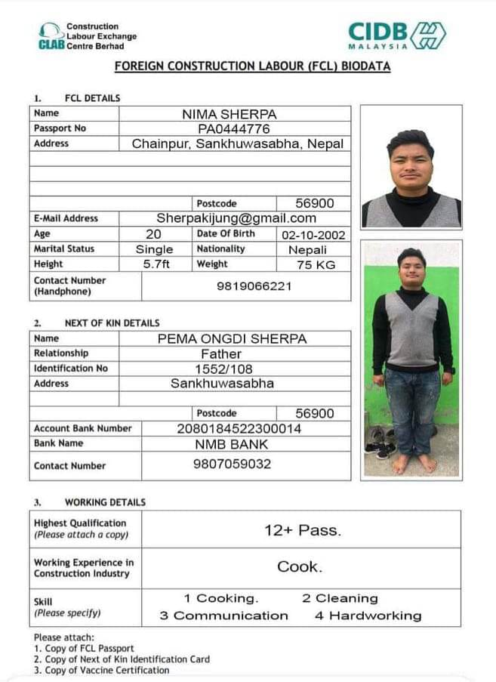Construction

Labour Exchange

Center Berhad

**FOREIGN CONSTRUCTION LABOUR (FCL) BIODATA**

**1. FCL DETAILS**

|  |  |  |  |
| --- | --- | --- | --- |
| **Name** | img2.jpgMAN BAHADUR RAI | | |
| **Passport No** | PA1202790 | | |
| **Address** | Dandabokhim,Bhojpur,Nepal | | |
|  | | | |
|  | | | |
|  | | | |
|  | | **Postcode** | 57000 |
| **E-Mail Address** | bahadurraiman3@gmail.com | | |
| **Age** | 32 | **Date of Birth** | 16-12-1991 |
| **Marital Status** | Married | **Nationality** | img1.jpgNepali |
| **Height** | 5.6ft | **Weight** | 60 KG |
| **Contact Number**  **(Handphone)** | 9862201497 | | |

**2. NEXT OF KIN DETAILS**

|  |  |  |  |  |
| --- | --- | --- | --- | --- |
| **Name** | AMBAR BAHADUR RAI | | | |
| **Relationship** | Father | | | |
| **Identification No** | 8871/1348/6420 | | | |
| **Address** | Bhojpur | | | |
|  |  | | | |
|  | | | Postcode | 57000 |
| **Account Bank Number** | | 2040100000714203 | | |
| **Bank Name** | | RASTRIYA BANIJYA BANK | | |
| **Contact Number** | | 9829391439 | | |

**3.WORKING DETAILS**

|  |  |
| --- | --- |
| **Highest Qualification**  *(please attach a copy)* | SLC PASS. |
| **Working Experience in**  **Construction Industry** | Salesman. |
| **Skill**  *(please specify)* | 1.Sales 2.Cleaning  3.Communication 4.Hardworking |

Please attach:

1.Copy of FCL Passport

2.Copy of Next of Kin identification Card

3.Copy of Vaccine Certification