^{WHAT IS CSS}
- ^{CSS GIVES STYLE TO RAW HTML}
- CSS STANDS FOR CASCADING STYLE SHEETS
- CSS IS USED TO GIVE STYLE TO OUR WEB PAGES
- CSS IS USED TO MAKE WEBSITES RESPONSIVE I.E ARRAGE ITSELF ACC TO MOBILE OR C
- HTML IS USED TO STRUCTURE A WEBSITE
- ^{CSS TAKES RESPONSIBILITY}

^{ROLE OF CSS}
IT MAKES OUR WEBSITES BEAUTIFUL AND MODERN LOOKING

^{CSS SYNTAX}
SECTOR PROPERTY VALUE
P { COLOR: BLUE;}

^{Header, p.intro} {
^{Background-color : red ;}
^{Border-radius : 3px ;}
}
^{Group of selectors} ^{declaration box}

THREE WAYS TO ADD CSS TO MARKUP

- Inline css: css is added to elements directly using style attribute
- Internal css: css is kept inside head tags in <style>tags
- External css: css is kept seperately inside a .css style sheet
    - ^{S1 write css in .css file}
    - S2 include that css file to markup

^{CSS SELECTORS}
- Css selectors are used to find the element whose property will be set
- Selectors are used to target the html elements
- Selectors make it easy for us to easily target single/multiple html elements in the target

^{Types of basic css selectors}
- ^{Css element selector}
- ^{Css id selector}
- ^{Css class selector}
- ^{Css grouping selector}

^{WHAT IS FLEXBOX?}
- Flexbox is a one dimensional layout method for laying out items in rows or columns
- Css flexbox is a better way to align items into a container
- ^{Flexbox= flexible + box}
- ^{Display: flex ;}
- 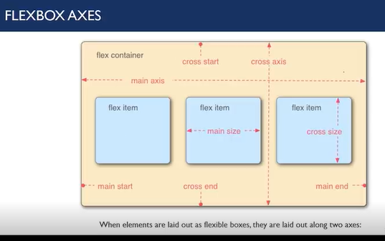

^{What is a responsive design?}
- Endless new resolution and devices are difficult to support separately for a web developer
- Responsive design is a way for a web developer to make his website adapt to all the devices and resolutions
- Responsive design is a necessity and not a luxury anymore!

Various ways to achieve responsive design
- ^{Setting up the viewport}
- ^{Use max-width/max-height}
- ^{Using css media queries}
- Using rem/vh/vw units over pixels

