Wealth Management Lakehouse
Project Report
Aryan Bansal | Databricks, PySpark, Delta Lake, Spark SQL

Overview
This project builds an end-to-end data pipeline on Databricks for a retail banking customer dataset, following the Medallion architecture pattern: Bronze, Silver, and Gold layers. The goal is to take raw, messy customer and portfolio data and turn it into clean, business-ready reporting tables, then use those tables to investigate what actually drives customer churn.
The dataset covers 10,000 retail banking customers after cleaning, with 42 fields spanning demographics, credit profile, investment holdings across 8 product categories, account activity, and churn status.

Architecture
The pipeline is structured in three layers, each with a distinct purpose:
Layer | Purpose | What Happens
Bronze | Raw ingestion | Reads the raw customer CSV as is, with schema inference. No cleaning or transformation.
Silver | Cleaning & feature engineering | Fixes column names, drops unusable columns, filters invalid records, and engineers’ new fields: Wealth Tier, Age Group, Credit Band, total investment count, and salary-to-debt ratio.
Gold | Business aggregation | Groups the cleaned data into reporting-ready summary tables by Wealth Tier, Age Group, and Country, each with averages and churn totals.

Methodology

Bronze Layer
Raw data (10,001 records, 39 columns) is read directly from a CSV source with header and schema inference enabled, with no modification.

Silver Layer
The raw data is cleaned and enriched. Records with invalid age, salary, or credit score are filtered out, leaving 10,000 clean records across 42 columns. Five business-friendly features are engineered on top of the raw fields:
- Wealth Tier: customers grouped into Affluent or Mass Market bands based on net assets
- Age Group: Under 30, 30s, 40s, 50s, or 60+
- Credit Band: Excellent, good, Fair, or Poor, based on credit score
- Investment Count: total number of investment products held across 8 categories
- Salary-to-Debt Ratio: estimated salary divided by outstanding debt

Gold Layer
Three summary tables are built from the Silver layer for reporting consumption, aggregating by Wealth Tier, by Age Group, and by Country and Wealth Tier together. Each table reports customer counts, average net assets, average portfolio return, and total churned customers.

Key Findings

Wealth Tier Summary
Wealth Tier | Customers | Avg. Net Assets | Avg. Return | Churn Rate
Affluent | 6,251 | $74,890 | 13.0% | 49.7%
Mass Market | 3,749 | $34,792 | 12.9% | 49.8%

Age Group Summary
Age Group | Customers | Avg. Net Assets | Avg. Return | Churn Rate
Under 30 | 1,641 | $60,572 | 13.0% | 48.3%
30s | 4,346 | $60,009 | 13.0% | 49.2%
40s | 2,618 | $59,804 | 12.9% | 50.7%
50s | 869 | $58,941 | 13.0% | 52.7%
60+ | 526 | $58,147 | 13.1% | 49.0%

Churn Analysis
The project's central business question was what drives customer churn. Every variable tested, Wealth Tier, Credit Band, Salary Band, Age Group, and number of products held, was checked against churn rate.
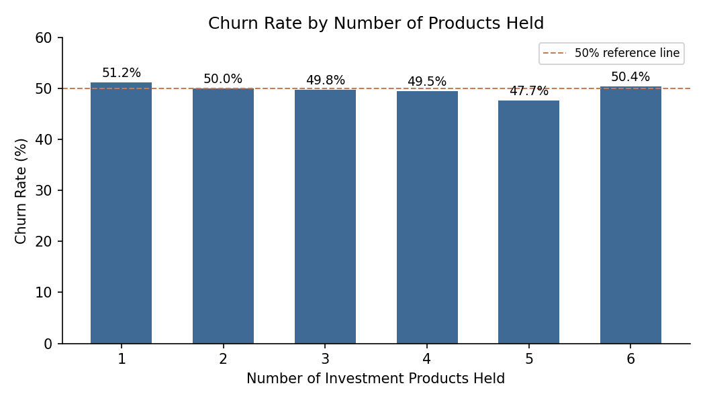
Churn rate by number of products held ranges narrowly from 47.7% to 51.2%, a spread of less than 4 percentage points across the entire range, with no clean or consistent trend. This does not support a claim that holding more products meaningfully reduces churn on its own.
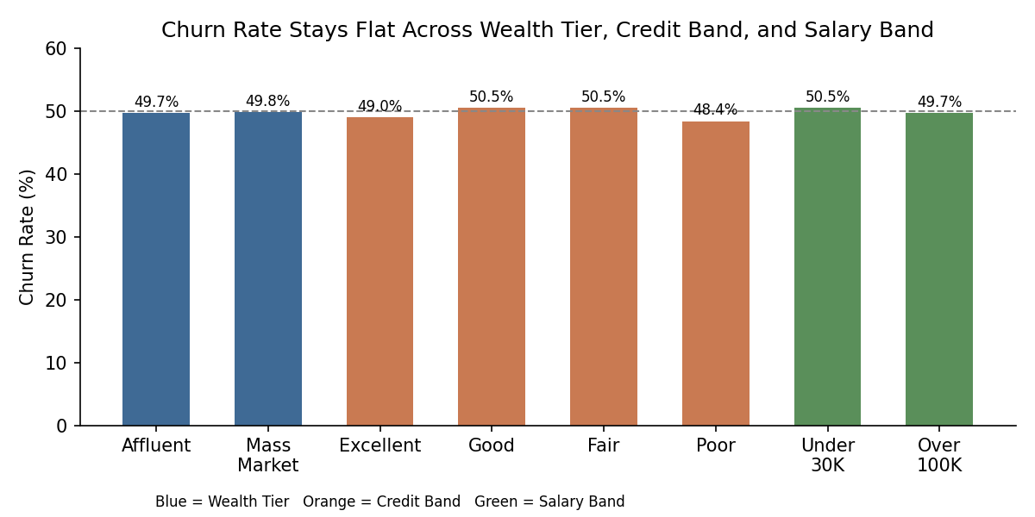
The same pattern holds across every other variable tested. Wealth Tier, Credit Band, and Salary Band all show churn rates clustered tightly between roughly 48% and 51%, regardless of category.

Conclusion
The honest finding from this analysis is that no single variable, wealth tier, credit band, salary band, age group, or number of products held, meaningfully predicts churn on its own. Churn holds steady in a narrow band across nearly every segment tested. The one place meaningful variation does appear is in specific intersections of multiple factors at once (for example, a particular age, credit band, and country combination together), though those segments are small enough in sample size that they would need further validation before being treated as reliable drivers.
This points to a clear next step: predicting churn in this dataset would require a model that considers combinations of factors together, rather than relying on any single variable in isolation. That is a more accurate and defensible conclusion than attributing churn to any one factor, and it reflects the kind of finding that should shape how this data is used in decision-making going forward.

