PROJECT REPORT
RADAR RETURN CLASSIFICATION
FOR IONOSPHERIC SIGNAL ANALYSIS
Machine Learning-Based Binary Classification Using Support Vector Machine (SVM)
Submitted by
[Student Name]
[Roll Number]
[Department / Branch]
[College / University]
Submitted to
[Professor / Faculty Name]
Academic Session: [2026–2027]

Abstract
This project investigates the classification of ionospheric radar returns into two categories: GOOD and BAD. The work uses the Ionosphere dataset available from the UCI Machine Learning Repository. The dataset contains 351 observations, 34 continuous input attributes derived from radar signal processing, and a binary class label. The objective is to build a supervised machine-learning model that can learn patterns in the attributes and predict the class of an unseen observation.
Only one classification algorithm is implemented: a Support Vector Machine (SVM) with a Radial Basis Function (RBF) kernel. The workflow includes dataset loading, exploratory data analysis, label encoding, a stratified 80:20 train-test split, feature standardization inside a pipeline, model training, testing, and five-fold stratified cross-validation. The initial implementation produced a held-out test accuracy of 95.77% and a five-fold cross-validation mean accuracy of 94.01% (the preliminary cross-validation was run on the complete dataset and should be identified as an initial estimate).
A parameter-tuning stage using GridSearchCV is also planned/executed in the notebook. Its final best parameters, tuned test metrics, and confusion matrix must be inserted from the actual Colab output before submission. The report also proposes, as future work only, an SDR/radar signal-acquisition front end connected to a signal-processing computer or embedded platform. No physical radar hardware is claimed to have been built.
Keywords: Ionosphere, radar return, binary classification, Support Vector Machine, RBF kernel, machine learning.

1. Introduction

1.1 Context and Problem Statement
Radar systems transmit electromagnetic energy and analyse the returned signals to infer information about a target or propagation environment. In the Ionosphere dataset, the observations originate from a high-frequency radar system that studied free electrons in the ionosphere. The dataset labels a return as GOOD when it shows evidence of structure in the ionosphere and BAD when it does not. The classification task is therefore to use the measured signal-derived attributes to predict the corresponding label.

1.2 Research Question
Can a Support Vector Machine with an RBF kernel learn from the 34 signal-derived attributes in the UCI Ionosphere dataset and classify unseen radar-return observations as GOOD or BAD with useful predictive performance?

1.3 Objectives
- Understand the radar-return classification problem and the meaning of the GOOD and BAD labels.
- Load and inspect the UCI Ionosphere dataset and perform exploratory data analysis.
- Prepare the target labels and divide the observations into training and testing subsets.
- Train one SVM classifier with an RBF kernel, using feature standardization.
- Evaluate the classifier using accuracy, precision, recall, F1-score, confusion matrix and cross-validation.
- Investigate SVM hyperparameters using GridSearchCV without fitting the model on the test data.
- Propose a future hardware integration architecture based on radar/SDR acquisition and signal processing.

1.4 Expected Outcome
The expected outcome is a reproducible software model that accepts 34 numeric features in the same format and order as the training dataset and returns a GOOD or BAD prediction. The model is a dataset-based proof of concept; it is not, by itself, a complete live radar system.

1.5 Structure of the Report
The report is organized into background and related works, methodology, results and analysis, and conclusion with future work. The methodology explains the complete processing pipeline, while the results section records the measured performance obtained from Google Colab.

2. Background and Related Works
This section summarizes research and technical resources relevant to the dataset, SVM classification, parameter selection and the Python machine-learning environment.
Sigillito, Wing, Hutton and Baker (1989). Introduced the Ionosphere radar-return classification study and investigated neural-network approaches on the dataset. It provides the original application context and a historical reference point for the classification problem.
Cortes and Vapnik (1995). Presented support-vector networks for two-group classification. Their work provides the theoretical foundation for the SVM classifier selected in this project.
Hsu, Chang and Lin (2003; updated 2016). Provided a practical guide to support-vector classification, including feature scaling, kernel selection and parameter selection. It supports the use of a systematic SVM workflow rather than arbitrary parameter choices.
Chang and Lin (2011). Described LIBSVM, a widely used support-vector-machine library, including optimization and parameter-selection details. It is relevant to the SVM implementation ecosystem used by machine-learning software.
Pedregosa et al. (2011). Presented scikit-learn, a Python machine-learning library offering consistent tools for preprocessing, model fitting and evaluation. The present project uses scikit-learn for its SVM pipeline and evaluation utilities.
Research gap addressed by this project: the work is a compact, reproducible implementation of the established Ionosphere binary-classification task using one SVM model, with a clearly separated training/testing workflow and a proposed path toward future hardware integration. It does not claim a new radar acquisition technique or a new learning algorithm.

3. Methodologies

3.1 Dataset Description
The project uses the Ionosphere dataset (UCI dataset ID 52). According to the UCI repository, it contains 351 instances and 34 continuous features. The target is binary, with labels g (GOOD) and b (BAD). The original data were collected using a phased-array high-frequency radar system in Goose Bay, Labrador. The measurements are signal-derived attributes associated with processed returns, rather than raw live radar waveforms.
Dataset property | Description
Dataset name | Ionosphere
Source | UCI Machine Learning Repository, dataset ID 52
Number of observations | 351
Number of input features | 34 continuous attributes
Target classes | g = GOOD; b = BAD
Task | Supervised binary classification
Missing values | UCI repository reports no missing values

3.2 Software and Tools
Tool / Library | Purpose
Google Colab | Cloud notebook environment used to execute the project.
Python | Programming language.
ucimlrepo | Retrieves the Ionosphere dataset from UCI.
Pandas and NumPy | Data loading, manipulation and numerical operations.
Matplotlib and Seaborn | Exploratory plots and result visualizations.
Scikit-learn | Train-test split, scaling, SVM, cross-validation and evaluation.
Joblib | Saving and loading the trained model.

3.3 Data Preprocessing
- Dataset loading: retrieve dataset ID 52 using fetch_ucirepo and separate the features (X) from the target (y).
- Data inspection: check the dataset shape, data types, missing values, duplicate rows and class distribution.
- Target encoding: convert g to 1 and b to 0 so that the target is numeric.
- Train-test split: use an 80:20 split with random_state=42 and stratify=y. This gives approximately 280 training rows and 71 testing rows.
- Feature scaling: use StandardScaler within a scikit-learn Pipeline. The scaler is fitted on training folds only during model fitting/cross-validation, preventing information leakage from the test data.
Note: the original dataset is documented as having no missing values. The notebook should still retain the inspection step so that data quality is explicitly verified during execution.

3.4 Exploratory Data Analysis (EDA)
EDA is used to understand the dataset before model training. The notebook includes a class-distribution plot to show the number of GOOD and BAD examples and a correlation heatmap to inspect relationships among numeric features. These visualizations help describe the data; they do not independently establish which features cause a particular radar-return class.
[Insert Figure 1: GOOD/BAD class distribution plot from Google Colab.]
[Insert Figure 2: Feature correlation heatmap from Google Colab.]

3.5 Selected Algorithm: Support Vector Machine (SVM)
An SVM is a supervised learning algorithm that finds a decision boundary separating classes. It uses support vectors near the boundary to determine the classifier. The RBF kernel allows a non-linear decision boundary by measuring similarity between observations in the feature space.
The selected initial configuration is SVC(kernel='rbf', C=1.0, gamma='scale'), wrapped in a Pipeline with StandardScaler. Standardization is important because SVM decisions depend on distances and feature scales. The pipeline ensures that scaling and classification are performed together.

3.6 Why SVM with RBF Kernel?
- The task has two output classes, which is a natural supervised classification setting for SVM.
- The RBF kernel can model non-linear separation between classes.
- Feature standardization is integrated into the pipeline.
- Scikit-learn provides a reproducible implementation and evaluation utilities.
- The project requirement specifies one selected algorithm; therefore, SVM is used as the sole classifier rather than presenting several competing algorithms as implemented models.

3.7 Methodological Workflow
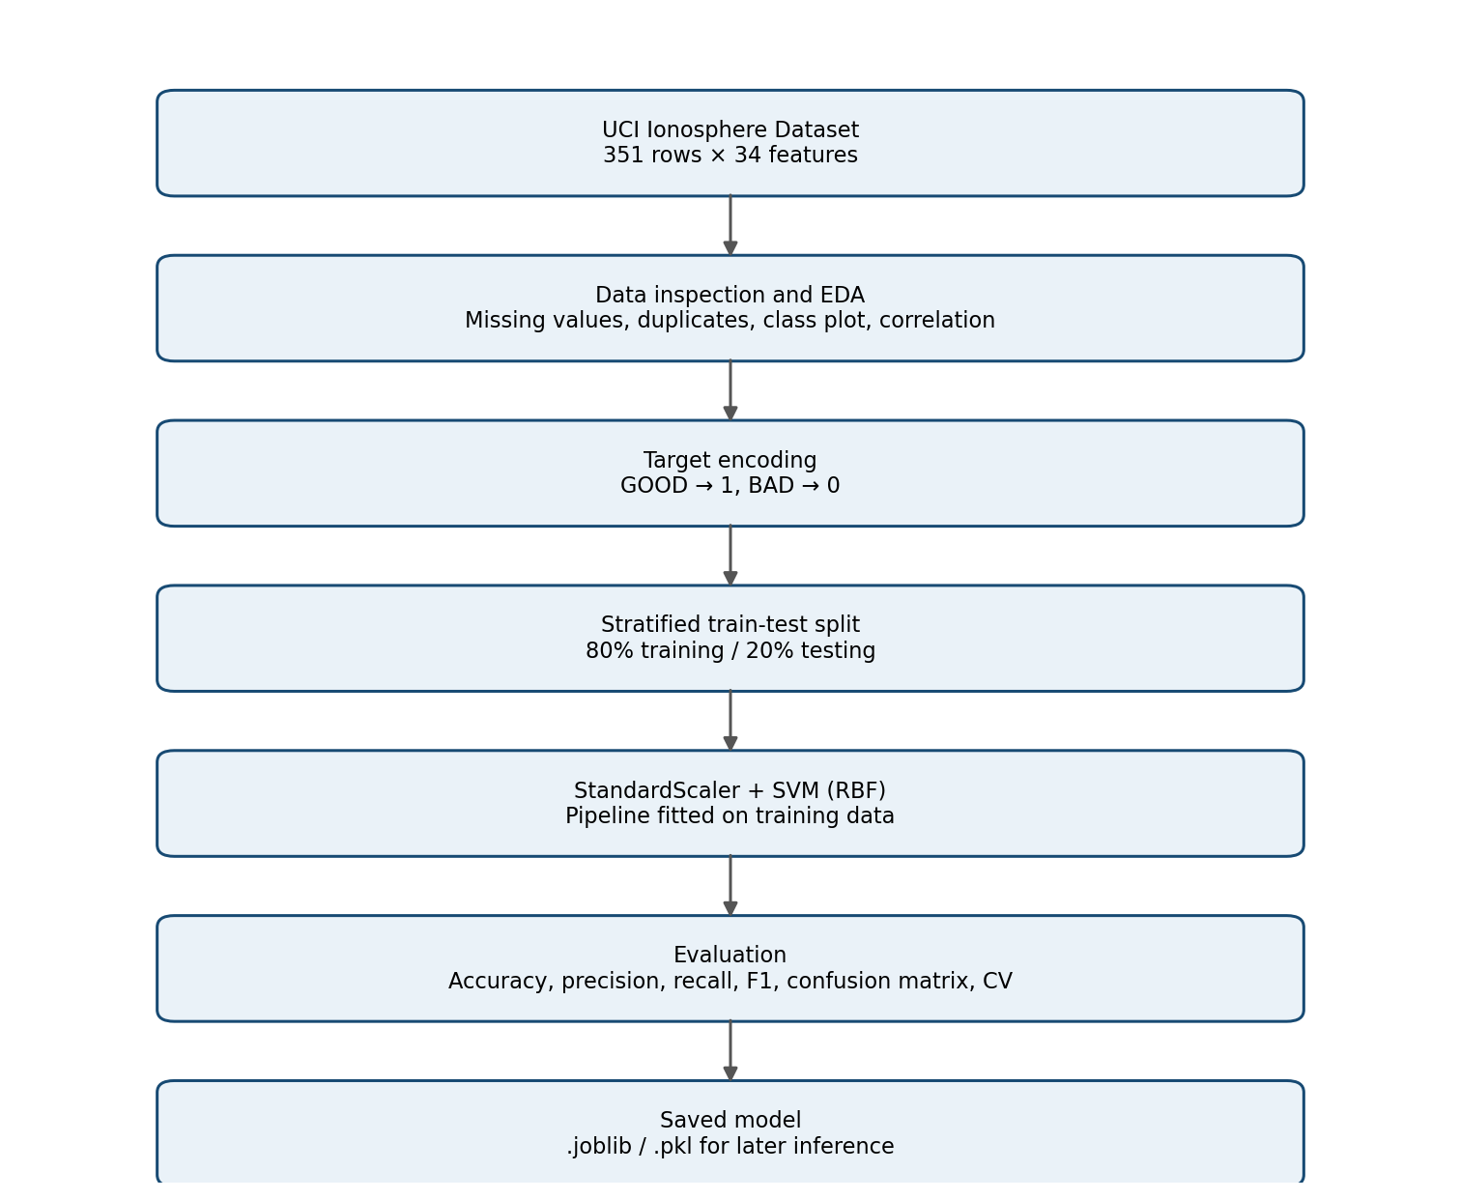
Figure 3. Methodological workflow of the software-based SVM classification system.

3.8 Hyperparameter Tuning
After the baseline SVM, GridSearchCV is used to investigate combinations of C, gamma and kernel using only the training subset. The candidate grid used in the notebook is C = [0.1, 1, 10, 100], gamma = ['scale', 'auto', 0.01, 0.1], and kernel = ['rbf', 'linear']. Five-fold StratifiedKFold cross-validation is used, with F1 as the search scoring metric. The best estimator is then evaluated once on the held-out test set. The best parameters and final scores must be copied from the actual notebook output.
Important reporting distinction: GridSearchCV's best_score_ is an F1 score because scoring='f1'; it must not be reported as accuracy. A separate accuracy calculation is required if accuracy is to be reported.

4. Results and Analysis

4.1 Research Questions
- How accurately can the selected SVM classify the held-out Ionosphere observations?
- How consistent is the model's performance across stratified cross-validation folds?
- Does hyperparameter tuning change the held-out performance compared with the baseline configuration?
- Which types of classification errors are visible in the confusion matrix?

4.2 Experiments Performed
- Experiment 1 – Baseline model: StandardScaler followed by SVC with RBF kernel, C=1.0 and gamma='scale'.
- Experiment 2 – Baseline evaluation: predict the held-out test set and calculate accuracy, classification report and confusion matrix.
- Experiment 3 – Preliminary cross-validation: five-fold stratified cross-validation on the dataset, producing the initial mean accuracy recorded below.
- Experiment 4 – Hyperparameter search: GridSearchCV on the training set only, followed by evaluation of the selected estimator on the held-out test set.

4.3 Baseline Results Available
Metric | Observed value | Interpretation
Baseline held-out test accuracy | 95.77% | Accuracy reported by the initial 80:20 split (71 test observations).
Preliminary 5-fold CV mean accuracy | 94.01% | Mean of [95.77%, 94.29%, 90.00%, 97.14%, 92.86%]; this initial CV was run on the full dataset.

Because the preliminary cross-validation was run using the complete dataset, it is not an independent estimate after the test set has already been examined. For the final tuned-model report, give priority to the cross-validation performed on X_train and y_train and the single held-out test evaluation.

4.4 Final Tuned Results – Complete from Colab
Required output | Value to enter from notebook
Best SVM parameters | [Paste grid_search.best_params_ here]
Best cross-validation F1 score | [Paste grid_search.best_score_ × 100 here]
Tuned training-only 5-fold CV accuracy | [Paste tuned_cv_accuracy here, if calculated]
Tuned held-out test accuracy | [Paste new_accuracy × 100 here]
GOOD precision / recall / F1 | [Copy from classification_report]
BAD precision / recall / F1 | [Copy from classification_report]

Do not fill these fields with estimated values. Insert the exact output from your final Google Colab run. If tuning does not improve the test accuracy, report that honestly; tuning is a search process, not a guarantee of improvement.

4.5 Confusion Matrix and Discussion
[Insert the final tuned-model confusion matrix image here.]
The confusion matrix counts correct GOOD predictions, correct BAD predictions, and the two types of incorrect predictions. Discuss which class has lower recall and whether false GOOD or false BAD predictions are more common. Use the actual matrix values from the final notebook; do not infer these values from accuracy alone.

4.6 Comparative Analysis
Comparison | Baseline SVM | Tuned SVM
Model configuration | RBF, C=1.0, gamma='scale' | [Insert best parameters]
Held-out test accuracy | 95.77% | [Insert measured result]
Cross-validation result | 94.01% preliminary full-data CV | [Insert training-only CV result]
F1 score | [Insert baseline classification report] | [Insert tuned classification report]

Compare the two models using the same held-out test set and clearly state the evaluation metric. The tuning search optimizes F1, so discuss F1 and class-wise precision/recall in addition to accuracy. A small test set means that one or two changed predictions can noticeably change the reported percentage.

5. Conclusion and Future Works

5.1 Conclusion
This project developed a software-based binary classifier for ionospheric radar-return observations using the UCI Ionosphere dataset. A single SVM classifier with an RBF kernel was selected and implemented in a pipeline with feature standardization. The initial model achieved 95.77% held-out test accuracy, while the preliminary five-fold cross-validation mean was 94.01%. These figures describe the initial baseline experiment. The final conclusion should be updated with the tuned model's actual results and class-wise metrics after the final notebook run.
The project demonstrates how machine learning can be applied to preprocessed radar signal attributes. However, the current implementation receives rows of dataset features; it does not directly acquire raw radar signals or operate a physical radar system.

5.2 Optional Future Hardware Extension (Proposed, Not Implemented)
The project outline lists an SDR/radar signal acquisition front end as the optional future hardware extension. This can be developed in a later phase by connecting a suitable signal-acquisition front end to a computer or embedded processing platform. The proposed system would need to acquire signals, perform signal processing, extract the same 34 attributes in the correct order and format, and pass those attributes to the trained SVM model.
Proposed component | Role in the future system | Status in this project
SDR / radar signal acquisition front end | Captures or provides digitized signal data for processing. | Proposed only
Computer / embedded processor | Runs signal-processing and inference software. | Proposed only
Signal-processing software | Converts acquired data into the required 34 model input features. | Not implemented
Trained SVM model | Classifies a correctly formatted 34-feature observation as GOOD or BAD. | Software model implemented
Display / dashboard | Shows the predicted class and relevant status information. | Optional software demonstration

5.3 Proposed Hardware Workflow
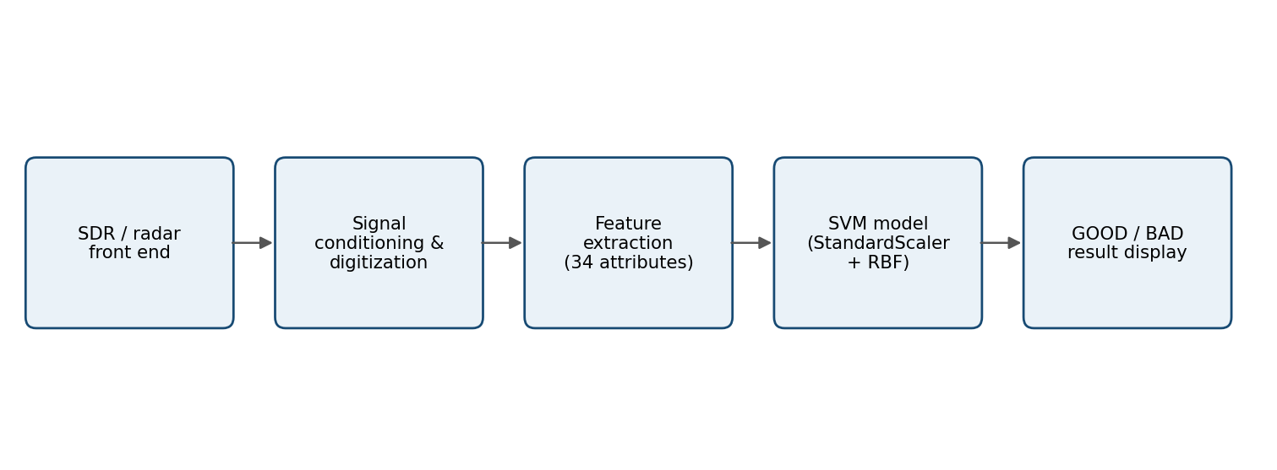
Figure 4. Proposed future hardware-to-classifier architecture. All acquisition and feature-extraction stages are future work.

5.4 Hardware Integration Considerations
- Feature compatibility: the hardware pipeline must produce the same 34 features, in the same order and with compatible numerical scaling, as the training dataset.
- Signal-processing validation: the feature-extraction method must be documented and validated against known reference examples before model predictions are trusted.
- Sampling and calibration: acquisition settings, calibration, noise handling and data quality need to be studied for the selected front end.
- Deployment: the saved preprocessing-plus-SVM pipeline should be deployed as one unit so that the same scaling is applied during inference.
- Testing: the integrated system requires independent measurements and validation; dataset accuracy alone does not prove real-time hardware performance.

5.5 Limitations
- The dataset is small (351 observations), so performance estimates can vary with the train-test split.
- The dataset contains processed signal attributes, not raw continuous radar waveforms.
- The project uses an offline dataset and does not demonstrate live radar acquisition.
- Model performance on this dataset may not transfer directly to other radar systems, locations or operating conditions.
- The hardware extension is proposed future work and has not been physically implemented or validated.

References
[1] Sigillito, V. G., Wing, S. P., Hutton, L. V., & Baker, K. B. (1989). Classification of radar returns from the ionosphere using neural networks. Johns Hopkins APL Technical Digest, 10, 262–266.
[2] UCI Machine Learning Repository. (1989/updated repository record). Ionosphere [Dataset]. https://doi.org/10.24432/C5W01B
[3] Cortes, C., & Vapnik, V. (1995). Support-vector networks. Machine Learning, 20, 273–297. https://doi.org/10.1007/BF00994018
[4] Hsu, C.-W., Chang, C.-C., & Lin, C.-J. (2003; updated 2016). A practical guide to support vector classification. National Taiwan University.
[5] Chang, C.-C., & Lin, C.-J. (2011). LIBSVM: A library for support vector machines. ACM Transactions on Intelligent Systems and Technology, 2(3), Article 27. https://doi.org/10.1145/1961189.1961199
[6] Pedregosa, F., et al. (2011). Scikit-learn: Machine learning in Python. Journal of Machine Learning Research, 12, 2825–2830.

Appendix A – Reproducibility Checklist
- Notebook runs from top to bottom without errors.
- Dataset source and dataset ID are stated.
- Train-test split uses stratify=y and a fixed random_state.
- Scaler is inside the SVM Pipeline.
- Hyperparameter search is fitted only on training data.
- Final test metrics and confusion matrix are copied from the final run.
- Saved model file is tested by loading it and predicting a sample.
- All figures have figure numbers and captions.
- All bracketed placeholders in this report are completed or removed before submission.

Appendix B – Information to Add Before Submission
Add your name, roll number, college, department, faculty name, and date. Insert the two EDA figures, the final confusion matrix, and the exact tuned SVM outputs. If a Gradio dashboard was successfully created, add one screenshot and describe it as a software demonstration using dataset feature inputs, not as a live radar interface.

