**NODE JS**

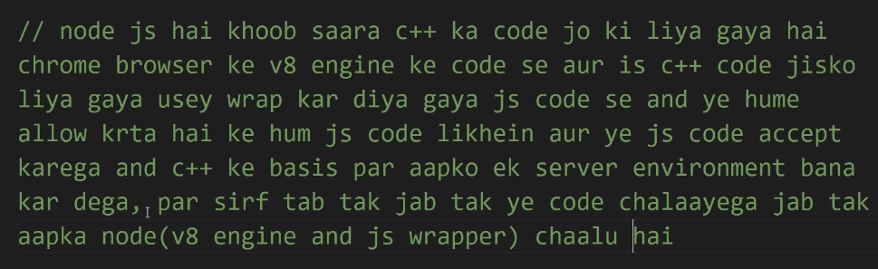

When you write a code ion node js the wrapper file reads the js code and converts it into the c++ code so that the v8 engine files can execute the code.

JavaScript alone cannot run a server that’s why we use node because it has the functionalities that make server run.

How a message is transferred from one device to another? (What is internet)

MAC address-basically differentiates between the devices in a local area network. For example, if a

WIFI router receives different messages from different devices in a room then on basis of MAC address it is decided that which message is to be sent on which device further and vice versa.

Client-server architecture

HTTP-Hyper Text Transfer Protocol

HTTPS- Hyper Text Transfer Protocol Secured

IMPORT/EXPORT in js

Script2.js

var d=12244;

module.exports=d;

Script.js

require('./script2')

For multiple variables

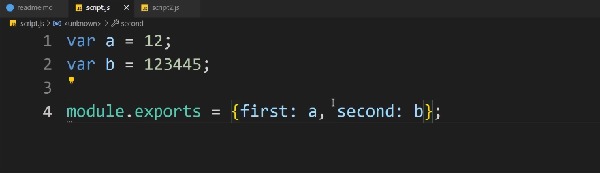



NPM

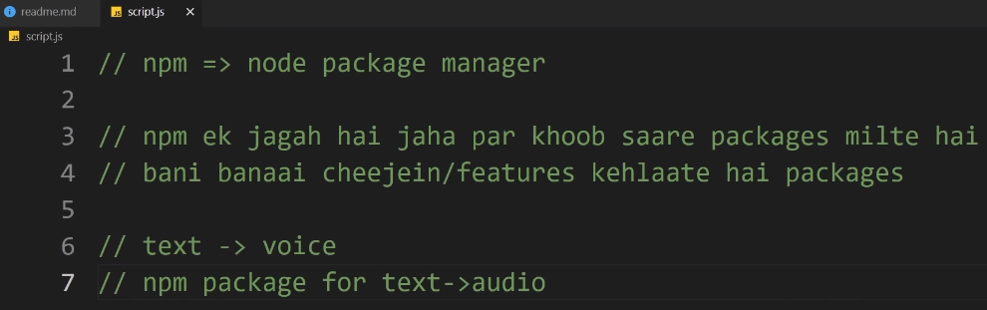

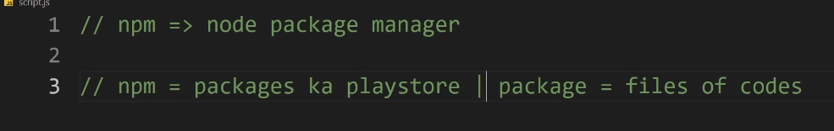

**HOW TO INSTALL SOMETHING FROM NPM**

npm i/install <package name>

**WHAT IS Express and ROUTING? Express is a framework used for routing.**

Alag alga route pe alag alg pages dikhata hai.

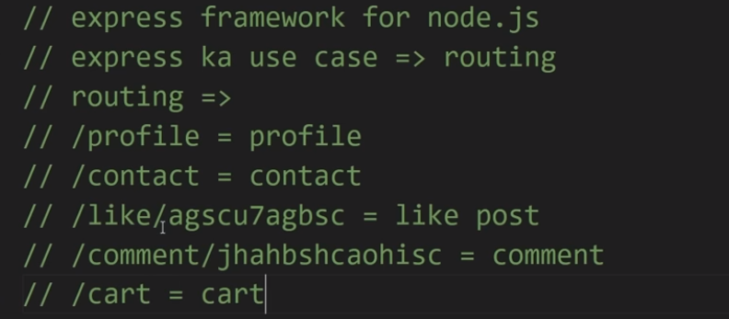

**TYPES OF ROUTES: -**

**GET, POST these two are main, there are more but the rest are very rarely used mostly in RestFul API**

**GET-if there is no problem that data can be showed on the url/route address then we use get route**

**POST-if we don’t want our data to be shown on the url address or route then we use post.**

**‘/’ route or base route-it is the route in which the website is at its base page.**

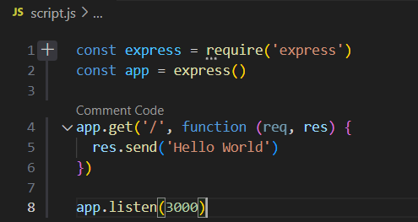

**Nodemon – it is a package which is used to run the node code without relaunching the server again and again.**

