Practical No. 1

Title:- Program to demonstrate the features of Dart Language.

- Features of DART Programming Language.
- Introduction to Visual Studio Code.
- How to install Flutter SDK.
Dart is an open-source general-purpose programming language developed by Google. It supports application development in both client and server-side. But it is widely used for the development of android apps, iOS apps, IoT (Internet of Things), and web applications using the Flutter Framework.

- Features of DART Programming Language:
The Dart programming language offers several key features:
- Open Source: Dart is freely available, developed by Google, and approved by the ECMA standard. It comes with a BSD license.
- Platform Independent: Dart runs on Windows, Linux, Macintosh, and other operating systems. It has its own Virtual Machine (Dart VM) for cross-platform execution.
- Object-Oriented: Dart supports OOP concepts like classes, inheritance, interfaces, and optional typing. It also includes advanced features like mixins, abstract classes, and a robust type system.
- Concurrency: Dart is asynchronous and supports multithreading using Isolates. Isolates communicate via message passing.
- Extensive Libraries: Dart provides built-in libraries (SDK, core, math,async, etc.) and allows organizing code into reusable libraries.
- Easy to Learn: If you know languages like Java, C#, or JavaScript, learning Dart is straightforward due to its similar syntax.
- Flexible Compilation: Dart supports both Ahead-of-Time (AOT) and Just-in-Time (JIT) compilation.
- Type Safe: Dart uses static type checking and runtime checks, making code more readable and reliable.
- Treats Everything as an Object: In Dart, everything is treated as an object.

- Introduction to Visual Studio Code:
Visual Studio Code, often referred to as VS Code, is a powerful source-code editor developed by Microsoft. It’s available for Windows, Linux, macOS, and even as a web-based version. Here are some steps to get started with it:
- Installation and Setup:
  - Download and Install: You can download VS Code from the official website. (Install VSCodeUserSetup-x64_1.81.1)
  - Open a Folder: After installation, open VS Code and use the menu option File > Open Folder (or press Ctrl+K Ctrl+O on Windows/Linux) to open a project folder.
  - Explorer View: Access your files and folders using the Explorer view (shortcut: Ctrl+Shift+E on Windows/Linux).
  - Search View: Use the Search view (shortcut: Ctrl+Shift+F on Windows/Linux) to find text across your project.
  - Source Control View: Manage version control with Git using the Source Control view.

- Editing and Customization:
  - Command Palette: Access various commands and settings via the Command Palette (shortcut: Ctrl+Shift+P on Windows/Linux).
  - Extensions: Enhance VS Code by installing extensions for different languages and frameworks (shortcut: Ctrl+Shift+X on Windows/Linux).
  - Themes: Customize the editor’s appearance by choosing a color theme.

- Running and Debugging:
  - Integrated Terminal: Use the integrated terminal to run commands and scripts.
  - Run and Debug: Start debugging your code (shortcut: F5).
  - Programming Language Extensions: Install extensions for languages like Python, JavaScript, Dart and more.
  - VS Code is widely used by developers due to its flexibility, rich features, and active community.

- How to install Flutter SDK:
Step 1:- Go to Browser → type flutter_windows_3.22.0-stable download → Install | FluttInstall | Flutter → Click on Windows Current Device → Choose Android → Click Download and Install Tab
→ Download the zip file → After Downloading zip file right click on it and select option extract here → You will get the flutter folder.

Step 2:- Go to C drive → Create New Folder and name it as src → copy that flutter folder and paste it inside C drive src folder.
Step 3:- Go to C drive → src → flutter → bin → copy path (C:\src\flutter\bin) → Click on This PC
→ Properties → Advanced System Settings → Click on Environment Variables → Under User variables → Select Path variable → Edit → C:\src\flutter\bin (Paste Path here) → Again Click on New Button → C:\src\flutter
→ OK.
Step 4:- Go to VS Code → Extensions (Ctrl+Shift+X) → Type Flutter → click on Flutter Dart Code
→ Install.
Step 5:- Go to Explorer (Ctrl+Shift+E) →View Tab → Command Palette → type flutter → Flutter New Project → Locate Folder → Go to C drive →src → Select flutter folder → Click on Set flutter SDK folder.
Step 6:- Create a folder on Desktop to save all files.
Step 7:- View Tab → Command Palette → type flutter → Flutter New Project → Empty Application
→ Select the folder to create folder in → Give proper name to application (Ex. Flutter_App_1) → Click on Checkbox → Yes, I trust the authors → After some installation you will get the main.dart file.
Step 8:- Right side of Lower Panel → Window(windows-x64) → Click on it → Select Chrome as browser.
Step 9:- To run an application press Ctrl+F5 (Run without Debugging).
Step 10:- Output for default “Hello World!” page (main.dart).

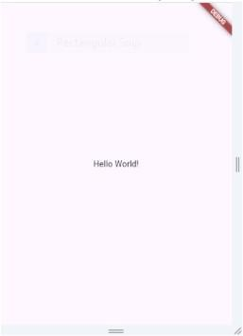

The main() function is a predefined method in Dart. This method acts as the entry point to the application. A Dart script needs the main() method for execution. print() is a predefined function that prints the specified string or value to the standard output i.e. the terminal.

Introduction to Dartpad
Go to browser → type dartpad → click on online editor link DartPad

- Example for type of the variable using Dartpad: Code:
void main() {
// Declaring and initialising variable int num1 = 10;
double num2 = 3.145; bool num3 = true;
String msg = 'Hello Everyone';
// Printing values of all variables print(num1);
print(num2); print(num3); print(msg);
}
Output:
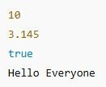

- Example for Different types of Operators in Dart: Code:
void main()
{
int a = 30, b = 20;
// Addition var c = a + b;
print('Sum of a and b is $c');
// Subtraction var d = a - b;
print('The difference between a and b is $d');
// Using Unary minus var e = -d;
print('The negation of difference is $e');
// Multiplication var f = a * b;
print('The multiplication of a and b is $f');
// Division var g = a / b;
print('The division of a and b is $g');
// Quotient var h = a ~/ b;
print('The quotient of a and b is $h');
// Remainder var i = a % b;
print('The remainder of a and b is $i');
}

Output:
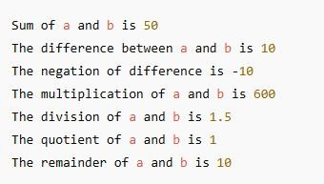
- Example for Decision making statement: Code:
void main()
{
var marks = 74; if (marks > 75)
{
print('Distinction');
}
else if (marks >= 60)
{
print('First Class');
}
else if (marks >= 40)
{
print('Second Class');
}
else
{
print('Fail');
}}
Output:
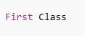

- Example for Function: Code: void main()
{
print(factorial(6));
}
factorial(number)
{
if (number <= 0)
{
return 1;
}
else
{
return (number * factorial(number - 1));
}
}
Output:
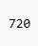

- Example for Defining a Class: Code:
// Defining class class Student {
var studName; var studAge; var studRno;
// Defining class function

showInfo() {
print('Student Name is : ${studName}'); print('Student Age is : ${studAge}'); print('Student Roll Number is : ${studRno}');
}
}
void main() {
// Creating object called stud var stud = new Student(); stud.studName = 'Harsh'; stud.studAge = 25;
stud.studRno = 105;
// Accessing class function stud.showInfo();
}
Output:
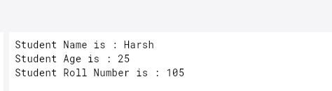

Practical No. 2

Title: - Designing the mobile app to implement different widgets.
- Basic Widgets
- Material Design Widgets
- Custom Widgets

  - Input:
import 'package:flutter/material.dart'; void main() {
runApp(const MainApp());
}
class MainApp extends StatelessWidget
{ const MainApp({super.key}); @override
Widget build(BuildContext context)
{ return const MaterialApp( home:
Scaffold( body:
Center( child: Text(
'Hello Everyone..!',
style: TextStyle(fontWeight: FontWeight.w900),
), // Text
), // Center
), // Scaffold
); // MaterialApp
}
}

Output:
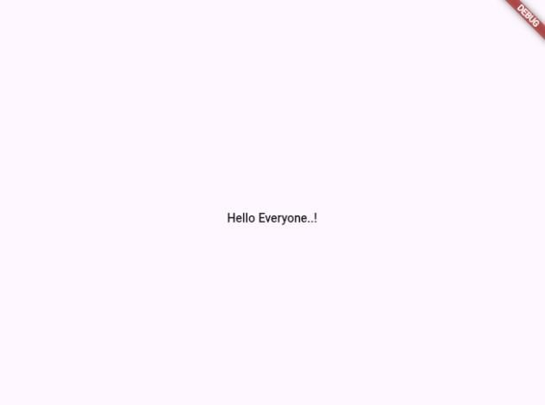

  - Input:
import 'package:flutter/material.dart';
void main() => runApp(const ElevatedButtonExampleApp()); class ElevatedButtonExampleApp extends StatelessWidget
{ const ElevatedButtonExampleApp({super.key}); @override
Widget build(BuildContext context)
{ return MaterialApp( home: Scaffold(
appBar: AppBar(title: const Text('ElevatedButton Sample')), body: const ElevatedButtonExample(),
), ); } }
class ElevatedButtonExample extends StatefulWidget
{ const ElevatedButtonExample({super.key}); @override
State<ElevatedButtonExample> createState() => _ElevatedButtonExampleState();
}
class _ElevatedButtonExampleState extends State<ElevatedButtonExample>
{ final ButtonStyle style = ElevatedButton.styleFrom(

textStyle: const TextStyle(fontSize: 20),
);
@override
Widget build(BuildContext context)
{ return Center( child: Column(
mainAxisSize: MainAxisSize.min, children:
<Widget>[ ElevatedButton( style: style,
onPressed: null, // Disabled button child: const Text('Disabled'),
),
const SizedBox(height: 30), ElevatedButton(
style: style, onPressed: () {
// You can add your onPressed logic here print('Enabled button pressed!');
},
child: const Text('Enabled'),
), ], ), ); } }
Output:
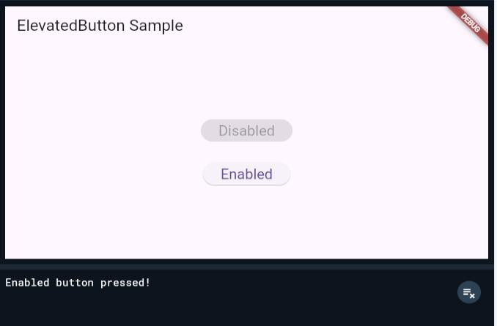

  - Input:
import 'package:flutter/material.dart';
// Flutter code sample for [AppBar].
void main() => runApp(const AppBarApp()); class AppBarApp extends StatelessWidget
{ const AppBarApp({super.key}); @override
Widget build(BuildContext context)
{ return const MaterialApp( home: AppBarExample(),
); } }
class AppBarExample extends StatelessWidget
{ const AppBarExample({super.key}); @override
Widget build(BuildContext context)
{ return Scaffold( appBar: AppBar(
title: const Text('AppBar Demo'), actions: <Widget>[
IconButton(
icon: const Icon(Icons.add_alert), tooltip: 'Show Snackbar', onPressed: () {
ScaffoldMessenger.of(context).showSnackBar( cons t SnackBar(content: Text('This is a snackbar')),
); }, ),
IconButton(
icon: const Icon(Icons.navigate_next), tooltip: 'Go to the next page',

onPressed: ()
{ Navigator.push ( context,
MaterialPageRoute<void>( builder: (BuildContext context) { return Scaffold(
appBar: AppBar(
title: const Text('Next page'),
),
body: const Center( child:
Text(
'This is the next page',
style: TextStyle(fontSize: 24),
), ), ); }, ), ); }, ), ], ),
body: const
Center( child: Text( 'This is the home page',
style: TextStyle(fontSize: 24),
), ), ); } }
Output:
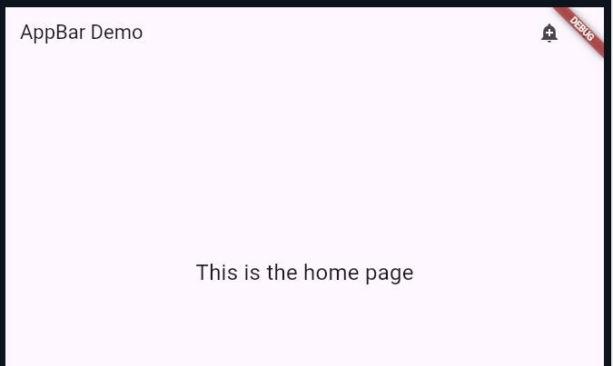

  - Input:
import 'package:flutter/material.dart'; List<String> titles =
<String>[ 'Cloud', 'Beach',
'Sunny',
];
void main() => runApp(const AppBarApp()); class AppBarApp extends StatelessWidget
{ const AppBarApp({super.key}); @override
Widget build(BuildContext context)
{ return MaterialApp( theme: ThemeData(
colorSchemeSeed: const Color(0xff6750a4), useMaterial3: true,
),
home: const AppBarExample(),
); } }
class AppBarExample extends StatelessWidget
{ const AppBarExample({super.key}); @override
Widget build(BuildContext context) {
final ColorScheme colorScheme = Theme.of(context).colorScheme; final Color oddItemColor = colorScheme.primary.withOpacity(0.05); final Color evenItemColor = colorScheme.primary.withOpacity(0.15); const int tabsCount = 3;
return DefaultTabController( initi alIndex: 1,
length: tabsCount,

child:
Scaffold( appBar:
AppBar(
title: const Text('AppBar Sample'), notificationPredicate: (ScrollNotification notification)
{ return notification.depth == 1;
},
scrolledUnderElevation: 4.0,
shadowColor: Theme.of(context).shadowColor, bottom: TabBar(
tabs:
<Widget>[ Ta b(
icon: const Icon(Icons.cloud_outlined), text: titles[0],
),
Tab(
icon: const Icon(Icons.beach_access_sharp), text: titles[1],
),
Tab(
icon: const Icon(Icons.brightness_5_sharp), text: titles[2],
), ], ), ),
body:
TabBarView( childr en:
<Widget>[ ListVie w.builder(
itemCount: 25,
itemBuilder: (BuildContext context, int index)

{ return ListTile(
tileColor: index.isOdd ? oddItemColor : evenItemColor, title: Text('${titles[0]} $index'),
); }, ),

ListView.builder( itemCount: 25,
itemBuilder: (BuildContext context, int index)
{ return ListTile(
tileColor: index.isOdd ? oddItemColor : evenItemColor, title: Text('${titles[1]} $index'),
); }, ),
ListView.builder( itemCount: 25,
itemBuilder: (BuildContext context, int index)
{ return ListTile(
tileColor: index.isOdd ? oddItemColor : evenItemColor, title: Text('${titles[2]} $index'),
); }, ), ], ), ), ); } }
Output:
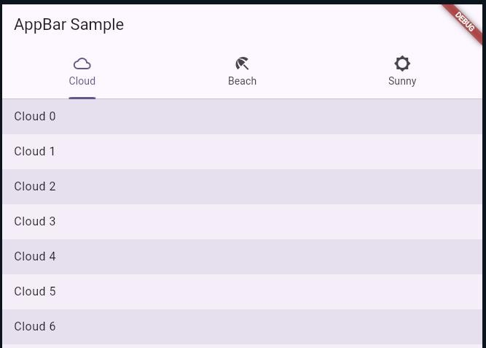

  - Input:
import 'package:flutter/material.dart';
/// Flutter code sample for [Scaffold].
void main() => runApp(const ScaffoldExampleApp()); class ScaffoldExampleApp extends StatelessWidget
{ const ScaffoldExampleApp({super.key}); @override
Widget build(BuildContext context)
{ return const MaterialApp( home: ScaffoldExample(),
); } }
class ScaffoldExample extends StatefulWidget
{ const ScaffoldExample({super.key}); @override
State<ScaffoldExample> createState() => _ScaffoldExampleState();
}
class _ScaffoldExampleState extends State<ScaffoldExample>
{ int _count = 0;
void _incrementCounter()
{ setState(() {
_count++;
} ); }
@override
Widget build(BuildContext context)
{ return Scaffold( appBar: AppBar(
title: const Text('Sample Code'),
),
body: Center( chil d: Text(

'You have pressed the button $_count times.', style: const TextStyle(fontSize: 18),
), ),
floatingActionButton: FloatingActionButton( onPressed:
_incrementCounter,
tooltip: 'Increment Counter', child: const Icon(Icons.add),
), ); } }
Output:
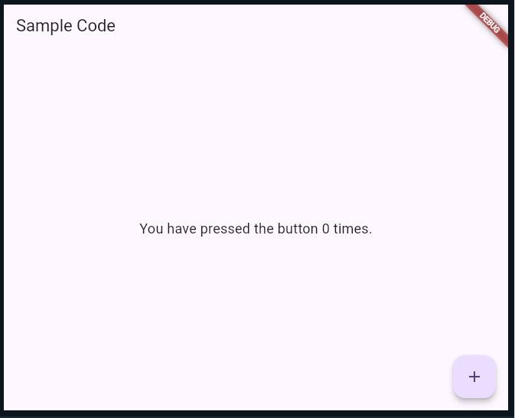
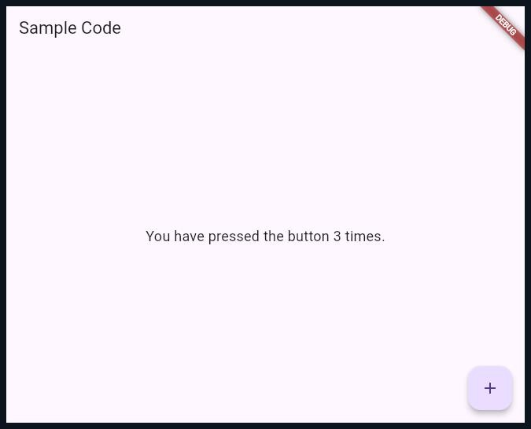

Practical No. 3

Title: - Designing the mobile app to implement different Layouts.
- Input:
import 'package:flutter/material.dart'; void main() {
runApp(const DemoApp());
}
class DemoApp extends StatelessWidget
{ const DemoApp({super.key}); @override
Widget build(BuildContext context)
{ return MaterialApp( title: 'My Application',
debugShowCheckedModeBanner: false, home: Scaffold(
body: Padding(
padding: const EdgeInsets.all(20.0), child: Center(
child: Column(
mainAxisAlignment: MainAxisAlignment.center, children: [
// First Row Row(
mainAxisAlignment: MainAxisAlignment.spaceEvenly, children: [
Container( h eight: 100,
width: 100,
color: Colors.teal,

),
Container( h eight: 100,
width: 100,
color: Colors.teal[900], // not const
), ], ),
const SizedBox(height: 20), // spacing between rows
// Second Row Row(
mainAxisAlignment: MainAxisAlignment.spaceEvenly, children: [
Container( h eight: 100,
width: 100,
color: Colors.amberAccent,
),
Container( h eight: 100,
width: 100,
color: Colors.amberAccent[100],
),
Container( h eight: 100,
width: 100,
color: Colors.amberAccent[200],
), ], ), ], ), ), ), ), ); } }

Output:
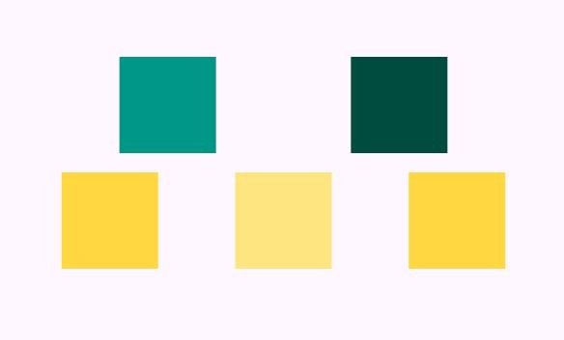

- Input:
import 'package:flutter/material.dart'; void main() => runApp(MyApp()); class MyApp extends StatelessWidget
{ @override
Widget build(BuildContext context)
{ return MaterialApp(
title: 'Multiple Layout Widget', debugShowCheckedModeBanner: false, theme: ThemeData(
primarySwatch: Colors.blue,
),
home: MyHomePage(),
); } }
class MyHomePage extends StatelessWidget
{ @override
Widget build(BuildContext context)
{ return Scaffold( backgroundColor: Colors.white, body: Center(

child: Stack(
alignment: Alignment.center, children: <Widget>[
// Blue container at the bottom Container(
color: Colors.blue, height: 300.0,
width: 300.0,
),
// Pink container in the middle Container(
color: Colors.pink, height: 200.0,
width: 200.0,
),
// Yellow container on top Container(
color: Colors.yellow, height: 100.0,
width: 100.0,
), ], ), ), ); } }
Output:

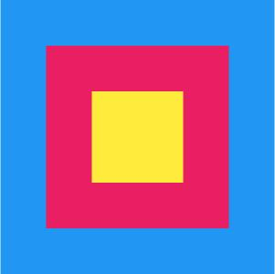

Practical No. 4

Title: - Designing the mobile app to implement different Gestures. Input:
import 'package:flutter/material.dart'; void main()
{ runApp(MaterialApp(home: MyApp()));
}
class MyApp extends StatefulWidget {
const MyApp({Key? key}) : super(key: key); @override
State<MyApp> createState() => _MyAppState();
}
class _MyAppState extends State<MyApp>
{ int numberOfTimesTapped = 0; @override
Widget build(BuildContext context)
{ return Scaffold( body:
Center( child:
Column(
mainAxisAlignment: MainAxisAlignment.spaceEvenly, children: [
Text(
'Tapped ' + numberOfTimesTapped.toString() + ' times', style: TextStyle(fontSize: 30),
),
GestureDetector( onTap: () {
setState(()

{ numberOfTimesTapped++;

} ); },
child: Container( padding: EdgeInsets.all(20), color: Colors.green[200], child: Text(
'TAP HERE',
style: TextStyle(fontSize: 30),
), ), ), ], ), ), ); } }

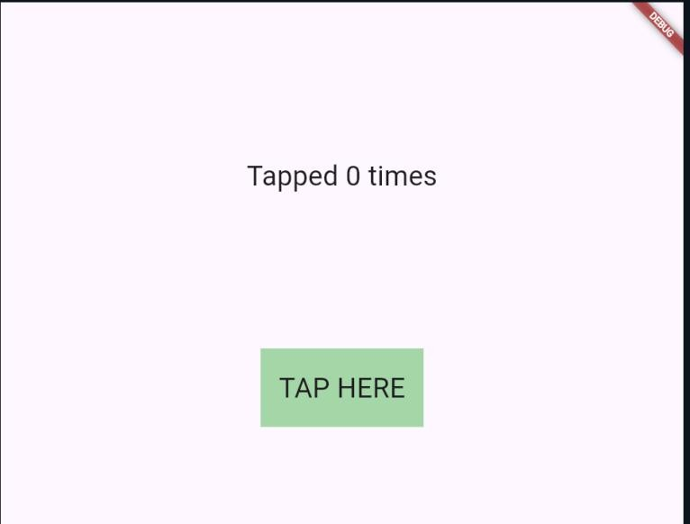
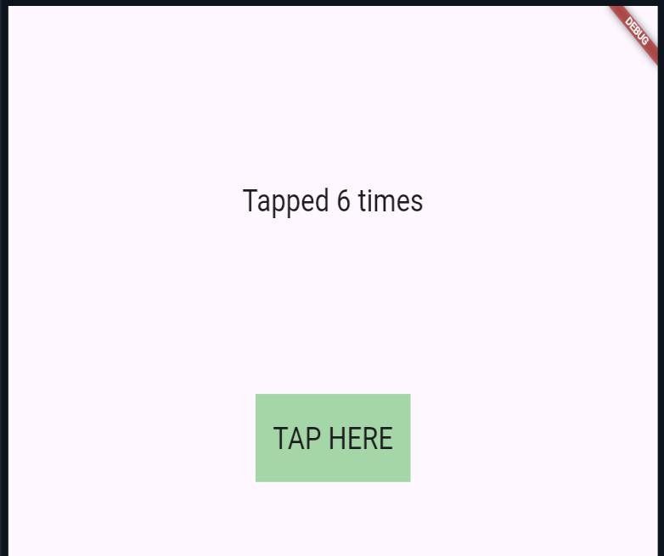

Practical No. 5

Title: - Designing the mobile app to implement the theming and styling. Input:
import 'package:flutter/material.dart'; void main() {
runApp(MaterialApp(
home: MyApp(), // MaterialApp
)); }
class MyApp extends StatelessWidget {
const MyApp({Key? key}) : super(key: key); @override
Widget build(BuildContext context)
{ return Scaffold( appBar: AppBar(
title: Text('Theming and Styling'), // AppBar
),
body:
Center( child:
Column(
mainAxisAlignment: MainAxisAlignment.spaceEvenly, children: [
Image.network(
'https://static.vecteezy.com/system/resources/previews/010/938/844/non_2x/tropical-purple- butterfly-illustration-beautiful-butterfly-vector.jpg',
height: 350,
width: 350,
), // Image.network
], ), ), ); } }

Output:
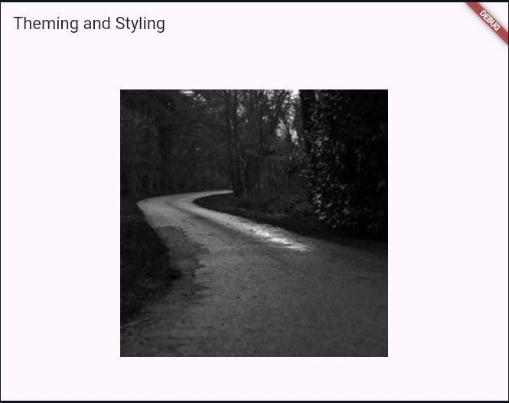

Input:
import 'package:flutter/material.dart'; void main() {
runApp(const MyApp());
}
class MyApp extends StatelessWidget
{ const MyApp({super.key}); @override
Widget build(BuildContext context)
{ const appName = 'Custom Themes'; return MaterialApp(
title: appName, theme:
ThemeData( useMate rial3: true, colorScheme:

ColorScheme.fromSeed( seedColor:
Colors.purple, brightness: Brightness.dark,),
textTheme: const TextTheme( displayLarge:
TextStyle( fontSize: 72,
fontWeight: FontWeight.bold,
), ), ),
home: MyHomePage(title: appName),
); } }
class MyHomePage extends StatelessWidget
{ final String title;
const MyHomePage({super.key, required this.title}); @override
Widget build(BuildContext context)
{ return Scaffold( appBar:
AppBar( title:
Text( title, style:
Theme.of(context).textTheme.titleLarge!.copyWith( c olor: Theme.of(context).colorScheme.onSecondary,
), ),
backgroundColor: Theme.of(context).colorScheme.secondary,
),
body:
Center( child:
Container(
padding: const EdgeInsets.symmetric(horizontal: 12, vertical: 12),

color: Theme.of(context).colorScheme.primary, child: Text(
28
'Text with a background color',
style: Theme.of(context).textTheme.bodyLarge!.copyWith( color: Theme.of(context).colorScheme.onPrimary,
), ), ), ),
floatingActionButton: Theme( data:
Theme.of(context).copyWith( colorSc heme:
ColorScheme.fromSeed( seedColor: Colors.pink,
brightness: Brightness.dark,
), ),
child: FloatingActionButton( onP ressed: () {},
child: const Icon(Icons.add),
), ), ); } }
Output:
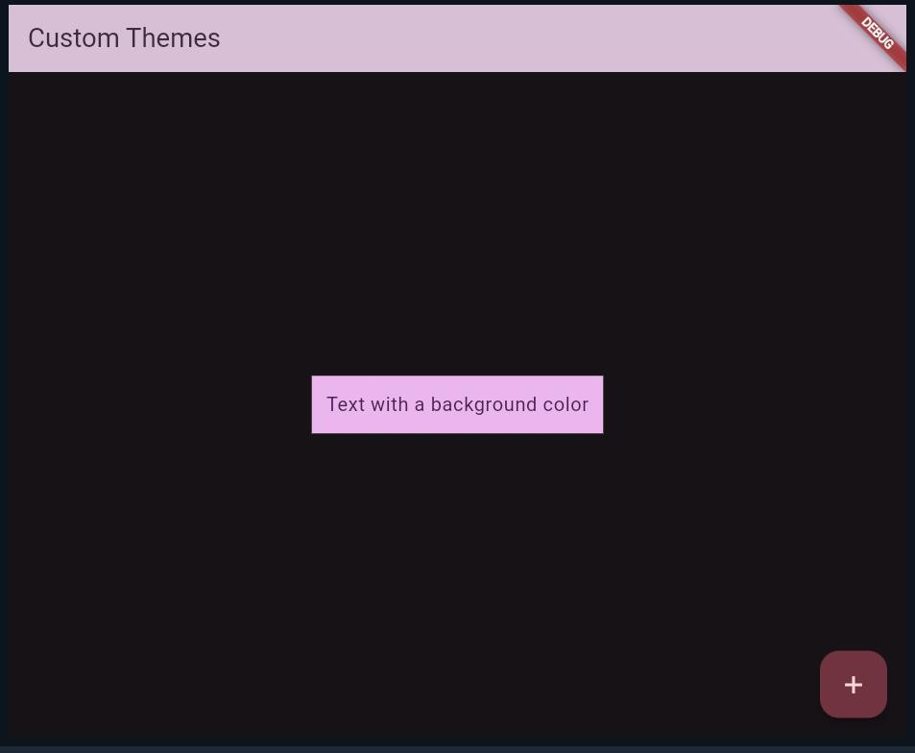

Practical No. 6

Title: - Designing the mobile app to create User Authentication. Input:
import 'package:flutter/material.dart'; void main() {
runApp(const MyApp());
}
class MyApp extends StatelessWidget {
const MyApp({Key? key}) : super(key: key); @override
Widget build(BuildContext context)
{ return const MaterialApp( title: 'User Authentication', home: Login(title: 'Login App'),
); } }
class Login extends StatefulWidget {
const Login({Key? key, required this.title}) : super(key: key); final String title;
@override
State<Login> createState() => _LoginState();
}
class _LoginState extends State<Login>
{ final _formKey = GlobalKey<FormState>();
TextEditingController emailController = TextEditingController(); TextEditingController passwordController = TextEditingController(); @override
Widget build(BuildContext context) {

return
Scaffold( appBar:
AppBar(
title: Text(widget.title),
),
body:
Form( key:
_formKey, child: Padding(
padding: const EdgeInsets.symmetric(horizontal: 8, vertical: 16), child: Column(
crossAxisAlignment: CrossAxisAlignment.center, children: [
Padding( paddin g:
const EdgeInsets.symmetric(horizontal: 8, vertical: 16), child: TextFormField(
controller: emailController, decoration: const InputDecoration( border: OutlineInputBorder(), labelText: "Email",
),
validator: (value) {
if (value == null || value.isEmpty)
{ return 'Please enter your email';
}
return null;
}, ), ),
Padding( paddin g:

const EdgeInsets.symmetric(horizontal: 8, vertical: 16), child: TextFormField(
controller: passwordController, obscureText: true,
decoration: const InputDecoration( border: OutlineInputBorder(), labelText: "Password",
),
validator: (value) {
if (value == null || value.isEmpty)
{ return 'Please enter your password';
}
return null;
}, ), ),
Padding( paddin g:
const EdgeInsets.symmetric(horizontal: 8, vertical: 16.0), child: Center(
child:
ElevatedButton( onP ressed: () {
if (_formKey.currentState!.validate()) {
if (emailController.text == "abc@gmail.com" && passwordController.text == "admin123")
{ Navigator.push( context, MaterialPageRoute( builder: (context) =>
HomePage( email: emailController.text,

), ), );
} else
{ ScaffoldMessenger.of(context).showSnackBar( const SnackBar(
content: Text('Invalid Credentials'),
), ); }
} else
{ ScaffoldMessenger.of(context).showSnackBar( c onst SnackBar(
content: Text('Please fill input'),
), ); } },
child: const Text('Submit'),
), ), ), ], ), ), ), ); } }
class HomePage extends StatelessWidget {
const HomePage({super.key, required this.email}); final String email;
@override
Widget build(BuildContext context)
{ return Scaffold( appBar: AppBar(
title: const Text('Home Page'),
),
body:
Column( chil dren:
[ Text(email), Center(
child:
ElevatedButton( onPressed: ()
{ Navigator.pop(context);
},

child: const Text("Go back!"),
33
), ), ], ), ); } }

Output:
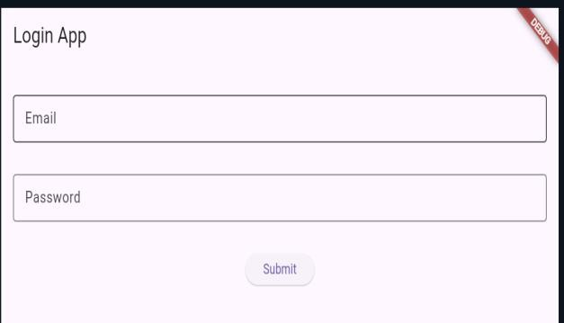

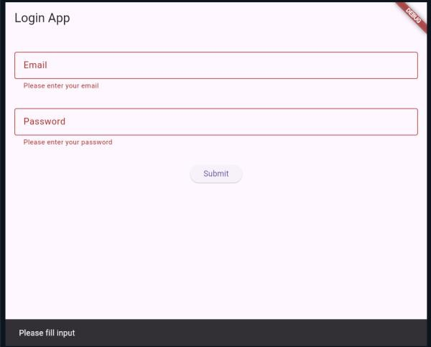
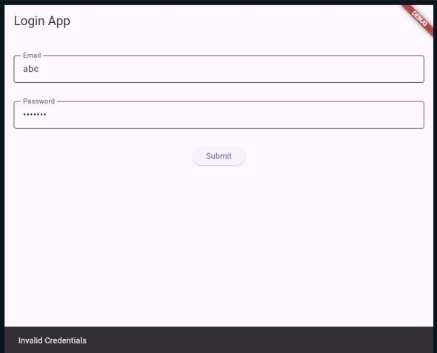
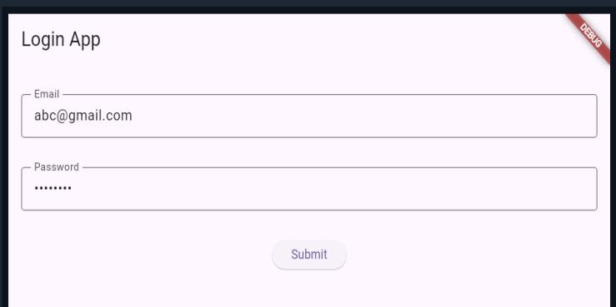
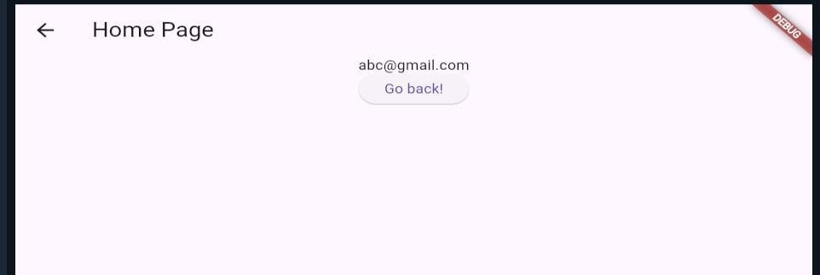

Practical No. 7

Title: - Designing the mobile app to create Countdown Timer. Input:
import 'package:flutter/material.dart'; import 'dart:async';
void main()
{ runApp(const MyApp());
}
class MyApp extends StatelessWidget
{ const MyApp({super.key}); @override
Widget build(BuildContext context)
{ return
MaterialApp( debugShowCheckedMode Banner: false, title: 'Countdown Timer Example', theme: ThemeData(
primarySwatch: Colors.blue,
),
home: const CodeDemo(),
); } }
class CodeDemo extends StatefulWidget
{ const CodeDemo({super.key});

@override
State<CodeDemo> createState() => _CodeDemoState();
}
class _CodeDemoState extends State<CodeDemo>
{ int _seconds = 0; int _minutes = 0;

int _hours = 0;
bool _isRunning = false; Timer? _timer;
void _startTimer()
{ setState(() {
_isRunning = true;
});
_timer = Timer.periodic(const Duration(seconds: 1), (timer)
{ setState(() {
if (_seconds > 0) {
_seconds--;
} else {
if (_minutes > 0) {
_minutes--;
_seconds = 59;
} else {
if (_hours > 0) {
_hours--;
_minutes = 59;
_seconds = 59;
} else {
_isRunning = false;
_timer?.cancel();
} } } } ); } ); }
void _pauseTimer()
{ setState(() {
_isRunning = false;
});
_timer?.cancel();
}

void _cancelTimer()
{ setState(() {
_hours = 0;
_minutes = 0;
_seconds = 0;
_isRunning = false;
} );
_timer?.cancel();
}
@override
Widget build(BuildContext context)
{ return Scaffold( appBar: AppBar(
title: const Text('Countdown Timer'),
),
body:
SingleChildScrollView( padding:
const EdgeInsets.all(16), child:
Center(
child: Column(
mainAxisAlignment: MainAxisAlignment.start, children: [
// Display time Container(
width: double.infinity, height: 200,
color: Colors.amber, child: Center(
child: Text(
'${_hours.toString().padLeft(2, '0')}:${_minutes.toString().padLeft(2, '0')}:${_seconds.toString().padLeft(2, '0')}',

style: const TextStyle( fontSize: 60,
fontWeight: FontWeight.bold,
), ), ), ),
const SizedBox(height: 50),
// Sliders for hours, minutes, seconds Column(
mainAxisSize: MainAxisSize.min, crossAxisAlignment: CrossAxisAlignment.center, children: [
Text('Hours: $_hours', style: const TextStyle(fontSize: 20)), Slider(
value: _hours.toDouble(), min: 0,
max: 24, onChanged: (value)
{ if (!_isRunning)
{ setState(() {
_hours = value.toInt();
} ); } },
divisions: 100,
label: 'Hours: $_hours',
),
Text('Minutes: $_minutes', style: const TextStyle(fontSize: 20)), Slider(
value: _minutes.toDouble(), min: 0,
max: 59, onChanged: (value)
{ if (!_isRunning)
{ setState(() {

_minutes = value.toInt();
} ); } },
divisions: 59,
label: 'Minutes: $_minutes',
),
Text('Seconds: $_seconds', style: const TextStyle(fontSize: 20)), Slider(
value: _seconds.toDouble(), min: 0,
max: 59, onChanged: (value)
{ if (!_isRunning)
{ setState(() {
_seconds = value.toInt();
} ); } },
divisions: 59,
label: 'Seconds: $_seconds',
), ], ),
const SizedBox(height: 50),
// Buttons Row(
mainAxisAlignment: MainAxisAlignment.spaceEvenly, children: [
ElevatedButton( onPre ssed: () {
if (_isRunning) {
_pauseTimer();
} else {
_startTimer();
} },

style: ElevatedButton.styleFrom( fixe dSize: const Size(150, 40),
),
child: _isRunning ? const Text('Pause') : const Text('Start'),
),
ElevatedButton( onPressed:
_cancelTimer, style:
ElevatedButton.styleFrom( bac kgroundColor: Colors.red, fixedSize: const Size(150, 40),
),
child: const Text('Cancel'),
), ], ), ], ), ), ), ); }
@override
void dispose() {
if (_timer != null) {
_timer!.cancel();
}
super.dispose();
} }
Output:
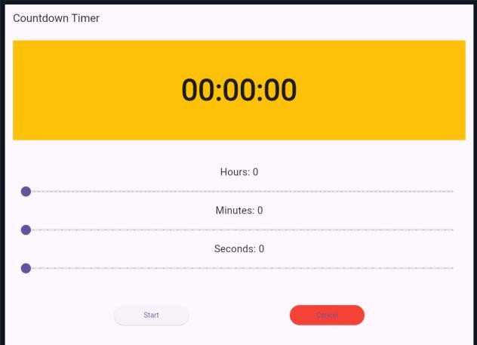
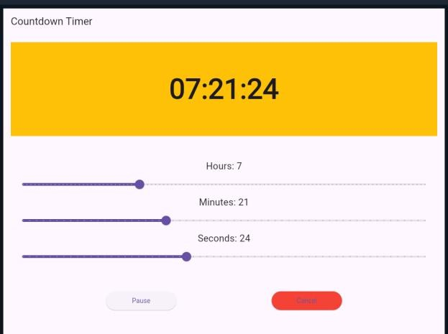

Practical no.8

Title: - Designing the mobile app to implement the routing. Input:
import 'package:flutter/material.dart'; void main() {
runApp(MaterialApp( h ome: MyApp(),
) ); }
class MyApp extends StatelessWidget {
const MyApp({Key? key}) : super(key: key); @override
Widget build(BuildContext context)
{ TextEditingController name = TextEditingController(); TextEditingController id = TextEditingController(); TextEditingController semester = TextEditingController(); TextEditingController dept = TextEditingController(); TextEditingController city = TextEditingController(); return Scaffold(
appBar: AppBar(
title: Text("Use Info"), centerTitle: true,
),
body:
Column( children:
[ SizedBox(height:
10), TextField( controller: name, decoration:
InputDecoration( labelText:
"Enter your name",

border: OutlineInputBorder( borderRadius: BorderRadius.circular(15),
), ), ),
SizedBox(height: 10), TextField(
controller: id, decoration:
InputDecoration( labelText:
"Enter your ID", border: OutlineInputBorder(
borderRadius: BorderRadius.circular(15),
), ), ),
SizedBox(height: 10), TextField(
controller: semester, decoration: InputDecoration(
labelText: "Enter your Semester", border: OutlineInputBorder(
borderRadius: BorderRadius.circular(15),
), ), ),
SizedBox(height: 10), TextField(
controller: dept, decoration:
InputDecoration( labelText: "Enter your Department", border: OutlineInputBorder(
borderRadius: BorderRadius.circular(15),
), ), ),
SizedBox(height: 10), TextField(

controller: city, decoration:
InputDecoration( labelText:
"Enter your City", border: OutlineInputBorder(
borderRadius: BorderRadius.circular(15),
), ), ),
SizedBox(height: 10), ElevatedButton( onPr essed: () {
Navigator.push( conte xt, MaterialPageRoute(
builder: (context) => NextScreen( name: name.text, id: id.text,
semester: semester.text, dept: dept.text,
city: city.text))).whenComplete(()
{ name.clear();
id.clear(); semester.clear(); dept.clear();
city.clear();
} ); },
child: Text("continue"),
), ], ), ); } }
class NextScreen extends StatelessWidget
{ String? name, id, semester, dept, city;
NextScreen(this.name, this.id, this.semester, this.dept, this.city); @override

Widget build(BuildContext context) { return
Scaffold( body:
Column( child ren: [
Text("Name: " + name.toString()), Text("Id: " + id.toString()), Text("Semester: " + semester.toString()), Text("Department: " + dept.toString()), Text("City: " + city.toString()),
], ), ); } }
Output:
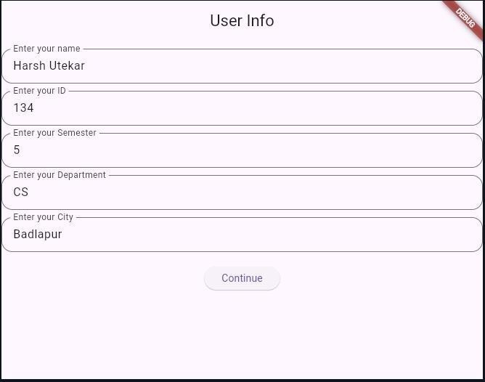
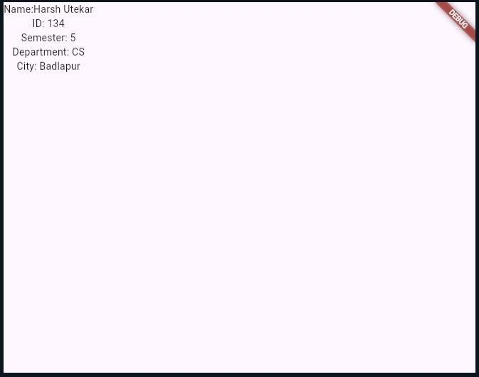

Practical no.:- 9

Title: - Designing the mobile app to demonstrate navigation in an app. Input:
import 'package:flutter/material.dart'; void main() {
runApp(const MyApp());
}
class MyApp extends StatelessWidget
{ const MyApp({super.key}); @override
Widget build(BuildContext context)
{ return const MaterialApp( home: HomePage(),
); } }
class HomePage extends StatelessWidget
{ const HomePage({super.key}); @override
Widget build(BuildContext context)
{ return Scaffold(
appBar: AppBar(title: const Text('Home Page')), drawer: Drawer(
child: ListView(
padding: EdgeInsets.zero, children:
<Widget>[ const DrawerHeader( decoration:
BoxDecoration( color:

Colors.blue,
),
child:
Text( 'Navigation Drawer', style:
TextStyle( color:
Colors.white, fontSize: 24,
), ), ),
ListTile(
leading: const Icon(Icons.home), title: const Text('Home'), onTap: ()
{ Navigator.pop(context);
}, ),
ListTile(
leading: const Icon(Icons.account_circle), title: const Text('Profile'),
onTap: ()
{ Navigator.push( co ntext,
MaterialPageRoute(builder: (context) => const ProfilePage()),
); }, ), ], ), ),
body: const Center(child: Text('Home Page Content')),
); } }
class ProfilePage extends StatelessWidget
{ const ProfilePage({super.key}); @override
Widget build(BuildContext context)
{ return Scaffold(
appBar: AppBar(title: const Text('Profile Page')), body:

const Center(child: Text('Profile Page Content')),
); } }

Output:
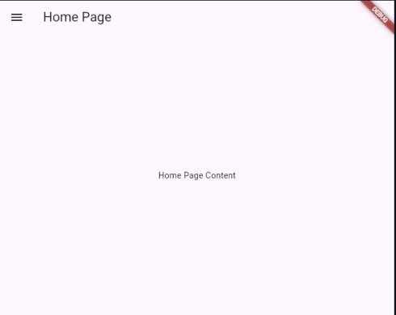
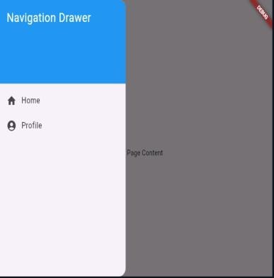

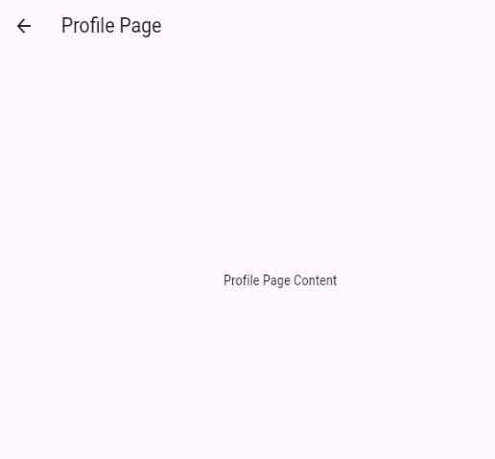
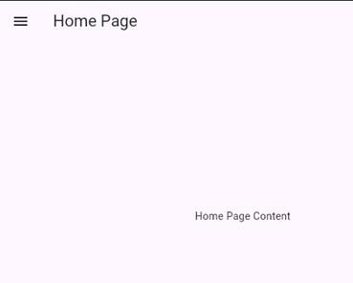

Practical no.10

Title: - Designing the mobile app to create a BMI Calculator. Input:
import 'package:flutter/material.dart'; void main() {
runApp(const MyApp());
}
class MyApp extends StatelessWidget {
const MyApp({Key? key}) : super(key: key); @override
Widget build(BuildContext context)
{ return const MaterialApp(
debugShowCheckedModeBanner: false, // Remove debug banner title: 'BMI Calculator',
home: BmiCalculatorScreen(),
); } }
class BmiCalculatorScreen extends StatefulWidget {
const BmiCalculatorScreen({Key? key}) : super(key: key); @override
State<BmiCalculatorScreen> createState() => _BmiCalculatorScreenState();
}
class _BmiCalculatorScreenState extends State<BmiCalculatorScreen>
{ final TextEditingController _heightController = TextEditingController(); final TextEditingController _weightController = TextEditingController(); String _bmiResult = '';
Color _resultColor = Colors.black; @override
void dispose() {
_heightController.dispose();

_weightController.dispose(); super.dispose();
}
void _calculateBMI() {
final double? height = double.tryParse(_heightController.text); final double? weight = double.tryParse(_weightController.text); if (height == null || height <= 0 || weight == null || weight <= 0)
{ setState(() {
_bmiResult = 'Please enter valid height and weight.';
_resultColor = Colors.red;
} );
return;
}
final double bmi = weight / (height * height); String category;
Color color;
if (bmi < 18.5) {
category = 'Underweight'; color = Colors.blue;
} else if (bmi >= 18.5 && bmi < 24.9)
{ category = 'Normal weight'; color = Colors.green;
} else if (bmi >= 25 && bmi < 29.9)
{ category = 'Overweight'; color = Colors.orange;
} else {
category = 'Obesity'; color = Colors.red;
}
setState(() {

_bmiResult = 'BMI: ${bmi.toStringAsFixed(2)}\nCategory: $category';
_resultColor = color;
} ); }
@override
Widget build(BuildContext context)
{ return Scaffold( appBar: AppBar(
title: const Text('BMI Calculator'), backgroundColor: Colors.deepOrange,
),
backgroundColor: Colors.grey[100], body: Center(
child:
SingleChildScrollView( padding:
const EdgeInsets.all(20), child:
SizedBox(
width: 380, // Slightly wider for better text fit on smaller screens child: Card(
color: Colors.white, elevation: 10, shape:
RoundedRectangleBorder( borderRadius: BorderRadius.circular(15),
),
child: Padding(
padding: const EdgeInsets.all(25), child: Column(
mainAxisSize: MainAxisSize.min, children: <Widget>[
const Text(
'Calculate Your Body Mass Index',

style: TextStyle(
fontSize: 20,
fontWeight: FontWeight.bold, color: Colors.deepOrange,
),
textAlign: TextAlign.center,
),
const SizedBox(height: 25), TextField(
controller: _heightController, keyboardType:
const TextInputType.numberWithOptions(decimal: true), decoration: InputDecoration(
labelText: 'Height (meters)', hintText: 'e.g., 1.75', border: OutlineInputBorder(
borderRadius: BorderRadius.circular(10)), prefixIcon: const Icon(Icons.height),
), ),
const SizedBox(height: 15), TextField(
controller: _weightController, keyboardType:
const TextInputType.numberWithOptions(decimal: true), decoration: InputDecoration(
labelText: 'Weight (kilograms)', hintText: 'e.g., 70.5',
border: OutlineInputBorder(
borderRadius: BorderRadius.circular(10)), prefixIcon: const Icon(Icons.scale),
), ),

const SizedBox(height: 30), ElevatedButton(
onPressed: _calculateBMI, style:
ElevatedButton.styleFrom( backgroundColo r: Colors.deepOrange, padding: const EdgeInsets.symmetric(
horizontal: 40, vertical: 15), shape: RoundedRectangleBorder(
borderRadius: BorderRadius.circular(10),
), ),
child: const
Text( 'Calculate BMI',
style: TextStyle(fontSize: 18, color: Colors.white),
), ),
const SizedBox(height: 25),
_bmiResult.isNotEmpty
? Text(
_bmiResult, style:
TextStyle( fontS ize: 22,
fontWeight: FontWeight.bold, color: _resultColor,
),
textAlign: TextAlign.center,
)
: const SizedBox.shrink(),
], ), ), ), ), ), ), ); } }

Output:-
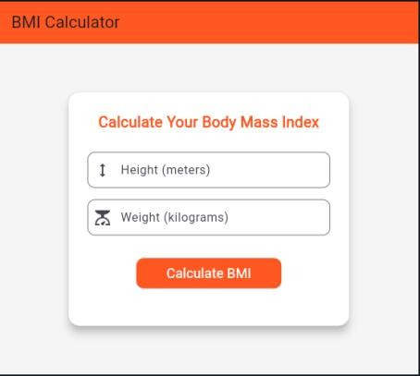
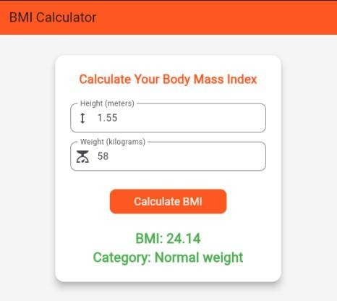

Practical no.11

Title: - Designing the mobile app to develop a simple TO-DO list app to manage the tasks. Input:
import 'package:flutter/material.dart'; void main() {
runApp(const MyApp());
}
class MyApp extends StatelessWidget
{ const MyApp({super.key}); @override
Widget build(BuildContext context)
{ return
MaterialApp( debugShowCheckedMode Banner: false, home: TodoListScreen(),
); } }
class TodoListScreen extends StatefulWidget
{ const TodoListScreen({super.key}); @override
TodoListScreenState createState() => TodoListScreenState();
}
class TodoListScreenState extends State<TodoListScreen>
{ List<String> _todos = []; void _addTodo()
{ String newTodo = '';
showDialog( contex t: context,
builder: (BuildContext context)
{ return AlertDialog(

title: const Text("Add a new To-Do"), content:
TextField( onChanged: (value) { newTodo = value;
}, ),
actions:
[ ElevatedButton( onPressed: () {
setState(() {
if (newTodo.isNotEmpty) {
_todos.add(newTodo);
}
Navigator.pop(context);
} ); },
child: const Text("Add"),
), ], ); }, ); }
@override
Widget build(BuildContext context)
{ return Scaffold( appBar: AppBar(
title: const Text("To-Do List"), backgroundColor: Colors.purple,
),
body:
ListView.builder( itemCount:
_todos.length, itemBuilder:
(context, index) { return Card( elevation: 4,
margin: const EdgeInsets.symmetric(vertical: 8, horizontal: 16), child: ListTile(

title: Text(
_todos[index],
style: const TextStyle(fontSize: 18),
),
trailing: IconButton(
icon: const Icon(Icons.delete), onPressed: () {
setState(() {
_todos.removeAt(index);
} ); }, ), ), ); }, ),
floatingActionButton: FloatingActionButton( onPressed:
_addTodo,
backgroundColor: Colors.purple, child: const Icon(Icons.add),
), ); } }
Output:
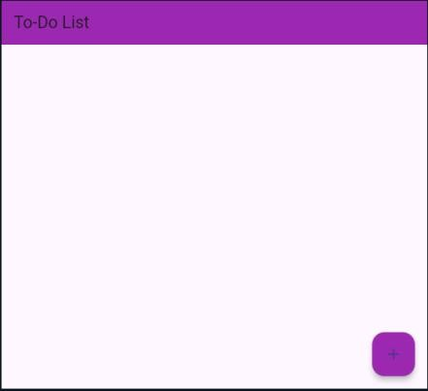
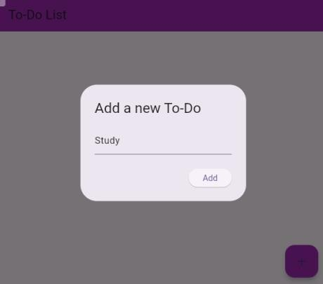
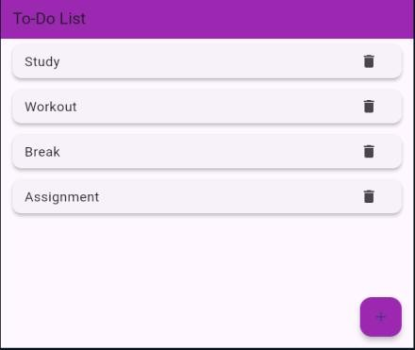
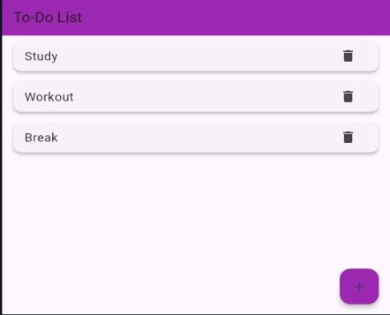

Practical no.12

Title: - Designing the mobile app to implement an Image Slider and Image Gallery. Input:
import 'package:flutter/material.dart'; void main()
{ runApp(ImageSliderApp());
}
class ImageSliderApp extends StatelessWidget
{ @override
Widget build(BuildContext context)
{ return
MaterialApp( debugShowCheckedMode Banner: false, home: ImageSliderScreen(),
); } }
class ImageSliderScreen extends StatefulWidget
{ @override
_ImageSliderScreenState createState() => _ImageSliderScreenState();
}
class _ImageSliderScreenState extends State<ImageSliderScreen>
{ final PageController _pageController = PageController(); int _currentPage = 0;
final List<String> _images =
[ 'https://picsum.photos/id/1011/600/400', 'https://picsum.photos/id/1012/600/400', 'https://picsum.photos/id/1013/600/400', 'https://picsum.photos/id/1014/600/400', 'https://picsum.photos/id/1015/600/400',
];

@override void initState()
{ super.initState();
_pageController.addListener(()
{ setState(() {
_currentPage = _pageController.page!.round();
} ); } ); }
@override
void dispose() {
_pageController.dispose(); super.dispose();
}
List<Widget> _buildPageIndicator() {
return List.generate(_images.length, (index)
{ return Container( width: 10,
height: 10,
margin: EdgeInsets.symmetric(horizontal: 4), decoration: BoxDecoration(
shape: BoxShape.circle,
color: _currentPage == index ? Colors.blue : Colors.grey,
), ); } ); }
@override
Widget build(BuildContext context)
{ return Scaffold( appBar: AppBar(
title: Text('Image Slider'), centerTitle: true,
),
body: Column(

children:
58
[ SizedBox(
height: 300, // Prevents overflow child:
PageView.builder( controller:
_pageController, itemCount:
_images.length, itemBuilder:
(context, index) {
return Image.network(
_images[index], fit: BoxFit.cover,
loadingBuilder: (context, child, loadingProgress)
{ if (loadingProgress == null) return child; return Center(child: CircularProgressIndicator());
},
errorBuilder: (context, error, stackTrace) {
return Center(child: Text('Failed to load image'));
}, ); }, ), ),
SizedBox(height: 20), Row(
mainAxisAlignment: MainAxisAlignment.center, children: _buildPageIndicator(),
), ], ), ); } }
Output:
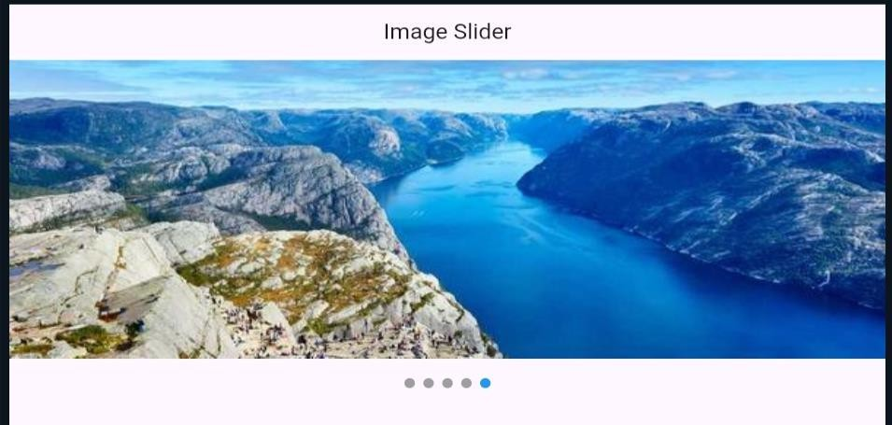

Input:
import 'package:flutter/material.dart'; void main() {
runApp(MyApp());
}
class MyApp extends StatelessWidget
{ @override
Widget build(BuildContext context)
{ return
MaterialApp( debugShowCheckedMode Banner: false, home:
ImageGalleryScreen(),
); } }
class ImageGalleryScreen extends StatelessWidget
{ final List<String> _images = [ 'https://images.pexels.com/photos/1108099/pexels-photo-1108099.jpeg', 'https://images.pexels.com/photos/213399/pexels-photo-213399.jpeg', 'https://images.pexels.com/photos/220453/pexels-photo-220453.jpeg', 'https://images.pexels.com/photos/302743/pexels-photo-302743.jpeg', 'https://images.pexels.com/photos/247932/pexels-photo-247932.jpeg', 'https://images.pexels.com/photos/1704120/pexels-photo-1704120.jpeg', 'https://images.pexels.com/photos/34950/pexels-photo.jpg', 'https://images.pexels.com/photos/733872/pexels-photo-733872.jpeg',
];
@override
Widget build(BuildContext context)
{ return Scaffold( appBar: AppBar(
title: Text("Image Gallery"), centerTitle: true,

backgroundColor: Colors.amber,
),
body: Padding(
padding: const EdgeInsets.all(8.0), child:
GridView.builder( itemCount:
_images.length, gridDelegate:
SliverGridDelegateWithFixedCrossAxisCount( crossAxisCount: 3,
crossAxisSpacing: 4,
mainAxisSpacing: 4,), itemBuilder: (context, index)
{ return ClipRRect(
borderRadius: BorderRadius.circular(4), child: Image.network(
_images[index], fit: BoxFit.cover,
), ); }, ), ), ); } }
Output:
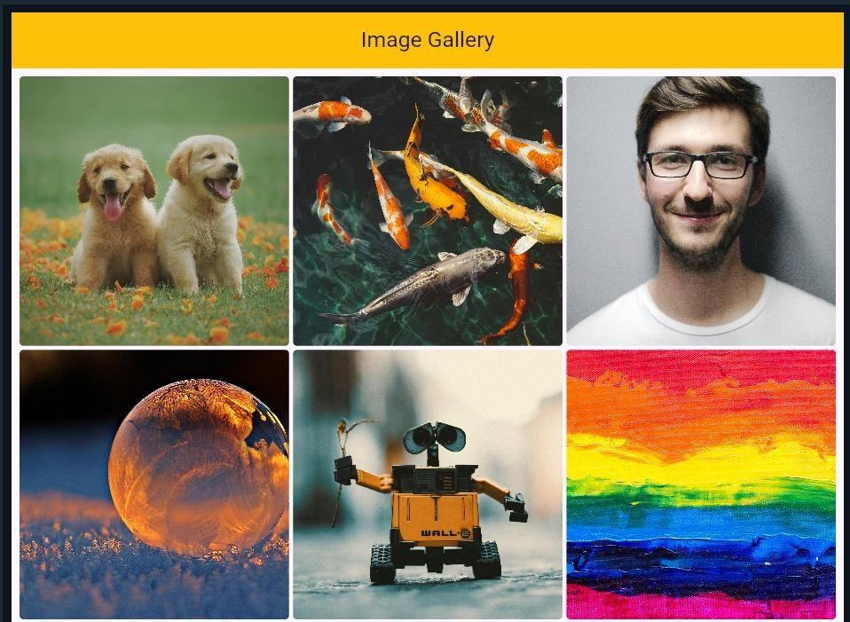

Practical no.13

Title: - Designing the mobile app to implement the state management. Input:
import 'package:flutter/material.dart'; void main() {
runApp(const MyApp());
}
class MyApp extends StatelessWidget {
const MyApp({Key? key}) : super(key: key); @override
Widget build(BuildContext context)
{ return MaterialApp(
debugShowCheckedModeBanner: false, // Hide the debug banner title: 'Checkbox Example',
theme:
ThemeData( useMat erial3: true,
),
home: const HomePage(),
); } }
class HomePage extends StatefulWidget {
const HomePage({Key? key}) : super(key: key); @override
State<HomePage> createState() => _HomePageState();
}
class _HomePageState extends State<HomePage> {
// Generate a list of available hobbies List<Map> availableHobbies = [
{"name": "Football", "isChecked": false},

{"name": "Baseball", "isChecked": false},
{
"name": "Video Games", "isChecked": false,
},
{"name": "Reading Books", "isChecked": false},
{"name": "Dancing", "isChecked": false}
];
@override
Widget build(BuildContext context)
{ return Scaffold( appBar: AppBar(
title: const Text('Checkbox Example'), backgroundColor: Colors.blueAccent, centerTitle: true,
),
body:
SingleChildScrollView( child:
Padding(
padding: const EdgeInsets.all(20), child: Column(
crossAxisAlignment: CrossAxisAlignment.start, children: [
const Text(
'Choose your hobbies:',
style: TextStyle(fontSize: 24),
),
const SizedBox(height: 10), const Divider(),
const SizedBox(height: 10),
// The checkboxes will be here

Column(
children: availableHobbies.map((hobby)
{ return CheckboxListTile( value: hobby["isChecked"], title: Text(hobby["name"]), onChanged: (newValue)
{ setState(() {
hobby["isChecked"] = newValue;
} ); }, );
} ).toList(),
),
// Display the result here const SizedBox(height: 10), const Divider(),
const SizedBox(height: 10), Wrap(
children: availableHobbies.map((hobby)
{ if (hobby["isChecked"] == true) { return
Card( elevation: 3, color: Colors.amber, child: Padding(
padding: const EdgeInsets.all(8.0), child: Text(hobby["name"]),
), ); }
return Container();
}).toList(),
), ], ), ), ), ); } }

Output:
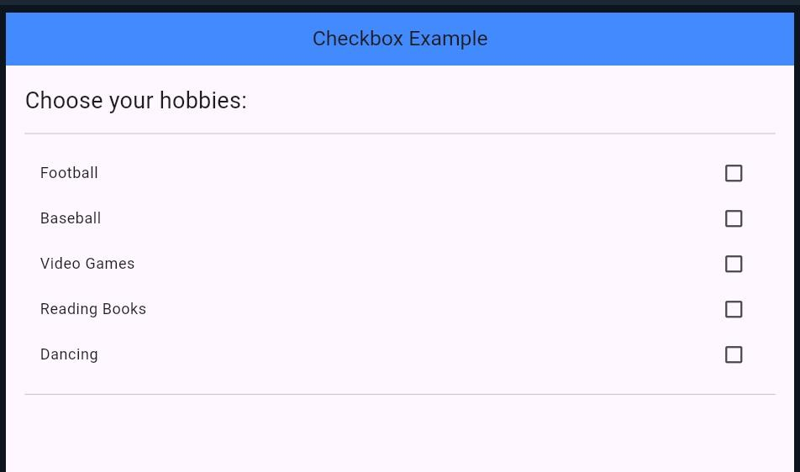
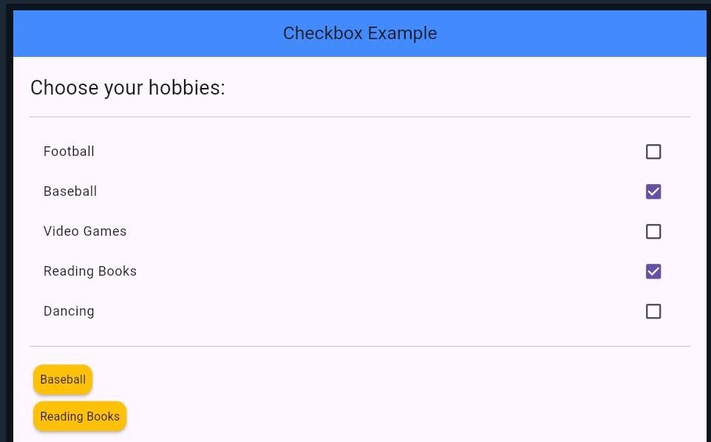

Practical no.14
Title: - Designing the mobile app to implement an animation. Input:
import 'package:flutter/material.dart'; void main() {
runApp(const MyApp());
}
class MyApp extends StatelessWidget {
const MyApp({Key? key}) : super(key: key); @override
Widget build(BuildContext context)
{ return const
MaterialApp( debugShowCheckedMode Banner: false, title: 'Animation Example', home: HomePage(),
); } }
class HomePage extends StatefulWidget {
const HomePage({Key? key}) : super(key: key); @override
State<HomePage> createState() => _HomePageState();
}
class _HomePageState extends State<HomePage> with TickerProviderStateMixin {
bool _isPlay = false;
late AnimationController _controller; @override
void initState() {
_controller =
AnimationController( duration: const Duration(seconds: 1), vsync: this,

);
super.initState();
}
// Dispose the controller @override
void dispose() {
_controller.dispose(); super.dispose();
}
@override
Widget build(BuildContext context)
{ return Scaffold( appBar: AppBar(
title: const Text('Animated Play/Pause Button'), backgroundColor: Colors.amberAccent, centerTitle: true,
),
body: Center( child:
GestureDetector( onT ap: () {
if (_isPlay == false) {
_controller.forward();
_isPlay = true;
} else {
_controller.reverse();
_isPlay = false;
} },
child: AnimatedIcon(
icon: AnimatedIcons.play_pause, progress: _controller,

size: 200,
color: Colors.blue,
), ), ), ); } }
Output:
