HEART DISEASE DATASET

Abstract
Heart disease is an important public-health concern, and analysing clinical data can help researchers explore patterns in patient characteristics and test hypotheses about cardiovascular risk. This article presents a brief exploratory analysis of a heart-disease dataset containing demographic information, chest-pain categories, blood pressure, cholesterol, exercise-related measurements and other clinical attributes. The analysis describes the dataset structure, data quality, and possible uses in statistical and machine-learning work. The dataset does not contain an obvious diagnosis or target column in the provided 14 columns, so it should not be used for supervised disease prediction until the intended target is identified.

1. Introduction
Heart disease is associated with a range of demographic, clinical and exercise-related factors. Exploratory data analysis (EDA) helps summarise such information, detect missing or unusual values, and identify patterns worth investigating. The goal here is to describe the supplied dataset rather than make clinical conclusions or diagnose individual patients.

2. Dataset Overview
The file contains 1,619 records and 14 columns. The fields include age, sex, chest-pain type (cp), resting blood pressure (trestbps), cholesterol (chol), fasting blood sugar (fbs), resting ECG result (restecg), maximum heart rate (thalch), exercise-induced angina (exang), ST-segment slope (slope), number of major vessels (ca), and thalassemia-related category (thal). The remaining two columns are an entirely empty column named 'Unnamed: 12' and a date field.
Attribute | Meaning | Data quality note
age | Age in years | Complete
sex | Recorded sex category | Complete
cp | Chest-pain category | Complete
trestbps | Resting blood pressure | 131 missing; includes zero values
chol | Serum cholesterol | 84 missing; includes zero values
fbs | Fasting blood sugar flag | 108 missing
restecg | Resting ECG category | 2 missing
thalch | Maximum heart rate achieved | 127 missing
exang | Exercise-induced angina flag | 127 missing
slope | Peak exercise ST-segment slope | 843 missing
ca | Number of major vessels | 1,301 missing
thal | Thal-related category | 1,119 missing
Unnamed: 12 | Unlabelled/empty column | All 1,619 values missing
date | Date field | Only 20 values present

3. Exploratory Data Analysis
Measure | Observed result
Number of records | 1,619
Age | Mean 51.8 years; range 28–77 years
Sex distribution | Male: 1,227; Female: 392
Chest-pain category | Most common: asymptomatic (718 records)
Resting blood pressure | Mean 131.5; median 130.0; 131 values missing
Cholesterol | Mean 212.7; median 224.0; 84 values missing
Maximum heart rate | Mean 139.7; 127 values missing
The dataset is unevenly distributed by sex: male records make up about 75.8% of all rows. Asymptomatic chest pain is the largest chest-pain category (718 records), followed by atypical angina (459), non-anginal pain (369) and typical angina (73). These are descriptions of the records, not evidence that one category causes or predicts disease.
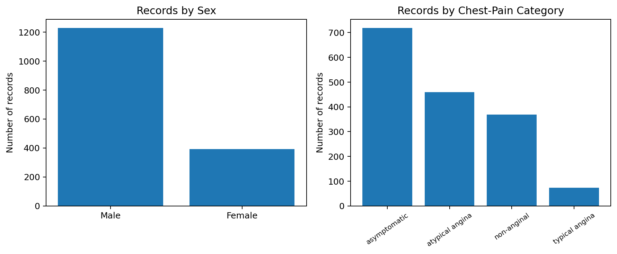
Figure 1. Counts by sex and recorded chest-pain category.

4. Missing Values and Data Quality
Data quality is the main limitation identified in this initial review. The 'Unnamed: 12' column is completely empty and can be removed. The date field contains only 20 non-missing values out of 1,619, so its purpose and reliability should be checked before use. The columns ca and thal have 1,301 and 1,119 missing values respectively, while slope has 843 missing values. Missingness at this scale can substantially affect analysis and may introduce bias if handled carelessly.
The blood-pressure and cholesterol columns include zero values. Since zero may be an invalid or placeholder measurement for these fields, those records should be checked against the data source rather than automatically treated as genuine measurements. Missing values should be summarised, investigated, and handled using a method appropriate to the analysis.

5. Recommended Preprocessing
- Remove the fully empty column and standardise column names (for example, remove the trailing space in 'date ').
- Inspect duplicate records, data types, category labels and implausible numeric values.
- Determine whether zero blood-pressure and cholesterol values represent missing or erroneous measurements.
- Report missingness for every feature; choose deletion or imputation only after considering the amount and likely cause of missing data.
- Encode categorical features when required by a statistical or machine-learning method.
- Identify and verify the correct outcome/diagnosis column before attempting supervised classification.

6. Potential Applications
After data cleaning and target verification, the dataset may be used for descriptive statistics, visualisation, association analysis and educational machine-learning experiments. If a valid diagnosis label is available, classification models could be evaluated using a held-out test set, cross-validation, sensitivity, specificity, precision, recall and ROC-AUC. Any model would require careful validation and must not be treated as a substitute for professional medical assessment.

7. Conclusion
The supplied dataset provides demographic and clinical measurements that are suitable for an initial exploratory analysis. It contains 1,619 records, an average age of about 51.8 years, a male-majority sample, and asymptomatic chest pain as the most common recorded chest-pain category. However, extensive missing values in several clinical fields, an empty column, a mostly missing date field, and the absence of a clearly identifiable target label limit what can be concluded. Cleaning and validation should therefore precede any predictive modelling. These findings describe this dataset only and are not medical advice.

