Synopsis

K-Means Clustering–Based Analytical System for Agricultural Region Classification.

- Problem ID: 04

Student Name : ARYAN GUSAIN , ADITYA AHLAWAT
University Roll Number : 2028669 , 2028621

Section : P

1. Introduction

Agriculture plays a vital role in the economy of many countries, especially in developing nations like India, where a significant portion of the population depends on farming for livelihood. Despite being a data-rich domain, agricultural planning and decision-making are often based on traditional knowledge, administrative boundaries, or limited datasets. This leads to inefficient resource allocation, inconsistent productivity, and suboptimal policy implementation.

With the advancement of data science and machine learning, it is now possible to analyze agricultural data in a structured and intelligent way. One such powerful technique is K-Means clustering, an unsupervised machine learning algorithm that groups similar data points together without prior labeling. By applying this method to agricultural datasets, regions can be classified into clusters based on environmental conditions, soil properties, and productivity metrics.

This project proposes the design and implementation of a K-Means clustering–based analytical system to classify agricultural regions into meaningful groups. The goal is to provide actionable insights for policymakers, researchers, and farmers by identifying patterns and similarities across different regions.

- STEPS OF IMPLEMENTATION :

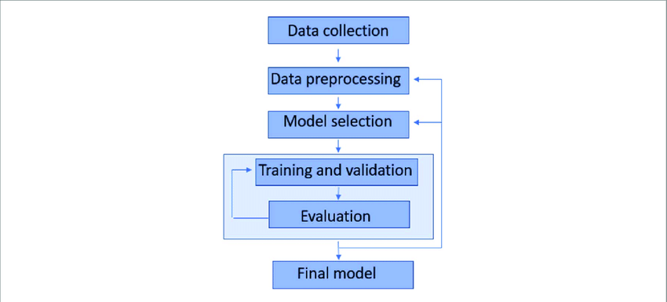

- DATA SET ATTACHED LINK :

agriculture_kmeans_dataset.csv

2. Problem Statement
Agricultural regions vary significantly in terms of:
- Rainfall patterns
- Temperature ranges
- Soil composition
- Irrigation facilities
- Crop productivity
Due to this variability, it becomes difficult to design uniform agricultural policies. Current approaches often rely on manual classification or administrative divisions, which may not reflect actual similarities between regions.
The main problem addressed in this project is:
How to systematically classify agricultural regions using data-driven techniques to enable better planning and decision-making?
This system aims to:
- Identify natural groupings of regions
- Improve resource allocation
- Support precision agriculture
- Enable region-specific recommendations

3. Objectives
The key objectives of this project are:
- To construct or utilize a dataset with multiple agricultural features.
- To perform exploratory data analysis (EDA) for understanding data patterns.
- To preprocess the data for effective clustering.
- To apply K-Means clustering for grouping regions.
- To evaluate clustering performance using appropriate metrics.
- To predict cluster membership for new regions.
- To visualize clusters for better interpretability.

4. Dataset Description
The dataset used in this project consists of 20 features per agricultural region, capturing environmental, soil, and productivity factors.

Features Included:
- Average rainfall (mm)
- Average temperature (°C)
- Soil moisture level (%)
- Soil pH
- Nitrogen content
- Phosphorus content
- Potassium content
- Irrigation coverage (%)
- Crop area (hectares)
- Fertilizer usage (kg/hectare)
- Pesticide usage (kg/hectare)
- Sunlight hours
- Humidity (%)
- Altitude (meters)
- Wind speed (km/h)
- Groundwater level (meters)
- Crop diversity index
- Farming mechanization score
- Historical yield variance
- Average crop yield (tons/hectare)
Each row represents a single agricultural region, and each column represents a feature.

5. Methodology

5.1 Data Collection and Loading
The dataset is either:
- Collected from real-world agricultural sources, or
- Generated synthetically for experimental purposes
The data is loaded using Pandas DataFrame, which allows easy manipulation and analysis.

5.2 Exploratory Data Analysis (EDA)
EDA is a crucial step to understand the dataset before applying machine learning.

Key Steps:
- Summary Statistics: Mean, median, standard deviation
- Histograms: To check distribution of features
- Box Plots: To detect outliers
- Correlation Heatmap: To identify relationships between features
- Scatter Plots: To visualize feature interactions
EDA helps in:
- Identifying skewness
- Detecting anomalies
- Understanding feature importance

5.3 Data Preprocessing
Proper preprocessing ensures that the clustering algorithm performs effectively.

Steps Involved:
- Handling Missing Values
  - Median imputation is used for numerical features.
- Outlier Detection
  - Using Interquartile Range (IQR) method
  - Outliers are either capped or removed
- Feature Scaling
  - StandardScaler (mean = 0, variance = 1)
  - Ensures equal importance of all features

5.4 Feature Selection
To improve model performance and reduce complexity:
- Backward Elimination: Remove least useful features
- Forward Selection: Add important features gradually
- VIF (Variance Inflation Factor): Detect multicollinearity
This step ensures:
- Reduced noise
- Better clustering quality

5.5 K-Means Clustering
K-Means is the core algorithm used in this project.

Working Principle:
- Choose number of clusters (K)
- Initialize centroids randomly
- Assign points to nearest centroid
- Update centroids
- Repeat until convergence

K-Means++ Initialization
Improves centroid selection and avoids poor clustering.

5.6 Determining Optimal Number of Clusters
Two main methods are used:

Elbow Method
- Plot WCSS vs K
- Optimal K is where the curve bends

Silhouette Score
- Measures cluster quality
- Value ranges from -1 to 1
- Higher value = better clustering

5.7 Dimensionality Reduction
Since data has many features:
- PCA (Principal Component Analysis) is used
- Reduces dimensions while preserving variance
Benefits:
- Better visualization
- Reduced computation

5.8 Prediction on New Data
The trained model can classify new agricultural regions:
Steps:
- Apply same preprocessing
- Use trained model
- Predict cluster label
This enables real-world application of the system.

6. Tools and Technologies

Programming Language
- Python

Libraries Used

Data Handling
- NumPy
- Pandas

Machine Learning
- Scikit-learn
  - KMeans
  - StandardScaler
  - PCA
  - silhouette_score

Visualization
- Matplotlib
- Seaborn
- Plotly (optional)

Utilities
- Joblib / Pickle (for model saving)

7. Evaluation Metrics

1. Silhouette Score
- Measures cohesion and separation
- Best value close to 1

2. WCSS (Within Cluster Sum of Squares)
- Used in elbow method
- Lower value is better

3. Davies-Bouldin Index
- Lower value indicates better clusters

4. Calinski-Harabasz Score
- Higher value indicates well-separated clusters

8. Visualization Techniques
- Correlation Heatmap
- Histograms
- Box Plots
- PCA Scatter Plot
- Elbow Curve
- Silhouette Plot
- Cluster Visualization
These help in understanding clustering results visually.

8.1. Histogram Analysis :
- Shows distribution of features like rainfall, temperature, soil moisture, etc.
- Most features follow approximately normal distribution
- No extreme skewness → good for clustering

8.2. Scatter Plot (Rainfall vs Yield) :
- Shows positive correlation
- Higher rainfall → higher crop yield
- Indicates strong dependency between environmental factors and yield

8.3. Correlation Heatmap :
- Displays relationships between all features
- Strong positive correlation observed between:
  - Rainfall & Yield
  - Soil Moisture & Yield
- Helps in feature selection (removing redundant variables)

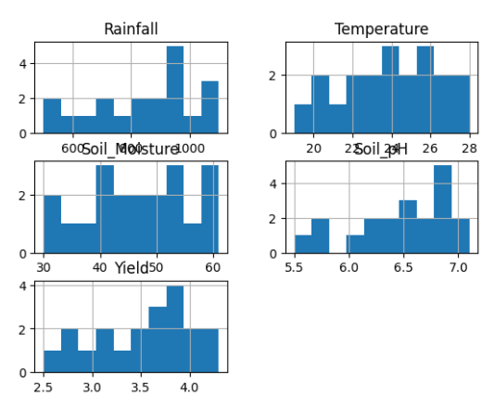

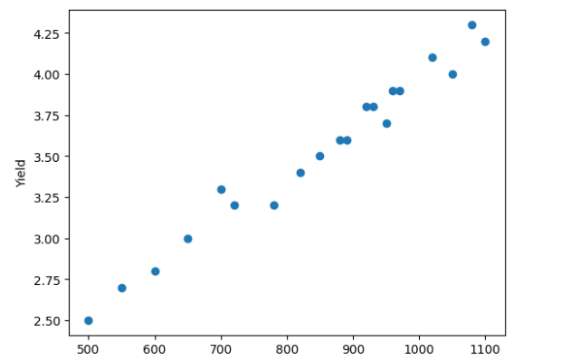

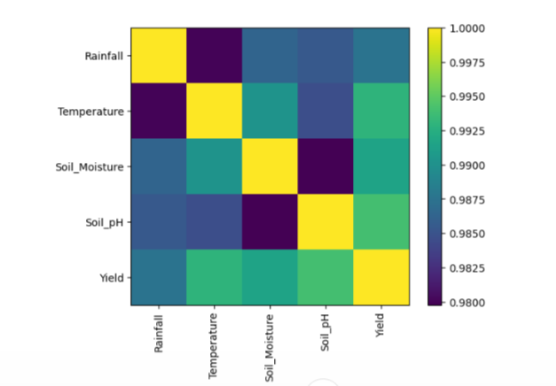

9. Applications
This system can be used in:
- Agricultural policy planning
- Crop recommendation systems
- Precision farming
- Resource optimization
- Climate impact studies

10. Advantages
- Data-driven decision making
- Identifies hidden patterns
- Improves productivity
- Reduces human bias

11. Limitations
- Sensitive to outliers
- Requires proper scaling
- Choosing K can be tricky
- Assumes spherical clusters

12. Future Scope
- Integration with real-time data
- Use of advanced clustering (DBSCAN, Hierarchical)
- Deployment as web application
- Integration with GIS systems

13. Conclusion
This project demonstrates how machine learning, specifically K-Means clustering, can be applied to agriculture for meaningful insights. By grouping regions based on multiple features, the system enables better understanding and decision-making.
The approach is scalable, adaptable, and can significantly contribute to modern agricultural practices
14. Required topics from the subject:
  - Unsupervised Machine Learning The core of the project is K-Means clustering, an unsupervised learning algorithm that partitions n observations into K clusters where each observation belongs to the cluster with the nearest centroid. Understanding the algorithmic mechanics — random initialization, iterative assignment, centroid update, and convergence — is essential. The concept of k-means++ initialization for better convergence must be covered.
  - Exploratory Data Analysis Students must understand how to profile a dataset statistically and visually before modeling. This includes computing descriptive statistics, understanding skewness and kurtosis, detecting outliers using IQR, and interpreting correlation matrices.
  - Data Preprocessing and Feature Engineering Topics include imputation strategies for missing values, the importance of feature scaling for distance-based algorithms, and the distinction between normalization and standardization. The impact of unscaled features on Euclidean distance-based clustering must be explained.
  - Dimensionality Reduction PCA theory is required — understanding eigenvalues, eigenvectors, explained variance ratio, and the scree plot. The difference between PCA (linear) and t-SNE (non-linear) for visualization and their appropriate use cases must be understood.
15. Platform Required:
  - Jupyter Notebook
16. Books and Link Sources:
https://scikit-learn.org/stable/modules/generated/sklearn.cluster.KMeans.html
https://scikit-learn.org/stable/modules/clustering.html
https://scikit-learn.org/stable/modules/generated/sklearn.metrics.silhouette_score.html
https://scikit-learn.org/stable/auto_examples/cluster/plot_kmeans_silhouette_analysis.htm

