Report
Of
GenAI-Powered Data Analytics for Predictive Collections Strategy
Submitted
To
School of Computer Science and Engineering
IILM University, Greater Noida, U.P.

In partial fulfilment of the requirement of degree of
B.Tech CSE



By
Roll Number of Student: 2410031399
Name of Student: Aryan Singh
Batch: 2024-28

2026-27

CANDIDATE’S DECLARATION

I, Aryan Singh do hereby declare that the internship report titled “GenAI-Powered Data Analytics for Predictive Collections Strategy” has been completed by me to fulfil the requirement for the award of the degree of Bachelor of Technology in CSE. All the references have been quoted and I have not taken as such any material from any other source. I affirm to you that this report is my own and has not been submitted to any other institute for any degree/diploma requirement and further I shall be solely responsible for any kind of copyright violation in this regard.

Signature
Student Name Aryan Singh
Roll No. 2410031399

ACKNOWLEDGEMENT

I am using this opportunity to express my gratitude to everyone who supported me throughout the Internship Program. I am thankful for their aspiring guidance, invaluably constructive criticism and friendly advice during this work. I am sincerely grateful to them for sharing their truthful and illuminating views on a number of issues related to this work.
I would like to thank the Tata Group and Tata iQ, in collaboration with Forage, for designing and providing the “GenAI Powered Data Analytics Job Simulation”, which gave me a structured, practical opportunity to apply data analytics and Generative AI tools to a real-world business problem. I am also thankful to my institute, IILM University, Greater Noida, and the faculty of the School of Computer Science and Engineering, for their continuous support and encouragement throughout this internship.
I express my gratitude to my parents for their blessings

Signature
Student Name: Aryan Singh
Roll No: 2410031399

Chapter No. | Chapter Name | Page Nos.
 | Cover Page
1. | Candidate’s Declaration | i
2. | Acknowledgment | ii
3. | Internship Completion Certificate
4. | Project Description  4 .1 Introduction  4.2 Organization Profile  4.3 Problem Statement  4.4 Project Objectives  4.5 Scope of the Project  4.6 Technologies and Tools Used  4.7 System Architecture  4.8 Methodology  4.9 Expected Outcomes  4.10 Certificates of completion and other communication mail proof must be attached | 1-7
5. | Bibliography/References | 8

3. INTERNSHIP COMPLETION CERTIFICATE
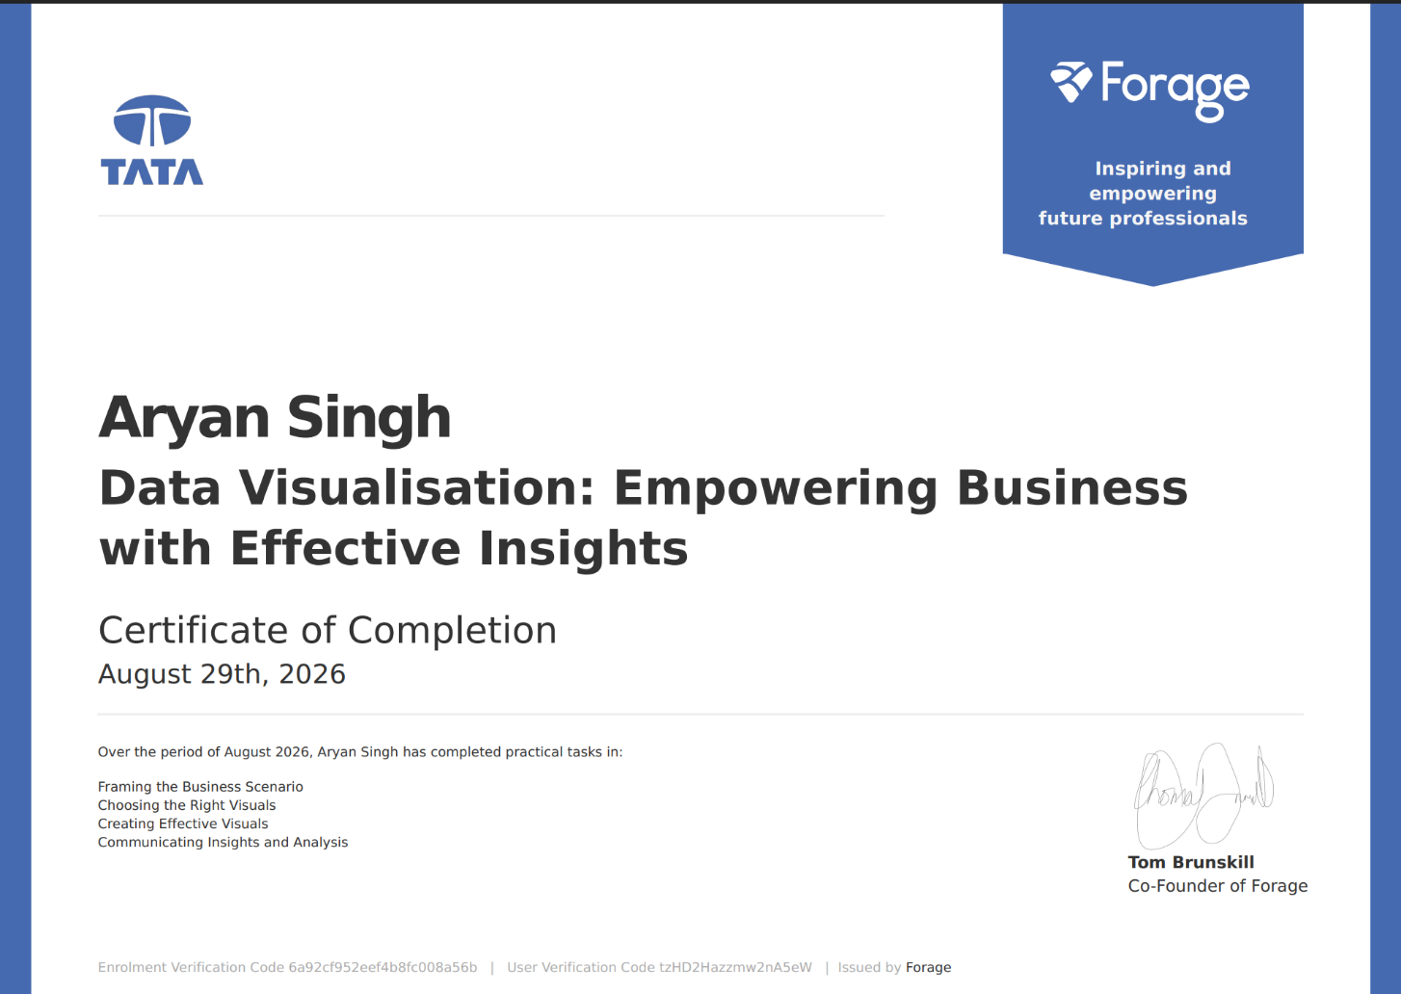
Certificate Link

4. PROJECT DESCRIPTION
4.1 Introduction
This report presents a detailed account of the internship undertaken under the “GenAI Powered Data Analytics Job Simulation”, offered by Tata (through Tata iQ) and hosted on the Forage virtual experience platform. The simulation was completed in August 2026 as part of the requirement of the Bachelor of Technology (Computer Science and Engineering) programme at IILM University, Greater Noida. The simulation placed the learner in the role of a data analyst supporting Geldium, a fictional consumer lending company, in building a predictive strategy to reduce customer delinquency and improve collections outcomes.
The programme was structured around four practical, business-facing tasks: exploratory data analysis and risk profiling, predictive model design, business reporting and data storytelling, and the design of an AI-driven collections strategy. Generative AI tools (such as ChatGPT) were used throughout as productivity aids — to scaffold analysis plans, draft pipeline outlines, and structure recommendations — while all quantitative findings were derived directly from the provided dataset. On successful completion of all four tasks, a Certificate of Completion was issued by Forage on behalf of Tata.
4.2 Organization Profile
Tata is one of India's largest and most diversified business conglomerates, with operations spanning information technology, financial services, steel, automotive, retail, and more. Tata iQ is the analytics and artificial-intelligence arm associated with the Tata ecosystem, focused on applying data science, machine learning, and Generative AI to solve real business problems across industries, including financial services and collections risk management.
Forage is a global virtual work-experience platform that partners with leading employers to design free, self-paced “job simulations” that mirror the actual tasks performed by professionals inside those organizations. Through Forage, students and early-career professionals can complete realistic, employer-designed projects and receive a verifiable Certificate of Completion. The GenAI Powered Data Analytics Job Simulation used in this internship was designed by Tata and delivered through Forage, giving participants hands-on exposure to how a real analytics team at a financial institution would approach a delinquency-prediction and collections-strategy problem.
4.3 Problem Statement
Geldium, the simulated lending organization at the centre of this project, faced a recurring business problem common across consumer-credit portfolios: a meaningful share of customers fall behind on payments, and the collections team lacked a systematic, data-driven way to identify at-risk customers early and to prioritize outreach efficiently. Reactive, post-due-date collections is costly to run and can damage the customer relationship, while a purely rules-based approach fails to capture the combined effect of behavioural and financial risk signals. The problem addressed by this internship was to analyse Geldium's customer dataset, design a predictive model capable of flagging delinquency risk before it materializes, and translate those findings into a responsible, business-ready collections strategy that balances accuracy, fairness, and explainability.
4.4 Project Objectives
- To assess the completeness and quality of a 500-record customer dataset and resolve missing values and inconsistencies ahead of modelling.
- To identify early behavioural and financial risk indicators associated with delinquency through exploratory data analysis (EDA).
- To design a predictive modelling pipeline — including feature selection, model choice, and evaluation strategy — to forecast customer delinquency risk.
- To translate model insights into a clear, non-technical business report using the SMART framework for actionable recommendations.
- To design an AI-driven, agentic collections strategy that automates routine outreach while keeping humans in the loop for high-impact decisions.
- To apply responsible-AI principles — fairness, explainability, transparency, and regulatory compliance — throughout the analytics and strategy work.
- To practise using Generative AI tools effectively and transparently as part of a professional data-analytics workflow.

4.5 Scope of the Project
The scope of this internship covered the full analytics-to-strategy lifecycle for a single simulated use case delinquency prediction for Geldium's consumer-lending portfolio using a dataset of 500 customer records across 19 fields (demographic, financial, and behavioural attributes, including six months of payment history). The work spanned data quality assessment and cleaning, exploratory risk-factor analysis, predictive-model planning (logistic regression and gradient-boosted trees), business-facing reporting for a non-technical stakeholder audience, and the design of an AI-powered, agentic collections-outreach framework with built-in governance and fairness guardrails. The internship was conducted entirely within Forage's simulated, self-paced virtual environment and did not involve deployment on any live organizational system or real customer data.
4.6 Technologies and Tools Used
- Data Analysis: Microsoft Excel (dataset review, summary statistics, pivot analysis)
- Generative AI Tools: ChatGPT (used for scaffolding analysis plans, pipeline outlines, and drafting assistance, then adapted and verified against the actual dataset)
- Documentation & Reporting: Microsoft Word (EDA summary report, business summary report, model plan)
- Presentation & Strategy Design: Microsoft PowerPoint (AI-driven collections strategy briefing)
- Modelling Concepts Applied: Logistic Regression and Gradient-Boosted Trees (e.g., XGBoost/LightGBM) as candidate delinquency-prediction models
- Evaluation Concepts Applied: Precision, Recall, F1-score, AUC-ROC, and Confusion Matrix analysis for imbalanced classification
4.7 System Architecture
The proposed solution follows a closed-loop, agentic-AI architecture designed during the collections-strategy task, in which every automated action feeds back into the model so that the system becomes progressively smarter and fairer over time. The architecture consists of four layers:
- Customer Data Layer: repayment history, credit utilization, engagement and contact history, and account status are ingested as the raw input signals.
- Decision Logic Layer: a predictive risk-scoring model (logistic regression, benchmarked against gradient-boosted trees) is combined with a business-rule overlay to assign each account to a risk tier — Low, Medium, or High.
- Automated Action Layer: tiered outreach is triggered according to risk tier — automated reminders for low risk, personalized repayment-plan outreach for medium risk, and escalation to a human agent for high-risk or hardship cases.
- Learning-Loop Layer: outcomes (repayment, complaints, disputes) are logged against each action, and the model is periodically retrained and its thresholds recalibrated, with bias and drift audits run on a fixed cadence.
Governance is built into the architecture itself: routine, low-stakes actions (sending reminders, nightly re-scoring, routing accounts) run autonomously, while any decision with material customer impact — hardship plans, settlement negotiation, dispute review, or actions affecting credit reporting — is routed to a human for review or approval.

4.8 Methodology
The internship followed a four-task, business-simulation methodology, moving from raw data to a governed AI strategy, as summarized below.
Table 4.1: Task-wise Internship Methodology Summary
Task | Focus Area | Description
1 | Exploratory Data Analysis & Risk Profiling | Assessed the completeness and quality of Geldium's 500-record customer dataset; identified and treated missing values in Income, Loan_Balance, and Credit_Score using grouped median imputation; standardized inconsistent Employment_Status labels; flagged anomalous over-100% Credit_Utilization records; and surfaced early risk indicators across employment status, card type, and location, while noting that univariate correlations with delinquency were unexpectedly weak.
2 | Predictive Modelling Approach | Designed a two-stage modelling pipeline — logistic regression as an interpretable baseline benchmarked against gradient-boosted trees for non-linear interactions. Prioritized Missed_Payments, Credit_Utilization, Debt_to_Income_Ratio, a payment-trend feature engineered from six months of history, and Credit_Score as the top predictive features, and defined an evaluation strategy centred on recall, precision, F1, and AUC-ROC given the 16% delinquency base rate, along with bias and fairness checks across demographic segments.
3 | Business Report & Data Storytelling | Translated the top three EDA and model-derived risk factors — credit utilization, missed-payment history, and income/tenure — into a business report for the Head of Collections. Applied the SMART framework to propose a specific, measurable, time-bound proactive-outreach programme for customers crossing a 70% utilization threshold, and documented fairness, explainability, and transparency safeguards for the Collections team.
4 | AI-Driven Collections Strategy | Designed an agentic-AI collections system covering the end-to-end workflow from customer data to a learning loop, defined which actions the system could take autonomously versus which required human-in-the-loop review, and articulated the expected business impact (lower delinquency, higher repayment rate, lower cost-to-collect) alongside responsible-AI guardrails aligned to FDCPA, ECOA/Reg B, FCRA, and GDPR/CCPA-style requirements.

Each task concluded with a structured, business-ready deliverable (an EDA summary report, a predictive-model plan, a business summary report, and a collections-strategy briefing), and Generative AI prompts used at each stage were documented transparently within the corresponding deliverable, consistent with the simulation's expectations around responsible GenAI usage.
4.9 Expected Outcomes
- Ability to assess data quality, identify missing values and inconsistencies, and apply justified imputation strategies before modelling.
- Practical understanding of how to translate exploratory findings into candidate predictive features and a two-model (simple vs. complex) evaluation plan.
- Capability to select and justify evaluation metrics (precision, recall, F1, AUC-ROC) appropriate for an imbalanced classification problem.
- Skill in communicating technical risk findings as a clear, SMART, business-ready recommendation for a non-technical stakeholder.
- Understanding of how to design an agentic-AI workflow with defined autonomous and human-in-the-loop decision boundaries.
- Awareness of responsible-AI practices — fairness monitoring, explainability, transparency, and regulatory alignment — in a financial-services context.
- A completed, end-to-end portfolio of four business deliverables demonstrating the full data-to-strategy analytics lifecycle.

4.10 Certificate of Completion and Communication Proof
The Certificate of Completion issued by Forage on behalf of Tata, confirming successful completion of the GenAI Powered Data Analytics Job Simulation by Aryan Singh on August 29, 2026, is attached in Chapter 3 of this report.
Certificate of completion
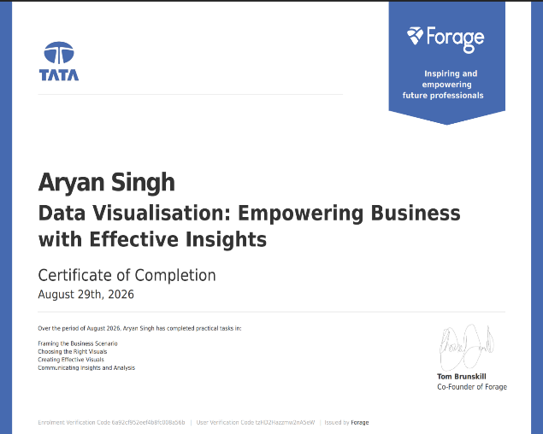
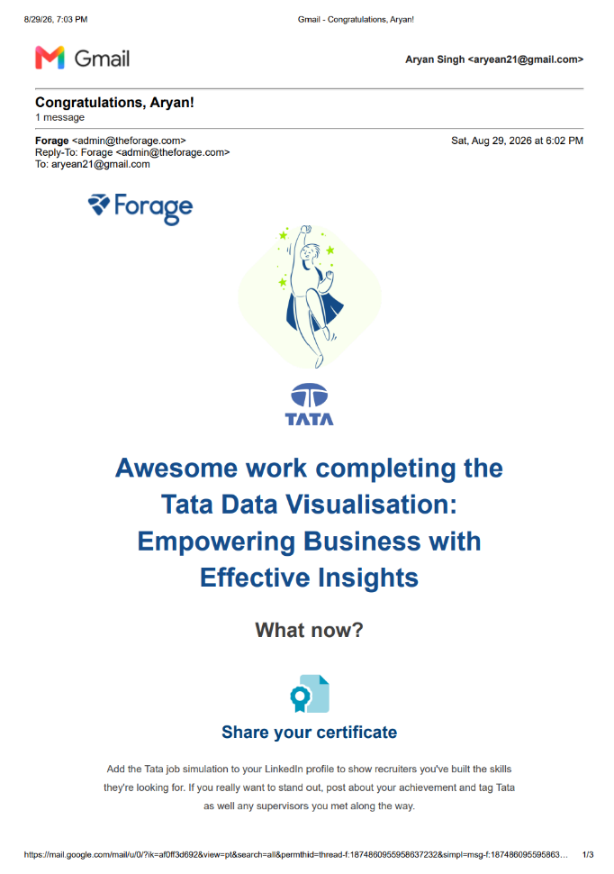
5. BIBLIOGRAPHY/REFERENCES
1. Tata / Forage, “GenAI Powered Data Analytics Job Simulation,” Certificate of Completion, Enrolment Verification Code 6a6c10731ebe2d46f87d1b60, User Verification Code 69634b484b3bff447af15dd1, issued August 29, 2026.
2. Geldium Delinquency Prediction Project — EDA Summary Report (Task 1), Tata iQ Analytics Team simulation deliverable, 2026.
3. Geldium Predictive Model Plan — Predictive Modelling Approach (Task 2), Tata iQ Analytics Team simulation deliverable, 2026.
4. Predictive Insights for Collections Strategy — Geldium Collections Business Report (Task 3), Tata iQ Analytics Team simulation deliverable, 2026.
5. AI-Powered Collections Strategy — Executive Briefing (Task 4), Tata iQ Analytics Team simulation deliverable, 2026.
6. Dataset Description Guide, Delinquency Prediction Dataset (500 customer records, 19 fields), provided as part of the Tata / Forage job simulation, 2026.
7. OpenAI, ChatGPT (Generative AI tool used for drafting assistance and pipeline scaffolding), https://chat.openai.com/

