**GAME ISLAND**

Name: - Aryan Singh: Email Id: - [aryan1389.be22@chitkara.edu.in](mailto:aryan1389.be22@chitkara.edu.in)

Name: - Arsh Jain: Email Id: - [arsh1361.be22@chitkara.edu.in](mailto:arsh1361.be22@chitkara.edu.in)

Name: - Aryan Kaushal: Email Id: - [aryan1382.be22@chitkara.edu.in](mailto:aryan1382.be22@chitkara.edu.in)

**ABSTRACT**

Bored? How about refreshing your mind? Here we are with our “Game Island” having a bunch of games which will give you an exciting and thrilling experience. It will help to improve the reflexes of the players. The proposed island includes games like Slither, Guess the Number, IKeyFlex, Shafty (proposed novel game), which demands all senses of the player to work in proper coordination. The main features of the proposed game island are merged with a minimalistic, user friendly and attractive graphical user interface like the option to play in either dark or light mode. Game Island can be operated by making an account with your email id which will use OTP Verification to secure the platform and data of the players. Our users also have an option to create a strong password using our password generator and get it protected and stored on cloud in encrypted form. This feature allows the players to retrieve the password automatically through OTP verification without remembering it. Every user will have a unique player id that will be used to store data of the games they have played and get that data stored on the cloud as well. The inclusion of learning games in the project will help the players to prepare for certain competitive exams at a certain level.

**IMPLEMENTATION**

The whole project revolves around GUI based platforms like Tkinter, CustomTkinter, Pygame and many more helping to make an interactive application for the users and help to store, retrieve, update the statistics of the player for different games played by him/her. The purpose of employing cloud services to store statistics/data is that the player can access the data from anywhere and can play more competitively to improve his score. The real time play and use of cloud base firebase services makes the games more interesting for the players. The list of games included in the project is as follows:

* Slither – Traditional snake game to improve reflexes.
* Guess the number – This game includes guessing the number between 1 to 100 that is chosen by our program.
* IKeyFlex – This is a reaction based game in which the player has to press the prescribed keys in the given time. This is a learning game that will help the players to prepare for certain competitive exams.
* Shafty – This is a board based game and different from any existing game somewhat similar to snakes and ladders. This is novel game design by authors and a unique feature of this Game Island.

**FLOW CHART OF GAME ISLAND**

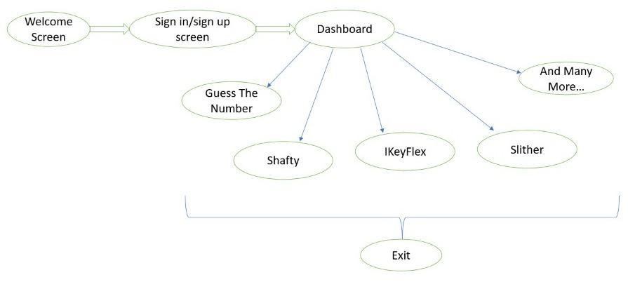

**Tools/Technique: Frontend:** Python Tkinter, CustomTkinter, Pygame

**Backend**: Pandas, Random Module, Pygame, Time, Openpyxl, os module, Pyrebase, hashlib, ast, smtplib, json, tkVideoplayer, datetime, pillow module, threading.

**Mentor Name:** - Dr. Anshu Singla