# Task 1: [3.5 marks]

1. Modify your Multinomial Naïve Bayes (MNB) classifier from **Etivity5, Task2** to train and test a sentiment classifier. [1 mark]

def multinomialNaiveBayesClassifier(trainingSet,testSet):

YOUR CODE HERE

trainingSet = [('Boxing scene was a disappointment','-'),('No plot twists or great scenes','-'),('Great satire and great plot twists','+'),('Great scenes a great film','+')]

testSet = [('Great disappointment indeed','?')]

multinomialNaiveBayesClassifier(trainingSet,testSet)

**Expected Output:**

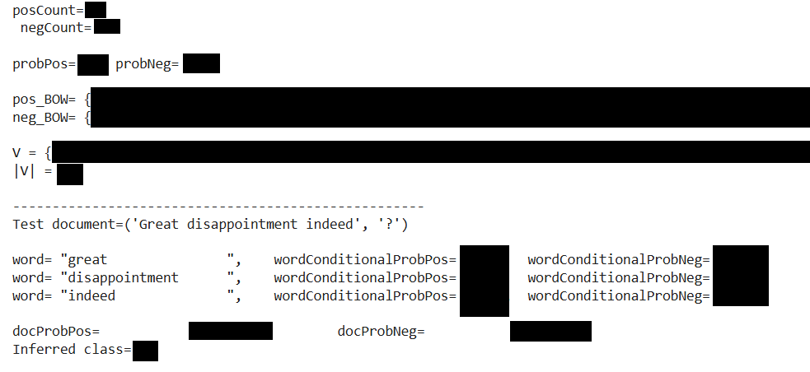

1. Copy your solution for **(a)** into a new code cell. Modify your code to optimise it for the task of sentiment analysis, i.e., change your classification algorithm from MNB to BMNB (Binary Multinomial Naïve Bayes). [2.5 marks]

def binaryMultinomialNaiveBayesClassifier(trainingSet,testSet):

YOUR CODE HERE

trainingSet = [('Boxing scene was a disappointment','-'),('No plot twists or great scenes','-'),('Great satire and great plot twists','+'),('Great scenes a great film','+')]

testSet = [('Great disappointment indeed','?')]

binaryMultinomialNaiveBayesClassifier(trainingSet,testSet)

**Expected Output:**



# Task 2: [1.5 marks]

Write a Sentiment Analysis function that takes a string as input and identifies its sentiment using the [TextBlob library](https://textblob.readthedocs.io/en/dev/quickstart.html#sentiment-analysis).

def sentimentAnalyzer(string):

**YOUR CODE HERE**

sentimentAnalyzer("NLP is cool")

sentimentAnalyzer("NLP is cool and useful")

sentimentAnalyzer("NLP is hard")

sentimentAnalyzer("NLP is hard and useless")

sentimentAnalyzer("NLP stands for Natural Language Processing")

**Expected Output:**

String= NLP is cool

Sentiment(polarity=0.35, subjectivity=0.65)

Positive sentiment 😊

Subjectivity: 0.65

---------------------------------

String= NLP is cool and useful

Sentiment(polarity=0.32499999999999996, subjectivity=0.325)

Positive sentiment 😊

Subjectivity: 0.325

---------------------------------

String= NLP is hard

Sentiment(polarity=-0.2916666666666667, subjectivity=0.5416666666666666)

Negative sentiment 😞

Subjectivity: 0.5416666666666666

---------------------------------

String= NLP is hard and useless

Sentiment(polarity=-0.39583333333333337, subjectivity=0.37083333333333335)

Negative sentiment 😞

Subjectivity: 0.37083333333333335

---------------------------------

**String= NLP stands for Natural Language Processing**

**Sentiment(polarity=0.1, subjectivity=0.4)**

**Neutral sentiment 😐**

**Subjectivity: 0.4**

**---------------------------------**

## 

## </END OF ETIVITY>