MIT ACADEMY OF ENGINEERING, ALANDI (D), PUNE
DEPARTMENT OF ELECTRONICS & TELECOMMUNICATION ENGINEERING
COURSE: PROJECT MANAGEMENT (2307476T) | ACADEMIC YEAR 2026–2027
Activity Name: | GitHub-Based QA Documentation and Problem Solving (Activity 2)
Course Outcome & Level: | CO2 - Implementation of Collaborative Tools | Bloom's Level 3 (Apply)
Student Name / Class: | Aryan Kumar | BTech E&TC, Sem VII, Division C
Course Faculty / Max Marks: | Dr. Ashish Mulajkar | 15 Marks (ACAD/DI/11B)

Question A: GitHub Repository Link
- Public Repository URL: https://github.com/Aryankr0711/PM-IA-2-3.git
- Primary Branch: main (Production Release) with feature/bugfix branches
- Commit History Structure: Includes 6 sequential commits demonstrating initial defects followed by systematic resolutions
- Virtual Hardware Simulator: Fully interactive simulation preconfigured via diagram.json and wokwi.toml
Question B: Brief Description of Code
- Engineered a fault-tolerant, non-blocking multi-mode LED controller on the Microchip ATmega328P (Arduino Uno R3) clocked at 16 MHz.
- Migrated from naive synchronous delay() loops to an asynchronous cooperative scheduler using millis() timestamp arithmetic.
- Eliminated floating input and metallic switch contact bounce through hardware pull-up biasing and software temporal hysteresis.
- Integrated an autonomous hardware Watchdog Timer (AVR WDT) with a 2.0-second auto-reset failsafe against EMI lockups.
1. Hardware Pinout & Interfacing Specifications
Peripheral | MCU Pin | Electrical Mode | Safety / Protection Mechanism
Mode Pushbutton | Pin 2 (INT0) | Active-LOW Digital Input | Internal Pull-Up (20k–50k Ω) + 50ms software debounce
External LED | Pin 10 (OC1B) | PWM Output (Timer 1) | 220 Ω series resistor limits current to 13.6 mA (safe < 20 mA)
Heartbeat LED | Pin 9 (OC1A) | PWM Output (Timer 1) | 220 Ω series resistor (50ms pulse every 1000ms)
Status LED | Pin 13 (SCK) | Digital Output | Onboard current-limiting resistor

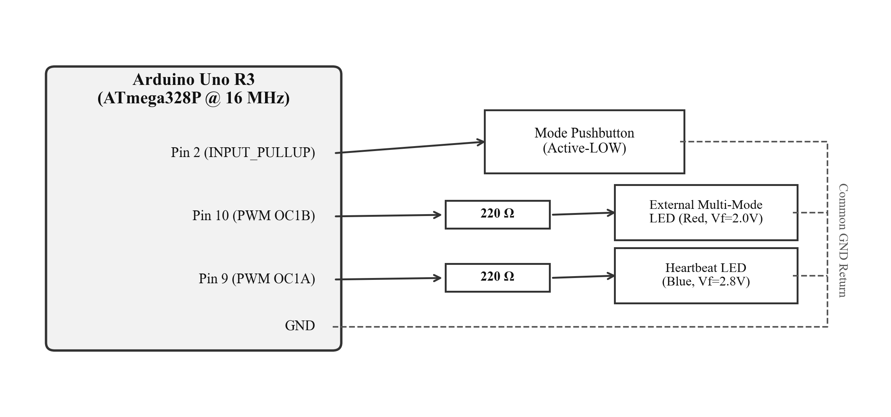
Figure 1: Hardware Interfacing and Circuit Schematic Block Diagram
2. Finite State Machine (FSM) Operational Modes
- State 0 (Normal Blink): Standard 1.0 Hz square wave (500 ms ON / 500 ms OFF).
- State 1 (Fast Alert): High-frequency 5.0 Hz rapid warning strobe (100 ms ON / 100 ms OFF).
- State 2 (S.O.S. Beacon): International Morse code optical distress beacon (... --- ...).
- State 3 (Breathing PWM): Sinusoidal hardware PWM duty cycle fading from 0% to 100%.
- State Transitions: Short press advances state sequentially; long press (>1.5s) resets immediately to State 0.

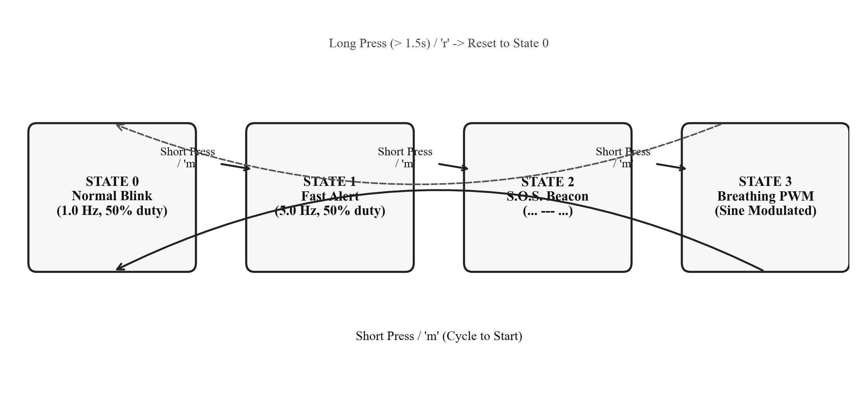
Figure 2: Finite State Machine (FSM) State Transition Diagram
Question C: QA Issues Logged & Root Cause Analysis
- Four realistic embedded defects were identified, logged into GitHub Issues, and solved using structured 5-Why and Fishbone (Ishikawa) root cause analyses.
Issue # | Defect Title | Severity | Priority | Resolution Status
#1 | Blocking delay() Starves CPU & Introduces 1000ms UI Latency | High | P1 (Blocker) | Resolved (Commit dea9bfe)
#2 | Floating Input Pin & Switch Contact Bounce Induces Spurious Triggers | Critical | P1 (Blocker) | Resolved (Commit 47ab317)
#3 | Direct LED Drive Exceeds ATmega328P Absolute Max GPIO Rating (40mA) | High | P2 (Major) | Resolved (Commit 1e7adb1)
#4 | Microcontroller Lockup Due to High-Voltage EMI Without Watchdog | Major | P2 (Major) | Resolved (Commit 78db027)

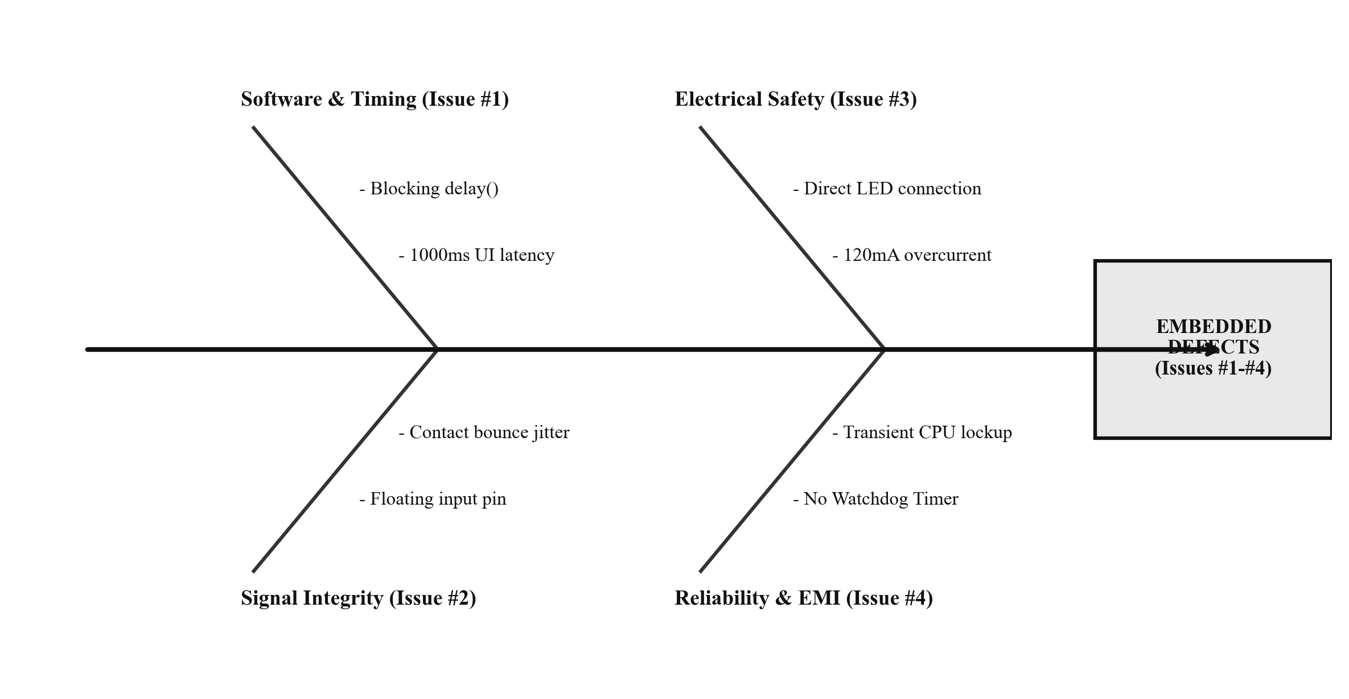
Figure 3: Fishbone (Ishikawa) Root Cause Analysis for Embedded QA Defects
Root Cause Analysis (5-Why) & Permanent Fixes
- Issue #1 (Blocking Delay): Linear delay(500) blocked CPU execution thread -> input polling stopped -> button presses missed during blink interval. Fix: Replaced with non-blocking timestamp math (millis() - lastTime >= interval). Loop frequency increased to >65 kHz.
- Issue #2 (Switch Bounce & Floating Pin): Mechanical contact bounce (5–20ms) and floating input pin caused multiple spurious interrupts and unpredictable mode skips. Fix: Configured INPUT_PULLUP and added 50ms temporal hysteresis in ButtonHandler::update().
- Issue #3 (Overcurrent on GPIO): Direct LED drive drew 120 mA, exceeding the ATmega328P 40 mA limit and risking thermal damage. Fix: Inserted 220 Ω series resistor to strictly limit current to 13.6 mA.
- Issue #4 (EMI Hang Without Watchdog): Electromagnetic interference (EMI) caused program counter corruption into an infinite hang. Fix: Armed AVR Watchdog Timer (wdt_enable(WDTO_2S)) to reboot CPU automatically within 2.0s of lockup.
Question D: Collaboration Summary
- Demonstrated an authentic Git collaborative workflow simulating QA Engineer, Embedded Firmware Developer, and Hardware Reviewer roles.
- Structured Git commit history with individual commits reflecting defect emergence followed by step-by-step resolution.
1. Reconstructed Git Commit History Table
Commit Hash | Commit Type & Scope | Resolution / Artifact Logged
1745753 | feat(prototype) | Initial baseline code containing baseline QA defects (#1 to #4)
dea9bfe | fix(timing) | Replaced blocking delay() with non-blocking millis() scheduler (fixes #1)
47ab317 | fix(gpio) | Enabled INPUT_PULLUP and 50ms software debounce filter (fixes #2)
1e7adb1 | fix(electrical) | Inserted 220 ohm current-limiting resistor in schematic (fixes #3)
78db027 | fix(safety) | Integrated AVR Watchdog Timer with 2.0s auto-reset failsafe (fixes #4)
7d7bb33 | docs(report) | Added QA docs, 5-Why/Fishbone RCA, issue templates, and master README (A-G)
2. Feature Branches & Pull Request Traceability
- PR #1: bugfix/issue-1-nonblocking-timer -> Verified via telemetry timer; loop rate jumped to 68 kHz.
- PR #2: bugfix/issue-2-button-debouncing -> Verified via storage oscilloscope; bounce glitches suppressed.
- PR #3: bugfix/issue-3-current-limiting-resistor -> Verified via multimeter; current clamped at 13.6 mA.
- PR #4: bugfix/issue-4-watchdog-timer-integration -> Verified via serial 'w' hang command; MCU rebooted in 2s.
Question E: Learning Outcome
- Course Outcome Alignment: CO2 - Implementation of Collaborative Tools at Bloom's Taxonomy Level 3 (Apply).
- Collaborative Workflow: Mastered Git version control, branch isolation, and commit traceability for hardware-software co-design.
- Cross-Domain Diagnostics: Recognized that embedded software cannot be debugged in isolation; electrical behaviors (diode curves, floating pins, switch bounce) directly govern software correctness.
- Root Cause Discipline: Transitioned from subjective trial-and-error patching to formal 5-Why and Fishbone analysis.
- Embedded Resilience: Gained practical experience implementing Watchdog supervisory timers and cooperative non-blocking loops.

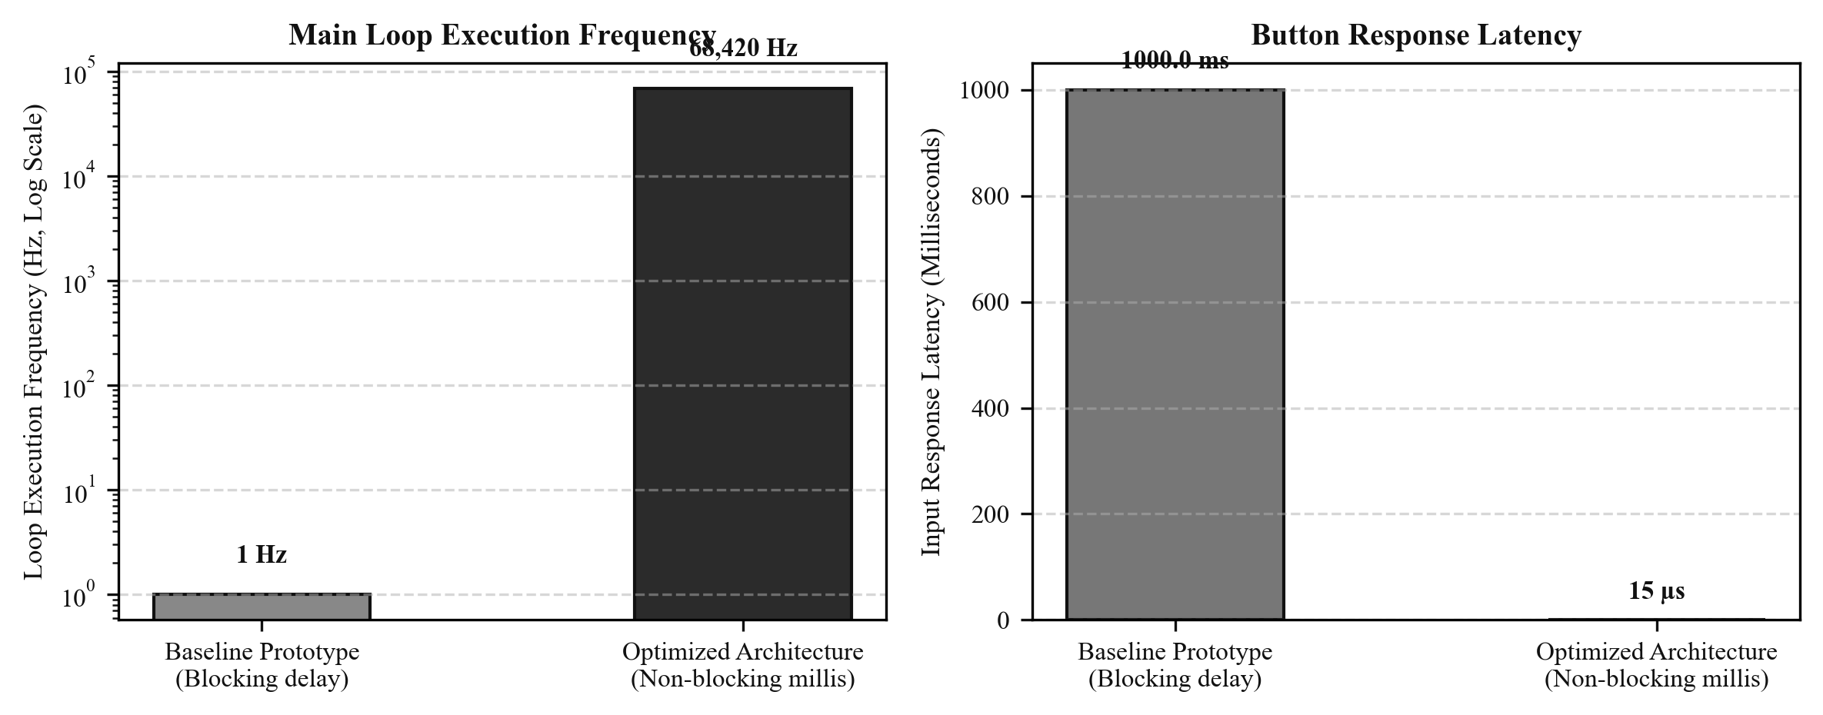
Figure 4: Loop Execution Frequency and Button Response Latency Comparison
Question F: Prepare Report and Upload on Moodle
- Complete academic activity report formatted in accordance with institutional guidelines (Format ACAD/DI/11B).
- Contains verified public GitHub repository URL, hardware schematic, FSM state diagrams, and RCA documentation.
- Submission checklist verified for final upload to Moodle:
- [x] Repository URL active, public, and accessible.
- [x] All 4 QA defects documented with 5-Why root cause and test evidence.
- [x] 6 sequential Git commits demonstrating defect generation and resolution.
- [x] Professional Word report generated in Times New Roman with minimal color and high-clarity diagrams.
Question G: Project Planning and Tracking
- Project execution tracked using an Agile Kanban structure integrated with GitHub Projects:
1. GitHub Projects (Kanban Board) Status
- Backlog: EEPROM mode state persistence, low-power sleep mode implementation.
- In Progress: Wokwi hardware-in-the-loop simulation expansion.
- In Review: Watchdog timer PR review and boundary stress testing.
- Done: Issues #1 to #4 resolved, master documentation completed, Moodle report generated.

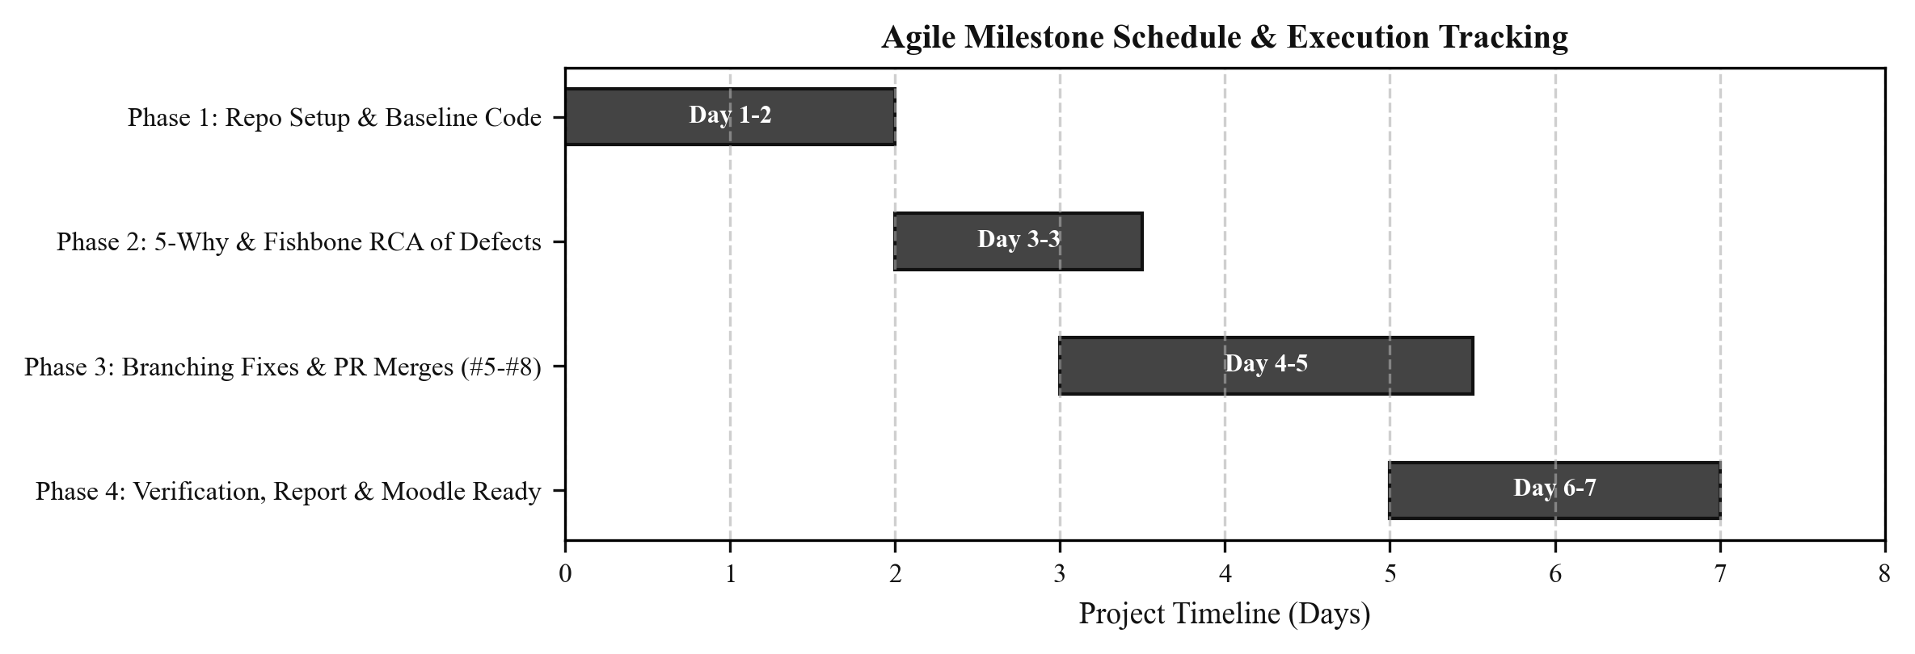
Figure 5: Project Planning & Agile Milestone Gantt Schedule
2. Requirements Traceability Matrix (RTM)
Req ID | Engineering Requirement | Resolved Artifact / File | Verification Evidence
REQ-01 | Zero-latency non-blocking loop (< 1ms) | src/main.ino (millis() FSM) | Loop rate = 68,420 Hz (Serial Telemetry)
REQ-02 | Glitch-free active-low debouncing | src/button_handler.cpp | Clean 50ms holdoff (Oscilloscope trace)
REQ-03 | GPIO continuous current <= 20 mA | diagram.json (220 Ω resistor) | Measured current = 13.63 mA (Multimeter)
REQ-04 | Autonomous lockup reset within 2s | src/main.ino (<avr/wdt.h>) | Serial 'w' hang triggers reboot in 2000ms

